Topic Exploration Pack

Topical issues

Teacher guide 2
Activity One 3
Activity Two 4
Activity Three 4
Student Activity 6
Student Resource 1 6
Student Resource 2 7
Student Resource 3 9
Student Resource 4 10
Student Resource 5 11

Instructions and answers for teachers

These instructions cover the student activity section which can be found on page 6. This Topic Exploration Pack supports OCR AS and A Level English Language.
When distributing the activity section to the students either as a printed copy or as a Word file you will need to remove the teacher instructions section.
ABC – This activity offers an opportunity for English skills development.

Teacher guide
This is an area that needs to be addressed in two distinct ways:
- Developing awareness and understanding of topical language issues, through the reading and exploration of relevant material
- Writing about topical language issues, in a variety of forms.
Each of these elements will be developed in the course of this Topic Exploration Pack, and each will be supported through a suggested range of discussion and research activities, as well as activities that relate more closely to preparation for the exam requirements.
This area is assessed at AS and in the A Level, and for AS students in particular it may involve engaging with new and sometimes challenging ideas. The task they are preparing for is that of writing about a topical language issue for a specified context, purpose and audience (although there may be an element of choice in terms of purpose, in that they may be invite to adopt one of several possible viewpoints). As students who have studied and achieved a GCSE English qualification, they should already be familiar with the task of writing for different contexts, purposes and audiences; the difference at AS/A Level will be that the contexts may be more wide-ranging and the audiences may be more sophisticated.
It may be very helpful, in enabling students to prepare to make this transition, to utilise some of the materials that are being studied for analytical purposes in other parts of the specification as resources to help promote awareness of and knowledge about more diverse contexts and audiences than those previously encountered.
In addition to developing the ability to write competently and confidently within a broader range of parameters, as described above, the task of writing about a language topic is likely to challenge students from the point of view of the content they will need to include. As they progress through the course they will learn not just about language per se, but they will also need to engage with ideas about language, and it is important that they are exposed to a range of texts that present them with contrasting viewpoints on a range of topics. Issues to do with gender and power need to be considered, especially at AS; while at A Level, language issues around technology, the spoken word, child language acquisition and language change should also be drawn in.

A theoretical awareness of topical issues is needed, in order to equip students to write critically and informatively; this would be expected to be broader and also more detailed at A Level than at AS.

Activity One
Teacher Summary
The lesson is designed to give students a sense of the scope and nature of the exam question. It is based on the premise that students need the ability to write for a range of different purposes, contexts/forms and audiences. Students need to start the activity by drawing three columns, using purpose, context/form and audience as headings. Working in groups or pairs they should then list as many ideas as they are able to in each column. Students might want to look at the Specimen papers and/or the Practice papers and/or Past papers when they are available as these might help provide a frame for some of their ideas.
In class, their ideas should be shared and the most useful/plausible six for each column decided upon. This would be an opportunity to revise the relevant genre characteristics.
Using Student Resource 1, each group/pair should then make three dice, (one for each column), using the six selected ideas, one for each face.
They then throw each of the dice and combine what is written on the three faces they ‘land’ on to create a practice exam question. (The topic/content will probably need to be suggested by the teacher, at least initially.)
Once the practice task has been decided upon, several options are available, eg: discuss, plan, draft first (or other) paragraph only, draft whole response, make notes, complete as formal exam practice. Ideally the dice should be stored for use in subsequent lessons where this was felt to be useful. Alternatively, students could be reminded of the principle of varying permutations: ‘Today we’ll combine x audience with y purpose and z context’ without any reliance on their physical presence.
Aims and Objectives
- To introduce the creative writing task
- To give students a sense of the scope of the forms of writing they may need to tackle in the exam
- To revise the relevant genre characteristics.
Resources
- Student Resource 1 (3 copies per group/pair)
- Glue/scissors/A4 sheets of cardboard if possible
- Whiteboard
Duration
This could take a number of lessons depending on how many practice tasks were felt to be desirable, and on the type of practice (eg notes/draft) selected for each of them.

Activity Two
Teacher Summary
To get them used to the idea of writing about language (as opposed to simply analysing texts), for this activity students are given a source to examine that focuses on one specific topical issue, jargon, and this is used as a springboard into their own creative writing.
Once they have completed the initial task, in which they mimic the source material (having first noted the way it has been constructed), students should then be asked to turn their attention to writing about jargon as a topical issue.
What are their feelings about it? What would the world of work/hobbies etc be like without it? They should then tackle the exam practice question that has been suggested at the end of Student Resource 2.
Aims and Objectives
- To revise the language levels and a range of features comprising them by studying a spoken word text
- To recognise the importance of selection and prioritising when approaching linguistic analysis
- To challenge preconceptions about use of language in relation to status
Resources
- Student Resource 2
Duration
The activity is designed to last for several lessons. Elements of it could be elongated or compressed depending on time constraints.

Activity Three
Teacher Summary
This activity has been designed to give students further exposure to a different topical language issue and to enable them to practise writing about it. The focus is on how writing – in this instance an article – needs to be shaped to meet the needs of different audiences.
Students should be given the topic and encouraged to consider what ideas/material might be useful in writing about it. This could be done in class, groups, pairs or individually.
Once some ideas have been assembled, students can be given the exact wording of the question, together with the instructions (Student Resources 3 and Student Resource 4). It is an activity that can easily be adapted to different topics, and is one that could usefully be revisited as the course goes on and students improve their levels of knowledge, skills and understanding. A blank copy of the layout has been supplied as Student Resource 5 in order to facilitate this.
Aims and Objectives
- To practise writing about topical issues
- To focus on adapting writing for the needs of a specified audience
- To focus on adapting writing for the needs of a specified context/form
Resources
- Student Resource 3 (task/instructions)
- Student Resource 4 (task/instructions)
- Student Resource 5 (task/instructions)
- Whiteboard
Duration
The activity is designed to last for several lessons. Elements of it could be elongated or compressed depending on time constraints.

We’d like to know your view on the resources we produce. By clicking on ‘Like’ or ‘Dislike’ you can help us to ensure that our resources work for you. When the email template pops up please add additional comments if you wish and then just click ‘Send’. Thank you.
If you do not currently offer this OCR qualification but would like to do so, please complete the Expression of Interest Form which can be found here: www.ocr.org.uk/expression-of-interest
Looking for a resource? There is now a quick and easy search tool to help find free resources for your qualification:
www.ocr.org.uk/i-want-to/find-resources/

OCR Resources: the small print
OCR’s resources are provided to support the teaching of OCR specifications, but in no way constitute an endorsed teaching method that is required by the Board, and the decision to use them lies with the individual teacher. Whilst every effort is made to ensure the accuracy of the content, OCR cannot be held responsible for any errors or omissions within these resources.
© OCR 2016 - This resource may be freely copied and distributed, as long as the OCR logo and this message remain intact and OCR is acknowledged as the originator of this work.
OCR acknowledges the use of the following content: Nathan Anderson quote and photo – Nathan Anderson/nathananderson.nyc
Please get in touch if you want to discuss the accessibility of resources we offer to support delivery of our qualifications: resources.feedback@ocr.org.uk

OCR Resources: the small print
OCR’s resources are provided to support the teaching of OCR specifications, but in no way constitute an endorsed teaching method that is required by the Board, and the decision to use them lies with the individual teacher. Whilst every effort is made to ensure the accuracy of the content, OCR cannot be held responsible for any errors or omissions within these resources.
© OCR 2015 - This resource may be freely copied and distributed, as long as the OCR logo and this message remain intact and OCR is acknowledged as the originator of this work.
OCR acknowledges the use of the following content: Page 10:George W Bush pressconference Transcribed by OCR from https://www.youtube.com/watch?v=VvvPzVdP-DM
Please get in touch if you want to discuss the accessibility of resources we offer to support delivery of our qualifications: resources.feedback@ocr.org.uk
We’d like to know your view on the resources we produce. By clicking on ‘Like’ or ‘Dislike’ you can help us to ensure that our resources work for you. When the email template pops up please add additional comments if you wish and then just click ‘Send’. Thank you.
If you do not currently offer this OCR qualification but would like to do so, please complete the Expression of Interest Form which can be found here: www.ocr.org.uk/expression-of-interest

Topic Exploration Pack

Topical issues

Student Activity

Student Resource 1
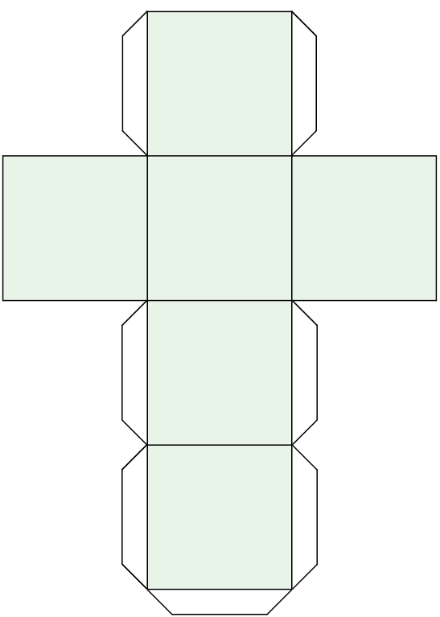

Student Resource 2
Introduction
In the exam you will be given a topic to write about that relates to ideas about language. The text below, which is a written representation of an extract from a comedy routine, uses humour to make a point about one specific feature of language use: jargon. It also raises questions about the importance of choosing your audience carefully when talking to others.
Task
Read the text below, which contains an image posted online containing part of a sketch by comedian Nathan Anderson, as well as a photo taken of him.
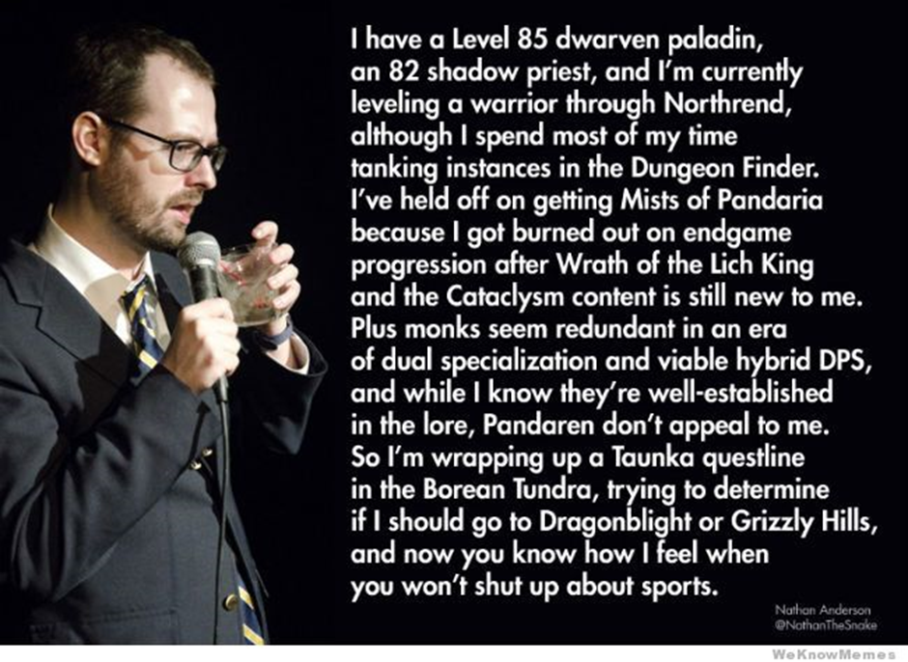Reproduced with permission from Nathan Anderson.
What language features does the text contain?
Now write a similar text yourself, parodying a specific type of jargon you feel particularly hostile towards. (You should aim to write approximately 500 words.)
Study hint: Identifying the language features in the stimulus text may give you clues as to the language features to use in your own version.
Finally, having considered jargon from a personal point of view, you now need to write about it as a topical language issue. Below is a sample question for you to tackle, using examples you have studied or encountered:
‘The world might be a less efficient place without jargon, but it would also be more honest’. Write a radio speech on this topic for an educated general audience, arguing either in favour of it or against it.

Student Resource 3
Your task is to write a short text and practise adapting it for a specified audience.
The topic is:
"And in a gutless act of political correctness, 'Pizza Day' will now be known as 'Italian-American Sauced Bread Day.”
- Principal Seymour Skinner, The Simpsons.'"
To what extent is political correctness over-emphasised in today’s world?

Write the first paragraph of a script for a speech on this topic, aimed at each of the following audiences:
A Level English Language students
Informed TV audience
Informed radio audience
English teachers

Student Resource 4
Now, using the same topic, write the final paragraph only of the following text types, all aimed at a general, educated audience:
"And in a gutless act of political correctness, 'Pizza Day' will now be known as 'Italian-American Sauced Bread Day.”
- Principal Seymour Skinner,
The Simpsons.'"
To what extent is political correctness over-emphasised in today’s world?

A TV documentary
A tabloid article
A podcast
A blog

A broadsheet editorial

Student Resource 5

