Chemistry PAG 1: Reactivity trend

Suggested Activity 2: Reactivity of metals

Instructions and answers for teachers & technicians
These instructions cover the learner activity section which can be found on page 9. This Practical activity supports OCR GCSE Chemistry and Combined Science.
When distributing the activity section to the learners, either as a printed copy or as a Word file, you will need to remove the teacher instructions section.
This is a suggested practical activity that can be used as part of teaching the GCSE (9-1) Gateway Science (A) and Twenty First Century Science (B) specifications.
These are not controlled assessment tasks, and there is no requirement to use these particular activities.
You may modify these activities to suit your learners and centre. Alternative activities are available from, for example, Royal Society of Biology, Royal Society of Chemistry, Institute of Physics, CLEAPSS and publishing companies, or of your own devising.
Further details are available in the specifications (Practical Skills Topics), and in these videos.
OCR recommendations:
Before carrying out any experiment or demonstration based on this guidance, it is the responsibility of teachers to ensure that they have undertaken a risk assessment in accordance with their employer’s requirements, making use of up-to-date information and taking account of their own particular circumstances. Any local rules or restrictions issued by the employer must always be followed.
CLEAPSS resources are useful for carrying out risk-assessments: (http://science.cleapss.org.uk).
Centres should trial experiments in advance of giving them to learners. Centres may choose to make adaptations to this practical activity, but should be aware that this may affect the Apparatus and Techniques covered by the learner.

Introduction
In this activity, learners carry out micro-scale reactions comparing the reactivity of four metals. The metals (magnesium, lead, iron, and copper) are placed in drops of solutions containing metal salts. Learners observe the rate and magnitude of reactivity between the two metals. A more reactive metal will displace a less reactive metal from its salt, resulting in metal deposition of the less reactive metal onto the more reactive metal surface. The magnetic properties of deposited iron will also be observed.
There are several advantages to using a micro-scale experiment. The activity uses a small amount of solution and metal, facilitating easy clean-up and minimising hazards. The full series of experiments can be done on one sheet, helping direct comparison of the metals’ reactivities.
This resource is adapted from the CLEAPSS activity ‘Displacement reactions’: https://www.youtube.com/watch?v=sk3ZolhPyWM
In addition to other practical activities available from OCR, suggested practical activities that fit into PAG 1 include:
- Reactions of halogens (as aqueous solutions) from the Nuffield Foundation / Royal Society of Chemistry Practical Chemistry Project

DfE Apparatus and Techniques covered
The codes used below match the OCR Practical Activity Learner Record Sheet (Chemistry / Combined Science) and Trackers (Chemistry / Combined Science) available online. There is no requirement to use these resources.
By doing this experiment, learners have an opportunity to develop the following skills:
3 [8]: Use of appropriate apparatus and techniques for: i) conducting and monitoring chemical reactions
6 [11]: Safe use and careful handling of gases, liquids and solids, including: i) careful mixing of reagents under controlled conditions; ii) using appropriate apparatus to explore chemical changes and/or products

Aims
To confirm the order of reactivity of a series of metals, and the magnetic nature of displaced iron.

Intended class time
15 – 25 minutes

Links to Specifications:

Gateway Science (Suite A) – including Working Scientifically (WS)
C4.1c recall the general properties of transition metals and their compounds and exemplify these by reference to a small number of transition metals [to include melting point, density, reactivity, formation of coloured ions with different charges and uses as catalysts]
C4.1f deduce an order of reactivity of metals based on experimental results
W1.3a presenting observations and other data using appropriate methods
W1.3e interpreting observations and other data
W1.3f presenting reasoned explanations
W1.4a use scientific vocabulary, terminology and definitions
WS2a carry out experiments
WS2b make and record observations and measurements using a range of apparatus and methods
WS2c presenting observations using appropriate methods

Twenty First Century Science (Suite B) – including Ideas about Science (IaS)
C2.5.1 recall the general properties of transition metals (melting point, density, reactivity, formation of coloured ions with different charges and uses as catalysts) and exemplify these by reference to copper, iron, chromium, silver and gold
C3.2.1 deduce an order of reactivity of metals based on experimental results including reactions with water, dilute acid and displacement reactions with other metals
IaS1.7. identify hazards associated with the data collection and suggest ways of minimizing the risk
IaS1.8. use appropriate scientific vocabulary, terminology and definitions to communicate the rationale for an investigation and the methods used using diagrammatic, graphical, numerical and symbolic forms
IaS2.11. in a given context interpret observations and other data (presented in diagrammatic, graphical, symbolic or numerical form) to make inferences and to draw reasoned conclusions, using appropriate scientific vocabulary and terminology to communicate the scientific rationale for findings and conclusions

Mathematical Skills covered
No defined mathematical skill is covered in this experiment.

Technical Requirements – PER GROUP

Chemicals
Identity | Approximate quantity required or produced PER GROUP | Hazard information |  | Risk information
0.1 mol/dm³ copper(II) sulfate(VI) solution | c. 1 cm³ | Currently not classified as hazardous at this concentration
0.1 mol/dm³ iron(II) sulfate(VI) solution or diammonium iron(II) sulfate  NB Solution will need making fresh as not acidified | c. 1 cm³ | Currently not classified as hazardous at this concentration
0.1 mol/dm³ lead(II) nitrate(V) solution | c. 1 cm³ | Currently not classified as hazardous at this concentration. However, labelling as follows is advised
DANGER
Hazardous substance
0.1 mol/dm³ magnesium sulfate(VI) solution | c. 1 cm³ | Currently not classified as hazardous at this concentration
small pieces (<0.5 cm) of  magnesium ribbon  lead foil  copper foil/turning/pins  iron nail/pin (check not zinc plated) | 4 pieces of each metal | Currently not classified as hazardous at this concentration |  | While magnesium is flammable, in solid form with no naked flames, it doesn’t present a hazard.  Ensure close supervision of magnesium.

Equipment
- Preparation of the metals - clean stock metals with fine emery paper before cutting to remove any outer layer of corrosion
- Solutions – best provided in dropping bottles, or in stock bottles with pipettes
- wooden splint or cocktail stick
- laminated copy reaction sheet
- bar magnet wrapped in cling film
- Access to a waste beaker with a sieve & squeeze bottle of tap water for rinsing sheets
- If available, a microscope projector to demonstrate the reactions/procedure

Notes
The reaction sheet can be placed in a plastic wallet or laminated.

Health and Safety
Eye protection should be worn at all times.
Ensure that there are no open flames in the laboratory.
Ensure that no learner is allowed to removed magnesium from the laboratory.
Dispose of the mixtures through a sieve into the waste beaker.

Method
Learners will add drops of solutions onto laminated sheets. Then they will place a piece of metal in each drop and observe the reactions. They will also use a magnet to observe which samples, after placing in iron salt solution, respond to a magnetic force.

Images from trials
=

Analysis of results – Trial results

Observations | Mg |  | Fe
 | MgSO₄  no change observed  Rate: n/a | FeSO₄  black solid formed on metal piece  Magnet: moved  Rate: slowest | MgSO₄  no change observed  Rate: n/a | FeSO₄  no change observed  Rate: n/a
 | Pb(NO₃)₂  ‘furry’ black solid formed on metal piece  Rate: medium rate | CuSO₄  small black pieces on metal piece  Rate: fastest | Pb(NO₃)₂  very small grey coating appeared on pin  Rate: slowest | CuSO₄  dark grey coating appears on pin  Rate: fastest
 | Pb |  | Cu
 | MgSO₄  no change observed  Rate: n/a | FeSO₄  no change observed  Magnet: n/a  Rate: n/a | MgSO₄  no change observed  Rate: n/a | FeSO₄  no change observed  Magnet: n/a  Rate: n/a
 | Pb(NO₃)₂  no change observed  Rate: n/a | CuSO₄  lead pieces got darker  Rate:n/a | Pb(NO₃)₂  no change observed  Rate: n/a | CuSO₄  no change observed  Rate: n/a

1. | Arrange the metals into order from least reactive to most reactive. Explain the evidence for this sequence with reference to your results. [5 marks]
Cu < Pb < Fe < Mg
Copper was not able to displace any of the other metal ions – no reactions were seen.
Lead displaced copper (grey coating) but not iron, magnesium or lead.
Iron displaced copper quickly (dark grey coating) and lead slowly (small grey coating).
Magnesium displaced copper quickly, and lead and iron slowly.

2. | Which metal(s) after contact with the iron salt solution moved towards the magnet? Explain your observations. [3 marks]
 | The magnesium responded to the magnet. This indicated that particles of iron were covering the magnesium. The magnesium is more reactive than iron, displacing the iron from the salt solution.

Extension opportunities
1. | Write word and symbol equations for the different reactions that have occurred:  - Lead [2 marks]
lead + copper sulfate → copper + lead nitrate
Pb(s) + CuSO₄(aq) → Cu(s) + Pb(NO₃)₂(aq)

 | - Iron [4 marks]
iron + copper sulfate → copper + iron(II) sulfate
Fe(s) + CuSO₄(aq) → Cu(s) + FeSO₄(aq)

iron + lead nitrate → lead + iron(II) nitrate
Fe(s) + Pb(NO₃)₂(aq) → Pb(s) + Fe(NO₃)₂(aq)

 | - Magnesium [6 marks]
magnesium + copper sulfate → copper + magnesium sulfate
Mg(s) + CuSO₄(aq) → Cu(s) + MgSO₄(aq)

magnesium + lead nitrate → lead + magnesium nitrate
Mg(s) + Pb(NO₃)₂(aq) → Pb(s) + Mg(NO₃)₂(aq)

magnesium + iron(II)sulfate → iron + magnesium sulfate
Mg(s) + FeSO₄(aq) → Fe(s) + MgSO₄(aq)

Document updates
v0.1 July 2016 Original version – DRAFT
v1 August 2016 Published on the qualification pages
v1.1 January 2017 Consolidated labelling and formatting of activities
We’d like to know your view on the resources we produce. By clicking on ‘Like’ or ‘Dislike’ you can help us to ensure that our resources work for you. When the email template pops up please add additional comments if you wish and then just click ‘Send’. Thank you.
If you do not currently offer this OCR qualification but would like to do so, please complete the Expression of Interest Form which can be found here: www.ocr.org.uk/expression-of-interest
Looking for a resource? There is now a quick and easy search tool to help find free resources for your qualification:
www.ocr.org.uk/i-want-to/find-resources/
OCR Resources: the small print
This formative assessment resource has been produced as part of our free GCSE teaching and learning support package. All the GCSE teaching and learning resources, including delivery guides, topic exploration packs, lesson elements and more are available on the qualification webpages.
If you are looking for examination practice materials, you can find Sample Assessment Materials (SAMs) on the qualification webpages: here

OCR’s resources are provided to support the teaching of OCR qualifications, but in no way constitute an endorsed teaching method that is required by the Board, and the decision to use them lies with the individual teacher. Whilst every effort is made to ensure the accuracy of the content, OCR cannot be held responsible for any errors or omissions within these resources.
© OCR 2017 - This resource may be freely copied and distributed, as long as the OCR logo and this message remain intact and OCR is acknowledged as the originator of this work.
OCR acknowledges the use of the following content: n/a
Please get in touch if you want to discuss the accessibility of resources we offer to support delivery of our qualifications: resources.feedback@ocr.org.uk

Chemistry PAG 1: Reactivity trend

Suggested Activity 2: Reactivity of metals

Learner Activity

Introduction
One of the key skills of a chemist is to identify and explain trends. In this activity, you will identify which pairs of substances react together and hence confirm the relative reactivity of a series of metals.
The reaction will be carried out in micro-scale, so it will help to develop your manual handling and close observation skills.

Aims
To confirm the order of reactivity of a series of metals, and the magnetic nature of displaced iron.
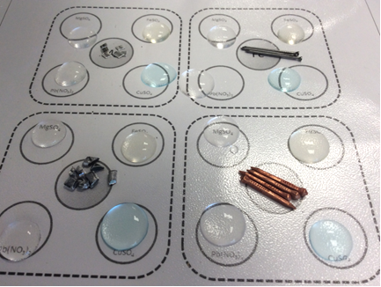
Figure 1: The experimental setup

Intended class time
15 – 25 minutes

Chemicals and equipment (per group)
- 0.1 mol/dm³ iron(II) sulfate
- 0.1 mol/dm³ copper sulfate solution
- 0.1 mol/dm³ lead nitrate solution
- 0.1 mol/dm³ magnesium sulfate solution

- small pieces of
  - magnesium ribbon
  - lead foil
  - copper foil/pin/turning
  - iron nails/pins

- magnet wrapped in cling film
- wooden splint or cocktail stick
- plastic covered copy of the reaction Figure 2 (laminated or in plastic wallet)

Health and Safety
- Eye protection should be worn at all times.
- Dispose of the mixtures through a sieve into the waste beaker.
- Clean up your equipment as instructed by your teacher.

Method
Setting up the reagents
- If you don’t have a laminated copy of the reaction sheet, place it inside a plastic envelope.
- In each of the large white circles, place 4-5 drops of the appropriate solution.
- In each of the smaller grey circles, place 4 pieces of the appropriate metal.

Carrying out the reactions
- With a wooden splint/tooth pick, carefully push a piece of the magnesium into each of the drops of the four metal solutions.
- Carefully observe each drop and record your observations in a table.
As well as identifying which metal and solution mixtures show a reaction, try to identify the quickest and slowest reactions.
- Repeat this part for each of iron, lead and copper.

Testing for the formation of iron
- Wrap a bar magnet in cling film.
- Bring the magnet close to each of the iron sulfate drops with the magnesium, lead and copper pieces in and carefully observe the piece of metal – if it moves, this indicates iron metal has been formed. Record your observations in a table.

Clearing away
- Pour the mixtures through a sieve into the waste beaker and rinse the sheet with the bottle of tap water to ensure all the metal pieces are in the sieve.
- Dry the sheet/plastic wallet as instructed by your teacher.

Demonstration
- Your teacher may demonstrate some of the reactions using a microscope projector. If available, you can also use the camera app on a smartphone to observe the drop under magnification and take pictures for your write-up.

Analysis of results
You can draw your own table, or use the one below:
Observations | Mg |  | Fe
 | MgSO₄  Rate: | FeSO₄  Magnet:  Rate: | MgSO₄  Rate: | FeSO₄  Rate:
 | Pb(NO₃)₂  Rate: | CuSO₄  Rate: | Pb(NO₃)₂  Rate: | CuSO₄  Rate:
 | Pb |  | Cu
 | MgSO₄  Rate: | FeSO₄  Magnet:  Rate: | MgSO₄  Rate: | FeSO₄  Magnet:  Rate:
 | Pb(NO₃)₂  Rate: | CuSO₄  Rate: | Pb(NO₃)₂  Rate: | CuSO₄  Rate:

Your ability to analyse your observations may depend on how much of the GCSE Chemistry/Combined Science course you have studied. Your teacher will let you know which questions you should focus on:
1. | Arrange the metals into order from least reactive to most reactive. Explain the evidence for this sequence with reference to your results. [5 marks]

2. | Which metal(s) after contact with the iron salt solution moved towards the magnet? Explain your observations. [3 marks]

Extension opportunities
1. | Write word and symbol equations for the different reactions that have occurred:  - Lead [2 marks]
 | - Iron [4 marks]
 | - Magnesium [6 marks]

DfE Apparatus and Techniques covered
If you are using the OCR Practical Activity Learner Record Sheet (Chemistry / Combined Science) you may be able to tick off the following skills:

Chemistry |  |  |  |  | Combined Science
3-i | 6-i | 6-ii |  |  | 8-i | 11-i | 11-ii

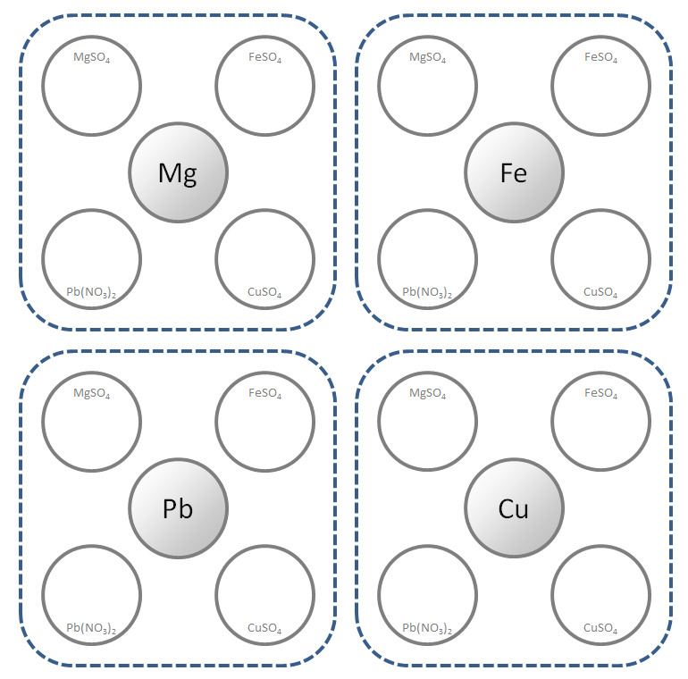

Figure 2: The reaction setup

