Chemistry PAG 3: Separation techniques

Combined Science PAG C3: Separation techniques

Suggested Activity 2: Chromatography of leaf chloroplasts

Instructions and answers for teachers & technicians
These instructions cover the learner activity section which can be found on page 10. This Practical activity supports OCR GCSE Chemistry and Combined Science.
When distributing the activity section to the learners, either as a printed copy or as a Word file, you will need to remove the teacher instructions section.
This is a suggested practical activity that can be used as part of teaching the GCSE Chemistry and Combined Science Gateway (A) and Twenty First Century (B) specifications. These are not controlled assessment tasks, and there is no requirement to use these activities. You may modify these activities to suit your learners and centre. Alternative activities are available from, for example, Royal Society of Chemistry LearnChemistry, CLEAPSS and publishing companies, or of your own devising.
OCR recommendations:
Before carrying out any experiment or demonstration based on this guidance, it is the responsibility of teachers to ensure that they have undertaken a risk assessment in accordance with their employer’s requirement, making use of up-to-date information and taking account of their own particular circumstances. Any local rules or restrictions issued by the employer must always be followed.
Use CLEAPSS resources (http://www.cleapss.org.uk) when carrying out risk-assessments.
Centres should trial experiments in advance of giving them to learners. Centres may choose to make adaptations to this practical, but should be aware that this may affect the Apparatus and Techniques covered by the learner.

Introduction
In this activity, learners will extract the chloroplasts from leaves and separate the chlorophyll by thin-lay chromatography. The activity is carried out at microscale to minimise the use of solvents.
This resource is adapted from the CLEAPSS experiment ‘Thin layer chromatography (TLC) of leaf chloroplast’ – https://www.youtube.com/watch?v=1ZSgwonXhkU, as further developed by CLEAPSS for the ASE 2015 Chemistry Workshops demonstration activities.
In addition to other practical activities available from OCR, suggested practical activities that fit into PAG 3 include:
- Preparing a soluble salt by neutralisation from the Nuffield Foundation / Royal Society of Chemistry Practical Chemistry Project
- Activities from CLEAPSS guidance leaflets PS67-14 (Chromatography) and PS67-15 Amino acids in soy sauces (login required).

DfE Apparatus and Techniques covered
The codes used below match the OCR Practical Activity Learner Record Sheet (Chemistry / Combined Science) and Trackers (Chemistry / Combined Science) available online. There is no requirement to use these resources.
3 [8]: Use of appropriate apparatus and techniques for: i) conducting and monitoring chemical reactions
4 [9]: Safe use of a range of equipment to purify and/or separate chemical mixtures including: iv) chromatography
6 [11]: Safe use and careful handling of gases, liquids and solids, including: i) careful mixing of reagents under controlled conditions

Aims
To separate the chlorophyll of plant chloroplasts by thin layer chromatography.

Intended class time
25 – 30 minutes

Links to Specifications:

Gateway Science (Suite A) – including Working Scientifically (WS)
C2.1g describe the techniques of paper and thin layer chromatography
C2.1h recall that chromatography involves a stationary and a mobile phase and that separation depends on the distribution between phases [to include: identification of the mobile and stationary phase]
C2.1i interpret chromatograms, including measuring R_{f} values [to include: the recall and the use of the formula]
C2.1j suggest suitable purification techniques given information about the substances involved
C2.1k suggest chromatographic methods for distinguishing pure from impure substances [to include paper, thin layer (TLC) and gas chromatography]
WS1.2e evaluate methods and suggest possible improvements and further investigations
WS1.3a presenting observations and other data using appropriate methods
WS1.3b translating data from one form to another
WS1.3c carrying out and representing mathematical and statistical analysis
WS1.3e interpreting observations and other data
WS1.3f presenting reasoned explanations relating data to hypotheses
WS1.3g evaluating data in terms of accuracy, precision, repeatability and reproducibility
WS1.3h identifying potential sources of random and systematic error
WS1.4a use scientific vocabulary, terminology and definitions
WS2a carry out experiments
WS2b make and record observations and measurements using a range of apparatus and methods
WS2c presenting observations using appropriate methods to include descriptive, tabular diagrammatic and graphically
WS2d communicating the scientific rationale for investigations, methods used, findings and reasoned conclusions

Twenty First Century Science (Suite B) – including Ideas about Science (IaS)
C5.1.4 recall that chromatography involves a stationary and a mobile phase and that separation depends on the distribution between the phases
C5.1.5 interpret chromatograms, including calculating Rf values
C5.1.6 suggest chromatographic methods for distinguishing pure from impure substances [including the use of a) paper chromatography, b) aqueous and non-aqueous solvents, c) locating agents]
C5.1.8 suggest suitable purification techniques given information about the substances involved
IaS1.8 use appropriate scientific vocabulary, terminology and definitions to communicate the rationale for an investigation and the methods used using diagrammatic, graphical, numerical and symbolic forms
IaS2.1 present observations and other data using appropriate formats
IaS2.4 be able to translate data from one form to another
IaS2.8 when analysing data identify patterns/trends, use statistics (range and mean) and obtain values from a line on a graph (including gradient, interpolation and extrapolation),
IaS2.9 in a given context evaluate data in terms of accuracy, precision, repeatability and reproducibility, identify potential sources of random and systematic error, and discuss the decision to discard or retain an outlier
IaS2.10 evaluate an experimental strategy, suggest improvements and explain why they would increase the quality (accuracy, precision, repeatability and reproducibility) of the data collected, and suggest further investigations
IaS2.11 in a given context interpret observations and other data (presented in diagrammatic, graphical, symbolic or numerical form) to make inferences and to draw reasoned conclusions, using appropriate scientific vocabulary and terminology to communicate the scientific rationale for findings and conclusions

Mathematical Skills covered
M3c substitute numerical values into algebraic equations using appropriate units for physical quantities.

Technical Requirements – PER GROUP

Chemicals (per group)
Identity | Approximate quantity required or produced PER GROUP | Hazard information |  |  | Risk information
extraction solvent  2:3 mixture by volume ethyl ethanoate: propanone | 0.25 cm³ |  | DANGER Highly flammable liquid and vapour. Causes serious eye irritation. May cause drowsiness or dizziness. Repeated exposure may cause skin dryness or cracking. |  | Ensure the room is well ventilated.  Ensure there are no naked flames in the laboratory.
developing solvent  5:3:2 mixture by volume of cyclohexane:ethyl ethanoate: propanone | 0.5 cm³ |  |  | DANGER Extremely flammable liquid and vapour; causes skin irritation; repeated exposure may cause skin dryness or cracking; causes serious eye irritation; may be fatal if swallowed and enters airways; may cause drowsiness or dizziness; very toxic to aquatic life with long lasting effects; may form explosive peroxides | Ensure the room is well ventilated.
anhydrous sodium sulfate(VI) solid, Na₂SO₄(s) | 0.5 g | Currently not classified as hazardous at this concentration

Equipment
- an Eppendorf tube (or test tube)
- dropping pipette
- blunt forceps
- scissors
- weigh boat
- micro-spatula
- 2 cm³ soft green plant leaf
- TLC plate (about 1.3 x 5 cm)
- glass vial with screw cap OR small beaker and aluminium foil
- very fine paint brush
- ruler with millimetre markings

Notes
Eppendorf tubes are available for about £12 per 500 (e.g. SciChem DCT470040, Timstar BT100554)
Test tubes can be used instead of Eppendorf tubes – doubling the quantities of leaf and extracting solvent would be recommended.
TLC plates (e.g. Timstar CH44018) silica applied on a polyester backing are available for about £80 per 50 sheets (50 x 200mm), each of which can be cut with scissors to 15 smaller plates (50 x 13 mm) – each individual plate then costs about 11p each.

Health and Safety
Eye protection should be worn at all times.
Ensure the laboratory is well ventilated. Take particular care if you have any asthmatic members of the group.

Method
Learners will extract the chloroplasts from a soft green leaf, then separate them by thin layer chromatography. As the chloroplasts are coloured, the plate does not need to be developed. Learners can then measure R_{f} values for the visible components.

Analysis of results – Trial results
Spot number | Distance travelled (x_{n}) / mm | R_{f}
solvent front | 50 | N/A
1 – faint yellow | 45 | 0.90
2 – grey | 30 | 0.60
3 – green | 26 | 0.52
4 – green | 24 | 0.48
5 - yellow | 20 | 0.40

1. | The discussion will depend on learner results.

Extension opportunities
The questions you set your learners will depend on the focus of the experiment.
1. | Anhydrous sodium sulfate is a drying agent. Explain why this was used in this experiment. [3 marks]
Chlorophylls are soluble in water…
…so removing the water helps extract the chlorophylls into the solvent.
Water would interfere with the running of the chromatography.

2. | State the stationary and mobile phase in this chromatography experiment.  [2 marks]
Stationary phase:
Stationary = silica (on the plastic support)
Mobile phase:
Mobile = developing solvent

3. | State and explain which of the substances (by spot number) is least and most soluble in the developing solvent. [4 marks]
Least soluble = spot 5 because it moves the least distance
Most soluble = spot 1 because it moves the most distance

4. | Research the role of locating agents in chromatography, and explain why one was not needed in this experiment. [2 marks]
Locating agents allow you to see where substances are on the stationary phase.
They aren’t needed in this experiment, as all of the substances are coloured.

5. | In a separate TLC experiment, a mixture was separated, but some of the spots had very similar R_{f} values (the spots overlapped with each other). State and explain what the scientist could do to obtain more useful results. [2 marks]
Use a different stationary and/or mobile phase
as the R_{f} of a substance depends on both of these.

6. | Look at the chromatogram below.  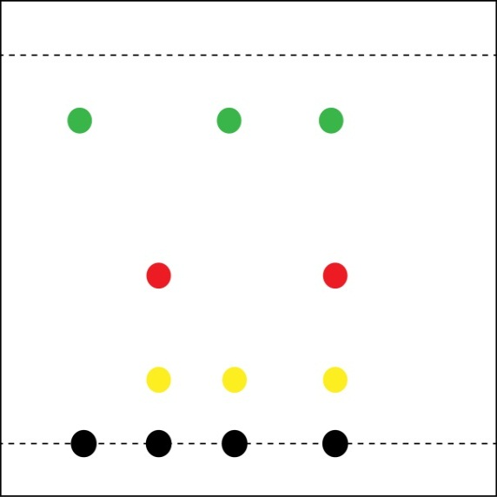  A B C black ink  Solvent front  Green spot  Red spot  Yellow spot
 | (i) | Calculate the R_{f} value of the yellow spot – show your workings. [2 marks]
 |  | Rf = 0.8(0) / 5.2 = 0.15

 | (ii) | State and explain which of the three samples contain yellow ink. [2 marks]
 |  | Sample B and C contain yellow ink as they have spots with the same R_{f} value as the yellow spot in the blank ink sample

 | (iii) | State and explain which of the three samples may be a pure substance.  [2 marks]
 |  | Sample A may be pure as it only contains one ink spot in this chromatogram .

Document updates
v0.2 July 2016 Draft version released on OCR Community
v1 August 2016 Published on the qualification pages
v1.1 January 2017 Consolidated labelling and formatting of activities
v1.2 June 2021 Updated to meet digital accessibility standards

We’d like to know your view on the resources we produce. Click ‘Like’ or ‘Dislike’ to send us an auto generated email about this resource. Add comments if you want to. Let us know how we can improve this resource or what else you need. Your email will not be used or shared for any marketing purposes.
Looking for another resource? There is now a quick and easy search tool to help find free resources for your qualification.
OCR is part of Cambridge Assessment, a department of the University of Cambridge.
For staff training purposes and as part of our quality assurance programme your call may be recorded or monitored.
Oxford Cambridge and RSA Examinations is a Company Limited by Guarantee. Registered in England. Registered office
The Triangle Building, Shaftesbury Road, Cambridge, CB2 8EA. Registered company number 3484466. OCR is an exempt charity.
OCR operates academic and vocational qualifications regulated by Ofqual, Qualifications Wales and CCEA as listed
in their qualifications registers including A Levels, GCSEs, Cambridge Technicals and Cambridge Nationals.
OCR provides resources to help you deliver our qualifications. These resources do not represent any particular teaching method we expect you to use. We update our resources regularly and aim to make sure content is accurate but please check the OCR website so that you have the most up to date version. OCR cannot be held responsible for any errors or omissions in these resources.
Though we make every effort to check our resources, there may be contradictions between published support and the specification, so it is important that you always use information in the latest specification. We indicate any specification changes within the document itself, change the version number and provide a summary of the changes. If you do notice a discrepancy between the specification and a resource, please contact us.
© OCR 2021 - You can copy and distribute this resource freely if you keep the OCR logo and this small print intact and you acknowledge OCR as the originator of the resource.
OCR acknowledges the use of the following content: N/A
Whether you already offer OCR qualifications, are new to OCR or are thinking about switching, you can request more information using our Expression of Interest form.
Please get in touch if you want to discuss the accessibility of resources we offer to support you in delivering our qualifications.

Chemistry PAG 3: Separation techniques

Combined Science PAG C3: Separation techniques

Suggested Activity 2: Chromatography of leaf chloroplasts

Learner Activity

Introduction
Chloroplasts are plant cell subunits that conduct photosynthesis, due to chlorophyll transferring energy from sunlight into stored chemical energy within molecules such as ATP. Chlorophyll is a mixture of various chemicals, such chlorophyll a and b, xanthophyll and carotene. These substances are coloured, can be separated by chromatography and directly seen during and at the end of the chromatography.

In this activity you will extract the chloroplast chemicals from a plant leaf, and separate them using thin layer chromatography (TLC). The stationary phase in TLC is usually a thin layer of silica held on a plastic plate. The sample is separated by the mobile phase, in this case a mixture of organic solvents. Due to the different solubilities of the chlorophyll in the solvent, they will move different distances on the plate.

This practical is based on a CLEAPSS activity – a short video is available at https://www.youtube.com/watch?v=1ZSgwonXhkU.

Aims
To prepare a sample from plant leaf and separate the photosynthetic chemicals by thin layer chromatography.
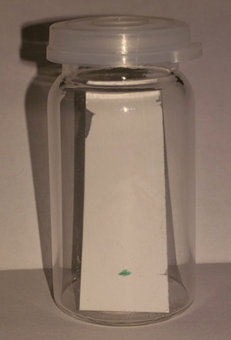
glass vial
TLC plate
plant extract
base line notch
Figure 1: Running a thin layer chromatography in a sample jar

Intended class time
25 – 30 minutes

Equipment (per group)
- an Eppendorf tube (or a test tube)
- dropping pipette
- blunt forceps
- scissors
- weigh boat
- micro-spatula
- 2 cm³ soft green plant leaf
- TLC plate (about 1.3 x 5 cm)
- glass vial with screw cap OR small beaker and aluminium foil
- very fine paint brush
- ruler with millimetre markings
- anhydrous sodium sulfate (Low hazard)
- extracting solvent (DANGER: Extremely flammable and harmful)
- developing solvent (DANGER: Extremely flammable and harmful)

Health and Safety
- Eye protection should be worn at all times.
- Ensure the laboratory is well ventilated.
- The liquid chemicals you are using are flammable and harmful. The risk to yourself and others is lowered by using small amounts, handling them carefully and following your teachers instructions. IF IN DOUBT, ask your teacher for extra advice and help.

Method
STAGE 1: Extraction of leaf chloroplasts  - Add a small spatula measure of anhydrous sodium sulfate to the Eppendorf tube.  - Cut up about 2 cm³ of a soft green leaf into small parts and place in the tube.  - Add 5 drops of the extraction solvent.  - Press and stir the leaf with tip of the forceps for 2 minutes to break up the leaf cells. | 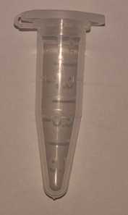
STAGE 2: Setting up the TLC plate
- Ensure that your TLC plate fits into your glass vial / small beaker.
- Make a small notch in the silica layer with the edge of the spatula about 1 cm from the bottom of the plate – this indicates the level of your baseline.
- Using the very fine paint brush, dip the tip into the coloured extracting solvent (from STAGE 1) and paint a very small amount onto the plate at the level of the notch.
- Blow gently onto the plate for 20-30 seconds to help the solvent to evaporate.
- Repeat steps 3 and 4 at 4-6 times, until you have a clearly visible green spot.

STAGE 3 : Running the chromatogram
- Using a dropper pipette, add developing solvent to the vial/small beaker to a depth of about 5 mm – hold your TLC plate next to the vial/beaker to check the solvent level is below your green spot.
- Place your TLC plate into the vial/beaker and place on the lid/cover with aluminium foil.
You should observe the solvent rising up the TLC plate, and separating the green spot.
- Remove the TLC plate from the vial/beaker with the cleaned forceps when the solvent is within 0.5 cm of the top.
- Make a notch in the silica at the side of the TLC plate where the solvent stopped – this is your solvent front.
- Allow the solvent to fully evaporate from the plate (2-3 minutes).

Stage 4: Measuring R_{f} values  - Take a photo of the plate for your records.  - Measure the distance in mm between the baseline notch and the solvent front notch – call this value y.  - Measure the distance in mm between the baseline notch and the centre of any coloured spots – call these values x₁, x₂, x₃ etc.  You can carefully draw a faint pencil line across the plate at the levels of the notches to help with these measurements. | 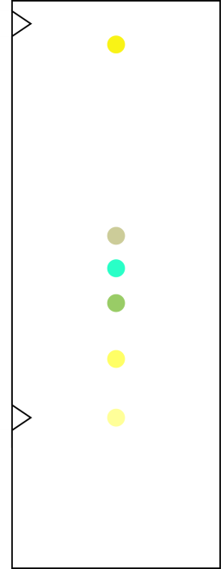

Analysis of results
You can draw your own table, or copy the one below. Calculate your R_{f} values using this equation:

Spot number - colour | Distance travelled (x_{n}) / mm | R_{f}
solvent front
1 –
2 –
3 –
4 –
5 –

1. | Compare your results with your teacher’s trail results. Discuss the agreement between your R_{f} values, and the number and colour of the spots seen.

Extension opportunities
Your ability to analyse your observations may depend on how much of the GCSE Chemistry course you have studied. Your teacher will let you know which questions you should focus on:
1. | Anhydrous sodium sulfate is a drying agent. Explain why this was used in this experiment. [3 marks]

2. | State the stationary and mobile phase in this chromatography experiment.  [2 marks]
 | Stationary phase:
 | Mobile phase:

3. | State and explain which of the substances (by spot number) is least and most soluble in the developing solvent. [4 marks]

4. | Research the role of locating agents in chromatography, and explain why one was not needed in this experiment. [2 marks]

5. | In a separate TLC experiment, a mixture was separated, but some of the spots had very similar R_{f} values (the spots overlapped with each other). State and explain what the scientist could do to obtain better results. [2 marks]

6. | Look at the chromatogram below.  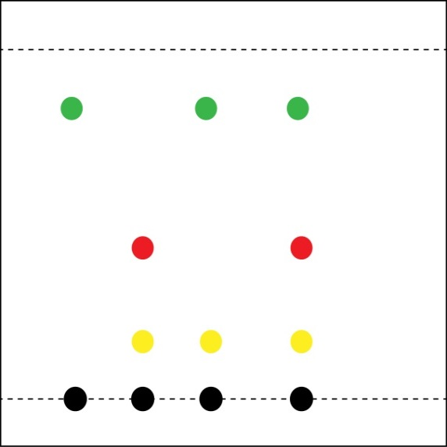  A B C black ink  Solvent front  Green spot  Red spot  Yellow spot
 | (i) | Calculate the R_{f} value of the yellow spot – show your workings. [2 marks]

 | (ii) | State and explain which of the three samples contain yellow ink. [2 marks]

 | (iii) | State and explain which of the three samples may be a pure substance.  [2 marks]

DfE Apparatus and Techniques covered
The codes used below match the OCR Practical Activity Learner Record Sheet (Chemistry / Combined Science) and Trackers (Chemistry / Combined Science) available online. There is no requirement to use these resources.
Chemistry |  |  |  |  | Combined Science
3-i | 4-iv | 6-i |  |  | 8-i | 9-iv | 11-i

