Chemistry PAG 4: Distillation

Combined Science PAG C2: Distillation

Suggested Activity 1: Extraction of limonene

Instructions and answers for teachers & technicians
These instructions cover the learner activity section which can be found on page 11. This Practical activity supports OCR GCSE Chemistry and Combined Science.
When distributing the activity section to the learners, either as a printed copy or as a Word file, you will need to remove the teacher instructions section.
This is a suggested practical activity that can be used as part of teaching the GCSE (9-1) Gateway Science (A) and Twenty First Century Science (B) specifications.
These are not controlled assessment tasks, and there is no requirement to use these particular activities.
You may modify these activities to suit your learners and centre. Alternative activities are available from, for example, Royal Society of Biology, Royal Society of Chemistry, Institute of Physics, CLEAPSS and publishing companies, or of your own devising.
Further details are available in the specifications (Practical Skills Topics), and in these videos.
OCR recommendations:
Before carrying out any experiment or demonstration based on this guidance, it is the responsibility of teachers to ensure that they have undertaken a risk assessment in accordance with their employer’s requirements, making use of up-to-date information and taking account of their own particular circumstances. Any local rules or restrictions issued by the employer must always be followed.
CLEAPSS resources are useful for carrying out risk-assessments: (http://science.cleapss.org.uk).
Centres should trial experiments in advance of giving them to learners. Centres may choose to make adaptations to this practical activity, but should be aware that this may affect the Apparatus and Techniques covered by the learner.

Introduction
In this activity, learners will extract orange oil, which contains limonene, from orange peel by distillation. They will then carry out qualitative analysis of the oily product with bromine water and/or potassium managanate(VII) to test for the presence of unsaturated compounds.
This activity is adapted from the CLEAPSS resource TL4 01/12 ‘Extracting limonene from orange peel’ http://science.cleapss.org.uk/Resource-Info/TL004-Extracting-limonene.aspx (login required).
A large scale demonstration of this is available from the Royal Society of Chemistry ‘Chemistry for non-specialists’ http://pubs.rsc.org/en/content/ebook/978-1-84973-112-6, specifically the practical ‘Extracting limonene from oranges’ http://www.rsc.org/learn-chemistry/resource/res00000692/extracting-limonene-from-oranges. A video of this large scale method is available from Farnborough Chemistry at https://www.youtube.com/watch?v=kfw0fECeOuE.
In addition to other practical activities available from OCR, suggested practical activities that fit into PAG 4 include:
- The fractional distillation of crude oil from the Nuffield Foundation / Royal Society of Chemistry Practical Chemistry Project

DfE Apparatus and Techniques covered
The codes used below match the OCR Practical Activity Learner Record Sheet (Chemistry / Combined Science) and Trackers (Chemistry / Combined Science) available online. There is no requirement to use these resources.
By doing this experiment, learners have an opportunity to develop the following skills:
1 [1]: Use of appropriate apparatus to make and record a range of measurements accurately, including: iii [v]) temperature
2 [2]: Safe use of appropriate heating devices and techniques including use of: i) a Bunsen burner
3 [8]: Use of appropriate apparatus and techniques for: i) conducting and monitoring chemical reactions
4 [9]: Safe use of a range of equipment to purify and/or separate chemical mixtures including: v) distillation
6 [11]: Safe use and careful handling of gases, liquids and solids, including: i) careful mixing of reagents under controlled conditions; ii) using appropriate apparatus to explore chemical changes and/or products

Aims
To extract limonene from orange peel by distillation and test for unsaturation.

Intended class time
30 – 40 minutes

Links to Specifications:

Gateway Science (Suite A) – including Working Scientifically (WS)
C2.1a explain what is meant by the purity of a substance, distinguishing between the scientific and everyday use of the term ‘pure’
C2.1f describe, explain and exemplify the processes of filtration, crystallisation, simple distillation, and fractional distillation
C6.2a recognise functional groups and identify members of the same homologous series (to include alkenes) (separate science)
C6.2b name and draw the structural formulae, using fully displayed formulae, of the first four members of the straight chain alkanes, alkenes, alcohols and carboxylic acids (separate science)
C6.2c predict the formulae and structures of products of reactions of the first four and other given members of the homologous series of alkanes, alkenes and alcohols (to include addition of bromine) (separate science)
WS1.2e evaluate methods and suggest possible improvements and further investigations
WS1.3a presenting observations and other data using appropriate methods
WS1.3e interpreting observations and other data
WS1.3f presenting reasoned explanations relating data to hypotheses
WS1.4a use scientific vocabulary, terminology and definitions
WS2a carry out experiments
WS2b make and record observations and measurements using a range of apparatus and methods
WS2c presenting observations using appropriate methods to include descriptive, tabular diagrammatic and graphically

Twenty First Century Science (Suite B) – including Ideas about Science (IaS)
C3.4.17 name and draw the structural formulae, using fully displayed formulae, of the first four members of the straight chain alkanes and alkenes, alcohols and carboxylic acids (separate science)
C3.4.18 predict the formulae and structures of products of reactions (combustion, addition across a double bond and oxidation of alcohols to carboxylic acids) of the first four and other given members of these homologous series (separate science only)
C3.4.19 recall that it is the generality of reactions of functional groups that determine the reactions of organic compounds (separate science only)
C5.1.7 describe, explain and exemplify the processes of filtration, crystallisation, simple distillation, and fractional distillation
C5.1.8 suggest suitable purification techniques given information about the substances involved
IaS2.1 present observations and other data using appropriate formats
IaS2.8 when analysing data identify patterns/trends, use statistics (range and mean) and obtain values from a line on a graph (including gradient, interpolation and extrapolation)
IaS2.10 evaluate an experimental strategy, suggest improvements and explain why they would increase the quality (accuracy, precision, repeatability and reproducibility) of the data collected, and suggest further investigations
IaS2.11 in a given context interpret observations and other data (presented in diagrammatic, graphical, symbolic or numerical form) to make inferences and to draw reasoned conclusions, using appropriate scientific vocabulary and terminology to communicate the scientific rationale for findings and conclusions

Mathematical Skills covered
No defined mathematical skill is covered in this experiment.

Technical Requirements – PER GROUP

Chemicals
Identity | Approximate quantity required or produced PER GROUP | Hazard information |  | Risk information
0.02 mol dm^{–3} bromine water (see CLEAPSS Recipe Book 17 / Hazcard 15B) | a few drops | Bromine water is currently not classified as hazardous. However, gas readily diffuses from the solution so label as: |  | Ensure the room is well ventilated.  Ensure there are no naked flames in the laboratory.  If available, bromine water and the hydrocarbons should be dispensed in a fume cupboard.
WARNING
May cause respiratory irritation
cyclohexane, C₆H₁₂(l) | a few drops |  | DANGER  May be fatal if swallowed and enters airways. May cause drowsiness or dizziness. Highly flammable liquid and vapour. Causes skin irritation. Very toxic or toxic to aquatic life with long lasting effects.
cyclohexene, C₆H₁₀(l) | a few drops |  | DANGER  Highly flammable liquid and vapour. Harmful if swallowed. May be fatal if swallowed and enters airways. Toxic to aquatic life with long lasting effects.
0.001 mol dm^{–3} aqueous potassium manganate(VII) in 0.005 mol dm^{–3} aqueous sulfuric(VI) acid, KMnO₄(aq) in H₂SO₄(aq) | a few drops | Currently not classified as hazardous at this concentration

Equipment
- eye protection
- Bunsen burner
- heat-resistant mat
- side-arm boiling tube with delivery tube (or a normal boiling tube, and bung with inserted delivery tube).
- bung with thermometer
- retort stand, boss and clamp
- test tube
- beaker (250 cm³)
- orange peel – blood oranges have been found to work best
- scissors
- dropper pipette
- test tubes (6) or dropping tile

Health and Safety
- Eye protection should be worn at all times.
- Ensure the laboratory is well ventilated. Take particular care if you have any asthmatic members of the group.
- If available, bromine water and the organic substances should be dispensed in a fume hood.

Method
The learners will gently heat the orange peel in the boiling tube for 5 minutes to help extract the orange oil. It is important that they don’t over-heat at this stage otherwise the water will distil off with minimal extraction of the orange oil.
The distillation stage also requires control of the heating to ensure the water doesn’t boil over into the delivery tube and hence into the test tube. Also, excessive heating is likely to burn the orange peel and increase the amount of work to clean the glassware.
Only a small amount of the orange oil will be produced, so learners will need to take care when extracting it and testing – this may help develop their manual handling skills. Learners could be asked to bring in their own oranges to make this a class investigation into the quantity of orange oil extracted from different types of oranges.
The use of cyclohexane and cyclohexene with bromine and potassium manganate(VII) solution provide a negative and positive control for the tests for unsaturation.
Note, if the side-arm boiling tube isn’t used, learners will not be measuring temperature in this activity.

Images from trials
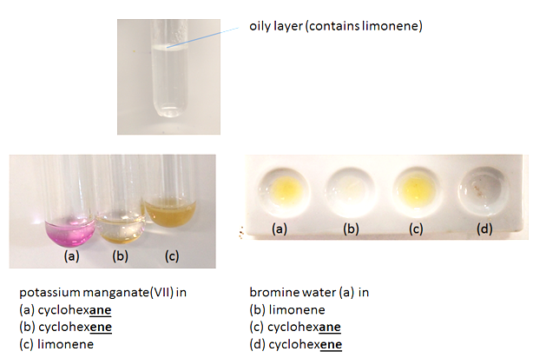
Figure 1 – Images from the trial

Analysis of results – Trial results
Sample | Observation with bromine water | Observation with potassium manganate(VII)
limonene | brown colour disappeared | purple colour disappeared
cyclohexane | brown colour remained | purple colour remained
cyclohexene | brown colour disappeared | purple colour disappeared

The questions you set your learners will depend on the focus of the experiment.

1. | Bromine water and potassium manganate(VII) solution decolourise quickly in the presence of compounds containing carbon-carbon double bonds (unsaturated hydrocarbons). With reference to your observations, describe the bonding in cyclohexane, cyclohexene and limonene. [3 marks]
Cyclohexane does not decolourise bromine water and potassium manganate(VII) (immediately), therefore it doesn’t contain carbon-carbon double bonds.
Cyclohexene and limonene do decolourise bromine water and/or potassium manganate(VII) quickly, therefore they do contain carbon-carbon double bonds. (one mark per hydrocarbon)

2. | Explain the purpose of the cyclohexane and cyclohexene in this experiment.  [3 marks]
 | Cyclohexane and cyclohexene are negative and positive controls which demonstrate how the qualitative reagents react .

Extension opportunities
1. | The molecular formula of limonene is C₁₀H₁₆. Using your knowledge of general formulae for hydrocarbons, predict how many carbon-carbon double bonds limonene contains. [5 marks]
Alkanes have the general formula C_{n}H_{2n+2.}
Alkenes have the general formula C_{n}H_{2n.}
Therefore every additional double bond removes two hydrogens.
As C₁₀H₁₆ has ‘lost’ six hydrogens…
…which implies limonene has three carbon-carbon double bonds.

2. | Use a textbook/internet search to find the actual structure of limonene. What affect does a ring in the structure have on the number of hydrogens in the compound?  [2 marks]
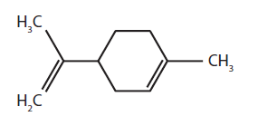
The ring causes the ‘loss’ of two hydrogens (so is similar to a carbon-carbon double bond in terms of numbers of hydrogens).

3. | Limonene is a chiral compound. Find out what this sentence means and the different properties of the two versions of limonene. [7 marks]
Chiral compounds can exist in different optical forms (isomers).
Limonene has two isomers called d-limonene and l-limonene.
d-limonene has an orange smell and used in medicines/food/fragrance/ insecticide/biofuel.
l-limonene has a piney/turpentine smell and used as a fragrance.

4. | Discuss how you would adapt this procedure to produce larger quantities of orange oil. [3 marks]
Any three appropriate suggestions , for example:
Cut up a large quantity of orange peel in a blender
Use a larger heating vessel (e.g. a round bottomed flask)
Use a (Liebig) condenser
Dry the oil (by mixing with anhydrous magnesium sulfate)

Document updates
v0.2 July 2016 Original draft version – released on OCR Community
v1 August 2016 Published on the qualification pages
v1.1 January 2017 Consolidated labelling and formatting of activities

We’d like to know your view on the resources we produce. Click ‘Like’ or ‘Dislike’ to send us an auto generated email about this resource. Add comments if you want to. Let us know how we can improve this resource or what else you need. Your email will not be used or shared for any marketing purposes.
Looking for another resource? There is now a quick and easy search tool to help find free resources for your qualification.
OCR is part of Cambridge Assessment, a department of the University of Cambridge.
For staff training purposes and as part of our quality assurance programme your call may be recorded or monitored.
Oxford Cambridge and RSA Examinations is a Company Limited by Guarantee. Registered in England. Registered office
The Triangle Building, Shaftesbury Road, Cambridge, CB2 8EA. Registered company number 3484466. OCR is an exempt charity.
OCR operates academic and vocational qualifications regulated by Ofqual, Qualifications Wales and CCEA as listed
in their qualifications registers including A Levels, GCSEs, Cambridge Technicals and Cambridge Nationals.
OCR provides resources to help you deliver our qualifications. These resources do not represent any particular teaching method we expect you to use. We update our resources regularly and aim to make sure content is accurate but please check the OCR website so that you have the most up to date version. OCR cannot be held responsible for any errors or omissions in these resources.
Though we make every effort to check our resources, there may be contradictions between published support and the specification, so it is important that you always use information in the latest specification. We indicate any specification changes within the document itself, change the version number and provide a summary of the changes. If you do notice a discrepancy between the specification and a resource, please contact us.
© OCR 2021 - You can copy and distribute this resource freely if you keep the OCR logo and this small print intact and you acknowledge OCR as the originator of the resource.
OCR acknowledges the use of the following content: N/A
Whether you already offer OCR qualifications, are new to OCR or are thinking about switching, you can request more information using our Expression of Interest form.
Please get in touch if you want to discuss the accessibility of resources we offer to support you in delivering our qualifications.
v1.2 June 2021 Update to meet digital accessibility standards

Chemistry PAG 4: Distillation

Combined Science PAG C2: Distillation

Suggested Activity 1: Extraction of limonene

Learner Activity

Introduction
Orange oil, which contains a compound called limonene, can be extracted from orange peel. Limonene is used in food manufacture, medicines and cleaning products. At room temperature it is a colourless oily liquid which smells of oranges. Limonene can be extracted from orange peel by distilling a water/oil mixture from a mixture of water and orange peel.

Aims
To extract limonene from orange peel by distillation and test for unsaturation.
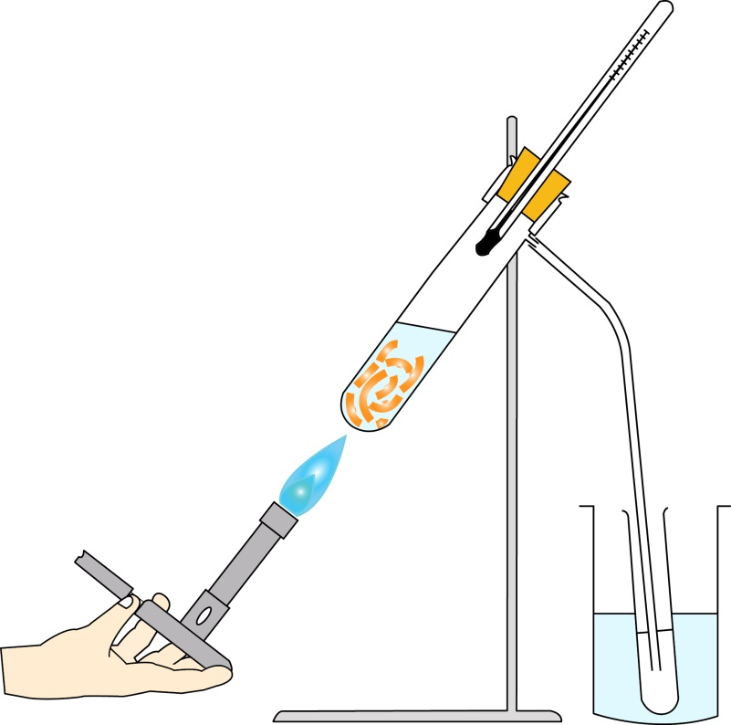
water
thermometer
delivery tube
beaker
stand
side arm boiling tube
clamp
orange peel and water

Figure 1: The experimental setup

Intended class time
30 – 40 minutes

Chemicals and equipment (per group)
- eye protection
- Bunsen burner
- heat-resistant mat
- side-arm boiling tube with delivery tube
- bung with thermometer
- retort stand, boss and clamp
- test tube
- beaker (250 cm³)
- orange peel
- scissors
- dropper pipette
- test tubes (6) or dropping tile
- bromine water (WARNING: Irritant)
- acidified potassium manganate(VII) solution (low hazard)
- cyclohexane (DANGER: Fatal if swallowed, flammable and irritant)
- cyclohexene (DANGER: Harmful/fatal if swallowed, flammable and irritant)

Health and Safety
- Eye protection should be worn at all times.
- Ensure the laboratory is well ventilated.
- If available, work in a fume cupboard for dispensing bromine water and cyclohexane/ene.

Method
STAGE 1: Distillation of orange oil from orange peel
- Cut up orange peel into small pieces (< 0.5 cm) and one–third fill the side–arm boiling tube.
- Add enough tap water to the tube to just cover the peel.
- Set up the apparatus as shown in Figure 1.
- Very gently heat the solution using a half–blue flame, for about 5 minutes, moving the flame up and down the tube – minimise the boiling of the water at this stage and avoid burning the orange.
- After the 5 minutes, heat the tube more strongly to distil off the water/orange oil mixture until the test tube is about half full.
- Measure and record the temperature of the water/oil vapour

STAGE 2: Testing the limonene in orange oil
- Allow the distillate to stand for 1-2 minutes until a cloudy layer has separated to the top of the test tube – this is called the upper organic layer and contains the limonene
- Carefully smell the solution in the test tube – your teacher will show you how to do this.
- Carefully pipette off the upper layer and divide it evenly between two test tubes.
- Add one drop of bromine water to the first tube and one drop of acidified potassium manganate(VII) to the second tube. Shake the tubes side to side and observe any colour changes.
- Repeat step 3 and 4 with cyclohexane then cyclohexene.
- ALTERNATIVELY carry out steps 3-5 in a dropping tile.

Analysis of results
You can draw your own table, or copy the one below:
Sample | Observation with bromine water | Observation with potassium manganate(VII)
limonene
cyclohexane
cyclohexene

Your ability to analyse your observations may depend on how much of the GCSE Chemistry/Combined Science course you have studied. Your teacher will let you know which questions you should focus on:
1. | Bromine water and potassium manganate(VII) solution decolourise quickly in the presence of compounds containing carbon-carbon double bonds (unsaturated hydrocarbons). With reference to your observations, describe the bonding in cyclohexane, cyclohexene and limonene. [3 marks]

2. | Explain the purpose of the cyclohexane and cyclohexene in this experiment.  [3 marks]

Extension opportunities
1. | The molecular formula of limonene is C₁₀H₁₆. Using your knowledge of general formulae of hydrocarbons, predict how many carbon-carbon double bonds limonene contains. [5 marks]

2. | Use a textbook/website search to find the actual structure of limonene. What affect does a ring in the structure have on the number of hydrogens in the compound?  [2 marks]

3. | Limonene is a chiral compound. Find out what this sentence means and the different properties of the two versions of limonene. [7 marks]

4. | Discuss how you would adapt this procedure to produce larger quantities of orange oil. [3 marks]

DfE Apparatus and Techniques covered
If you are using the OCR Practical Activity Learner Record Sheet (Chemistry / Combined Science) you may be able to tick off the following skills:

Chemistry |  |  |  |  | Combined Science
1-iii | 2-i | 3-i | 4-v |  | 1-v | 2-i | 8-i | 9-v
6-i | 6-ii |  |  |  | 11-i | 11-ii

