Checkpoint Task

Organism Level Systems

Instructions and answers for teachers

These instructions cover the learner activity section which can be found on page 8. This Checkpoint Task should be used in conjunction with the KS3–4 Biology Transition Guide: Organism level systems, which supports OCR GCSE (9‒1) Gateway Science Biology A.
When distributing the activity section to the learners either as a printed copy or as a Word file you will need to remove the teacher instructions section.

Introduction
This checkpoint task is designed to consolidate Key Stage 3 learning. It consists of four sections, the first three can be printed and given to learners to work through individually. The final section is a card sort.
Section one asks learners to label diagrams of the male and female reproductive systems and match the parts to their role. For lower ability learners you may want to hand out a separate sheet with the keywords written on, or put the keywords on the classroom whiteboard.
Section two requires learners to colour code a 28 day cycle to show what processes occur during the menstrual cycle.
Section three gives learners the answers to some questions and learners have to write the question. There is no one correct question for each answer, expect to receive a variety of questions from the class for each answer. To check learners’ understanding of the processes and key terminology, teachers should encourage learners to use key words learnt throughout the topic when writing the questions.
Section four is a card sort grouping the changes that occur during puberty. Learners group each change under the headings 'girls', 'boys' or 'both'. This could also be done as a whole class mini whiteboard activity.

Teacher Preparation
For lower ability learners, the sheet with the key words for labelling the reproductive system diagrams in section one will need to be printed out. This can be done for the whole class, or for individuals within a class.
Before the task, teachers will need to photocopy and cut out the cards for the card sort activity. It can be done individually or in pairs. Alternatively, the teacher can read out the statements individually and learners can write 'B', 'G' or 'Both' on a mini whiteboard and hold it up after a count of three.
Learners should be issued with the worksheet 'Adolescence and reproduction - Checkpoint task - Learner'. Learners should be able to work through the tasks on the worksheet individually. The last task is a card sort or if the teacher prefers, a whole class mini whiteboard question and answer task using the statements from the card sort.

Task 1 – The Reproductive System
Label the diagrams of the male and female reproductive systems below:
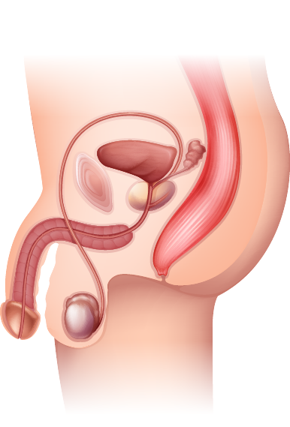

2 penis
3 urethra
4 scrotum
1 sperm duct

5 testes

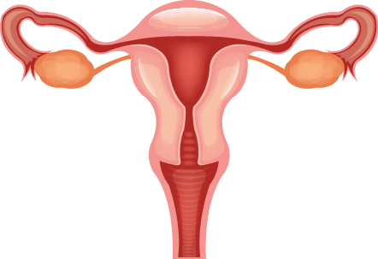
6 fallopian tubes
7 ovary
8 cervix
9 vagina
11 uterus
10 uterus lining

Using the diagrams, write the number of the correct reproductive part next to each statement below:
5
- Where sperm is made
7
- Eggs are released from here once a month
1
- Carries sperm from testis to urethra
2
- Becomes erect and sperm is ejaculated
10
- A fertilised egg will implant here
6
- An egg may be fertilised by a sperm here
10
- This breaks down and is shed during a menstrual bleed

Task 2 – The Menstrual Cycle
Ovulation

1 | 2 | 3 | 4 | 5 | 6 | 7 | 8 | 9 | 10 | 11 | 12 | 13 | 14 | 15 | 16 | 17 | 18 | 19 | 20 | 21 | 22 | 23 | 24 | 25 | 26 | 27 | 28

The menstrual cycle lasts approximately 28 days.
On the 28 day cycle above
- Colour the days a menstrual bleed occurs in RED
- Colour the days the uterus lining builds up and thickens YELLOW
- Draw an ARROW pointing to the day an egg is released from an ovary.
  - Label the arrow with the name of this process.
- Colour the days when the uterus lining stays thick in case a fertilised egg arrives in GREEN

Task 3 – Fertilisation, Gestation and Birth
Below are the answers to some questions. Write down a possible question for each answer.
Learners may come up with a number of different questions. Below are some examples.
Question | Answer
Name the process where the sperm nucleus and egg nucleus fuse together. | Fertilisation
When the fertilised egg becomes a small ball of cells, what is it called? | Embryo
What does the embryo turn into after 9 or 10 weeks? | Foetus
What is the function of the amniotic fluid? | Acts as a shock absorber
What passes from the mother's blood into the blood of the foetus at the placenta? | Oxygen and food/nutrients
Does the blood of the foetus and the blood of the mother mix in the placenta? | No, they don't mix
What causes the contractions that pushes the baby out at birth? | Muscles in the uterus wall

Task 4 – Puberty
Answers to the card sort:
Boys | Girls | Both
Voice deepens | Breasts develop | Body shape changes
Testicles produce sperm | Hips widen | Weight gain
Penis increases in length and width | Periods start | Mood swings and irritability
Testicles become larger and fuller | Ovaries start releasing eggs | Spots form on skin
 |  | Hair grows on face, underarms and genitals
 |  | Sweat more
 |  | Emotional changes
 |  | Sex hormones produced

Voice deepens | Breasts develop
Body shape changes | Testicles produce sperm
Hips widen | Weight gain
Penis increases in length and width | Periods start
Mood swings and irritability | Testicles become larger and fuller
Ovaries start releasing eggs | Spots from on skin
Hair grows on face, underarms and genitals | Sweat more
Emotional changes | Sex hormones produced

OCR Resources: the small print
OCR’s resources are provided to support the delivery of OCR qualifications, but in no way constitute an endorsed teaching method that is required by the Board, and the decision to use them lies with the individual teacher. Whilst every effort is made to ensure the accuracy of the content, OCR cannot be held responsible for any errors or omissions within these resources.
© OCR 2016 - This resource may be freely copied and distributed, as long as the OCR logo and this message remain intact and OCR is acknowledged as the originator of this work.
OCR acknowledges the use of the following content: pages 2 and 9 – male reproductive system: Blue Ring Media/Shutterstock.com, pages 3 and 9: female reproductive system: Pretty Vectors/Shutterstock.com
Please get in touch if you want to discuss the accessibility of resources we offer to support delivery of our qualifications: resources.feedback@ocr.org.uk
We’d like to know your view on the resources we produce. By clicking on ‘Like’ or ‘Dislike’ you can help us to ensure that our resources work for you. When the email template pops up please add additional comments if you wish and then just click ‘Send’. Thank you.
Whether you already offer OCR qualifications, are new to OCR, or are considering switching from your current provider/awarding organisation, you can request more information by completing the Expression of Interest form which can be found here: www.ocr.org.uk/expression-of-interest
Looking for a resource? There is now a quick and easy search tool to help find free resources for your qualification:
www.ocr.org.uk/i-want-to/find-resources/

Checkpoint Task

Organism Level Systems

Learner Activity

Task 1 – The Reproductive System

The Reproductive System - Keywords
Learners could use the words below to label the diagrams of the male and female reproductive systems or do this from their existing knowledge without the list:
Testes Penis
Urethra Ovary
Uterus Fallopian tube
Cervix Scrotum
Sperm duct Uterus lining
Vagina
6.
7.
8.
9.
11.
10.
5.
4.
3.
2.
1.
Using the diagrams, write the number of the correct reproductive part next to each statement below:

- Where sperm is made

- Eggs are released from here once a month

- Carries sperm from testis to urethra

- Becomes erect and sperm is ejaculated

- A fertilised egg will implant here

- An egg may be fertilised by a sperm here

- This breaks down and is shed during a menstrual bleed

Task 2 – The Menstrual Cycle

1 | 2 | 3 | 4 | 5 | 6 | 7 | 8 | 9 | 10 | 11 | 12 | 13 | 14 | 15 | 16 | 17 | 18 | 19 | 20 | 21 | 22 | 23 | 24 | 25 | 26 | 27 | 28

The menstrual cycle lasts approximately 28 days.
On the 28 day cycle above
- Shade in the days a menstrual bleed occurs.
- Draw dots on the days the uterus lining builds up and thickens.
- Draw an ARROW pointing to the day an egg is released from an ovary.
Label the arrow with the name of this process.
- Draw stripes on the days when the uterus lining stays thick in case a fertilised egg arrives.

Task 3 – Fertilisation, Gestation and Birth
Below are the answers to some questions. Write down a possible question for each answer.
Question | Answer
 | Fertilisation
 | Embryo
 | Foetus
 | Acts as a shock absorber
 | Oxygen and food
 | No, they don't mix
 | Muscles in the uterus wall

