Physics PAG 7: Series and parallel circuits

Combined Science PAG P6: Circuits

Suggested Activity 1: Investigate the brightness of bulbs in series and parallel

Instructions and answers for teachers & technicians
These instructions cover the learner activity section which can be found on page 10. This Practical activity supports OCR GCSE Physics.
When distributing the activity section to the learners either as a printed copy or as a Word file you will need to remove the teacher instructions section.
This is a suggested practical activity that can be used as part of teaching the GCSE (9-1) Gateway Science (A) and Twenty First Century Science (B) specifications.
These are not controlled assessment tasks, and there is no requirement to use these particular activities.
You may modify these activities to suit your learners and centre. Alternative activities are available from, for example, Royal Society of Biology, Royal Society of Chemistry, Institute of Physics, CLEAPSS and publishing companies, or of your own devising.
Further details are available in the specifications (Practical Skills Topics), and in these videos.
OCR recommendations:
Before carrying out any experiment or demonstration based on this guidance, it is the responsibility of teachers to ensure that they have undertaken a risk assessment in accordance with their employer’s requirements, making use of up-to-date information and taking account of their own particular circumstances. Any local rules or restrictions issued by the employer must always be followed.
CLEAPSS resources are useful for carrying out risk-assessments: (http://science.cleapss.org.uk).
Centres should trial experiments in advance of giving them to learners. Centres may choose to make adaptations to this practical activity, but should be aware that this may affect the Apparatus and Techniques covered by the learner.

Introduction
In this activity you will investigate how the brightness of bulbs change depending on whether they are in series or parallel.

DfE Apparatus and Techniques covered
The codes used below match the OCR Practical Activity Learner Record Sheet (Physics / Combined Science) and Trackers (Physics / Combined Science) available online. There is no requirement to use these resources.
5 [17]) Safe use of appropriate apparatus in a range of contexts to measure: i) energy changes/transfers; ii) associated values such as work done
7 [19]) Use of circuit diagrams to construct and check: i [i]) series circuits including a variety of common circuit elements; ii [ii]) parallel circuits including a variety of common circuit elements

Aims
To see how the brightness of bulbs change as they are connected in series and parallel
To measure the voltage across bulbs in series and parallel.
To measure the current through bulbs in series and parallel.

Intended class time
50-60 minutes

Links to Specifications:

Gateway Science (Suite A) including Working Scientifically (WS)
P3.2a describe the differences between series and parallel circuits positioning of measuring instruments in circuits and descriptions of the behaviour of energy, current and potential difference
P3.2b represent d.c. circuits with the conventions of positive and negative terminals, and the symbols that represent common circuit elements
P3.2c recall that current (I) depends on both resistance (R) and potential difference (V) and the units in which these are measured
P3.2d recall and apply the relationship between I, R and V, and that for some resistors the value of R remains constant but that in others it can change as the current changes
P3.2i explain why, if two resistors are in series the net resistance is increased, whereas with two in parallel the net resistance is decreased (qualitative explanation only)
P3.2j calculate the currents, potential differences and resistances in d.c. series and parallel circuits
WS1.1b, Use models to solve problems, make predictions and to develop scientific explanations and understanding of familiar and unfamiliar facts representational, spatial, descriptive, computational and mathematical models
WS1.2a, use scientific theories and explanations to develop hypotheses
WS1.2b, plan experiments or devise procedures to make observations, produce or characterise a substance, test hypotheses, check data or explore phenomena
WS1.2c, apply a knowledge of a range of techniques, instruments, apparatus, and materials to select those appropriate to the experiment
WS1.3b, translating data from one form to another
WS1.3e, interpreting observations and other data
WS1.3f, presenting reasoned explanations
WS1.3h, identifying potential sources of random and systematic error
WS1.4a use scientific vocabulary, terminology and definitions
WS2a, carry out experiments
WS2c, presenting observations using appropriate methods
WS2d communicating the scientific rationale for investigations, methods used, findings and reasoned conclusions

Twenty First Century Science (Suite B) including Ideas about Science (IaS)
P3.2.3 recall that current (I) depends on both resistance ( R) and potential difference (V) and the units in which these quantities are measured
P3.2.4(a) recall and apply the relationship between I, R, and V, to calculate the currents, potential differences and resistances in d.c. series circuits: potential difference (V) = current (A) × resistance (Ω)
P3.2.5 recall that for some components the value of R remains constant (fixed resistors) but that in others it can change as the current changes (e.g. heating elements, lamp filaments)
P3.2.7 represent circuits with the conventions of positive and negative terminals, and the symbols that represent common circuit elements, including filament lamps, diodes, LDRs and thermistors
P3.3.2(a) (b) describe the difference between series and parallel circuits: to include ideas about how the current through each component and the potential difference across each component is affected by a change in resistance of a component b) describe how to practically investigate the brightness of bulbs in series and parallel circuits. Be able to draw circuit diagrams for the circuits used
P3.3.3 explain, why, if two resistors are in series the net resistance is increased, whereas with two in parallel the net resistance is decreased qualitative only
IaS1.1 present observations and other data using appropriate formats
IaS1.2 when processing data use SI units where appropriate (e.g. kg, g, mg; km, m, mm; kJ, J) and IUPAC chemical nomenclature unless inappropriate
IaS1.3 when processing data use prefixes (e.g. tera, giga, mega, kilo, centi, milli, micro and nano) and powers of ten for orders of magnitude
IaS1.4 be able to translate data from one form to another
IaS1.5 when processing data interconvert units
IaS1.6 when processing data use an appropriate number of significant figures
IaS1.7 when displaying data graphically select an appropriate graphical form, use appropriate axes and scales, plot data points correctly, draw an appropriate line of best fit, and indicate uncertainty (e.g. range bars)
IaS1.8 when analysing data identify patterns/trends, use statistics (range and mean) and obtain values from a line on a graph (including gradient, interpolation and extrapolation),
IaS2.9 in a given context evaluate data in terms of accuracy, precision, repeatability and reproducibility, identify potential sources of random and systematic error, and discuss the decision to discard or retain an outlier
IaS2.11 in a given context interpret observations and other data (presented in diagrammatic, graphical, symbolic or numerical form) to make inferences and to draw reasoned conclusions, using appropriate scientific vocabulary and terminology to communicate the scientific rationale for findings and conclusions
IaS2.12 explain the extent to which data increase or decrease confidence in a prediction or hypothesis
IaS3.1 use ideas about correlation and cause to: - identify a correlation in data presented as text, in a table, or as a graph M2g - distinguish between a correlation and a cause effect link - suggest factors that might increase the chance of a particular outcome in a given situation, but do not invariably lead to it - explain why individual cases do not provide convincing evidence for or against a correlation - identify the presence (or absence) of a plausible mechanism as reasonable grounds for accepting (or rejecting) a claim that a factor is a cause of an outcome

Health and Safety
Check with your teacher the circuit is set up correctly
Turn off switch between readings to ensure components don’t get too hot
Be aware that components can get very hot so do not touch the components until they are cooled down
Always have components on a heat proof mat
Before carrying out any experiment or demonstration based on this guidance, it is the responsibility of teachers to ensure that they have undertaken a risk assessment in accordance with their employer’s requirements, making use of up-to-date information and taking account of their own particular circumstances. Any local rules or restrictions issued by the employer must always be followed.
CLEAPSS document R151 “Ammeters,Voltmeters etc,for Class Use” and the Laboratory Handbook sections 12.3.1 “DMMs compared to analogue meters”, 12.3.2 “Provision of digital multimeters” and 12.3.3 “Which DMMs to buy”, contain useful information on selection and use of digital multimeters
Based on the components available the teacher should assess the maximum permissible current and define this to the learners.

Method 1
Learners set up series and parallel circuits and compare the brightness of bulbs in each circuit. They use their results to write a qualitative conclusion about bulbs in series and parallel.

Method 2
Learners now add voltmeters and ammeters to the same circuits and analyse their results to draw conclusions about voltage and current in series and parallel circuits.

Notes
This practical activity is expected to be completely investigative; learners should draw their own conclusions from the results gained.
Teachers should trial this activity to be able to modify the learner sheet in the light of the equipment and lesson time available at the centre. These should include the appropriate voltage setting.

Method 1observations
Circuit 1: bulb is bright
Circuit 2: bulbs get dimmer in series
Circuit 3: bulbs as bright as circuit 1
Circuit 4: bulbs as bright as circuit 1
Circuit 5: branch with two bulbs dimmer, branch with one bulb as bright as circuit 1
Circuit 6: both bulbs in both branches as dim as circuit 2.

Method 2 observations
Circuit 1: measurement of V and I
Circuit 2: current approximately half, voltage shared across each component
Circuit 3: current in each branch same as circuit 1, each branch current adds to total current. Each voltage across each bulb, same as circuit 1
Circuit 4: current the same as circuit 1 in each branch, adds up to total current through cell/powerpack (higher total current so total resistance has decreased)
Circuit 5: half the current and half the voltage across each bulb in the branch with two bulbs. Branch with one bulb as circuit 1
Circuit 6: all readings as circuit 2

Technicians notes

For this practical the teacher will require:
- 12V variable supply or 4 x 1.5V cells
- 4mm connecting leads
- Ammeter (multimeter)
- Voltmeter (multimeter)
- 6V/12V filament bulbs
- Switch (optional)
- Heat proof mat

Answers for quiz questions
1. (a) | A student wants to measure the current and potential difference for a fixed resistor in a circuit. Draw the circuit diagram that they could use to measure these values. [3 marks]
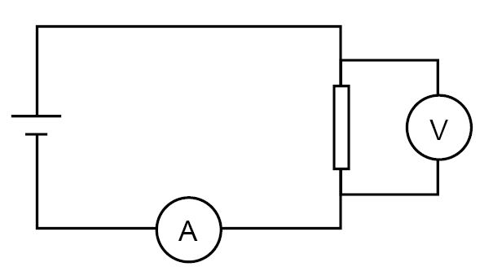
Ammeter in correct position
Voltmeter in correct position
Correct symbol for fixed resistor

(b) | In the experiment the current reading is 0.15 A and the potential difference is 2.0 V. What formula could the student use to find the resistance of the resistor? [1 mark]
 | Potential difference = current x resistance

(c) | Work out the resistance of the resistor to 3 significant figures and write down the units.  [4 marks]
2.0 ÷ 0.15
13.3
3 sig. fig
Ohms

2 | Name the following circuit components. [4 marks]
(a) | diode

(b) | thermistor

(c) | LDR

(d) | variable resistor

Document updates
v1 Published on the qualification pages
v1.1 January 2017 Consolidated labelling and formatting of activities
v1.2 June 2021 Updated to meet digital accessibility standard

We’d like to know your view on the resources we produce. Click ‘Like’ or ‘Dislike’ to send us an auto generated email about this resource. Add comments if you want to. Let us know how we can improve this resource or what else you need. Your email will not be used or shared for any marketing purposes.
Looking for another resource? There is now a quick and easy search tool to help find free resources for your qualification.
OCR is part of Cambridge Assessment, a department of the University of Cambridge.
For staff training purposes and as part of our quality assurance programme your call may be recorded or monitored.
Oxford Cambridge and RSA Examinations is a Company Limited by Guarantee. Registered in England. Registered office
The Triangle Building, Shaftesbury Road, Cambridge, CB2 8EA. Registered company number 3484466. OCR is an exempt charity.
OCR operates academic and vocational qualifications regulated by Ofqual, Qualifications Wales and CCEA as listed
in their qualifications registers including A Levels, GCSEs, Cambridge Technicals and Cambridge Nationals.
OCR provides resources to help you deliver our qualifications. These resources do not represent any particular teaching method we expect you to use. We update our resources regularly and aim to make sure content is accurate but please check the OCR website so that you have the most up to date version. OCR cannot be held responsible for any errors or omissions in these resources.
Though we make every effort to check our resources, there may be contradictions between published support and the specification, so it is important that you always use information in the latest specification. We indicate any specification changes within the document itself, change the version number and provide a summary of the changes. If you do notice a discrepancy between the specification and a resource, please contact us.
© OCR 2021 - You can copy and distribute this resource freely if you keep the OCR logo and this small print intact and you acknowledge OCR as the originator of the resource.
OCR acknowledges the use of the following content: N/A
Whether you already offer OCR qualifications, are new to OCR or are thinking about switching, you can request more information using our Expression of Interest form.
Please get in touch if you want to discuss the accessibility of resources we offer to support you in delivering our qualifications.

Physics PAG 7: Series and parallel circuits

Combined Science PAG P6: Circuits

Suggested Activity 1: Investigate the brightness of bulbs in series and parallel

Learner Activity

Introduction

In this activity you will investigate how the brightness of bulbs change depending on whether they are in series or parallel

Aims
To see how the brightness of bulbs change as they are connected in series and parallel
To measure the voltage across bulbs in series and parallel.
To measure the current through bulbs in series and parallel.

Intended class time
50-60 minutes

Equipment (per group)
- 12V variable supply or 4 x 1.5V cells
- 4mm connecting leads
- Ammeter (multimeter)
- Voltmeter (multimeter)
- 6V/12V filament bulbs
- Switch (optional)
- Heat proof mat

Health and Safety
Check with your teacher the circuit is set up correctly
Turn off switch or disconnect leads between observations to bulbs don’t get too hot
Be aware that components can get very hot so do not touch the components until they are cooled down
Always have components on a heat mat

Method 1 – Brightness
- Set up each circuit one by one
- Complete the results table to indicate the brightness of each bulb in each circuit; write a ‘B’ for bright and ‘D’ for dim
- Compare each circuit and write down why you think some bulbs are dim and some bulbs are bright.

Circuit 1

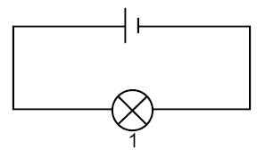

Circuit 2
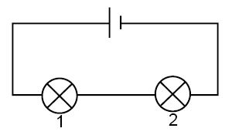

Circuit 3
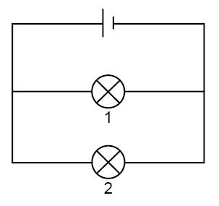

Circuit 4
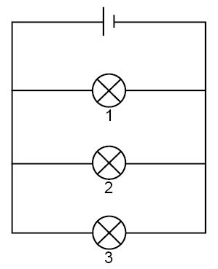

3
2
1
Circuit 5
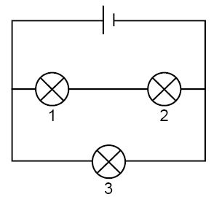

Circuit 6

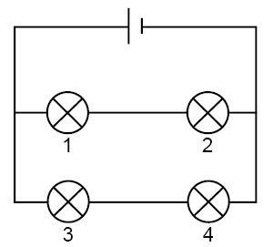

Results
 | Brightness of bulb (B = Bright D = Dim)
 | Bulb 1 | Bulb 2 | Bulb 3 | Bulb 4
Circuit 1
Circuit 2
Circuit 3
Circuit 4
Circuit 5
Circuit 6

Evaluation
- What conclusions can you draw from the above experiment? Why are some bulbs brighter and some bulbs dimmer?

Method 2

1. Your teacher will give you a voltmeter and an ammeter; do the same experiment again, this time check the current through each bulb and the voltage across it.
2. Write the values of current and voltage in the below table.
3. What does this tell you about current and voltage in a parallel circuit?

Results
 | Voltage across bulbs (V)
 | Bulb 1 | Bulb 2 | Bulb 3 | Bulb 4
Circuit 1
Circuit 2
Circuit 3
Circuit 4
Circuit 5
Circuit 6

 | Current through bulbs (A)
 | Bulb 1 | Bulb 2 | Bulb 3 | Bulb 4
Circuit 1
Circuit 2
Circuit 3
Circuit 4
Circuit 5
Circuit 6

Evaluation
- How does current behave in a series circuit?

- How does potential difference behave in a series circuit?

- How does current behave in a parallel circuit?

- How does potential difference behave in a parallel circuit?

Quiz - test your knowledge and understanding
1. (a) | A student wants to measure the current and potential difference for a fixed resistor in a circuit. Draw the circuit diagram that they could use to measure these values.  [3 marks]

(b) | In the experiment the current reading is 0.15 A and the potential difference is 2.0 V. What formula could the student use to find the resistance of the resistor? [1 mark]

(c) | Work out the resistance of the resistor to 3 significant figures and write down the units.  [4 marks]

2 | Name the following circuit components. [4 marks]
(a)

(b)

(c)

(d)

DfE Apparatus and Techniques covered
If you are using the OCR Practical Activity Learner Record Sheet (Physics / Combined Science) you may be able to tick off the following skills:

Physics |  |  |  |  | Combined Science
5–i | 5–ii | 7–i | 7–ii |  | 17–i | 17–ii | 19–i | 19–ii

