Lesson Element

Jelly Mods

Instructions and answers for teachers

These instructions cover the student activity section which can be found on page 10. This Lesson Element supports OCR A Level Biology A and OCR A Level Biology B (Advancing Biology).
When distributing the activity section to the students either as a printed copy or as a Word file you will need to remove the teacher instructions section.

Introduction
‘Jelly mods’ biological molecule activity allows students to build biological molecules of varying complexity and explore the following concepts:
- the structure of monomers and polymers in a range of biological molecules e.g. carbohydrates
- condensation and hydrolysis reactions in formation and breakdown of biological molecules.
This activity can be developed using ‘molymod’ kits or jelly sweets and cocktail sticks. The objective is to broaden student knowledge of biological molecules and to aid understanding of those molecules included on the specification. The concepts learned will support advancement to A level as a range of molecules are discussed.

Key terms
- monomer, monosaccharide, disaccharide, triose, pentose, hexose, isomer, polymer, polysaccharide, glycosidic bond, condensation, hydrolysis.
These key terms can be consolidated by the quiz activity that follows the lesson as plenary or starter for following lesson, whereby students are given ‘bingo’ cards. The bingo caller calls out definitions for the key terms which students match to their bingo cards.

Common misconceptions
- students often memorise which monomers each polymer is made of but then struggle to apply knowledge to ‘new’ molecules which have not been studied in detail
- students fail to recognise the link between triose (C3), pentose (C5) and hexose (C6) in metabolic reactions, such as respiration
- students looking at ring form structures of monosaccharides often relate the terms pentose and hexose to the shape of the molecule rather than the number of carbon atoms it has
- students often suggest that alpha glucose forms ‘alpha helices’ during condensation reactions, a misconception stemming from protein structure.

Student instructions for ‘Jelly Mods’ activity
If jelly sweets are used - each student will select at least six black jelly sweets (carbon atoms), six red jelly sweets (oxygen atoms) and twelve white OR yellow jelly sweets (hydrogen atoms). Each student will also need approximately 25 cocktail sticks-these can be broken in half or quarters to provide bonds.
OR
- Molymods ® can be used if sufficient kits are available.
- Students can work in groups of two-four and complete the activities on the student activity worksheet using models and information sheet on carbohydrates.
- If jelly sweets are used a centre risk assessment should be carried out regarding handling of sweets (i.e. need to wash hands) and use of sharp-ended cocktail sticks.
- ‘wine gums’ or ‘midget gems’ provide the appropriate colours and consistency for the jelly sweets in this activity.

Student instructions for ‘Bingo’ starter/plenary activity
- There is also a starter or plenary ‘bingo’ activity that consolidates key terms.
- Each student or group of students is given a bingo card with key terms (these can be laminated for reuse). The bingo caller pulls out a random number from 1 to 12 and reads out the definition associated with the number (random number generator can be used). Students must pick the key term that matches the definition read by the caller and cross it off on their card. The winner is the first to cross out the six definitions on their card.

Student Worksheet for ‘Jelly Mods’ Activity: Answers

Task 1
Using your jelly sweets and cocktail sticks, construct models for each of the molecules A- F shown on the sheets provided.

Key:
- Black sweets - carbon atoms
- Red sweets - oxygen atoms
- White OR yellow sweets - hydrogen atoms
- Cocktail sticks - bonds.

The box below gives information about molecule A
Molecule A is α glucose
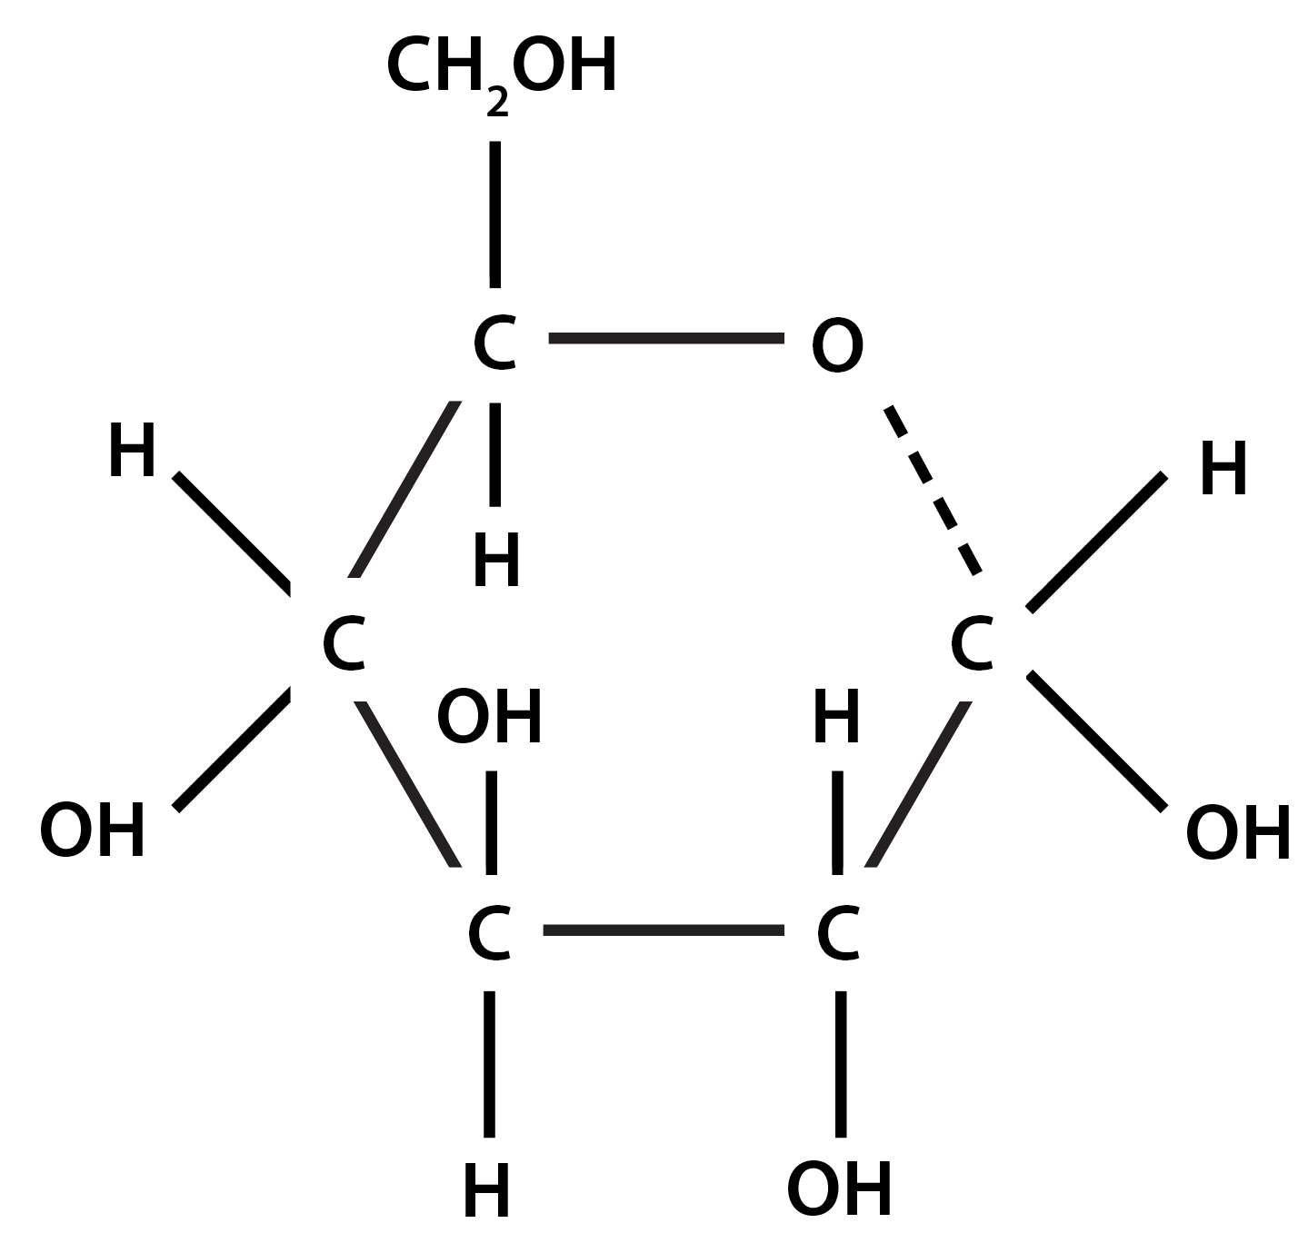
It is a monosaccharide
It is a hexose sugar
It has six carbon atoms
It has the molecular formula: C₆H₁₂O₆
Using your models and the information sheet provided, complete the boxes for molecules B–F.
Molecule B is β glucose

Correctly drawn β glucose molecule

It is a monosaccharide
It is a hexose sugar
It has six carbon atoms
It has the molecular formula: C₆H₁₂O₆
Molecule C is galactose

Correctly drawn β galactose molecule

It is a monosaccharide
It is a hexose sugar
It has six carbon atoms
It has the molecular formula: C₆H₁₂O₆
Molecule D is ribose

Correctly drawn ribose molecule

It is a monosaccharide
It is a pentose sugar
It has five carbon atoms
It has the molecular formula: C₅H₁₀O₅

Molecule E is glyceraldehyde

Correctly drawn glyceraldehyde molecule

It is a monosaccharide
It is a triose sugar
It has three carbon atoms
It has the molecular formula: C₃H₆O₃

Molecule F is fructose

Correctly drawn fructose molecule

It is a monosaccharide
It is a hexose sugar
It has six carbon atoms
It has the molecular formula: C₆H₁₂O₆

Task 2
- Using your jelly models, change molecule B into molecule A. You now have two models of molecule A.
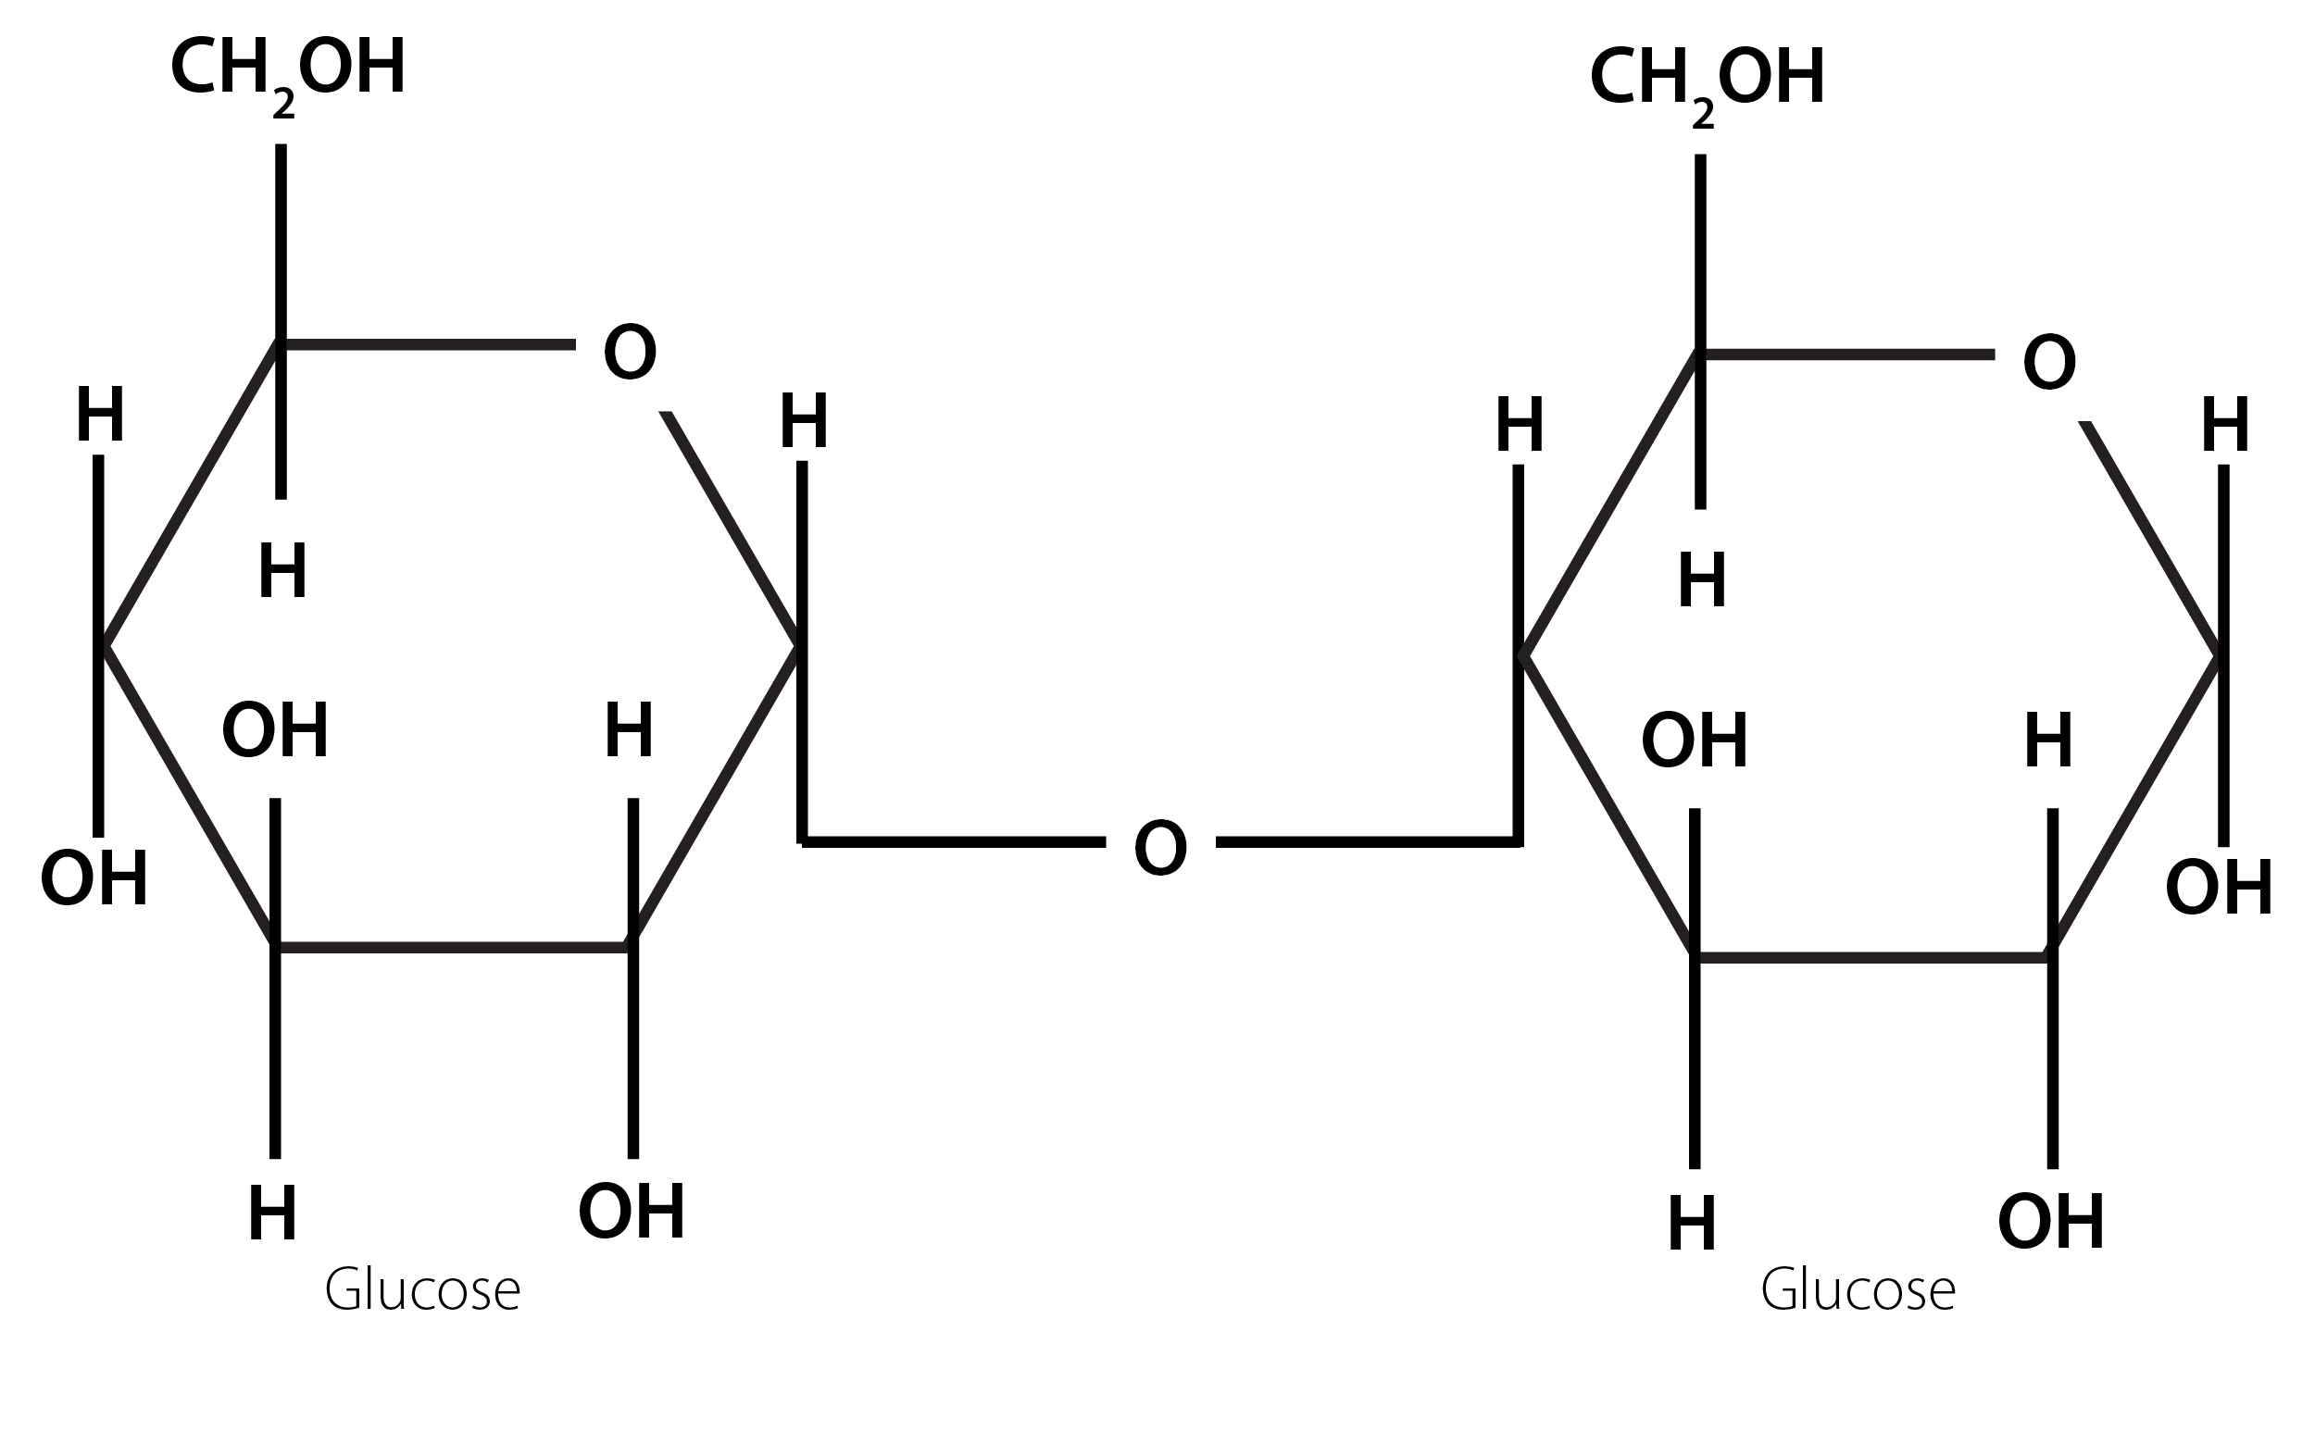
- Join these two molecules together as shown below:

- Reverse your actions to get two models of molecule A again.
- Now repeat (b) using models of molecules A and F. Draw this new molecule below:
Correctly drawn sucrose molecule

Discussion and Research Questions

Task 1 Questions
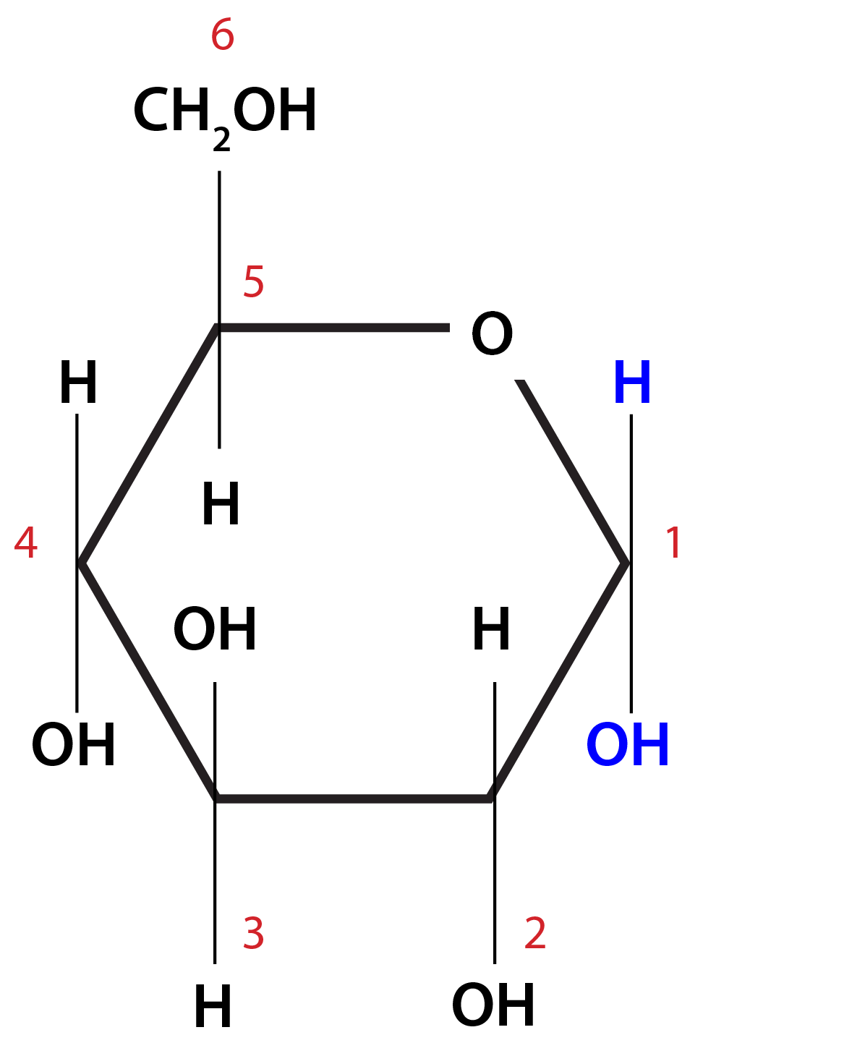
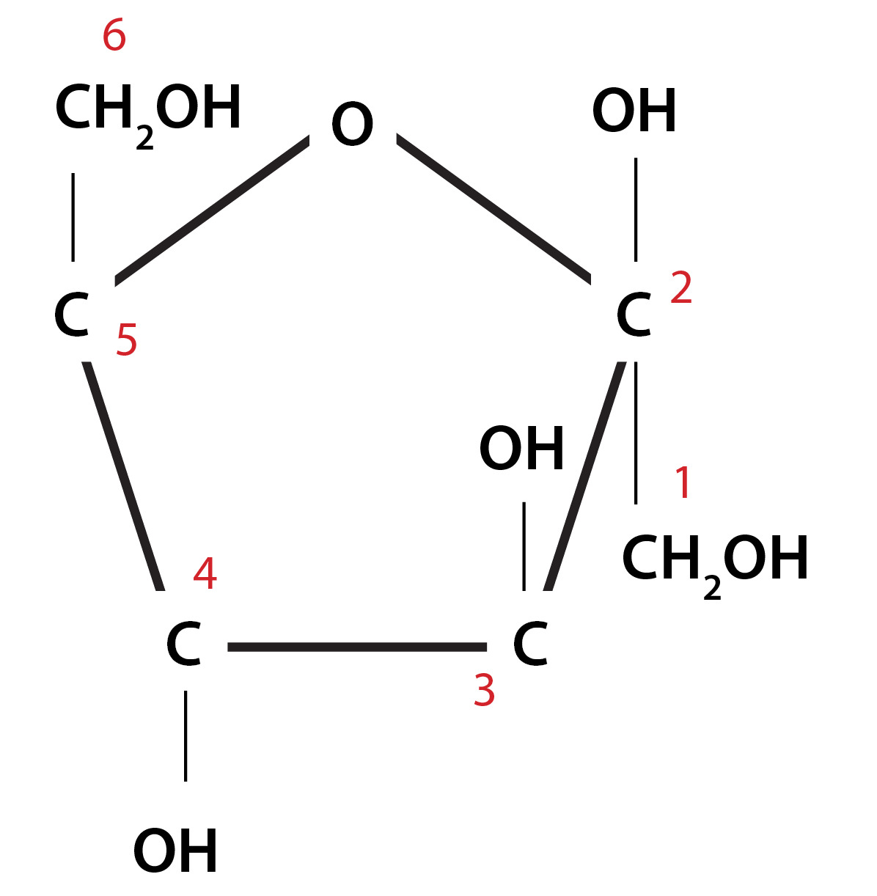
- Number the carbon atoms on molecule A and F (you may need to research this).
Molecule A
Molecule F

- Compare your models and the information you have written for molecules A, B, C and F. Describe and explain the similarities and differences between the molecules.
All the molecules have six carbon atoms. They are all hexose sugars and have the same molecular formulae. They have different structures / different arrangements of atoms in their structures. They are isomers of each other.

- Compare your models and the information you have written for molecules D and F. Describe the similarities and differences between the two molecules.
Molecule D is a pentose sugar but molecule F is hexose (accept descriptions of number of carbon atoms). They have different molecular formulae. They have a similar shape when drawn in 2D which looks to be the shape of a pentagon (accept descriptions-this tackles one of the misconceptions about naming monosaccharides).

- Molecules A, B, C and F are structural isomers.
- Explain the term ‘structural isomer’.
Structural isomers are molecules which have the same molecular formula but different structural formulae.

- Explain how the difference in structure may affect the properties of these isomers.
All are soluble and sweet. Affects the disaccharides and polysaccharides formed (glucose is particularly important in this role). Affects ability to form branched / storage molecules. Glucose is the most common respiratory substrate and the most common monosaccharide.

- Molecule D and E are found in mammals. Research these two molecules and describe where they occur and what they are used for.
Molecule A | Glyceraldehyde | Intermediate in respiration (as in glycolysis)
Molecule D | Ribose | Synthesis of nucleic acids, ribose is a constituent of RNA

Task 2 Questions
- What atoms were removed to make the new molecule in (b)?
Two ‘hydrogens’ and an ‘oxygen’

- What is the type of molecule you have produced by removing these atoms and joining the two molecules in (b)?
A disaccharide

- What is the full name for the bond formed in (b)? (You may need to refer to your answers in Task 1 Question 1.
(b) α 1–4 glycosidic bond/link

- What are the molecular formulae of the new molecules produced in (b) and (d)? Can the two new molecules be described as isomers?
They are isomers. C₁₂H₂₂O₁₁

- The process in (b) is a condensation reaction and (d) is a hydrolysis reaction. Research these reactions and explain how they are carried out in mammals and the importance to the organism.
Enzymes are required for both types of reaction. Condensation reactions occur when two or more molecules join together to form one larger molecule and water. In a hydrolysis reaction, larger molecules such as disaccharides and polysaccharides are split up again into the monomers (monosaccharides) they were made from. This happens when water reacts with the bonds holding the molecules together.

Condensation reactions are important in building up large molecules e.g. glucose to glycogen for storage. Hydrolysis reactions are important in breakdown of large, insoluble molecules into smaller, soluble molecules e.g. glycogen to glucose for respiration.

OCR Resources: the small print
OCR’s resources are provided to support the teaching of OCR specifications, but in no way constitute an endorsed teaching method that is required by the Board, and the decision to use them lies with the individual teacher. Whilst every effort is made to ensure the accuracy of the content, OCR cannot be held responsible for any errors or omissions within these resources.
© OCR 2016 - This resource may be freely copied and distributed, as long as the OCR logo and this message remain intact and OCR is acknowledged as the originator of this work.
OCR acknowledges the use of the following content: n/a
Please get in touch if you want to discuss the accessibility of resources we offer to support delivery of our qualifications: resources.feedback@ocr.org.uk
We’d like to know your view on the resources we produce. By clicking on ‘Like’ or ‘Dislike’ you can help us to ensure that our resources work for you. When the email template pops up please add additional comments if you wish and then just click ‘Send’. Thank you.
If you do not currently offer this OCR qualification but would like to do so, please complete the Expression of Interest Form which can be found here: www.ocr.org.uk/expression-of-interest

Lesson Element

Jelly mods

Student Activity

Student Worksheet for ‘Jelly Mods’ Activity

Task 1
Using your jelly sweets and cocktail sticks, construct models for each of the molecules A- F shown on the sheets provided.

Key:
- Black sweets - carbon atoms
- Red sweets - oxygen atoms
- White OR yellow sweets - hydrogen atoms
- Cocktail sticks - bonds.
The box below gives information about molecule A.
Molecule A is α glucose
It is a monosaccharide
It is a hexose sugar
It has six carbon atoms
It has the molecular formula: C₆H₁₂O₆

Using your models and the information sheet provided, complete the boxes for molecules B–F.
Molecule B is β glucose

Molecule C is galactose

Molecule E is glyceraldehyde

Molecule D is ribose

Task 2
Molecule F is fructose
- Using your jelly models, change molecule B into molecule A. You now have two models of molecule A.
- Join these two molecules together as shown below:
- Reverse your actions to get two models of molecule A again.
- Now repeat (b) using models of molecules A and F. Draw this new molecule below:

Discussion and Research Questions

Task 1 Questions
- Number the carbon atoms on molecule A and F (you may need to research this).

- Compare your models and the information you have written for molecules A, B, C and F. Describe and explain the similarities and differences between the molecules.

- Compare your models and the information you have written for molecules D and F. Describe the similarities and differences between the two molecules.

- Molecules A, B, C and F are structural isomers.
- Explain the term ‘structural isomer’.

- Explain how the difference in structure may affect the properties of these isomers.

- Molecule D and E are found in mammals. Research these two molecules and describe where they occur and what they are used for.

Task 2 Questions
- What atoms were removed to make the new molecule in (b)?

- What is the type of molecule you have produced by removing these atoms and joining the two molecules in (b)?

- What is the full name for the bond formed in (b)? (You may need to refer to your answers in Task 1 Question 1.

- What are the molecular formulae of the new molecules produced in (b) and (d)? Can the two new molecules be described as isomers?

- The process in (b) is a condensation reaction and (d) is a hydrolysis reaction. Research these reactions and explain how they are carried out in mammals and the importance to the organism.

References
http://science.uvu.edu/ochem/index.php/alphabetical/g-h/haworth-formula/
www.rpi.edu

