Topic Exploration Pack

Electrophilic addition and Markownikoff’s rule

Mapping to the specification level 2
Introduction 2
List of Activities supplied: 6
Answers for teachers 7
Learner Activity 23

Instructions and answers for teachers

These instructions cover the learner activity section which can be found on page 23. This Topic Exploration Pack supports OCR AS and A Level Chemistry A.
When distributing the activity section to the learners either as a printed copy or as a Word file you will need to remove the teacher instructions section.

Mapping to the specification level
4.1.1(f) the different types of covalent bond fission:
(i) homolytic fission (in terms of each bonding atom receiving one electron from the bonded pair, forming two radicals)
(ii) heterolytic fission (in terms of one bonding atom receiving both electrons from the bonded pair)
4.1.1(h) a ‘curly arrow’ described as the movement of an electron pair, showing either heterolytic fission or formation of a covalent bond
4.1.1(i) reaction mechanisms, using diagrams, to show clearly the movement of an electron pair with ‘curly arrows’ and relevant dipoles
4.1.3(g) definition and use of the term electrophile (an electron pair acceptor)
4.1.3(h) the mechanism of electrophilic addition in alkenes by heterolytic fission (see also 4.1.1 h–i)
4.1.3(i) use of Markownikoff’s rule to predict formation of a major organic product in addition reactions of H–X to unsymmetrical alkenes, e.g. H–Br to propene, in terms of the relative stabilities of carbocation intermediates in the mechanism
4.2.2(b) definition and use of the term nucleophile (an electron pair donor)
4.2.2(c) the mechanism of nucleophilic substitution in the hydrolysis of primary haloalkanes with aqueous alkali

Introduction
Organic chemistry can be a confusing jumble of reagents and conditions. Learners may struggle to master an overview and feel they have to commit to rote learning. However, once learners understand organic mechanisms, they can begin to appreciate why one chemical will or will not react with another and to predict outcomes under different conditions. A new approach, ‘Mechanisms before reactions’ (http://www.rsc.org/eic/2015/06/teaching-organic-chemistry-reaction-mechanism) suggests teaching the principles of organic mechanisms before learners study particular examples in the hope that they will be able to assimilate the array of reagents and conditions more easily.

Following the study of alkanes and free radical substitution (4.1.2(f)) is perhaps a natural point at which to begin introducing mechanisms before getting immersed in the detail of particular reactions. Learners should be enabled to suggest how alkenes and haloalkanes might react with specified reagents and thus predict the products.

This topic exploration pack covers in detail the reaction mechanism of electrophilic addition, and the use of Markownikoff’s rule to predict the formation of a major product in the addition of H–X to unsymmetrical alkenes in terms of the relative stabilities of intermediate carbocations in the mechanism.

Context
It is envisaged that this work will be taught after free radical substitution in alkanes, as per the specification. Learners will have begun their study of organic chemistry and be familiar with the naming of organic compounds as well as different ways of writing formulae. It is hoped that the ‘new approach’ may be followed and you will find that an introduction to the principles will enhance the learning of the topics of both electrophilic addition and nucleophilic substitution, which can be approached similarly in terms of ‘electron pushing’.

Aims
To understand how alkenes undergo addition reactions with electrophiles and how a major product can be predicted in a reaction between H–X and an unsymmetrical alkene.

Objectives
- Familiarity and proficiency with the use of curly arrows in a mechanism.
- Define and correctly use the terms electrophile, nucleophile and carbocation.
- Be able to draw/complete the mechanism for electrophilic addition with H–X.
- Recognise that there are two possible products with H–X and unsymmetrical alkenes.
- Use Markownikoff’s rule to predict the major product in 4 and explain in terms of relative stabilities of carbocations.
- Consider how the concepts above will relate to nucleophilic substitution.

Common misconceptions
- Learners often think a reaction produces a major product because of Markownikoff’s rule. It is important to stress that the rule is only a summary of what happens and does not determine the outcome. Rather it is the stability of the intermediate carbocation which determines the outcome.
- Understanding the link between relative stabilities of carbocations and the major product formed can be tenuous without a knowledge of kinetics. A synoptic link can be made between this topic and enthalpy profiles of reactions. The activation energy for the formation of the less stable carbocation is higher than that for formation of the more stable intermediate. Learners might plot this on an enthalpy profile diagram, and link to the Boltzmann distribution to explain the different rates of formation for the two products.

Useful websites
http://www.rsc.org/learn-chemistry/resource/res00000383/investigate-organic-reaction-mechanisms?cmpid=CMP00000453
http://www.chemguide.co.uk/mechanisms/eladd/symhbr.html#top

Formative assessment
There are many opportunities for teachers to gauge learners’ knowledge as this topic is studied and to point them in the direction of further questions to probe their understanding. Learners who sail through this work can tackle the extension work provided. It is easy to add stretch and challenge to an activity by, for example, asking for skeletal formulae or isomers.

Consolidation
Activity 5 in this pack provides a ‘recap’ exercise, while Activity 6 consists of test-yourself questions that can be used at the end of this topic or during revision.
See also sample OCR exam question:
H432/02 – A Level Chemistry A H432/02 Sample Question Paper 2, question 16(c)

Suggested activities
- Recap on homolytic fission with methane and chlorine in UV light and contrast this with heterolytic fission, using suitable examples such as a chlorine molecule splitting to give one positive and one negative ion. Get learners to come up to the board and draw their own examples. Ask them to toss a coin: ‘heads’ they have to draw a homolytic example and ‘tails’ a heterolytic one. Maybe use a name selector powerpoint so that this is seen to be fair.
https://www.teacherspayteachers.com/Product/Scrolling-names-Random-Name-generator-ppt-343143
- Use the Knockardy ‘Muddle your way through organic mechanisms’ PowerPoint to introduce the idea of mechanisms and relate to the work on alkanes done previously. You will need to edit to delete slides which are irrelevant at this stage. www.knockhardy.org.uk/ppoints_htm_files/mecmudpps.pps
- Introduce the terms electrophile (by analogy to ‘chocophile’) and heterolytic fission
(cf. homolytic in free radical substitution) and ask for suggestions for a term to denote electron pair donor.
- Exercise to recognise electrophiles: Activity 1.
- Now introduce the idea of a ‘curly arrow’ to show the movement of an electron pair; where do curly arrows start from (lone pair or a bond) and where do they end up (positive ion or partial positive ion)?
- Use the Steve Lewis RSC Organic Mechanisms PowerPoint to develop the mechanism of electrophilic addition in symmetrical alkenes, using curly arrows. http://www.google.co.uk/url?sa=t&rct=j&q=&esrc=s&source=web&cd=2&ved=0ahUKEwjYoJvfh7nKAhVGEJAKHXZiAMoQFggkMAE&url=http%3A%2F%2Fwww.ysgolgyfunemlyn.amdro.org.uk%2FSiteCollectionDocuments%2FScience%2Forganic%2520mechanisms%2520OCR.ppt&usg=AFQjCNGbB0Ed6GiNhK1Q0LMk4poEURHOkg&sig2=r03yWqNxjrcb4QY_53z9YQ
- The first part of Activity 2 is an exercise in which a mechanism must be completed. This could be projected: ask a few volunteers to come up and draw the mechanism, asking the rest of the group if what is being offered is correct.
- Introduce an unsymmetrical alkene and ask what the potential problem may be with
H–X. Use the OCR presentation on Markownikoff’s Rule to show how this is resolved. http://www.ocr.org.uk/Images/250388-markownikoff-s-rule-presentation.ppt
- Now complete the rest of Activity 2 with mechanisms and common errors.
- Activity 3 offers additional support for classifying carbocations. Activity 4 is a card sort in which learners are asked to recognise unsymmetrical alkenes. Copy sufficient sets of cards for each group of between two and four students. Ask learners to sort these into two piles: unsymmetrical and symmetrical alkenes. This could be done with a small prize for the first group to finish correctly sorted piles. Extension could be to name the alkenes.
- Introduce ‘Unto him that hath shall more be given’ or ‘Greed’ analogy as a way to remember Markownikoff’s rule, watching the video https://www.youtube.com/watch?v=N8-Wz8AtXoA for some fun. Exercises to check understanding and application of the rule: Activity 5.
- Choose a learner to draw the displayed structure of bromoethane on the board and another to add any dipole(s). Ask for suggestions of where the structure is likely to be attacked, which kind of reagents will do so and why, leading onto products and names. Extension: you could change the halogen and ask whether the reaction will be faster or slower; linking to C–X bond strength.
- Provide examples of different nucleophiles (cyanide ion, amide, alkoxide ion et al.) and ask learners to choose their own haloalkane and predict the products with a particular nucleophile. Ask why the reverse reaction does not happen; link to stability of products.
- In summary, divide the board into three columns for free radical substitution, electrophilic addition and nucleophilic substitution and ask learners to think of and write up words associated with each mechanism. This gives opportunity for compare and contrast and peer review.
- As a plenary, and returning to the main objectives of this session, ask learners to come up with alternative ways of helping them to remember Markownikoff’s Rule and illustrate on a poster.

List of Activities supplied:
- Spot the electrophile! – Worksheet Activity 1.
- Electrophilic addition mechanisms – Activity 2.
- Classifying carbocations – Activity 3.
- Recognising unsymmetrical alkenes – Card sort Activity 4.
- Recap exercise – Activity 5.
- Test-yourself questions – Activity 6.

Answers for teachers

Activity 1 – Spot the electrophile!

You may feel that this is an over-ambitious activity as there are some species which we traditionally regard as nucleophiles that have partial positive charges as well! Nevertheless, it is a useful way of engaging learners in thinking about the features of these species which determine the type of reaction they undergo with organic molecules.
1. a) Work in pairs. Discuss which of these species could qualify as electrophiles and why.
Cl⁺ OH– NO₂⁺ H₂O HBr NH₃ Br₂ CH₃CO⁺
Three of the species are electrophiles because of positive charge. HBr has a partial positive charge on the hydrogen atom. Br₂ may have an induced partial positive charge.
Learners may select H₂O and NH₃ as there are partial positive charges in both molecules. These do not act as electrophiles in the context of reactions discussed at AS/A Level.

- Can you explain why you did not select some of these?
OH– has a negative charge. H₂O and NH₃ have lone pairs.

- Are there any species which might be both an electrophile and nucleophile?
Learners may select H₂O and NH₃ as there are partial positive charges in both molecules.

- Why are negative species not going to be attracted to a region of high electron density?
Repulsion.

- How might the bromine molecule be able to act as an electrophile?
Induction of a dipole as the molecule approaches an area of high electron density.

- Why does HBr have a partial positive charge, δ+, and where is this found?
The partial charge is on the hydrogen, bromine is more electronegative than hydrogen so the electron pair is displaced towards the bromine atom in this molecule.

Extension
Suggest some other species that are electrophiles.
E.g. HCl, Cl₂, I⁺, etc

Activity 2 – Electrophilic addition mechanisms

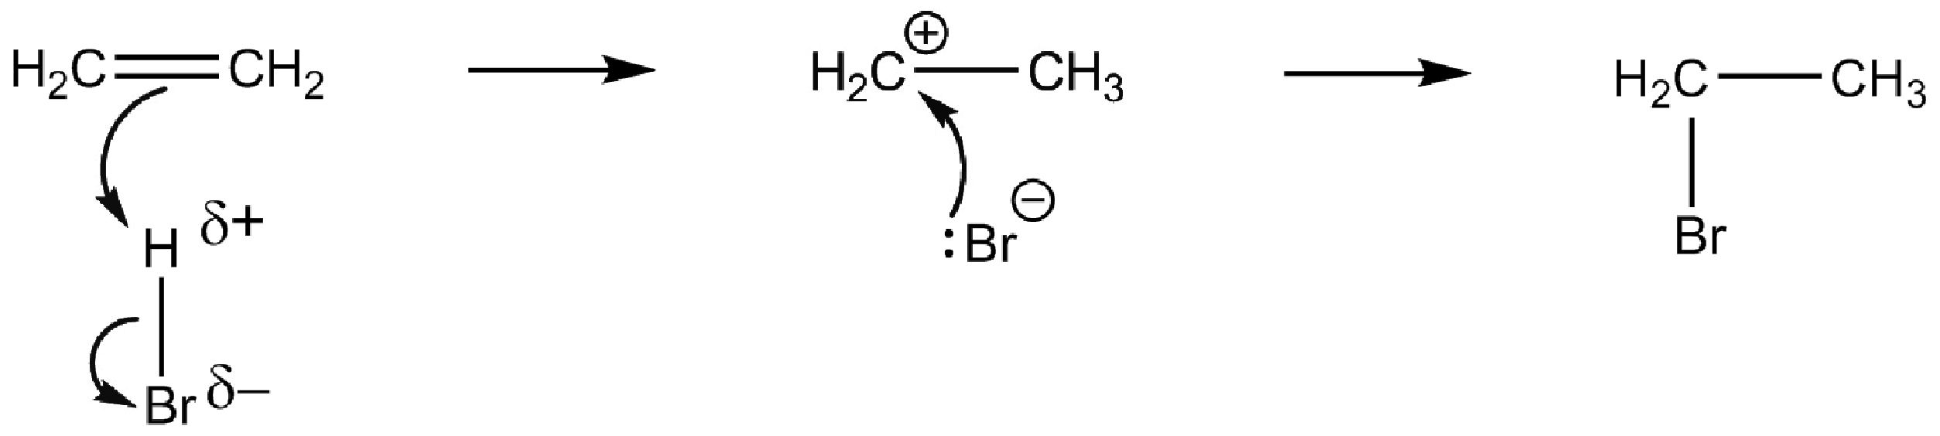
1. Add curly arrows and the carbocation intermediate to complete the mechanism.

- Give the structures of the alkene and the product of this reaction with HCl.
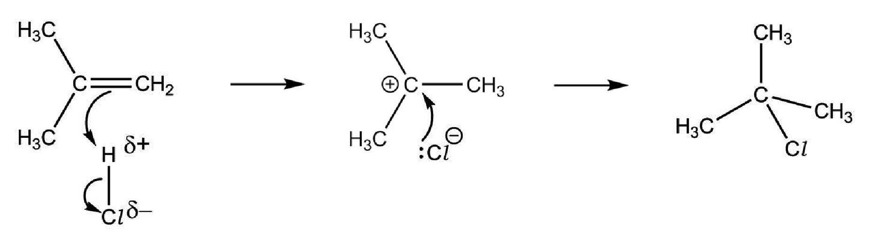
Add curly arrows and dipoles to complete the reaction mechanism.

- Draw the structure of an alternative product between the starting alkene in Question 2 and HCl.
State, with explanation, whether this is the major or minor product.
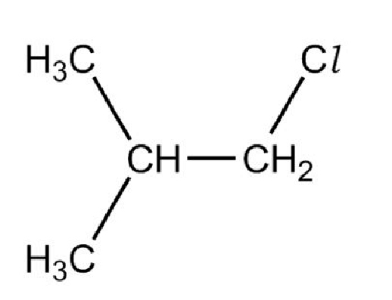

This is the minor product. It is formed from a primary carbocation, which is less stable than the alternative tertiary carbocation.

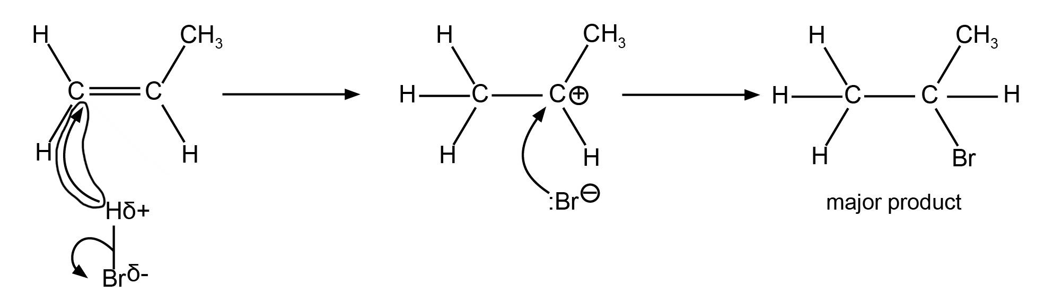
4. This reaction mechanism contains one incorrect curly arrow. Circle the incorrect arrow.

In the first step of the mechanism, the arrow from the hydrogen to the alkene is incorrect. The arrow should be from the middle of the double bond to the H^{δ+}.

5. This reaction mechanism contains one incorrect curly arrow. Circle the incorrect arrow.
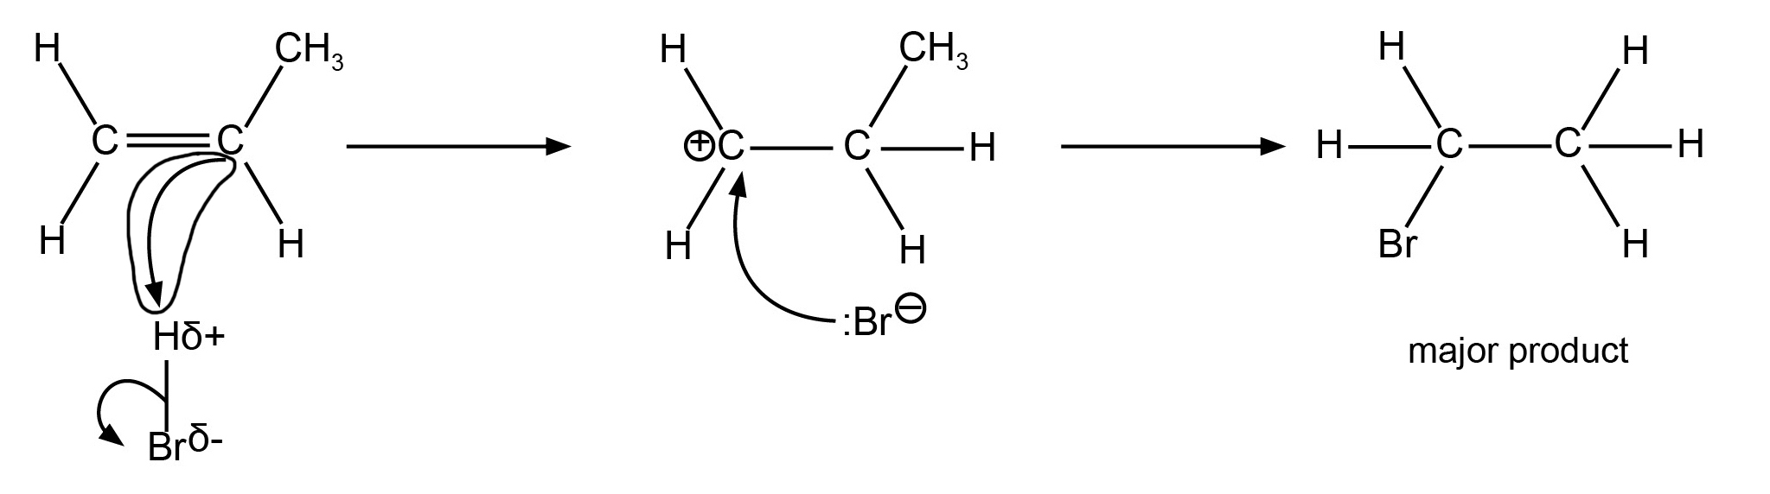
Identify any additional errors in the structures and/or labelling.

In the first step of the mechanism, the arrow to the H^{δ+} should come from the middle of the double bond.
The primary carbocation depicted would not produce the major product. Either the carbocation and product structure, or the ‘major product’ label needs to be revised.
The structure of the product is missing a methyl group on the right-hand carbon.

6. This reaction mechanism contains one incorrect curly arrow. Circle the incorrect arrow.
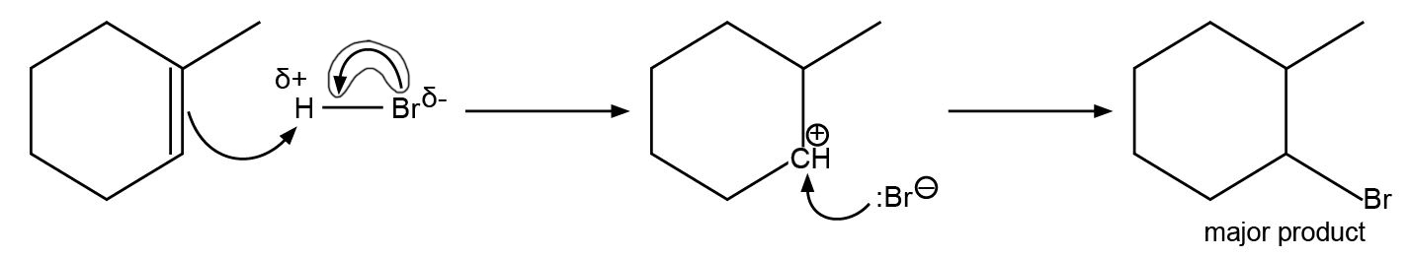
Identify any additional errors in the structures and/or labelling.

In the first step of the mechanism, the curly arrow within the HBr should go from the middle of the bond to the bromine atom.
The primary carbocation depicted would not produce the major product. Either the carbocation and product structure, or the ‘major product’ label needs to be revised.

Activity 3 – Classifying carbocations

1. Classify each of these carbocations as primary, secondary or tertiary.
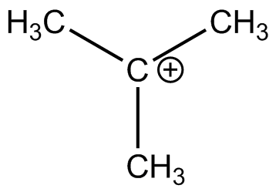
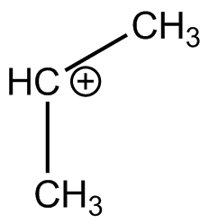
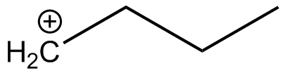
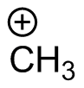
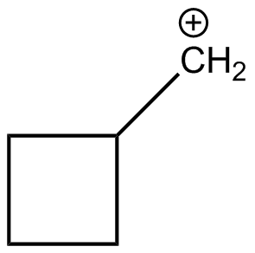
a)
tertiary

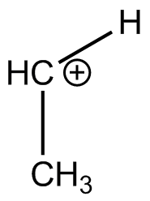
b)
primary

c)
secondary

d)
primary

primary
e)

f)
primary

Activity 4 – Recognising unsymmetrical alkenes – Card sort
The unsymmetrical alkenes, which would give two distinct products in addition of H–X,
are 2, 4, 5, 6, 8, 9 and 12.
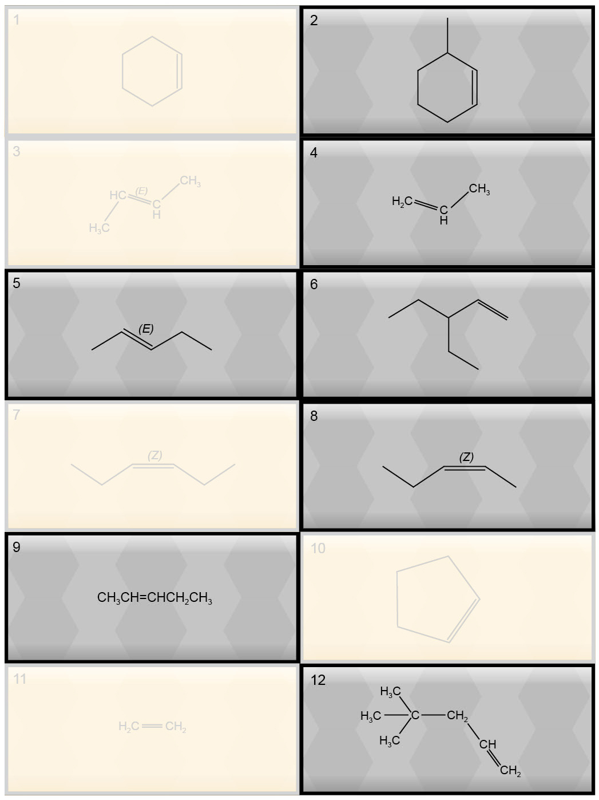

Activity 5 – Recap exercise
1. Consider the following reaction:
methane + chlorine → ?
a) Write out the mechanism to show formation of the product.
Cl₂ → 2Cl•
Cl• + CH₄ → CH₃• + HCl
CH₃• + Cl₂ → CH₃Cl + Cl•
Cl• + CH₃• → CH₃Cl

b) What conditions are needed to initiate the reaction?
UV light or very high temperature.

c) What is homolytic fission?
The equal splitting of a covalent bond so that each species retains one electron.

d) How could ethane be formed?
Two methyl radicals combining.

2. Consider the following reaction:
pent-2-ene + hydrogen bromide → ? + ?
a) Draw the mechanism to show formation of one of the products.
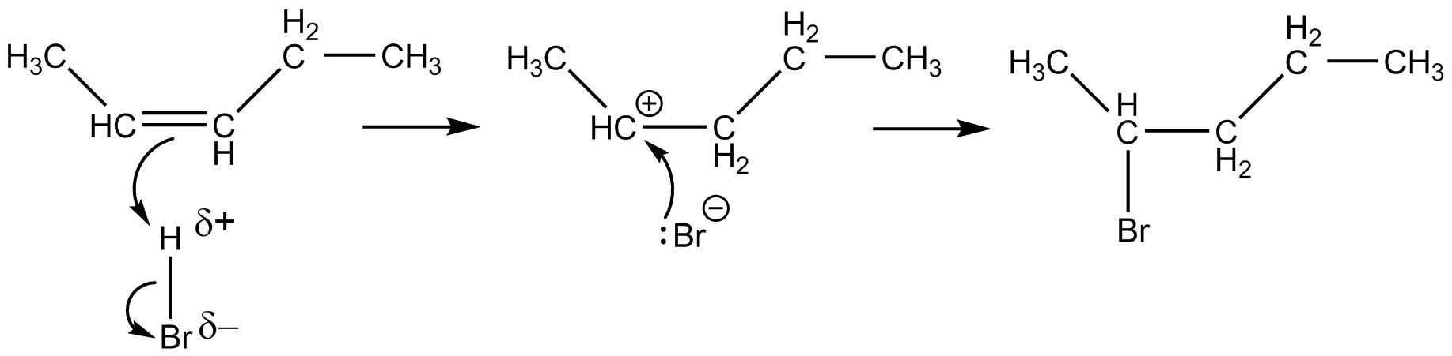
E.g.:

The alternative mechanism has the carbocation on the third carbon, producing
3-bromopentane. Learners may have drawn the reagent as the E-isomer rather than the Z-isomer.

b) What is an electrophile?
An electron pair acceptor.

c) Name the two products formed in the reaction.
2-bromopentane and 3-bromopentane

d) Can you predict, using Markownikoff’s rule, whether there will be a major and a minor product?
Both of the carbocation intermediates are secondary carbocations. Therefore, Markownikoff’s rule cannot be used to predict whether there will be a major product.

3. Put these four sentences into the correct order to describe the electrophilic addition mechanism between ethane and bromine.
1 The π-bond breaks and an electron pair forms a new bond with the positively charged bromine atom.
2 A covalent bond is formed between the carbocation and the bromide ion.
3 At the same time that the bond is formed between the carbon atom and the bromine atom, the Br–Br bond breaks (heterolytic fission) to form a bromide ion and a carbocation.
4 As the bromine molecule approaches the ethene, it becomes polarised by the high density of electrons present in the double bond.
4, 1, 3, 2

4. For each of the following alkenes, draw all the possible products of complete electrophilic addition with HBr.
For each structure there will be four products.
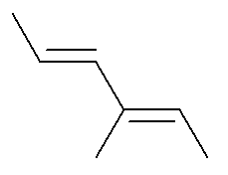
Extension: label each double bond as E or Z.
i)
The top double bond is E.
The bottom double bond is E.

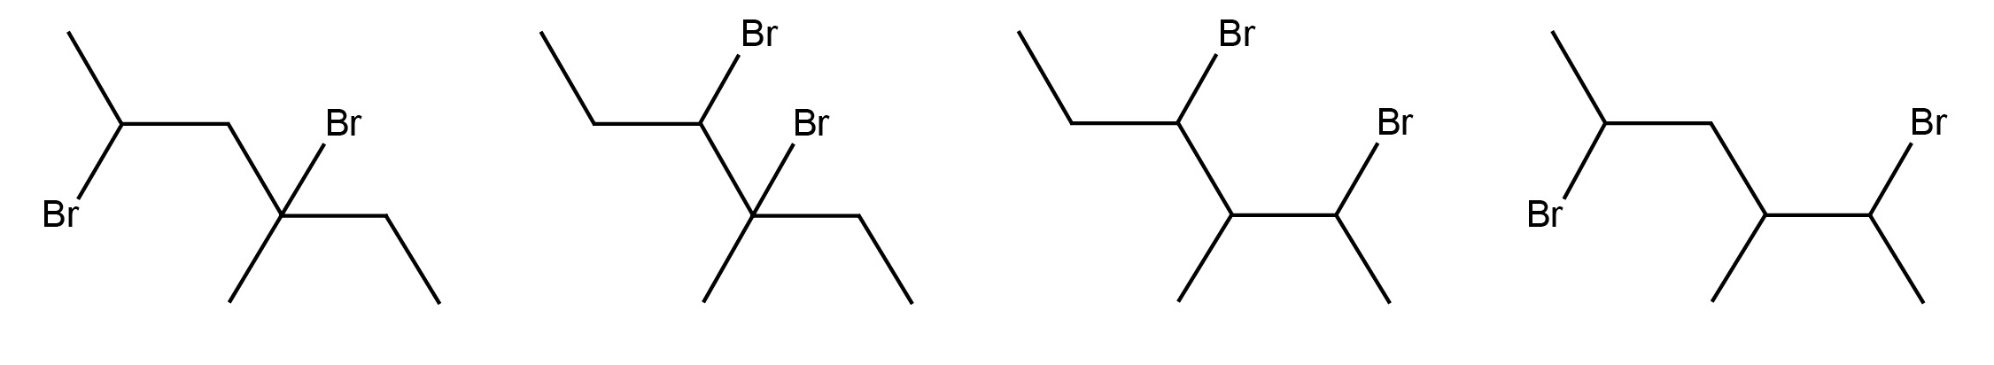

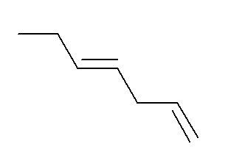
ii)
The top double bond is E.
The bottom double bond is not E or Z. The final carbon atom in the chain is bonded to two hydrogen atoms.

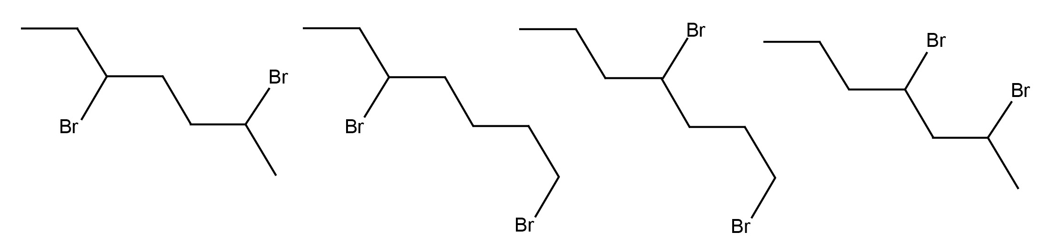

Activity 6 Test-Yourself Questions

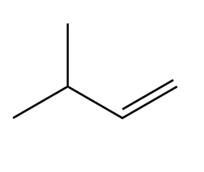
- Using Markownikoff’s rule, what is the name of the major product formed when the following molecule reacts with hydrogen iodide?
A | 1-iodo-3-methylbutane
B | 2-iodomethylbutane
C | 2-iodo-3-methylbutane
D  C | 4-iodo-2-methylbutane

2. Propene and hydrogen fluoride react by electrophilic addition.
What is the structural formula of the intermediate species in the mechanism for the major product?
A | CH₃C⁺CHCH₂F
B | CH₃CHFC⁺H₂
C | CH₃C⁺HCH₃
D  C | CH₃CH₂C⁺CH₂

3. Which alkene will not give two products in reaction with HX?
A | but-1-ene
B | hex-3-ene
C | 2-methylbut-2-ene
D  B | pent-2-ene
4. Which carbocation is secondary?
A | (CH₃)₂C⁺H
B | (CH₃)₃C⁺
C | C₂H₅(CH₃)C⁺CH₃
D  A | H₃C⁺
5. Which term best describes the reaction between 2-methybut-1-ene and
hydrogen chloride?
A | electrophilic addition
B | electrophilic substitution
C | free radical substitution
D  A | Markownikoff
6. Deuterium, D, is an isotope of hydrogen.
What is the major product of the reaction between but-1-ene and DBr?
A | CH₂DCHCH₂CH₂Br
B | CH₂DCHCHBrCH₃
C | CH₃CH₂CHBrCH₂D
D  C | CH₃CH₂CHDCH₂Br

- In the addition of HCl to 1-methylcyclohexene, which of the following statements is/are correct?
- This is the structure of 1-methylcyclohexene.
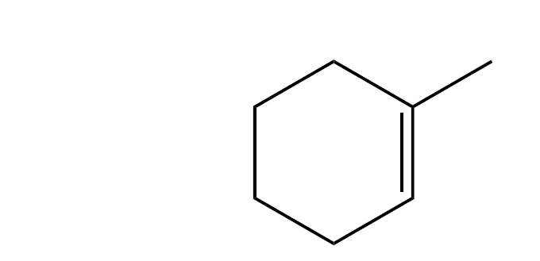
- The alkene is unsymmetrical so there will be two products in the reaction.
- The carbocation intermediate which leads to the formation of the major product is tertiary.
A | 1, 2 and 3
B | only 1 and 2
C | only 2 and 3
D  A | only 1
8. In the electrophilic addition of HX to an unsymmetrical alkene, which of the following statements is/are correct?
1 The stability of the carbocation intermediate determines which is the major product.
2 The major product is the most stable.
3 There is only one product.
A | 1, 2 and 3
B | only 1 and 2
C | only 2 and 3
D  D | only 1

9. In the electrophilic addition of HX to an alkene, which of the following statements is/are correct?
1 There are sometimes two products.
2 The mechanism involves a carbocation.
3 The symmetry of the alkene is not important.
A | 1, 2 and 3
B | only 1 and 2
C | only 2 and 3
D  B | only 1
- In the electrophilic addition of IBr to propene, which of these statements is/are correct?
- The major product is 2-bromo-1-iodopropane.
- Br in IBr has a δ– charge.
- The minor product is propane.
A | 1, 2 and 3
B | only 1 and 2
C | only 2 and 3
D  B | only 1

11. In the electrophilic addition of HF to but-1-ene, which of these statements is/are correct?
1 An intermediate called a carbanion is formed.
2 Heterolytic fission is involved in the first step.
3 The major product is 2-fluorobutane.
A | 1, 2 and 3
B | only 1 and 2
C | only 2 and 3
D  C | only 1

Unstructured questions
- Outline the mechanism for the reaction between but-1-ene and HBr and explain why there are two different products, one major and the other minor.
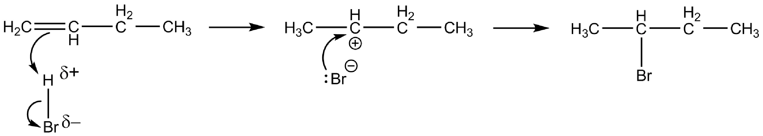
There are two different products because there is an alternative (primary) carbocation intermediate, which leads to the formation of 1-bromopropane.

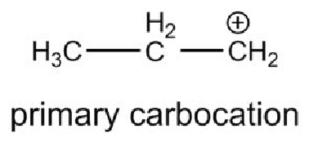
13. Two products are made when propene reacts with HCl. Draw the structure of the intermediate during the formation of the minor product and give the name of this type of structure.

14. Draw the structure of the alkene that would form 1,2-dibromo-3-methylbutane when reacted with bromine.
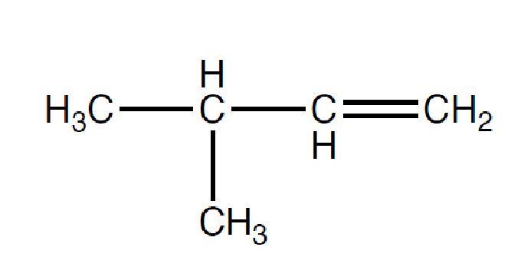
OCR Resources: the small print
OCR’s resources are provided to support the teaching of OCR qualifications, but in no way constitute an endorsed teaching method that is required by the Board, and the decision to use them lies with the individual teacher. Whilst every effort is made to ensure the accuracy of the content, OCR cannot be held responsible for any errors or omissions within these resources.
© OCR 2016 - This resource may be freely copied and distributed, as long as the OCR logo and this message remain intact and OCR is acknowledged as the originator of this work.
OCR acknowledges the use of the following content: n/a
Please get in touch if you want to discuss the accessibility of resources we offer to support delivery of our qualifications: resources.feedback@ocr.org.uk
We’d like to know your view on the resources we produce. By clicking on ‘Like’ or ‘Dislike’ you can help us to ensure that our resources work for you. When the email template pops up please add additional comments if you wish and then just click ‘Send’. Thank you.
If you do not currently offer this OCR qualification but would like to do so, please complete the Expression of Interest Form which can be found here: www.ocr.org.uk/expression-of-interest

Activity 1 – Spot the electrophile!

Learner Activity

An electrophile is an electron pair acceptor – an atom or group of atoms that is attracted to a region of high electron density and can accept a pair of electrons.
An electrophile is normally either a positive ion or a molecule containing an atom with a partial positive charge, δ+. Sometimes this partial positive charge can be induced rather than permanent.
1. a) Work in pairs. Discuss which of these species could qualify as electrophiles and why.
Cl⁺ OH– NO₂⁺ H₂O HBr NH₃ Br₂ CH₃CO⁺

- Can you explain why you did not select some of these?

- Are there any species which might be both an electrophile and nucleophile?

- Why are negative species not going to be attracted to a region of high electron density?

- How might the bromine molecule be able to act as an electrophile?

- Why does HBr have a partial positive charge, δ+, and where is this found?

Extension
Suggest some other species that are electrophiles.

Activity 2 – Electrophilic addition mechanisms

Part 1– Completing electrophilic addition mechanisms
1. Add curly arrows and the carbocation intermediate to complete the mechanism.
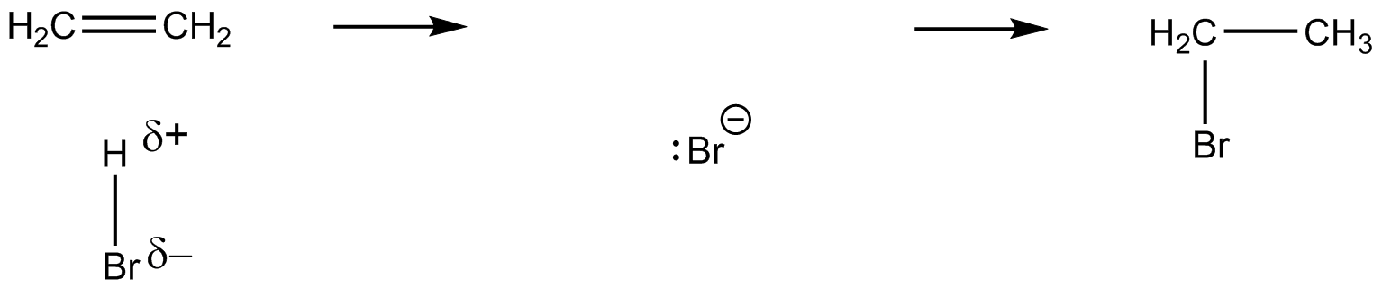

- Give the structures of the alkene and the product of this reaction with HCl.
Add curly arrows and dipoles to complete the reaction mechanism.
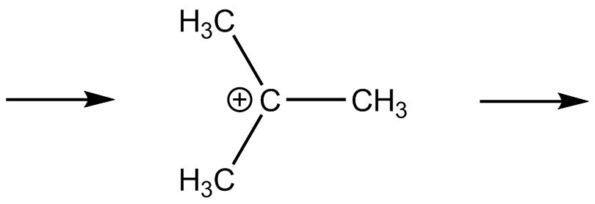

- Draw the structure of an alternative product between the starting alkene in Question
2 and HCl.
State, with explanation, whether this is the major or minor product.

4. This reaction mechanism contains one incorrect curly arrow. Circle the incorrect arrow.
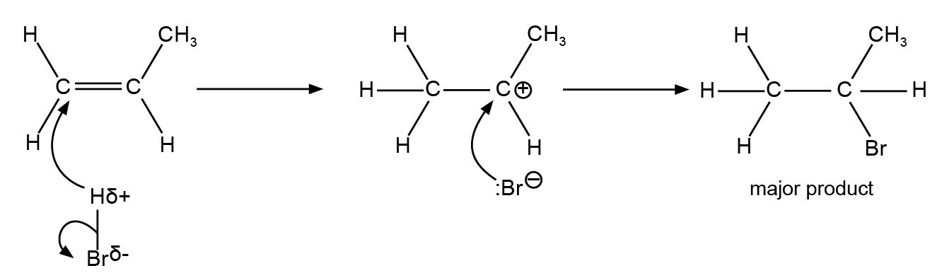

5. This reaction mechanism contains one incorrect curly arrow. Circle the incorrect arrow.
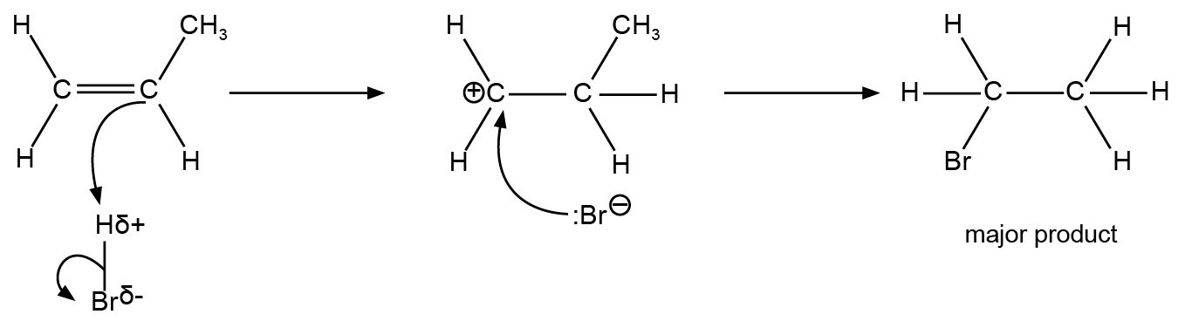
Identify any additional errors in the structures and/or labelling.

6. This reaction mechanism contains one incorrect curly arrow. Circle the incorrect arrow.
Identify any additional errors in the structures and/or labelling.
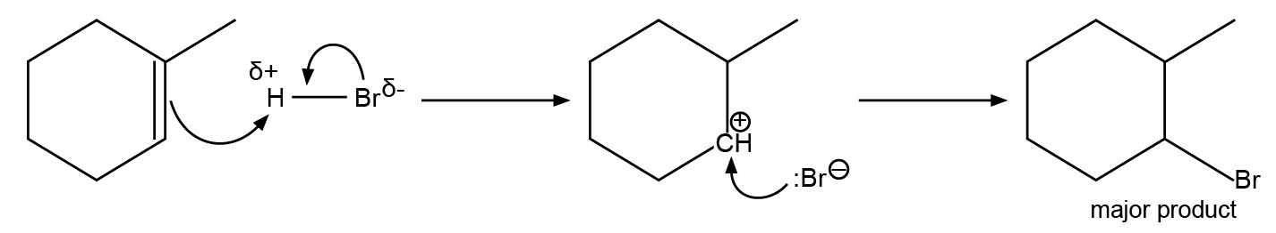

Activity 3 – Classifying carbocations
Remember:
- a primary (1º) carbocation has no more than one R group on the carbon bearing the positive charge
- a secondary (2º) carbocation has two R groups
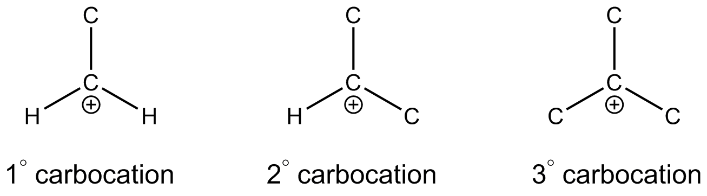
- a tertiary (3º) carbocation has three R groups.

1. Classify each of these carbocations as primary, secondary or tertiary.
a)

b)

c)

d)
e)

f)

2. Draw a tertiary carbocation of your choice here.

Activity 4 – Recognising unsymmetrical alkenes – Card sort
Identify the unsymmetrical alkenes from the following:
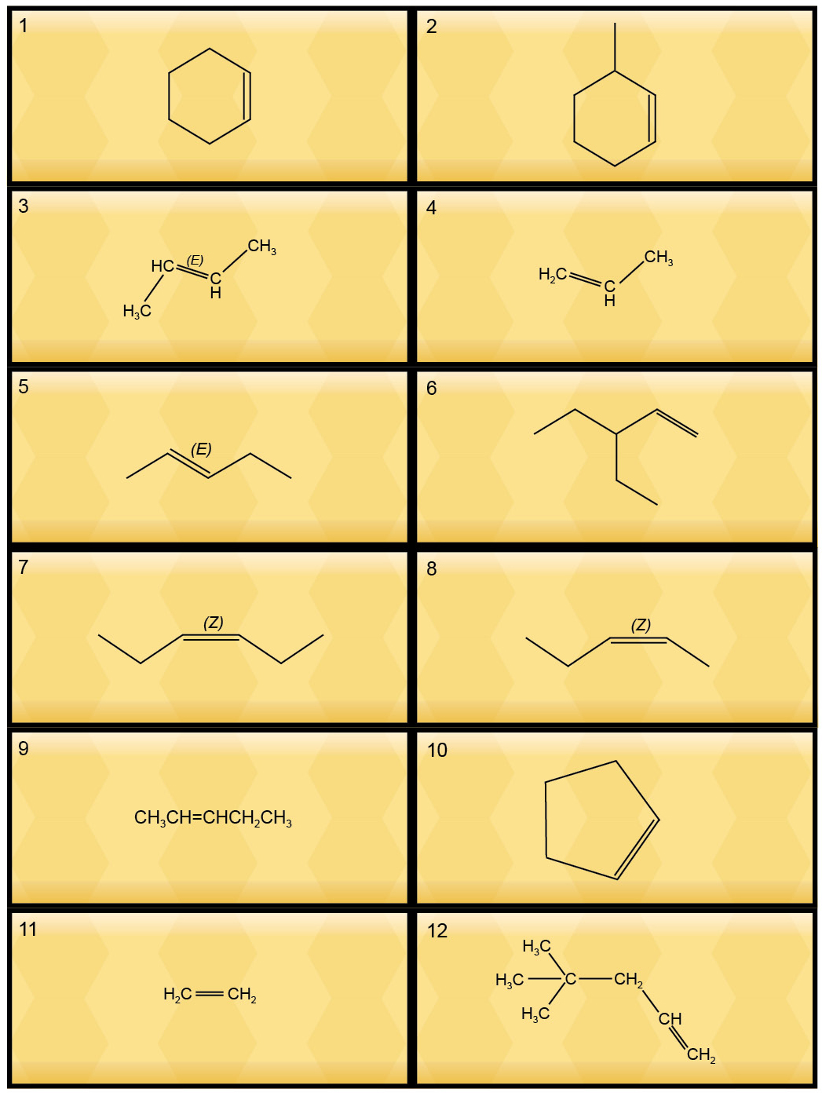

Activity 5 – Recap exercise

Two mechanisms
1. Consider the following reaction:
methane + chlorine → ?
a) Write out the mechanism to show formation of the product.

b) What conditions are needed to initiate the reaction?

c) What is homolytic fission?

d) How could ethane be formed?

2. Consider the following reaction:
pent-2-ene + hydrogen bromide → ? + ?
a) Draw the mechanism to show formation of one of the products.

b) What is an electrophile?

c) Name the two products formed in the reaction.

d) Can you predict, using Markownikoff’s rule, whether there will be a major and a minor product?

Describing the electrophilic addition mechanism

3. Put these four sentences into the correct order to describe the electrophilic addition mechanism between ethane and bromine.
1 The π-bond breaks and an electron pair forms a new bond with the positively charged bromine atom.
2 A covalent bond is formed between the carbocation and the bromide ion.
3 At the same time that the bond is formed between the carbon atom and the bromine atom, the Br–Br bond breaks (heterolytic fission) to form a bromide ion and a carbocation.
4 As the bromine molecule approaches the ethene, it becomes polarised by the high density of electrons present in the double bond.

Predicting products
4. For each of the following alkenes, draw all the possible products of complete electrophilic addition with HBr.
For each structure there will be four products.
Extension: label each double bond as E or Z.
i)

ii)

Activity 6 Test-yourself questions

- Using Markownikoff’s rule, what is the name of the major product formed when the following molecule reacts with hydrogen iodide?
A | 1-iodo-3-methylbutane
B | 2-iodomethylbutane
C | 2-iodo-3-methylbutane
D | 4-iodo-2-methylbutane

2. Propene and hydrogen fluoride react by electrophilic addition.
What is the structural formula of the intermediate species in the mechanism for the major product?
A | CH₃C⁺CHCH₂F
B | CH₃CHFC⁺H₂
C | CH₃C⁺HCH₃
D | CH₃CH₂C⁺CH₂

3. Which alkene will not give two products in reaction with HX?
A | but-1-ene
B | hex-3-ene
C | 2-methylbut-2-ene
D | pent-2-ene
4. Which carbocation is secondary?
A | (CH₃)₂C⁺H
B | (CH₃)₃C⁺
C | C₂H₅(CH₃)C⁺CH₃
D | H₃C⁺
5. Which term best describes the reaction between 2-methybut-1-ene and hydrogen chloride?
A | electrophilic addition
B | electrophilic substitution
C | free radical substitution
D | Markownikoff
Extension
6. Deuterium, D, is an isotope of hydrogen.
What is the major product of the reaction between but-1-ene and DBr?
A | CH₂DCHCH₂CH₂Br
B | CH₂DCHCHBrCH₃
C | CH₃CH₂CHBrCH₂D
D | CH₃CH₂CHDCH₂Br

Multiple choice questions
- In the addition of HCl to 1-methylcyclohexene, which of the following statements is/are correct?
1 This is the structure of 1-methylcyclohexene.
2 The alkene is unsymmetrical so there will be two products in the reaction.
3 The carbocation intermediate which leads to the formation of the major product is tertiary.
A | 1, 2 and 3
B | only 1 and 2
C | only 2 and 3
D | only 1
8. In the electrophilic addition of HX to an unsymmetrical alkene, which of the following statements is/are correct?
1 The stability of the carbocation intermediate determines which is the major product.
2 The major product is the most stable.
3 There is only one product.
A | 1, 2 and 3
B | only 1 and 2
C | only 2 and 3
D | only 1

9. In the electrophilic addition of HX to an alkene, which of the following statements is/are correct?
1 There are sometimes two products.
2 The mechanism involves a carbocation.
3 The symmetry of the alkene is not important.
A | 1, 2 and 3
B | only 1 and 2
C | only 2 and 3
D | only 1
- In the electrophilic addition of IBr to propene, which of these statements is/are correct?
- The major product is 2-bromo-1-iodopropane.
- Br in IBr has a δ– charge.
- The minor product is propane.
A | 1, 2 and 3
B | only 1 and 2
C | only 2 and 3
D | only 1

11. In the electrophilic addition of HF to but-1-ene, which of these statements is/are correct?
1 An intermediate called a carbanion is formed.
2 Heterolytic fission is involved in the first step.
3 The major product is 2-fluorobutane.
A | 1, 2 and 3
B | only 1 and 2
C | only 2 and 3
D | only 1

Unstructured questions
- Outline the mechanism for the reaction between but-1-ene and HBr and explain why there are two different products, one major and the other minor.

13. Two products are made when propene reacts with HCl. Draw the structure of the intermediate during the formation of the minor product and give the name of this type of structure.

14. Draw the structure of the alkene that would form 1,2-dibromo-3-methylbutane when reacted with bromine.

