Checkpoint Task

Radioactivity

Instructions and answers for teachers

These instructions cover the learner activity section which can be found on page 6. This Checkpoint Task should be used in conjunction with the KS3–KS4 Physics Transition Guide: Generating Electricity, which supports OCR GCSE (9-1) Twenty First Century Science Physics B.
When distributing the activity section to the learners either as a printed copy or as a Word file you will need to remove the teacher instructions section.

Overview
The learner tasks below focus mainly on simple experiments to simulate half-lives using sweets and dice, going on to deal with ideas of how data is interpreted and how experiments are modelled, along with an introduction to the idea of radioactive dating. The idea is at least partly to give learners a sense that they are engaging fully with the ideas and not just performing tasks by rote; this is why they are asked to analyse and explain their data and speculate on improvements to the experiment. They should be encouraged at all times to modify and improve any and all aspects of the experiment. For those learners who may not eat sweets, dice provide a perfectly good inedible alternative.

Teacher Preparation
The materials for this experiment are sweets such as Snowies (white chocolate buttons with hundreds and thousands on one side) and a large number of dice. In addition, polyhedral dice with more than six faces as used in various types of games could be offered as an alternative; indeed, it is hoped that some learners might suggest their use.

Task instructions and answers

Activity 1
This task involves learners performing experiments to model half-lives using sweets and dice. The specifics of the design of the graphs have deliberately been left to the discretion of the learners; this should encourage them to think about how best to display their data, and by extension to consider how and why information is presented in the ways we commonly use. Of course, we are essentially looking for an exponential decay curve, but the small populations in some learners’ experiments may give some unusual results. Learners should be encouraged to collaborate and share data; if the experiments are identical, the data can safely be added together to give a larger and more representative result, just as happens in real science.

Activity 2
- Firstly, look at graph 1. Try to draw a line of best fit through the points. You might find that you need a curve instead of a straight line. If so, do your best to draw a smooth curve freehand.
With any luck, the line should be a curve.
- Then, work out the half-life of your sweets. Remember that the half-life of a substance is the amount of time it takes for half of the atoms (in this case, sweets) to decay. How long, measured in the number of throws, did it take for half the sweets to decay? To do this, you can check the point on the line where the number of “decayed” sweets is exactly half the number you started with.
The half-life the sweets should be around one throw. It should be fairly easy to prove this given a decay probability of 50% per generation.

- Bearing in mind that, because the “decay” was a random process, this half-life is only an approximation; how could you have worked out a value for the estimated half-life of the sweets without doing the experiment?
See above.

- Now, do the same with graph 2. Try and find a line of best fit, decide whether it should be straight or curved, and work out the half-life as best you can from the graph.
Again, we hope for a curve. This time, though, the half-life is not so straightforward. Learners might surmise that it ought to be, for instance, exactly three throws, but of course the difficulty here is that the decay is exponential. Answers will, of course, tend to fall around the four-throw mark.
- Bearing in mind that, because the “decay” was a random process, this half-life is only an approximation, how could you have worked out a value for the half-life of the dice without doing the experiment?
More able learners might be able to work out, for instance, that they can find out an approximate result by multiplying the number of dice remaining by 5/6 for each throw, and observe that the figure of 0.5 is not an integer power of 5/6. Very advanced learners might come up with the correct techniques unprompted, but this is unlikely in most.

- Do the graphs have a similar shape, or different shapes? Explain why you think this is.
With any luck, the similarity of the underlying mechanism should be clear to learners; this, however, encourages them to explain it to someone else, which is always a useful way of clarifying ideas in one’s own mind.

Extension task: improving the experiment
- What are the differences between the experiment you did and real radioactive decay of atoms?
This is necessarily qualitative. Learners will have plenty of glib answers about the difference between uranium and sweets, but the insights we are looking for are to do with the difference in scale, with astronomical numbers of atoms inside any object of macroscopic size, and of course the fact that atomic nuclei do not decay at regular intervals but at random times. More observant learners may also have noticed that, in most real-life radioactive decay, the atoms that have decayed do not disappear; they remain a part of the population, and just end up outnumbering the undecayed ones by an increasing amount.

- How could you improve the experiment so that it matched real results from radioactive substances better?
Given the above observations, improvements are likely to focus in increasing the population size, but we should also consider decreasing the probability of decay in order to give more generations between decays and provide a finer “grain” to the decay process. If, for instance, dice are thrown in pairs and only doubles of the chosen number are considered to have decayed, the experiment will take longer, but the decay patterns will start to look a little more realistic; there will be a greater time resolution to the results. Also, learners who are familiar with them may suggest other probabilistic ways of getting results, from non-cuboid polyhedral dice through to playing cards or other objects.

OCR Resources: the small print
OCR’s resources are provided to support the teaching of OCR specifications, but in no way constitute an endorsed teaching method that is required by the Board, and the decision to use them lies with the individual teacher. Whilst every effort is made to ensure the accuracy of the content, OCR cannot be held responsible for any errors or omissions within these resources.
© OCR 2016 - This resource may be freely copied and distributed, as long as the OCR logo and this message remain intact and OCR is acknowledged as the originator of this work.
OCR acknowledges the use of the following content: n/a
Please get in touch if you want to discuss the accessibility of resources we offer to support delivery of our qualifications: resources.feedback@ocr.org.uk

OCR Resources: the small print
OCR’s resources are provided to support the teaching of OCR specifications, but in no way constitute an endorsed teaching method that is required by the Board, and the decision to use them lies with the individual teacher. Whilst every effort is made to ensure the accuracy of the content, OCR cannot be held responsible for any errors or omissions within these resources.
© OCR 2016 - This resource may be freely copied and distributed, as long as the OCR logo and this message remain intact and OCR is acknowledged as the originator of this work.
OCR acknowledges the use of the following content: n/a
Please get in touch if you want to discuss the accessibility of resources we offer to support delivery of our qualifications: resources.feedback@ocr.org.uk

We’d like to know your view on the resources we produce. By clicking on ‘Like’ or ‘Dislike’ you can help us to ensure that our resources work for you. When the email template pops up please add additional comments if you wish and then just click ‘Send’. Thank you.
If you do not currently offer this OCR qualification but would like to do so, please complete the Expression of Interest Form which can be found here: www.ocr.org.uk/expression-of-interest
Looking for a resource? There is now a quick and easy search tool to help find free resources for your qualification:
www.ocr.org.uk/i-want-to/find-resources/

We’d like to know your view on the resources we produce. By clicking on ‘Like’ or ‘Dislike’ you can help us to ensure that our resources work for you. When the email template pops up please add additional comments if you wish and then just click ‘Send’. Thank you.
If you do not currently offer this OCR qualification but would like to do so, please complete the Expression of Interest Form which can be found here: www.ocr.org.uk/expression-of-interest
Looking for a resource? There is now a quick and easy search tool to help find free resources for your qualification:
www.ocr.org.uk/i-want-to/find-resources/

Checkpoint Task

Radioactivity

Learner Activity

Introduction for learners
There are three main types of radioactive decay; all of them involve the nucleus. The outer shell of electrons is largely unaffected. Alpha decay happens when the nucleus of an atom emits a group of four particles; two protons and two neutrons. Beta decay happens when one of the neutrons in the nucleus becomes a proton and emits an electron. Gamma decay happens when the nucleus emits a burst of very high-energy electromagnetic radiation, usually because it has been left with excess energy after undergoing one of the other types of decay.
The amount of time it takes for different kinds of atoms to decay is measured using the concept of half-life. The half-life is the amount of time it takes for half of the atoms in any given sample of the substance to decay. If a substance has a half-life of one minute and you start with 800 atoms, there will be approximately 400 left at the end of a minute, and 200 left at the end of two minutes, and 100 left at the end of three minutes, and so on. Because most ordinary objects have very very large numbers of atoms in them, this means that it can take an extremely long time for materials to decay.
The reason the number of atoms that have decayed after one minute is approximately 400 and not exactly 400 is that radioactive decay is random. We can say how likely an atom is to decay in a certain amount of time, but we cannot predict when any individual atom will decay. This is a bit like rolling two dice and hoping for a double six; you know you have a one in thirty-six chance of it happening, but you don’t know when it will happen. It might happen on the first roll, or you might be unlucky and not see it happen in a hundred rolls. Each atom in a radioactive substance is a bit like that. It might decay in an instant, or it might take many times the half-life of the substance to decay. In theory, it might never ever decay, just as it’s theoretically possible for you to keep rolling dice for a hundred years and never get a double six. It’s just very unlikely.
However, some substances have half-lives that are so long that, even though the atoms in them were formed billions of years ago inside supernovae, they are still radioactive today. The half-life of Uranium-238 is about 4.47 billion years.

Learner Activity 1
Modelling a half-life
The half-life of a radioactive substance is the amount of time it takes for half of the atoms in any given sample to decay.
You will be drawing 2 graphs.
For graph 1, take a number of sweets. These sweets have two sides, and the odds of them landing on either side when you empty them out of a bag have are 50-50.
Count the sweets
Put the sweets into a bag, and shake the bag up thoroughly so that the sweets are definitely jumbled up randomly. Empty them out of the bag on to a convenient (and hygienic) surface.
At this point, you have to decide which side of the sweet counts as “decayed” and which counts as “undecayed”. Your sweets are modelling atoms in a radioactive substance. Those that have “decayed” can be discarded, and possibly eaten. Write down how many are left in the table below.

Number of throws | Undecayed modelling atoms

Repeat the process of putting the sweets in the bag, shaking the bag, emptying them out, discarding the “decayed” ones and counting those that remain, until the sweets are all gone. Record your results in the table.
Plot a graph of your results. You can choose your own labels and coordinates; just make sure you represent the data so that anyone who sees it can clearly work out what the graph represents.
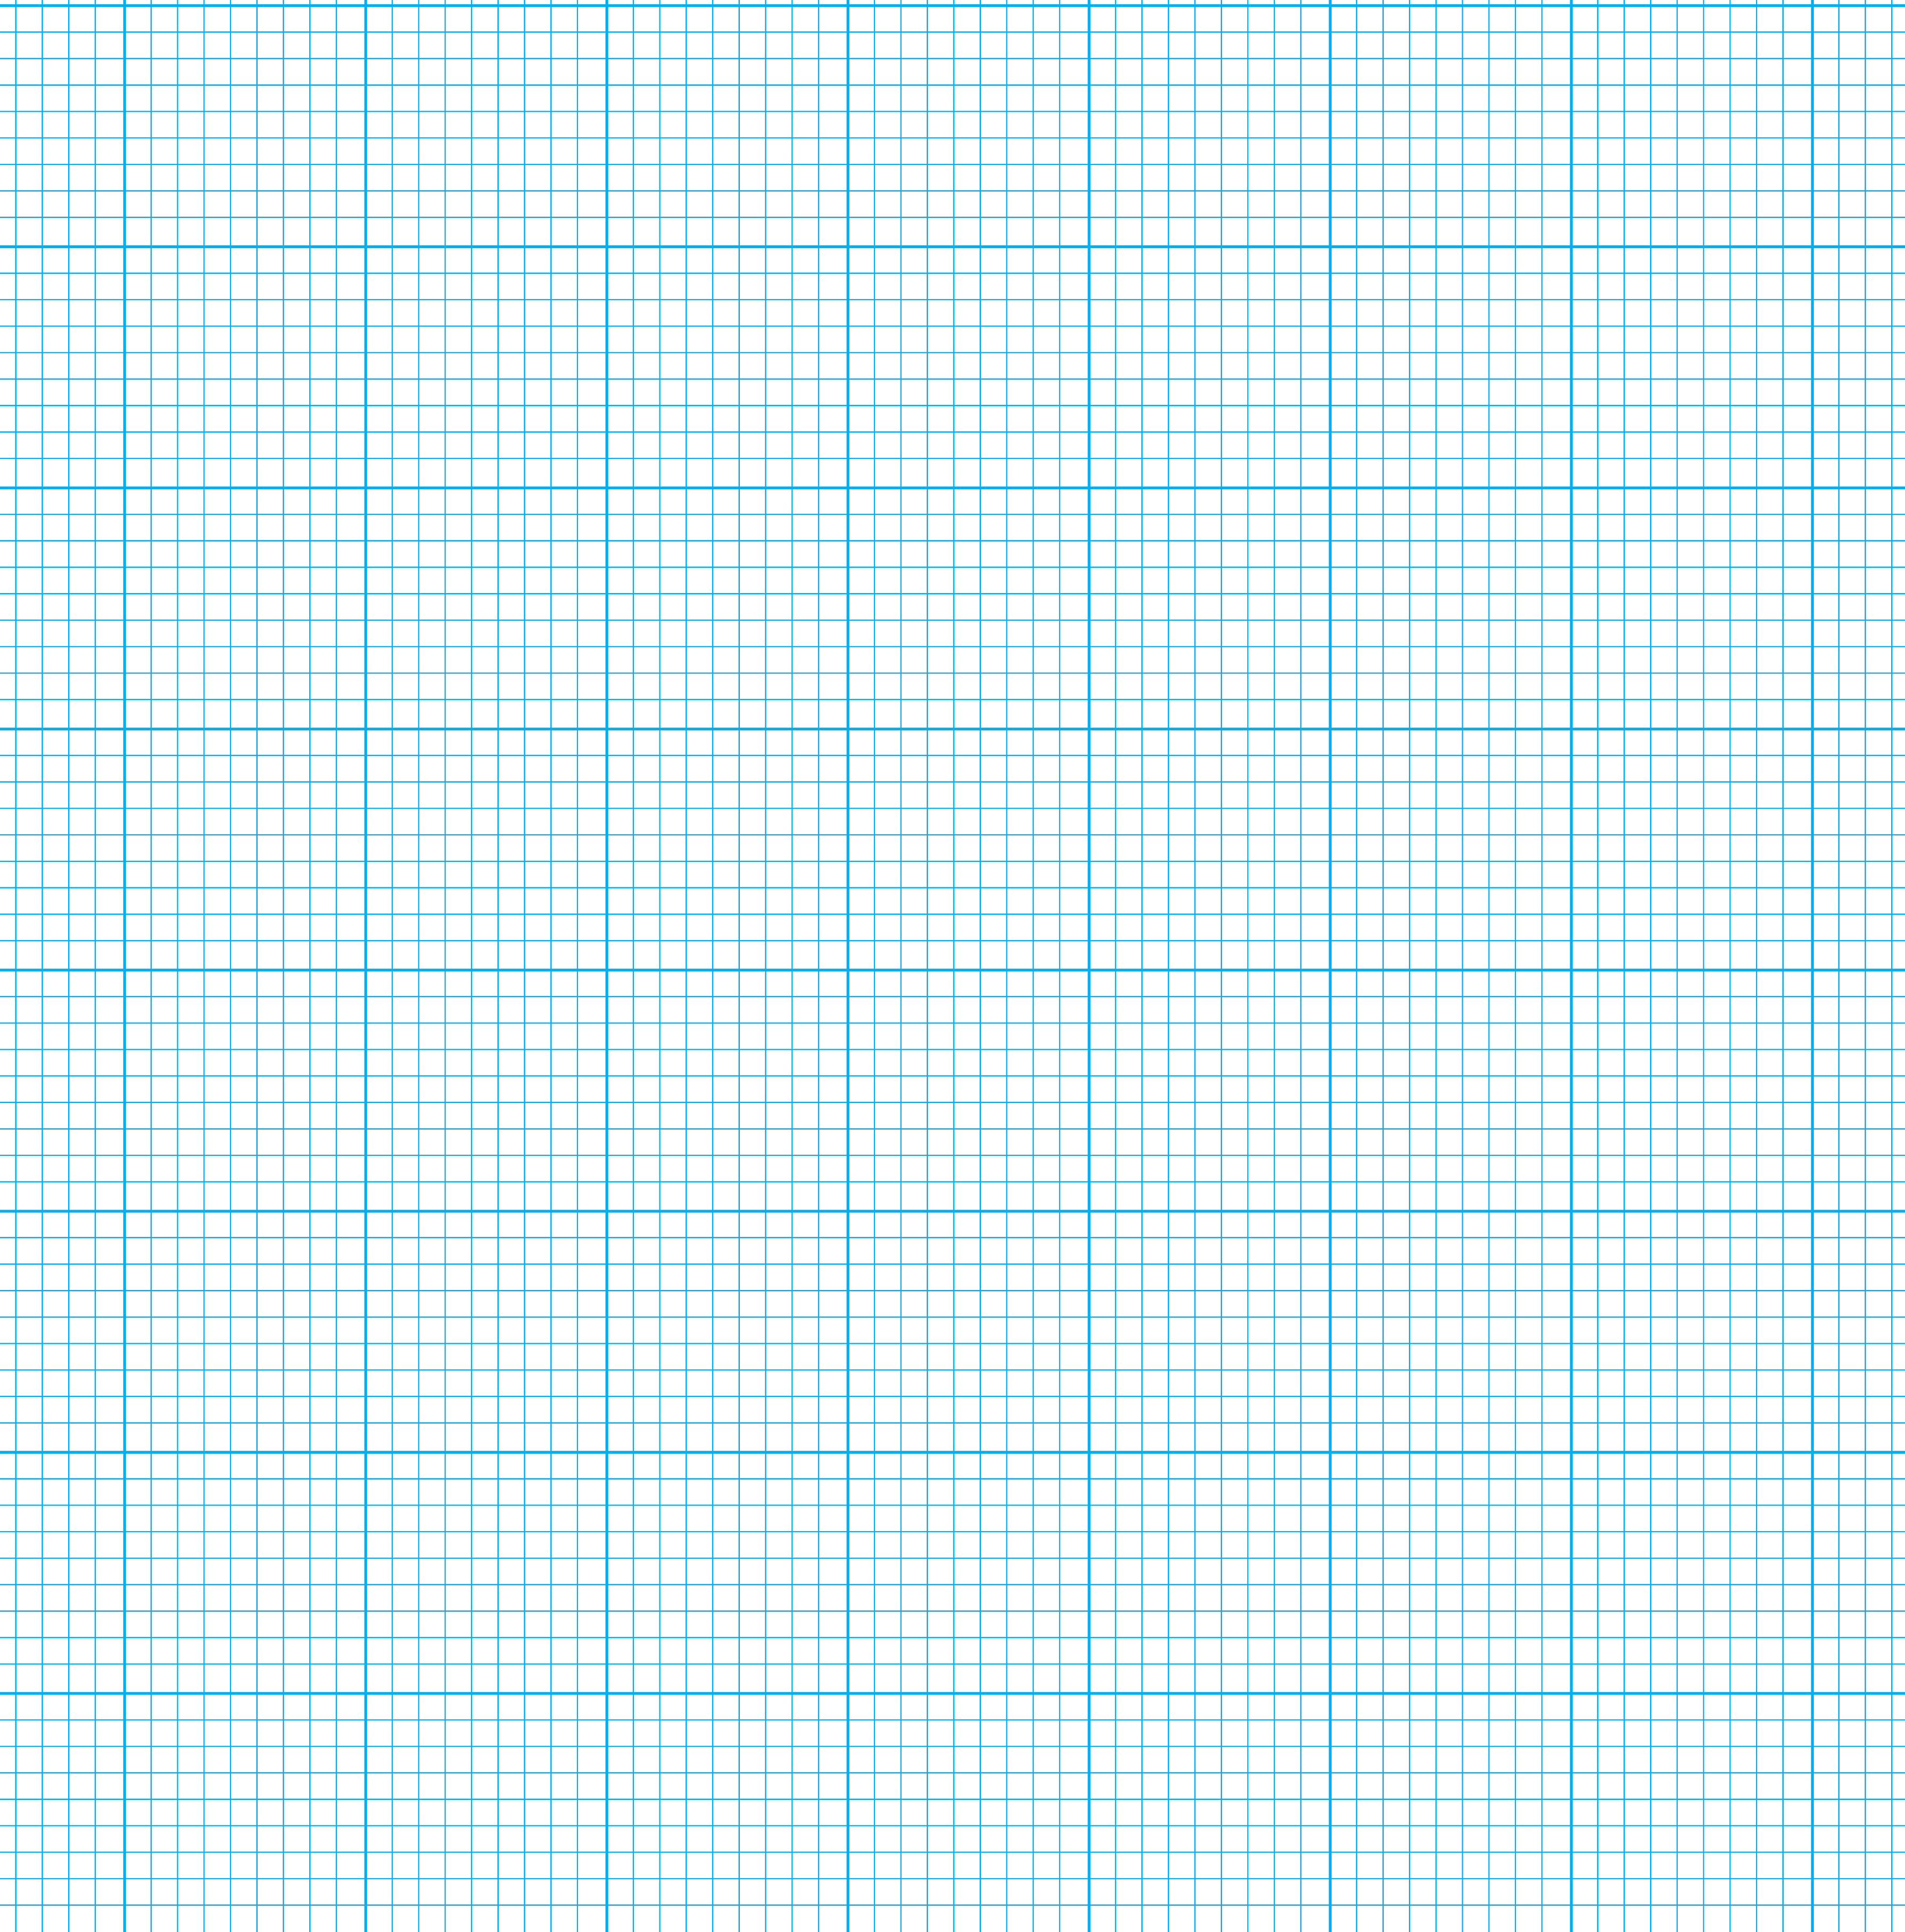

For graph 2, do the same with dice. Design a results table then take some dice; count them; roll all of them and decide which number counts as “decayed”. Make sure you keep the same number, so nobody can accuse you of bias. Keep doing it until all the dice are “decayed” and there are none left. Put the results into graph 2.

Activity 2
Looking at the graphs
- Firstly, look at graph 1. Try to draw a line of best fit through all the points. You might find that you need a curve instead of a straight line. If so, do your best to draw a smooth curve freehand.
- Then, work out the half-life of your sweets. Remember that the half-life of a substance is the amount of time it takes for half of the atoms (in this case, sweets) to decay. How long, measured in the number of throws, did it take for half the sweets to decay? To do this, you can check the point on the line where the number of “decayed” sweets is exactly half the number you started with.

- Bearing in mind that, because the “decay” was a random process, this half-life is only an approximation; how could you have worked out a value for the half-life of the sweets without doing the experiment?

- Now, do the same with graph 2. Try and find a line of best fit, decide whether it should be straight or curved, and work out the half-life as best you can from the graph.

- Bearing in mind that, because the “decay” was a random process, this half-life is only an approximation; how could you have worked out a value for the half-life of the dice without doing the experiment?

- Do the graphs have a similar shape, or different shapes? Explain why you think this is

Extension task
Improving the experiment
- What are the differences between the experiment you did and real radioactive decay of atoms?

- How could you improve the experiment so that it matched real results from radioactive substances better?

