Student handbook: Guide to assessment

Introduction

This guide is designed to provide you with some tips on how to prepare for the exams at the end of the year. It should be noted that this document is a guide only, but as mentioned it is designed to aid you in your preparation for the exams.
This document will suggest different resources and activities for you to use. However, depending on your learning ability some activities may be more suitable than others.

What resources do I have at my fingertips?

Class notes
Your class notes will be an important resource where you can refer to key terms and important details about studies. You may also want to look at your class notes to see areas you have not explained as well and focus on these sections to improve your understanding.
Beyond this using feedback in your work from teachers will enable you to focus on what you need to do to improve your written responses and what you need to do to improve explanations in particular topics.

Textbooks
Referring to textbooks can help you to understand the level of detail required for core studies, theories and areas, so you know how much detail you need to include in your responses to exam style questions.
Textbooks also explain key evaluation issues to you and are good to remind you of why evaluation issues are relevant to specific studies and areas. Once you are happy with the content you can use the exam style questions which are normally found at the end of each chapter.

The exam specification
The specification details everything you need to know for the exam and how the exam will be structured, it is often useful to look at this and check you understand everything you need to.
You can access it by following this link:
http://www.ocr.org.uk/qualifications/as-a-level-gce-psychology-h167-h567-from-2015/

Quizlet
Quizlet is a free website you can use through a web browser or by downloading the app. It is a great tool as you can not only create your own quizzes but you can use existing quizzes other students and their teachers have made.
Through this website you are able to use flashcards, revision games, tests and matching games to help you recall the correct information in the exam and improve your use of key terms.
https://quizlet.com/

YouTube
There are lots of videos on YouTube to help you understand the core studies and areas. Try following Jonathon Evans. See the link below to his clip on Bocchiaro et al.:
https://www.youtube.com/channel/UC2VbjeIhKZ6JUa3yM3Sl4Ew

OCR Podcasts
You can also listen to podcasts about core studies, key themes and debates to spice up your learning and hear from subject specialists as they explain key concepts involved and supporting evidence you will need to use in the exam.
https://audioboom.com/channel/ocr

Suggested activities

1. Set the scene!
The first task really is to understand what it is that you need to know for the exam and how you can break this down into chunks or subtopics. This could be by using the checklist in the appendix, your class notes, existing lists of the topics covered or a textbook to summarise the key elements you need to know and ensure you both understand and remember.
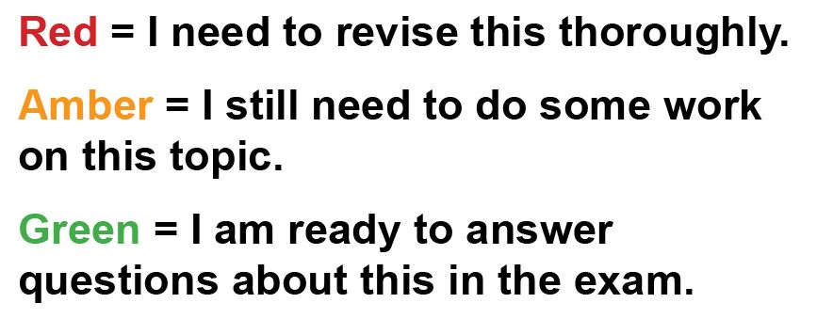
Once you have your checklist of topics you can RAG them! This means to rate how well you understand each concept or study.
Set yourself regular reminders to revisit the checklist to check how far you have to go before the exam and so you can prioritise key areas.

2. Create a timetable
Use the advice in the previous section to map out when you are practically going to do revisit each topic setting yourself clear goals on what you are going to cover. You can design your timetables so that you have daily tasks or weekly tasks. See the appendix for examples of timetables you can fill in.
When completing your timetable consider:
- Record when your exams are.
- Record when your lessons and other ‘busy’ times are.
- Plan to suit your learning habits and preferred time to work. Maybe block out certain times of the day.
- Set yourself time limits. Possibly 20-30 minute chunks.
- Check your plans over visually – are they realistic?

Chunking your learning in this way makes it feel much more manageable and motivates you to revise little and often.

3. Get to know what the examiners expect
By reading mark schemes for assessments you have had and by gaining an understanding of the mark schemes on the OCR website for the sample assessment material, you will be more informed about the skills needed to answer the exam questions appropriately.
Marking your own work using the mark scheme is also useful as it helps you to understand what the examiners expect and if you are currently answering the questions as you should.
Once you have marked your answers you could improve them using the mark scheme.

4. Flashcards
Aim: To recall facts and key information from each study.
Flashcards allow you to create cards with questions and answers on specific facts such as sample sizes or strengths and weaknesses of experimental design. The first step is making the cards and you could make these in PowerPoint and simply print them off.
Once you have made your flashcards you can use them to test yourself and your peers to see how many you get correct. You should use these regularly to ensure your memory recall of the key facts is strong.
To make sure you always include the important parts of the definition you could put these in bold like the example below.
Q: What is a laboratory experiment?

A: This type of experiment typically has high levels of control and due to this takes place in an artificial setting where the independent variable can be tested in relative isolation.

You can find key terms and definitions in the appendix that you could use for flashcards.

5. Diagrams
Aim: To represent information from core studies or key research methods.
A diagram is often used to represent information in a visual way and can be really useful to help you see the bigger picture.
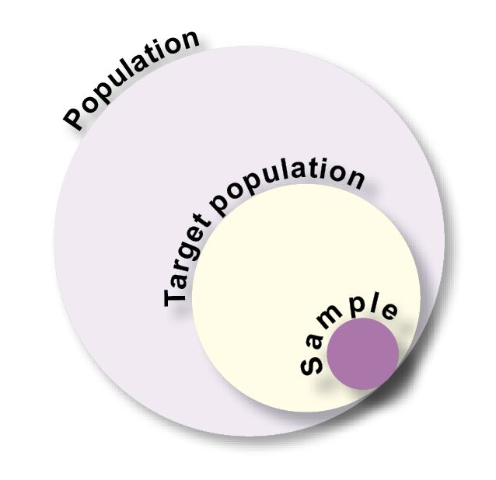
You could even annotate diagrams with the key features you need to know and further key terms.
For the images below can you identify where the following features may fit?
- Representative.
- Symmetry.
- Generalisable.
- Tails off to meet the x-axis.
- Bell shape.
- Population validity.

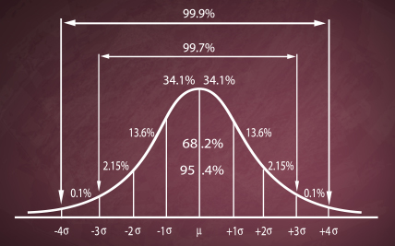
You can use a table (like the one below) to break down information further into a simple diagram. Below is an example on how you can use a table to break down information for the social learning theory?
Key term | Process | Definition
Role model | The individual observes another person who they look up to. | Someone with whom an individual identifies.
Vicarious reinforcement | Operant conditioning – positive or negative reinforcement or punishment. | In operant conditioning this is indirect reinforcement.
Internal mental representation | They observe that the other person is rewarded in some way as a consequence of the behaviour. | Expectancies of future outcomes are represented and stored.
Imitation | The individual copies the behaviour which they previously observed. | Performance of a behaviour learnt by observation.
Direct reinforcement | The individual experiences the consequences of the new behaviour. | Internal reinforcement through positive mental images.
Self -reinforcement | They imagine themselves doing the same behaviour with the same consequences. | The individual values the new learnt behaviour and it’s maintained.

6. Mind maps
Aim: To visually organise the information you need to learn for each topic and act as a trigger for memory recall of certain topics.
The idea is you would put your main topic in the centre and the branches off will be the main ideas or concepts within the topic.
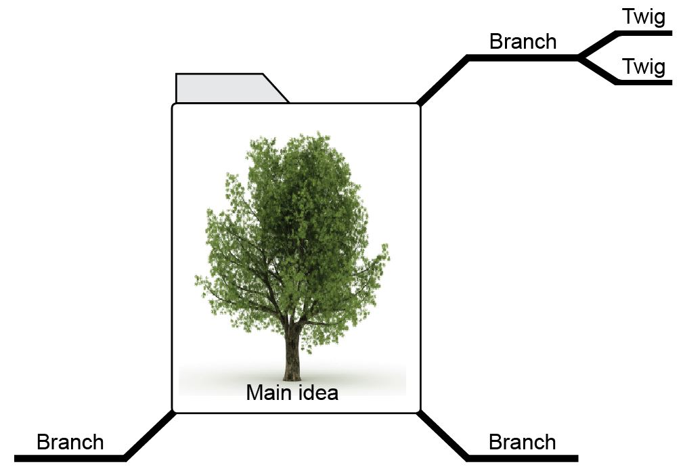

Can you create a mind map of the five key areas of psychology with the key themes and studies concepts included?
Read more at: http://www.mindmapping.com/theory-behind-mind-maps.php

7. Practise exam questions
Aim: To improve your exam technique and develop your ability to explain answers.
Soon you will be sitting the exam and be required to respond to a range of exam questions. In order to prepare for the exams the final part is ensuring you are able to tackle questions from different topics and that you can respond appropriately to the command words in the question itself.
Try completing exam style questions from the OCR website, your textbook or that your teacher has given you using the rule of one minute per mark.
Try checking back your answer by seeing if you have done what the command words below demand.
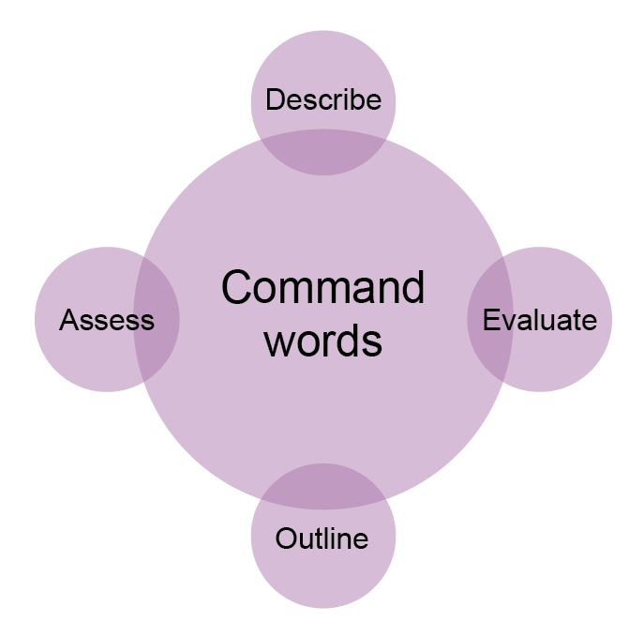

8. Quizzes
Aim: To test your knowledge and improve your memory recall in terms of both accuracy and speed.
You may already do quizzes in lessons to test your recall of facts, figures, definitions and evaluation points and this is a useful way of testing your knowledge.
You can create quizzes yourself or use existing ones on free websites/ apps such as Quizlet.
Try a quiz on Bocchiaro et al. at: https://quizlet.com/96132096/bocchiaros-study-of-disobedience-and-whistle-blowing-key-facts-flash-cards/
You can download a range of apps onto your phone or other devices so you can do these quizzes when you have a spare 10 minutes at college or on the bus!

9. Group activities
Aim: To challenge yourself and others to improve the quality of your answers.
Working in groups can help you to improve your knowledge and understanding in a fun way and motivate you and your peers.
Try some of the following activities:
- Make a set of open question cards such as ‘What may be limiting about studying children?’ that you can all answer individually and then discuss your responses. Once you have discussed your responses you can annotate your own with further detail to improve the level of response you can give in the exam.
- Pair up with a peer you know is really good at a particular topic and teach each other your area of expertise. Not only will you be helping a friend but it is shown in research that by explaining a concept to others you actually improve your own ability to explain it.
- Challenge a friend to answer as many closed question flashcards, such as ‘what is an open question?’ in 3 minutes and keep a tally of the scores. You can even use apps discussed above to do this.

10. Improving marked work
Aim of this strategy: To understand the demands of the exam and what the examiners will be looking for in your answer.
As part of your exam preparation you need to put your learning into practice and gear up for what the exam will actually want from you. Understanding how the knowledge and understanding you have needs to be expressed in the exam is vital and this strategy is reported as highly effective by both students and research.
Once you have some feedback from your teachers take a different coloured pen and annotate your answer with improvements to their comments. Once you have done this it is useful to reattempt the question again at a later time to see if you have adjusted your exam technique and understanding following your improvements.

Appendix
Checklist all topics – for AS
Exam | Topic | Key concepts | RAG? | Revisited RAG?
Component 1 | Planning and conducting research | Research aim  Research question  Null hypothesis  Alternative hypothesis  One-tailed (directional) hypothesis  Two-tailed (non-directional) hypothesis
 | Planning and conducting research | Target population  Sample  Random sampling  Snowball sampling  Opportunity sampling  Self-selected sampling
 | Planning and conducting research | Independent variable (IV)  Dependent variable  Control of extraneous variables  Operationalisation
 | Self-report | Questionnaire  Interviews  Structured, semi-structured, unstructured
 | Self-report | Open questions  Closed questions  Rating scales (Likert rating scale & Semantic differential rating scale)
 | Experiment | Laboratory experiment  Field experiment  Quasi experiment
 | Experiment | Experimental design  Repeated measures design  Independent measures design  Matched pairs design
 | Observation | Structured  Unstructured  Naturalistic  Controlled  Participant  Non-participant  Overt  Covert
 | Observation | Behavioural categories  Coding frames  Time sampling  Event sampling
 | Correlation | Positive correlation  Negative correlation  No correlation
 | Data | Design raw data recording tables  Use raw data recording tables  Standard and decimal form  Significant figures  Estimating from data collected
 | Data | Levels of data  Nominal data  Ordinal data  Interval data  Types of data  Quantitative data  Qualitative data  Primary/ Secondary data
 | Data | Descriptive statistics  Measures of central tendency - Mean, median, mode  Measures of dispersion – variance, range, standard deviation  Ratios  Percentages  Fractions  Frequency table (tally chart)  Line graph, pie chart, bar chart, histogram, scatter diagram
 | Data | Inferential statistics  Normal distribution curves  Skewed distribution curves (positive/ negative)  Probability  Significance levels  Using statistical tables of critical values  Criteria for a parametric test  When to use the following non-parametric inferential tests: Mann-Whitney U, Wilcoxon Signed Ranks test, Chi-square, Binomial Sign test, Spearman’s Rho)  Type 1 and Type 2 errors  Symbols =, <, <<, >>, >, ∝, ~.
 | Methodological issues | Representativeness  Generalisability  Reliability (Internal, External, Inter-rater, Test-retest, Split-half)  Validity (Internal, Face, Construct, Concurrent, Criterion, External, Population, Ecological)  Demand characteristics  Social desirability bias  Researcher/ observer bias  Researcher/ observer effect (s)  Ethical considerations
 | Report writing | Sections and sub-sections of a practical report (abstract, introduction, method (design, sample, materials/ apparatus, procedure), results, discussion, references, appendices)  Familiarity of how to cite using Harvard referencing e.g. Milgram, S. (1963) Behavioral study of obedience. Journal of Abnormal and Social Psychology, 67, (4), 371–378.  Understanding of peer review
 | How science works | The study of cause and effect  Falsification  Replicability  Objectivity  Induction  Deduction  Hypothesis testing  Manipulation of variables  Control and standardisation  Quantifiable measurements
Component 2 | Studies in their key themes  You should know for each study: Background, method, results and conclusions.  For each pair of studies you should know: similarities, differences, how the contemporary study changes our understanding of the key theme and about individual, social and cultural diversity. | Social – Responses to people in authority  Milgram (1963) Obedience  Bocchiaro et al. (2012) Disobedience and whistle-blowing
Cognitive – Memory
Loftus and Palmer (1974) Eyewitness testimony
Grant et al. (1998) Context-dependent memory
Developmental – External influences on children’s behaviour
Bandura et al. (1961) Transmission of aggression
Chaney et al. (2004) Funhaler study
Biological – Regions of the brain
Sperry (1968) Split brain study
Casey et al. (2011) Neural correlates of delay of gratification
Individual differences – Understanding disorders
Freud (1909) Little Hans
Baron-Cohen et al. (1997) Autism in adults
 | Areas and perspectives | For Section B you should know: defining principles of area/ perspective, research to illustrate the area/ perspective, strengths and weaknesses, applications and how the area/ perspective differ.  Social  Cognitive  Developmental  Biological  Individual Differences  Behaviourist perspective  Psychodynamic perspective
 | Debates | For Section B you should know: defining principles of debate, research to illustrate the debate, different positions in the debate, applications and how the debates differ.  Nature/ Nurture  Freewill/ Determinism  Reductionism/ Holism  Individual/ Situational explanations  Usefulness of research  Ethical considerations  Conducting socially sensitive research  Psychology as a science

Timetable examples
You can choose what to write in the first column, such as:
- Lessons in a day
- Hours in a day
- Morning/ Afternoon/ Evening
Week commencing Monday _______________________
 | Monday | Tuesday | Wednesday | Thursday | Friday | Saturday | Sunday
1
2
3
4
5
6
7
8

Research methods key terms
This document is a guide only and includes definitions of key terms.

Key term | Definition | Learnt? | Studies relevant to?
Experiment | An experiment involves the manipulation of an independent variable in order to see its effect on the dependent variable.
Laboratory experiment | This type of experiment typically has high levels of control and due to this takes place in an artificial setting where the independent variable can be tested in relative isolation.
Field experiment | This type of experiment takes place in a more natural setting where the experimenter manipulates the independent variable.
Quasi experiment | This type of experiment occurs naturally when other forces create a manipulation of the independent variable and the researcher is then able to document the results. Often this allows research to take place that would be unethical to directly manipulate.
Observation | The observational method is used when watching participants (human or animal) directly in order to obtain data and gather information about their behaviour.
Structured observation | A structured observation is one which uses an explicitly, pre-defined coding framework for recording data that clearly outlines the behavioural categories to be used.
Unstructured observation | An unstructured observation is where the researcher recording the behaviour they can see. In this type of observation they do not have a prescribed list of behaviour they need to look for. Instead researchers collect qualitative data about relevant behaviours of interest.
Naturalistic observation | Observing behaviour in its natural setting such as observing children in the local nursery.
Controlled observation | This type of observation takes place in an environment that is set up by the experimenter to enable some control whilst observing behaviour.
Participant observation | Participant observation is where the researcher(s) are in some way part of the activity/ group of people whose behaviour is being observed.
Non-participant observation | Non-participant observation is a type of observational technique where the researcher observes the behaviour of an individual or group without intruding into the situation being studied.
Overt | This is an observation here the participant is aware they are being observed.
Covert | Any observation where the participant is unaware that they are being observed.
Behavioural categories | Behavioural categories are the operationally defined units of events used in a structured observation to break a continuous stream of activity into discrete recordable events.
Coding frames | A coding frame is used to operationalise behaviour and allow the researcher to record observations. Researchers will categorise behaviour and create a table in order to record the occurrence of each category.
Time sampling | Time sampling involves observations at set lengths of time at set intervals. As an example a traffic survey may be carried out over a 3 hour observation period in which the intervals are every hour.
Event sampling | Event sampling involves observations at a specific event each time it occurs throughout the duration of the observation period. In other words, the observer records behaviour continuously.
Self-report | A self-report method is a way to obtain data by asking participants to provide information about themselves.
Questionnaire | This is a method of collecting data from a respondent and typically involves them responding to a number of questions in written form or electronically.
Interviews | This method involves an interviewer asking a respondent a series of questions about the topic of interest and typically takes place face-to-face.
Structured interview | A structured interview asks predominantly closed questions in a fixed order. The questions are likely to be scripted so they are standardised, and consistency might even be required for the interviewer's posture etc.
Semi-structured interview | A semi-structured interview uses a fixed list of open and closed questions, although the interviewer can introduce additional questions if required.
Unstructured interview | An unstructured interview generally begins with a standard question for all participants but from there on, questions depend on the respondent's answers. There might be a list of topics for the interviewer to cover.
Open questions | An open question is one in which individuals can respond in any way they like and are not restricted in any way.
Closed questions | A closed question is one in which individuals select their response from a predetermined set of options.
Rating scale questions | A rating scale question is one where the respondent has to state where along a scale they position themselves. This could be as a likert scale or even a semantic differential scale.
Likert rating scale | This is a type of question that measures the attitude of individuals. An attitude statement is given and individuals have to select the statement most suited to them. This is normally on a five point scale ranging from ‘strongly agree’, ‘mildly agree’, ‘neither agree nor disagree’, ‘mildly disagree’ to ‘strongly disagree’.
Semantic differential rating scale | This is another type of rating scale that elicits the respondent’s attitudes using positive and negative descriptors such as ‘happy-sad’ or ‘funny-boring’. Responses can then be analysed using the point scale between the two extremes.
Correlation | Correlational analysis is a technique used to investigate a relationship between two measured variables.
Positive correlation | A positive correlation is where as the values of one variable increase, related values of the second variable also tend to increase (although not necessarily at the same rate).
Negative correlation | A negative correlation is where as the values of one variable increase the values of the other tend to decrease, although not necessarily at the same rate.
No correlation | There is now relationship between the variables.
Scattergraph | A scattergraph is a visual display of two variables expressed numerically, one on each axis and indicated at the intersection of the two values.
Correlation coefficient | The correlation coefficient is a measure of the strength of a correlation, usually expressed as an 'r' value between 0 and 1. A high value, e.g. r=0.8, means that there is a strong correlation, and r=0 means there is no correlation.
Research aim | This is a statement of what the researcher wants to find out and should be clearly worded so that the variables are clear.
Research question | This is what the researcher wants to find out overall such as ‘Do people have an excessive fear of crime?’ and should include the key aspects interested in.
Null hypothesis | This is a prediction that states there will be no significant difference (experiment/ relationship correlation). The results are down to chance.
Alternate hypothesis | This is a prediction that states what you believe to be true. In other words, you state what you expect the difference (experiment)/ relationship (correlation) to be. A hypothesis needs to be testable so it can be supported or rejected.
One-tailed (directional) hypothesis | This type of alternate hypothesis is used when the results are expected to go a particular way, for example students performing better when studying in silence.
Two-tailed (non-directional) hypothesis | Type of alternate hypothesis is used when a researcher is unsure what the difference in results will be but they expect a difference between conditions of some kind.
Target population | This is a specific group of people that the researcher is interested in studying and from which the sample is drawn from.
Sample | The sample is the selection of participants from the wider target population that are actually used in the research.
Sampling method | You rarely get the opportunity to study all of the people in your target population (it just isn't practical) so this is how you go about gathering a selection of people from the target population.
Random sampling | This type of sampling involves having access to all members of the target population. Random sampling can be done by manual selection (such as names in a hat) or using random number tables or computer based selection; as long as there is an equal chance of each individual in the T.P being chosen.
Snowball sampling | This is a method of gaining participants for the sample by asking current participants to refer others they know who are suitable. This is often used for specific samples that may be hard to find such as gamblers.
Opportunity sampling | This type of sampling is also referred to as a convenience sample as it involves gathering participants who are in the right place at the right time.
Self-selected sampling | Individuals volunteer themselves to take part. This is usually due to a response to newspaper advertisements, posters or call outs on a radio station.
Experimental design | The term experimental design refers to the way in which participants are allocated to levels of the IV (the different conditions).
Repeated measures design | A repeated measures design is where participants take part in both (or all) conditions of an experiment.
Independent measures design | An independent measures design is where participants only take part in one condition of the experiment. This means that different participants complete each condition.
Matched participants design | A matched pairs design is an experimental design in which participants are arranged into pairs. Each pair is similar in ways that are important to the study (characteristics such as IQ or personality) and the members of each pair perform in the two different levels of the IV.
Order effects | In a repeated measures design, order effects can produce changes in performance between conditions that are not due to the IV, so can obscure the effect of the DV.
Practice effect | The practice effect refers to the situation where participants' performance improves because they experience the experimental task more than once. They might become more familiar with the task or recall their previous answers.
Fatigue effect | The fatigue effect refers to the situation where the participants' performance declines because they have experiences an experimental task more than once. They might be bored or tired.
Independent variable (IV) | The independent variable (IV) is the factor in an experiment that is manipulated, changed or compared by the researcher; it is expected to have an influence on the dependant variable.
Dependent variable | The dependant variable (DV) is he factor in an experiment that is measured by the researcher. Changes in this factor are predicted to be caused by changes in the independent variable.
Confounding variable | A confounding variable is created when there is the possibility of uncontrolled factors influencing the behaviour being measured (DV). This may lead to an incorrect conclusions being drawn and the results lacking internal validity.
Extraneous variables | An extraneous variable is any variable other than the IV that may possibly influence the behaviour being studied. Researchers need to be aware of these and minimise their influence before the study takes place by putting controls in place.
Operationalise | The definition of variables so that they can be accurately manipulated, measured and replicated.
Data recording, analysis and presentation – useful terms
Raw data | This is the data that is collected in research before it is processed or analysed. This could take the form of scores, interview transcripts or coding scheme tallies.
Standard form | Standard form is used to represent very big numbers more concisely. As an example 15,000,000 can be written as 11.5 x 10⁷ in standard form.
Decimal form | Decimal form is used to represent the whole units and their parts.
Significant figure | Significant figures are used to give a rounded answer rather than including a long and precise number. This can be used if you calculate an average that has many decimal point and you only use the first two decimal places.
Estimations | This is a rough calculation and can be used to work out approximate fractions for example.
Level of data | Depending on how you operationalise variables you will produce different types of data which can be described as the level of data. The level of the data dictates how you can analyse your results.
Nominal level data | This refers to the level of data that is categorical and merely places a behaviour or person into a category with no further distinction. Examples of categorical data are male/ female or even subjects chosen at A Level.
Ordinal level data | This refers to data that can be ordered into rank such as place in a race or favourite song out of five.
Interval level data | This refers to data that has fixed units of measurement such as cm or IQ scores. Unlike ratio data this level of data has no true zero (you can’t have an IQ of 0) and therefore we cannot say that one score is proportionate to another.
Quantitative data | This type of data is data that can be expressed numerically in some way (measurement of the DV in numbers).
Qualitative data | Qualitative data is descriptive, in-depth and rich data that can give you insight into the participants' thoughts and beliefs.
Primary data | This is data collected directly from the participants by the researcher.
Secondary data | This is data that the researcher utilises that has previously been collected by people beyond the research.
Descriptive statistics | These are a method of summarising data from research to provide an overview of the findings.
Measures of central tendency | These measures calculate the typical scores for a set of data.
Mode | This measure of central tendency is calculated by finding the most common value in a set of data. The median is worked out by using nominal data.
Median | The median calculates the mid-point in an ordered set of data. This requires using ordinal data so that the individual pieces of data.
Mean | The mean is the arithmetic average that indicates the typical score in a data set. The mean is calculated by summing all the scores in a data set and dividing by the number of entries constituting the data set.
Measures of dispersion | These calculate the spread or variation in a data set.
Variance | This records how spread out data is from the mean.
Range | This is a measure of dispersion that is calculated by subtracting the lowest score from the highest score and then adding one.
Standard deviation | This is a measure of dispersion that calculates the square root of the variance.
Ratio | This is used to show the quantitative relationship between two results. As an example the ratio of females taking A Level Psychology to males is 2:1 would mean that twice as many females take the subject than males.
Percentages | This is a way of presenting the results as a fraction out of 100.
Fractions | These represent the findings by simplifying them to the most basic proportions. As an example if 40% of the class like apples and 60% like pears this would be presented as 2/5 of the class like apples.
Frequency tables (tally chart) | These are used to record the frequency of scores in a study.
Line graph | This is used to present data that is continuous such as the development of a chosen behaviour over hours or even test results over time.
Pie chart | This is a chart that represents the proportion of the whole that different categories occurred.
Bar chart | This is a way of graphically representing the scores from your research. A bar chart presents bars with gaps between to represent the data in each category.
Histograms | This a graph that represents frequency where the data is continuous, such as the grades achieved in an exam or times a race was completed in.
Scatter diagram | This is a graph used to represent the relationship in a correlation where each individual score is recorded with an X.
Inferential statistics | These are techniques used to assess the probability of chance occurrence within a set of data. This allows researchers to see if a relationship or difference is significant or if it is due to chance.
Normal distribution curves | If data is normally distributed it will create the bell-shaped curve when presented on a frequency graph. This means that most scores are clustered around the average score with a lower frequency of scores further away.
Skewed distribution curves | If data is presented on a graph and the majority of scores are clustered around one end of the graph this is known as skewed distribution.
Probability | This is a statement of how likely it is that a given behaviour or effect will occur. This is presented as certain, with a score of 1, through to impossibility, with a score of 0. Most researchers use a probability level of 0.05 when carrying out statistical tests to assess the likelihood that the results are down to chance.
Significance levels | This is the level of chance the researcher has chosen to base their statistical analysis on. Most researchers will use a significance level of 0.05 and will decide if the results were due to chance or some other variable having an effect.
Critical values | This is the corresponding value to the researchers chosen significance level. The researcher can only reject the null hypothesis if the test statistic found a value higher than the critical value.
Parametric test
Non-parametric test
*left out stats tests definitions*
Type 1 error | This error occurs when you incorrectly reject the null hypothesis and suggest there is an effect. This is also known as the false positive.
Type 2 error | This error occurs when you incorrectly accept the null hypothesis when there is actually a significant effect. This is also known as the false negative.
*left out symbols* | =, <, <<, >>, >, ∝, ~.
Methodological issues | These are issues that arise due to the way the research was carried out that may impact on the reliability or validity of the results.
Representativeness | This refers to the extent to which the sample in research can reflect the characteristics and behaviour of the target population or of the behaviour in everyday life.
Generalisability | This is the ability to generalise the results beyond the research sample or circumstance.
Reliability | Reliability is the consistency of a measure, e.g. whether results from the same participants would be similar each time.
Internal reliability | This refers to the consistency of a test or measure in research. To be internally reliable tests need to be set at the same difficulty throughout and a participants behaviour should not contradict itself. Internal reliability can be assessed using the split-half method.
External reliability | This refers to the consistency of results over time to ensure that behaviour is recorded in the same way and that results can be used to explain behaviour reliably. This can be assessed using the test-retest method.
Inter-rater reliability | This is the degree to which different raters or observers agree in the recordings of behaviour they have made. If inter-rater reliability is high it means that raters have consistently agreed on what the behaviour seen is coded as.
Test-retest | Test retest is a measure of reliability that uses the same test twice, if the participants' two sets of scores correlate well, the measure has good reliability.
Split-half | Split-half is a measure of reliability that compares two halves of a test, e.g. odd and even-numbered questions. If the participants' scores correlate well, the measure has good reliability.
Validity | Validity is the extent to which a test or tool measures what it claims to measure. In other words, how accurate is it?
Internal validity | This refers to the extent to which results are really caused by the variables the researcher is studying. This can be lowered by factors such as demand characteristics, poor operationalisation of variables or experimenter bias.
Face validity | Face validity refers to how appropriate the measure of behaviour is. Face validity is high if it is clear what a test or study is measuring and if this is clearly what the researchers intended to study.
Construct validity | This type of validity is used more broadly to support the existence of a particular hypothetical measure by using the data available in various tests and evidence.  This is important as we cannot every physically ‘see’ many psychological concepts such as happiness or extroversion so we have to ‘paint a picture’ of the concept with as much evidence as possible.
Criterion validity | Broadly criterion validity is the ability of a measure to relate to other known data about a particular behaviour. There are two types of criterion validity; predictive validity and concurrent validity.  Concurrent validity is high if the new measure of behaviour, such as a new test, is in agreement with a previously established test.  Predictive validity is when a test can be used to predict future behaviour and this is commonly used with intelligence tests to suggest future outcomes of those who score highly, for example, in such tests. If these predictions are found to be accurate then predictive validity is seen to be high.
External validity | This is the extent to which findings of research can be generalised beyond the research situation and to other people in the target population beyond the sample.
Population validity | This refers to the extent that you can generalise from the population used in the research (the sample) to those in the target population. If they are, we call this representative i.e. population accurately shows how that T.P. behave.
Historical validity | This is the degree to which results will be accurate over time when explaining behaviour. Changes in society/ culture or technology may change how accurate results are over time.
Ecological validity | This refers to the extent to which the results of an investigation can be generalised beyond the immediate setting to the real world where behaviour is seen as natural.
Demand characteristics | Demand characteristics are features of an experimental setting that indicate to participants the aims of the study and so can influence their behaviour.
Single blind | A single blind experimental procedure ensures that participants are unaware of the levels of the IV in which they are performing (the conditions). This helps to reduce the effect of demand characteristics.
Double blind | A double blind experimental procedure protects against both demand characteristics and experimental bias. It ensures that neither the researcher working with the participants nor the participants themselves are aware of which condition an individual is in.
Social desirability bias | This refers to participants desire to be approved of socially and therefore the changes in their behaviour they may make to present themselves in the best light.
Researcher/ observer bias | Bias is the tendency to to treat an individual or a group differently to others. This can be positive by treating them favourably or negative where unfavourable behaviour is shown. Both types reduce the accuracy of the data collected about participants and lead to inaccurate results.
Researcher/ observer effect (s) | This refers to the aspect of the experimenter's character or behaviour that has an effect on the behaviour of the participant in a study. If an experimenter acts overfriendly they may create a situation where the participants’ behaviour is affected by this.
Participant variables | This is a type of variable associated with characteristics about the participants themselves such as their age, IQ or previous experience. These variables will adversely affect the results if they are not controlled.
Ethical guidelines | These are based on what is considered as acceptable or right behaviour when conducting research and working with participants and the public. Issues arise when the BPS guidelines are not adhered to and participants are at risk.
Informed consent | This is an ethical guideline that requires researchers to ensure that all participants or clients agree to the procedures that are to take place and are aware of their rights.
Right to withdraw | This is an ethical guideline that refers to a participants’ entitlement to be able to leave a piece of research at any time if they wish to do so.
Confidentiality | This is an ethical requirement when carrying out research or therapy. This means keeping the information participants or clients tell you private and stored safely.
Competence | This refers to the BPS ethical principles and ensures that research is only carried out by those who are trained in specific research areas. This helps to prevent any harm to those involved.
Protection of participant | Researchers must protect participants from both physical and psychological harm during the investigation.
Debrief | This is a process carried out post-research with participants to ensure the participant is leaving in the same psychological state as they started the research in to ensure they are not harmed. This is often an opportunity to inform the participant of the true aim.
Deception | This is where participants are deliberately misled during research by researchers either lying to them or omitting to tell them some important detail of the study.
Report writing | This is an important part of the research process where investigators present their research, findings and conclusions to be submitted to a journal.
Abstract | This is presented at the beginning of a report and summarises the research. It outlines the aim, method, participants, results and discussion and is very useful when deciding if you want to read the entire article.
Introduction | This part of the report is used to give some context about the area of research the study is in and any key developments in explaining the behaviour of interest. Usually this part will also explain the rationale for this specific piece of research and why it will further research in this area.
Method | This is a step-by-step set of instructions about how you will carry out your research and should be clear enough that another person could replicate your procedure in exactly the same way. This means having precise timings and measurements that include the design, sample, materials/ apparatus and the procedure itself.
Results | This section of the report will firstly present the raw data and give a written summary of this along with descriptive statistics.  Further to graphical representations inferential statistics will be presented and the outcome of rejecting or accepting the null hypothesis will be outlined.
Discussion | This section refers back to the rationale of the study and explains what progress the research has made in its field, if any. Further to this any criticisms of the study will be presented here along with suggestions for future research.
References | This is a record of all the sources of information the researcher/s have used such as books or journal articles.
Appendices | This section is used to include any further information or analyses that may be of use to the reader and will be referred to in the article.
Peer review | Before scientific research can be published it is reviewed by others who are experts in the same field as the research completed. They review work to ensure it has been carried out appropriately and is of a high quality; if it is not then they can reject it and journals will not publish the work in order to maintain scientific credibility.
How science works
Cause and effect | This is the process of manipulating variables to show that one factor has an effect on another. Cause and effect is clearer if control of extraneous variables is high.
Falsification | This is the ability to disprove a theory as well as prove it. This enables researchers to eliminate factors that are not contributing and to strengthen explanations with evidence.
Replicability | This refers to the extent to which research can be carried out again and allow researchers to test behaviour in the same way to ensure results are reliable.
Objectivity | Research has to reduce biased and subjective, opinion based judgements in order to be objective.
Induction | Induction is the process of making observations and through generalisations proposing theories about how behaviour occurs.
Deduction | Deduction is the process of testing a hypothesis and concluding based on experimental results or evidence that something is true. Following this theories are then supported or refuted.
Hypothesis testing | Following a theory being created based on observations hypotheses are created to enable researchers to test the theory scientifically.
Manipulation of variables | This refers to the process of manipulating the independent variable in order to see its effect on behaviour. This is done by creating different conditions in which the varying presence of the IV can be assessed.
Controls | These are put in place in research when it is designed to prevent factors other than those selected for study from affecting the outcome of the research. This aims to ensure that results are valid.
Standardisation | This requires you to keep the conditions in the research, such as timings or the instructions, the same for every participant.
Quantifiable measurements | In order to assess the effect, if any, the independent variable has had quantitative data needs to be used that is clearly observable.
Pilot study | A pilot study is a small-scale trial run of a method to identify any practical or ethical problems and resolve them.
OCR Resources: the small print
OCR’s resources are provided to support the teaching of OCR specifications, but in no way constitute an endorsed teaching method that is required by the Board, and the decision to use them lies with the individual teacher. Whilst every effort is made to ensure the accuracy of the content, OCR cannot be held responsible for any errors or omissions within these resources.
© OCR 2016 - This resource may be freely copied and distributed, as long as the OCR logo and this message remain intact and OCR is acknowledged as the originator of this work.
OCR acknowledges the use of the following content: Tree image – ukmooney/Shutterstock.com
Please get in touch if you want to discuss the accessibility of resources we offer to support delivery of our qualifications: resources.feedback@ocr.org.uk
We’d like to know your view on the resources we produce. By clicking on ‘Like’ or ‘Dislike’ you can help us to ensure that our resources work for you. When the email template pops up please add additional comments if you wish and then just click ‘Send’. Thank you.
If you do not currently offer this OCR qualification but would like to do so, please complete the Expression of Interest Form which can be found here: www.ocr.org.uk/expression-of-interest

