# Topic Exploration Pack

# Rates of reaction and the Arrhenius equation

# Contents

Introduction 2

Suggested Learner Activities 4

Teacher Preparation 5

Answers to Learner Activities Questions 7

This Topic Exploration Pack is accompanied by the OCR resources:

* Learner Activity 1 – Recapping Rates of Reaction
* Learner Activity 2 – Boltzmann Distribution Curves
* Learner Activity 3 – The Arrhenius Equation

These resources are available to download from the OCR website:

<http://www.ocr.org.uk/qualifications/as-a-level-gce-chemistry-a-h032-h432-from-2015/>

# Introduction

### Reviewing Module 3 chemistry – rates of reaction

Before covering the chemistry on rates in Module 5, it is worth checking that students are still confident with the chemistry that they have covered in their first year in Module 3. You may find that your stronger learners need only a quick recap before moving on, whereas weaker learners will need more time to go over previous material. Two of the activities provided in this pack can be used to review and refresh the Module 3 content.

It is also worth reviewing the distinction between homogeneous catalysts (reactants and catalysts are in the same phase) and heterogeneous catalysts (different phase). Learners are likely to have seen demonstrations of heterogeneous catalysts (e.g. addition of manganese(IV) oxide to hydrogen peroxide and soap – the elephant’s toothpaste). A demonstration of homogeneous catalysis would also be appropriate (e.g. catalytic oxidation of Rochelle salt by hydrogen peroxide with a cobalt salt catalyst, e.g. <http://www.rsc.org/learn-chemistry/resource/res00001736/involvement-of-catalysts-in-reactions?cmpid=CMP00006604>).

### Graphs

Learners can usually drawing good concentration – time graphs by this stage, but rate – concentration graphs can be trickier, because the rate numbers are often small. It is worth spending some time checking that learners can confidently convert numbers such as 0.00013 into standard form: 1.3 × 10−4. It is then useful to discuss how to plot these numbers on an axis. Learners can often plot graphs more easily when standard form is used, and the axis is labelled in the form ‘Rate / × 10−4 mol dm−3 s−1’.

### Orders of reaction

Orders of reaction and the rate equation are the topics that need time spending on them. Ensure that learners know what a typical rate equation looks like, what the power values mean and how they can be used to work out the overall order. It can be useful to start the topic with the learners carrying out a rate of reaction experiment to generate their own data. These can then be used in various activities, such as practising drawing rate–concentration graphs, working out the order of each reactant, and then working out the overall order of reaction. The sodium thiosulfate + acid reaction (often carried out at GCSE) is a possibility, as is the iodine clock reaction (iodine–persulfate reaction). There are also several suggested activities for Practical Activity Groups (PAG) 9 (rates of reaction – continuous monitoring) and 10 (rates of reaction – initial rates method), available on OCR Interchange.

Useful links:

<http://www.rsc.org/learn-chemistry/resource/res00000744/iodine-clock-reaction>

<http://www.rsc.org/learn-chemistry/resource/res00000598/a-chemical-stop-clock-iodine-clock-reaction>

<https://interchange.ocr.org.uk/Downloads/GCE_Chemistry_PAG9.zip>

<https://interchange.ocr.org.uk/Downloads/GCE_Chemistry_PAG10.zip>

The following website contains a number of useful rate of reaction experiments:

<http://www.nuffieldfoundation.org/practical-chemistry/rates-reaction>

Once learners have got used to manipulating data, some time can then be spent on practicing of working out the rate equation from results of initial rate experiments. This is a common exam question, in which learners are given initial rate data for a number of runs of the same reaction, in which the concentrations of the reactants have been changed. Some learners will learn how to do these types of questions fairly quickly, whereas others will need more practice. Practice, practice, practice is the key.

### Arrhenius Equation

Learners need to understand the terms in the equation. Learners will have no problems with *E*a and *T*, and should be okay with *R*, especially if you link back at this stage to the gas equation: *pV* = *nRT*. Detailed discussion of ‘e’ isn’t needed. It is, however, important that they understand ‘e’ and ‘ln’ are inverse functions to each other, and how to use the appropriate keys on their calculators. For interested learners, explain that *A* is termed the pre-exponential (or Arrhenius) factor, and is related to the collision frequency and orientation of the particles when they collide in a reaction mixture. *A* has the same units as *k*. If they want to read up on it more, then refer them to some of the websites listed in the notes for Learner Activity 4.

Units are an easy one to slip up on here. Remember: *T* must be in kelvin (K) and *E*a has to be in J mol−1 (NOT kJ mol−1). However, energies may then need to be quoted in kJ mol−1, so pupils will need training in checking this and changing if necessary.

# Suggested activities

### Learner Activity 1: Recapping Rates of Reaction

This activity has been designed so that learners can work individually through at their own pace. Answers are provided in this document, and can be distributed to learners for self- or peer-assessment.

### Learner Activity 2: Boltzmann Distribution Curves

A PowerPoint with some recap questions covering Boltzmann distribution curves.

### Learner Activity 3: The Arrhenius Equation

A worksheet with some Arrhenius questions.

### Learner Activity 4: Additional resources

There are more questions and examples on various websites, some of which are listed below. The links will take you to the page referring to the Arrhenius equation, but both the DocBrown website and the chemguide website have other webpages on orders of reaction, and all other aspects of rates at A Level.

* <http://www.docbrown.info/page03/ASA2rates2.htm#5>
* <http://chemwiki.ucdavis.edu/Physical_Chemistry/Kinetics/Modeling_Reaction_Kinetics/Temperature_Dependence_of_Reaction_Rates/The_Arrhenius_Law/Arrhenius_Equation>
* <http://www.chemguide.co.uk/physical/basicrates/arrhenius.html>
* <http://www.knockhardy.org.uk/sci_htm_files/15kinet.pdf>

Rate of reaction is a topic ideally suited to improving learners’ practical skills. There are hazards associated with the reactions suggested, and teachers should ensure that they carry out their own risk assessments before carrying out any practical work.

Jim Clark, who authors the chemguide website, has also written a book called *Calculations in AS/A Level Chemistry* (ISBN 0582411270), which contains further examples and questions on all aspects of rates.

The IsaacChemistry project provides many other rates of reaction questions, with an online automatic marking functionality: <http://www.isaacchemistry.org>

# Teacher Preparation

A separate activity sheet is provided for learners. Teacher instructions and answers are given below.

### Learner Activity 1: Recapping Rates of Reaction

This activity is designed for learners to work through at their own pace, and can be assessed by self- or peer-assessment by supplying the learners with the mark scheme (see below). Many of the topics covered in this worksheet are ones that learners will already be familiar with from their first year of A Level study, so learners can pick and choose which Tasks they feel they need to spend more time on.

The first task is a revision worksheet for the learners to work through on their own. This may be set as a homework activity in the week before formal teaching of the topic begins. The start of the first teaching lesson may then involve generating feedback from learners on how they did with the worksheet, and then pitching the lesson accordingly. It may be necessary to spend a lesson going over some of the chemistry from Module 3, or it may be that learners are confident in this area and can move on. The second task is a quick self-assessment activity, and may be useful in conjunction with the revision task in identifying how well the learners are self-assessing their knowledge and understanding. The last task is a quiz that could be used to more formally assess learners’ knowledge and understanding.

### Activity 2: Boltzmann Distribution Curves

This is a PowerPoint, rather than a worksheet, so no photocopying required. Use of mini-whiteboards in these activities would allow for rapid class-wide feedback to the teacher on the learners knowledge and understanding.

### Activity 3: The Arrhenius Equation

This worksheet takes learners through the Arrhenius equation, assessing their understanding of the equation, in both its forms.

This activity contains two questions where learners have to work out the *E*a and *A*. These questions are quite involved, and there are many places where learners may slip up. It may be useful to work through the first question together as a group, pointing out where slip ups are likely to occur. The main ones are:

1. The graph to be drawn needs to be ln *k* vs. 1/*T*, where *T* is in K. Learners can use the blank columns in the table to calculate *T* in K, , and ln *k*.
2. Make sure learners are using the ‘In’ button on their calculator correctly.
3. Learners then need to plot points on a graph. Some learners may find the axes tricky if the numbers are very small or very large – encourage them to record their calculated values in standard form.
4. A line of best fit is then drawn.
5. Learners then need to calculate the gradient of the line of best fit. The gradient is NOT the activation energy, it is −*E*a/*R*. Learners need to take the value of the gradient and multiply it by ‑8.314.
6. To calculate *A*, the learners will need to calculate the intercept on the y-axis, using their measured gradient, and a value on the line of best fit. They cannot extrapolate the line of best fit to the y-axis as the x-axis does not start at zero. The calculated intercept will be ln *A*, so *A = *
7. It is worth stressing the importance of careful analysis of given data in this kind of processing – temperature may be given in °C or K, and *k* may be given as ln *k*. It can be easy to miss out a simple conversion step, leading to incorrect *E*a and *A* value.
8. While plotting of these data on a spreadsheet will give a quick graph, line of best fit, gradient and intercept, it is worth the learners’ completing this by hand, as these skills that can be assessed in exams.

# Answers to Learner Activities

### Activity 1: Recapping Rates of Reaction

**Task 1**

**You can answer the first four questions by completing this sheet, by discussing with a friend, by producing a poster, an electronic presentation or a short video clip.**

1. What is meant by the following terms: rate, collision theory, catalyst, activation energy?

Presence of a catalyst, concentration of reactants, pressure of reactants, surface area of reactants, temperature of the reaction.

**Rate**: a measure of the speed of the reaction.

**Collision theory:** Reactions can only occur when the reacting particles collide with a minimum energy

**Catalyst:** a substance which increases reaction rate without being used up in the overall reaction, by providing a reaction pathway with lower activation energy.

**Activation energy:** minimum energy of the colliding particles required for a reaction to occur.

1. State five factors that affect the rate of a reaction.
2. Explain, using diagrams and in words, how and why these five factors affect rate. Use collision theory in your explanations.

**Catalyst:** Allows a reaction to proceed via a different route with lower activation energy.

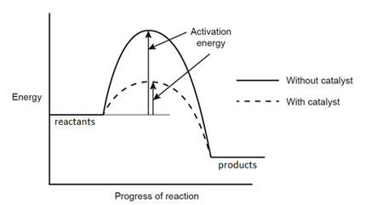

**Concentration:** This applies to solutions. As the concentration of reactants increases, the rate of reaction increases as the reactant particles are closer together so there are more collisions per unit time.

**Pressure:** This applies to gases. As pressure increases, the rate of reaction increases because the reactant particles are closer together, so there are more collisions per unit time.

**Surface area:** This applies to solids. As surface area increases, rate of reaction increases. If a large lump of solid is broken up into smaller pieces, its surface area increases, more particles are exposed to the other reactants so there are more collisions per unit time.

**Temperature:** As temperature increases, the rate of reaction increases. At higher temperatures, the reactant particles are moving more quickly as they have higher energy, and therefore collide more often per unit time. Additionally, more of the collisions have the minimum required energy, which also increases the rate of reaction.

1. Describe an experiment that you could carry out to follow the rate of reaction when calcium carbonate is added to an acid.

There are two main ways:

* Put the reaction vessel, e.g. a conical flask, on a mass balance while the reaction proceeds, and measure the mass over time.
* Connect the reaction vessel up to a gas syringe, and measure the volume of gas (carbon dioxide) produced over time.

1. The graphs below are from the results of the type of experiment carried out in Q4. Draw in the line of best fit on each, label the axes (the first graph can have 2 possible labels on its y-axis), and explain the shape of the different parts of the graphs. Explain how you could calculate the rate of a reaction at a certain point.

Graph 1

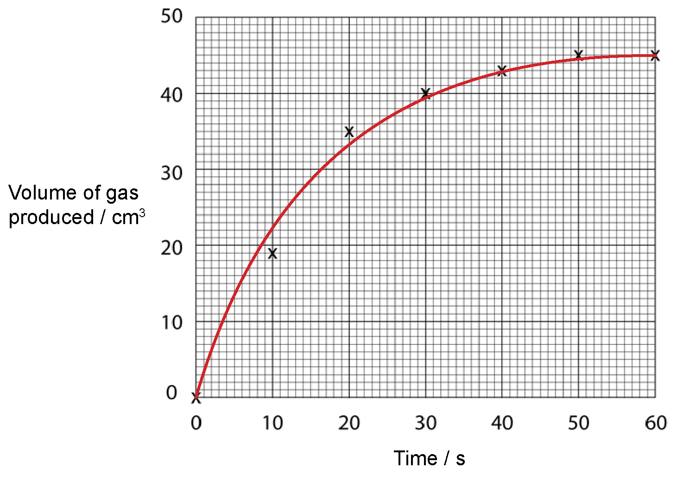

Graph 2

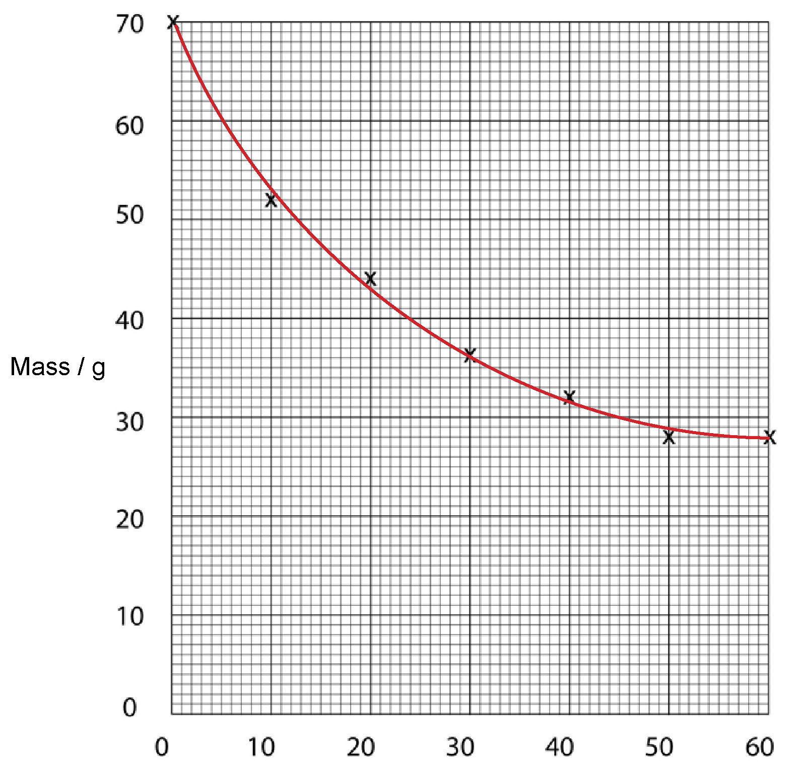

**Graph 1:** *x*-axis: Time/s (or Time/min); *y*-axis: Volume of gas produced/cm3, or loss in mass/g

**Graph 2:** *x*-axis: Time/s (or Time/min); *y*-axis: Mass/g

For both graphs, the line of best fit is steep at first, indicating a fast rate of reaction. The line gradually becomes less steep indicating that the rate is slowing, until eventually the line plateaus, indicating that the reaction has stopped.

To measure the rate at a particular point, you would need to take the gradient of the line at that point i.e.  OR .

**Task 3: Quiz Marks: 21 / Time: 20 minutes**

1. Explain what is meant by the term ***collision theory.*** **[1 mark]**

Reactions can only happen if the reactant particles collide with a minimum energy (the activation energy) ✓

1. Draw an energy profile diagram showing what happens to the activation energy when a catalyst is added to a reaction. **[3 marks]**



Mark 1: axes labelled correctly

Mark 2: 2 graphs with a difference in activation energy, labelled correctly

Mark 3: activation energy shown and labelled

1. a) State how the temperature of a reaction can affect the rate of a reaction. **[1 mark]**

As the temperature of the reaction increases, the rate of reaction also increases ✓.

b) Explain why the temperature of a reaction can affect the rate of a reaction. **[3 marks]**

At higher temperatures, the reactant particles move more quickly because they have more energy ✓*.* This causes the particles to collide more often ✓ , and more of the collisions have the minimum required energy for the reaction to occur ✓.

c) State how the concentration of reactants can affect the rate of a reaction. **[1 mark]**

As concentration of reactants increases, the rate of reaction will increase ✓.

d) Explain why the concentration of reactants can affect the rate of a reaction. **[2 marks]**

At higher concentrations, the reactant particles are closer together ✓ so there are more collisions per unit time ✓.

1. a) What would be the best way to follow the rate of the reaction when magnesium is   
    added to an acid? **[2 marks]**

Collect the gas over water in an inverted burette or measuring cylinder ✓ and record the volume of gas produced over time ✓

b) Draw a sketch graph of the data you might collect in the experiment you described in Q4(a). **[3 marks]**

Mark 1: correct shape of graph

Mark 2: plateaus to horizontal

Mark 3: correct labels on axes

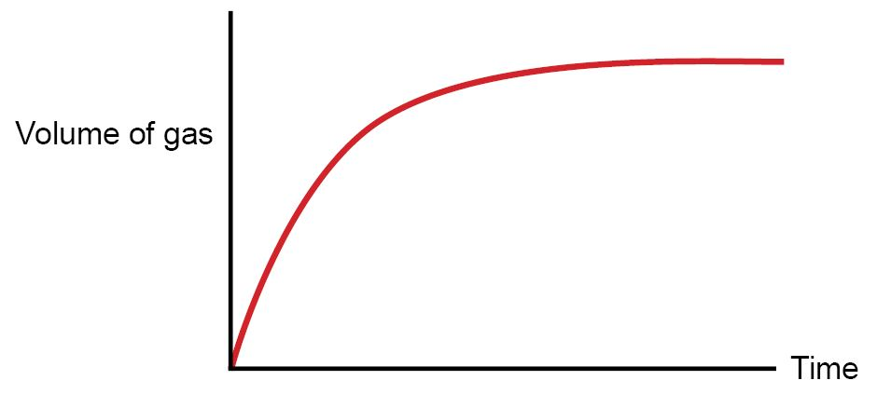

c) Describe and explain what is happening to the rate of reaction as the reaction proceeds

The rate of reaction is high at the start of the reaction, decreases as the reaction proceeds, and reaches zero when the reaction stops ✓. The reaction slows as the concentration of the acid decreases (OR amount of magnesium remaining decreases) ✓ hence there are fewer collisions per unit time ✓

**[3 marks]**

d) Describe how you could calculate the rate at a particular point on the graph. **[2 marks]**

Draw a tangent to the line of best fit at the particular point ✓ then calculate the gradient of the tangent which equals the rate of reaction ✓

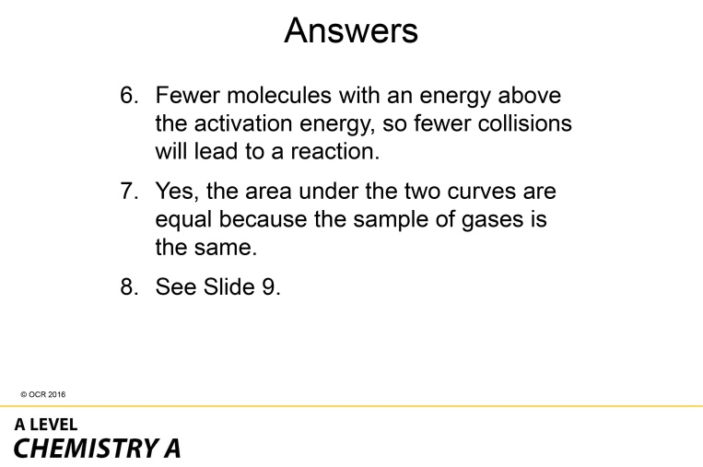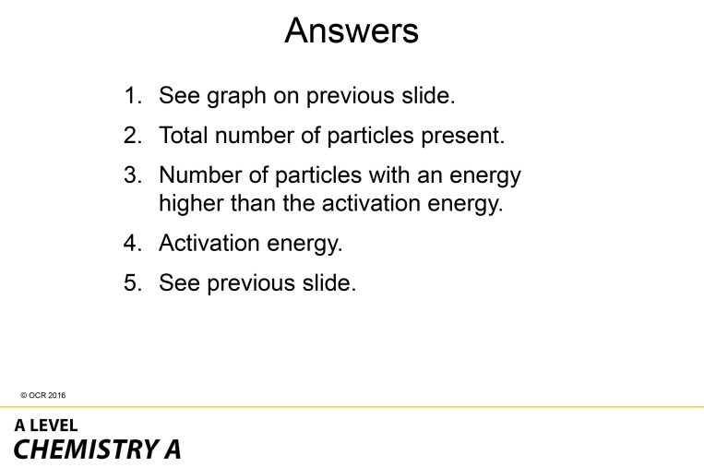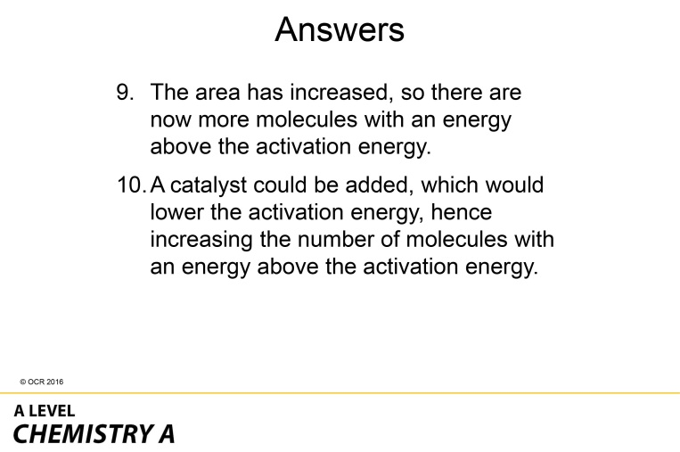

### Answers to Learner Activity 3: The Arrhenius Equation

1. State the Arrhenius Equation, and state the names and units of each variable/constant in the equation.

|  |
| --- |
| where *k* = rate constant, units depend on the overall order of reaction  *A* = pre-exponential (OR Arrhenius) factor, same units as *k*  *E*a = activation energy, in J mol −1  *R* = gas constant = 8.314 J K −1 mol −1  *T* = temperature, in K |

1. The Arrhenius equation can also be written in the linear form:



This form is useful as it has the same structure as the formula for a straight line.



State which parts of the first equation equate to which parts of the second equation:

|  |  |
| --- | --- |
| *y =* | ln *k* |
|  |  |
| *m =* | −*E*a/*R* |
|  |  |
| *x =* | 1/T |
|  |  |
| *c =* | ln *A* |
|  |  |

1. Determine the activation energy, in kJ mol-1, and the value of *A*, given the following data:

| ***T* / °C** | ***k* / mol** −**1 dm3 s** −**1** | ***T* / K** | **1/*T* / 1/K** | **ln *k*** |
| --- | --- | --- | --- | --- |
| 5 | 0.326 | 278 | 3.60 × 10–3 | -1.121 |
| 15 | 0.543 | 288 | 3.47 × 10–3 | -0.611 |
| 25 | 1.06 | 298 | 3.36 × 10–3 | 0.060 |
| 35 | 1.64 | 308 | 3.25 × 10–3 | 0.500 |
| 45 | 2.09 | 318 | 3.14 × 10–3 | 0.740 |

|  |
| --- |
| Activation of energy  Taking two points on the line, (3.18×10–3, 0.70) and (3.46×10-3, –0.50):  *m* = = –4286 =  *E*a = – –4286 × 8.314 = 35634 = 36 kJ mol–1 (2 s.f.)  ln *A = c = y – mx =* –0.50 – –4286 × 3.46×10–3 = 14.330  *A* = eln *A* = e14.330 = 1.7 × 106 mol-1 dm3 s–1 (2 s.f.) |

1. Determine the activation energy, in kJ mol-1, and the value of *A*, given the following data:

| ***T* / °C** | ***k* / mol** −**1 dm3 s** −**1** | ***T* / K** | **1/*T* / 1/K** | **ln *k*** |
| --- | --- | --- | --- | --- |
| 50 | 3.35 × 10–4 | 323 | 3.10 | –8.001 |
| 78 | 1.66 × 10–3 | 351 | 2.85 | –6.401 |
| 111 | 4.08 × 10–2 | 384 | 2.60 | –3.199 |
| 203 | 8.19 × 10–1 | 476 | 2.10 | –0.200 |
| 298 | 7.39 | 571 | 1.75 | –2.000 |

|  |
| --- |
| Activation of energy  Taking two points on the line, (1.90 ×10–3, 1.20) and (2.70×10-3, –4.80):  *m* = = –7500 =  *E*a = – –7500 × 8.314 = 62355 = 62 kJ mol–1 (2 s.f.)  ln *A = c = y – mx =* 1.20 – –7500 × 1.90×10–3 = 15.45  *A* = eln *A* = e15.45 = 5.1 × 106 mol-1 dm3 s–1 (2 s.f.) |