Activity 1 – Does salt make ice melt?

KS4 Science – KS5 Geology

Instructions and answers for teachers

This activity should be used in conjunction with the KS4 Science – KS5 Geology Transition Guide, which supports OCR A Level Geology.

Introduction
This activity introduces the concept of phase diagrams for a binary system (using mixture of H₂O and NaCl as an example). Does the salt melt the ice? How much salt do we need to clear the playground? Making ice cream with salt, what is ice cream (ice + syrup + butter fat)?

Task preparation
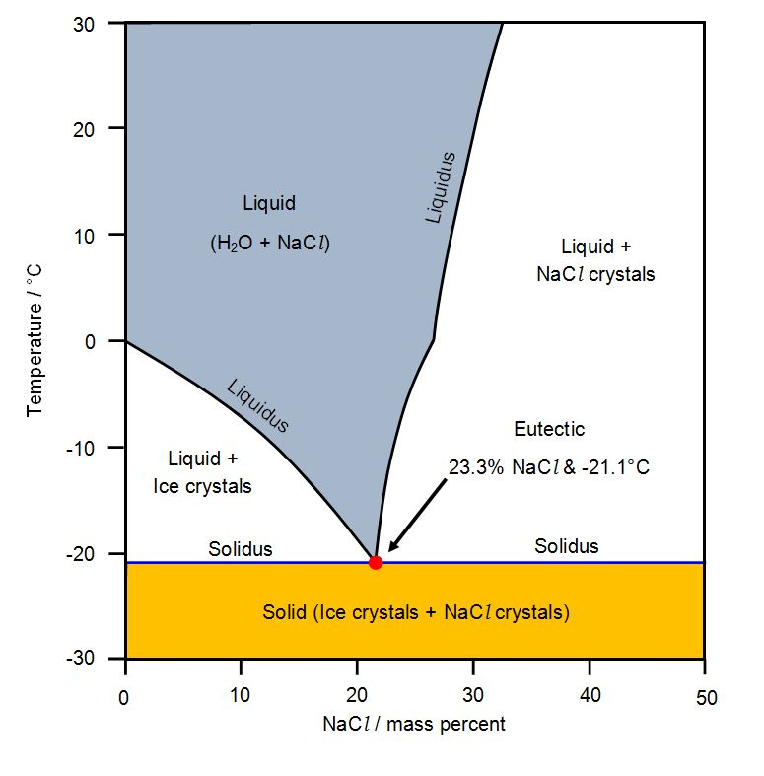
Learners will need access to a copy of the phase diagram which they can annotate and interpret.
It may be helpful to project an image of the phase diagram at the front of the classroom.

Learners will need to be familiarised with the terminology (i.e. liqidus, solidus and eutectic) and the path taken by seawater as it freezes (the brine cools until it intercepts the liquidus, it then moves down the liquidus and remains at the eutectic until all the salt has crystallised at which time it moves across and cools as a 3.5% mixture of H₂O and NaCl). On heating the mixture reverses the path, moving vertically on the phase diagram until it intercepts the solidus. It then sits at the eutectic continuing to melt as a brine with 23.3% NaCl until all the salt is in solution, and then follows the liquidus until a brine with 3.5% NaCl is achieved. An explanation of why this happens can be found on General Chemistry online: http://antoine.frostburg.edu/chem/senese/101/solutions/faq/why-salt-melts-ice.shtml

NaCl dissolves readily in water but does not fit easily inside the crystalline structure of ice which shifts the balance of the equilibrium between melting and freezing away from freezing of H₂O (as some of the water has been replaced by NaCl). A sugar solution will have the same effect; however it is cheaper to put salt on roads rather than sugar or the ethylene glycol found in screen wash.
Has the salt melted the ice or just depressed the melting point?
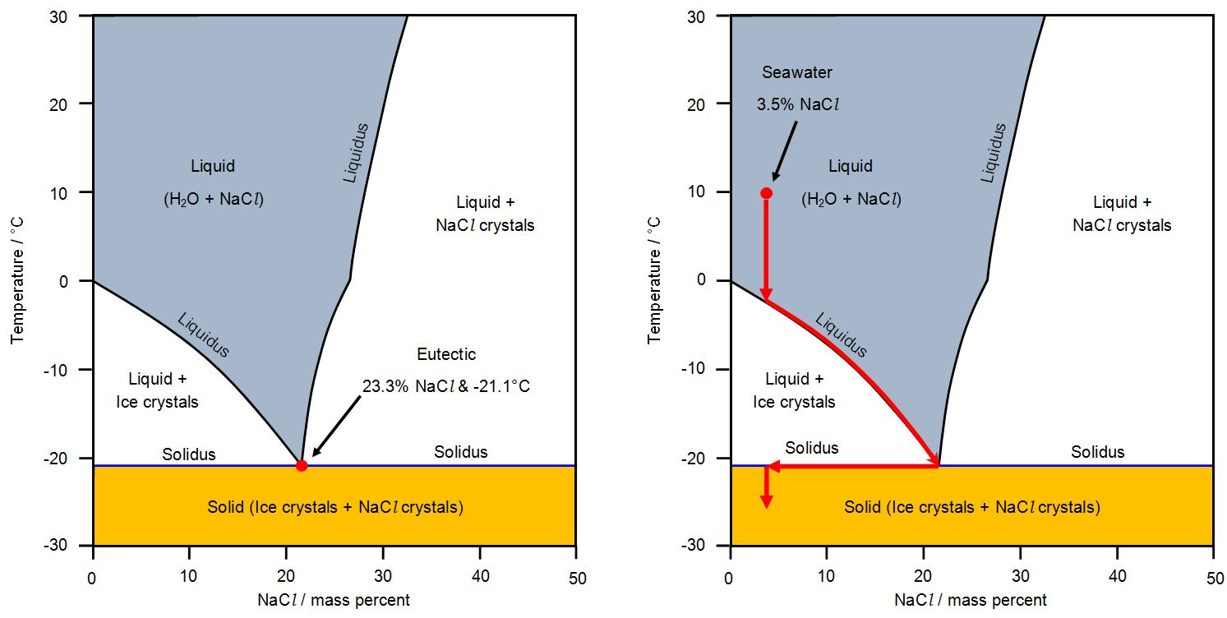
Learners could calculate how much salt would be needed to melt a 2mm layer of ice on a playground – 100m x 50m x 0.002m = 10m³ = 10000kg of H₂O, if the temperature were -5°C then to make an 8% solution would require 870kg of NaCl.
As an extension exercise learners can make ice cream by taking advantage of melting point depression. A plastic cup of milk with two tablespoons of sugar is placed in a resealable freezer bag, this is placed inside a larger sealable bag with six to eight cups of ice cubes to which half a cup of salt is added. Learners take turns squeezing the sealed bags and after 10 minutes they will have made ice cream in the inner bag.
Details and a demonstration video can be found at Science on the Brain http://marshallbrain.com/science/ice-cream.htm
Learners can consider what changes they observed and can use the temperature in the bags to interpret what the ice cream must be, by using the phase diagram. The actual composition of ice cream (ice + syrup + butter fat) is complicated as it is a ternary mixture and therefore the liquidus forms a three dimensional surface. Most igneous rocks are mixtures of two or three minerals and as they cool from a magma melt their behaviour can also be explained using phase diagrams.
OCR Resources: the small print
OCR’s resources are provided to support the delivery of OCR qualifications, but in no way constitute an endorsed teaching method that is required by the Board, and the decision to use them lies with the individual teacher. Whilst every effort is made to ensure the accuracy of the content, OCR cannot be held responsible for any errors or omissions within these resources.
© OCR 2016 - This resource may be freely copied and distributed, as long as the OCR logo and this message remain intact and OCR is acknowledged as the originator of this work.
OCR acknowledges the use of the following content: n/a
Please get in touch if you want to discuss the accessibility of resources we offer to support delivery of our qualifications: resources.feedback@ocr.org.uk
We’d like to know your view on the resources we produce. By clicking on ‘Like’ or ‘Dislike’ you can help us to ensure that our resources work for you. When the email template pops up please add additional comments if you wish and then just click ‘Send’. Thank you.
Whether you already offer OCR qualifications, are new to OCR, or are considering switching from your current provider/awarding organisation, you can request more information by completing the Expression of Interest form which can be found here: www.ocr.org.uk/expression-of-interest
Looking for a resource? There is now a quick and easy search tool to help find free resources for your qualification:
www.ocr.org.uk/i-want-to/find-resources/

Student Activity

Phase Diagram

