Lesson Element

Modelling covalent bonding

Instructions and answers for teachers

These instructions cover the learner activity section which can be found on page 6. This Lesson Element supports OCR GCSE (9-1) Gateway Science Chemistry A and Combined Science A, and Twenty First Century Science Chemistry B and Combined Science B.
When distributing the activity section to the learners, either as a printed copy or as a Word file, you will need to remove the teacher instructions section.

Mapping to specification level
J248: Gateway Chemistry A
C2.2d describe and compare the nature and arrangement of chemical bonds in …. ii. simple molecules…
C2.2f construct dot and cross diagrams for simple covalent and binary ionic substances
C2.3a recall that carbon can form four covalent bonds
WS1.1b use models to solve problems, make predictions and to develop scientific explanations and understanding of familiar and unfamiliar facts (including representational, spatial, descriptive, computational and mathematical models)
J250: Combined Science A
C2.2f describe and compare the nature and arrangement of chemical bonds in …. ii. simple molecules
C2.2h construct dot and cross diagrams for simple covalent and binary ionic substances
C2.3a recall that carbon can form four covalent bonds
WS1.1b use models to solve problems, make predictions and to develop scientific explanations and understanding of familiar and unfamiliar facts (including representational, spatial, descriptive, computational and mathematical models)

J258: Twenty First Century Chemistry B
C3.4.9 explain covalent bonding in terms of the sharing of electrons
C3.4.10 construct dot and cross diagrams for simple covalent structures
C4.3.2 recall that carbon can form four covalent bonds
IaS3.4 use a variety of models (including representational, spatial, descriptive, computational and mathematical models) to: solve problems; make predictions; develop scientific explanations and understanding; identify limitations of models.
J260: Twenty First Century Chemistry B
C3.4.9 explain covalent bonding in terms of the sharing of electrons
C3.4.10 construct dot and cross diagrams for simple covalent structures
C4.2.3 recall that carbon can form four covalent bonds
IaS3.4 use a variety of models (including representational, spatial, descriptive, computational and mathematical models) to: solve problems; make predictions; develop scientific explanations and understanding; identify limitations of models.

Introduction
In this task learners will make physical models of covalently bonded molecules. Prior to beginning this task learners should have some familiarity with the concepts involved, including Lewis dot and cross diagrams as well as Kekulé representations (where a bond is shown as a line between two atoms). They should know the definition of a covalent bond as a shared pair of electrons. The task can be differentiated to provide the right level of support and challenge for different groups of learners and also makes a useful revision exercise.

Teacher preparation
This activity is best run after learners have been introduced to Lewis dot and cross diagrams for showing covalent bonding. It provides useful consolidation of the concept in a very visual and hands on lesson. Learners can take the models home with them to provide a useful memory aid for revision or they can make a classroom display from them.
Materials needed
- Pipe cleaners/chenilles (available from craft stores / supermarkets / on–line)
- Beads (pony beads work best; available as above)
- Scissors
- Backing card
- Stapler
The trickiest part of the activity is getting the learners to represent the sharing of the electrons through threading two pipe cleaners (representing the outer shells of atoms) through the holes in the two beads representing the shared pair of electrons.
The models prepared provide a useful physical stimulus for discussion of the concepts underpinning covalent bonding including the usefulness and limitation of the octet rule and ideas about electrons existing in pairs (which can be counterintuitive to some learners since they carry negative charges and so would be expected to repel).
Dr Kristy Turner

Further details about the theory behind the use of this modelling activity can be found in Dr Kristy Turner’s paper in the Journal of Chemical Education (2016, 93(6), pp 1073-1080) : http://pubs.acs.org/doi/abs/10.1021/acs.jchemed.5b00981. Kristy is a school chemistry teacher at Bolton School, and a chemistry lecturer and researcher at Manchester University. She co-authored the Royal Society of Chemistry resource ‘Starters for Ten’ (http://www.rsc.org/learn-chemistry/resource/res00000954/starters-for-ten), and regularly blogs (https://dockristy.wordpress.com/) and tweets (https://twitter.com/doc_kristy) about various aspects of chemistry and education.

Task instructions and answers

Starter 1
Present learners with a visual of covalent molecules represented as both Lewis diagrams and Kekulé diagrams. Discuss with the class what the different representations show as well as what the definition of a covalent bond is. Lower achieving classes may need reminding that covalent bonding occurs between non-metal atoms.

Starter 2
Present learners with three examples of covalent molecules on the board. Get them to draw Lewis diagrams for these molecules – use of mini/personal whiteboards allows for rapid formative assessment across the whole class. The molecules should be differentiated to the appropriate level, with molecules such as CH4 and Cl2 being appropriate for classes with insecure prior knowledge and more challenging molecules such as O2 and CH2CH2 being introduced for more confident classes.

Task 1
Introduce the task and show the learners the materials to use. Assign each learner a molecule to model, differentiated to an appropriate level of challenge and support.
LOW | MEDIUM | HIGH
Single bonds only | Double bonds and electron deficient | Multiple bonds, hypervalent and resonance
H2  HCl / HBr / HI  H2O  NH3  CH4 / CH3Br  CCl4  CH3CH3  CH3OH | O2  CO2  HCOCl  CH2CH2  HCOOH  BF3 | H2SO4  SO2  SO3  H3PO4  N2

Give learners five minutes to plan their model by drawing the Kekulé and Lewis diagrams and then hand out the materials. Learners may need some help and guidance at first in making the bonds by putting two pipe cleaners through the holes in the beads. For clarity it is usually easier for learners to colour code their models using a different colour pipe cleaner/bead for each type of atom.

Task 2
Learners can prepare a backing card for their molecules giving details of the bonding and properties of the substance. An alternative for classes with good learning behaviour is for each learner to show their model to someone else in the class and get them to work out which molecule it is by counting electrons and thus identifying the elements present.

Extension task
For learners who are confident in their modelling, the extension activities provides some stimulus for discussion of atomic radius, the octet rule and dative covalent bonds.

Follow up questions
Show the class some of the models and get them to suggest which molecules they are. Ask them to explain their reasoning.
If learners find this hard then the following prompts may help:
How could we work out from this model what the molecule is?
How many bonds does it have?
How many electrons are there in the outer shell of this atom? What could its identity be?
Other useful questions to ask are:
Are all atoms the same size?
What are the limitations of our models?
How do these physical models relate to the Lewis model we may have to draw in exams?
OCR Resources: the small print
OCR’s resources are provided to support the teaching of OCR specifications, but in no way constitute an endorsed teaching method that is required by the Board, and the decision to use them lies with the individual teacher. Whilst every effort is made to ensure the accuracy of the content, OCR cannot be held responsible for any errors or omissions within these resources.
© OCR 2016 - This resource may be freely copied and distributed, as long as the OCR logo and this message remain intact and OCR is acknowledged as the originator of this work.
OCR acknowledges the use of the following content: n/a
Please get in touch if you want to discuss the accessibility of resources we offer to support delivery of our qualifications: resources.feedback@ocr.org.uk
We’d like to know your view on the resources we produce. By clicking on ‘Like’ or ‘Dislike’ you can help us to ensure that our resources work for you. When the email template pops up please add additional comments if you wish and then just click ‘Send’. Thank you.
If you do not currently offer this OCR qualification but would like to do so, please complete the Expression of Interest Form which can be found here: www.ocr.org.uk/expression-of-interest

Lesson Element

Modelling covalent bonding

Learner Activity

Introduction
This activity will help you to secure your understanding of what covalent bonds are and how they are represented.
Covalent bonding occurs between non-metal atoms e.g. hydrogen and oxygen. A covalent bond is defined as a ‘shared pair of electrons’. The outer shells of the atoms involved overlap and the shared electrons are now in both outer shells.
Covalent molecules can be represented in two ways in diagrams.
- With lines: in these diagrams the line represents two electrons in a bond.

- As a dot and cross (Lewis) diagram: in these diagrams each dot and cross pair represents two electrons in a bond. There may be other electrons on the atom that are not involved in bonding and these will be shown as either a pair of crosses or a pair of dots – these are known as ‘lone-pairs of electrons’.
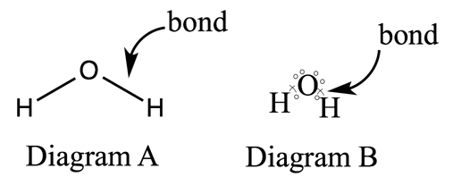
The diagrams above both show a molecule of water. In diagram A, the covalent bonds are shown as lines. Diagram B gives us a little more information about the electrons in the molecule. Oxygen has six electrons in its outer shell and these are represented with dots. Two of these are involved in bonding with the hydrogen atoms and the O–H bonds are shown as a dot and cross pair. The other four electrons are shown as two lone-pairs.

In this activity you will make a physical model of the covalent bonding in a molecule using pipe cleaners and beads. Below is an example of water modelled in this way.
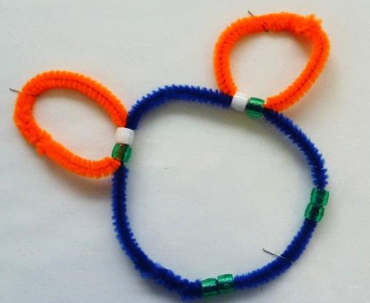

Task 1
To build your model –
- First draw two diagrams of your molecule, one with lines for the bonds and one Lewis dot and cross diagram. You’ll need to know how many electrons are in the outer shell of each atom – use a Periodic Table to help you if needed.
- Get your teacher to check your diagrams before you start modelling.
- Now plan your model. You’ll need a pipe cleaner for each of the atom outer shells (so as water has three atoms, three pipe cleaners are needed). You’ll need enough beads to represent all the outer–shell electrons in your molecule. Count how many electrons there are in your Lewis dot and cross diagram; don’t forget the lone pairs of electrons! Ideally your dots and crosses should be different coloured beads.
- Now collect your materials.
- Construct your model.
To make a bond, get the two beads making up the bond and thread the two pipe cleaners through the holes of both beads; the bead ‘electrons’ are now shared between the two pipe cleaner outer shells. Bend the pipe cleaners round into circles to make the outer shell shapes.
Construct all the bonds in the same way.
Go back and check for any lone pairs of electrons on the atoms and make sure you have placed beads n the correct pipe cleaner outer shells to represent them.
- You can now twist the pipe cleaner ends around each other to secure your outer shells.

Task 2
Get a piece of card and put your molecule in the middle of it. Secure it with a few staples.
Add information about your substance around the side. Especially useful is information about the properties of the substance as they can be linked back to the bonding. These could be physical properties like melting point or solubility, or chemical properties such as what other kinds of substances it can react with.

Extension task 1
Use the internet and/or textbooks to find some information about the sizes of atoms. Are all atoms the same size? How are atoms measured?
Look up the atomic radius measurements for the atoms used in your model.
How could your model be adapted to show the relative size of the atoms?

Extension task 2
The diagram below shows a representation of the bonding in a molecule of sulfuric acid. Each line is a shared pair of electrons. Make a model of this using beads and pipe cleaners. You will find it easiest to build this model ‘bond by bond’ and starting with the sulfur atom. Once you have built the model look at it closely. What is unusual about the bonding around sulfur?
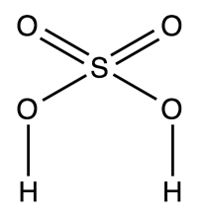

Extension task 3
Carbon monoxide molecules are made from one carbon atom triple bonded to an oxygen atom. Make a model of this using beads and pipe cleaners. What is unusual about the electrons involved in the triple bond?

