Topic Exploration Pack

Postmodernism

Teacher section including answers to tasks 2
Introduction 3
Section 1: What are sociological theories? 4
Task 1: Different perspectives 6
Section 2: A brief history of postmodernism 8
Task 2: Questions about key ideas of postmodern theory 9
Section 3: A postmodern view of culture 10
Task 3: Applying postmodern ideas in understanding culture 10
Section 4: A postmodern view of socialisation 11
Task 4: Applying postmodern ideas to the concept of socialisation 11
Task 5: Questions on key postmodernists 12
Section 5: A postmodern view of identity 14
Task 6: Applying postmodernism to the concept of identity 14
Section 6: Consolidation activity 15
Task 7: Key concepts 15

Student activity section 17
Task 1: Different perspectives 19
Task 2: Questions about key ideas of postmodern theory 22
Task 3: Applying postmodern ideas in understanding culture 23
Task 4: Applying postmodern ideas to the concept of socialisation 24
Task 5: Questions on key postmodernists 25
Task 6: Applying postmodernism to the concept of identity 27
Task 7: Key concepts 28

Instructions and answers for teachers

These instructions cover the student activity section which can be found on page 17. This Topic Exploration Pack supports OCR AS and A Level Sociology.
When distributing the activity section to students either as a printed copy or as a Word file you will need to remove the teacher instructions section.

Introduction
This Topic Exploration Pack introduces students to postmodern theory and allows them to apply their knowledge to a range of topics within Component 1. Whilst theory is not directly on the specification for Component 1 Section A, most teachers will want to introduce theory as a defining feature of sociology and a key theme of the specification in general is a focus on the application of theoretical perspectives. It is important therefore, that students are competent in understanding the context in which postmodern theories emerged as sociology and indeed society has evolved. The aim of this Topic Exploration Pack is to encourage students to feel confident in applying theories to any of the areas that they will study. This pack works well in conjunction with the other OCR packs that focus on sociological theory.
This pack begins by exploring the key differences between modern and postmodern theories, or different perspectives on a range of issues, or ways of explaining social change and the world around them in both the modern and the postmodern era. Students need to be aware that the structure versus action dichotomy has been a central tension within the discipline and that postmodern theory offers a completely new way of understanding society. It is possible to introduce theories using this postmodernism pack, although functionalism is the usual starting point for most teachers of social theory. It would also make great sense to explore the theories initially as they emerged chronologically.
This Topic Exploration Pack is excellent in demonstrating the range of ideas within one particular theoretical perspective and begins from the view that sociology is not a united perspective. The pack describes the way in which postmodernist thought built on and responds to traditional tensions within the discipline. Unlike some other theories, postmodernism goes beyond sociology into wider culture and reflects many of the changes that are occurring within a wider global context.
Finally, some consideration needs to be given to the fact that the theories explored within the A Level mainly represent western social theories which are not necessarily easily applicable to phenomena beyond Western society. Western forms of social theory for example, explore notions of what it means to be part of society in the West. Postmodernism is different in the sense that it refers to more global scale themes and ideas. Given that the OCR specification has content that looks globally this issue is worth picking up.
Students should be encouraged to consider their own personal reaction to each theory and decide which they identify most readily with, but also be aware that their task is to discuss the views in a balanced way, considering the contribution that each theory makes as well as the problems with each. In order to teach social theory effectively, students need some basic knowledge of the political spectrum and understand it is another dimension of the debate. This becomes important throughout the course when considering the relationship between sociology and social policy.
The pack finishes with a series of application activities, focusing on postmodernism in particular, in the context of the topics in Component 1, in order to consolidate knowledge and develop higher level skills. These activities also encourage students to consider the relevance of social theories to a range of contemporary issues that are relevant to the course.
Aims and objectives
- To understand what perspectives and different types of social theories are
- To understand the difference between modern and postmodern theories
- To understand the context in which postmodernism developed
- To be able to apply postmodernism to a range of topics within Component 1: socialisation, culture and identity.
Formative assessment: A range of tasks throughout the document to check knowledge and understanding.
Summative assessment: Examine the usefulness of postmodernism in understanding the concepts of socialisation, culture and identity within contemporary society

Section 1: What are sociological theories?
Sociology emerged as part of an attempt to explain the rapid social changes that were taking place in society in the eighteen and nineteen hundreds. There were several key changes which are relevant for understanding theoretical developments:
- Urbanisation (the movement of people from the country into the city).
- Social Mobility (the movement of people’s socioeconomic position).
- Increasing developments in transport and technology.
These changes were part of the industrial revolution, which is where the economy changed from being based on farming to becoming based on machinery. This process is sometimes also referred to as ‘modernisation’.
During this period a series of sociological theories (sets of ideas) emerged as described below. Although they overlapped somewhat we can broadly understand their development in this order:

Modern theories | Functionalism, Marxism, Feminism
Late modern theories | Interpretivism
Postmodern theory | Postmodernism

In order to understand postmodernism (literally after modernity) it is important to understand what modernity and modern theories were like.
Modern society | Postmodern society
1900-1980 (approximately) | 1980’s onwards
Identity fixed | Complex identities
Family structure stable | Family diversity
Traditional roles in the family | Increasingly negotiated roles within the family
Limited access to technology | Huge advances in IT, including personal computers, smartphones
Media less developed | Huge array of media available in a range of forms
Science and religion seen as important, containing the answers to all of life’s questions | Secularisation (a decline in traditional religious beliefs) while at the same time less faith in science and a range of new forms of religion and ideas
Social change | Rapid global social change
Work locally, factory/office/professional | Work becomes reliant on IT skills and involves working all over the world, virtually or face to face, a huge rise in the service industry and multinational companies
Nationality important and stable | National identity has become less important for some and very important for others as global ideas spread around the world and cultural ideas are shared
Greater expectation to conform to shared social expectations | Greater individualisation, more likely to act in your own interests rather than do what you feel you are expected to do

Task 1: Different perspectives (with answers)
- In your own words explain the difference between modern and postmodern society:

- Here are some images. Using what you have learnt above, say whether the image represents modernity or postmodernity and explain why.

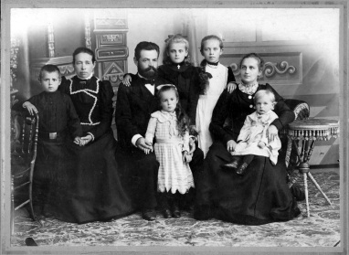 |  | Modern – traditional families were the norm.
 |  | Postmodern society has resulted in new ways of working using IT.
 |  | Modern – people were more religious in a conventional sense.
 |  | Postmodern – greater family diversity and same sex couples are just one such example.
 |  | Postmodern society leads to negotiated and possibly non-traditional gender roles.
 |  | Postmodern society - emerging forms of new social media.
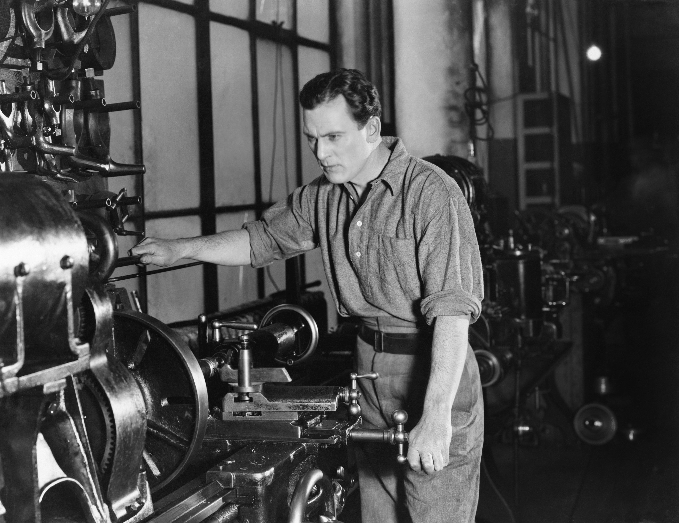 |  | Modern – traditional working in a factory.

Section 2: A brief history of postmodernism
Some sociologists argue that recent social changes have meant that previous modern theoretical explanations of the social world are no longer relevant – we have entered a new world, a postmodern world. Therefore the modern types of theory are no longer necessary. Therefore postmodernism cannot be labelled as structural/agency, micro/macro, conflict/consensus, since all of these labels are considered to be linked to ideas of modernity.
Postmodernists argue that a new theory is necessary to understand this rapidly different new world that we live in today, given that huge social changes are continually taking place. These changes have important consequences for sociology according to postmodernists:
- Sociology has previously been concerned with making generalisations and employing key variables such as gender and class. While these are still important, there are many other factors to consider such as ethnicity.
- As the world is changing so rapidly, people feel increasingly uncertain about the modern ‘grand narratives’, in other words, large scale theories (like functionalism and Marxism) which tend to overly simplify social life.
- Postmodernists argue that sociology is only one of many sets of ideas and that we can’t establish which is better than others. Therefore we cannot use sociology to change society.

Evaluation of postmodern theories
- Giddens argues that although there have been a lot of changes, we may not have actually reached a postmodern society yet but a late modern one instead.
- Giddens argues that reflexivity is important. This means that we should reflect and question knowledge rather than simply accept it. This reflection leads us to try and improve the world which is a feature of modernity.
- Beck argues that postmodern society brings greater choice but at the same time is a ‘risk society’ with high levels of uncertainty or anxiety such as family instability, environmental issues such as global warming.
- Postmodernists have been criticised for ignoring inequalities that exist in society, which may mean that people have less choice than postmodernists suggest.

Task 2: Questions about key ideas of postmodern theory (with answers)

- Why can labels not be applied to postmodernist theories?
Because the labels are linked to modernity which postmodernism claims to have moved beyond/are no longer relevant to society today.

- Which key variables did sociologists used to focus on?
Class and gender.

- What is a ‘grand narrative’, give an example
A big theory or set of answers which could explain change in society.

- What is reflexivity?
The idea that we should reflect on, question and consider forms of knowledge and not see one as necessarily better than another.

- What is risk society?
Beck’s idea that postmodernism brings greater choice but also increased risk.

Section 3: A postmodern view of culture

Task 3: Applying postmodern ideas in understanding culture (with answers)
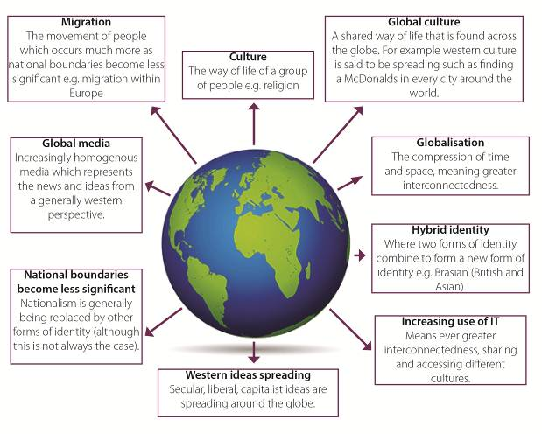
Postmodernists argue that globalisation has led to significant changes in culture. These are described below. For each box define the concept and add examples or develop each point.

Section 4: A postmodern view of socialisation

Task 4: Applying postmodern ideas to the concept of socialisation (with answers)
Postmodernists explore the ways in which traditional processes such as socialisation are changing as the institutions in society reflect a wider range of views and cultures.
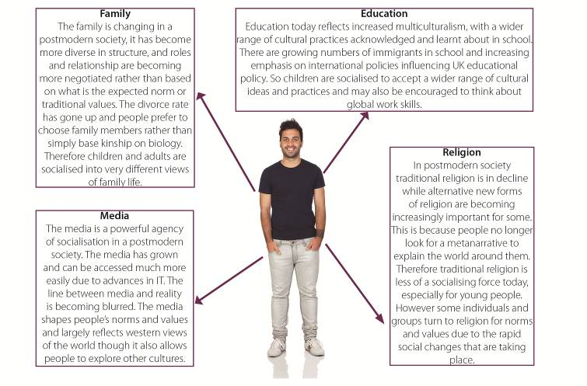
Using the diagram below consider how the role of each agency of socialisation has changed as society has become postmodern and make notes on how this may affect the socialisation process; education has been done for you already. You may wish to refer to earlier notes on the characteristics of modernity to help you here.

Task 5: Questions on key postmodernists (with answers)

Stacey (1996) Choice in the postmodern family
Carrying out ethnographic research in Silicon Valley California, this is long term research where a researcher lives among the people that they are studying. Judith Stacey, a postmodernist feminist explores the changes in society and family life which are a product of living in a postmodern era.
Stacey argues that when both men and women work it gives women much greater ability to negotiate the roles that are played in the family. Stacey sees this change as a very positive one, especially for women who were previously expected to conform to stereotypical traditional caring and housekeeping roles.
Stacey claims that women are able to use their newly found ability to make choices. They can decide if a relationship is oppressive, or whether they can expect more support, or else leave and perhaps become a self-supporting single mother. The significant finding here was that people are becoming more individualistic in their family lives, putting their own needs first.
- What is ethnographic research?
Detailed long term research where the researcher often lives among the people who they are researching.

- What kind of perspective does Stacey have?
Postmodernist feminist.

- Why might postmodernity benefit women in particular in terms of family life?
It gives them greater choice about roles and relationships, so if they are unhappy they have greater ability to leave and re-start/live alone.

Beck and Beck Gernsheim (1992, 1995) Risk Society and Individualisation
Beck argues that one feature of late modern and postmodern society is risk. This means that now that there are so many choices available about family life and relationships, people are less likely to live in long term stable relationships if they are unhappy as the expectations are less important now. Instead people focus on their individual needs and wishes, individualisation.
Beck and Beck Gernsheim argue that today the ‘norms’ of family life are being replaced with a huge array of alternative relationship structures. For example; homosexual relationships, relationships where people do not live together, raising children together even if you a couple who are separated or divorced (co-parenting).

Beck and Gernshiem however are not as optimistic as Stacey about increased choice, instead they express concern about the breakdown of quality family life which they argue requires a degree of stability and commitment to benefit family members, for example, to raise children. They suggest there is a danger that people become overly focussed on their own needs and fulfilment at the expense of others.
- What is individualisation?
The process of becoming more focussed on individual needs and wishes rather than conforming to societal expectations.

- Why has individualism become central to family life?
Postmodern society allows greater choice and societal pressure to conform has become weaker.

- Can you think of any other alternative family arrangements that might exist in postmodern society apart from the ones suggested above?
Stepfamilies, reconstituted families, single person households.

- How are Beck and Beck Gernsheim’s views different to Stacey’s views?
Beck is less optimistic about the changes, arguing that increased individualism could lead to instability and overly self-absorbed attitudes.

Section 5: A postmodern view of identity

Task 6: Applying postmodernism to the concept of identity (with answers)
Postmodernists believe that in contemporary global society people’s identities are chosen rather than ascribed (given). In the past identity tended to be more simple and fixed, being defined by class, gender and age in a more straightforward way.
Fill the gaps: Why the changes in identity?
internet
- Due to greater access to technological advances such as the people are coming into greater contact with other cultures meaning that they are exposed to a greater range of ways to express their identity.
value consensus
- There is no longer an agreed or shared set of ideas about what it means to be ‘male’ or ‘female’ for example, and this means that people can create their own self-selected identities, showing how has become central.
migrate
individualism
- As people as a result of globalisation, with greater opportunities for travel, for work or for other reasons, people may choose to retain or change certain parts of their identity to help them cope with the transition.
metanarratives
- A general rejection of (grand theories) such as science and traditional religion leading people to look for other ways of expressing their identity.
Nationality
- has become less important in defining people’s identity, as globalisation has progressed and national boundaries become less relevant. People are able to travel and use the internet to understand other cultures.
social change
- In some cases, the rapid rate of has led to some needing to find new ways to express their identity even more clearly and strongly, such as by joining new religious movements.
social stigma
- Less (attaching a negative label to a behaviour) about alternative forms of relationships, gender and sexuality as (a decline in religious belief) occurs, leading to a whole range of relationships and lifestyle choices.
Hybrid identity
secularisation
- is occurring whereby people select different parts of their identity and combine these to create new forms of identity.
Hybrid identity social stigma secularisation
migrate metanarratives internet individualism
value consensus Nationality social change

Section 6: Consolidation activity

Task 7: Key concepts (with answers)
Key Term/ Concept | Definition
Postmodernity | An age characterised by uncertainty, the pace of change quickens, the spread of a global culture and economy which breaks down boundaries of time and space. Social relationships become fluid.
Modern theories | Term used to refer to the structural theories of Marxism and functionalism.
Individualism | A decline in accepting socially approved roles and an increasing stress on personal choice.
Reflexivity | The ability to consider different forms of knowledge and be aware that none are more correct than the others.
Hybridity | Taking elements from a range of different things to create something individual.
Globalisation | Process where the world becomes smaller due to the compression of time and place via increased communication and technology. Breaking down of national identities.
Fragmentation | Knowledge is broken up. The breaking down of major structures such as Churches leaving a wide range of choices – lots of different ‘bits’ or fragments.
Media saturation | Idea that we live in a world that is increasingly perceived and experienced via the media.
Modernity | Period characterised economically by capitalism, politically by the democratic nation state and culturally by reason not tradition.
Metanarratives | Grand theories or explanations of the world associated with the modern era.
Key terms and concepts: Modernity Postmodernity Globalisation Metanarratives Individualism Hybridity Media saturation Reflexivity Fragmentation Modern theories

References
Beck, U. (1992) Risk Society: Towards a New Modernity. London: Sage.

Beck, U & Beck-Gernsheim, E. (1995). The Normal Chaos of Love, Cambridge: Polity Press.
Giddens, A (1991) Modernity and Self-Identity: Self and Society in the Late, Cambridge: Polity Press

Stacey, J (1996) In the Name of the Family: Rethinking Family Values in the Postmodern Age, Beacon Press, ISBN: 978-0807004326

We’d like to know your view on the resources we produce. By clicking on ‘Like’ or ‘Dislike’ you can help us to ensure that our resources work for you. When the email template pops up please add additional comments if you wish and then just click ‘Send’. Thank you.
If you do not currently offer this OCR qualification but would like to do so, please complete the Expression of Interest Form which can be found here: www.ocr.org.uk/expression-of-interest
OCR Resources: the small print
OCR’s resources are provided to support the teaching of OCR specifications, but in no way constitute an endorsed teaching method that is required by the Board, and the decision to use them lies with the individual teacher. Whilst every effort is made to ensure the accuracy of the content, OCR cannot be held responsible for any errors or omissions within these resources.
© OCR 2016 - This resource may be freely copied and distributed, as long as the OCR logo and this message remain intact and OCR is acknowledged as the originator of this work.
OCR acknowledges the use of the following content: iStock.com/Maria Pavlova, Shutterstock.com/MonkeyBusinessImages, Shutterstock.com/Lisa_F_Young, Shutterstock.com/CREATISISTA, Shutterstock.com/tanuha2001, Shutterstock.com/Everett Collection, Shutterstock.com/Gelpi, Shutterstock.com/DaxiaoProductions
Please get in touch if you want to discuss the accessibility of resources we offer to support delivery of our qualifications: resources.feedback@ocr.org.uk

Topic Exploration Pack

Postmodernism

Student activity section

Task 1: Different perspectives worksheet
Sociology emerged as part of an attempt to explain the rapid social changes that were taking place in society in the eighteen and nineteen hundreds. There were several key changes which are relevant for understanding theoretical developments:
- Urbanisation (the movement of people from the country into the city).
- Social Mobility (the movement of people’s socioeconomic position).
- Increasing developments in transport and technology.
These changes were part of the industrial revolution, which is where the economy changed from being based on farming to becoming based on machinery. This process is sometimes also referred to as ‘modernisation’.
During this period a series of sociological theories (sets of ideas) emerged as described below. Although they overlapped somewhat we can broadly understand their development in this order:

Modern theories | Functionalism, Marxism, Feminism
Late modern theories | Interpretivism
Postmodern theory | Postmodernism

In order to understand postmodernism (literally after modernity) it is important to understand what modernity and modern theories were like.
Modern society | Postmodern society
1900-1980 (approximately) | 1980’s onwards
Identity fixed | Complex identities
Family structure stable | Family diversity
Traditional roles in the family | Increasingly negotiated roles within the family
Limited access to technology | Huge advances in IT, including personal computers, smartphones
Media less developed | Huge array of media available in a range of forms
Science and religion seen as important, containing the answers to all of life’s questions | Secularisation (a decline in traditional religious beliefs) while at the same time less faith in science and a range of new forms of religion and ideas
Social change | Rapid global social change
Work locally, factory/office/professional | Work becomes reliant on IT skills and involves working all over the world, virtually or face to face, a huge rise in the service industry and multinational companies
Nationality important and stable | National identity has become less important for some and very important for others as global ideas spread around the world and cultural ideas are shared
Greater expectation to conform to shared social expectations | Greater individualisation, more likely to act in your own interests rather than do what you feel you are expected to do

Task 1: Different perspectives
- In your own words explain the difference between modern and postmodern society:

- Here are some images. Using what you have learnt above, say whether the image represents modernity or postmodernity and explain why.

Section 2: A brief history of postmodernism
Some sociologists argue that recent social changes have meant that previous modern theoretical explanations of the social world are no longer relevant – we have entered a new world, a postmodern world. Therefore the modern types of theory are no longer necessary. Therefore postmodernism cannot be labelled as structural/agency, micro/macro, conflict/consensus, since all of these labels are considered to be linked to ideas of modernity.
Postmodernists argue that a new theory is necessary to understand this rapidly different new world that we live in today, given that huge social changes are continually taking place. These changes have important consequences for sociology according to postmodernists:
- Sociology has previously been concerned with making generalisations and employing key variables such as gender and class. While these are still important, there are many other factors to consider such as ethnicity.
- As the world is changing so rapidly, people feel increasingly uncertain about the modern ‘grand narratives’ in other words, large scale theories (like Functionalism and Marxism) which tend to overly simplify social life.
- Postmodernists argue that sociology is only one of many sets of ideas and that we can’t establish which is better than others. Therefore we cannot use sociology to change society.

Evaluation of postmodern theories
- Giddens argues that although there have been a lot of changes, we may not have actually reached a postmodern society yet but a late modern one instead.
- Giddens argues that reflexivity is important. This means that we should reflect and question knowledge rather than simply accept it. This reflection leads us to try and improve the world which is a feature of modernity.
- Beck argues that postmodern society brings greater choice but at the same time is a ‘risk society’ with high levels of uncertainty or anxiety such as family instability, environmental issues such as global warming.
- Postmodernists have been criticised for ignoring inequalities that exist in society, which may mean that people have less choice than postmodernists suggest.

Task 2: Questions about key ideas of postmodern theory
- Why can labels not be applied to postmodernist theories?

- Which key variables did sociologists used to focus on?

- What is a ‘grand narrative’, give an example

- What is reflexivity?

- What is risk society?

Section 3: A postmodern view of culture

Task 3: Applying postmodern ideas in understanding culture
Postmodernists argue that globalisation has led to significant changes in culture. These are described below. For each box define the concept and add examples or develop each point.
Culture

Global culture

Migration

Globalisation

Global media

Hybrid identities

Increasing use of IT

National boundaries become less significant

Western ideas spreading

Section 4: A postmodern view of socialisation

Task 4: Applying postmodern ideas to the concept of socialisation
Postmodernists explore the ways in which traditional processes such as socialisation are changing as the institutions in society reflect a wider range of views and cultures.
Using the diagram below consider how the role of each agency of socialisation has changed as society has become postmodern and make notes on how this may affect the socialisation process; education has been done for you already. You may wish to refer to earlier notes on the characteristics of modernity to help you here.
Education
Education today reflects increased multiculturalism, with a wider range of cultural practices acknowledged and learnt about in school. There are growing numbers of immigrants in school and increasing emphasis on international policies influencing UK educational policy. So children are socialised to accept a wider range of cultural ideas and practices and may also be encouraged to think about global work skills.

Task 5: Questions on key postmodernists

Stacey (1996) Choice in the postmodern family
Carrying out ethnographic research in Silicon Valley California, this is long term research where a researcher lives among the people that they are studying. Judith Stacey, a postmodernist feminist explores the changes in society and family life which are a product of living in a postmodern era.
Stacey argues that when both men and women work it gives women much greater ability to negotiate the roles that are played in the family. Stacey sees this change as a very positive one, especially for women who were previously expected to conform to stereotypical traditional caring and housekeeping roles.
Stacey claims that women are able to use their newly found ability to make choices. They can decide if a relationship is oppressive, or whether they can expect more support, or else leave and perhaps become a self-supporting single mother. The significant finding here was that people are becoming more individualistic in their family lives, putting their own needs first.
- What is ethnographic research?

- What kind of perspective does Stacey have?

- Why might postmodernity benefit women in particular in terms of family life?

Beck and Beck Gernsheim (1992, 1995) Risk Society and Individualisation
Beck argues that one feature of late modern and postmodern society is risk. This means that now that there are so many choices available about family life and relationships, people are less likely to live in long term stable relationships if they are unhappy as the expectations are less important now. Instead people focus on their individual needs and wishes, individualisation.
Beck and Beck Gernsheim argue that today the ‘norms’ of family life are being replaced with a huge array of alternative relationship structures. For example; homosexual relationships, relationships where people do not live together, raising children together even if you a couple who are separated or divorced (co-parenting).
Beck and Gernshiem however are not as optimistic as Stacey about increased choice, instead they express concern about the breakdown of quality family life which they argue requires a degree of stability and commitment to benefit family members, for example, to raise children. They suggest there is a danger that people become overly focussed on their own needs and fulfilment at the expense of others.
- What is individualisation?

- Why has individualism become central to family life?

- Can you think of any other alternative family arrangements that might exist in postmodern society apart from the ones suggested above?

- How are Beck and Beck Gernsheim’s views different to Stacey’s views?

Section 5: A postmodern view of identity

Task 6: Applying postmodernism to the concept of identity
Postmodernists believe that in contemporary global society people’s identities are chosen rather than ascribed (given). In the past identity tended to be more simple and fixed, being defined by class, gender and age in a more straightforward way.
Fill the gaps: Why the changes in identity?

Due to greater access to technological advances such as the people are coming into greater contact with other cultures meaning that they are exposed to a greater range of ways to express their identity.

There is no longer an agreed or shared set of ideas about what it means to be ‘male’ or ‘female’ for example, and this means that people can create their own self-selected identities, showing how has become central.

As people as a result of globalisation, with greater opportunities for travel, for work or for other reasons, people may choose to retain or change certain parts of their identity to help them cope with the transition.

A general rejection of (grand theories) such as science and traditional religion leading people to look for other ways of expressing their identity.

has become less important in defining people’s identity, as globalisation has progressed and national boundaries become less relevant. People are able to travel and use the internet to understand other cultures.

In some cases, the rapid rate of has led to some needing to find new ways to express their identity even more clearly and strongly, such as by joining new religious movements.

Less (attaching a negative label to a behaviour) about alternative forms of relationships, gender and sexuality as (a decline in religious belief) occurs, leading to a whole range of relationships and lifestyle choices.

is occurring whereby people select different parts of their identity and combine these to create new forms of identity.
Hybrid identity social stigma secularisation
migrate metanarratives internet individualism
value consensus Nationality social change

Section 6: Consolidation activity

Task 7: Key concepts
Key Term/Concept | Definition
 | An age characterised by uncertainty, the pace of change quickens, the spread of a global culture and economy which breaks down boundaries of time and space. Social relationships become fluid.
 | Term used to refer to the structural theories of Marxism and functionalism.
 | A decline in accepting socially approved roles and an increasing stress on personal choice.
 | The ability to consider different forms of knowledge and be aware that none are more correct than the others.
 | Taking elements from a range of different things to create something individual.
 | Process where the world becomes smaller due to the compression of time and place via increased communication and technology. Breaking down of national identities.
 | Knowledge is broken up. The breaking down of major structures such as Churches leaving a wide range of choices – lots of different ‘bits’ or fragments.
 | Idea that we live in a world that is increasingly perceived and experienced via the media.
 | Period characterised economically by capitalism, politically by the democratic nation state and culturally by reason not tradition.
 | Grand theories or explanations of the world associated with the modern era.
Key terms and concepts: Modernity Postmodernity Globalisation Metanarratives Individualisation Hybridity Media saturation Reflexivity Fragmentation Modern theories

References
Beck, U. (1992) Risk Society: Towards a New Modernity. London: Sage.

Beck, U & Beck-Gernsheim, E. (1995). The Normal Chaos of Love, Cambridge: Polity Press.
Giddens, A (1991) Modernity and Self-Identity: Self and Society in the Late, Cambridge: Polity Press

Stacey, J (1996) In the Name of the Family: Rethinking Family Values in the Postmodern Age, Beacon Press, ISBN: 978-0807004326

