Lesson Element

Marriage and the wedding ceremony

Learning outcome
This lesson element relates to ‘Beliefs and teachings and practices – The role of the church in the local community and living practices’ and in particular:
- Common and divergent attitudes of different Christian denominations towards and practices connected with the celebration of marriage.
Learners will need to:
- Know what happens in a wedding ceremony
- Understand why marriage is important for Christians
- Be able to discuss sensitively the role of weddings and marriage.

The following teacher instructions cover the learner activity section which can be found on page 8. This Lesson Element supports OCR GCSE (9‒1) Religious Studies.
When distributing the activity section to the learners either as a printed copy or as a Word file, you will need to remove the teacher instructions section.

Introduction
Christian marriage is not only an important rite of passage but also the building block for family and is therefore a key pillar of their beliefs. The church ceremony is a fundamental part of a Christian wedding. Here they are surrounded by loving friends and family who will witness their wedding and support them in their marriage.
There are many different elements to Christian weddings. These elements have religious and spiritual significance and also bring joy to the couple and observers. Some elements include: the singing of hymns, the saying of prayers, the exchange of rings, the declaration and the saying of specific vows such as ‘to love and to cherish, in sickness and in health’. The Church provides a place to conduct weddings.
Prior Learning:
Rites of Passage and their significance, prayer.

Teacher preparation
Things to consider:
Many learners may have experienced a wedding ceremony before. It may be helpful to spend a little time at the beginning of the lesson allowing learners to discuss their experiences.
Materials:
PowerPoint for lesson element and learner activity section (page 7 onwards).

Activities
Five activities are suggested below, with the associated worksheets in the learner activity section on page 7.

Activity 1: Starter activity
It is valuable to encourage learners to consider not only what happens at a wedding but to consider why we have them in the first place. Learners read through the different reasons for marriage on the learner activity sheet (these can also be found on the corresponding PowerPoint for this lesson element). There are different ways of conducting this activity. Learners could use a key, and colour the reasons they agree with in one colour, and the reasons they considered inadequate in another colour. Alternatively learners could discuss all the views in pairs and decide which they most and least agree with; or, you could print out the views onto larger pieces of paper, put them in different areas of the room, ask learners to move to the reason for marriage they most agree with, ask them to explain their answers.

Activity 2: Thinking further
Whilst watching the following video, learners are to further consider why marriage is important to Christians, they may wish to make notes whilst watching. Learners can also make notes about what actually happens in a wedding ceremony.

https://www.truetube.co.uk/film/christian-marriage

Activity 3: Development task
This activity is designed to teach learners about what happens during the wedding service and what the spiritual/religious significance of these actions are. There are a variety of ways of conducting this part of the lesson element. You could run it as a standard card sort: Hand out card sort to learners who must connect the element of the wedding to its meaning or connection to religious/spiritual belief. Alternatively, if you have a small enough group, you could give one card to each learner, ask them to find their partner, then ask learners to order themselves into the order they think a wedding ceremony happens (along with the corresponding meaning/significance).

Correct answers for the card sort are provided on the next page.

Answers
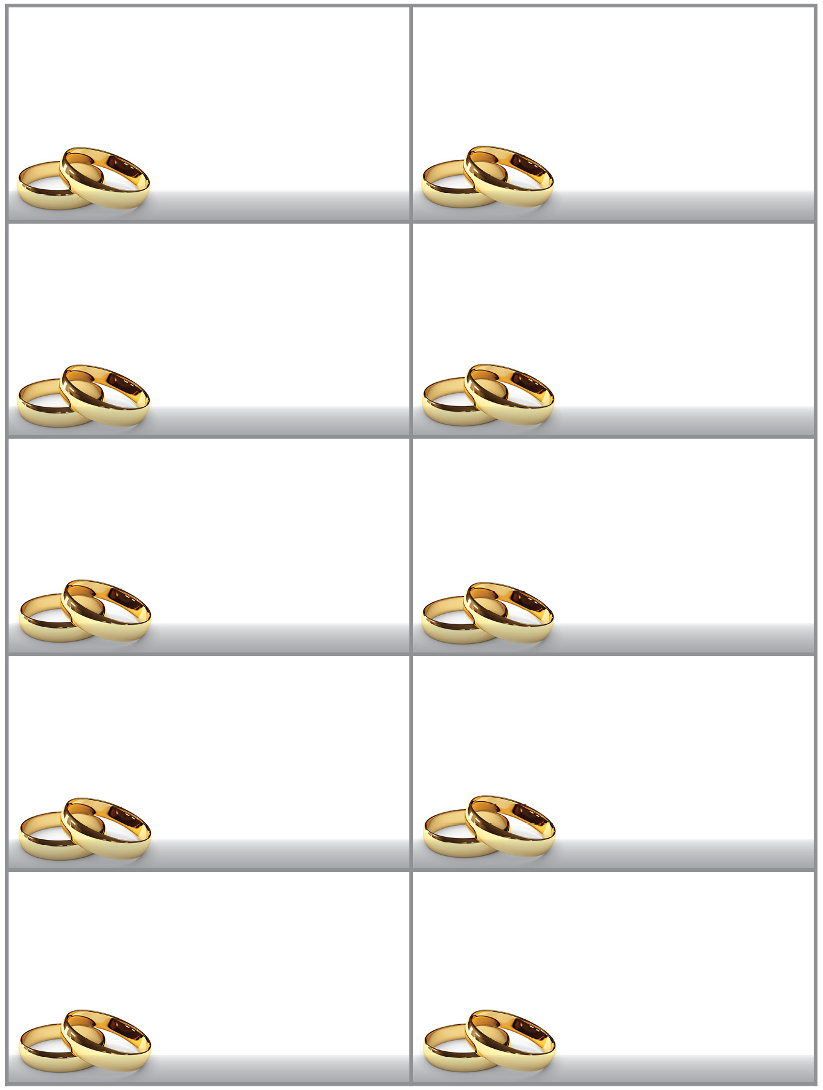
Element of the wedding: Meaning or religious/spiritual belief:
This often symbolises purity. Within Christianity it is ideal if chastity is maintained until marriage. Hebrews 13:4 ‘Let marriage be held in honour among all, and let the marriage bed be undefiled, for God will judge the sexually immoral’.

Although this has not spiritual or religious significance, it is a vital legal element of a wedding. This is why couples have to have their banns read a few weeks prior to the ceremony. This ensures that polygamy doesn’t occur.
For some Christians, they believe that the husband is in authority over the wife. This is due to the Bible verse which says ‘Wives, submit yourselves to your own husbands as you do to the Lord…Husbands, love your wives, just as Christ loved the church’ Ephesians 5:22-25.
The Bible is an invaluable source of knowledge regarding what love and marriage should look like for Christians. It provides a benchmark to remind Christians of the expectations upon them concerning marriage.
This demonstrates that the service is dedicated to God. It also allows the couple to focus on the purposes and significance of marriage to Christianity and to God. Additionally it allows the congregation to support and surround the couple with prayers to God.
Declarations are said by the bride, husband and congregation, which state that they know of no lawful reason why the couple cannot marry.
In some Christian ceremonies the priests asks ‘who gives this woman to be married?’ – the father then says ‘I do’, and passes his daughter’s hand across to the husband.
Bible readings, such as 1 Corinthians 13 are read which describes the nature of love for example: ‘love is patient, love is kind’.
Hymns are sung and prayers are said.
Bride often wears a white dress.
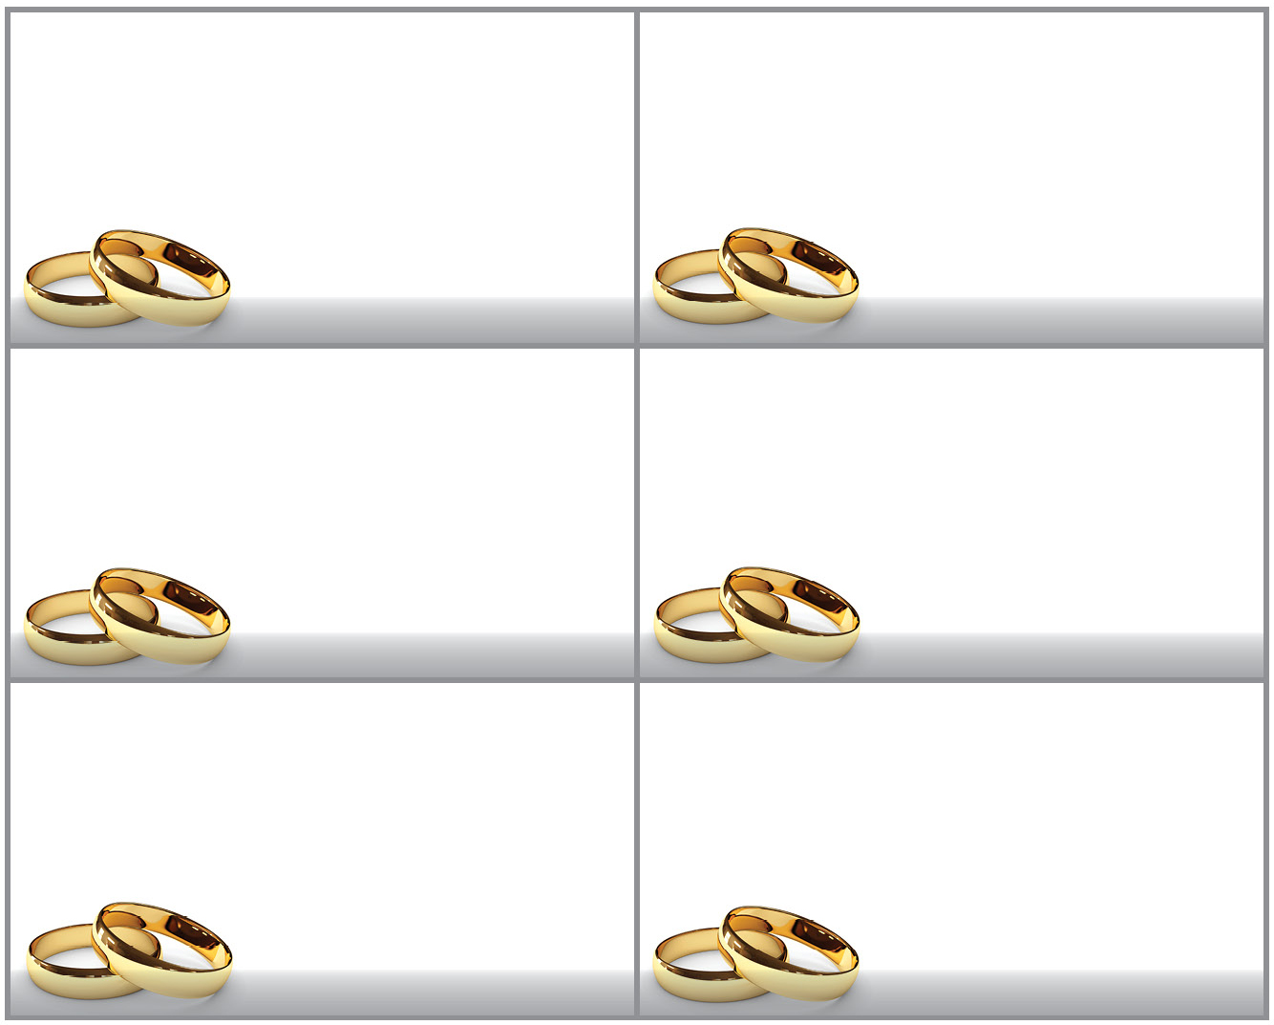
These are symbols of the couples unending love for each other as declared in the vows
‘I promise to love you … til death do us part’.
A circle has no beginning or end; hence the use of these as a representation of eternal love.
This serves to remind both the couple and the congregation that although the love between husband and wife is paramount, more significant is their belief that God’s loved the world so much that He sent Jesus to die on the cross for their sins.
These are promises made by the couple to each other. They serve to remind them of the expectations placed on them as a spouse. They encourage selfless dedication to each other, forsaking all others.
The couple exchange rings.
A sermon is preached, this often talks about the love of God and the sacrifice that Christians believe Jesus made upon the cross.
Vows are said by both husband and wife such as, ‘in sickness and in health’
Activity 4: Understanding divergence
It is important that learners understand that there are different Christian views regarding both the meaning of marriage and the interpretation of the vows and how they outwork in the couples life. In pairs, using the vows sheet, learners are to choose one set of vows then consider and discuss what some of the different interpretations of the vow may be, and what situations you could apply that vow in. They can also consider what Christian values are demonstrated through the vows: e.g. ‘til death do us part’ demonstrates that marriage is a lifelong commitment which shouldn’t easily be broken, in fact only death can sever the bonds of marriage. This is demonstrated through the giving of rings – these signify never-ending loving as a circle has no beginning or end.

This activity could be made more kinaesthetic: once pairs have discussed and made notes on one vow, they can label themselves A and B. As are to remain seated, Bs are to stand up. Bs are to move around the room and find a new A and explain their interpretation of the vow to. As must then counter their interpretation and try and think of another interpretation of the vow, or give the B another situation the vow could be applied to. When the Bs move again, they can then choose whether they keep their interpretation/situation or utilise the ideas of the A they have spoken to.

For stretch and challenge learners may further consider and discuss whether there are some situations which disqualify that vow, should they be followed universally or are there certain situations that it would be unfair to expect a spouse to maintain that vow?

Activity 5: Securing understanding
This task seeks to secure the learners understanding and it can also be a useful revision tool for them closer to their examination. Using the question sheet, learners must consider a range of viewpoints. Learners must consider the question ‘Marriage today is pointless’. You could blow the sheet up onto A3 sized paper and ask the learners to develop ideas in pairs, or learners can work individually. This sheet could later be used to answer the given question under exam conditions and can further be used as a revision tool. Allowing dialogue between learners is conducive for higher level exam answers from learners. Suggested success criteria for the sheet could consist of: to include a detailed explanation of the elements of a wedding ceremony [and what they signify] and to connect these to why marriage isn’t pointless, to include different Christian perspectives, including at least two Bible Verses.

Supporting/further information
http://www.bbc.co.uk/schools/gcsebitesize/rs/relationships/chmarriageanddivorcerev1.shtml - a useful source of information and revision tool for learners.
http://rsrevision.com/GCSE/christian_perspectives/relationships/index.htm - a useful source of information and revision tool for learners.
OCR Resources: the small print
OCR’s resources are provided to support the teaching of OCR specifications, but in no way constitute an endorsed teaching method that is required by the Board, and the decision to use them lies with the individual teacher. Whilst every effort is made to ensure the accuracy of the content, OCR cannot be held responsible for any errors or omissions within these resources.
© OCR 2016 - This resource may be freely copied and distributed, as long as the OCR logo and this message remain intact and OCR is acknowledged as the originator of this work.
OCR acknowledges the use of the following content: Wedding rings – Oleksandr Koval/Shutterstock.com, Scroll – Seregam/Shutterstock.com
Please get in touch if you want to discuss the accessibility of resources we offer to support delivery of our qualifications: resources.feedback@ocr.org.uk
We’d like to know your view on the resources we produce. By clicking on ‘Like’ or ‘Dislike’ you can help us to ensure that our resources work for you. When the email template pops up please add additional comments if you wish and then just click ‘Send’. Thank you.
If you do not currently offer this OCR qualification but would like to do so, please complete the Expression of Interest Form which can be found here: www.ocr.org.uk/expression-of-interest
Looking for a resource? There is now a quick and easy search tool to help find free resources for your qualification:
www.ocr.org.uk/i-want-to/find-resources/

Lesson Element

Marriage and the wedding ceremony

Introduction
Christian marriage is not only an important rite of passage but also the building block for family and is therefore a key pillar of Christian beliefs. The church ceremony is a fundamental part of a Christian wedding. Here they are surrounded by loving friends and family who will witness their wedding and support them in their marriage.
There are many different elements to Christian weddings, these elements have religious and spiritual significance and also bring joy to the couple and observers. Some elements include: the singing of hymns, the saying of prayers, the exchange of rings, the declaration and the saying of specific vows such as ‘to love and to cherish, in sickness and in health’. The Church provides a place to conduct weddings.
Activity 1
There are many reasons why Christians may consider marriage. Read the following statements and decide which you agree/disagree with and to what extent.
I can’t wait to have children. A marriage is the perfect place for me to bring children up in.
Marriage is important for me as it is the start of a sexual relationship. I am a Christian so am waiting until I am married.

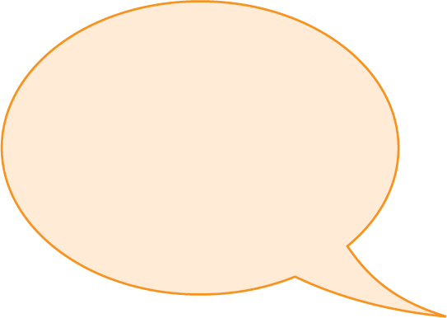
I’m a Christian. I have already started having sex with my fiancé so the important thing about marriage for me is showing my love and commitment to my husband.

I don’t want to be lonely. By getting married I am guaranteeing that I won’t be on my own.

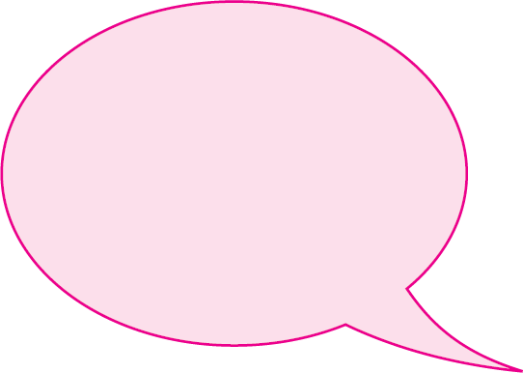
My girlfriend is pregnant with my baby. I want to marry her so the baby has both biological parents at home.
I want to show my love for my fiancé in the present of God and other people. It properly seals the bond.

Activity 2
Watch the following video whilst making notes on why marriage is important to Christians and what actually happens in a wedding ceremony.

https://www.truetube.co.uk/film/christian-marriage
Activity 3
There are many elements within a Christian wedding ceremony. You must connect the element of the wedding to its meaning or religious/spiritual belief.
Element of the wedding: Meaning or religious/spiritual belief:
This demonstrates that the service is dedicated to God. It also allows the couple to focus on the purposes and significance of marriage to Christianity and to God. Additionally it allows the congregation to support and surround the couple with prayers to God.
Although this has not spiritual or religious significance, it is a vital legal element of a wedding. This is why couples have to have their banns read a few weeks prior to the ceremony. This ensures that polygamy doesn’t occur.
This serves to remind both the couple and the congregation that although the love between husband and wife is paramount, more significant is their belief that God’s loved the world so much that He sent Jesus to die on the cross for their sins.
Vows are said by both husband and wife such as, ‘in sickness and in health’
A sermon is preached, this often talks about the love of God and the sacrifice that Christians believe Jesus made upon the cross.
The couple exchange rings.
Bride often wears a white dress.
Hymns are sung and prayers are said.
Bible readings, such as 1 Corinthians 13 are read which describes the nature of love for example: ‘love is patient, love is kind’.
In some Christian ceremonies the priests asks ‘who gives this woman to be married?’ – the father then says ‘I do’, and passes his daughter’s hand across to the husband.
Declarations are said by the bride, husband and congregation, which state that they know of no lawful reason why the couple cannot marry.
These are promises made by the couple to each other. They serve to remind them of the expectations placed on them as a spouse. They encourage selfless dedication to each other, forsaking all others.
For some Christians, they believe that the husband is in authority over the wife. This is due to the Bible verse which says ‘Wives, submit yourselves to your own husbands as you do to the Lord…Husbands, love your wives, just as Christ loved the church’ Ephesians 5:22-25.
The Bible is an invaluable source of knowledge regarding what love and marriage should look like for Christians. It provides a benchmark to remind Christians of the expectations upon them concerning marriage.
These are symbols of the couples unending love for each other as declared in the vows
‘I promise to love you … til death do us part’.
A circle has no beginning or end; hence the use of these as a representation of eternal love.
This often symbolises purity. Within Christianity it is ideal if chastity is maintained until marriage. Hebrews 13:4 ‘Let marriage be held in honour among all, and let the marriage bed be undefiled, for God will judge the sexually immoral’.

Activity 4
In pairs you must choose one set of vows then consider and discuss what some of the different interpretations of the vow may be, and what situations you could apply that vow in. You must also consider what Christian values are demonstrated through the vows.
For example, ‘til death do us part’ demonstrates that marriage is a lifelong commitment which shouldn’t easily be broken, in fact only death can sever the bonds of marriage.
This is demonstrated through the giving of rings – these signify never-ending loving as a circle has no beginning or end.
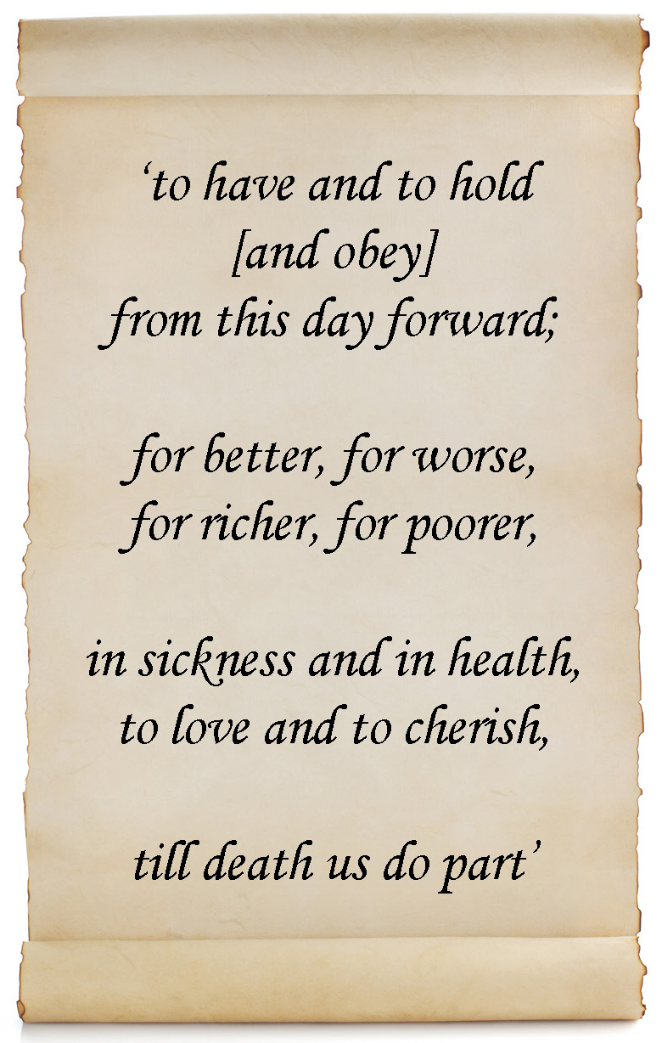

Activity 5
Fill in the sheet; you must include a detailed explanation of the elements of a wedding ceremony [and what they signify] and to connect these to why marriage isn’t pointless, to include differing viewpoints from Christian perspectives, including at least two Bible Verses.

‘Marriage today is pointless’.
Discuss this statement. In your answer, you should:
Draw on your learning from across your course of study, including reference to beliefs, teachings and practices within Christianity. Explain and evaluate the importance of points of view from the perspective of Christianity.

