This Checkpoint Task should be used in conjunction with the KS3–KS4 Transition Guide – Equations

**Checkpoint Task – Equations**

***Instructions and answers for teachers***

*Screenshot of Starter Activity****These instructions should accompany the OCR resource ‘Equations’ activity*** *which supports OCR GCSE (9–1) Mathematics.*

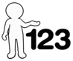

*This activity offers an opportunity for English skills development.*

*This activity offers an opportunity for maths skills development.*

**Associated materials:**

‘Equations’ Checkpoint Task activity sheet.

**Aim:**

To develop understanding of solving linear equations in one unknown algebraically.

These activities are appropriate for Foundation tier students at KS4. The level of demand of the starter activity can be adapted to be used with Higher tier students at KS4.

**The mathematics covered in this activity:**

Knowing that only like terms can be collected together when working with algebraic expressions.

Knowing that to solve an equation, each side of the equation must balance with the other side. A number of different techniques may be used when solving equations, from using function machines and inverse function machines, the balancing method i.e. applying the same operation (addition, subtraction, multiplication or division) to both sides of the equation, to using inverse operations when terms move to the opposite side of the equation (change side, change operation).

These activities focus on solving linear equations in mathematical contexts, including those with the unknown on both sides of the equation.

**Activity guidance:**

The activities build from the concept of balancing to then solving an unknown in a pyramid puzzle to the more formal method of solving an equation where lines of working are communicated in the solution. This is then extended to setting up and solving equations to solve problems in geometry contexts and finally using algebra to generalise solutions to linear equations. Support can be given through careful questioning or perhaps through scaffolding the resources.

The **Starter Activity** is an open activity which requires minimal explanation. The aim of the activity is to develop multiple interesting forms of the initial equation using the rules for manipulating and solving equations. The initial equation can be differentiated to allow students to show their understanding or to scaffold the task as needed.

In **Activity 2** learners complete number pyramids by adding the 2 numbers in the bricks immediately below together. They can then move on from the numerical pyramids to the algebraic pyramids or straight to the solving equations examples, depending on levels of understanding. Learners can work individually or in groups to complete this activity. It is also good practice for learners to verify their solutions in groups and to justify their working to each other.

The focus of **Activity 3** is on communicating the solution of an equation formally. Once learners are competent in communicating the solution to an equation with one unknown on one side they can then move onto solving equations with the unknown on both sides before using this knowledge to find a solution to a general equation with the unknown on both sides. Students should be encouraged to manipulate the equation to define their own rules for solving equations. Assessment should be made through asking questions as the students are completing the activity and allowing time for peer assessment.

**Suggested questions:**

* What do you know?
* What do you need to find out?
* What would be a good way to work that out?
* If you don’t know how to get the answer, what can you work out using the given information?
* Are you being systematic in how you are working?
* Are you communicating what you are doing?

# Answers

# Starter Activity: How many ways can you rewrite this equation?

Work with your partner to find different ways of writing this equation.

There are many possible answers. Three examples are given below.

7*x* = 18

9*x* + 15 = 2*x* + 33

6*x* + 5 = 23 – *x*

7*x* + 5 = 23

*The initial equation can be altered to suit the level of students.*

# Activity 2: Using Number Pyramids

**Remember, the numbers in the bricks are found by adding the 2 bricks immediately below together.**

1. Complete this number pyramid.

54

30

24

5

11

3

7

16

14

10

1. Place the numbers 1 to 5 in the bottom row of the pyramid in any order.

What is the largest possible number that can be made in the top brick? Explain why.

61

29

32

4

8

9

6

12

17

15

1

3

5

4

2

Place the largest number, 5, in the centre position and the remaining numbers in descending order from the centre outwards (as shown above). This ensures the largest numbers are generated in row two and therefore in subsequent rows above.

1. Complete these 2 pyramids.

3*x* + 17

2*x* + 7

*x* + 10

2*x*

7

*x* + 3

*x* + 13

*x* + 5

8

*x*

5

3

1. Complete these pyramids. For each one, form an equation and solve it to find *x*.

Here is an example.

20

2*x* + 3

9

2*x*

3

6

20

2*x*

3

6

So 2*x* + 3 + 9 = 20

2*x* + 12 = 20 and now you can solve the equation to find the value of *x*, in this case *x* = 4.

Now try these.

25

*x* + 6

11

*x*

6

5

*x* + 17 = 25

*x* = 25 – 17

*x* = 8

12

3 + *p*

*p* + 5

3

*p*

5

2*p* + 8 = 12

*p* = 2

30

2*y* + 8

*y* + 13

5

*y*

3

7

5 + *y*

*y* + 3

10

3*y* + 21 = 30

*y* = 3

1. For each of these pyramids, form an equation and solve it to find *x*.

*x* + 25

3*x* + 8

11

3*x*

8

3

2*x* + 2

*x* + 1

6

*x*

1

5

*x* + 7 = 2*x* + 2 3*x* + 19 = *x* + 25

*x* = 5 *x* = 3

4*x* + 30

4*x* + 12

2*x* + 19

5

2*x*

7

5

5 + 2*x*

2*x* + 7

12

3*x* – 3

*x* + 11

16

*x*

4

3

6

*x* + 4

7

9

*x* + 27 = 3*x* – 3 6*x* + 31 = 4*x* + 30

*x* = 15 *x* = -0.5

To give us feedback on, or ideas about the OCR resources you have used, email [resourcesfeedback@ocr.org.uk](mailto:resourcesfeedback@ocr.org.uk)

To give us feedback on, or ideas about the OCR resources you have used, email [resourcesfeedback@ocr.org.uk](mailto:resourcesfeedback@ocr.org.uk)

To give us feedback on, or ideas about the OCR resources you have used, email [resourcesfeedback@ocr.org.uk](mailto:resourcesfeedback@ocr.org.uk)

To give us feedback on, or ideas about the OCR resources you have used, email [resourcesfeedback@ocr.org.uk](mailto:resourcesfeedback@ocr.org.uk)

To give us feedback on, or ideas about the OCR resources you have used, email [resourcesfeedback@ocr.org.uk](mailto:resourcesfeedback@ocr.org.uk)

To give us feedback on, or ideas about the OCR resources you have used, email [resourcesfeedback@ocr.org.uk](mailto:resourcesfeedback@ocr.org.uk)

**OCR Resources**: *the small print*OCR’s resources are provided to support the teaching of OCR specifications, but in no way constitute an endorsed teaching method that is required by the Board, and the decision to use them lies with the individual teacher. Whilst every effort is made to ensure the accuracy of the content, OCR cannot be held responsible for any errors or omissions within these resources.   
© OCR 2014 - This resource may be freely copied and distributed, as long as the OCR logo and this message remain intact and OCR is acknowledged as the originator of this work.

**OCR Resources**: *the small print*OCR’s resources are provided to support the teaching of OCR specifications, but in no way constitute an endorsed teaching method that is required by the Board, and the decision to use them lies with the individual teacher. Whilst every effort is made to ensure the accuracy of the content, OCR cannot be held responsible for any errors or omissions within these resources.   
© OCR 2014 - This resource may be freely copied and distributed, as long as the OCR logo and this message remain intact and OCR is acknowledged as the originator of this work.

OCR acknowledges the use of the following content::  
⚫ Garden: Elen Eliseeva/Shutterstock.com ⚫ Flag: Pixel Europe/Shutterstock.com

To give us feedback on, or ideas about the OCR resources you have used, email resourcesfeedback@ocr.org.uk

# Activity 3: Generalising Equations

**A: Solving simple equations**

Solve the equations showing all steps clearly.

1. 3*x* + 7 = 13 *x* = 2
2. 5*x* – 4 = 11 *x* = 3
3. 2*x* + 5 = 3 *x* = -1
4. 6*x* – 2 = 1 *x* = 0.5
5. 7*x* + 5 = 3 *x* = -

*Do you need some more examples to work on?*

**Extension task 1**

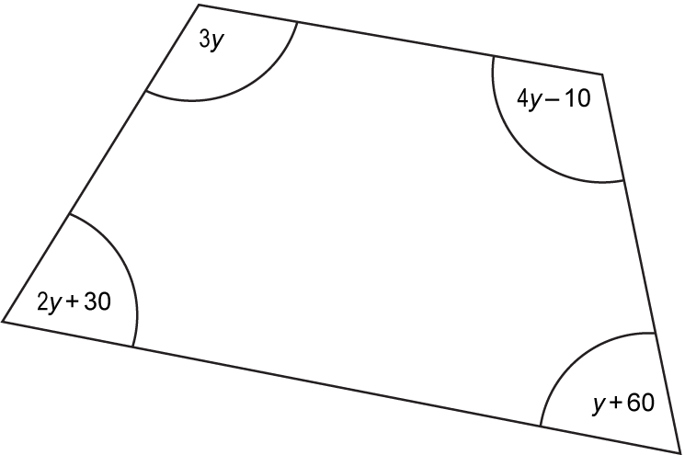

Use the diagram to form an equation and then find the size of each angle of the quadrilateral.

10*y* + 80 = 360

*y* = 28

So the four angles are 84°, 102°, 88° and 86°.

**B: Solving equations with the unknown on both sides**

How do we solve the following equation?

5*x* + 3 = 2*x* + 18

Show your steps clearly. 5*x* – 2*x* = 18 – 3

3*x* = 15

*x* = 

*x* = 5

What happens if we change the numerical values of this equation? Can we still solve it?

Try these 3 examples.

1. 7*x* + 5 = 9*x* – 5 *x* = 5
2. 4*x* – 4 = 3*x* – 3 *x* = 1
3. 5*x* + 0.6 = 3*x* + 1 *x* = 0.2

*Do you need some more examples to work on?*

Write 3 equations with the unknown on both sides for your partner to solve. Make use of negatives and decimals if you would like to increase the difficulty.

**Extension task 2**

The diagram shows a rectangle. All of the sides are measured in centimetres.



1. Explain why 4*x* + 17 = 7*x* + 5. These two sides are the same size
2. Solve the equation 4*x* + 17 = 7*x* + 5. *x* = 4
3. Calculate the perimeter of the rectangle. 90 cm

**C: Generalising**

We can write a general solution for **all** equations of this form using just letter terms.

For example, the most simple equation can be generalised here.

*x* + *a* = *b*

*x* = *b* – *a*

Can you use your working to deduce a general solution for these equations?

1. *x* – *a* = *b* *x* = *b* + *a*
2. *ax* = *b x* = 
3.  *x* = *ab*
4. *ax* – *b* = *c ax* = *c* + *b*

*x* = 

1. *ax* + *b* = *cx* + *d ax* – *cx* = *d* – *b*

*x*(*a* – *c)* = *d* – *b*

*x* = 

Show all steps in your working. Can you explain your working to your partner and justify each step?

**OCR Resources**: *the small print*OCR’s resources are provided to support the teaching of OCR specifications, but in no way constitute an endorsed teaching method that is required by the Board, and the decision to use them lies with the individual teacher. Whilst every effort is made to ensure the accuracy of the content, OCR cannot be held responsible for any errors or omissions within these resources. We update our resources on a regular basis, so please check the OCR website to ensure you have the most up to date version.  
© OCR 2016 - This resource may be freely copied and distributed, as long as the OCR logo and this message remain intact and OCR is acknowledged as the originator of this work.

OCR acknowledges the use of the following content: Maths and English icons: Air0ne/Shutterstock.com

We’d like to know your view on the resources we produce. By clicking on the ‘Like’ or ‘Dislike’ button you can help us to ensure that our resources work for you. When the email template pops up please add additional comments if you wish and then just click ‘Send’. Thank you.

