Topic Exploration Pack

Enthalpy cycles in Developing Fuels

Learning outcomes 3
Introduction 3
Activity 1 – Measuring enthalpy change 4
Activity 2 – Calculating enthalpy changes from experimental data 5
Activity 3 – Using Hess’s Law Diagrams 5
Test yourself questions – Answers 6
Additional guidance: 7
Activity 1: Measuring enthalpy change 7
Activity 2: Calculating enthalpy changes from experimental data 8
Activity 3: Using Hess’s Law diagrams 8
Learner activity 1 – Measuring enthalpy changes of combustion 9
Learner activity 2 – Calculating enthalpy changes from experimental data 13
Learner activity 3 – Using Hess’s Law Diagrams 14
Test yourself questions 18

Instructions and answers for teachers

These instructions cover the student activity section which can be found on page 8. This Topic Exploration Pack supports OCR AS and A Level Chemistry B (Salters).
When distributing the activity section to the learners either as a printed copy or as a Word file you will need to remove the teacher instructions section.

Learning outcomes
- DF(f) techniques and procedures for measuring the energy transferred when reactions occur in solution (or solids reacting with solutions) or when flammable liquids burn; the calculation of energy changes from experimental results
- DF(g) the determination of enthalpy changes of reaction from enthalpy cycles and enthalpy level diagrams based on Hess’ law.

Introduction
This topic sits in the Developing Fuels module in the specification. In order to contextualise the learning, the learners could consider the importance of both measuring and predicting enthalpy changes to the development of technology in the design of fuels for high performance, domestic and commercial vehicles. The links between small scale laboratory work and how this translates into application of the chemical theory could be illustrated by comparing examples of different types of performance needed for different vehicles. The topic links fuel efficiency with both fuel engineering and with reducing pollutant gases. All of these effects depend on chemists and engineers being able to quantify the enthalpy values of fuels.
This topic explores enthalpy of combustion, starting with the design and conduct of small scale experiments to investigate the combustion of alcohols. The learners plan and carry out their experiments, and process the data either on paper or using a spreadsheet. There is a link to a simulated activity to mirror their practical work. The topic concludes with some more advanced work in using combustion data to generate Hess cycles to calculate enthalpy change of formation. This could form the basis of future or extended work into other types of Hess cycle calculations such as those to determine standard enthalpy changes of reaction.
It is helpful if learners are familiar with the definitions for standard enthalpy change of combustion and formation. They should also be familiar with the concept of exothermic reactions, and comfortable with seeing enthalpy change data presented as negative values. They should also understand how energy changes can be represented using energy level diagrams and that energy changes depend on the formation and breaking of bonds. In order to process the calculations, learners need to be familiar with mole calculations.
Any practical work carried out for this topic can contribute to the Practical Endorsement assessment, in the context of PAG3.

Activity 1 – Measuring enthalpy change
This activity could be used as a preparation for enthalpy practical work. In this activity the learners look at a basic set of equipment and consider what choices and controls they can introduce to lead to the collection of high quality data. This activity works best if it is introduced before the learners have seen a written experimental method and before they have tried the experiment themselves. After this activity, learners could then go on to do a related practical activity, which would fit the requirement for PAG 3 of the Practical Endorsement. The pre-lab activity helps engage learners with the experimental design of this type of practical.
An introduction to this activity could be to show learners the basic equipment available for for them to do a practical determination of enthalpy change of combustion. Learners may then consider the choices to be made in setting up and conducting an experiment into the measurement of enthalpy change of combustion. A range of images of experimental methods is provided for learners to discuss in their groups. The main task may be copied for each learner and/or displayed on the main board. Each group can then propose an ‘ideal’ experiment and justify the choices they have made in their plan in terms of aiming to collect high quality data.
The main features of a ‘good’ plan could be discussed via whole class plenary with individual learners from each group discussing justifications for their choice of apparatus and method. Key points include:
- volume of water and temperature change need to be large enough to give a significant change in the mass of the alcohol burned but not so large that the heat loss becomes problematic
(25–50 cm³ water and about a 20 ºC rise in temperature)
- the flame needs to be close enough to the calorimeter to minimise heat loss (learners may discuss making this a constant for all alcohols tested)
- a draft shield needs to be used and should surround the burner and calorimeter
- the thermometer needs to be of an appropriate scale to measure the temperature change with low uncertainty.

Extension: The activity could end with showing some ‘unusual’ and more complex set-ups of enthalpy change determination e.g. using a coke can, coffee cup (which is not suitable for enthalpy of combustion measurements) or a bomb calorimeter (which is designed to minimise errors due to heat loss). Learners could evaluate these methods compared to their own.

Extension: This activity could be followed by learners carrying out their plans or a similar experiment to investigate enthalpy changes of combustion. It is suggested that each group measures a selection of alcohols (perhaps two) to pool results. It does not matter if each group uses different volumes or temperature changes: these provide a discussion point when results are pooled. OCR activity PAG3.3 can be used as a reference for this activity:
https://interchange.ocr.org.uk/Downloads/GCE_Chemistry_PAG3.zip

Activity 2 – Calculating enthalpy changes from experimental data
This activity is designed to be used after learners have carried out a practical experiment to measure temperature changes due to combustion of alcohols. The activity provides structure to develop learners’ understanding of how they should process their results. The activity may be run in two ways. One option is to pool learner data from all groups first, then each group or pair of learners develop their own spreadsheet to include all data. They then develop their formulae to calculate enthalpy changes.
A second option is to have a spreadsheet already constructed (without formulae) to collect data. This could be displayed on the main board. Learners all type into the same class sheet as they collect data during the practical session. After the practical, time is given for learners to do calculations on paper, then suggest formulae for the spreadsheet. The teacher could enter the formulae and the spreadsheet answers could then be compared to those calculated on paper.
In either case, the lesson could end with a discussion of why the size of the experimental change is always smaller than the data book value. Discussions relating to the main sources of heat loss, and patterns in degree of incomplete combustion as the molecules increase in size could be introduced during this plenary. The plenary could also discuss the difference between experimental values and standard enthalpy changes.

Using a simulation to model the whole process of calculation of enthalpy change of combustion
The Royal Society of Chemistry has an online simulation of the experimental measurement of enthalpy changes to give simulated results leading to calculations and analysis which learners may use to supplement their own practical work. The simulation works through a series of interactive activities:

http://www.rsc.org/learn-chemistry/resource/res00002094/heat-of-combustion-of-alcohols-simulation?cmpid=CMP00007033

Activity 3 – Using Hess’s Law Diagrams
The series of sheets is designed to increase in difficulty. Sheet 2 gives a structured calculation. Sheet 3 does not give prompts in the boxes, there is no guidance relating to what values to look up and the equation is not repeated. Learners could be asked to leave Sheet 2 face down as they attempt Sheet 3. Sheet 4 has no structure at all and, as the product (methanol) includes oxygen, it is tempting to balance the equation by giving 2CH₃OH (i.e. forgetting that enthalpy change of formation relates to a single mole of product). Again, learners could be asked not to look at the earlier sheets as they work.

Extension: Learners could consult data books to check how closely their calculated values agree with published values.

Answers: Data table on Sheet 2 needed for all calculations:
 | Δ_{c}Hº / kJ mol^{–1}
C(s) | –393
H₂(g) | –286
CH₄(g) | –890

Sheet 2: Δ_{f}Hº(CH₄(g)) = –75 kJ mol^{–1}
Sheet 3: Δ_{f}Hº(C₆H₆(l)) = +45 kJ mol^{–1}
Sheet 4: Δ_{f}Hº(CH₃OH(l)) = –239 kJ mol^{–1}

Test yourself questions – Answers
1 (a) E.g.: same/given amount of water; same/given temperature change (of 10–30 °C); use a thermometer with high resolution / resolution of smaller than 1 °C; use a draught shield; same distance from flame to calorimeter.
(b) (i) energy = 50 × 4.18 × 55 = 11 495 J / 11.495 kJ
(ii) mass of ethanol burned = 1.10 g
amount of ethanol burned = 1.10 / 46.0 = 0.023913 mol
enthalpy change = 11.495 / 0.023913 = 481 kJ mol^{–1}
N.B. as the smallest number of significant figures among the source data is 2, the final answer should be reported as 480 kJ mol^{–1} or, preferably, as 4.8 × 10² kJ mol^{–1}. Rounding should only take place after the final step in the calculation.
(iii) E.g. loss of heat energy to surroundings; some heat increases temperature of apparatus; incomplete combustion; not performed under standard conditions; evaporation of water.
2 (a) In equations representing standard enthalpy changes, substances are given in their standard state. The standard state for water is liquid.
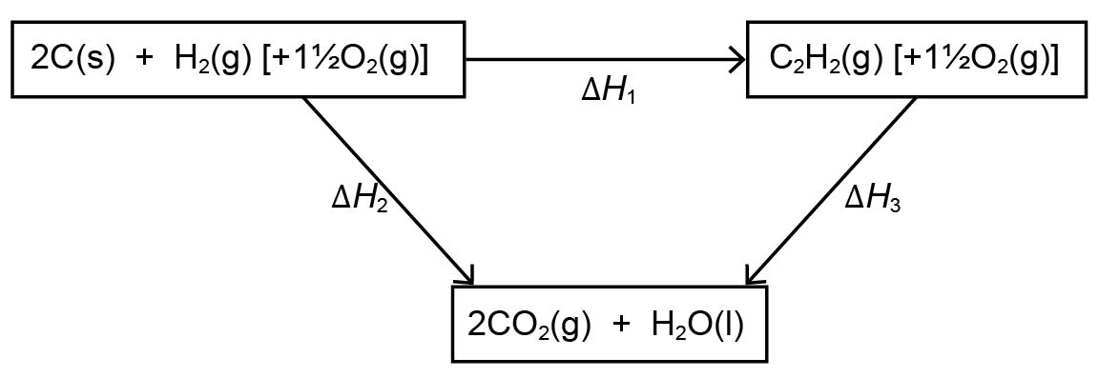
(b) Δ_{c}Hº has a large negative value.
(c)

(d) 2 × –393 + 1 × –286 – 1 × –1300 = –786 – 286 + 1300 = +228 kJ mol^{–1}

Additional guidance:

Activity 1: Measuring enthalpy change
Sheet one of the activity could be displayed on the main board as a talking point during the introduction and plenary for the activity.

Learners may think it is necessary to heat the water to boiling point. This results in very large heat losses. A ‘happy medium’ needs to be struck to use a large enough temperature change to give a measureable mass change, but not so great that the heat losses become very significant.

For the plenary discussion, examples of other methods of determination of enthalpy change can be found:
Enthalpy change during combustion of biodiesel using a coke can calorimeter:
http://www.rsc.org/images/hartmann%20enthalpy%20expt_tcm18-92011.jpg
Use of a coffee cup calorimeter
https://www.learner.org/courses/chemistry/images/text_img/CoffeeCalorimeter.jpg
Use of a bomb calorimeter:
https://www.learner.org/courses/chemistry/images/lrg_img/BombCalorimeter.jpg

A basic experimental method (which uses a conical flask, rather than a calorimeter) can be sourced from the Royal Society of Chemistry:
http://www.rsc.org/learn-chemistry/resource/res00001733/heat-energy-from-alcohols?cmpid=CMP00005247

Activity 2: Calculating enthalpy changes from experimental data
If it is decided to have a joint, class spreadsheet, this will need populating with headers before the lesson (see the bulleted list in Learner Activity 2 for the data needed). Learners may well forget that there is a unit conversion from J to kJ necessary when working out values in kJ mol^{–1}.
Learners will need access to data book values for the enthalpy of combustion of alcohols.
Encourage learners to be careful about including a negative sign in front of all values for enthalpy changes of combustion.

Activity 3: Using Hess’s Law diagrams
One way of introducing this activity would be to use images of current car advertisements, demolition explosives or rocket fuel ignitions to discuss how important it is that chemists can predict exactly what energy changes they expect in any reaction, even ones that have not yet been attempted.
Learners will need access to data books to look up Δ_{c}Hº values and to compare their answers with published Δ_{f}Hº values.
A common error is to forget that enthalpy changes of formation refer to 1 mol of compound. For sheet 4, learners may well balance the equation by working to 2 mol of methanol, giving a double value for Δ_{f}Hº. This could either be headed off at an early stage by a discussion and intervention, or used as a talking point when data book values are compared at the end of the activity.

OCR Resources: the small print
OCR’s resources are provided to support the teaching of OCR specifications, but in no way constitute an endorsed teaching method that is required by the Board, and the decision to use them lies with the individual teacher. Whilst every effort is made to ensure the accuracy of the content, OCR cannot be held responsible for any errors or omissions within these resources.
© OCR 2017 - This resource may be freely copied and distributed, as long as the OCR logo and this message remain intact and OCR is acknowledged as the originator of this work.
OCR acknowledges the use of the following content: n/a
Please get in touch if you want to discuss the accessibility of resources we offer to support delivery of our qualifications: resources.feedback@ocr.org.uk

We’d like to know your view on the resources we produce. By clicking on ‘Like’ or ‘Dislike’ you can help us to ensure that our resources work for you. When the email template pops up please add additional comments if you wish and then just click ‘Send’. Thank you.
If you do not currently offer this OCR qualification but would like to do so, please complete the Expression of Interest Form which can be found here: www.ocr.org.uk/expression-of-interest
Looking for a resource? There is now a quick and easy search tool to help find free resources for your qualification:
www.ocr.org.uk/i-want-to/find-resources/

OCR Resources: the small print
OCR’s resources are provided to support the teaching of OCR specifications, but in no way constitute an endorsed teaching method that is required by the Board, and the decision to use them lies with the individual teacher. Whilst every effort is made to ensure the accuracy of the content, OCR cannot be held responsible for any errors or omissions within these resources.
© OCR 2016 - This resource may be freely copied and distributed, as long as the OCR logo and this message remain intact and OCR is acknowledged as the originator of this work.
OCR acknowledges the use of the following content: n/a
Please get in touch if you want to discuss the accessibility of resources we offer to support delivery of our qualifications: resources.feedback@ocr.org.uk
We’d like to know your view on the resources we produce. By clicking on ‘Like’ or ‘Dislike’ you can help us to ensure that our resources work for you. When the email template pops up please add additional comments if you wish and then just click ‘Send’. Thank you.
If you do not currently offer this OCR qualification but would like to do so, please complete the Expression of Interest Form which can be found here: www.ocr.org.uk/expression-of-interest

Topic Exploration Pack

Learner activity 1 –
Measuring enthalpy changes of combustion

Three students measure and compare the enthalpy change of combustion of a range of alcohols using spirit burners.
Each student has selected and set up equipment to measure the mass of each spirit burner before and after heating a fixed volume of water. They have each decided on a temperature change at which to stop heating.

What to do:
- In your group, evaluate each student’s method.
- Produce your own plan for the experiment.
- Justify the choices you have made in your plan by explaining how they will lead to high quality data.

Amina’s method

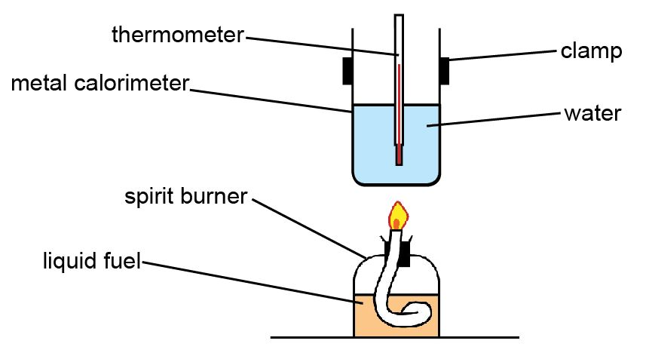

Volume of water used / cm³ | Temperature change of water / ºC | Other notes
50 | 20 | Thermometer measures –20 to 110 ºC with 1 ºC graduations

Ben’s method
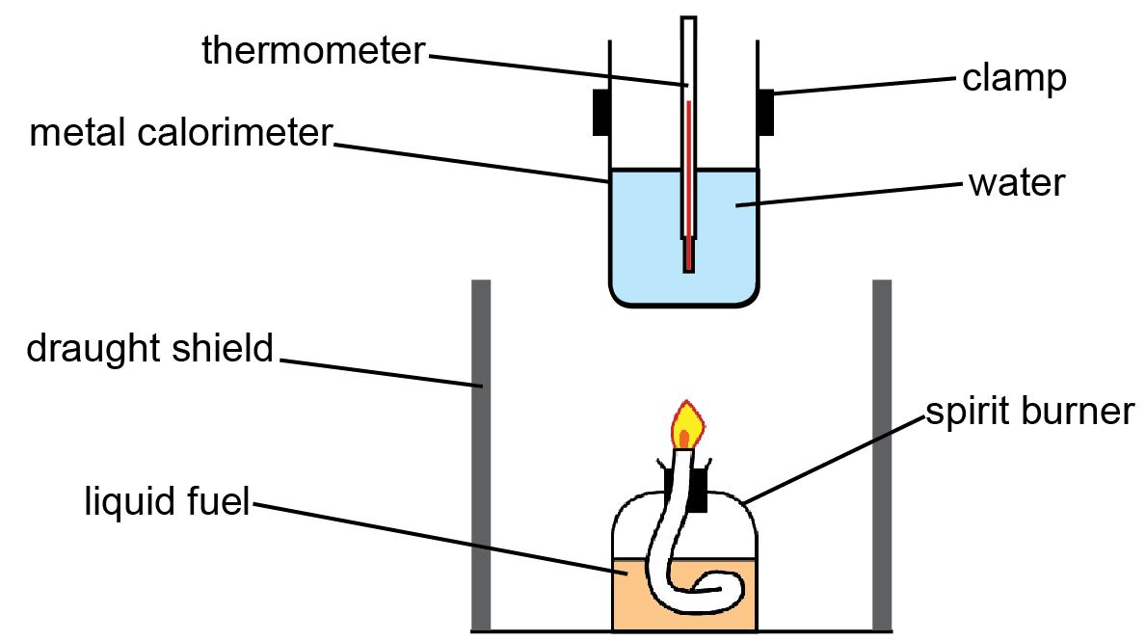

Volume of water used / cm³ | Temperature change of water / ºC | Other notes
25 | 100 | Heat until water boils

Cat’s method
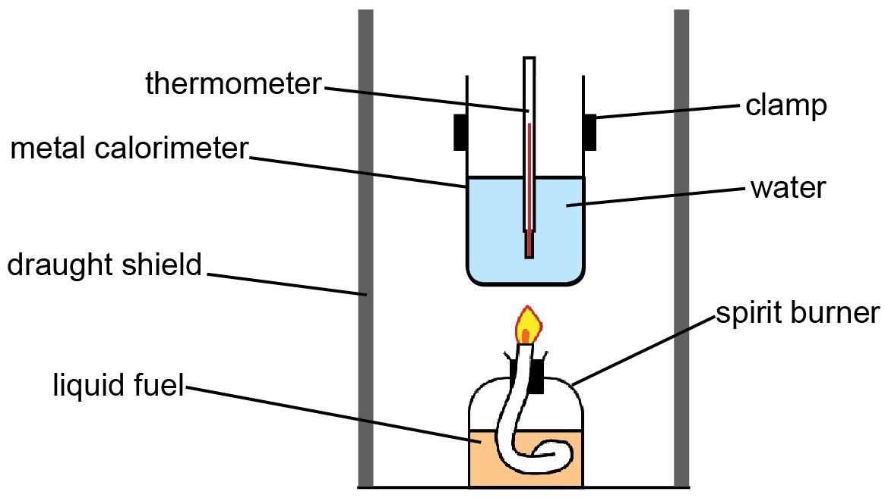

Volume of water used / cm³ | Temperature change of water / ºC | Other notes
10 | 5 | Thermometer measures –10 to 50 ºC with 0.5 ºC graduations

Learner activity 2 –
Calculating enthalpy changes from
experimental data

The enthalpy change in your experiment (in joules) can be calculated using the equation:
q = mcΔT
If we know the molar mass of each alcohol, the experimental value can be used to calculate the enthalpy change in kJ mol^{–1}. The experimental value can then be compared to the data book value to give information about the size of errors in your experiment.

To calculate the enthalpy change from your experiments and compare it to data book values you need this data:
- mass of water used (as the density of water is 1 g cm^{–3}, this is the same as the volume in cm³)
- temperature change
- mass of each alcohol used
- molar mass of each alcohol
- data book value of enthalpy of combustion of each alcohol.

You need to do two calculations:
- working out enthalpy change in your experiments for each alcohol (using q = mcΔT)
- converting this value into kJ mol^{–1} by using the molar mass of each alcohol.

What to do:
1. Pool the results from all groups in your class (it does not matter if other groups have used different volumes or temperature changes).
2. Record all necessary data in a spreadsheet.
3. Work out formulae to insert into the spreadsheet to calculate for each alcohol:
- the enthalpy change in each experiment in J
- the experimental enthalpy change in kJ mol^{–1}
- if more than one group has values for the same alcohol, the mean experimental enthalpy change for each alcohol.
4. In your group, discuss reasons why the experimental enthalpy values and the data book values are different.

Learner activity 3 –
Using Hess’s Law Diagrams

Standard enthalpy changes of combustion can be used to work out standard enthalpy changes of formation

Remember: The standard enthalpy change of formation is the enthalpy change when one mole of a compound is formed from its elements in their standard states.
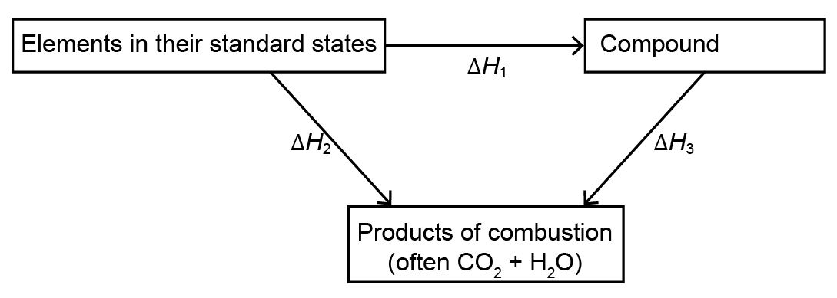

ΔH₁ is the standard enthalpy change of formation, Δ_{f}Hº (make sure the equation is balanced).
ΔH₂ is the total standard enthalpy change of combustion, Δ_{c}Hº, for all of the elements (remember to take into account the number of moles of each element).
ΔH₃ is the standard enthalpy change of combustion, Δ_{c}Hº, for the compound.

The standard enthalpy change of formation can be calculated using the equation
ΔH₁ = ΔH₂ − ΔH₃

Calculating the standard enthalpy change of formation
of methane
Methane, CH₄, cannot be made directly from its elements, but we can work out the enthalpy change of formation of methane using a Hess cycle and data about enthalpy change of combustion.

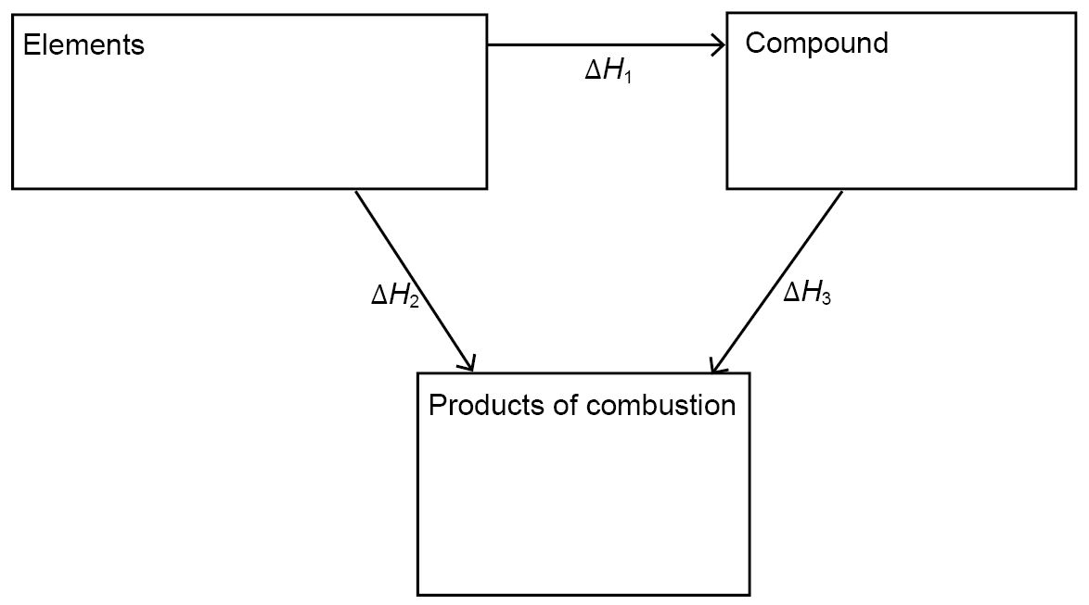
1. Complete the diagram (remember to balance each box).

2. Use a data book to look up the values for the standard enthalpy changes of combustion.

Δ_{c}Hº / kJ mol^{–1}
C(s)
H₂(g)
CH₄(g)

3. Use these values to calculate the standard enthalpy change of formation for methane.
Use the equation
ΔH₁ = ΔH₂ − ΔH₃

Calculating the standard enthalpy change of formation
of benzene

Benzene, C₆H₆, is a petrol additive which helps to stop ‘knocking’.

1. Complete the Hess cycle to show how you will use standard enthalpy change of combustion data to calculate the standard enthalpy change of formation of benzene, C₆H₆.
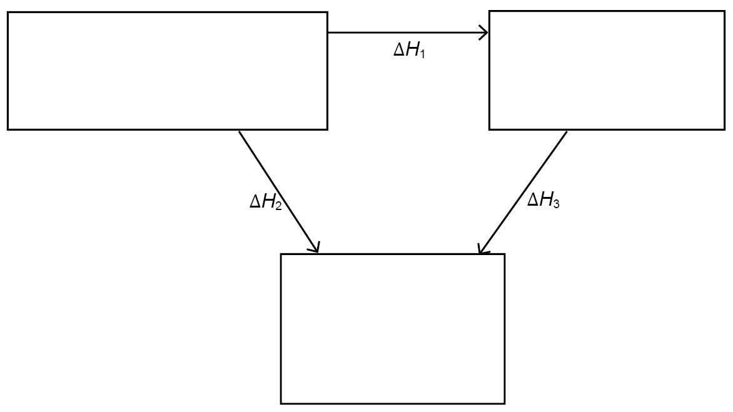

2. Use your diagram to calculate the standard enthalpy change of formation for benzene.

Calculating the standard enthalpy change of formation of methanol

Methanol, CH₃OH, is added to petrol because it is an ‘oxygenate’. It helps the petrol burn smoothly because it already contains some of its own oxygen supply.

1. Complete the Hess cycle to show how you will use standard enthalpy change of combustion data to calculate the standard enthalpy change of formation of methanol.

2. Use your diagram to calculate the standard enthalpy change of formation for methanol.

Test yourself questions
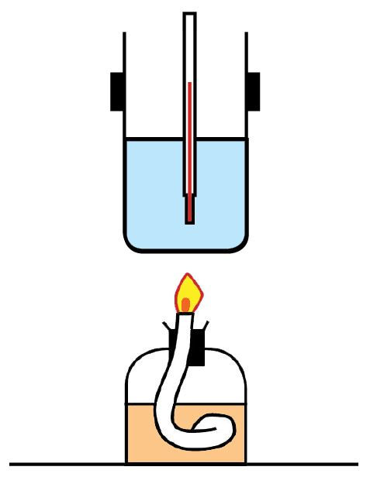
1 A student did an experiment to calculate the enthalpy change of combustion of several alcohols.

This is the equipment he used.

(a) Suggest some factors that the student needs to control to collect high quality data.

(b) These are the student’s results for ethanol, C₂H₅OH.
Mass of water used / g | 50
Mass of ethanol and burner at start / g | 43.56
Mass of ethanol and burner at end / g | 42.46
Initial temperature of water / ºC | 20
Final temperature of water / ºC | 75
Specific heat capacity of water / J g^{–1} K^{–1} | 4.18
Molar mass of ethanol / g mol^{–1} | 46.0

i) Use the results to calculate the energy transferred to the water in the experiment.

ii) Use your answer to (i) to calculate the experimental enthalpy change of combustion in kJ mol^{–1}.

iii) The data book value for the standard enthalpy change of combustion of ethanol is
–1367 kJ mol^{–1}.
Discuss reasons why this value differs to your answer to (ii).

2 Ethyne is a gas used in welding. The gas burns to give a flame with a very high temperature, which melts metal so that it can be joined together.

The reaction equation for the standard enthalpy change of combustion of ethyne is

C₂H₂(g) + O₂(g) → CO₂(g) + H₂O(l) Δ_{c}Hº = –1300 kJ mol^{–1}

(a) At the high temperatures of the flame, the water is given off as steam. Explain why the equation shows its state as a liquid.

(b) Explain how the information shows that this reaction gives off a large amount of energy.

(c) Draw a Hess cycle to show how standard enthalpy change of combustion data can be used to calculate the enthalpy change of formation of ethyne.

(d) Use this data to calculate the standard enthalpy change of formation of ethyne.
 | Δ_{c}Hº / kJ mol^{–1}
C(s) | –393
H₂(g) | –286
C₂H₂(g) | –1300

