Set Text Guide for students

Verse Literature B – Euripides

General Introduction

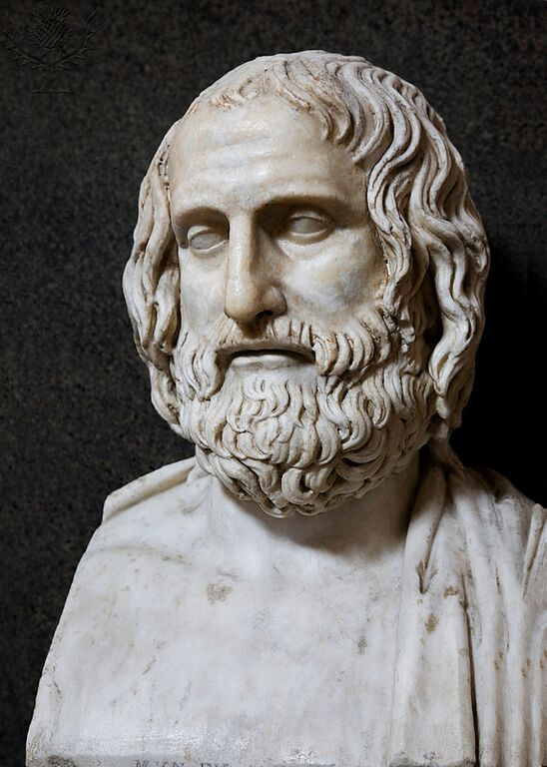
Euripides
Euripides was the latest of the three most celebrated Attic tragedians, after Aeschylus and Sophocles, and a contemporary of the comic playwright Aristophanes. Born in the 480s on Salamis, he spent most of his life in Athens and was the author of at least 88 plays, 19 of which survive. He died in 406 in Macedon, at the court of King Archelaus. After his death he became one of the most celebrated tragedians of his era and his influence on later Greek and Roman playwrights was profound. Common themes in Euripides’ plays include the terrible impact of war, female psychology, the battle between the sexes, and the capricious nature of the gods.

Alcestis
Alcestis was first produced in 438 BC, making it one of the earliest surviving plays by Euripides. Its ambiguous, tone, both tragic and comic, has earned it the label of a "problem play".
The play is set in Thessaly at the court of King Admetus, who lives with his wife Alcestis and their son Eumelus, as well as his elderly father Pheres. It is a drama of life, love and death; of dying wishes and broken promises; and of a magical world in which gods seem to walk on earth and the dead come back to life.
Alcestis is one of the most unusual of Euripides’ surviving works. We know that it was performed in 438 BC not as one of the three tragedies but in the place of the satyr play. This may explain some of its surprising features, like the buffoonish character of Heracles, and the happy ending. It is a good reminder of how Greek drama was varied and flexible, and not always strictly bound by formal conventions.

Talking Points
Talking Point | Notes
Which other dramas, Greek and more widely, do we know of as ‘tragedies’?
Thinking beyond drama, what does ‘tragedy’ mean to us? How many different ways do we use the word?

Context

Fifth-century Athens
In the fifth century democratic Athens was at the height of its powers. This century is often called ‘the Golden Age’ of Athens. The city was immensely wealthy, drawing tribute from the many other Greek city states that formed its empire. Under the direction of the statesman Pericles, the Athenians built the lavish architecture of the Acropolis, including the Parthenon, the great temple dedicated to Athens’ patron goddess Athene. The cult statue of Athene inside the Parthenon incorporated over a metric ton of gold – the weight of an elephant.
Athens was governed by a system of direct democracy, but only adult male citizens were able to vote on the laws and other political resolutions. Many of the most famous figures from ancient Greece were active at this time: the philosopher Socrates; Hippocrates, ‘the father of medicine’ (from whom we get the Hippocratic Oath, a form of which doctors still swear today); the historians Herodotus and Thucydides; and the playwrights Aristophanes, Aeschylus, Sophocles and Euripides.

Athenian Drama
Almost all the Greek drama that survives for us comes from Athens. Plays were performed in outdoor theatres, by actors – all men – who wore elaborate costumes and masks. There were three main dramatic genres, Tragedy, Comedy, and Satyr Play. Each had their own set of conventions, including a particular type of mask for the actors to wear. Like modern opera, Greek plays were written to be performed by a Chorus, a group of around 12 performers who moved and danced together, and a smaller cast of up to three principal actors. The Chorus represented a group of characters with a particular viewpoint on the action, sometimes as in the case of Alcestis, a group of elderly men who might show a mixture of wisdom and short-sightedness.
In the 5th century BC, tragedies explored the darker aspects of human nature usually through mythological themes and characters, familiar from the Homeric epics (like Agamemnon) or from other myths (like Medea, or Alcestis.)
Comedies were more rooted in the present-day, showing up the oddities or ridiculousness of politics by presenting the audience with a world turned upside down. In Aristophanes’ Assemblywomen (Ἐκκλησιάζουσαι), for example, the audience is presented with an Athens governed by women – utterly unthinkable for the time!
Satyr plays featured choruses of satyrs, the half-man, half-goat followers of Dionysos. Although, like tragedies, they were often about mythological themes, they were high-spirited, raucous and bawdy.

The City Dionysia
Euripides’ plays were performed at the city (or Great) Dionysia (in Greek, Διονύσια τὰ ἐν Ἄστει or τὰ Μεγάλα). This was one of the most important religious festivals in the Athenian calendar. It was held every March or April in honour of the god Dionysos, and took the form of drama competitions between different playwrights, who were each commissioned to produce three tragedies and a more light-hearted satyr play.
The Dionysia is believed to go back as far as the 6th century BC, and the first tragedy presented there was said to have been by the actor and playwright Thespis. In the 5th century BC it had developed into an elaborate, five-day festival in which Athens showed off her cultural and imperial wealth, and the wealthiest citizens paid for public entertainments out of their own pockets. The archon (chief magistrate) would appoint a number of the city’s men as “Chorus-leaders” (χορήγοι) to commission and pay for the playwright, actors and choruses.
Days Three to Five (οἱ ἀγῶνες – the Contests) were devoted to the dramatic contests. Tragedies took place in the morning. Each company had a morning to perform a ‘tetralogy’ of four plays: three tragedies, followed by a satyr play. Comedies were performed in the afternoon. The plays were judged and ranked.
We know that the tetralogy containing Alcestis came second when it was first performed at the Dionysia of 438 BC. Euripides, in fact, only won first prize four or five times in his career, compared with Aeschylus’s 13 and possibly over 20 for Sophocles. Unfortunately the vast majority of Greek drama has been lost; bear in mind that we can only read Classical books because they have been copied and distributed through the ages, which - especially before the invention of the printing press - was expensive and difficult. We may never have a chance to read the plays that the Athenian judges preferred!
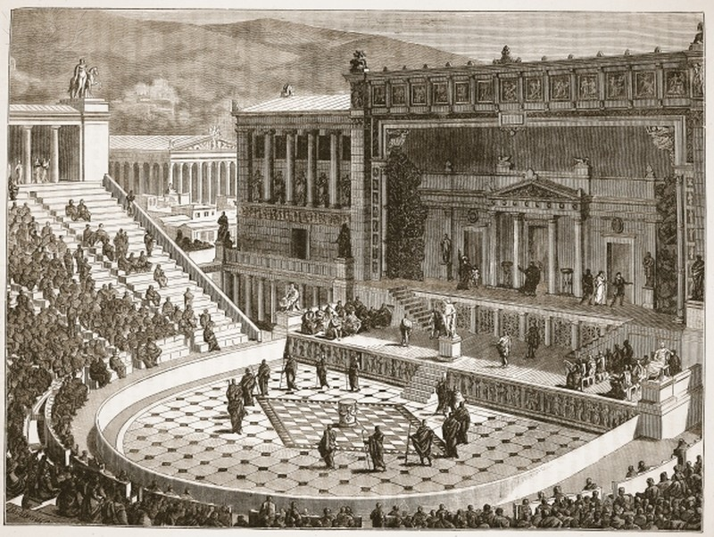

Talking points
Talking Point | Notes
Theatre was an essential part of life in 5th Century Athens, as it was part of a huge festival attended very widely. Is this comparable to theatre today?
Greek drama was usually quite clearly divided into Comedy, Tragedy and Satyr plays. Do we see the same divisions in modern drama?
Given that many people today consider Euripides’s plays to be some of the very best ever written, his small handful of victories at the City Dionysia seems strange to us. Did the judges get it wrong? Is there always a ‘right answer’ when judging artistic competitions?

The Text

The plot of Alcestis
In the play’s prologue, the god Apollo describes how Zeus once condemned him to be a servant among men on earth, but King Admetus showed him hospitality. In return Apollo tricked the Fates into allowing Admetus to escape death by giving another person’s life to the Underworld instead. His parents refused to give up their lives, so when the time came for him to die his devoted wife Alcestis volunteered her life instead.
As the play opens, Death appears and accuses Apollo of trickery and cheating; after an inconclusive argument Apollo leaves, prophesying that ‘a man’ (Heracles, easily identified by the reference to his eighth labour) will take Alcestis from Death by force.
Alcestis is carried off by Death, but help comes in the form of the hero Heracles, an old friend of Admetus (they had travelled together on the Argo). Heracles, on his way to perform his eighth labour, is portrayed here as a buffoonish, larger-than-life boozer; he wrestles Death and forces him to give up Alcestis. He returns her to Admetus, and the play – unusually – has a happy ending.

The death of Alcestis lines 280-393
In the section you will be reading, Alcestis addresses Admetus just before she dies, explaining why she has decided to sacrifice herself: she prefers to die herself than have to live without him. She asks him to promise that he will not marry again, and Admetus agrees. He promises that he will live in sorrow without her, and says that if there was anything he could do to persuade the gods of the Underworld to release her, he would. The Chorus promises to stand by Admetus, and finally Alcestis dies.

Themes and Motifs
Mortality Drama, like all forms of art, often finds itself exploring questions of life and death. Alcestis confronts the issue head-on, with the twist that the characters have made deliberate choices about whether (or not) to give their lives for another. By using the mythical story and bringing the gods onstage, Euripides could place his characters in an extreme situation that is not ‘realistic’, and explore its implications. Remember that ‘life expectancy’ was very different in ancient Athens; although many people lived to 80 and beyond, death at younger ages (and especially in early childhood) was far more common than in most parts of the world today.
Family Alcestis wishes for Admetus not to marry again, saying that she does not wish for a stepmother to join the family. In her view, it seems, none but the birth-mother will do to bring up a daughter; by contrast, her son will have Admetus as a guardian and role-model.
Mourning Greek society had its own ways of dealing with death, including ritualised mourning. In his speech, Admetus promises the various ways that he will show his sadness once Alcestis is gone, as well as promising to obey Alcestis’s dying wish that he should not take another bride. This will go on to be a key theme in the rest of the play, as both promises will be challenged.

Stylistic Features
Here are just some of the ways that Euripides crafts his poetry. Often you will find these techniques in combination. Whenever you think about a poet’s style you should ask yourself why the writer might choose to use a particular technique; the technique is only interesting if you can explain how it enhances the meaning.
Choice of vocabulary What is the difference between ‘great sadness’, ‘bitter grief’ and ‘abject misery’? Which of these is the best translation of πένθος λυπρόν when the Chorus speak (369-70)? Euripides chose his words extremely carefully, giving subtle emphasis to particular ideas, and we can ask ourselves exactly what the resulting effect is.
Word order As you know, the order of words in Greek is much more free than in English. Euripides is usually free to choose which word comes first in each line and each phrase, for example; these are ‘emphatic’ positions. When Admetus starts a line with ‘παύσω’ (343), he seems more forceful in his decision to stop merry-making at his court. When he ends his observation about seeing our loved ones in dreams with the word ‘χρόνον’ he draws attention to the aspect of time (i.e. it is pleasant no matter how long we see them for.)
Repetition Many poetic effects (including alliteration and assonance) rely on repeating something: a sound, a word, or an idea. Repetition reinforces the idea behind the words, and sometimes literally ‘acts out’ the thoughts of a character. Alcestis emphasises how much of her daughter’s life she will be missing by repeating the negative words (two of them in emphatic position at the start of the line!): οὐ... οὔτε... οὔτ᾽(317-8); indeed the latter part of her speech features many negative statements.

Glossary of Key Terms
Key terms regarding content and literary techniques. | Now over to you.  Now find your own examples of these techniques and list them in the boxes below.
Alliteration
The repetition of similar consonant sounds.
Anaphora
A repeated structure.
Apostrophe
Addressing a divine character, usually in a moment of high emotion.
Assonance
The repetition of similar vowel sounds.
Catharsis
The feeling of relief that audience members may experience through watching an emotionally charged tragedy. (κάθαρσις literally means ‘purification’).
Chorus
A group of characters in a play who comment on but are not directly involved in the action. In Alcestis, the Chorus is made up of old men. Their choral ‘songs’ employ a variety of different ‘metres’ (or ‘rhythmic schemes’), often extremely complex.
iambic trimester
The name of the poetic metre that Euripides’ dialogue is written in: essentially a sequence of alternating light and heavy syllables (each pair an iambic ‘foot’) organised into three ‘metra’ in each line, each containing two feet. For comparison, Shakespeare’s verse is largely set in iambic pentameter, with five feet per line.
Key terms regarding content and literary techniques. | Now over to you.  Now find your own examples of these techniques and list them in the boxes below.
Pathos
A sense of pity that audience members may experience through watching specific events (note that pathos usually applies to individual moments or situations, unlike the more general feeling of catharsis, above).
Rhetorical question
A question that is asked without expecting an answer, often because the only possible answer is very obvious, or because the question is unanswerable. Both Alcestis and Admetus use these to great effect.
Stasimon
An interlude, or choral song, in which the Chorus comments on the action.
Stichomythia
Quick-fire dialogue; a sequence where alternating lines are given to alternating characters. The final section of your passage, the dialogue between Admetus and Alcestis, uses stichomythia; as does the argument between Apollo and Death early in the play. In Greek στιχομυθία literally means “line-speech” (στίχος + μῦθος).
Tragedy
In Greek, tragedy means “goat song” (τράγος = goat). The reasons for this are disputed, but legend has it that Thespis, the first actor to perform at the Dionysia, was rewarded with a goat.

Talking points
Talking Point | Notes
Trading lives: if it was possible to swap one life for another, as Apollo has promised to Admetus, how would we choose when to do so? Or would we simply never take up the offer?
The wishes of the dead: should we always respect the wishes of those who have died, or are there occasions when this is impractical or even wrong?
Stylistic writing: which of Euripides’s techniques, both dramatic and verbal, do we find most effective? Which are still in use today?

Activities and tasks
Introducing Greek Tragedy
National Theatre
https://www.nationaltheatre.org.uk/backstage/greek-theatre
Explore videos introducing Greek Tragedy, with particular focus on the National Theatre’s recent production of Sophocles’s Antigone. Note the links on the right of the page to further videos on particular aspects of the drama.
Exploring the metre and techniques of Greek poetry
Armand D’Angour
http://www.armand-dangour.com/mnemonics-for-greek-metre/
Explore the different rhythms used by Greek poets including Euripides, through English rhymes that approximate to the Greek metres. Find the Iambic Trimeter on the page and identify how the scansion applies.
Alcestis in the original language
Barnard/Columbia Ancient Drama Group
https://www.youtube.com/watch?v=EmA6z2YAeLE
Watch a production of Alcestis in Ancient Greek, with English subtitles. You may wish to locate and focus on the section that you are reading in Greek.

We’d like to know your view on the resources we produce. By clicking on ‘Like’ or ‘Dislike’ you can help us to ensure that our resources work for you. When the email template pops up please add additional comments if you wish and then just click ‘Send’. Thank you.
Whether you already offer OCR qualifications, are new to OCR, or are considering switching from your current provider/awarding organisation, you can request more information by completing the Expression of Interest form which can be found here: www.ocr.org.uk/expression-of-interest
Looking for a resource? There is now a quick and easy search tool to help find free resources for your qualification:
www.ocr.org.uk/i-want-to/find-resources/

OCR Resources: the small print
OCR’s resources are provided to support the delivery of OCR qualifications, but in no way constitute an endorsed teaching method that is required by the Board, and the decision to use them lies with the individual teacher. Whilst every effort is made to ensure the accuracy of the content, OCR cannot be held responsible for any errors or omissions within these resources.
© OCR 2017 - This resource may be freely copied and distributed, as long as the OCR logo and this message remain intact and OCR is acknowledged as the originator of this work.
OCR acknowledges the use of the following content: Euripides: SHEILA TERRY/SCIENCE PHOTO LIBRARY / UIG, Theatrical performance in Ancient Greece: Private Collection / The Stapleton Collection / Bridgeman Art Library / Universal Images Group
Please get in touch if you want to discuss the accessibility of resources we offer to support delivery of our qualifications: resources.feedback@ocr.org.uk

