Checkpoint Task

Bonding and structure

Instructions and answers for teachers

These instructions cover the learner activity section which can be found on page 6. This Checkpoint Task should be used in conjunction with the KS4–5 A Level Chemistry Transition Guide Bonding and Structure, which supports OCR A Level Chemistry A and Chemistry B (Salters).
When distributing the activity section to the students either as a printed copy or as a Word file you will need to remove the teacher instructions section.

Unbreakable Rule or Rule of Thumb?
This is a card sort/discussion based activity that provides learners with twenty statements about bonding and the ‘octet rule’. The card sort can be used at the start of the A Level course in order to gain a better understanding of how learners have been taught and what misconceptions they may have acquired at Key Stage 4; this is particularly useful when dealing with a mixed class from different secondary backgrounds.
The learners are asked to consider each statement and decide whether it is an ‘unbreakable rule’ that always applies in every circumstance, or whether it is a ‘rule of thumb’ – a useful guideline that usually applies but for which there can be exceptions. Depending on the class, you may offer learners an option of a third ‘not sure’ pile. Plenty of time should be allowed for learners to discuss their ideas and if possible provide whiteboards for their ‘exceptions’ explanations so that they can adjust their ideas as they talk to each other. They should also be encouraged to consult textbooks, data books and revision guides for ideas.
There are ten statements which have exceptions; going through all of these at once at the start of the course is likely to push learners past their conceptual limit and make them frustrated. An alternative strategy is to take a photo of their answers or record them in some other way. They can then be used to inform teaching strategies and, every time an exception is met, learners can be encouraged to re-evaluate their answers. For example, following a demonstration and discussion of the formation of aluminium chloride (including dimer formation) learners can be asked to re-evaluate their ideas about covalent bonding and the octet rule.

Teacher preparation
The statements should ideally be printed onto card or laminated, and cut out before the activity to save time. The learners will probably need at least half an hour and preferably
40–50 minutes for the activity. Circulation during the activity will provide many opportunities to listen in on misconceptions, but avoid the temptation to leap in with corrections or give learners answers without allowing them the space to think it through. If learners are struggling with the concepts too much, try giving them a few prompts in the form of example reactions or processes on the board. For the questions relating to energy changes, encourage learners to make associations between electrostatic attractions and the energy needed to overcome these – are electrostatic attractions being made or overcome in each example?
You may want to use the activity twice – once at the start of the bonding topic and once again at the end. Learners could rate their confidence level on each occasion, giving you a better idea as to whether they are making ‘best guesses’ or are more secure in their knowledge. The first time you use the activity, as mentioned above, it is probably best not to go through every card as a class but to reassure learners that by the end of the topic all of the statements will have been covered. When using the cards at the end of the topic, they can be used to check that learners are confident and any further misconceptions can be addressed before moving on.

Instructions
Here are twenty statements about chemical bonding. Discuss each statement within your pair or group and decide whether the statement is always true (unbreakable rule) or usually true (rule of thumb).
1. Separate the statements into two piles – always true or usually true.
2. For the statements that you think are not always true, try to think up some exceptions to the rule. You could use an equation or example element or compound to illustrate the ‘exception to the rule’.

Answers
Unbreakable Rule Statements
A. The atoms of Group 2 elements have two electrons in their outer shell.
This is not a guideline but relates to the position of elements in the periodic table. As learners are introduced to more complex ideas at A Level (such as s,p,d,f notation) they can grow doubtful of earlier, simpler ideas in case they turn out to now be ‘wrong’.

D. Oppositely charged ions attract.
This is of course always true, but the statement is included for the same reasons as the one above.

E. Delocalised electrons are more stable than electrons in fixed atomic orbitals.
Learners have probably only met delocalised electrons in metals and graphite at this stage, but this will become important in organic chemistry later in the course.

F. Energy is released when ionic bonds form.
Always true: if separating ions means overcoming electrostatic attractions and an input of energy, the reverse must be true when ions come together to form a lattice.

G. In an ionic compound, ions are combined in proportions which balance out the electrical charges.
Always true: ionic compounds cannot have a charge overall, but this tests learners’ understanding of the term ‘compound’ as they will have come across molecular ions.

H. Energy is needed to break covalent bonds.
Always true, because an electrostatic attraction is being overcome.

I. Energy is required to form positive ions from atoms.
Always true, for the same reasons as above.

L. Electrons shared between atoms (in molecular orbitals) are more stable than electrons in atomic orbitals.
Always true but the wording may confuse students. This is linked to the idea in I – if energy is needed to pull apart the atoms in a covalent molecule, the electrons within the bonding orbital must be more energetically stable.

M. Electrons that are closer to the nucleus experience less shielding and are more strongly attracted than electrons further away.
Always true; again because of the electrostatic attractions involved.

Rule of Thumb Statements
B. Noble gases do not form any types of bonds because they have full outer shells.
Exception: Noble gases further down the group, such as xenon, do react with very reactive elements such as fluorine as they are able to accommodate more than eight electrons in their outer shell.

C. Ionic substances have higher melting points than covalent substances.
Exception: This is usually true but not the case for giant covalent structures such as diamond, graphite and silicon dioxide.

J. Energy is released when negative ions are formed from atoms.
Exception: Energy is usually released when anions with a single negative charge form. However, adding an electron to a negatively charged ion is always very endothermic and so formation of 2– or 3– ions is usually endothermic. In addition to this, the first electron affinity of some elements such as nitrogen, beryllium and noble gases are also endothermic.

K. Bonding within compounds is either ionic or covalent.
Exception: Once again, the existence of molecular ions means this is only a rule of thumb – many common substances contain both covalent and ionic bonding. Additionally there are covalent molecules which readily dissociate in solution to form ions.

N. Exception: dative covalent bonds are formed when one atom donates a pair of electrons to an electron-deficient species.
Exception: dative covalent bonds are formed when one atom donates a pair of electrons to an electron-deficient species.

O. Compounds are more stable than elements.
Exception: The formation of some compounds requires the breaking of very strong covalent bonds – as a result, these compounds are generally less stable than the elements. Oxides of nitrogen are a good example of this; ethane and hydrogen iodide also have a positive enthalpy of formation.

P. Elements always react to form ions with noble gas electron configurations.
Exception: Transition metals generally do not form ions with noble gas configurations as this would require the removal of a large number of electrons.

Q. Ionic compounds are formed when metals react with non-metals.
Exception: Aluminium forms several covalent compounds. Ionic compounds can also be formed from the combination of ammonium ions with non-metal anions, and organic acids and amines can form ionic salts.

R. Covalent compounds are formed when non-metals react with other non-metals.
Exception: Aluminium and beryllium form several covalent compounds. Ionic compounds can also be formed from the combination of ammonium ions with non-metal anions.

S. Hydrogen atoms form ions by losing one electron and becoming H⁺.
Exception: In metal hydrides, hydrogen atoms gain an electron to form H– ions.

T. Within a covalent compound, all elements except hydrogen have eight electrons in their outer shells.
Exception: Group 13 elements can only share three electrons and so have six electrons in their outer shells. Elements in Period 3 or below can have more than eight (PF₅, SF₆)

Supporting/further information
The Royal Society of Chemistry has produced some excellent classroom resources to help identify and address learner misconceptions about bonding and ion formation; the three resources most pertinent to the checkpoint task are given below.
Stability and reactivity:
http://www.rsc.org/learn-chemistry/resource/res00001103/stability-and-reactivity
This resource gets learners to think in further detail about the relative stability of atoms and ions as well as elements vs compounds.
Why do atoms form ions?:
http://www.rsc.org/learn-chemistry/resource/res00000111/afl-why-do-atoms-form-ions
This ties in very well with the resource above and can help learners think about ion formation and ionic bond formation in the context of energy changes and electrostatic attractions.
Ionisation energy:
http://www.rsc.org/learn-chemistry/resource/res00001101/ionisation-energy
This is a fairly challenging true/false exercise which learners can use to test their understanding of ion formation, again in terms of energy changes and electrostatic attractions rather than the octet rule.
OCR Resources: the small print
OCR’s resources are provided to support the teaching of OCR specifications, but in no way constitute an endorsed teaching method that is required by the Board, and the decision to use them lies with the individual teacher. Whilst every effort is made to ensure the accuracy of the content, OCR cannot be held responsible for any errors or omissions within these resources.
© OCR 2016 - This resource may be freely copied and distributed, as long as the OCR logo and this message remain intact and OCR is acknowledged as the originator of this work.
OCR acknowledges the use of the following content: n/a
Please get in touch if you want to discuss the accessibility of resources we offer to support delivery of our qualifications: resources.feedback@ocr.org.uk
We’d like to know your view on the resources we produce. By clicking on ‘Like’ or ‘Dislike’ you can help us to ensure that our resources work for you. When the email template pops up please add additional comments if you wish and then just click ‘Send’. Thank you.
If you do not currently offer this OCR qualification but would like to do so, please complete the Expression of Interest Form which can be found here: www.ocr.org.uk/expression-of-interest
Looking for a resource? There is now a quick and easy search tool to help find free resources for your qualification:
www.ocr.org.uk/i-want-to/find-resources/

Checkpoint Task

Bonding and structure

Student Activity

Introduction
In your study of Bonding and Structure at A Level, you will be building a lot on ideas that you have already covered previously. Because bonding is a complex subject that is often simplified at GCSE, many learners can have unclear ideas or misconceptions about the topic. This activity will encourage you to explore what you already understand about chemical bonding, and to identify those areas that you still struggle with or require refinement at A Level.

Task 1
Here are twenty statements about chemical bonding. Discuss each statement within your pair or group and decide whether the statement is always true (unbreakable rule) or usually true (rule of thumb).
Separate the statements into two piles – always true or usually true. Make sure that you discuss the statements with your partner or in a group as you may have different ideas. It is more important to think carefully about each statement than to get to the end of the activity.

Task 2
For the statements that you think are not always true, try to think up some exceptions to the rule. You could use an equation or example element or compound to illustrate the ‘exception to the rule’. Feel free to consult textbooks or other resources to help you with this.

Extension
If you have confidently identified all of the ‘rules of thumb’ and provided each with an exception to the rule, now see if you can think of any other parts of chemistry where we use ‘rules of thumb’, analogies or simplifications that are not strictly true. Some topics you could think about include atomic structure, reactivity, solubility, or acid–base theory.

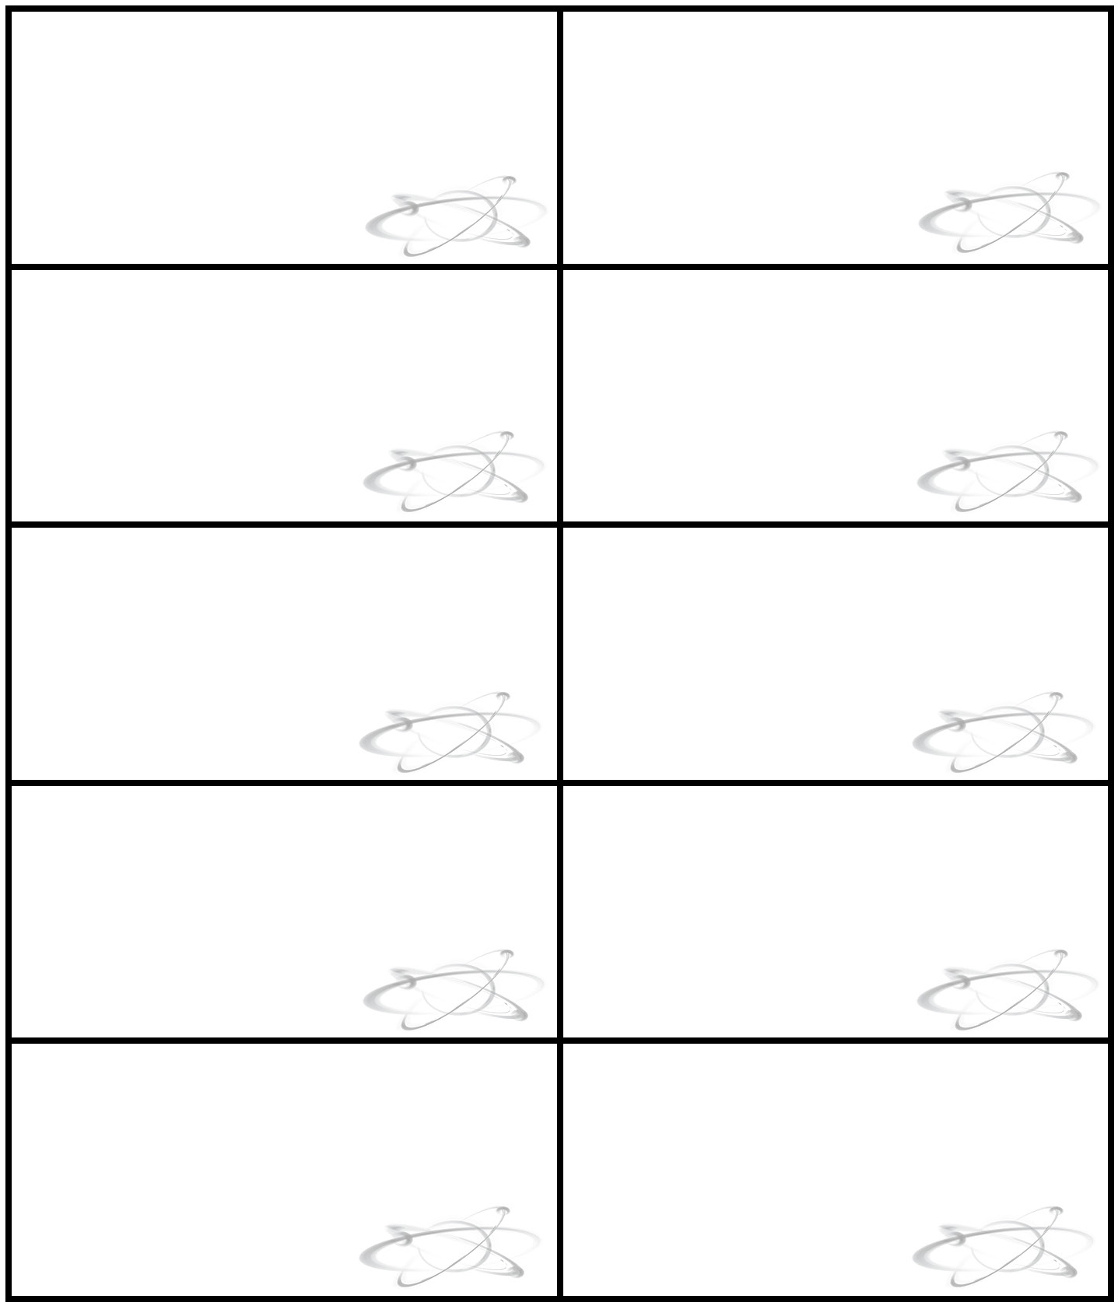
Statements for use in activity
A. The atoms of Group 2 elements have two electrons in their outer shell.
B. Noble gases do not form any types of bonds because they have full outer shells.
C. Ionic substances have higher melting points than covalent substances.
D. Oppositely charged ions attract.
E. Delocalised electrons are more stable than electrons in fixed atomic orbitals.
F. Energy is released when ionic bonds form.
G. In an ionic compound, ions are combined in proportions which balance out the electrical charges.
H. Energy is needed to break covalent bonds.
I. Energy is required to form positive ions from atoms.
J. Energy is released when negative ions are formed from atoms.
Statements for use in activity
K. Bonding within compounds is either ionic or covalent.
L. Electrons shared between atoms (in molecular orbitals) are more stable than electrons in atomic orbitals.
M. Electrons that are closer to the nucleus experience less shielding and are more strongly attracted than electrons further away.
N. A covalent bond is formed from a shared pair of electrons; one electron comes from each atom within the bond.
O. Compounds are more stable than elements.
P. Elements always react to form ions with noble gas electron configurations.
Q. Ionic compounds are formed when metals react with non-metals.
R. Covalent compounds are formed when non-metals react with other non-metals.
S. Hydrogen atoms form ions by losing one electron and becoming H⁺.
T. Within a covalent compound, all elements except hydrogen have eight electrons in their outer shells.

