Topic Exploration Pack

Sauces

Sauces explained 2
Function and working characteristics of the main ingredients 4
Sauces 5
1. How to make starch based sauces 5
2. Technical skill - gelatinisation 6
3. A chart to show the viscosity of white sauces 6
4. Reduction sauce 7
5. Emulsion sauce 7
Useful links 9
Student Activity 21

Instructions and answers for teachers

These instructions cover the student activity section which can be found on page 21. This Topic Exploration Pack supports OCR GCSE (9‒1) Food Preparation and Nutrition.
When distributing the activity section to the students either as a printed copy or as a Word file you will need to remove the teacher instructions section.

ABC – This activity offers an opportunity for English skills development.
123 – This activity offers an opportunity for maths skills development.

SECTION D – Topic 4 - Skills requirements: preparation and cooking techniques (Sauces).
- Make a blended white sauce (starch gelatinisation), such as a roux, and an all-in-one blended sauce, infused sauce, veloute, bechamel, to demonstrate understanding of how liquid: starch ratios affect the viscosity and how conduction and convection work to cook the sauce and the need for agitation.
- Make a reduction sauce such as pasta sauce, curry sauce, gravy or meat sauce (including meat alternatives such as mycoprotein and textured vegetable protein) to demonstrate how evaporation concentrates flavour and changes the viscosity of the sauce.
- Make an emulsion sauce such as a salad dressing, mayonnaise or hollandaise to demonstrate the technical skill of how to make a stabilised emulsion.

SECTION C – Topic 1 – Working characteristics and the functional and chemical properties of ingredient groups
- Carbohydrates : gelatinisation
- Fats/oils : emulsification

Sauces explained
Definition
A sauce is a thickened, flavoured liquid which can be added to a range of savoury and sweet dishes.
There are several types of sauces based on different ways of thickening mixtures.
Main types of sauces
- Blended
- Reduction
- Emulsion

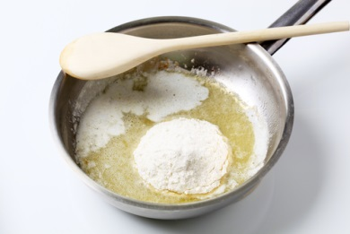  Blended | Starch- based sauces- starch from wheat flour, cornflour or arrowroot is used to thicken liquids such as water and stock.  - Wheat flour is used in a white sauce  - Cornflour is used in custard and gravy  - Arrowroot is used in a glaze for fruit flans or gateaux.  - Potato flour (fecule) used for thickening soups.  Egg based sauces- eggs blended with a liquid. Eggs coagulate on heating and thicken a liquid.
Reduction  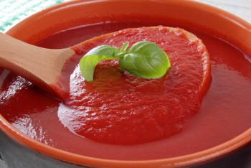 | Fruit or vegetable sauces. Vegetables are sweated in fat/oil and then liquid is added and the ingredients are cooked until soft. Flavour develops through cooking and intensifies as the liquid evaporates.  Fruit can be pureed or blended to make it thicken, for example a fruit coulis.  Fruit can also be cooked, blended or pureed.
Emulsion  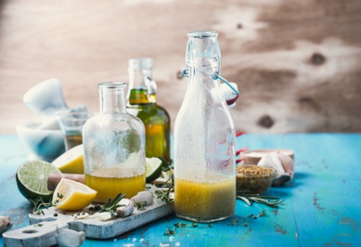 | Oil/water emulsion sauces- used for oil and vinegar dressings .Egg yolk stabilises the emulsion used to make a mayonnaise or hollandaise sauce.

The main functions of sauces are:
- To add liquid to moisten a food or dish.
- To add flavour.
- To add colour.
- To bind ingredients together.
- To add nutrients.
- To make dishes more interesting and appealing.
A wide variety of different sauces can be used to produce dishes using a vast range of skills, to develop differing flavours and textures. These can include a coating, accompaniment or part of a meal.

Function and working characteristics of the main ingredients
Scientific explanation
The main ingredients used in sauce making are, flour or thickening agent, fat, liquid and flavourings.
Flour
Generally, a soft flour with a low gluten content is used, for example plain flour and cornflour.
When flour is mixed with a liquid and heated in a sauce the mixture will thicken.
This is known as gelatinisation.
This occurs because:
- the starch grains cannot dissolve in the liquid, so they form a suspension and;
- as the liquid is heated the starch grains swell at 60 ̊ C and as more heat is applied the starch grains break open, causing the mixture to thicken at 80̊C. The process of gelatinisation is completed at 100̊C.
Other thickening agents:
- Roux – this is mixture of flour and fat.
There are three types of roux:
  - White – used for Bechamel sauce, this is a mixture of flour, fat and milk
  - Blond – used for a Veloute sauce –this is a mixture of flour, fat and stock.
  - Brown – used for an Espagnole sauce- this is a mixture flour, fat and veal stock.
- Egg yolks- These are used for sauces hot (hollandaise) and cold (mayonnaise).
- Bread – bread sauce.
- Vegetables and potatoes, fresh fruit, for example apple and cranberry sauce.

Fat is added in small quantities to a sauce to add flavour and colour. The main types of fat used are butter, margarine, white fat and oils. Butter is used in an emulsified form for example butter sauce and white wine sauce for fish.
Liquid
A wide range of liquid ingredients can be used depending on the type of sauce being prepared.
These could include:
Water, cream, milk, yogurt, stock, wine, vinegar, vegetable liquor, meat juices, oils and lemon juice.
Liquids add flavour, moisture, and visual appeal to a dish.

Flavourings
Herbs: parsley, thyme, chervil, tarragon, marjoram, basil, bay leaves, oregano and mint and rosemary.
Spices: black and white peppercorns, nutmeg and cloves.
Bouquet garni.

Finely diced vegetables (mirepoix) e.g. carrots, onions and celery.

Sauces
In this section you will cover:
- How to make a roux, all-in one and blended white sauce.
- The use of technical skills- starch gelatinisation.
- Demonstrate an understanding of how liquid: starch ratios affect the viscosity of sauces
- How to make a reduction sauce and demonstrate how evaporation concentrates flavour and changes the viscosity of the sauce.
- How to make an emulsion sauce and understand the technical skill of how to make a stabilised emulsion.

How to make starch based sauces
Thickening a liquid with starch
The most common methods for starch based sauce making are:
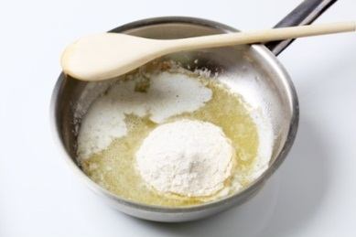
Roux method - flour is stirred into melted fat. Liquid is then carefully added. The sauce is heated and brought to the boil, stirring all the time.

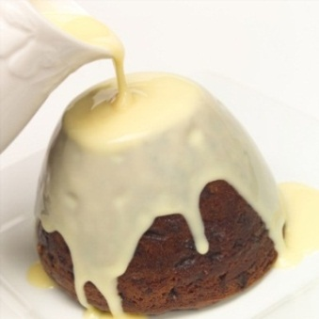
Blended method – starch is blended with the liquid. No fat is added. The remaining liquid is heated. The hot liquid is poured onto the cornflour blended mixture stirring carefully. The sauce is returned to the pan and brought back up to the boil stirring all the time.

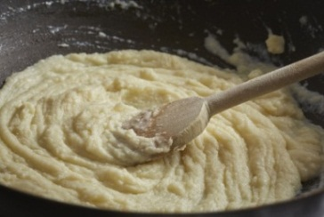
All-in-one - uses the same ingredients and proportions as the roux method but all ingredients and cold liquid are mixed together in a pan then brought to the boil. Stirring or whisking is required all the time to prevent the sauce from going lumpy.

Technical skill - gelatinisation (scientific explanation)

(thickening a liquid with a starch when heat is applied)
Starch grains are mixed into a liquid. The starch grains do not dissolve they are suspended in the liquid. This is called a suspension. When the starch grains are put in a liquid and then heated, the starch grains will start to absorb the liquid. They will swell and get bigger this will start at 60̊C. This makes the sauce start to thicken, because there is less room for the swollen grains to move around. Stirring helps to keep the starch grains suspended. If the liquid is not stirred, the starch grains will join together and form lumps.
At 80̊C the starch grains are so swollen that they start to burst and release starch molecules into the surrounding liquid. At boiling point 100̊C the sauce completely thickens.
The whole process is known as gelatinisation.

A chart to show the viscosity of white sauces
Different types of sauces use similar ingredients but are combined in different ratios using varied methods to produce a variety of thickness, textures and finishes. Traditionally three thicknesses can be achieved, a pouring sauce, a coating sauce and a binding sauce.
 | Proportion of ingredients | Ratio | Method | Outcome
Pouring white sauce | 15g plain flour  15g fat  250ml milk | 1:1:15 | Roux or all in one method | Smooth well flavoured sauce Pours freely
Coating white sauce | 25g plain flour  25g fat  250ml milk | 1:1:10 | Roux or all in one method | Smooth well flavoured sauce, thick enough to coat the back of a spoon
Binding white sauce | 50g plain flour  50g fat  250ml milk | 1:1:5 | Roux or all in one method | Smooth well flavoured sauce Very thick to hold other ingredients or bind them together

Reduction sauce
In cooking, reduction is the process of thickening and intensifying the flavour of a liquid mixture such as soup, sauce, wine or juice by simmering or boiling.

Emulsion sauce
Food products such as mayonnaise, milk, butter and Hollandaise sauces are emulsions of either oil in water or water in oil.
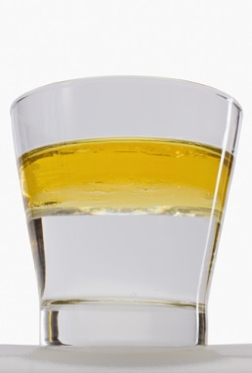
Liquids such as oil and water do not mix. They are said to be ‘immiscible’, they do not mix.
To stop the mixture from separating an extra substance must be added to attract the two parts together. The ‘matchmaker’ is called an emulsifying agent.

An emulsifying agent is a substance which contains both a:
- ‘water loving ‘ group of molecules – hydrophilic
- ‘water hating’ group of molecules – hydrophobic
One part attracts to water and one part attracts to oil to hold the water emulsion together. The emulsifying agent lowers the surface tension between the two liquids so that they combine and form a stable emulsion.
An example of an emulsifying agent is lecithin in egg yolk. Lecithin stabilises mayonnaise and creamed mixtures.
How to make a mayonnaise
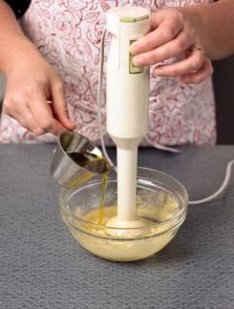
Salt, mustard, vinegar or lemon juice and egg yolks are place into a mixing bowl. Using an electric whisk or blender, the ingredients are all combined. Whisking is continued using the electric mixer whisk or blender and the oil is gradually added. Whisking/ blending is continued until thick and seasoning is added.

Type of sauce | Basic Recipe | Description of sauce | What happens when it is cooked | Example of dishes
Blended white sauce, such as a roux, all in one  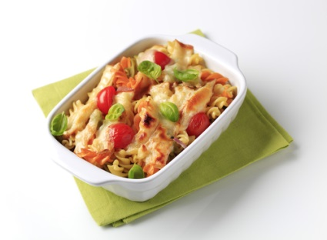 | 25g fat usually butter  25g plain flour  250ml liquid usually milk  Veloute – stock used instead of milk | Coating – coats the back of the spoon | The starch in the flour softens with the heat and absorbs the fat.  The starch grains then absorb the milk as it is heated and swell.  This causes the sauce to thicken.  Some of the starch comes out of the granules and gelatinises adding to the texture of the sauce. | Vegetable pasta bake  Fish pie  Vol au vents with creamy chicken sauce  Cauliflower cheese  Ham with parsley sauce
Reduction sauces to include, pasta, curry, gravy, meat and vegetables  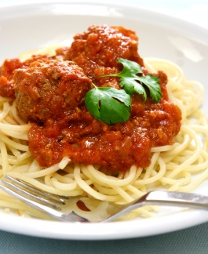 | Tomato sauce  400g tomatoes  1onion  1 clove of garlic  1 celery stick  Stock  2 tbsp oil  Herbs 1tsp | Reduced sauces  The softening of vegetables/  tomatoes adds to the texture which can be blended for a smooth consistency. | In cooking ‘reduction is the process of thickening a sauce. During boiling or simmering the water evaporates, which in turn reduces the volume of liquid and intensifies the flavour of the sauce. | Chicken with a curry sauce  Quorn with a vegetable sauce  Homemade burgers with fresh tomato sauce  Salmon with lemon, tarragon sauce

Type of sauce | Basic Recipe | Description of sauce | What happens when it is cooked | Example of dishes
Emulsion sauces to include mayonnaise, Hollandaise and salad dressings  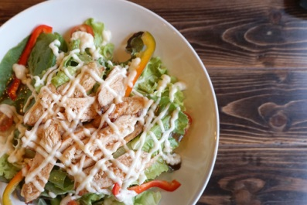 | Mayonnaise  Salt pinch  Pepper pinch  Mustard ½ tsp  2 egg yolks  Vinegar 1 tbsp  200ml oil  Salt  Boiling water | An emulsion is formed when oil and a liquid are mixed together | The oil is gradually added to the egg yolk, vinegar, salt and pepper and mustard. The lecithin in the yolk, acts as an emulsifier . Emulsifiers are molecules with two ends. One end is attracted to the vinegar and the other end is attracted to oil. Once the emulsifier has been added, the molecules arrange themselves so that they prevent the oil and vinegar from separating.  As the oil is gradually whisked in, the mayonnaise thickens. | Mayonnaise can be added to a variety of salads, or used as an accompaniment. Eggs benedict  Teriyaki chicken salad with soy and mayonnaise dressing  Tartare sauce with fish dishes.

Useful links
www.cookinglight.com/cooking-101/techniques/how-to-make-sauces
www.simplyrecipes.com/recipes/type/sauce/
http://www.jamieoliver.com/news-and-features/features/step-by-step-perfect-hollandaise-sauce/
https://www.nutrition.org.uk/healthyliving/resources.html
www.bbcgoodfood.com/videos/techniques/how-make-bechamel-white-sauce

Activity 1 - Using different sauces to make a range of recipes
Ask your students to complete Activity 1 by selecting a range of recipes which use each of the THREE different types of sauces above. List the recipe and skill level required to make each different dish/sauce item.
Sauce | Three recipes | Justify skills level High/Medium/Low
Blended | 1 Lemon meringue pie  2  3 | High  2. Preparation and techniques  5. Set a mixture  3. Cooking methods  6. Raising agents  7. Dough  8. Judge and manipulate sensory properties
Reduction | 1 Spaghetti, meatballs and tomato sauce  2  3 | Medium  High if pasta dough is made  1. Knife skills  2. Preparation and techniques  3. Cooking methods  4. Sauces  3. Cooking methods  7. Dough  8. Judge and manipulate sensory properties
Emulsion | 1 Salmon and potato fishcakes with watercress and hollandaise sauce  2  3 | High  1. Knife skills  3. Cooking methods  2. Preparation and techniques  3. Cooking methods  4. Sauces  8. Judge and manipulate sensory properties

Activity 2 - Functions of ingredients in key types of sauces
Ask your students to complete Activity 2 by completing the key functions of ingredients when making three different types of sauces. Answers are shown below.
Ingredient | Blended | Reduction | Emulsion
Flour  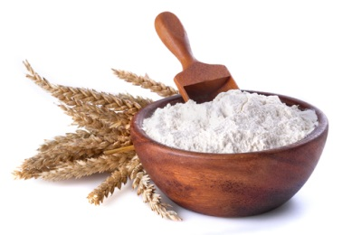 | Why is plain flour used?  The starch in the flour softens with the heat  To thicken the sauce  Gelatinisation | Not used  However the starch in potatoes (fecule) softens with the heat and thickens  Gelatinisation | Not used

Ingredient | Blended | Reduction | Emulsion
Fat  Hard margarine, butter and white fat  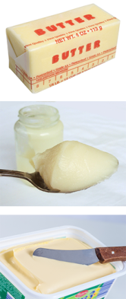 | What function does fat have in this sauce?  The starch absorbs the fat when heated  Provides flavour and colour | Not used | What function does fat/oil have in making a salad dressing?  To form an emulsion  Oil is used and it thickens the mayonnaise as it is whisked in the mixture.

Ingredient | Blended | Reduction | Emulsion
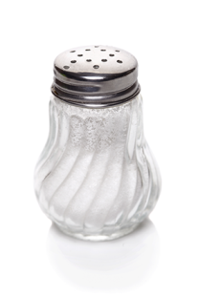  Salt  Herbs  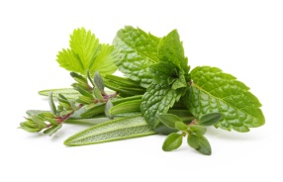 | Why is salt and/or herbs added?  Helps develop the flavour. | Why is salt and/or herbs added?  Helps develop different flavours. | Why is salt and/or herbs added?  Helps develop different flavours.
Eggs  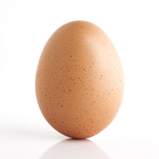 | Not used | Not used | What are the key functions of using egg in a sauce?  Enriches and thickens the sauce  Forms an emulsion when mixed with fat
Liquid – Milk/Stock/Water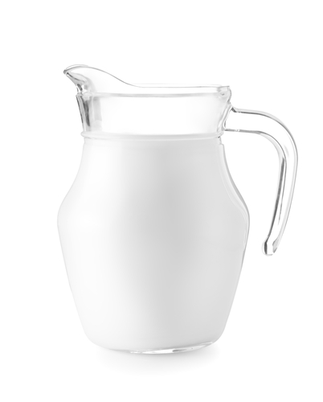 | What is the function of a liquid?  Starch granules absorb the liquid and swell when heated | What is the function of a liquid?  Starch granules absorb the liquid and swell when heated | What is the function of a liquid?  Not used

Activity 3 - Recognising faults when making a sauce – Fact Sheet
There are many reasons why a sauce is not successful and many common faults that can occur when making different sauces. Some faults have more than one reason. Here is the fault/reason list which is also in the student section; you may want students to complete the table with or without the aid of this fact sheet.
Fault | Reason
Roux sauce - lumpy | Fat too hot when the flour was added.  The roux was not cooked enough.  The liquid was added to quickly and the mixture was not stirred sufficiently.  The sauce was not stirred during the cooking.
Blended sauce - lumpy | The cornflour/flour and liquid not blended sufficiently.  The sauce was not stirred during the cooking.
All-in-one sauce - lumpy | The sauce was not stirred during the cooking.
Roux, blended, and all-in-one - raw flavour | The sauce was not cooked for long enough.
Roux, blended and all-in-one - too thick or too thin | Incorrect weighing and / or measuring of ingredients.
Roux, blended and all-in-one - greasy | Too much fat added to sauce mixture.
Mayonnaise - curdled | Too much acid may have been added. In most cases curdling occurs because proteins in the sauce are denatured and bind with each other forming lumps or clumps.
Mayonnaise – too thin | Too much oil added.

Activity 4 – Fact sheet
This is what happens when GELATINSATION occurs.
There is a change in the shape and size of the granules when they have been mixed with a liquid and heated because:
- the starch granules swell and absorb the liquid;
- as the starch is heated some of the granules ‘ escape’ into the surrounding liquid;
- the starch granules continue to absorb the water and swell until they become weak and break (rupture);
- this happens especially when the mixture is stirred;
- when the granules rupture starch is released and the thickness/viscosity of the mixture begins to increase;
- the network of starch and swollen granules forms, this is called a gel;
- the whole process is called gelatinisation of starch.

The higher the ratio of starch to a liquid the thicker the gel becomes. This explains why a recipe for a coating sauce has more flour than for a pouring sauce.
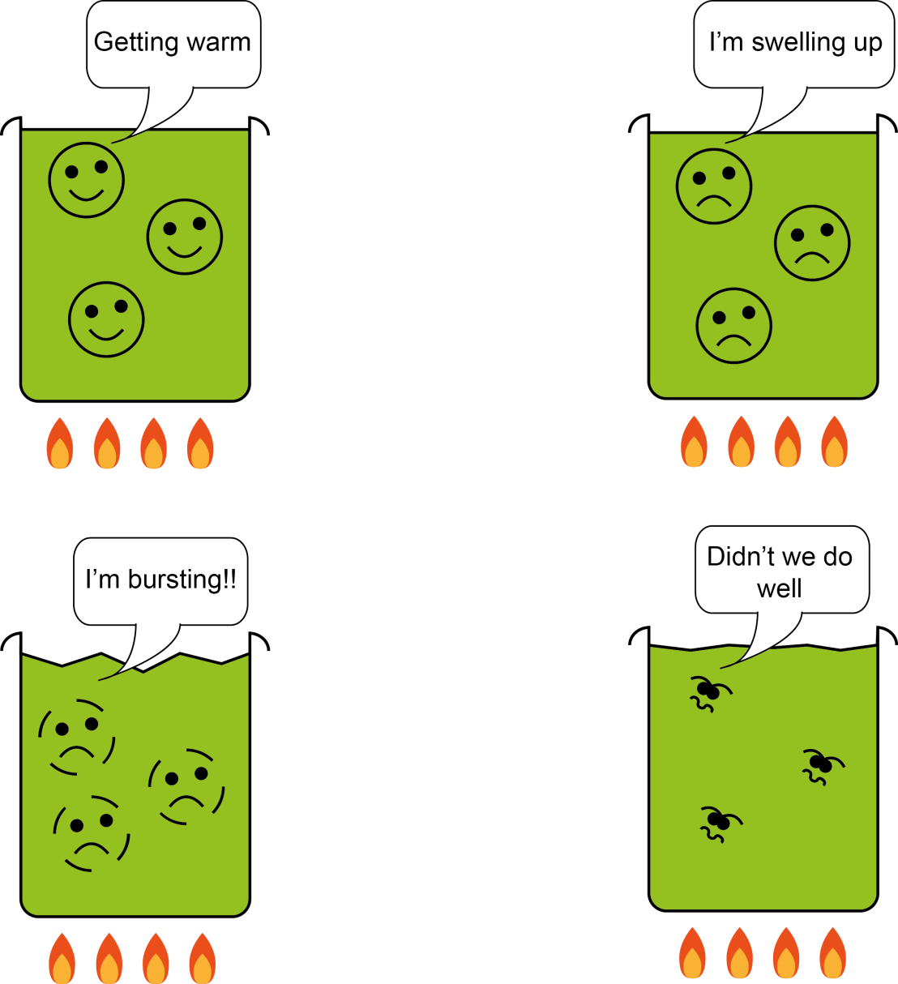
Heat starch granules in liquid
Starch granules burst
The liquid thickens and gelatinises
Starch granules become swollen
Starch gelatinises when heated in a liquid, producing a thickened liquid.
Gelatinisation of Starch - Recap
Starch grains will not dissolve in liquid.
The liquid must be HEATED so the starch grains will swell and rupture.
At 60̊ C liquid is absorbed by starch.
The starch grains SOFTEN and SWELL up to five times their original size.
Heating continues to 80̊̊ C.
The starch grains RUPTURE releasing starch.
The mixture becomes THICK and VISCOUS.
The starch had GELATINISED – a gel has formed.
When cool the gel SETS and the sauce becomes SOLID.

Activity 5 - Do starches change when heated in water?
This aim of this scientific task will enable you to see if there is a change in the size and appearance of starches when they are heated in water.
Materials required
1 teaspoon (5g) plain flour
1 teaspoon (5g) cornflour
2 dessertspoons (10ml) of boiling water
2 small basins or 2 x 100ml glass beakers
Microscope
2 microscope slides
2 coverslips
Mounted needle
1 label ‘wheat starch’
1 label ‘corn starch’

Instructions to follow
Test one – plain flour
- Put a teaspoon(5g) of plain flour in basin
- Pour one dessertspoon(10ml) of boiling water over it and stir to mix
- Put a drop of mixture onto a microscope slide and label.
- Record what you see
- Draw the granules to show their shape and size
Test two – cornflour
- Put a teaspoon of cornflour in a basin
- Pour one dessertspoon of boiling water over and mix
- Follow stages 3 to 5 above from test one
- Compare the size and shape of the wheat flour and cornflour granules.
- Record your observations.

Useful links

www.slideshare.net/harrietcarpenter/carbohydrates-gelatinisation-and-modified-starch
www.foodscience-avenue.com/2012/02/process-of-gelatinization.html

Activity 6 - Sauces from around the world and serving suggestions for sauces
Select a traditional British sauce and one from a different country to try. You can even adapt the recipe to suit your own dish and taste.
Serving suggestions for sauces
Matching the right sauce to the right dish is as important as making the sauce in the first place. Sauces should complement the food with which they are served. The end result of combined flavours, colours, and textures need to be considered as a whole - not the result of a few randomly slung together parts! It’s often a good idea to experiment, as sometimes the most unexpected tasty dishes can be made this way.

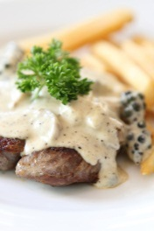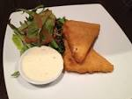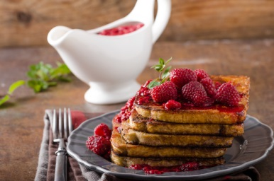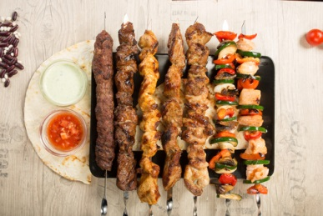

Some popular savoury British sauces
- Gravy - probably the best known sauce. Imagine your roast dinner without it.
- Bread sauce has been served with chicken for hundreds of years.
- Cheese sauce can be adapted to go with just about any fish, vegetable, poultry, ham, bacon and egg dishes.
- Onion sauce with sausages as well as lamb is delicious. It is also good with cold meats and can be mixed with grated cheese and toasted to make a tasty snack.
- Tomato sauce is an extremely versatile sauce. Excellent with homemade burgers.
- Hollandaise sauce is a classic - serve with fish, egg, chicken and vegetable dishes.
- Apple sauce is traditionally served with pork and cranberry sauce with turkey.
Some popular sauces from around the world
- Chinese cuisine - uses soy, hoisin, oyster, sweet and sour and chilli bean sauce.
- Indian cuisine - uses tomato based curry sauces, tamarind sauce, coconut based sauces and chutneys. Many sauces use a mix of onion, ginger and garlic as the base of various sauces. Vegetable oils and ghee are used to fry the sauce ingredients.
- Mexican - pico, salsa, guacamole, hot sauce and mole are all integral to Mexican cuisine.
- Japanese – horseradish or wasabi sauce is used on sushi or sashimi.
- Italian – Sauces in Italian cuisine include: Bolognese, arrabiata, pesto, pomodoro (tomato) and marinara sauce.
- Korean -uses sauces such doenjang, gochujang, samjang, aekjeot and soy sauce.
- French cuisine – some classic sauces are Bechamel, , roux, veloute and Hollandaise.
Useful links:
How to make a variety of tasty sauces - www.learncooking.co.uk › Stocks & Sauces

www.cookinglight.com/cooking-101/techniques/how-to-make-sauces
www.rouxbe.com/how-to-cook/how-to-make-sauce

We’d like to know your view on the resources we produce. By clicking on ‘Like’ or ‘Dislike’ you can help us to ensure that our resources work for you. When the email template pops up please add additional comments if you wish and then just click ‘Send’. Thank you.
Whether you already offer OCR qualifications, are new to OCR, or are considering switching from your current provider/awarding organisation, you can request more information by completing the Expression of Interest form which can be found here: www.ocr.org.uk/expression-of-interest
Looking for a resource? There is now a quick and easy search tool to help find free resources for your qualification:
www.ocr.org.uk/i-want-to/find-resources/

OCR Resources: the small print
OCR’s resources are provided to support the teaching of OCR specifications, but in no way constitute an endorsed teaching method that is required by the Board, and the decision to use them lies with the individual teacher. Whilst every effort is made to ensure the accuracy of the content, OCR cannot be held responsible for any errors or omissions within these resources.
© OCR 2017 - This resource may be freely copied and distributed, as long as the OCR logo and this message remain intact and OCR is acknowledged as the originator of this work.
OCR acknowledges the use of the following content: pages 3 and 5: Roux sauce – Viktor1/Shutterstock.com, page 3: Reduction sauce – Deniolog/Shutterstock.com, Emulsion sauce – Istetiana/Shutterstock.com, page 5: Blended method – Lisaadphotography/Shutterstock.com, All-in-one – Brian Yarvin/Shutterstock.com, page 7: Oil and water – Imagedb.com/Shutterstock.com, Making mayo – Bratwustle/Shutterstock.com, page 8: Pasta dish – Viktor1/Shutterstock.com, Meatballs – Jurich Mosin/Shutterstock.com, page 9: Salad – Augustcindy/Shutterstock.com, pages 11 and 22: Flour – Ddsign/Shutterstock.com, pages 12 and 23: Butter – Hurst photo/Shutterstock.com, Lard – Sattva78/Shutterstock.com, Margarine – JPC-PROD/Shutterstock.com, pages 12 and 23: Salt – Artproem/Shutterstock.com, Herbs – Valentine Razumova/Shutterstock.com, Egg – Saradesh Papairat/Shutterstock.com, page 14 and 24: Milk/Shutterstock.com, pages 18 and 26: Scientist – Espies/Shutterstock.com, page 19: Beef – Piyato/Shutterstock.com, Raspberries on French toast – Stepanek Photography/Shutterstock.com, Kebabs - Kopytin Georgy/Shutterstock.com, page 29: Moules Mariniere – Darren Baker/Shutterstock.com, Curry – Ramon Grosso Dolorea/Shutterstock.com, Cranberry sauce – Michelle Lee Photography/Shutterstock.com, Hollondaise sauce – Koss13/Shutterstock.com
Please get in touch if you want to discuss the accessibility of resources we offer to support delivery of our qualifications: resources.feedback@ocr.org.uk

Topic Exploration Pack

Sauces

Student Activity
Sauce | Three recipes | Justify skills level High/Medium/Low
Blended | 1  2  3
Reduction | 1  2  3
Emulsion | 1  2  3

Activity - 1 Using different sauces to make a range of recipes
Using the three different sauces, make a range of recipes

Activity 2 -Functions of ingredients in key types of sauces
Complete Student Activity 2 by completing the key functions of ingredients when making three different types of sauces. Answers are shown below.
Ingredient | Blended | Reduction | Emulsion
Flour | Why is plain flour used? | Not used | Not used
Fat  Hard margarine, butter and white fat | What function does fat have in this sauce? | Not used | What function does fat/oil have in making a salad dressing?
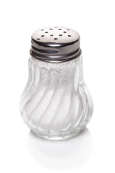  Salt  Herbs  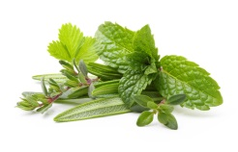 | Why is salt and/ or herbs added? | Why is salt and/or herbs added? | Why is salt and/or herbs added?
Eggs | Not used | Not used | What are the key functions of using egg in a sauce?
Liquid – Milk/Stock/Water | What is the function of a liquid? | What is the function of a liquid? | Not used

Activity 3 - Recognising faults when making a sauce – Fact Sheet
Complete Activity 3 by completing the chart of common faults with reasons when making different sauces. Some faults have more than one reason.
Fault | Reason
Roux sauce - lumpy
Blended sauce - lumpy
All-in-one sauce - lumpy
Roux, blended, and all-in-one - raw flavour
Roux, blended and all-in-one - too thick or too thin
Roux, blended and all-in-one - greasy
Mayonnaise - curdled
Mayonnaise – too thin

Activity 4 – Do Starches change when heated in water?
This aim of this scientific task will enable you to see if there is a change in the size and appearance of starches when they are heated in water.
Materials required
1 teaspoon (5g) plain flour
1 teaspoon (5g) cornflour
2 dessert spoons (10ml) of boiling water
2 small basins or 2 x 100ml glass beakers
Microscope
2 microscope slides
2 coverslips
Mounted needle
1 label ‘wheat starch’
1 label ‘corn starch’

Instructions to follow
Test one – plain flour
- Put a teaspoon(5g) of plain flour in basin.
- Pour one dessertspoon(10ml) of boiling water over it and stir to mix.
- Put a drop of mixture onto a microscope slide and label.
- Record what you see.
- Draw the granules to show their shape and size.
Test two – cornflour
- Put a teaspoon of cornflour in a basin.
- Pour one dessertspoon of boiling water over and mix.
- Follow stages 3 to 5 above from test one.
- Compare the size and shape of the wheat flour and cornflour granules.
- Record your observations.

Key facts

Activity 5 – Gelatinisation of starch
Test your knowledge by answering the questions in Section A and filling in the missing words in Section B.
Recap activity A
What do starch granules require to dissolve?

What happens to the starch granules when liquid is heated?

What temperature does starch get absorbed in a liquid?

How many times can starch granules increase their size when making a sauce?

What temperature does heating continue to reach?

What is the scientific term used when the starch is released?

What happened to the mixture?

What is the term used when starch becomes a gel?

What happens to the gel when it cools?

Complete gaps in the sentences below

Recap activity B

Starch granules will not dissolve in

The liquid must be HEATED so the granules will and

At C liquid is absorbed by starch

The granules and up to times their original size

Heating continues to C

The starch granules releasing starch

The mixture becomes and

The starch had a gel has formed

When cool the gel and the sauce becomes

The term for this process is called

Activity 6 - Sauces from around the world and serving suggestions for sauces
Select a traditional British sauce and one from a different country to try. You can even adapt the recipe to suit your own dish and taste.
Remember to be adventurous and choose and cook something you have not attempted before.
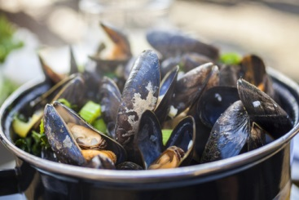 Moules Mariniere
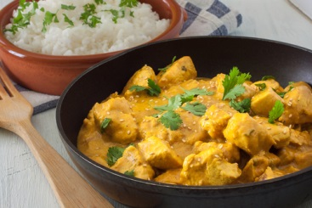 Curry sauce
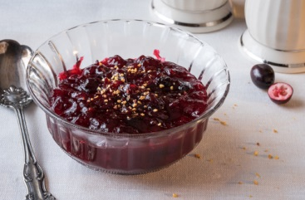 Cranberry sauce
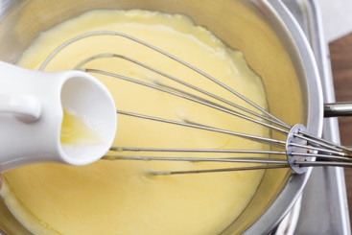 Hollandaise sauce

