Chemistry PAG 5: Identification of species

Suggested Activity 1: Precipitation and flame tests

Instructions and answers for teachers
and technicians
These instructions cover the learner activity section which can be found on page 16. This Practical activity supports OCR GCSE Chemistry. While precipitation and flame tests are not part of the Combined Science course, this activity can still be used in teaching this course to provide interesting context, and several Apparatus and Techniques common to Chemistry and Combined Science are covered.
When distributing the activity section to the learners either as a printed copy or as a Word file you will need to remove the teacher instructions section.
This is a suggested practical activity that can be used as part of teaching the GCSE (9-1) Gateway Science (A) and Twenty First Century Science (B) specifications.
These are not controlled assessment tasks, and there is no requirement to use these particular activities.
You may modify these activities to suit your learners and centre. Alternative activities are available from, for example, Royal Society of Biology, Royal Society of Chemistry, Institute of Physics, CLEAPSS and publishing companies, or of your own devising.
Further details are available in the specifications (Practical Skills Topics), and in these videos.

This resource is adapted from the Classic Chemistry Experiments book, developed by the Royal Society of Chemistry –http://pubs.rsc.org/en/content/ebook/978-0-85404-919-6 specifically the practical ‘Testing salts for anions and cations’ – http://www.rsc.org/learn-chemistry/resource/res00000464/testing-salts-for-anions-and-cations.

OCR recommendations:
Before carrying out any experiment or demonstration based on this guidance, it is the responsibility of teachers to ensure that they have undertaken a risk assessment in accordance with their employer’s requirements, making use of up-to-date information and taking account of their own particular circumstances. Any local rules or restrictions issued by the employer must always be followed.
CLEAPSS resources are useful for carrying out risk-assessments: (http://science.cleapss.org.uk).
Centres should trial experiments in advance of giving them to learners. Centres may choose to make adaptations to this practical activity, but should be aware that this may affect the Apparatus and Techniques covered by the learner.

Introduction
In this activity, learners will investigate up to eight samples of unknown composition by precipitation and flame test analysis.
The teacher should demonstrate each expected observation first, and learners note they have seen the expected observation. They then work in groups of 4 to complete analysis of up to eight of the samples (1 to 8). Learners can then carry out flame testing on the solid samples.

DfE Apparatus and Techniques covered
The codes used below match the OCR Practical Activity Learner Record Sheet (Chemistry / Combined Science) and Trackers (Chemistry / Combined Science) available online. There is no requirement to use these resources.
By doing this experiment, learners have an opportunity to develop the following skills:
2 [2]: Safe use of appropriate heating devices and techniques including use of: i) a Bunsen burner
3 [8]: Use of appropriate apparatus and techniques for: i) conducting and monitoring chemical reactions; ii) conducting and monitoring chemical reactions, including appropriate reagents and/or techniques for the measurement of pH in different situations
6 [11]: Safe use and careful handling of gases, liquids and solids, including: i) careful mixing of reagents under controlled conditions; ii) using appropriate apparatus to explore chemical changes and/or products
8: Use of appropriate qualitative reagents and techniques to analyse and identify unknown samples or products including: i) gas tests; ii) flame tests; iii) precipitation reactions

Aims
To identify ions by qualitative analysis and determine the composition of an unknown substance.

Intended class time
45–50 min

Links to Specifications:

Gateway Science (Suite A) – including Working Scientifically (WS)
C3.1a use chemical symbols to write the formulae of elements and simple covalent and ionic compounds
C3.1e construct balanced ionic equations
C3.1f describe the physical states of products and reactants using state symbols (s, l, g and aq)
C3.3f recall that carbonates and some metals react with acids and write balanced equations predicting products from given reactants
C4.2b describe tests to identify aqueous cations and aqueous anions [to include calcium, copper, iron(II), iron(III) and zinc using sodium hydroxide; carbonates and sulfates using aqueous barium chloride followed by hydrochloric acid; chloride, bromide and iodide using silver nitrate]
C4.2c describe how to perform a flame test
C4.2d identify species from test results
C4.2e interpret flame tests to identify metal ions
WS1.3a/WS2c presenting observations and other data using appropriate methods
WS1.3e interpreting observations and other data
WS1.3f presenting reasoned explanations
WS1.3i/WS2d communicating the scientific rationale for investigations, methods used, findings and reasoned conclusions.
WS1.4a use scientific vocabulary, terminology and definitions
WS2a carry out experiments
WS2b make and record observations and measurements using a range of apparatus and methods

Twenty First Century Science (Suite B) – including Ideas about Science (IaS)
C2.4.4 describe the physical states of products and reactants using state symbols (s, l, g and aq)
C3.2.3 use the names and symbols of common elements and compounds and the principle of conservation of mass to write formulae and balanced chemical equations and ionic equations
C5.2.2 interpret flame tests to identify metal ions, including the ions of lithium, sodium, potassium, calcium and copper
C5.2.4 describe tests to identify aqueous cations and aqueous anions and identify species from test results including: a) tests and expected results for metal ions in solution by precipitation reactions using dilute sodium hydroxide (calcium, copper, iron(II), iron(III), zinc) b) tests and expected results for carbonate ions (using dilute acid), chloride, bromide and iodide ions (using acidified dilute silver nitrate) and sulfate ions (using acidified dilute barium chloride or acidified barium nitrate)
C6.1.1 recall that acids react with some metals and with carbonates and write equations predicting products from given reactants
IaS2.1 present observations and other data using appropriate formats
IaS2.4 be able to translate data from one form to another
IaS2.8 when analysing data identify patterns/trends, use statistics (range and mean) and obtain values from a line on a graph (including gradient, interpolation and extrapolation),
IaS2.10 evaluate an experimental strategy, suggest improvements and explain why they would increase the quality (accuracy, precision, repeatability and reproducibility) of the data collected, and suggest further investigations
IaS2.11 in a given context interpret observations and other data (presented in diagrammatic, graphical, symbolic or numerical form) to make inferences and to draw reasoned conclusions, using appropriate scientific vocabulary and terminology to communicate the scientific rationale for findings and conclusions

Mathematical Skills covered
No defined mathematical skill is covered in this experiment.

Technical Requirements – PER GROUP

Chemicals
Identity | Approximate quantity required | Hazard information |  | Risk information
PAG 5.1 – Sample 1  copper(II) chloride-2-water solid, CuCl₂·5H₂O(s) | small pot |  | WARNING  Harmful if swallowed, causes skin irritation and serious eye irritation, very toxic to aquatic life with long lasting effects.
PAG 5.1 – Sample 2  potassium carbonate solid, K₂CO₃(s) | small pot |  | WARNING  Causes serious eye irritation
PAG 5.1 – Sample 3  potassium iodide solid, KI(s) | small pot | Not currently classified as hazardous
PAG 5.1 – Sample 4  copper(II) sulfate-5-water solid, CuSO₄·5H₂O(s) | small pot |  | WARNING  Harmful if swallowed, causes skin and serious eye irritation, very toxic to aquatic life with long lasting effects
PAG 5.1 – Sample 5  iron(III) chloride-6-water solid, FeCl₃·6H₂O(s) | small pot |  | DANGER  Harmful is swallowed, causes skin and serious eye irritation
PAG 5.1 – Sample 6  iron(II) sulfate-7-water solid, FeSO₄·7H₂O(s) | small pot |  | WARNING  Harmful if swallowed, causes skin and serious eye irritation
PAG 5.1 – Sample 7  aluminium chloride-6-water solid, AlCl₃·6H₂O(s) | small pot |  | WARNING  Causes skin and serious eye irritation, may cause respiratory irritation
PAG 5.1 – Sample 8  lithium chloride solid, LiCl(s) | small pot |  | WARNING  Harmful if swallowed, causes skin irritation and serious eye irritation
0.4 mol/dm³ aqueous nitric(V) acid, HNO₃(aq) | 35 cm³ |  | WARNING  Causes skin irritation and serious eye irritation
0.05 mol/dm³ aqueous silver nitrate(V), AgNO₃(aq) | 35 cm³ | Currently not classified as hazardous at this concentration |  | Solutions cause skin to blacken and will stain clothing and some bench surfaces.
0.4 mol/dm³ aqueous nitric acid HNO₃ (aq) | 60 cm³ |  | WARNING  Causes skin and eye irritation
1.0 mol/dm³ aqueous ammonia, NH₃(aq) | 90 cm³ |  | WARNING  Causes skin and eye irritation | Ensure room is well ventilated  Avoid inhaling vapour
0.4 mol/dm³ aqueous hydrochloric acid, HCl(aq) | 60 cm³ | Currently not classified as hazardous at this concentration
0.1 mol/dm³ aqueous barium chloride, BaCl₂(aq) | 35 cm³ | Currently not classified as hazardous at this concentration
0.4 mol/dm³ aqueous sodium hydroxide, NaOH(aq) | 50 cm³ |  | WARNING  Causes skin irritation and serious eye irritation
sodium chloride solid, NaCl(s) | 5 g | Currently not classified as hazardous
sodium bromide solid, NaBr(s) | 5 g | Currently not classified as hazardous
sodium iodide solid, NaI(s) | 5 g | Currently not classified as hazardous
copper(II) sulfate-5-water solid, CuSO₄·5H₂O(s) | 5 g |  | WARNING  Harmful if swallowed, causes skin and serious eye irritation, very toxic to aquatic life with long lasting effects
iron(II) sulfate-7-water solid, FeSO₄·7H₂O(s) | 5 g |  | WARNING  Harmful if swallowed, causes skin and serious eye irritation
iron(III) chloride-6-water solid, FeCl₃·6H₂O(s) | 5 g |  | DANGER  Harmful is swallowed, causes skin and serious eye irritation
lead(II) nitrate(V), Pb(NO₃)₂(s) | 5 g |  | DANGER  Harmful if swallowed or inhaled, may damage the unborn child and suspected of damaging fertility. May cause damage to organs through prolonged or repeated exposure. Very toxic to aquatic life with long lasting effects.
zinc(II) sulfate(VI)-7-water, ZnSO₄·7H₂O(s) | 5 g |  | DANGER  Harmful if swallowed. Causes serious eye damage. Very toxic to aquatic life with long lasting effects.
aluminium chloride-6-water solid, AlCl₃(s) | 5 g |  | WARNING  Causes skin and serious eye irritation. May cause respiratory irritation.
ammonium chloride solid, NH₄Cl(s) | 5 g |  | WARNING  Causes serious eye irritation.
calcium carbonate solid, CaCO₃(s) | 5 g | Currently not classified as hazardous
barium carbonate solid, BaCO₃(s) | 5 g |  | WARNING  Harmful if swallowed
lithium chloride solid, LiCl(s) | 5 g |  | WARNING  Harmful if swallowed. Causes skin and serious eye irritation.
potassium chloride, KCl(s) | 5 g | Currently not classified as hazardous
magnesium sulfate, MgSO₄(s) | 5 g | Currently not classified as hazardous
wide range of salts  PRODUCED | small amounts PRODUCED | Given the presence of lead and barium, assume the mixture is harmful. |  | All mixtures should be collected in a waste container and disposed of via a foul water drain with copious amounts of water

Equipment – assuming 8 groups
- Per group:
  - 2 boiling tubes (16 total)
  - 10 test tubes (80 total)
  - access to pots of Sample 1, Sample 2 etc with a spatula
  - access to deionised water
  - measuring cylinder (10 cm³)
  - dropper pipette
  - glass marker pen

- Five wet-chemistry stations:
  - 3 dropping pipette per solution (24 total)
  - red litmus paper / full range indicator paper (for Test D station)
  - tissues / paper towels

- One Bunsen burner station
  - 3 heat proof mat
  - 3 Bunsen burners
  - 8 clean nichrome loops (labelled Sample 1, Sample 2 etc)
  - 3 beakers of deionised water

- For teacher demonstrations
  - 14 boiling tubes
  - spatula
  - tissue / paper towel

- Large container for waste collection

Health and Safety
Eye protection should be worn at all times.
Ensure the laboratory is well ventilated. Take particular care if you have any asthmatic members of the group.
This can be a very busy lesson with lots of equipment and different substances being used. Be particularly vigilant of glassware and samples near edges of benches, spills and learners deviating from the given method.
A half full bucket of water is a useful waste receptacle for learners’ waste solutions, allowing for proper disposal at the end of the lesson.

Method
Demonstration of the expected results
- Depending on the size of the group / room / access to a visualiser / USB webcam etc, decide how large a sample to make up to demonstrate the expected observations.
- Carry out Test A on samples of sodium chloride, sodium bromide and sodium iodide.
- Carry out Test B on a sample of magnesium sulfate.
- Carry out Test C on a sample of potassium carbonate.
- Carry out Test D and Test E on samples of copper sulfate, iron(II) sulfate, iron(III) chloride, lead nitrate, zinc chloride, aluminium chloride and ammonium chloride.
- Carry out flame tests on barium carbonate, calcium carbonate, copper sulfate, lithium chloride, potassium chloride, sodium chloride and iron(III) chloride.
- NOTE: If nichrome loops are being reused, they can be cleaned with concentrated hydrochloric acid (DANGER: Causes severe skin burns and eye damage. May cause respiratory irritation) and flaming. Carry out your own risk assessment as to whether you allow your learners to use this technique.
- NOTE: There are some ‘false positives’ in these reactions. e.g. Test A for halides on Sample 6. FeSO₄ will give a white precipitate. Learners should ensure they are making their determination of the compound based on all the data they collect.

Learner data collection
- Set up the equipment for Test A-E at five stations around the room (the wet chemistry stations) and a Bunsen burner station for the flame tests.
- Divide the learners into groups of 4, with each pair completing tests on one of the eight Samples, then sharing results.
- If time and resources are available, learners can carry out tests on additional Samples.
- Given the large amount of liquid manipulation required in this activity, there is potential for cross-contamination of stock bottles. Labelled pipettes can minimise this risk, or having available a 250 cm³ beaker of deionised water available for rinsing pipettes.
- Use of spatulas can also cause issues with cross-contamination. Having tissues / paper towels available to wipe clean spatulas can help here.

Images from trials
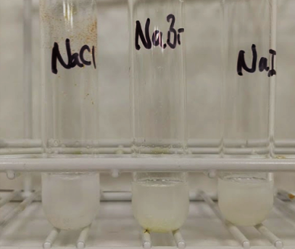 | 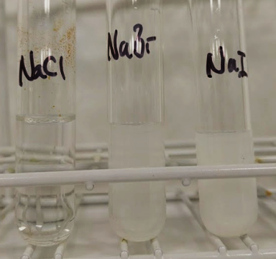
Sodium halides + nitric acid + silver nitrate | Silver halide precipitates + ammonia solution
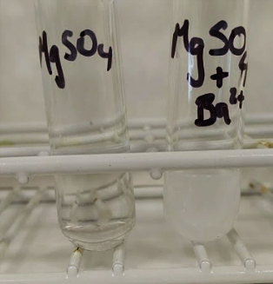 | 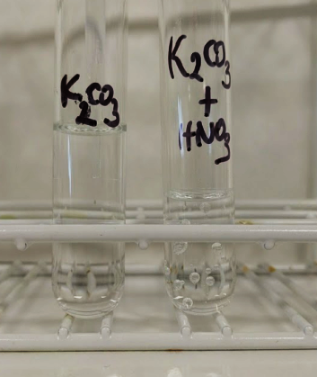
magnesium sulfate + nitric acid + barium nitrate | potassium carbonate + nitric acid

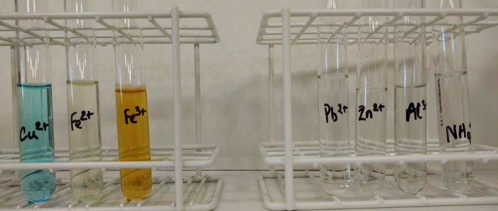 | 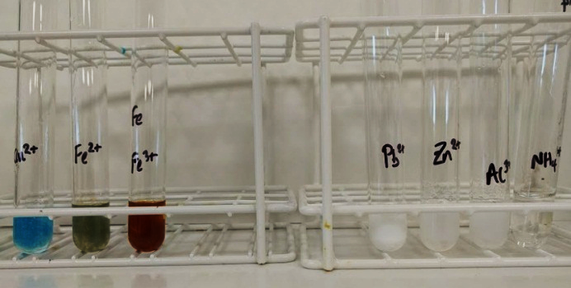
metal ion solutions | metal ion solutions + sodium hydroxide
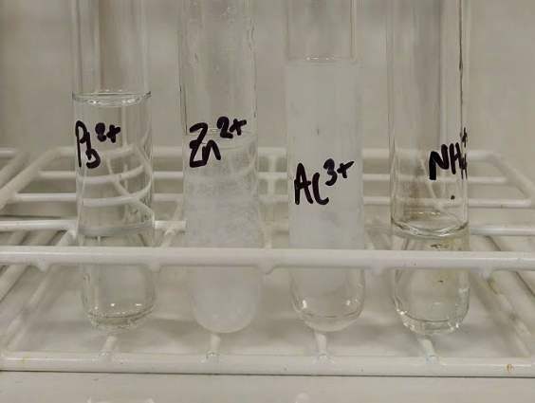 | 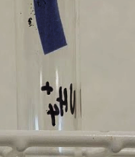
white precipitates + excess sodium hydroxide | red litmus paper in mouth of ammonium ion solution
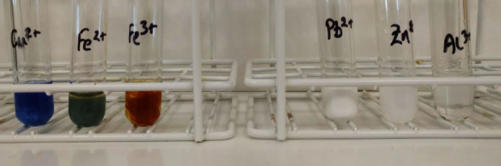 | 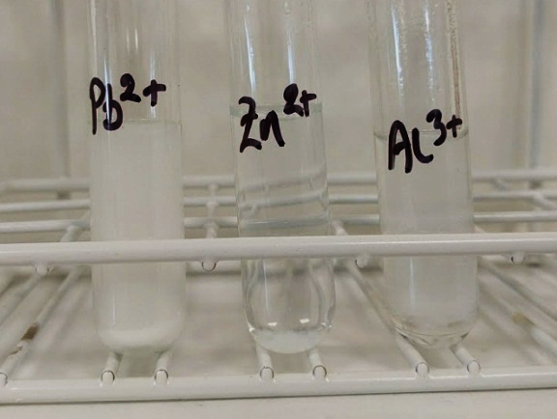
metal ion solutions + ammonia solution | white precipitates + excess ammonia

(apple green) – not seen in trial | 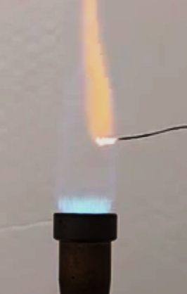 | 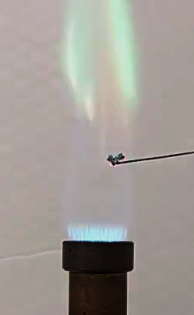 | 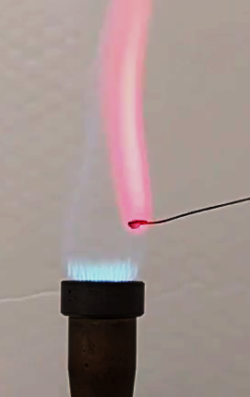
BaCO₃ | CaCO₃ | CuSO₄ | LiCl
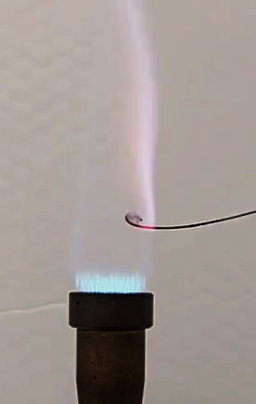 | 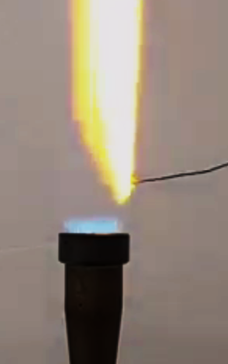 | 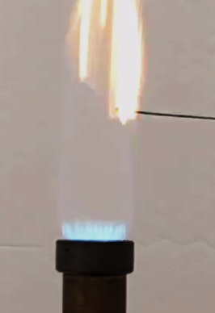
KCl | NaCl | FeCl₃

Analysis of results – Model results

Sample | Test A  Ag⁺/H⁺ | Test B  Ba²⁺ | Test C  H⁺ | Test D  OH– | Test E  NH₃ | Flame test
Example  CuI₂ | yellow precipitate formed, didn’t dissolve in ammonia | no change | no change | blue precipitate | blue precipitate, dissolves in excess NH₃ | green/blue
1: copper chloride  CuCl₂ | white precipitate formed, dissolved in ammonia | no change | no change | blue precipitate | blue precipitate, dissolves in excess NH₃ | green/blue
2: potassium carbonate K₂CO₃ | bubbles formed | bubbles formed | bubbles formed | no change | no change | lilac
3: potassium iodide KI | yellow precipitate formed, didn’t dissolve in ammonia | no change | no change | no change | no change | lilac
4: copper sulfate CuSO₄ | white precipitate formed | white precipitate | no change | blue precipitate | blue precipitate, dissolves in excess NH₃ | green/blue
5: iron(III) chloride FeCl₃ | white precipitate formed, dissolved in ammonia | no change | no change | brown precipitate | brown precipitate | orange
6: iron(II) sulfate  FeSO₄ | white precipitate formed | white precipitate | no change | green precipitate | green precipitate | orange
7: aluminium chloride AlCl₃ | white precipitate formed, dissolved in ammonia | no change | no change | white precipitate | white precipitate | no change
8: lithium chloride LiCl | white precipitate formed, dissolved in ammonia | no change | no change | no change | no change | bright red

Extension opportunities
1. | Write word and ionic equations for each positive test you carried out for the substance you tested.
The word and symbol equations learners will write depend on their sample:

silver nitrate + potassium chloride → silver chloride + potassium nitrate
AgNO₃ (aq) + KCl(aq) → AgCl(s) + KNO₃(aq)
Ag⁺(aq) + Cl–(aq) → AgCl(s)

silver nitrate + potassium bromide → silver bromide + potassium nitrate
AgNO₃ (aq) + KBr(aq) → AgBr(s) + KNO₃(aq)
Ag⁺(aq) + Br–(aq) → AgBr(s)

silver nitrate + potassium iodide → silver iodide + potassium nitrate
AgNO₃ (aq) + KI(aq) → AgI(s) + KNO₃(aq)
Ag⁺(aq) + I–(aq) → AgI(s)

sodium hydroxide + iron(II) sulfate → iron(II) hydroxide + sodium sulfate
2NaOH(aq) + FeSO₄(aq) → Fe(OH)₂(s) + Na₂SO₄(aq)
2OH–(aq) + Fe²⁺(aq) → Fe(OH)₂(s)

sodium hydroxide + iron(III) sulfate → iron(III) hydroxide + sodium sulfate
6NaOH(aq) + Fe₂(SO₄)₃(aq) → 2Fe(OH)₃(s) + 3Na₂SO₄(aq)
3OH–(aq) + Fe³⁺(aq) → Fe(OH)₃(s)

sodium hydroxide + copper(II) sulfate → copper(II) hydroxide + sodium sulfate
2NaOH(aq) + CuSO₄(aq) → Cu(OH)₂(s) + Na₂SO₄(aq)
2OH–(aq) + Cu²⁺(aq) → Cu(OH)₂(s)

sodium hydroxide + zinc chloride → zinc hydroxide + sodium chloride
2NaOH(aq) + ZnCl₂(aq) → Zn(OH)₂(s) + 2NaCl (aq)
2OH–(aq) + Zn²⁺(aq) → Zn(OH)₂(s)

sodium hydroxide + calcium chloride → calcium hydroxide + sodium chloride
2NaOH(aq) + CaCl₂(aq) → Ca(OH)₂(s) + 2NaCl (aq)
2OH–(aq) + Ca²⁺(aq) → Ca(OH)₂(s)

potassium carbonate + hydrochloric acid → potassium chloride + carbon dioxide + water
K₂CO₃(s) + 2HCl(aq) → 2KCl(aq) + CO₂(g) + H₂O(l)
CO₃^{2–}(aq) + 2H⁺(aq) → CO₂(g) + H₂O(l)

2. | An analytical chemist has received a small sample of a contaminant found in a batch of pain killers. They need to identify the chemical identity of the contaminant quickly. Discuss the advantages of using instrumental techniques. [3 marks]
As instrumental techniques are sensitive, they can produce results from the small amounts of substance present .
These techniques can also be quicker than manual techniques, so results can be obtained quickly as required.
Finally, the techniques have high accuracy, which will be important to ensure the contaminant is dealt with correctly.

Document updates
v1.1 January 2017 Original - Published on qualification page

OCR Resources: the small print
This formative assessment resource has been produced as part of our free GCSE teaching and learning support package. All the GCSE teaching and learning resources, including delivery guides, topic exploration packs, lesson elements and more are available on the qualification webpages.
If you are looking for examination practice materials, you can find Sample Assessment Materials (SAMs) on the qualification webpages: here

OCR’s resources are provided to support the teaching of OCR qualifications, but in no way constitute an endorsed teaching method that is required by the Board, and the decision to use them lies with the individual teacher. Whilst every effort is made to ensure the accuracy of the content, OCR cannot be held responsible for any errors or omissions within these resources.
© OCR 2017, © Royal Society of Chemistry – this resource may freely copied and distributed by teachers for teaching purposes, student assessment and private use and by students for private use only. The OCR logo, this message and the notice of Content from the Royal Society of Chemistry must remain intact.
OCR acknowledges the use of the following content: http://www.rsc.org/learn-chemistry/resource/res00000464/testing-salts-for-anions-and-cations.
Please get in touch if you want to discuss the accessibility of resources we offer to support delivery of our qualifications: resources.feedback@ocr.org.uk
We’d like to know your view on the resources we produce. By clicking on ‘Like’ or ‘Dislike’ you can help us to ensure that our resources work for you. When the email template pops up please add additional comments if you wish and then just click ‘Send’. Thank you.
If you do not currently offer this OCR qualification but would like to do so, please complete the Expression of Interest Form which can be found here: www.ocr.org.uk/expression-of-interest
Looking for a resource? There is now a quick and easy search tool to help find free resources for your qualification:
www.ocr.org.uk/i-want-to/find-resources/

Chemistry PAG 5: Identification of species

Suggested Activity 1: Precipitation and flame tests

Learner Activity

Introduction
Identification of species in samples is a key chemical technique in a wide range of industries, such as food production, environmental monitoring and mining. Tests are divided into quantitative, where the amount of a substance is accurately determined, and qualitative, where the presence of a compound is confirmed or excluded.
In this experiment, you will carry out the experiments to identify cations (positive ions) and anions (negative ions) in pure samples, and then identify the ions in samples of unknown composition.
This resource is adapted from the Classic Chemistry Experiments book, developed by the Royal Society of Chemistry –http://pubs.rsc.org/en/content/ebook/978-0-85404-919-6 specifically the practical ‘Testing salts for anions and cations’ – http://www.rsc.org/learn-chemistry/resource/res00000464/testing-salts-for-anions-and-cations.

Aims
To identify ions by qualitative analysis and determine the composition of an unknown substance.

Intended class time
45–50 hours

Chemicals and equipment (per group)
- 2 boiling tubes
- 10 test tubes
- access to pots of Sample 1, Sample 2 etc with a spatula
- access to deionised water
- measuring cylinder (10 cm³)
- dropper pipettes
- glass marker pen
- (other equipment will be available at the wet chemistry & Bunsen burner stations)

- 1 mol/dm³ ammonia solution (WARNING: Irritant)
- 0.4 mol/dm³ sodium hydroxide solution (WARNING: Irritant)
- 0.4 mol/dm³ nitric acid solution (WARNING: Irritant)
- 0.05 mol/dm³silver nitrate solution (CARE: May blacken skin and stain clothes)
- 0.4 mol/dm³ hydrochloric acid
- 0.1 mol/dm³ barium chloride
- stock bottles of solid unknown substances (1-8) (WARNING: treat all as harmful and irritant)

Health and Safety
Eye protection should be worn at all times.
Ensure the laboratory is well ventilated.
Wipe up spills immediately and let your teacher know.

Method
STAGE 1: Confirm the positive tests for common cations and anions
- Your teacher will demonstrate the positive tests for the common cations and anions – tick off each observation on your notes sheet as you see them.

STAGE 2: Identifying the composition of unknown substances
- In your group of four, work in two pairs to analyse the two substances that you have been allocated.
- Ensure that you label your test-tubes carefully so that other members of your group can make their own observations.
- For each unknown sample, add a spatula of the substance to a labelled boiling tube and dissolve in 10 cm³ deionised water.
- Add 2 cm³ of the solution to each of five clean test tubes and label 1A, 1B, 1C, 1D and 1E or similar.
- Carry out the appropriate test in each test tube and note your observations – e.g. in tube 3B, add 2 cm³ of the solution of unknown substance 3, then add a few drops of dilute hydrochloric acid, then a few drops of barium chloride solution.

STAGE 3: Flame tests
- Half fill the beaker with deionised water.
- Light the Bunsen and adjust the flame until it is just blue.
- Rinse the nichrome wire loop in the water, then heat the loop in the flame until the flame is no longer coloured. (Repeat this washing and flaming as necessary – speak to your teacher if you can’t get a colourless flame from the loop).
- Dip the loop in deionised water, then into the solid sample.
- Hold the wire in the edge of the flame.
- Observe and record the colour of the flame.

Qualitative Test and Observations Sheet
Your teacher will demonstrate each qualitative test with a pure sample of known substance to show you the expected observation – tick off when you have made each observation.
During your investigation of the unknown samples 1-8, use this sheet to direct your method and to help you identify the ions present.
Carry out each test (A, B, C, D and E) in separate test tubes with 2 cm³ of your unknown substance solution
Anion | Test | Expected observation | Observation made ()
chloride (Cl–) | A - Test for halide ions  - add 3–4 drops of dilute nitric acid  - add 3–4 drops of silver nitrate solution (precipitate forms)  - add 2–3 cm³ of 1 mol dm^{–3} ammonia solution | - white precipitate forms – AgCl(s)  - precipitate is soluble in ammonia solution (dissolves)
bromide (Br–) |  | - pale cream precipitate forms – AgBr(s)  - precipitate is slightly soluble in ammonia (partially dissolves)
iodide (I–) |  | - pale yellow precipitate forms – AgI(s)  - precipitate is insoluble in ammonia solution (doesn’t dissolve)
sulfate (SO₄^{2–}) | B – test for sulfate ions  - add a few drops of dilute nitric acid  - add a few drops of barium nitrate solution | a white precipitate forms – BaSO₄(s)
carbonate (CO₃^{2–}) | C – test for carbonate ions  - add 1 cm³ dilute nitric acid drop by drop down the inside of the tube | bubbles of gas form – CO₂(g)

Cation | Test D – add 1 cm³ sodium hydroxide solution drop-by-drop |  | Test E – add 1 cm³ ammonia solution drop-by-drop
 | Expected observation | Observation made () | Expected observation | Observation made ()
copper (Cu²⁺) | Blue gelatinous precipitate forms – Cu(OH)₂(s) |  | Blue gelatinous precipitate forms; dissolves in excess NH₃
iron(II) (Fe²⁺) | green gelatinous precipitate forms – Fe(OH)₂(s) |  | Green gelatinous precipitate forms
iron(III) (Fe³⁺) | rust-brown gelatinous precipitate forms – Fe(OH)₃(s) |  | Rust-brown gelatinous precipitate forms
lead(II) (Pb²⁺) | white precipitate forms (Pb(OH)₂(s)) – dissolves in excess sodium hydroxide |  | white precipitate forms
zinc (Zn²⁺) | white precipitate – Zn(OH)₂(s) |  | white precipitate forms which dissolves in excess ammonia
aluminium (Al³⁺) | white precipitate – Al(OH)₃(s) |  | white precipitate forms.
ammonium (NH₄⁺) | (Carry out Test D then place damp red litmus paper at the mouth of the test tube)  Red litmus paper turns blue |  | N/A
NOTE: gelatinous means jelly-like
Flame tests
Metal present | Colour of flame | Observation made ()
barium | apple-green
calcium | brick-red
copper | green with blue streaks
lithium | bright red (crimson)
potassium | lilac
sodium | bright yellow
iron | orange/golden

Analysis of results
For each of the two samples in your group of four, complete a table such as the one below. If you have time, make observations of two other different samples from another group.
Use your observations to identify the chemical substance in your samples by name and formula.
Sample | Test A  Ag⁺/H⁺ | Test B  Ba²⁺ | Test C  H⁺ | Test D  OH– | Test E  NH₃ | Flame  test
Example | yellow precipitate, didn’t dissolve in NH₃ | no change | no change | blue precipitate | blue precipitate, dissolves in excess NH₃ | green/ blue
Sample name/formula |  | copper iodide, CuI₂
Sample name/formula
Sample name/formula
Sample name/formula
Sample name/formula

Extension opportunities
1. | Write word and ionic equations for each positive test that you carried out for the substances you tested.

2. | An analytical chemist has received a small sample of a contaminant found in a batch of pain killers. They need to identify the chemical identity of the contaminant quickly. Discuss the advantages of using instrumental techniques. [3 marks]

DfE Apparatus and Techniques covered
If you are using the OCR Practical Activity Learner Record Sheet (Chemistry / Combined Science) you may be able to tick off the following skills:

Chemistry |  |  |  |  | Combined Science
2-i | 3-i | 3-ii | 6-i |  | 2-i | 8-i | 8-ii | 11-i
6-ii | 8-i | 8-ii | 8-iii |  | 11-ii

