GCSE Art and Design (J170 –J176) Portfolio Tasks

Introduction
This document provides centres with guidance to support them in designing and setting portfolio tasks for GCSE Art and Design.
GCSE Art and Design Portfolio tasks could be
- teacher developed and set
- grown and defined through teacher discussion with learners.
The OCR GCSE Art and Design specification does not impose ways of working for teachers and learners. It seeks to promote novel and creative responses arising from their understanding of the specification. Learning in art and design encourages a spirit of creative enquiry that recognises the potential for countless ingenious end results.

Assessment Objectives
There are four Assessment Objectives in OCR GCSE (9–1) in Art and Design.
Portfolio tasks should support learners in producing sufficient convincing evidence of their ability to:-
AO1
Develop ideas through investigations, demonstrating critical understanding of sources

AO2
Refine work by exploring ideas, selecting and experimenting with appropriate media, materials, techniques and processes.

AO3
Record ideas, observations and insights relevant to intentions as work progresses

AO4
Present a personal and meaningful response that realises intentions and demonstrates understanding of visual language

Although the assessment objectives are numbered 1 to 4 teachers and learners should not conclude the specification recommends a preferred sequence of activities (derived from the assessment objectives) underpinning a GCSE course of study, project or task. A portfolio task could grow from a number of assessment objective inspired activity sequences.
The task setting guidance diagram below illustrates the underlying principle of developing activities informed and inspired by different assessment objective sequences.

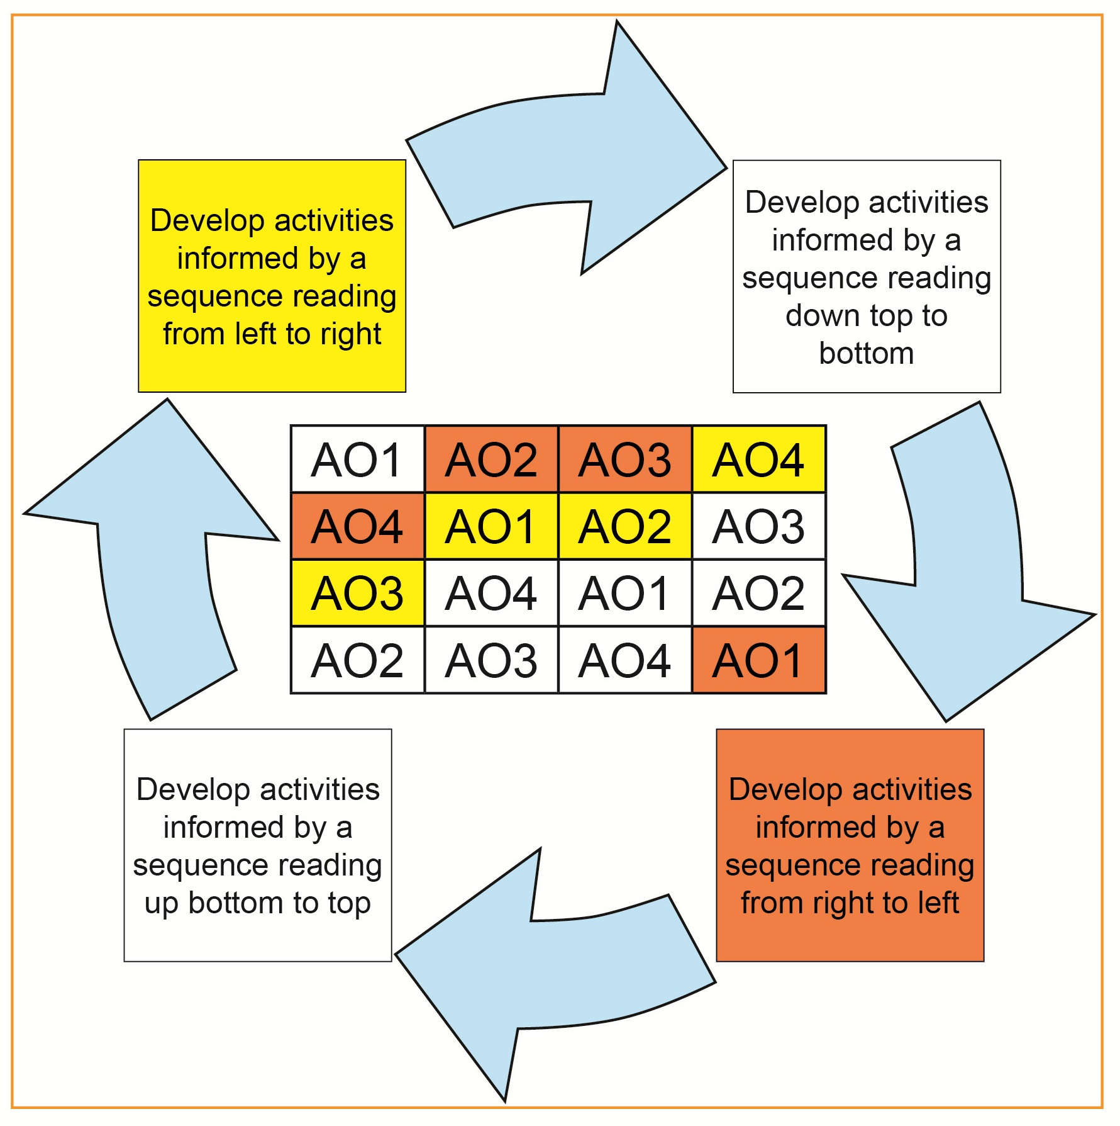
In the example (highlighted in yellow) above reading left to right, a project or course of study could open with tasks designed to focus primarily on recording observations relevant to a teacher or learner stated broad theme (AO3) followed by tasks designed to support documenting investigation and understanding of sources (AO1) followed by tasks aimed at refining and exploring ideas and selecting and experimenting with appropriate media, materials, techniques and processes (AO2) followed by tasks designed essentially to sustain the presentation of responses that realise intentions and demonstrate understanding of visual language (AO4). The course of study could continue with a further sequence informed by an evaluation of emerging responses. For example, it may be that the quality of a growing response might be improved by using information gathered through further visual research activities (AO3), investigation of critical sources (AO1) and refinement (AO2).
Equally (in the example highlighted in orange above) reading right to left, a project or course of study could open with tasks designed to focus primarily on documenting investigation and understanding of sources relevant to a stated broad theme (AO1) followed by tasks designed to support the recording of appropriate observations (AO3) followed by tasks aimed at refining and exploring ideas and selecting and experimenting with appropriate media, materials, techniques and processes (AO2) followed by tasks designed essentially to sustain the presentation of responses that realise intentions and demonstrate understanding of visual language (AO4). The course of study could continue with a further sequence informed by an evaluation of emerging responses. For example, it may be that the quality of a growing response might be improved by using information gathered through further visual research activities (AO3), investigation of critical sources (AO1) and refinement (AO2).
It should be emphasised that, in this document, suggested ways in which meeting assessment objectives could be evidenced in a body of GCSE work should not be seen as prescriptive or exhaustive. In a project or course of study, assessment objectives could be approached individually or in a mixture to acknowledge the holistic character of GCSE art and design assessment. Evidence for attainment in recording an observation (AO3) could also reveal elements of attainment in the development of an idea (AO1), attainment in refinement, exploration and experimentation (AO2) and attainment in presenting a response (AO4).

Assessment Objectives (Intentions and Evidence)
AO1: Develop ideas through investigations, demonstrating critical understanding of sources
Evidence from activities designed to show that a student has met AO1 must show that ideas have developed from sources. Investigating sources can be carried out at any point on a creative journey. Sources could serve to inspire thinking at the start of a project, encourage technical development, suggest the use of materials or propose ways of working to record or present ideas and final visual statements.
Appropriate sources might relate to historical, contemporary, social and cultural contexts, the different purposes, intentions and functions of art, craft and design and encompass the work of artists, crafts people and designers, the natural or man-made world, the wider arts landscape (sound, visual or written), traditions or issues.
Developing ideas through investigations, demonstrating critical understanding of sources can be evidenced in a range of ways in GCSE art and design. For example, a transcription as a visual analysis of a source aimed at exploring formal characteristics or how materials and techniques could be used to progress a creative journey.

AO2: Refine work by exploring ideas, selecting and experimenting with appropriate media, materials, techniques and processes
Evidence from activities designed to show that a student has met AO2 must show that ideas have been explored, progressed and refined by a creative developmental journey of experimentation, trying out, testing and/or problem-solving. A journey could be planned to follow a particular sequence of exploration or the approach could be tentative and involve risk-taking and searching of the unknown. Activities could focus on the fine-tuning of a central idea or deliberation on a variety of possible creative routes.
Refinement of ideas might involve investigating sources with a focus on the use of media, materials, techniques and processes or in relation to style, genre, purpose or function. Evidence for AO2 could entail exploration of the creative possibilities offered by pursuing different designs through test pieces, maquettes or mock-up proposals, possible futures made available by investigating and applying the different visual and physical properties of a range of media, diverse ways of working and representing ideas in two and three-dimensions, a range of scale or digital experimentation.

AO3: Record ideas, observations and insights relevant to intentions as work progresses
Activities designed to show that a student has met AO3 must show a suitable record of ideas, observations and insights as work grows and develops. Recording can take place at any stage of the creative journey process and be shown individually or mixed together in many ways including visual, written and digital forms.
Evidence for assessment objective AO3 could encompass, for example, mind maps, thumbnail sketches, design sheets, journals, working drawings or plans, digital presentations, drawing from imagination or from first-hand experience and/or secondary sources, photographs, computer generated imagery and/or written notes

AO4: Present a personal and meaningful response that realises intentions and demonstrates understanding of visual language
Evidence for the presentation of an informed and meaningful personal response, productively influenced by purposeful connections with sources, can take many forms and emerge at any stage on the creative journey. Indicators for the realisation of intentions could include a completely finalised outcome or several developmental sample responses or studies. Evidence for understanding of visual language could be discovered visually in the connection between preparatory work and final statements, in the completed outcome or in a creative process through design sheets or in work journal pages.

Developing a portfolio task – an example
Stage | Purpose |  | Example
1 | Teacher and/or learner to propose a broad overarching theme |  | Surroundings
2 | Teacher and/or learner to open out the broad theme’s possibilities (a list, thought shower or mind map for example) |  | surroundings environment  location  setting  place  scene  locale  area  landscape  town  city  village |  | private space  public space  atmosphere  neighbourhood  countryside  outside  inside  urban  rural  real place  imagined place
3 | To select the most interesting or promising focus for work from the mind map | The centre of attention for the work will be a real interior or exterior setting, area or place |  | The centre of attention for the work will be a real urban exterior setting, area or place
4 | To select the specification title for the work from:-  Art, Craft and Design  Fine Art  Graphic Communication  Photography  Textile Design  Three-Dimensional Design  Critical and Contextual Studies | Fine Art  The work will grow from the individual exploration of an idea, experience or theme rather than for practical purpose or function |  | Graphic Communication  The work will emerge from a response to a specific need, brief, practical purpose or function.
5 | To select the main area of study from within the specification title | Painting  Selected from :-  Drawing  Installation  Lens-/Light-based media  Mixed-media  Land art  Printing  Painting  Sculpture |  | Advertising  Selected from:-  Advertising  Communication graphics  Design for print  Illustration  Interactive design (including web, app and game design)  Multi-media  Package design  Signage  Typography

6 | To identify broadly the likely final product and its focus or brief | The focus will be a semi figurative or semi abstract painting describing an interior or exterior space and expressing a mood or atmosphere | The brief will be to produce an advertisement to be displayed on line, at a place, or in a print publication encouraging travellers to visit an actual location
7 | To select the initial sequence | AO3 Record  AO1 Develop  AO2 Refine  AO4 Present | AO3 Record  AO1 Develop  AO2 Refine  AO4 Present
8 | To select activities for AO3 evidence | Suggested activities or tasks  Record observations of first-hand experience and/or secondary sources by drawing, painting, photography, computer/tablet made imagery (using different viewpoints, from close up, from a distance, in different media, using different scales) from the following starting points  - Everyday items  - Equipment  - Possessions  - Clothes  - Footwear  - Jewellery  - Furniture  - Decorative objects found in interior spaces.  - Landforms  - Coastlines  - Urban or rural streets  - Architecture  - Vehicles  - Trees  - Plants  - Skies  - Different light and/or weather conditions  - Natural and/or man-made shelters  - Dwellings | Suggested activities or tasks  Record observations from first-hand experience and/or secondary sources by drawing, photography, painting, computer/tablet generated imagery and collected material (using different viewpoints, from close up, from a distance, in different media, using different scales) from the following starting points:  - Landforms  - Coastlines  - Urban or rural streets  - Architecture  - Vehicles  - Trees  - Plants  - Skies  - Different light and/or weather conditions  - Natural and/or man-made shelters.
9 | T select activities for AO1 evidence | Suggested activities or tasks  Explore, record and transcribe (using different media, scale and focusing on the whole work or details) the relevant work and approaches of fine artists (and other enriching resources) from contemporary and/or historical contexts, periods, societies and cultures focusing on interior and exterior spaces by:  - visiting and recording in a museum or gallery  - recording research from internet museum, gallery or artist websites  - investigating and recording from art books and journals  - investigating and recording from other culturally inspiring sources | Suggested activities or tasks  Explore, record and transcribe (using different media, scale and focusing on the whole work or details) the relevant work and approaches of graphic designers (and other enriching resources) focusing on exterior spaces by:  - visiting and recording in a museum or gallery  - recording research from internet museum, gallery or graphic designer websites  - investigating and recording from graphic design books and journals  - investigating and recording from other culturally inspiring sources
10 | To select activities for AO2 | Suggested activities or tasks  Explore and improve ideas for the painting by  Experimenting with different designs and refining ideas for the final outcome (informed by the relevant work and approaches of artists studied for AO1 evidence) by  - selecting  - editing  - using different media  - using different ways of working  - using different scales  - using different treatment  - using different, shape  - using different styles | Suggested activities or tasks  Explore and improve ideas for the graphic design by  Experimenting with different designs and refining ideas for the final outcome (informed by the relevant graphic design studied for AO1 evidence) by  - selecting  - editing  - using different media  - using different ways of working  - using different scales  - using different treatment  - using different, shape  - using different styles  - using different imagery  - using different typography  - using different illustration,  - using different layout  - using different style
11 | To select activities for AO4 | Suggested activities or tasks  Begin to realise painting intentions by producing the final outcome (or several developmental responses or studies) making direct reference to evidence collected so far for AO1 AO2 and AO3. | Suggested activities or tasks  Begin to realise graphic communication intentions by producing the final outcome (or several developmental responses or studies) making direct reference to evidence collected so far for AO1 AO2 and AO3.
12 | To review/evaluate progress/success of emerging realisation of final outcome(s)  To produce final outcome(s) | Suggested activities or tasks  Consider the success of the emerging final outcome and if pertinent return to stages 8, 9 and 10 above (in any appropriate order) to sustain the best possible final statement.  - Carry out further investigation of context/sources (AO1)  - Carry out further visual research (AO3)  - Carry out further refinement of idea (AO2)  Continue to produce the final outcome (or several developmental responses or studies) making direct reference to evidence collected for AO1, AO2 and AO3.  Consider the success of the emerging final outcome and if relevant return to stages 8, 9 and 10 above (in any appropriate order) to sustain the best possible final statement. | Suggested activities or tasks  - Consider the success of the emerging final outcome and if pertinent return to stages 8, 9 and 10 above (in any appropriate order) to sustain the best possible final statement.  - Carry out further investigation of context/ sources (AO1)  - Carry out further visual research (AO3)  - Carry out further refinement of idea (AO2)  Continue to produce the final outcome (or several developmental responses or studies) making direct reference to evidence collected for AO1, AO2 and AO3.  Consider the success of the emerging final outcome and if relevant return to stages 8, 9 and 10 above (in any appropriate order) to sustain the best possible final statement.
OCR Resources: the small print
OCR’s resources are provided to support the delivery of OCR qualifications, but in no way constitute an endorsed teaching method that is required by the Board, and the decision to use them lies with the individual teacher. Whilst every effort is made to ensure the accuracy of the content, OCR cannot be held responsible for any errors or omissions within these resources.
© OCR 2017 - This resource may be freely copied and distributed, as long as the OCR logo and this message remain intact and OCR is acknowledged as the originator of this work.
OCR acknowledges the use of the following content: n/a
Please get in touch if you want to discuss the accessibility of resources we offer to support delivery of our qualifications: resources.feedback@ocr.org.uk

