Topic Exploration Pack

Language and Power
Topic Exploration Pack 1
Language and Power 1
Instructions and answers for teachers 3
Teacher Guide 4
Introduction 4
Approaches to teaching the content 5
Lesson Activity 1 – Getting What You Want. A power continuum 6
Lesson Activity 2 7
Jigsawing Some Power Texts 7
Lesson Activity 3 7
MMR Vaccinations Text 7
Student Sheets 8
Lesson Activity 1A 10
Lesson Activity 1B 28
Lesson Activity 2A 29
Lesson Activity 2B 36
Lesson Activity 3A 37
Activity Sheet 3B 38
Student Activity 3C 40
Student Activity 3D 43

Instructions and answers for teachers

These instructions cover the student activity section which can be found on page 7. This Topic Exploration Pack supports OCR AS and A Level English Literature.
When distributing the activity section to the students either as a printed copy or as a Word file you will need to remove the teacher instructions section.

ABC – This activity offers an opportunity for English skills development.

Teacher Guide
This is a teacher guide for introducing the topic of Language and Power
Content (from A-level)
Language and Power is part of AS Component 2 (Exploring Contexts),and A Level Component 2 (Dimensions of Linguistic Variation)

Introduction
Language and power is a broad topic, potentially working its way into just about every communication we make, whether spoken, written or multi-modal. When preparing to teach power, therefore, one way to break it down is to divide the teaching into two areas:-
- Power used between individuals in their daily lives, often in speech but sometimes in writing (think of emails and texts), where the status of one person affects the way they use language to exercise power over another person or small group. In terms of the way students will be tested, at AS and A level the Power ‘option’ in Component 2 will be multi-modal and so will not be a transcript. However power is also highly likely to be relevant in the comparative task that students undertake in Component 1 at both AS and A level, where one text is always a transcript of speech. Locating the more powerful participant is always a useful starting point as they get underway with any analysis of speech. It could also appear in transcripts of parents, carers or teachers exercising a degree of power within child directed speech in Component 2 of the A level. Arguably, the kind of negotiation we enter into in personal discourse should be the basis of a student’s understanding of power in a range of more general communications.
- Power used by large organisations including persuasive speeches and other literature used to persuade an audience to do something. On the whole this will be written material, such as campaign literature, adverts, advisory leaflets, webpages, newspaper columns and so on. It could also include public speeches, however. Students will need this knowledge to tackle the multi-modal text in the Power option on the AS paper (the specimen paper is a website advising people about starting a new job). In the first task in Component 1 of both AS and A2, however, texts will often be selected partly because the writers are seeking to persuade (in the AS specimen paper, for example, a letter of apology from the Department for Work is clearly trying to put off recipients from complaining about the fact they have lost their data!).
The activities in this pack offer some useful introductions to these two ways of looking at texts where power is key, asking students to consider power in talk and power in written and multimodal texts. Students will often be unaware of the subtleties of the power relationships they negotiate every day, and the way they both manipulate each other and are manipulated themselves; this is therefore a good place to start.

Approaches to teaching the content
The following list of aspects of power is by no means exhaustive, but could act as a rudimentary checklist of the kinds of knowledge and skills that students need to cover.
- Power used between individuals in spoken and, in some cases, written communication.
- Topic control and other strategies used to exercise power in conversations: talking at length, interrupting, changing the topic of conversation and so on.
- Pragmatics: we rarely order people to do things in a direct way, so we need to study how a higher status figure will imply certain meanings in order to get someone else to do what they want (eg Caretaker to trespasser on school property: Can I help you?) expecting the listener (or reader of, for example, an email or text) to infer what they have to do.
- Face: positive face describes the need we all have to preserve our self-esteem. If someone challenges this, they are, according to Goffman, conducting a face-threatening act. (For example if a teacher has to tell a student that they are struggling in a subject.) Negative face is our desire not to go out of our way for others. If you are asking someone to lend you some money, for example, you are threatening their negative face. Power is vital in both cases, because if one person is of a similar status to another they will probably use face saving strategies to get someone to do what they want or to criticise them. More powerful participants in the communication might exercise power in a more direct way (Parent to child: Pick that up now! )
- Politeness: Grice’s work on cooperative and non-cooperative conversation is useful (people who talk a lot or are deliberately silent are being non-cooperative). Students also get a lot out of Brown and Levinson’s work on politeness. For example, in negative politeness, you might be concerned that the person will not do as you ask, and so might give them alternatives or at least the illusion of choice (You couldn’t help me sort out this cupboard, could you?)
- When we are saying something awkward, which is in some way potentially face threatening, we will often use hedging which is the practice of padding out what we say with ‘sort of’, ‘I think that maybe you could’ and so on, to soften the impact of what we are saying
- The application of the language levels (in addition to pragmatics), in particular grammar. For example, modal auxiliary verbs (would, could, should) and pronoun use (We can do this together etc) are key ways that we influence others to do things for us without sounding to bossy.
- Power used in mass communication. In addition to the aspects listed above, students need to know the following:-
- Rhetorical devices: this is a particular form of language use that seems to have changed little since classical times. It has a lot to do with grammar and syntax, of course. Repeated grammatical structures, for example, are often a key to success in a good speech.
- Multi-modal elements where text, image and graphological features like type-face influence the reader in printed material
- Discourse structures: in newspaper columns, for example, the reader will often be presented with a counter argument before the argument is delivered to them
- Synthetic personalisation: coined by Fairclough in his 2001 book Language and Power, this is the practice of authors of large scale communications (a company to its customers, a management to their staff and so on) making out that they are talking personally to the recipient of the text.
- Instrumental and influential power. If the producer of the text holds direct authority over their subordinates (the boss of a company, for example, or a parent), and is therefore simply enforcing their authority we can call this instrumental power. With influential power, meanwhile, the producer of the text has no actual power over the receiver of the text and seeks to gain it by the power of persuasion, through the manipulation of language.
Of course, there are times when these two types of power overlap. In the pack that follows, however, you will find activities to help introduce students to a number of the aspects of power listed above.
Students will often not fully appreciate how subtle the power relationship is in life.

Lesson Activity 1 – Getting What You Want. A power continuum
Aim: to introduce students to the kinds of negotiation we undertake every day and to consider how we are influenced by persuasive speech, writing and image and to consider the ways in which context affects power relationships.
  - On Lesson Activity Sheet 1A there are 18 requests or attempts to persuade the reader or listener to do something. These need to be blown up to A3 and then folded along the dotted line, so that the coloured text is on one side and the short textual extracts are on the other.
  - The two signs (Lesson Activity Sheet 1B) are placed at either end of the classroom, like this:
LEAST POWERFUL
MOST POWERFUL

- Each student receives one of the 18 sheets that make up Lesson Activity Sheet 1A. They stand at the front of the class in a line. Each student shows their card to the student next to them and they have to decide between the two of them whose text more overtly demonstrates power and whose text is more subtly negotiated. This process is repeated so students can move up and down the line. It is important that the students talk to each other, ‘trickling up and down’ the continuum and discussing how powerful their texts are. They should not simply march to one end of the line because they think their text is powerful. They also need to consider how some texts are powerful without being direct.
- When the line has settled, each student reads their text aloud and explains why they are standing where they are. Other members of the class might make suggestions at this point if they think that student’s text belongs at a different place on the continuum.
- Students then move into groups according to the colour on the back of their sheet (the sheet will have come from Activity Sheet 1A). They discuss their texts, using the questions that are on the ‘back’ (on the other half of the dotted line) on the sheets. They may annotate a handout version of all 18 texts as they listen to one another.

Lesson Activity 2

Jigsawing Some Power Texts
This activity uses most of the same texts as the continuum activity from Lesson Activity 1 and can be used as a follow on, in which case you would miss out stage 5, above.
- Students start out in groups of four (or five, but operating as a four with a pair as a ‘one’); each student has a copy of all the Lesson Activity Sheet 2A, including the instruction sheet. Each sheet has four mini texts on it with prompts.
- In their group, students follow the instructions on the instruction sheet (Lesson Activity Sheet 2B), using the discussion prompts next to each text.
- They then move to new groups and listen to the findings of other students on different texts.
- As the teacher you can work round and get involved in the discussions.
At the end you can coordinate a final discussion, perhaps testing their knowledge and understanding in relation to the concepts on the cards.

Lesson Activity 3

MMR Vaccinations Text
This activity studies how an advisory text produced online by the National Health Service uses language to make a case that parents should have their children vaccinated. Power is important here because the NHS has no actual legal authority over British citizens and so needs to use language to influence readers.
The stages of the activity
  - Students start out reading a short introduction (Lesson Activity Sheet 3A - which also contains the instructions for the lesson activity), alerting them to the complicated power relationship the writers of NHS advisory texts have with their readers. Unlike a government text, such as information about tax returns, the NHS cannot force people to do as it says, making the language used all the more interesting, arguably
  - They go on to look at the original version of the web page and the altered version. (Lesson Activity Sheet 3B). The text itself treads a careful line between insisting and suggesting and the altered text pushes the language in different directions at different points. As a result some of the changes are more forceful, some less so.
  - Attached is a table with the changes listed next door to the originals. Some suggested readings have been filled in. Lesson Activity Sheet 3C is a blank version of this table. Students can, in pairs, complete a line of this table ready to feedback to the class.
  - Following on from the completed table is a copy of the students sheet (Lesson Activity Sheet 3D).

Student Sheets
Please provide the content for any students sheets needed for the suggested activities (minimum of 3 full novel activities)
There are 8 Lesson Activity Sheets. These are
Lesson Activity Sheet 1A
Lesson Activity Sheet 1B
Lesson Activity Sheet 2A
Lesson Activity Sheet 2B
Lesson Activity Sheet 3A
Lesson Activity Sheet 3B
Lesson Activity Sheet 3C
Lesson Activity Sheet 3D
OCR Resources: the small print
OCR’s resources are provided to support the teaching of OCR specifications, but in no way constitute an endorsed teaching method that is required by the Board, and the decision to use them lies with the individual teacher. Whilst every effort is made to ensure the accuracy of the content, OCR cannot be held responsible for any errors or omissions within these resources.
© OCR 2017 - This resource may be freely copied and distributed, as long as the OCR logo and this message remain intact and OCR is acknowledged as the originator of this work.
OCR acknowledges the use of the following content: Page 12 Bottle feeding a baby, Nicolesa/Shutterstock.com: Page 13 From a Salvation Army letter 2010: Page 14 No smoking sign, owen1978/Shutterstock.com: Page 16 Back of Kelloggs Special K packet Nov 2014, Courtesy of Kellogg’s: Page 21 Switch off that light, The National Archives 2017:Page 37/40 MMR vaccine, Sherry Yates Young/Shutterstock.com, Happy Toddler, Olga Shiyakhtina/Shutterstock.com
Please get in touch if you want to discuss the accessibility of resources we offer to support delivery of our qualifications: resources.feedback@ocr.org.uk
We’d like to know your view on the resources we produce. By clicking on ‘Like’ or ‘Dislike’ you can help us to ensure that our resources work for you. When the email template pops up please add additional comments if you wish and then just click ‘Send’. Thank you.
If you do not currently offer this OCR qualification but would like to do so, please complete the Expression of Interest Form which can be found here: www.ocr.org.uk/expression-of-interest

Topic Exploration Pack

Language and Power

Lesson Activity 1A
Teacher to student:
‘I reckon you could, you know, put a bit more effort in, don’t you?’
There is an expression called saving face, which is where you try to preserve someone’s self-confidence, even though you are criticising them.
- How does this utterance help to save the face of the receiver?
Teacher to pupils:
‘Line up!’
Some requests are simply blunt commands (imperatives)
- Is this command acceptable in the context?
One student to another:
‘Can I just borrow that pen for a second?

Negative politeness is used when we think we might not get what we want and we find ways to lessen the impact of our request.
- How is this request using negative politeness?
Hedging is when we pad out what we say with words and phrases that don’t need to be there to make sense, but which soften the force of what we are saying and make it more polite.
- What examples of hedging or other devices can you find in this text?
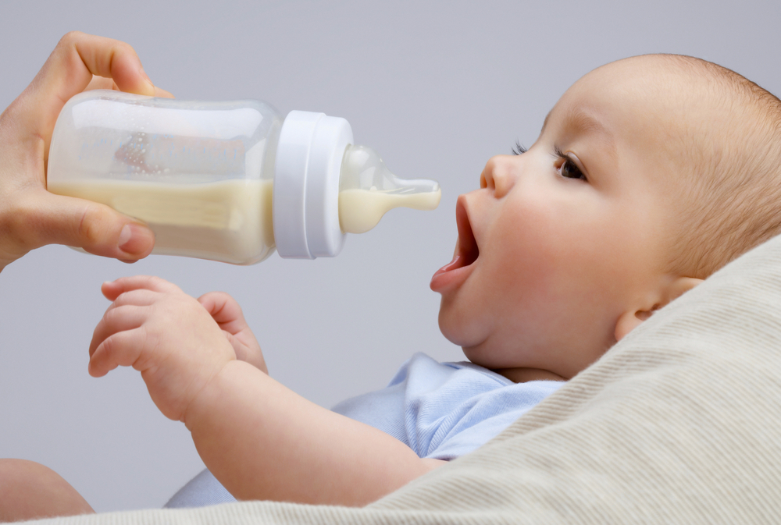
The text below is
taken from an
advert for
follow-on milk for
mothers who want
to bottle feed babies:
“If you choose to move on, Aptamil with Pronutra+ Follow On Milk is our most advanced formula yet…. Helping you lay the foundations for you baby’s future”.

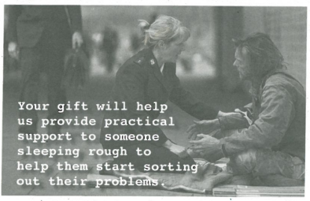
We use positive politeness when we think the person we are communicating with is likely to agree with our request.
- Would you say this is positive politeness? Any other features you can spot that attempt to gain power over the reader?
From a Salvation Army letter 2010

Notice on a train station platform:
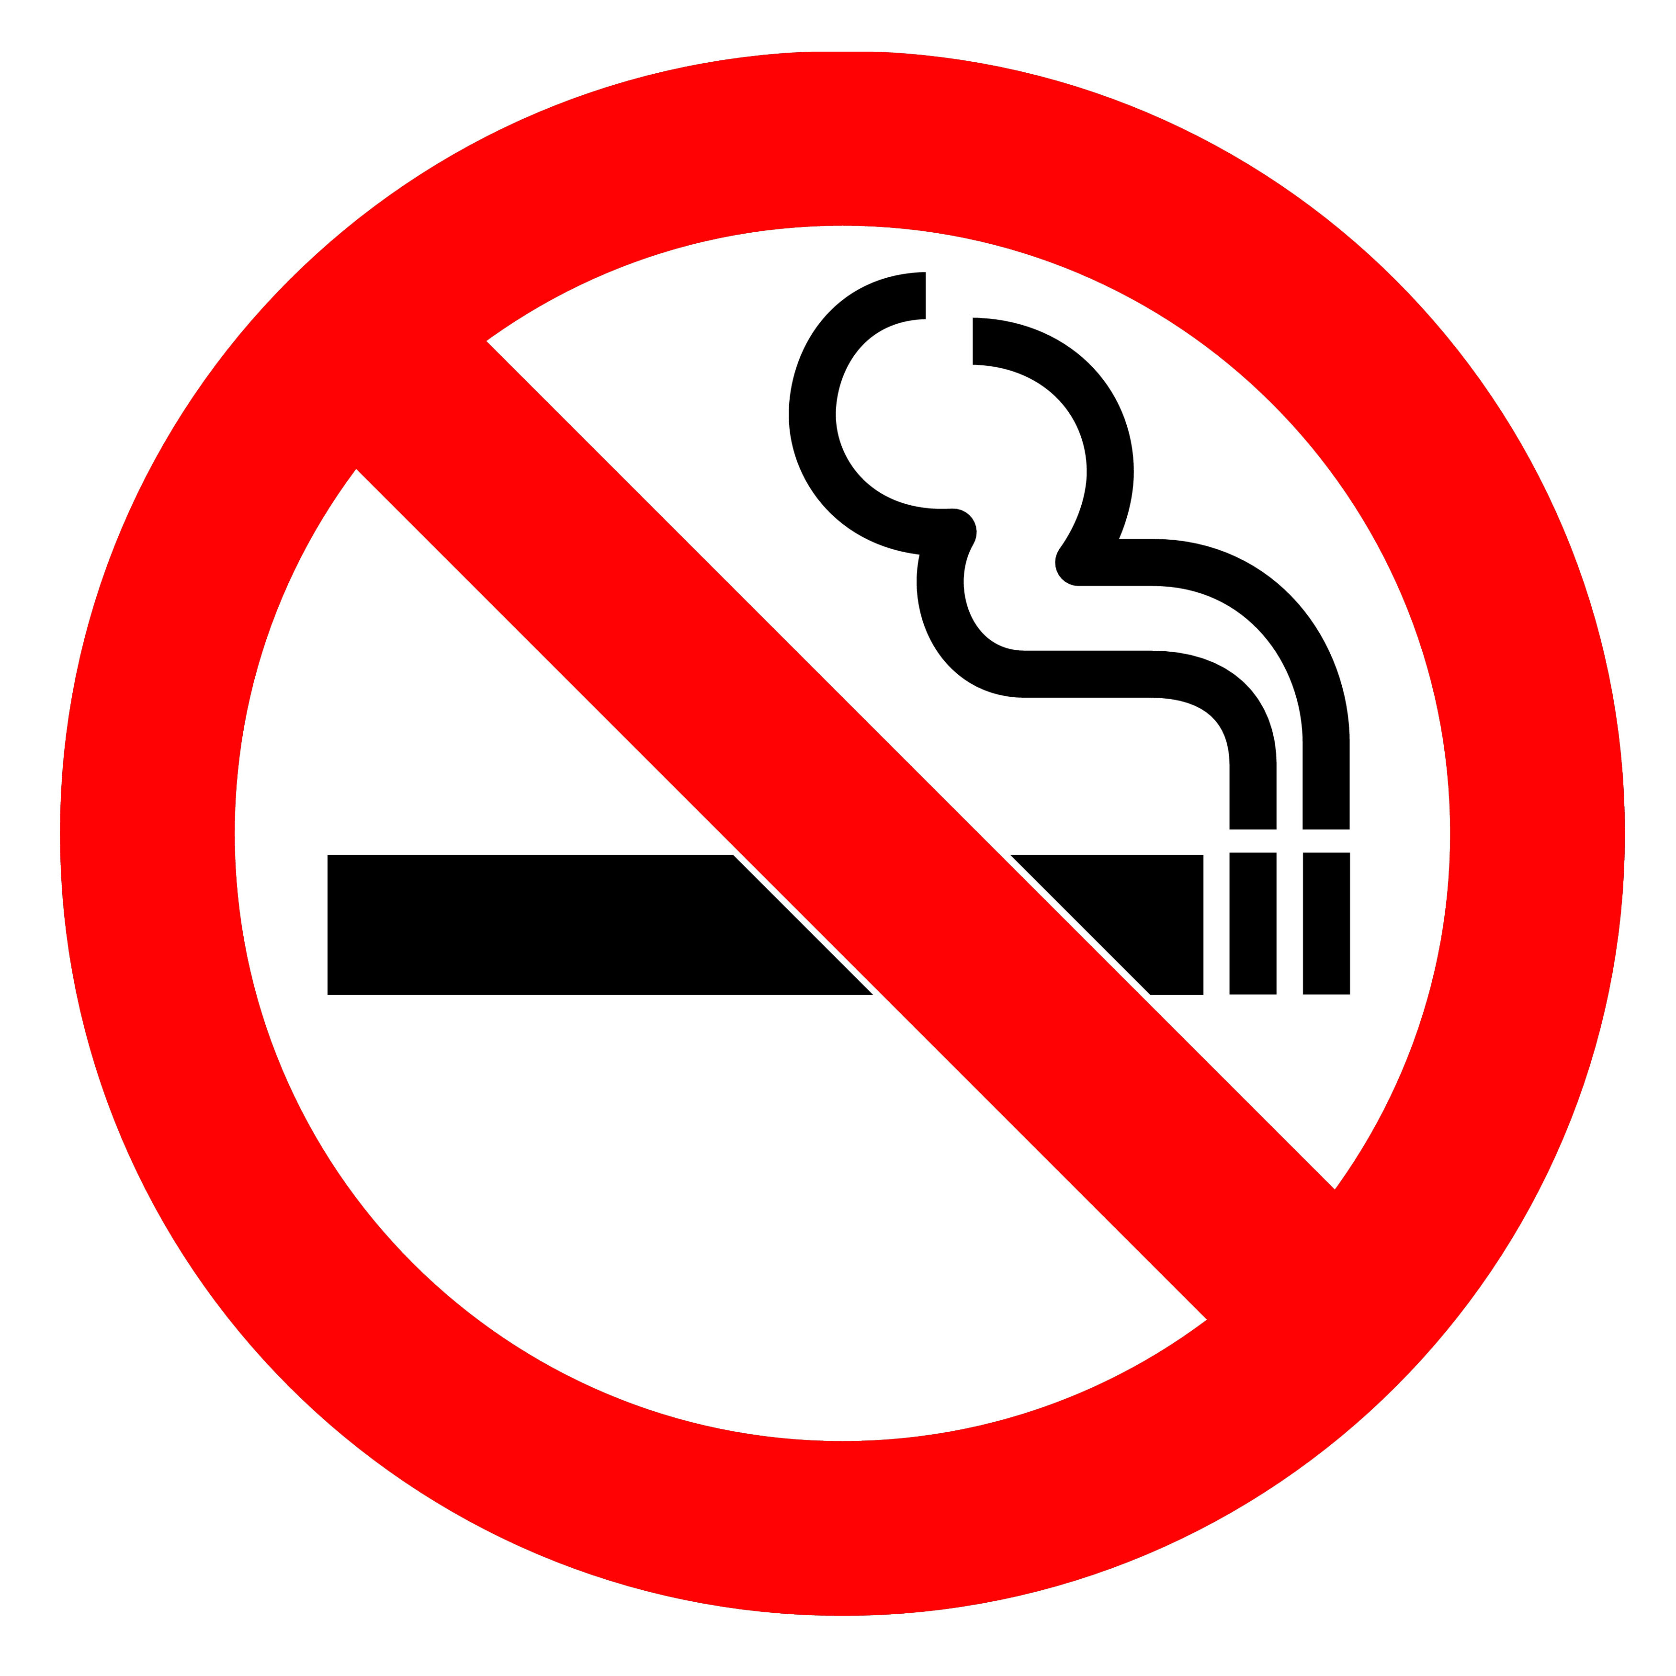
Some texts use the passive voice to sound impressive and authoritative.
- Identify the passive construction here and suggest why it has been chosen in this context.
Smoking is not allowed anywhere on this station
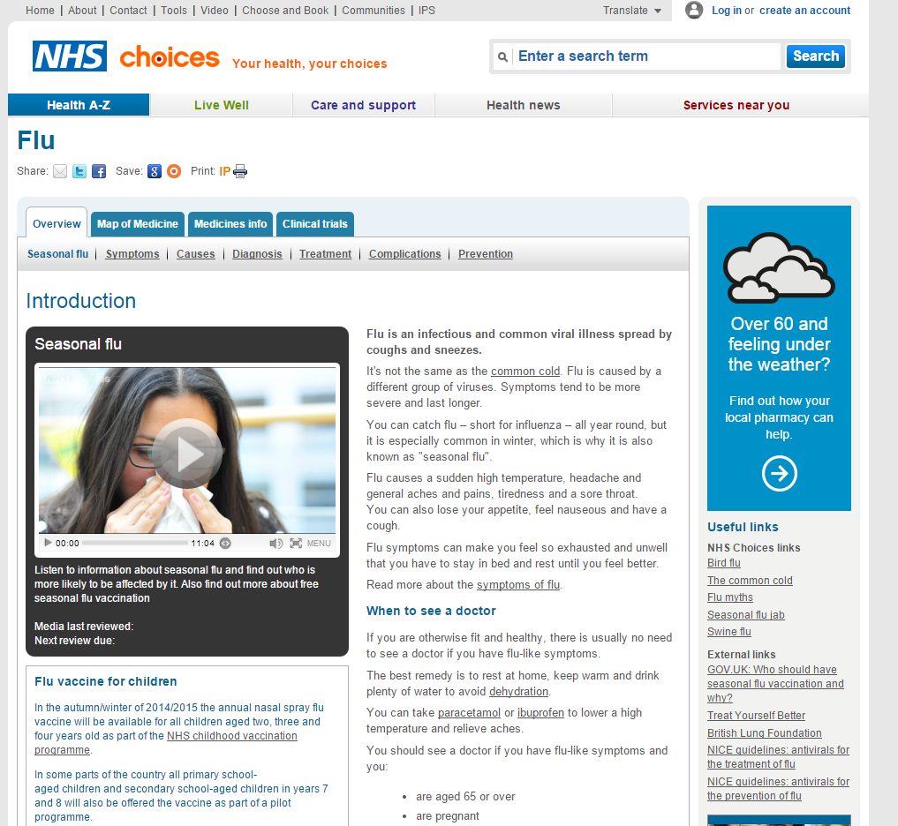
Advice on
the NHS
choices
website:

You should see a doctor if you have flu-like symptoms and you have a weakened immune system.
Modal verbs are would, may, could, should, might, can, must, will. We often use them to soften the impact of a request.
- Which modal is used in the utterance on this card and how forceful is it? Are any other devices used?

The back of a Kellogs Special K cereal packet presenting a global campaign for girls’ and womens’ empowerment  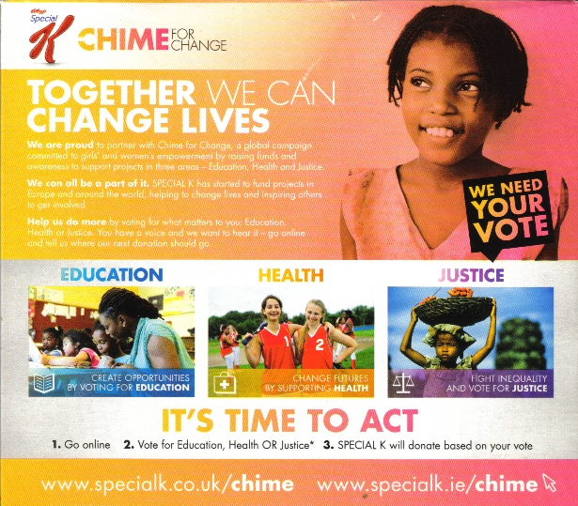  Together we can change lives… … We can all be a part of it… You have a voice and we want to hear it | Personal pronouns (I, you, he, we, they) are often used to help soften a request.  - How are the pronouns used here to influence the reader?
Back of Kellogs Special K packet Nov. 2014
Back of Kellogs Special K packet Nov. 2014
Back of Kelloggs Special K packet Nov. 2014
Courtesy of Kellogg's.

Mother to child:  ‘Shall we take your coat off, Ruby?’ | Pragmatics is: what we mean by what we say in a particular context. We are not always direct when we make requests.  - What would a child make of this request?

Speech by US president John F Kennedy  Ask not what your country can do for you. Ask what you can do for you country. | Contrasting pair is a rhetorical device where a pair of utterances are similar in structure but contrasting in meaning.  - How is the contrasting pair and other elements of this helping to bring his audience on side?

A caretaker to a member of the public who has wandered onto school property  Can I help you? | Our negative face is the desire we have not be put out, asked to do something we don’t want to do. A key face saving strategy therefore, defined by Brown and Levinson’s concept of negative politeness is to be indirect and allow the listener to infer a meaning, pragmatically from what we say. Can you use these terms to explain this utterance?
Presenter and interviewer Jeremy Paxman interviewing actor, comedian and writer Russell Brand on BBC TV  If you can’t be arsed to vote why should we be arsed to listen to your political point of view? | When you criticise someone or say something that could have an impact on their self-esteem you are conducting a face threatening act.  - How is Brand’s face being threatened here?  - What else do you find interesting about the language here?

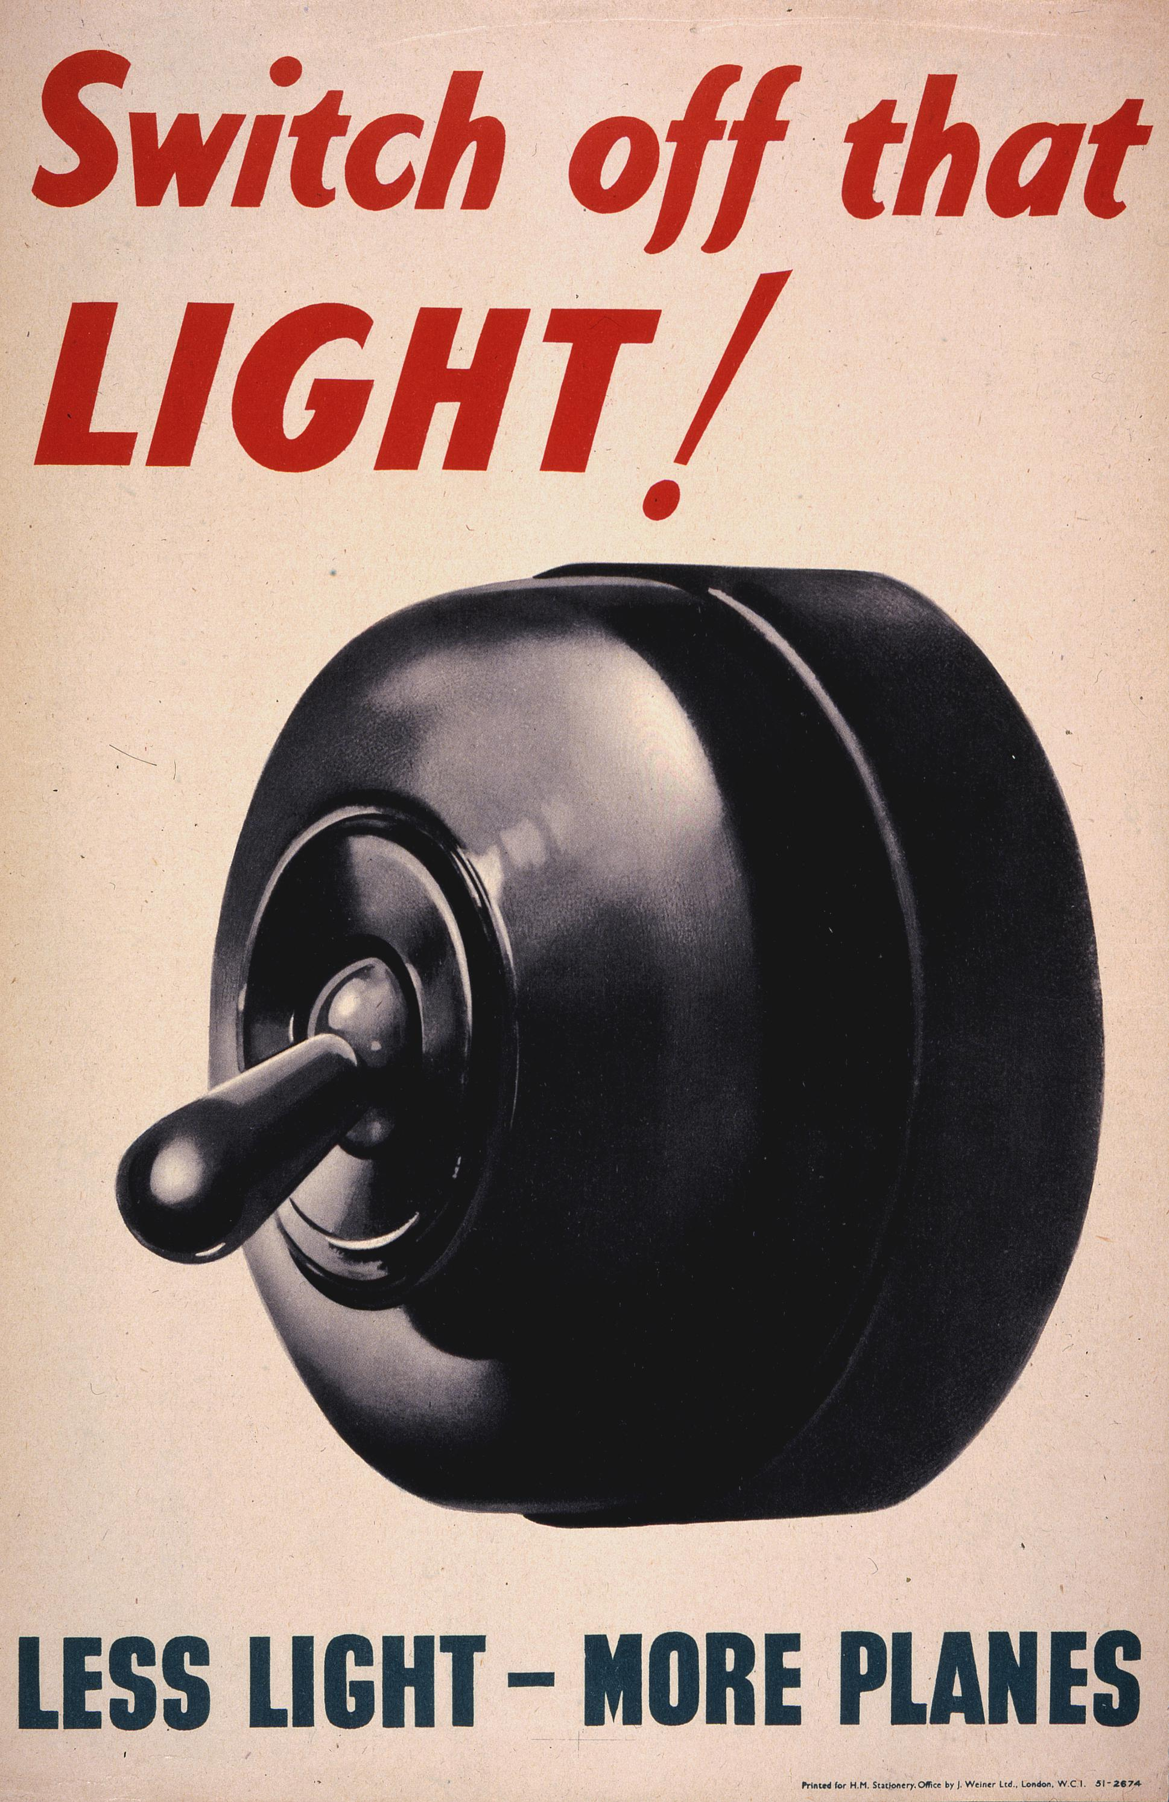  The National Archives – 2017 | Context is important in determining the power of a request. This is a poster put up around British cities during World War Two when the government needed energy for arms factories.  - How does context affect the power of this text on its intended audience?

Nurse to patient:  ‘Can you roll up  your sleeve for me?’ | Influential power: you don’t have actual and you must use language to persuade someone to do what you want. Instrumental power: you have actual power over someone (you are their boss, for example).  - Which form of power is being demonstrated here? What features are being used?

From one family member to another:  ‘You couldn’t put the bins out could you?’ | Negative politeness is used when we think we might not get what we want and we find ways to lessen the impact of our request.  - How is the request on this card using negative politeness?

A shop assistant to a customer who is browsing in clothes’ shop.  Can I help you? | Pragmatics is: what we mean by what we say in a particular context. We are not always direct when we make requests.  - What is going on here in terms of pragmatics?

Park maintenance manager to worker:  ‘We should get on with that hedge trimming today.’ | Personal pronouns (I, you, he, we, they) are often used to help soften a request.  - How are the pronouns used here to influence the reader?

Legal writ, requiring a bailiff to take possession of property (which a bailiff would be able to show the owner of the property who might, for example, owe money to a creditor [the Claimant] and not be able to pay)  YOU ARE NOW COMMANDED to enter the land detailed in the Schedule and cause the Claimant to have possession of it | Texts written in more specialist registers (ie with low frequency lexis specific to a particular professional field) can be intimidating to some readers.  - Could the register of this text be considered powerful in certain contexts?

Lesson Activity 1B

LEAST POWERFUL
MOST

POWERFUL

Lesson Activity 2A

Group one – Power texts
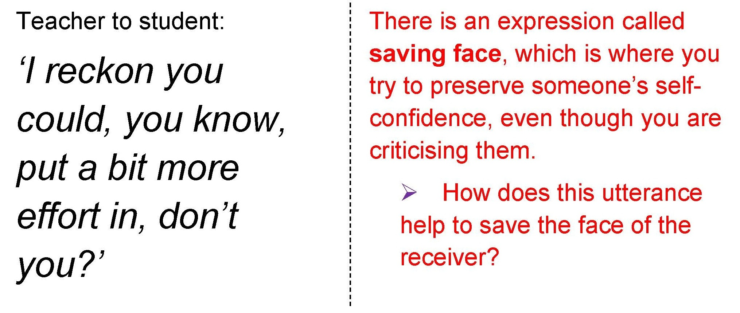 | 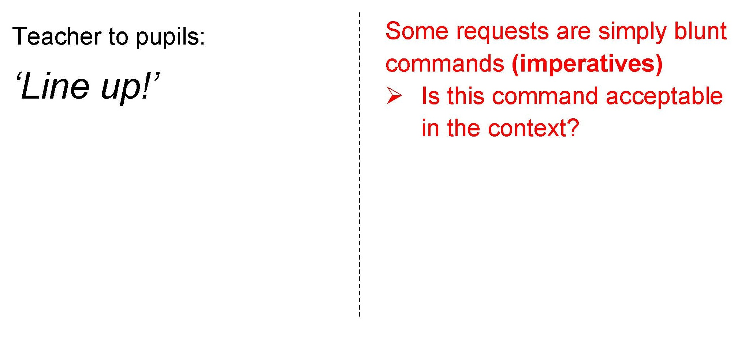
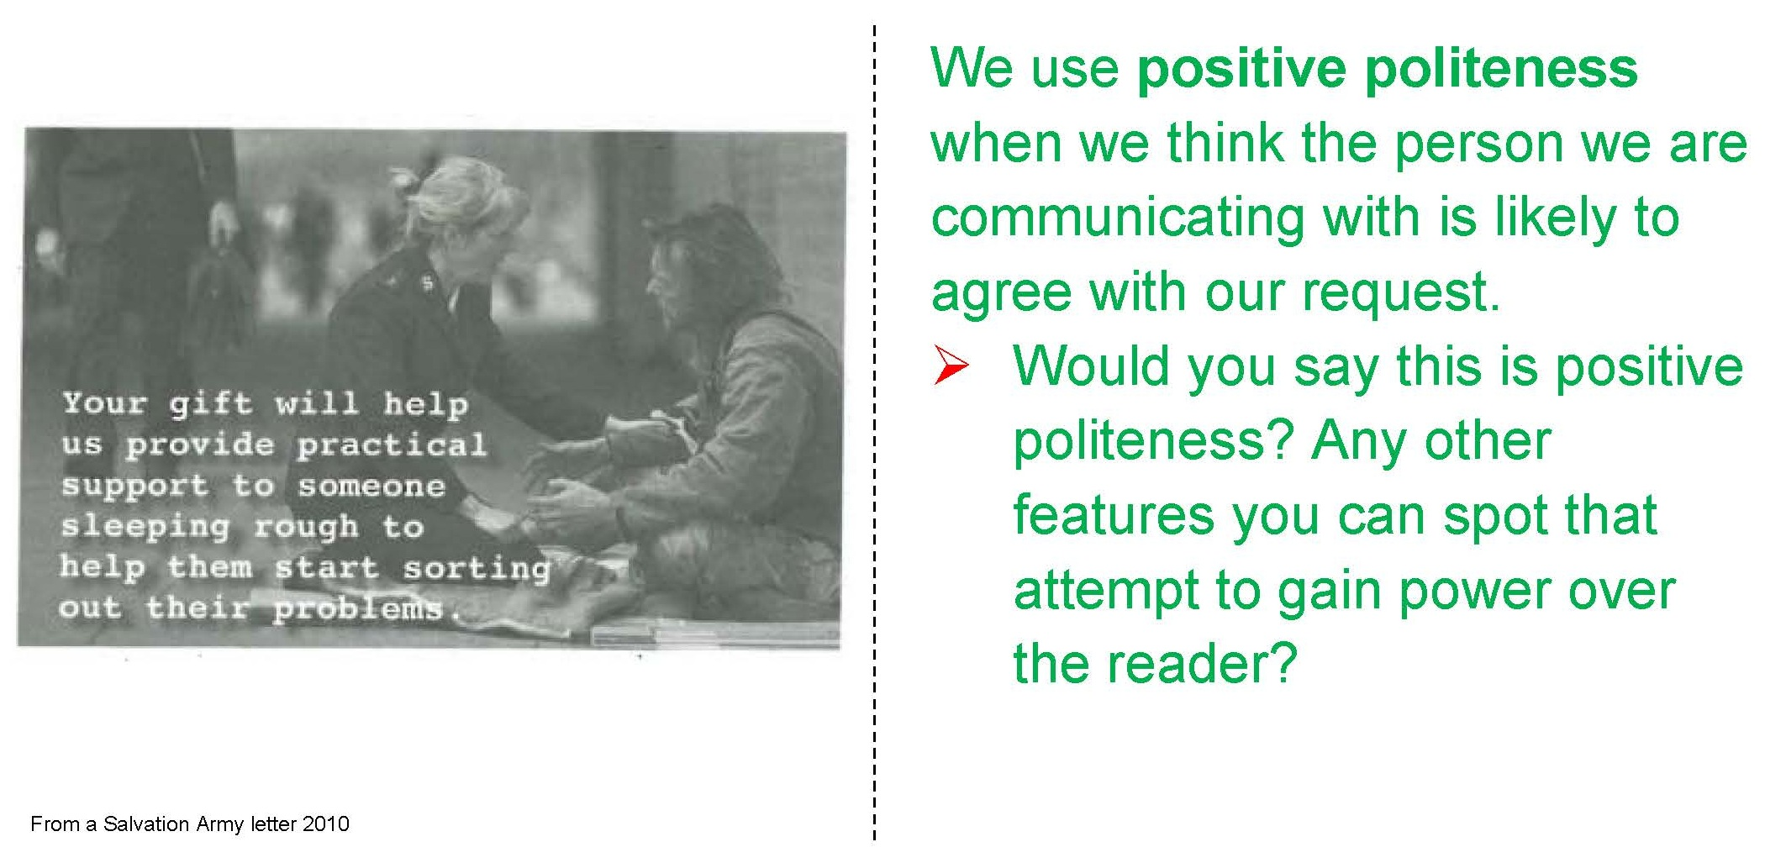 | 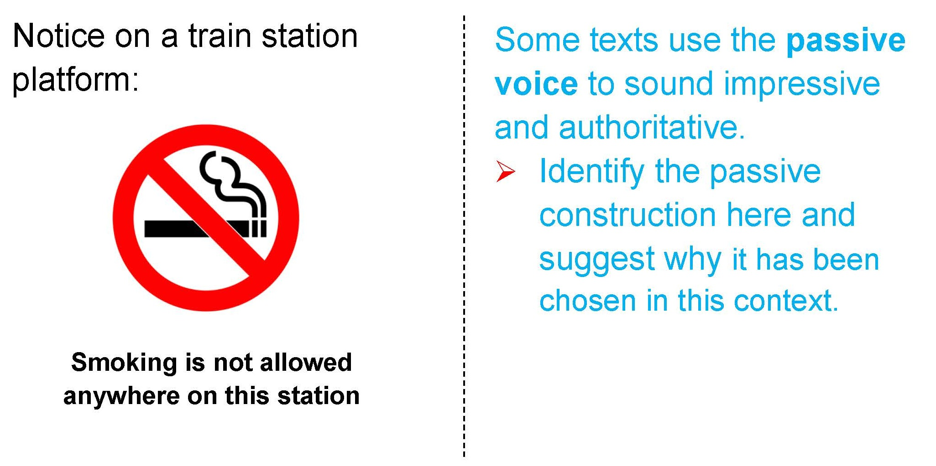

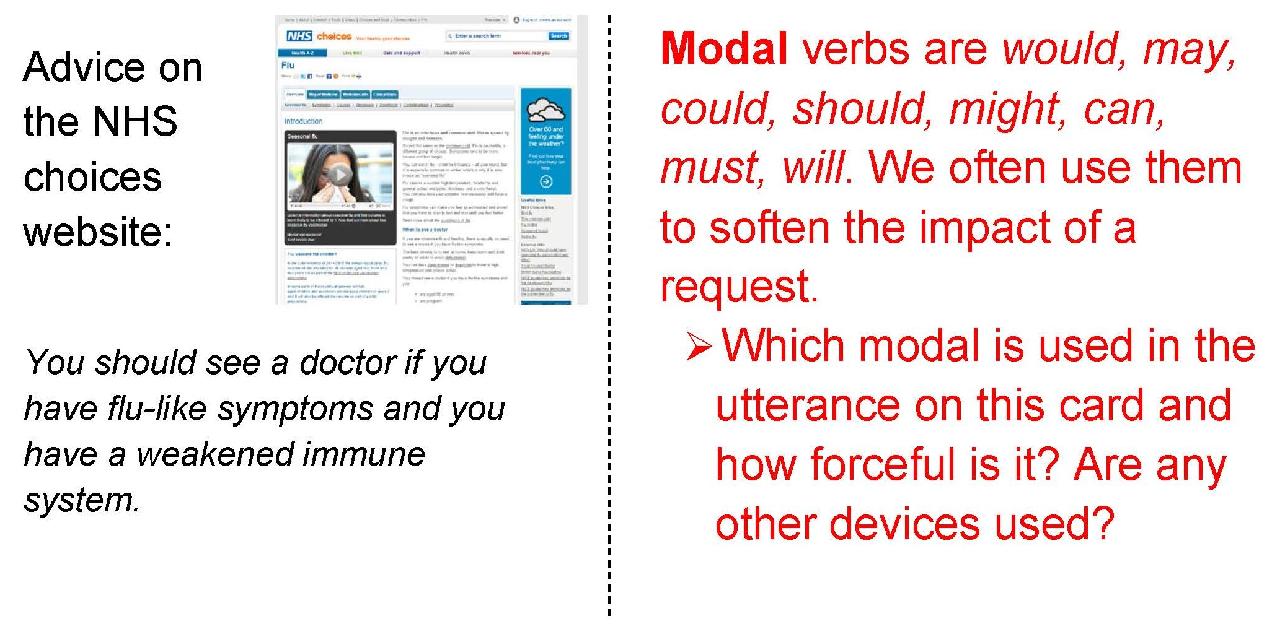 | 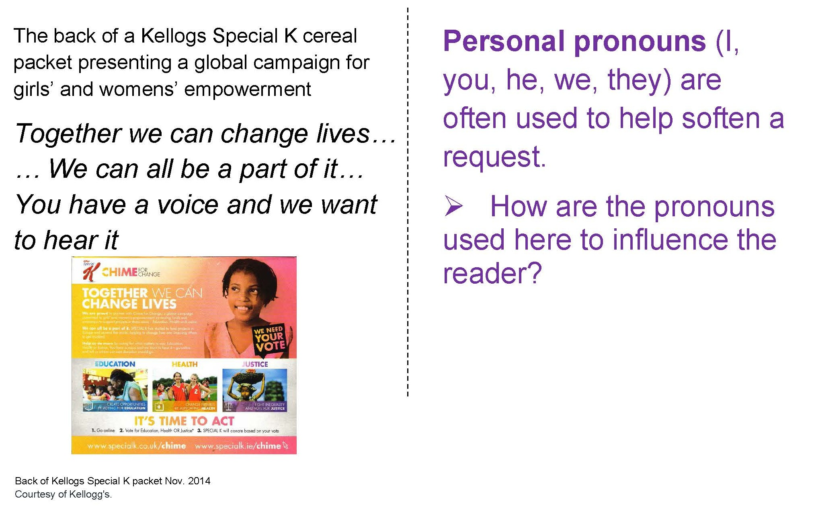

Group Two – Power texts
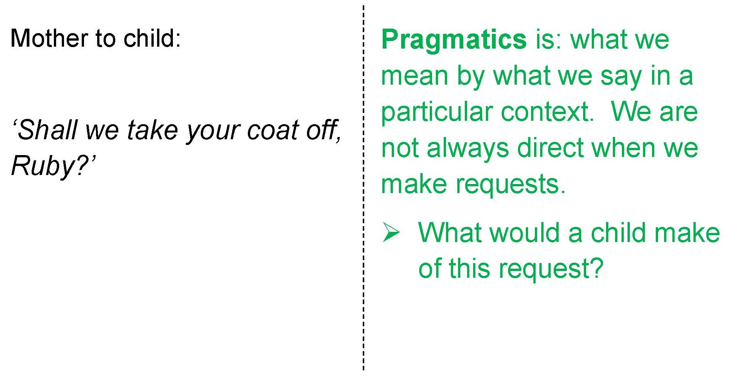 | 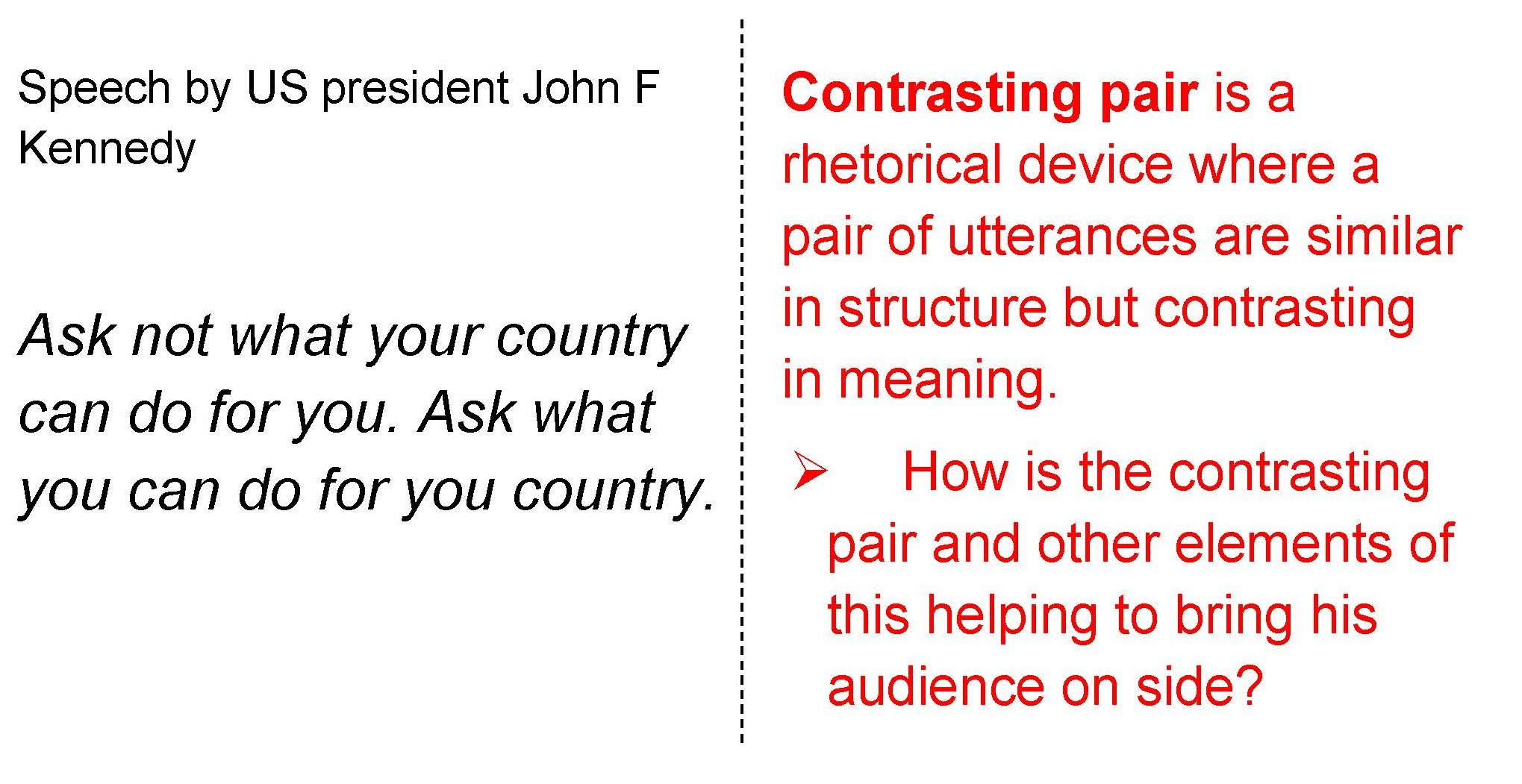

Group Three – Power texts
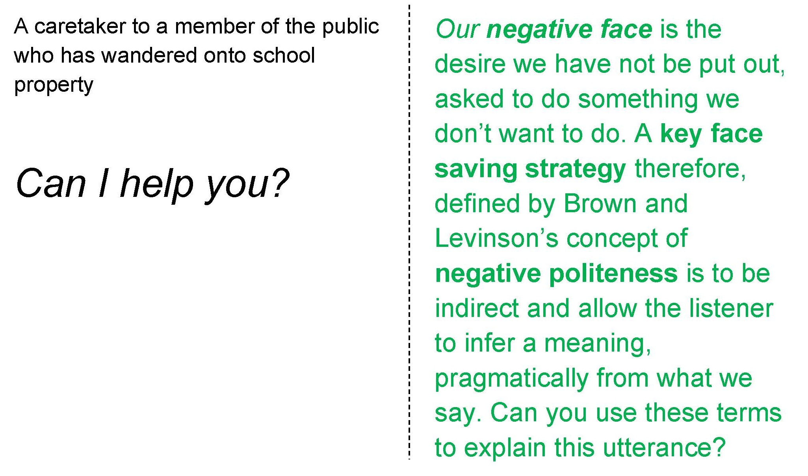 | 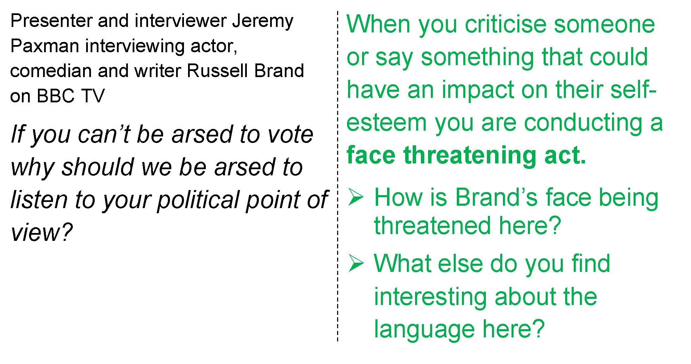
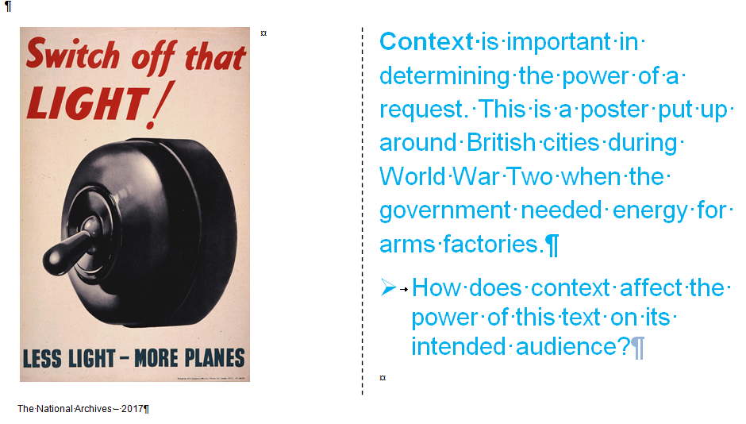 | 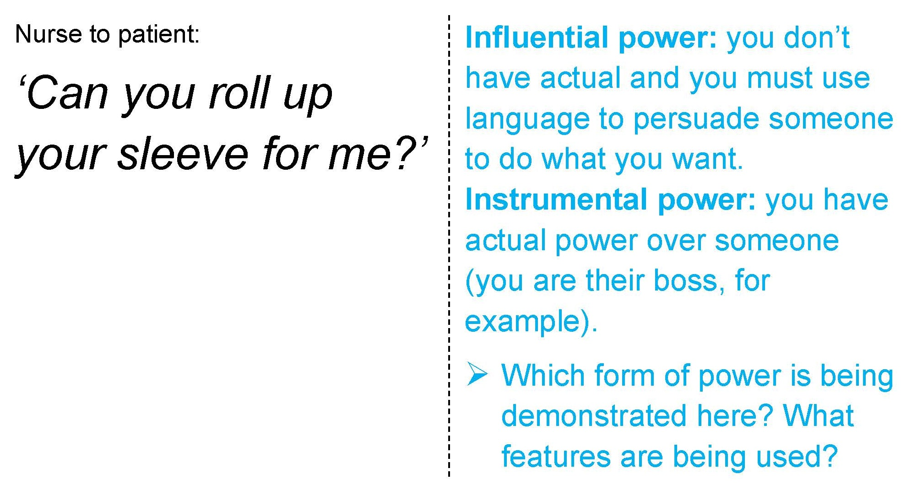

Group Four– Power texts
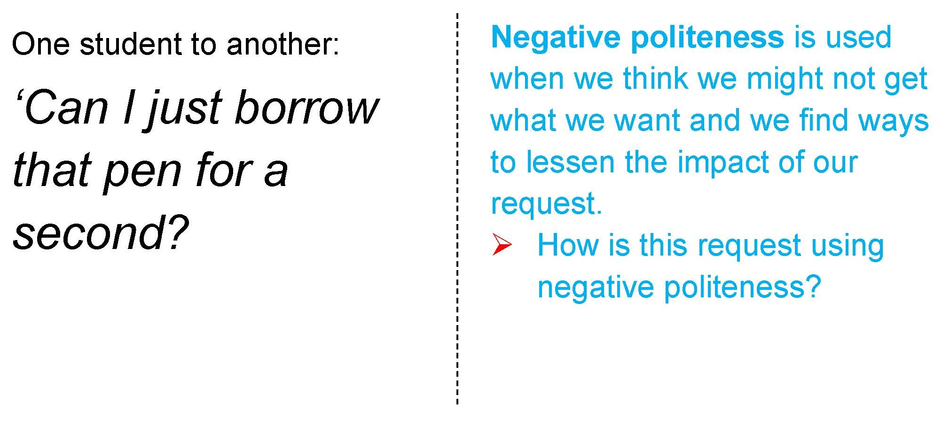 | 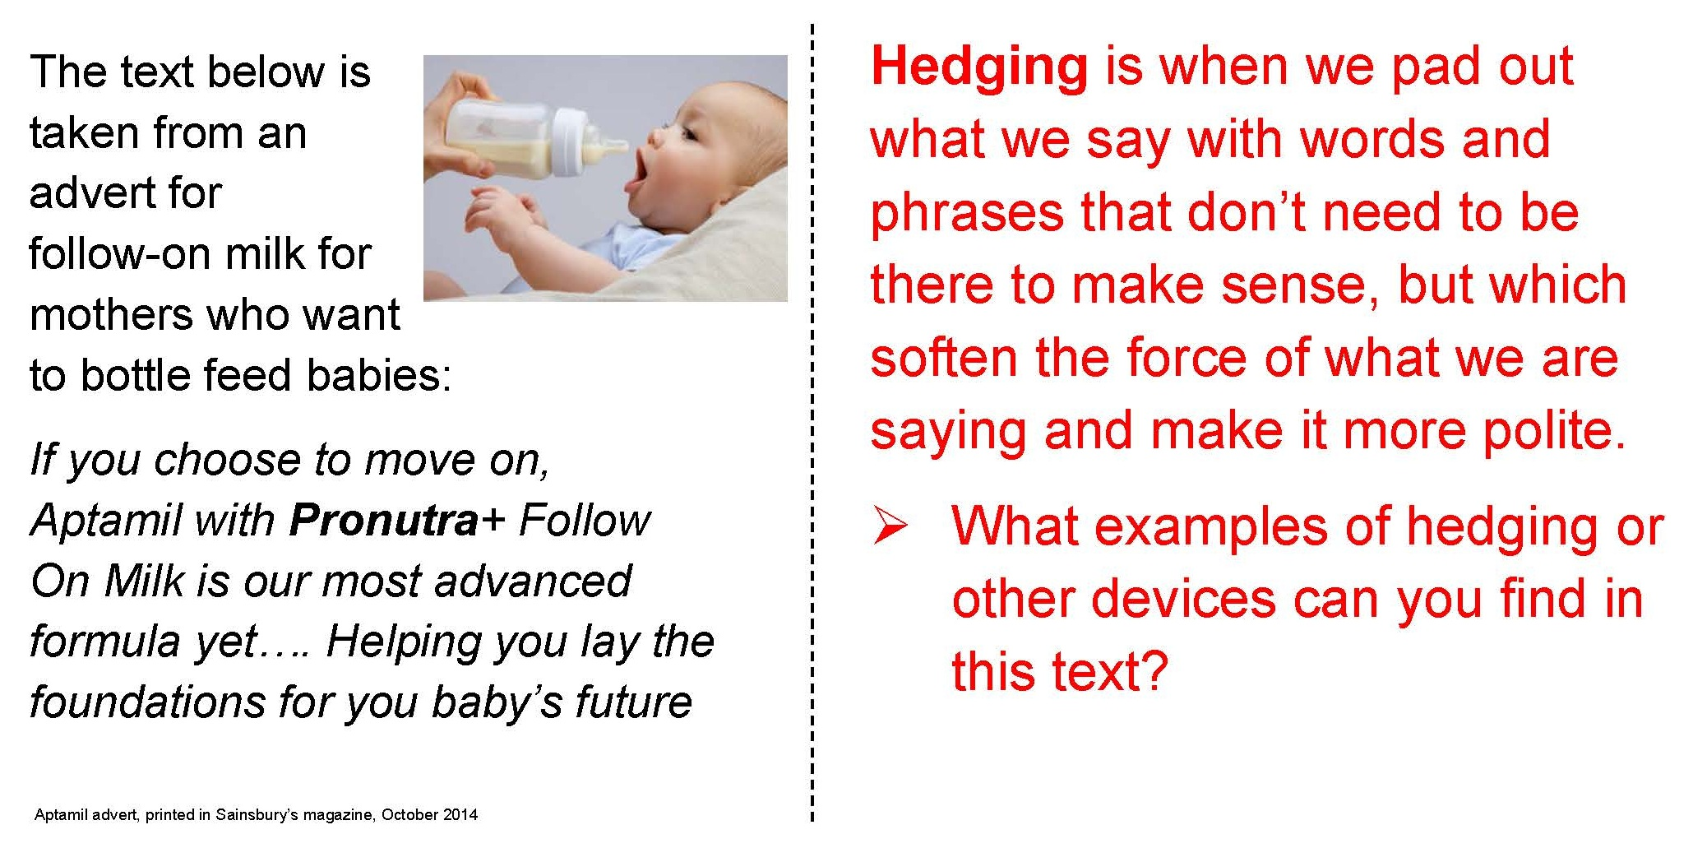
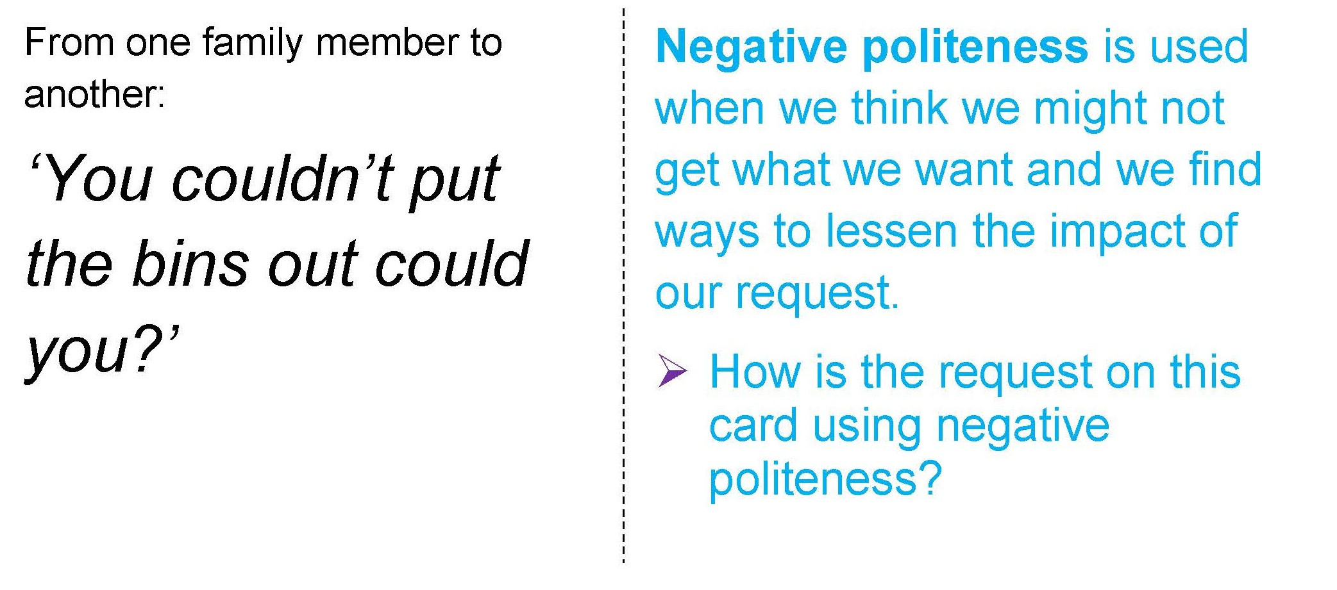 | 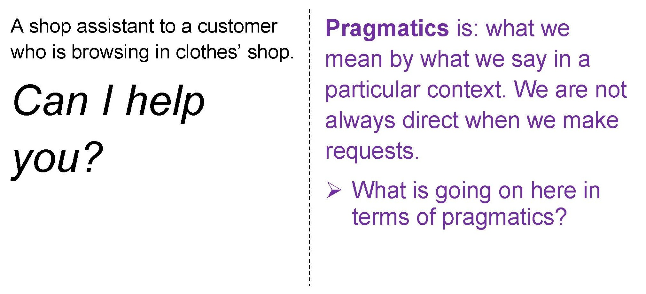

Two Extra Power Texts
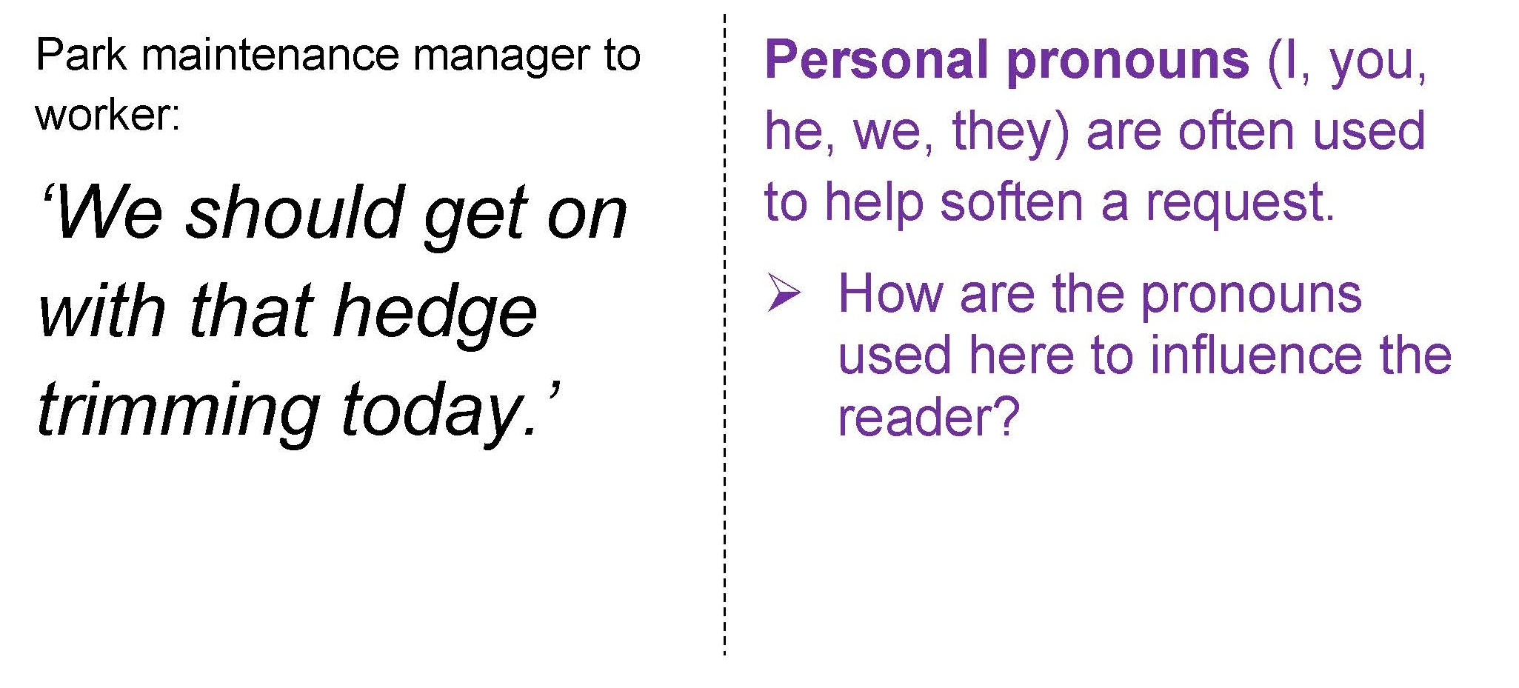 | 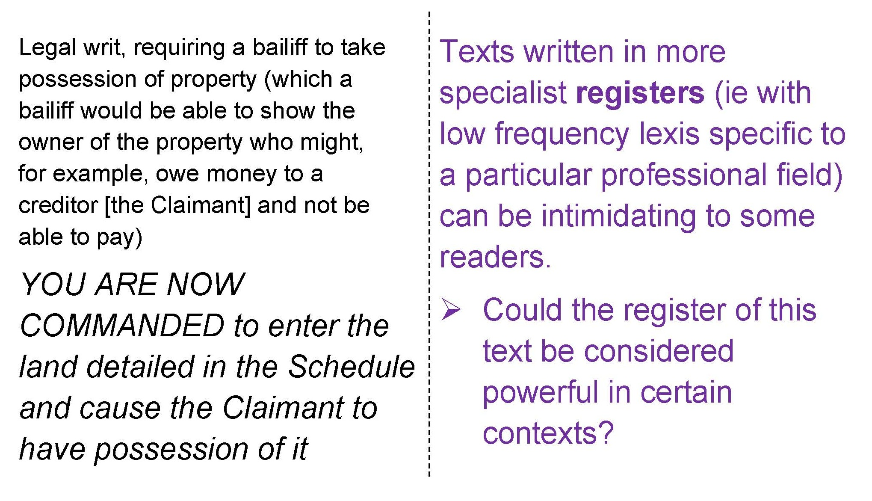

Lesson Activity 2B

Jigsawing Some Power Texts
On these pages you will find 18 texts. The texts to analyse are on the left of each card: some are spoken, some are written, some are multi-modal – a mixture of words and images. On the right are some prompts to help discussion.
- You start in a group of four students (if you have five in a group, two people need to work as ‘one’ for this activity). Around the room you will find 4 other groups. You are working on one sheet with four texts on it.
- On your own, take a minute in silence with one of the four texts. Annotate it and make some decisions about how powerful it is in relation to the other four texts.
- Now talk to the other group members. Decide which is the most powerful and which one is the least powerful. Rank order them. To make your decision you will need to take account of how overt the use of power is. Some very powerful texts are actually quite subtle in the way they work.
- Use the coloured prompts to talk about each text in turn, discussing aspects of power. Perhaps, as you are talking, you will find yourselves changing the order slightly.
- When the whole class has had enough time to discuss all the texts in their group, number yourselves off 1-4. Stand up and move into a new group with the three other students in the room who have the same number as you.
- Present the findings of your group and listen to the findings of the other three people in your new group. Check that you understand any terms that are new to you.
- Make a decision about the most and least powerful text out of all the texts. Be prepared to discuss this with the teacher and the class.

Lesson Activity 3A

Language and Power Text: ‘MMR Vaccine’
- Read ‘Some background to the MMR’ on student page 2
- Now study student pages 5 and 6. You will find two versions of the webpage produced by the NHS advising parents about the importance of immunising their children via the MMR vaccination. Page 5 is the real one and page 6 has eight key changes
- In pair or small group, take one of the changes and discuss the following:-
  - What specific linguistic feature, including multi-modal features such as images, font, hyperlinks etc. has been changed?
  - Has the change made that part of the text more or less forceful and/or face-threatening?
  - Is it more powerful, in the sense that people are more or less likely to be influenced by it?
- Feed your findings back to the class via a mini-whiteboard, verbal feedback or a portion of the main class whiteboard
- As a class, you might now discuss how texts which need to affect public opinion use language to achieve their aims.

Activity Sheet 3B
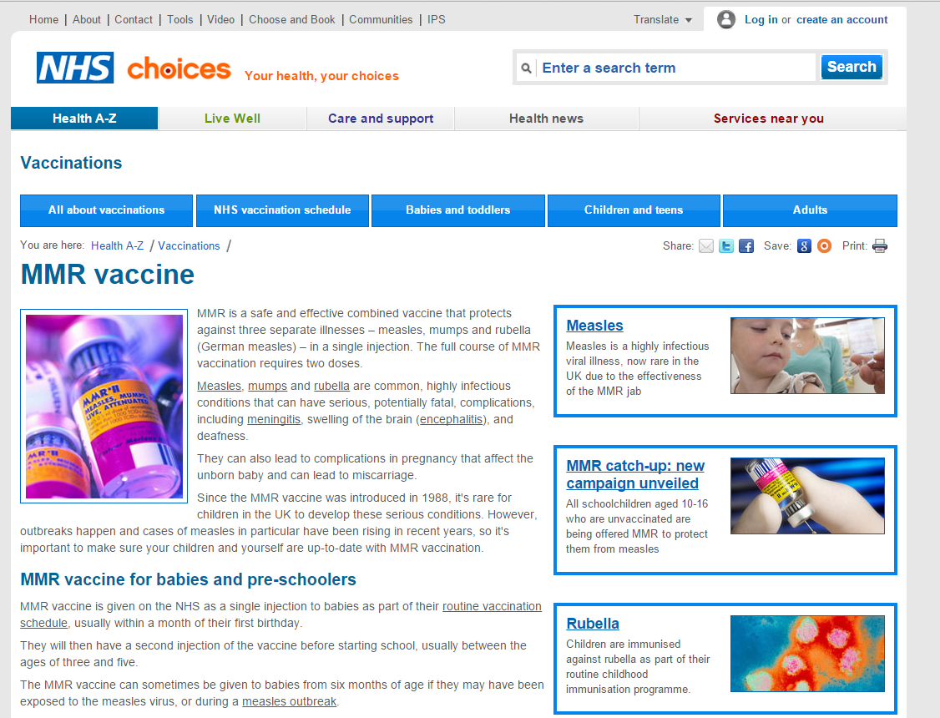
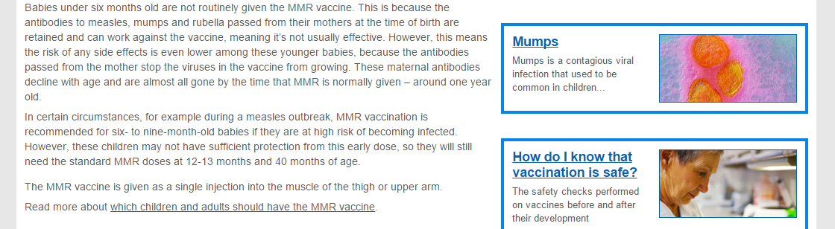
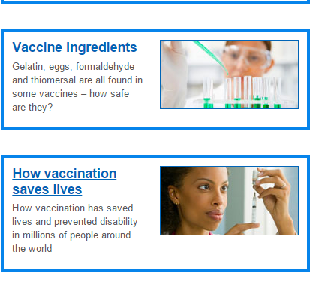
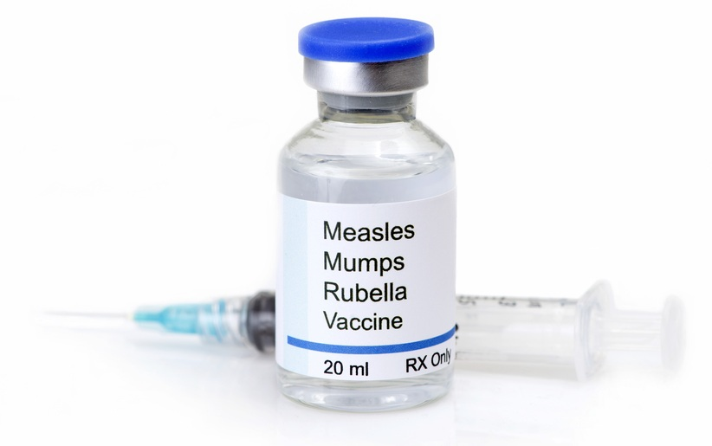
1
2
They can also lead to complications in pregnancy that affect the unborn baby and can lead to miscarriage.
Since the MMR vaccine was introduced in 1988, it's rare for children in the UK to develop these serious conditions. However, outbreaks happen and cases of measles in particular have been rising in recent years, so it's important to make sure your children and yourself are up-to-date with MMR vaccination.
MMR vaccine for babies and pre-schoolers
MMR vaccine is given on the NHS as a single injection to babies as part of their routine vaccination schedule, usually within a month of their first birthday.
They will then have a second injection of the vaccine before starting school, usually between the ages of three and five.
The MMR vaccine can sometimes be given to babies from six months of age if they may have been exposed to the measles virus, or during a measles outbreak.
some text removed]
MMR for older children
Children of any age up to 18 who missed, or only partially completed, their earlier MMR vaccination, can have a 'catch-up' MMR vaccination on the NHS.
If you know, or suspect, your child hasn't been fully immunised, arrange with your GP for them to have a catch-up MMR vaccination,
Single measles, mumps and rubella vaccines
Single vaccines are not available on the NHS in the UK because there is a risk that fewer children would receive all the necessary injections, increasing the levels of measles, mumps and rubella in the UK.
The delay in having six separate injections would also put more children at risk of developing the conditions, as well as increasing the amount of work and inconvenience for parents and those administering the vaccines.
7.
6.
8.
4
MMR is a safe and effective combined vaccine that protects against three separate illnesses – measles, mumps and rubella (German measles) – in a single injection. The full course of MMR vaccination requires two doses.
Measles, mumps and rubella are common, highly infectious conditions that can have serious, potentially fatal, complications, including meningitis, swelling of the brain (encephalitis), and deafness.
They can also lead to complications in pregnancy that affect the unborn baby and can lead to miscarriage.

4.
MMR is a safe and effective combined vaccine that protects against three separate illnesses – measles, mumps and rubella (German measles) – in a single injection. The full course of MMR vaccination requires two doses.
Measles, mumps and rubella are common, highly infectious conditions that can have serious, potentially fatal, complications, including meningitis, swelling of the brain (encephalitis), and deafness.
They can also lead to complications in pregnancy that affect the unborn baby and can lead to miscarriage.

5.
3.
NHS Choices – 2016’


They can also lead to complications in pregnancy that affect the unborn baby and can lead to miscarriage.
Since the MMR vaccine was introduced in 1988, it's rare for children in the UK to develop these serious conditions. However, outbreaks happen and cases of measles in particular have been rising in recent years, so it's important to make sure both children and adults are up-to-date with MMR vaccination.
MMR vaccine for babies and pre-schoolers
MMR vaccine is given on the NHS as a single injection to babies as part of their routine vaccination schedule, usually within a month of their first birthday.
They will then have a second injection of the vaccine before starting school, usually between the ages of three and five.
The MMR vaccine can sometimes be given to babies from six months of age if they may have been exposed to the measles virus, or during a measles outbreak.
[some text removed]
MMR for older children
Children of any age up to 18 who missed, or only partially completed, their earlier MMR vaccination, must have a 'catch-up' MMR vaccination on the NHS.
If you know, or suspect, your child hasn't been fully immunised, you should arrange with your GP for them to have a catch-up MMR vaccination,
Single measles, mumps and rubella vaccines
You cannot avoid the MMR by opting for single vaccines as these are not available on the NHS in the UK. This is because there is a risk that fewer children would receive all the necessary injections, increasing the levels of measles, mumps and rubella in the UK. As a nation we cannot delay the immunisation process. This would put more children at risk of developing the conditions, as well as increasing the amount of work and inconvenience for parents and those administering the vaccines.
2
1.
5.
6.
1.
8.
7.
MMR is a vitally important combined vaccine that protects against three separate illnesses – measles, mumps and rubella (German measles) – in a single injection. The full course of MMR vaccination requires two doses.
Measles, mumps and rubella are common infectious diseases that can have serious and potentially even life-threatening consequences for children and can affect the way a child develops in adulthood.
They can also lead to complications in pregnancy that affect the unborn baby and can lead to miscarriage.

MMR: Why you must immunise
3.
5.
5.
NHS Choices – 2016’

Student Activity 3C

ORIGINAL VERSION | CHANGED VERSION
- NHS choices Your health, your choices | - ADVICE LINE Helping you to health
- MMR Vaccine | - MMR: Why you must immunise
2. | 2.

- MMR is a safe and effective combined vaccine | 3.MMR is a vitally important combined vaccine
4.to make sure your children and yourself are up-to-date with MMR | - make sure both children and adults are up-to-date with MMR
- Measles, mumps and rubella are common, highly infectious conditions that can have serious, potentially fatal, complications, including meningitis, swelling of the brain (encephalitis), and deafness. | - Measles, mumps and rubella are common infectious diseases that can have serious and potentially even life-threatening consequences for children and can affect the way a child develops in adulthood.
- If you know, or suspect, your child hasn't been fully immunised, arrange with your GP for them to have a catch-up MMR vaccination. | - If you know, or suspect, your child hasn't been fully immunised, you should arrange with your GP for them to have a catch-up MMR vaccination.

- Children of any age up to 18 who missed, or only partially completed, their earlier MMR vaccination, can have a 'catch-up' MMR vaccination on the NHS | - Children of any age up to 18 who missed, or only partially completed, their earlier MMR vaccination, must have a 'catch-up' MMR vaccination on the NHS
- Single vaccines are not available on the NHS in the UK because there is a risk that fewer children would receive all the necessary injections, increasing the levels of measles, mumps and rubella in the UK.  The delay in having six separate injections would also put more children at risk of developing the conditions, as well as increasing the amount of work and inconvenience for parents and those administering the vaccines | - You cannot avoid the MMR by opting for single vaccines as these are not available on the NHS in the UK. This is because there is a risk that fewer children would receive all the necessary injections, increasing the levels of measles, mumps and rubella in the UK. As a nation we cannot delay the immunisation process. This would put more children at risk of developing the conditions, as well as increasing the amount of work and inconvenience for parents and those administering the vaccines  .

Student Activity 3D

ORIGINAL VERSION | CHANGED VERSION
- NHS choices Your health, your choices | - ADVICE LINE Helping you to health
‘choices’ which has a sense that it is up to you to take the advice they offer. The direct address in the caption, ‘your’, is meant to engage readers with the choosing process, and the parallel phrasing of ‘your health, your choices’ means that you naturally link one to the other | Arguably this is more insistent, with a sense that the NHS has an agenda to ‘help’ people to ‘health’. The choice of verb ‘helping’ does suggest that the NHS will not force you, but will support you.
- MMR Vaccine | - MMR: Why you must immunise
A simple heading, with no verbs. On its own, without the other multi-modal elements in the text such as pictures of viruses, it is neutral. It says, simple, ‘here is some information’ | This is deliberately forceful, with the modal auxiliary verb ‘must’ and the direct address (‘you’) directly challenging the reader to take action.
2. | 2.
The main picture has a serious feel to it, when compared to the smiling child. On its own it is reasonably neutral, but you could argue that, tied to the other images on the page, including the microscopic viruses themselves (which are tinted in similar colours to the main shot) it does present a sense of threat. | The smiling child – happy not doubt because they have been immunised and are therefore being kept healthy is a more optimistic approach to encouraging parents to immunise

- MMR is a safe and effective combined vaccine | 3.MMR is a vitally important combined vaccine
The adjective ‘safe’ is significant, given the fact that at one time there was some doubt raised by a (no discredited) study that linked the vaccination with autism. ‘Effective’, meanwhile, is also key: this is something that works. | The adjectival phrase ‘vitally important’ is somewhat empty, but is designed to set a tone of significance to the rest of this advisory text.
4.to make sure your children and yourself are up-to-date with MMR | - make sure both children and adults are up-to-date with MMR
The use of direct address, with the possessive determiner ‘your’ and reflexive pronoun ‘yourself’ ties back to the main caption ‘your choices, your health’. | Without the direct address, this seems more like a general statement of what needs to be done: the reader is not implicated and has less obligation to act, perhaps
- Measles, mumps and rubella are common, highly infectious conditions that can have serious, potentially fatal, complications, including meningitis, swelling of the brain (encephalitis), and deafness. | - Measles, mumps and rubella are common infectious diseases that can have serious and potentially even life-threatening consequences for children and can affect the way a child develops in adulthood.
This description of the three diseases that the initialism MMR stands for may be intended to focus the reader’s mind: despite the modal auxiliary ‘can’, the chosen ‘complications’ all sound menacing, and are meant to. The choice of latinate vocabulary ‘fatal’ and ‘complications’ joins the scientific/medical register of the actual names of the complications (‘eg ‘encaphalitis’) to keep the tone serious. All these names are hyperlinked, showing the reader that the website covers all of this in some depth, perhaps further reassuring the reader. | This version is somewhat softer than the original. ‘Life-threatening consequences’ is rather vague in comparison, for example. Without the actual descriptions of possible complications you could argue it becomes less effective overall.
- If you know, or suspect, your child hasn't been fully immunised, arrange with your GP for them to have a catch-up MMR vaccination. | - If you know, or suspect, your child hasn't been fully immunised, you should arrange with your GP for them to have a catch-up MMR vaccination.
After the ‘if’ clause, which softens the impact of the imperative a little, there is no further hedging – just the verb ‘arrange’. It is a point where the text becomes more insistent. | The inclusion of the modal auxiliary ‘should’ is softer, less insistent. It works as a hedge to invite rather than compel.

- Children of any age up to 18 who missed, or only partially completed, their earlier MMR vaccination, can have a 'catch-up' MMR vaccination on the NHS | - Children of any age up to 18 who missed, or only partially completed, their earlier MMR vaccination, must have a 'catch-up' MMR vaccination on the NHS
The choice of ‘can’ here is interesting: it is offering an option | Here the use of ‘must’ is a modal auxiliary of obligation. It is arguably further than this text can go.
- Single vaccines are not available on the NHS in the UK because there is a risk that fewer children would receive all the necessary injections, increasing the levels of measles, mumps and rubella in the UK.  The delay in having six separate injections would also put more children at risk of developing the conditions, as well as increasing the amount of work and inconvenience for parents and those administering the vaccines | - You cannot avoid the MMR by opting for single vaccines as these are not available on the NHS in the UK. This is because there is a risk that fewer children would receive all the necessary injections, increasing the levels of measles, mumps and rubella in the UK. As a nation we cannot delay the immunisation process. This would put more children at risk of developing the conditions, as well as increasing the amount of work and inconvenience for parents and those administering the vaccines  .
These important paragraphs are clearly stating that single vaccinations for the three illnesses are not available. It would be possible to use them, but it would cost the government more money and would not be as efficient. The language here is stressing ‘inconvenience’ and repeats ‘risk’ twice to help persuade the reader that three jabs are not an option | This is a more forceful version. The first sentence implies that the reader should forget any ideas of an alternative. The sentence ‘As a nation… ‘ meanwhile is arguably attempting to mobilise the reader into a kind of patriotic action in immunising their child.

