Checkpoint Task

Enthalpy changes

Instructions and answers for teachers
These instructions cover the learner activity section which can be found on page 6. This Checkpoint Task should be used in conjunction with the KS4–5 A Level Chemistry Transition Guide Amount of Substance, which supports OCR A Level Chemistry A and Chemistry B (Salters).
When distributing the activity section to the learners either as a printed copy or as a Word file you will need to remove the teacher instructions section.

Overview
This activity tests learners’ understanding of energy profile diagrams, exothermic and endothermic reactions, finally leading on bond enthalpy calculations. Activation energy could also be included here, depending on what you know about learners’ prior knowledge.
The activity allows teachers to gauge how well the learners understand the main ideas, enabling them to focus on any misconceptions before embarking on the A Level content.
Exothermic reactions
1. Write a definition of an exothermic reaction.
An exothermic reaction is one in which energy is given out to the surroundings.

2. Draw an enthalpy profile diagram for an exothermic reaction.
Label the axes, ΔH and the activation energy.
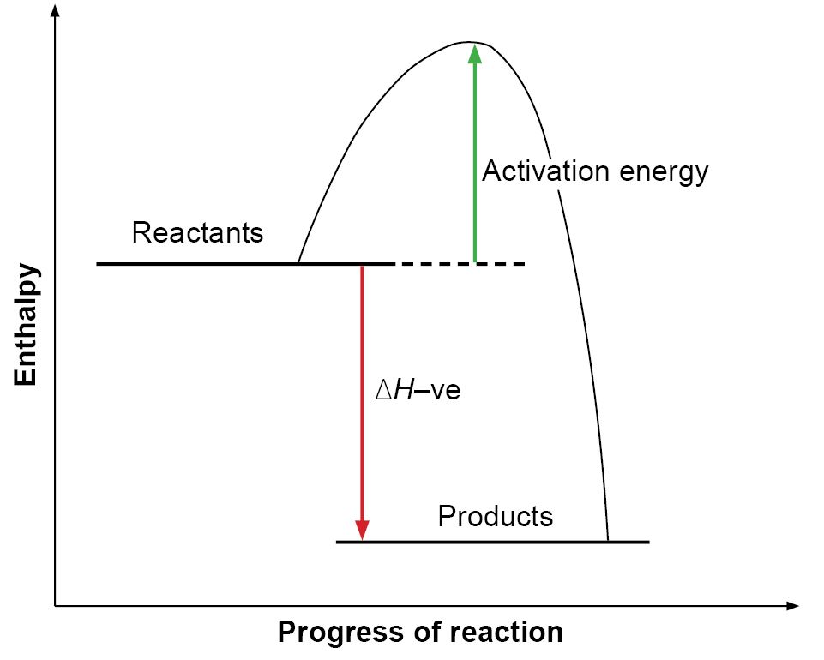

3. Give an example of an exothermic reaction.
E.g. combustion, lots of oxidation reactions (including rusting), neutralisation.

Endothermic reactions
4. Write a definition of an endothermic reaction.
An endothermic reaction is one in which energy is taken in from the surroundings.
5. Draw an enthalpy profile diagram for an endothermic reaction.
Label the axes, ΔH and the activation energy.
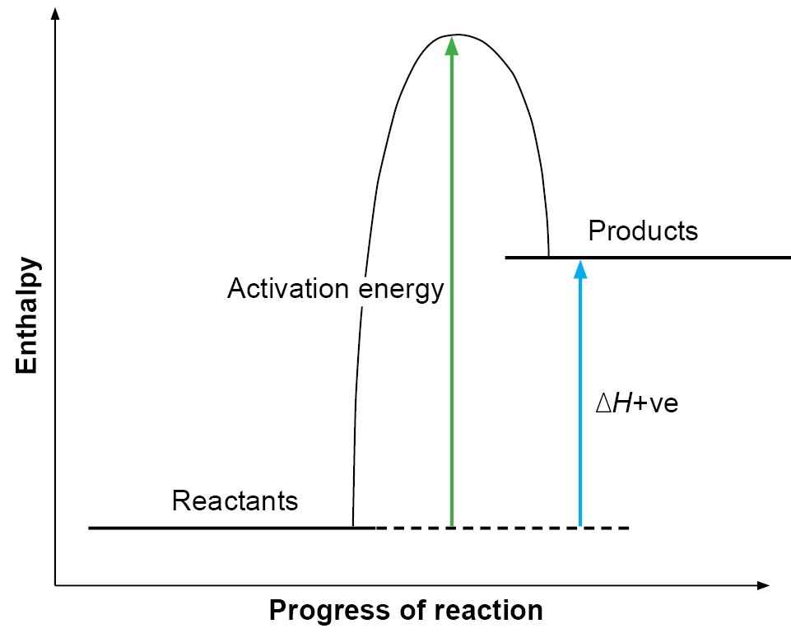

6. Give an example of an endothermic reaction.
E.g. decomposition of metal carbonates, electrolysis, reaction between ethanoic acid and sodium carbonate, cracking, photosynthesis.

Bond enthalpy
7. Write a definition of bond enthalpy. (You might know this term as ‘bond energy’.)
The energy needed to break one mole of a given bond in a gaseous molecule. The units are kJ mol^{–1} (kilojoules per mole).

8. In a chemical reaction, bonds in the reactants are broken, and new bonds are formed to make the products. Complete the following sentences.
required
Energy is to break bonds.
released
Energy is when bonds are formed.
The overall energy change of a reaction is the
energy required minus energy released
Calculations
9. Use bond enthalpies to calculate the enthalpy change for the following reaction.
H₂(g) + Br₂(g) → 2HBr(g)
Bond | H–H | Br–Br | H–Br
Bond enthalpy / kJ mol^{–1} | 438 | 193 | 366

Energy required to break bonds:
(H–H) + (Br–Br) = 631 kJ mol^{–1}

Energy released in forming new bonds:
2 × (H–Br) = 732 kJ mol^{–1}

Enthalpy change:
631 – 732 = –101 kJ mol^{–1}

10. Use bond enthalpies to calculate the enthalpy change for the combustion of methane.
CH₄(g) + 2O₂(g) → CO₂(g) + 2H₂O(g)
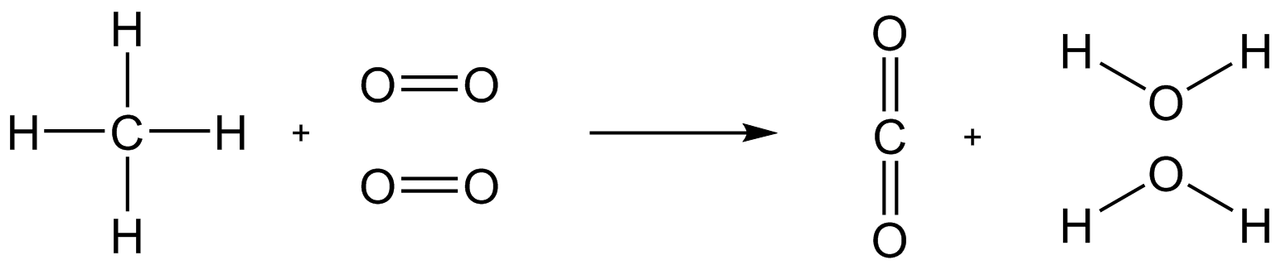
Bond | C–H | C–C | O–H | C=O | O=O
Bond enthalpy / kJ mol^{–1} | 413 | 347 | 464 | 805 | 498

Energy required to break bonds:
4 × (C–H) + 2 × (O=O) = 2648 kJ mol^{–1}
Energy released in forming new bonds:
2 × (C=O) + 4 × (O–H) = 3466 kJ mol^{–1}

Enthalpy change:
2648 – 3466 = –818 kJ mol^{–1}

11.
Bond | C–H | C–C | H–H | C=C
Bond enthalpy / kJ mol^{–1} | 413 | 347 | 436 | 612

Use the bond energies above to calculate
a) the enthalpy change for the hydrogenation of ethene
CH₂=CH₂(g) + H₂(g) → CH₃CH₃(g)
Energy required to break bonds: 4 × (C–H) + (C=C) + (H–H) = 2700 kJ mol^{–1}
Energy released in forming new bonds: 6 × (C–H) + 1 × (C–C) = 2825 kJ mol^{–1}
Enthalpy change: 2700 – 2825 = –125 kJ mol^{–1}

b) the enthalpy change for the cracking of decane
C₁₀H₂₂(g) → CH₂=CH₂(g) + C₈H₁₈(g)
Energy required to break bonds: 22 × (C–H) + 9 × (C–C) = 12 209 kJ mol^{–1}
Energy released in forming new bonds: 22 × (C–H) + (C=C) + 7 × (C–C) = 12 127 kJ mol^{–1}
Enthalpy change: 12 127 – 12 209 = +82 kJ mol^{–1}
N.B. This can be more easily calculated by realising that the overall reaction involves breaking of 2 C–C bonds and formation of 1 new C=C bond. The calculation is then
Energy required to break bonds: 2 × (C–C) = 694 kJ mol^{–1}
Energy released in forming new bonds: 1 × (C=C) = 612 kJ mol^{–1}
Enthalpy change: 694 – 612 = +82 kJ mol^{–1}

12. Explain in terms of bond breaking and bond formation why combustion reactions are exothermic but cracking reactions are endothermic.
In combustion reactions, the bond enthalpies in the products are greater than those in the reactants. Therefore, more energy is released in making the bonds in the products than is required to break the bonds in the reactants.
In cracking reactions, the bond enthalpies in the products are smaller than those in the reactants. Therefore, less energy is released in making the bonds in the products than is required to break the bonds in the reactants.

OCR Resources: the small print
OCR’s resources are provided to support the teaching of OCR specifications, but in no way constitute an endorsed teaching method that is required by the Board, and the decision to use them lies with the individual teacher. Whilst every effort is made to ensure the accuracy of the content, OCR cannot be held responsible for any errors or omissions within these resources.
© OCR 2017 - This resource may be freely copied and distributed, as long as the OCR logo and this message remain intact and OCR is acknowledged as the originator of this work.
OCR acknowledges the use of the following content: n/a
Please get in touch if you want to discuss the accessibility of resources we offer to support delivery of our qualifications: resources.feedback@ocr.org.uk
We’d like to know your view on the resources we produce. By clicking on ‘Like’ or ‘Dislike’ you can help us to ensure that our resources work for you. When the email template pops up please add additional comments if you wish and then just click ‘Send’. Thank you.
Whether you already offer OCR qualifications, are new to OCR, or are considering switching from your current provider/awarding organisation, you can request more information by completing the Expression of Interest form which can be found here: www.ocr.org.uk/expression-of-interest
Looking for a resource? There is now a quick and easy search tool to help find free resources for your qualification:
www.ocr.org.uk/i-want-to/find-resources/

Checkpoint Task

Enthalpy changes

Learner Activity

Exothermic reactions
1. Write a definition of an exothermic reaction.

2. Draw an enthalpy profile diagram for an exothermic reaction.
Label the axes, ΔH and the activation energy.

3. Give an example of an exothermic reaction.

Endothermic reactions
4. Write a definition of an endothermic reaction.

5. Draw an enthalpy profile diagram for an endothermic reaction.
Label the axes, ΔH and the activation energy.

6. Give an example of an endothermic reaction.

Bond enthalpy
7. Write a definition of bond enthalpy. (You might know this term as ‘bond energy’.)

8. In a chemical reaction, bonds in the reactants are broken, and new bonds are formed to make the products. Complete the following sentences.
Energy is to break bonds.

Energy is when bonds are formed.
The overall energy change of a reaction is the

Calculations
Remember:
enthalpy change = energy required to break bonds – energy released in making bonds
or
Δ_{r}H = Σ(bond enthalpies in reactants) – Σ(bond enthalpies in products)
9. Use bond enthalpies to calculate the enthalpy change for the following reaction.
H₂(g) + Br₂(g) → 2HBr(g)
Bond | H–H | Br–Br | H–Br
Bond enthalpy / kJ mol^{–1} | 438 | 193 | 366

Energy required to break bonds:

Energy released in forming new bonds:

Enthalpy change:

10. Use bond enthalpies to calculate the enthalpy change for the combustion of methane.
CH₄(g) + 2O₂(g) → CO₂(g) + 2H₂O(g)
Bond | C–H | C–C | O–H | C=O | O=O
Bond enthalpy / kJ mol^{–1} | 413 | 347 | 464 | 805 | 498

Energy required to break bonds:

Energy released in forming new bonds:

Enthalpy change:

11.
Bond | C–H | C–C | H–H | C=C
Bond enthalpy / kJ mol^{–1} | 413 | 347 | 436 | 612

Use the bond energies above to calculate
a) the enthalpy change for the hydrogenation of ethene
H₂C=CH₂(g) + H₂(g) → CH₃CH₃(g)

b) the enthalpy change for the cracking of decane
C₁₀H₂₂(g) → H₂C=CH₂(g) + C₈H₁₈(g)

12. Explain in terms of bond breaking and bond formation why combustion reactions are exothermic but cracking reactions are endothermic.

