Lesson Element

Unit R065: Design a business proposal

Which method?

Instructions and answers for teachers

These instructions cover the learner activity section which can be found on page 4. This Lesson Element supports Cambridge Nationals Level 1/2 in Enterprise and Marketing.
When distributing the activity section to the learners either as a printed copy or as a Word file you will need to remove the teacher instructions section.

The activity
You could introduce the topic of market research by posing the question ‘Who has been asked some questions about a product or service in a shop, on the street or on the internet whilst shopping?’ Learners could be asked the question and invited to respond appropriately. This could then be followed up by further questions such as:
‘Why do you think a business would want to find out your opinion of a product or service?’
‘What may the business do with the responses that are given by people?’
The discussion could end with the teacher explaining that a questionnaire is a form of primary research meaning that businesses who use this method are finding out ‘original information’. The teacher could then provide an explanation of secondary research. The teacher could state that the most common tool that people use these days for secondary research is the internet as it is a quick and easy method of finding out specific information. This is compared to years ago when books would have been the main source of secondary research.

Suggested timings
- Activity 1: 30 minutes
- Activity 2: 20 minutes
- Activity 3: 5 minutes

Activity 1
Ask your learners to work in pairs to complete some research. Learners could research several different types of market research methods that a business may find useful when wanting to make an important decision about products or services that they sell. Learners could investigate some or all of the following methods of research:
- Questionnaire or survey
- Focus group
- Observations
- Competitor research
- Interviews
- Government publications with examples
- Published literature with examples.

Learners could compile an explanation of each method as well as an example of a scenario in which the type of research may be used. Learners could also identify if it is a primary or secondary research method. This could either be presented in class books or in the form of a document created on a computer such as an information booklet based on research methods.
Useful website links:
http://www.bbc.co.uk/education/guides/zd4kq6f/revision/3
http://www.tutor2u.net/business/reference/marketing-primary-market-research
http://www.tutor2u.net/business/reference/marketing-research-secondaryresearch
http://www.bbc.co.uk/schools/gcsebitesize/business/marketing/marketresearchrev3.shtml

Activity 2
Learners should each be given three different scenarios to consider. They should read each scenario and provide an individual detailed response answering the following two questions:
- What research method should be used to decide if this would be a good idea?
- Why would you recommend this form of research?
The teacher could explain that the same research method cannot be used for each scenario.
Scenario A
A new bank account is being created specifically for 16-18 year olds to encourage them to save money each month. The bank has decided to include some incentives to try and get young people to open the account. They need some help in deciding what the incentives should be.

Scenario B
Ralph’s Supplies is a local store that is considering expanding its range of frozen goods.
Scenario C
Special offers on products can often persuade customers to buy particular products. Winter car kits need to be sold in autumn by a car business. They have decided to produce a special offer display in the shop.
Suggested answers: - it is suggested that the best forms of market research for the scenarios are:
Scenario A – Focus group
Scenario B – Questionnaire
Scenario C – Observation of customers.
Learners should create a detailed explanation to enable them to demonstrate their knowledge and understanding of the topic.

Activity 3
To review the lesson, teachers could provide learners with different statements relating to both primary and secondary research, with learners identifying which are true and which are false. Learners could then identify the different forms of each method of primary or secondary research that a business may complete.

This short activity should enable learners to clarify their understanding of the lesson element completed on market research.

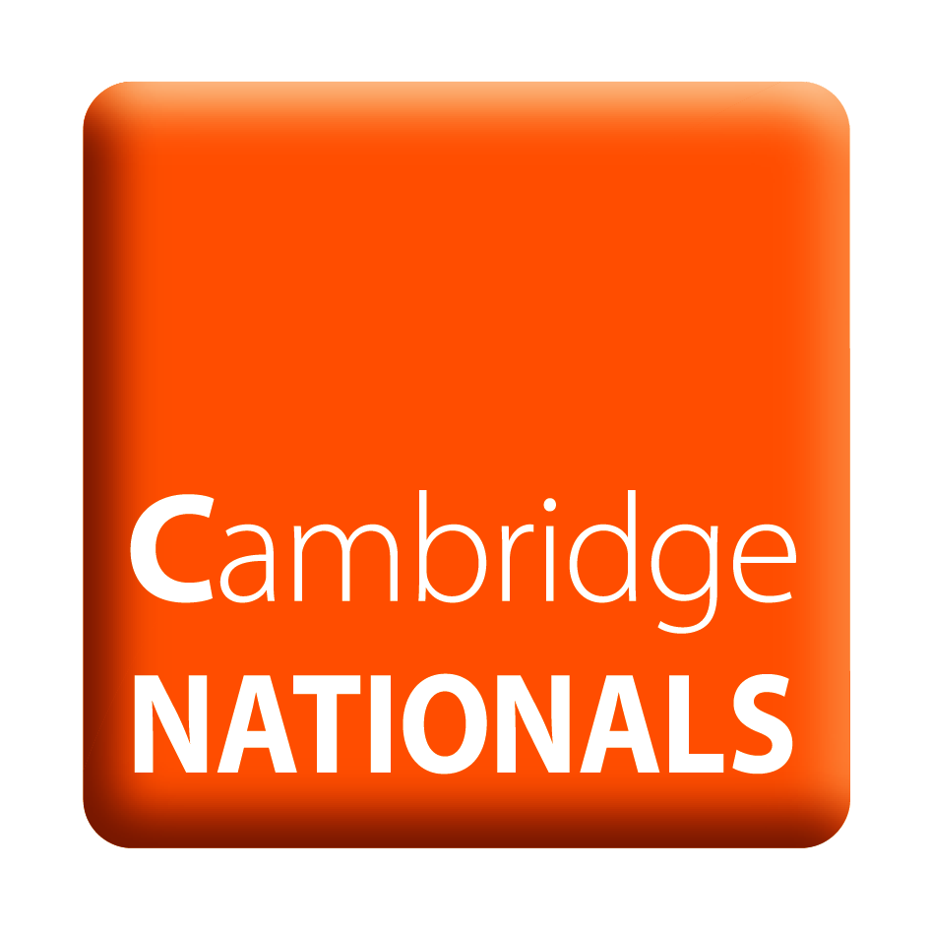
The statements can be found on page 6 and could either be shown on a class board or be printed and cut up as an activity.
OCR Resources: the small print
OCR’s resources are provided to support the teaching of OCR qualifications, but in no way constitute an endorsed teaching method that is required by the Board, and the decision to use them lies with the individual teacher. Whilst every effort is made to ensure the accuracy of the content, OCR cannot be held responsible for any errors or omissions within these resources.
© OCR 2017 - This resource may be freely copied and distributed, as long as the OCR logo and this message remain intact and OCR is acknowledged as the originator of this work.
OCR acknowledges the use of the following content: Piggy bank saver – ESB Professional/Shutterstock.com, Shopkeeper – SpeedKingz/Shutterstock.com, Special offer – mangpor2004/Shutterstock.com
Please get in touch if you want to discuss the accessibility of resources we offer to support delivery of our qualifications: resources.feedback@ocr.org.uk
We’d like to know your view on the resources we produce. By clicking on ‘Like’ or ‘Dislike’ you can help us to ensure that our resources work for you. When the email template pops up please add additional comments if you wish and then just click ‘Send’. Thank you.
Whether you already offer OCR qualifications, are new to OCR, or are considering switching from your current provider/awarding organisation, you can request more information by completing the Expression of Interest form which can be found here: www.ocr.org.uk/expression-of-interest
Looking for a resource? There is now a quick and easy search tool to help find free resources for your qualification:
www.ocr.org.uk/i-want-to/find-resources/

Lesson Element

Unit R065: Design a business proposal

Which method?

Learner Activity

Your teacher will ask you a number of different questions which will help you gain an understanding of why businesses complete research. Try to answer the questions, listening to others and contribute to a small class discussion about research. You will discover the many different forms of research that businesses use.
Activity 1
You will work in pairs to investigate different market research methods that a business may find useful when wanting to make an important decision about products or services that they sell. You could investigate some or all of the following methods of research:
- Questionnaire or survey
- Focus group
- Observations
- Competitor research
- Interviews
- Government publications with examples
- Published literature with examples.

You need to create a document which provides an explanation of the research methods that you have investigated. You should also devise a specific scenario to explain when the type of research would be used to show your understanding of the research method.
For example: A shop specialising in selling surfing related products wants to find out if customers would be interested in a repair service. They have decided to ask customers directly using a questionnaire.
You should also state if the type of research is either a primary research method or a secondary research method.
You may find the following websites useful when completing your research:
http://www.bbc.co.uk/education/guides/zd4kq6f/revision/3
http://www.tutor2u.net/business/reference/marketing-primary-market-research
http://www.tutor2u.net/business/reference/marketing-research-secondaryresearch
http://www.bbc.co.uk/schools/gcsebitesize/business/marketing/marketresearchrev3.shtml
Activity 2
Listed below are three different scenarios for you to read. Using your knowledge of primary and secondary market research methods, you must identify and explain which form of research method you would suggest the business in each scenario uses and justify your decisions.
Please note you must suggest a different, appropriate form of research for each scenario.

Scenario A

A new bank account is being created specifically for 16-18 year olds to encourage them to save money each month. The bank has decided to include some incentives to try and get young people to open the account. They need some help in deciding what the incentives should be.

Scenario B

Ralph’s Supplies is a local store that is considering expanding its range of frozen goods.


Scenario C
Special offers on products can often persuade customers to buy particular products. Winter car kits need to be sold in autumn by a car business. They have decided to produce a special offer display in the shop.

Activity 3
Statements about primary and secondary research are shown below. You need to decide which statements are true and which are false.
This will enable you to ensure that you understand the main differences between primary and secondary research.
Primary research is a when a business finds out information for specific purposes. | Primary research is only completed by a young person.
Primary research enables a business to see who their competitors are. | Magazines are an example of primary research.
Primary research is when the business uses information from the government. | Secondary research does not already exist.
Secondary research is a method of finding out information from other sources. | A survey is a form of secondary research.
Secondary research is when a business can access information that has already been gathered. | When a business gathers new data that has not been collected before, it is called secondary research.

