Lesson Element

The Superheroes of the Atomic Model

Instructions and answers for teachers

These instructions cover the learner activity section which can be found on page 7. This Lesson Element supports OCR GCSE (9-1) Gateway Science Chemistry A and the Twenty First Century Science Chemistry B qualifications.
When distributing the activity section to the learners either as a printed copy or as a Word file you will need to remove the teacher instructions section.

Mapping to specification level (Learning outcomes)
GCSE (9–1) Gateway Science Chemistry A/Combined Science A
C1.2a describe how and why the atomic model has changed over time
GCSE (9–1) Twenty First Century Science Chemistry B/Combined Science B
C2.1.1 describe how and why the atomic model has changed over time to include the main ideas of Dalton, Thomson, Rutherford and Bohr

Background information
‘The Superheroes of the atomic model’ task covers the development of the atomic model in an active fact finding resource. This could be an initial lesson on the atomic model and the scientists that developed it into the current atomic model (WS1.1b); or it could be the introduction for a homework looking at the development of the atomic model over time and how scientific ideas change with experimental evidence (WS1.1a).
Learners will need to have been introduced to the basic atomic parts: electrons, protons, neutrons and the nucleus, but they need not have an understanding of how these parts come together to form the structure of an atom.

Barriers to learning
This knowledge can often be time consuming and difficult for learners to retain the important information. This activity aims to address this by allowing all learners to be active participants in the lesson.

Common misconceptions
There is a direct link between the atomic model and the chemical characteristics of elements. Prior to Mendeleev most scientists ranked elements by atomic weight (relative atomic mass). Mendeleev discovered that when he arranged elements in a grid there were patterns where the characteristics of each element gradually changed across each row and down each column (periodicity) hence the periodic table. Using periodicity Mendeleev saw that the atomic weights (relative atomic mass) of elements were sometimes out of sequence and also accurately predicted the characteristics of missing elements. Although Mendeleev did not know what his ranking system was in 1869 we now know that he arranged by atomic number. This is an important concept for learners to understand which can be developed in follow-up lessons reflecting back on the Superhero information finding task.

Supporting Information
Learners should have covered content on the structure of the atom identifying the different parts and their charges. This will support their understanding of the Gold Foil Experiment and its method. Learners will be introduced to alpha, beta and gamma radiation and the properties of each in Gateway Physics (Topic 6: Radioactive Decay - Waves and Particles).
Learners may struggle with understanding the results of the Gold Foil Experiment and how it led to the disregard of the Plum Pudding Model. Learners may need a diagram of this method which they can annotate to aid their understanding or an analogy of what is happening.
For example the goalie in the goal: the goalie represents a positive nucleus and the goal mouth the empty space. The footballs represent alpha particles (helium nucleus). As in the Gold Foil Experiment most footballs (alpha particles) will fly past the goalie as there is a lot of empty space. Occasionally a football will come within reach of the goalie who will hit it throwing it back at a different angle or straight back.
In the plum pudding model there would be no goalie as the charge is spread throughout the goal. So all footballs would pass straight through.

Running the Activity
The Superheroes of the Atomic Model Teacher Pack contains sets of four information cards on each of the Superheroes (scientists) Dalton, Thomson, Rutherford, Bohr and Geiger & Marsden and their contribution to the atomic model.
Also included in the pack are Superhero (scientist) mini posters with a silhouette/sketch corresponding to a specific scientist and their model. For each Superhero (scientist) their information cards and mini posters have an identifying colour.

Activity 1
- Set out the mini posters to create 7 workstations around the classroom; Mendeleev, Democritus and our 5 other Superheroes (scientists).
- Cut out the information cards for each superhero (scientist)
- As each learner enters the room they are given a Superhero (scientist) information card to hold or to pin onto their clothes. Alternatively the Superhero (scientist) cards could be arranged around the room.
- Learners form groups with the three other learners whose Superhero (scientist) card information shares the same identifying colour. Each group of learners is given a blank learner worksheet (foundation or higher).
- Each group then finds the workstation for their Superhero (scientist). Together each group can now put together the information on their superhero (scientist) and record their answers onto the learner worksheet in the relevant boxes.

Activity 2
- Learners now need to complete the learner worksheet to cover all the superheroes. In order to do this the Superhero cards are set aside and the next stage can either be run as a look-and-draw or a speed dating activity. By either of these processes learners will be able to answer their learner worksheet completely.
  - As a look-and-draw two learners from each group are sent out to get one piece of information at a time, they then return to their group and share the information or describe the atomic model.
  - As a speed dating activity half the group stay at the workstation and the other two members move between workstations; the teacher sets up a timer or countdown clock and the rotating learners only have 3 minute to gather information at each workstation (timings may need to be adjusted for your class).

Extension Tasks
- Learners could discuss which scientist they believe to have made the greatest contribution to the development of the atomic model.
- Learners can then produce a time line of the development of the atomic model and how this links to the periodic table detailing years and scientists with a brief summary of their research.
- Learners could produce a Sciencebook page using the resources on TES connect:
- https://www.tes.co.uk/teaching-resource/Sciencebook-Famous-Scientist-Worksheets-6319512
- https://www.tes.co.uk/teaching-resource/Facebook-template-page-6025698
- Learners could practice level of response questions (for example):
Describe and explain how a scientific model you have studied has changed over time and how this model has allowed scientists to make predictions. You should make use of diagrams in your answer. [6]

- Learner learning could be reviewed at the end of the Topic using the AS/A Level GCE Chemistry B (Salters) Atomic structure checkpoint task activity:
http://www.ocr.org.uk/Images/170274-atomic-structure-checkpoint-task-instructions-.pdf

The superheroes of the atomic model – Learner Worksheet Foundation
Dalton | What conclusions were made by Dalton about compounds?  Compounds are formed from multiple atoms combined together. | During what time period were Dalton’s theories made?  1800s | Whose idea did Dalton revive?  Greek philosophers  Democritus and Leucippus | True or False – Dalton believed atoms could be broken into smaller parts.  False
Thomson | What did Thomson discover?  The electron | What year did he discover this?  1897 | What part of Dalton’s theory did Thomson disprove?  Atoms cannot be broken into smaller parts | What was the name of his atomic model?  Plum Pudding
Rutherford | What was Rutherford’s forename?  Ernest | 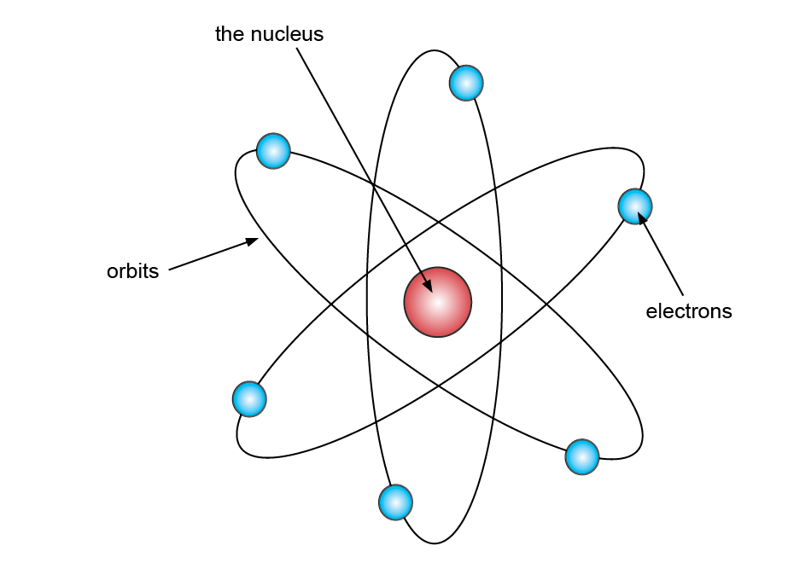  Sketch his model | What charge did he conclude the nucleus to have?  Positive | In what year did Rutherford make his findings?  1911
Bohr | How did he suggest electrons were arranged?  Around the nucleus with different energy levels | In which year did he publish his model?  1913 | Whose theory did he build upon?  Rutherford’s theory | 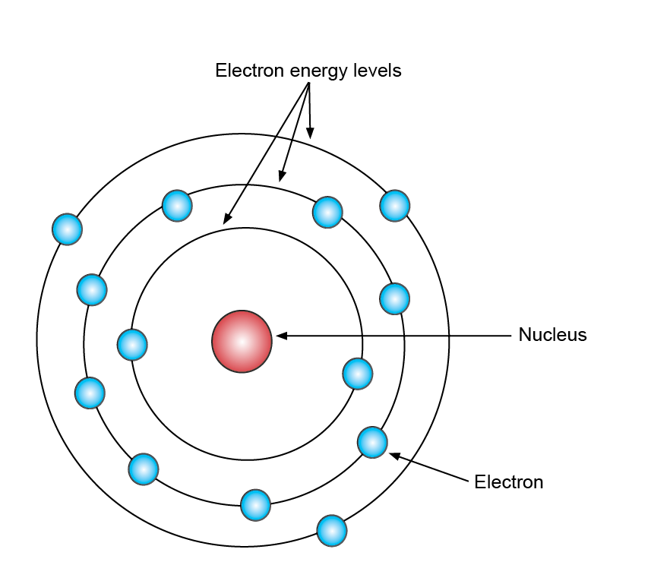  Sketch his model  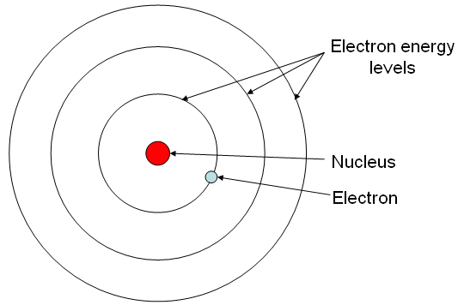

The superheroes of the atomic model – Learner Worksheet Higher
Dalton | What conclusions were made by Dalton about compounds?  Compounds are formed from multiple atoms combined together. | During what time period were Dalton’s theories made?  1800s | Whose idea did Dalton revive?  Greek philosophers  Democritus and Leucippus | True or False – Dalton believed atoms could be broken into smaller parts.  False
Thomson | What did Thomson discover?  The electron | What year did he discover this?  1897 | What part of Dalton’s theory did Thomson disprove?  Atoms cannot be broken into smaller parts | What was the name of his atomic model?  Plum Pudding
Rutherford | What was Rutherford’s forename?  Ernest | Sketch his model | What charge did he conclude the nucleus to have?  Positive | In what year did Rutherford make his findings?  1911
Bohr | How did he suggest electrons were arranged?  Around the nucleus with different energy levels | In which year did he publish his model?  1913 | Whose theory did he build upon?  Rutherford’s theory | Sketch his model
Geiger & Marsden | Who did Geiger and Marsden complete their research for?  Rutherford | Describe the experiment they carried out  Fire a beam of particles at a thin piece of gold foil and record the passage of the alpha particles. | What model was disproved due to this experiment  Plum Pudding Model | What date did they carry out their experiment?  1905

We’d like to know your view on the resources we produce. By clicking on ‘Like’ or ‘Dislike’ you can help us to ensure that our resources work for you. When the email template pops up please add additional comments if you wish and then just click ‘Send’. Thank you.
Whether you already offer OCR qualifications, are new to OCR, or are considering switching from your current provider/awarding organisation, you can request more information by completing the Expression of Interest form which can be found here: www.ocr.org.uk/expression-of-interest
Looking for a resource? There is now a quick and easy search tool to help find free resources for your qualification:
www.ocr.org.uk/i-want-to/find-resources/
OCR Resources: the small print
OCR’s resources are provided to support the delivery of OCR qualifications, but in no way constitute an endorsed teaching method that is required by the Board, and the decision to use them lies with the individual teacher. Whilst every effort is made to ensure the accuracy of the content, OCR cannot be held responsible for any errors or omissions within these resources.
© OCR 2017 - This resource may be freely copied and distributed, as long as the OCR logo and this message remain intact and OCR is acknowledged as the originator of this work.
OCR acknowledges the use of the following content: Billiard Ball Model: tescha555/Shutterstock.com
Please get in touch if you want to discuss the accessibility of resources we offer to support delivery of our qualifications: resources.feedback@ocr.org.uk

The superheroes of the atomic model – Learner Worksheet Foundation
Dalton | What conclusions were made by Dalton about compounds? | During what time period were Dalton’s theories made? | Whose idea did Dalton revive? | True or False – Dalton believed atoms could be broken into smaller parts.
Thomson | What did Thomson discover? | What year did he discover this? | What part of Dalton’s theory did Thomson disprove? | What was the name of his atomic model?
Rutherford | What was Rutherford’s forename? | Sketch his model | What charge did he conclude the nucleus to have? | In what year did Rutherford make his findings?
Bohr | How did he suggest electrons were arranged? | In which year did he publish his model? | Whose theory did he build upon? | Sketch his model

The superheroes of the atomic model – Learner Worksheet Higher
Dalton | What conclusions were made by Dalton about compounds? | During what time period were Dalton’s theories made? | Whose idea did Dalton revive? | True or False – Dalton believed atoms could be broken into smaller parts.
Thomson | What did Thomson discover? | What year did he discover this? | What part of Dalton’s theory did Thomson disprove? | What was the name of his atomic model?
Rutherford | What was Rutherford’s forename? | Sketch his model | What charge did he conclude the nucleus to have? | In what year did Rutherford make his findings?
Bohr | How did he suggest electrons were arranged? | In which year did he publish his model? | Whose theory did he build upon? | Sketch his model
Geiger & Marsden | Who did Geiger and Marsden complete their research for? | Describe the experiment they carried out | What model was disproved due to this experiment | What date did they carry out their experiment?

Teacher Pack

This pack contains:
Four information cards for each of the following superheroes (scientists):
- Dalton
- Thomson
- Rutherford
- Bohr
- Geiger and Marsden

A mini poster for each of the following superheroes (scientists):
- Dalton
- Thomson
- Rutherford
- Bohr
- Geiger and Marsden
- Mendeleev
- Democritus

John Dalton

John Dalton was born in 1766 and died in 1844.
His atomic theory was developed in the 1800s.

This scientist revived the ideas of Greek Philosophers, Democritus and Leucippus who thought there was a limit to the size that things could be broken down into. They called these pieces atoms.

This scientist discovered that when he reacted two elements together they always reacted in the same proportions. Based on this pattern he stated that elements were made of one type of atom and compounds are formed from atoms of different elements combined together.

Mendeleev used this scientist’s theories about atoms when he developed the Periodic Table. For example each element is made up from only one type of atom and different types of atom can be ranked by their proportional mass.

Joseph Thomson
This scientist discovered the electron in 1897 when he weighed the particles from a cathode ray tube and found they were 1800 times lighter than the Hydrogen atom.

This scientist used the discovery of electrons, a smaller part of an atom, to disprove Dalton’s theory that atoms cannot be broken into smaller parts.

Thomson’s model was called the Plum Pudding. He thought the atom was like a positively charged ball with the electrons moving around inside the ball like raisins in a Christmas pudding.

This scientist showed that the tiny particles he discovered were identical to those emitted by radioactive and photoelectrical materials.

Ernest Rutherford
Ernest Rutherford was born in 1871 in New Zealand. He was part of a large family with many brothers and sisters.

This scientist agreed with Thomson’s idea that there were electrons but he thought that the positive charge was concentrated at the centre of the atom, which he called the nucleus.

This scientist proposed his model of the atom in 1911 after carrying out lots of experiments and was the first person to split an atom.

This scientist’s proposed model is sometimes called the planetary model because it looks like a mini solar system with each electron orbiting the nucleus in a different path.

Neils Bohr
Bohr built upon the ideas previously developed by other scientists especially Rutherford.

This scientist’s idea that the electrons were arranged at discrete energy levels around the nucleus was published in 1913.

This scientist’s model is named after him.

This scientist agreed with Rutherford that in an atom the electrons surround the nucleus. But in his model the electrons are in fixed shells (at discrete energy levels) and there is a maximum number of electrons per shell.

Geiger and Marsden
These scientists carried out the Gold Foil Experiment. This involved firing a beam of alpha particles at a thin piece of gold foil. The passage of the alpha particles was then recorded on a detector screen.

These scientists expected that all the alpha particles would pass straight through the gold foil; however some alpha particles were deflected even bouncing straight back. This disproved the Plum Pudding model as only a concentrated positive charge could repel the positively charged alpha particles.

Geiger and Marsden were learners of Rutherford and carried out the Gold Foil Experiment for him at Manchester University.

The Gold Foil Experiment was carried out in 1905 by these scientists.

