STUDENT WORKBOOK

Section 1: Introduction

Descriptive Statistics
This workbook will help you become familiar with the content below, that you need to know for the descriptive statistics part of the specification.
Analysing Research | Learners should be able to demonstrate knowledge and understanding of the process and procedures involved in the collection, construction, interpretation, analysis and representation of data. This will necessitate the ability to perform some calculations.
Types of Data | - Quantitative data  - Qualitative data  - Primary data  - Secondary data  - Strengths of each type of data
Descriptive statistics | - Measures of Central Tendency  - mode (including modal class)  - median  - mean  - Range  - Ratio  - Percentages  - Fractions  - Expressions in decimal and standard form  - Decimal places and significant figures  - Normal distributions  - Estimations from data collected
Tables, charts and graphs | - Frequency tables (tally chart)  - Bar charts  - Pie Charts  - Histograms  - Line graphs  - Scatter diagrams.

Section 2: Standard and Decimal Form

Standard Form
Sometimes psychologists will come across very large or very small numbers. If you are interested in enormous numbers, this website is all about the most famous big numbers http://listverse.com/2012/03/12/10-enormous-numbers/
Because of the nature of very large numbers, it is often necessary to simplify these using shorthand, this is known as standard form.
For example:
5,000,000 would be 5 x 10⁶ - this means 5 x (10 x 10 x 10 x 10 x 10 x 10)
65,000 would be 6.5 x 10⁴ – this means 6.5 x (10 x 10 x 10 x 10)
0.000001 would be 1 x 10⁻⁶ this means 1 x (-10 x -10 x -10 x -10 x -10 x -10)
http://www.mathsrevision.net/gcse-maths-revision/number/standard-form explains this further
Some more examples for you to simplify:
- 8,000,000
- 33,000
- 44,000,000
- 0.0006
Further exercises on this can be found here:
http://www.cimt.plymouth.ac.uk/projects/mepres/book9/bk9i3/bk9_3i4.html

Decimal Form
Once analysis of data starts to take place, decimal form is often used. It allows portions of whole numbers to be represented. Each digit after the decimal point is 1/10 the size of the one before.
For example:
0.9 = 9/10
0.09 = 9/100
0.009 = 9/1000
0.0009 = 9/10000

Significant Figures
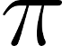
One of the things you may remember from your study of maths at school is Pi, although you may not remember that Pi is the ratio of the circumference of a circle to its diameter. Pi is always the same number, no matter which circle you use to compute it.
How much of Pi do you remember?
How many significant figures do you think are needed?
Pi information
A significant figure is a meaningful figure, so for example Pi is 3 to one significant figure, 3.1 to two significant figures and 3.14 to three significant figures and so on.
The same idea applies when looking at correlation co-efficients (which range from -1 to +1). In a study by Holmes and Rahe, they found a correlation of +0.118 between amount of life events and amount stress. 0.118 has been simplified to three significant figures. This can be simplified further to 0.12 (two significant figures) and even further to 0.1, which is one significant figure.
In order to reduce the number of significant figures, rounding is required. However, depending on the value of the digit after the one you want to keep you may either have to round up or down. If the next digit is 5 or above, we round up. If it is below 5, we round down.
For example, when considering Pi to four significant figures we must consider the next digit after 3.141, this is 31415. We therefore round up to 3.142, as we always round up with a 5. To work out Pi to five significant figures is we must look at 3.14159, as 9 is greater than 5, we round up to 3.1416.
To give an approximated answer, we round off using significant figures.
When we round off, we do so using a certain number of significant figures. The most common are 1, 2 or 3 significant figures.
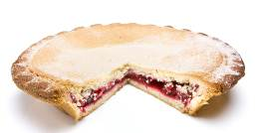
Rules:
- The first non-zero digit reading from left to right is the first significant figure.
- For numbers 5 and above we round up.
- For numbers 4 and below we round down.
Worked examples:
1 significant figure: 4 2 3 2 4 9 = 400000 (rounded down)

1st sig figure

1 significant figure 0 . 0 0 3 7 9 = 0.004 (rounded up)

1st sig figure (1st number after zeros)

2 significant figures 0 . 0 0 4 0 3 5 2 = 0.0040 (rounded down)
1st & 2nd sig figures (ignoring zeros)

- The world’s oldest living plant is the Tasmanian King’s Holly at 43,600 years old. – 2 significant figures = 44,000
- 1,143,552 paper bags are used in the USA every hour – 3 significant figures = 1.14 million
- There are 635,013,559,599 possible hands in a game of bridge. – 2 significant figures = 640 million

Activity
Work out the following:
For further up to date, interesting examples go to http://www.worldometers.info/. Choose three and express them to 1, 2, and 3 significant figures.

56982 to 1 and 2 significant figures
0.0030490 to 1 and 2 significant figures
0.008237 to 1 and 2 significant figures
566064 to 3 significant figures

Make estimations from data collected
When making estimations, you may want to round figures to one digit (one significant figure). For example, with the sum 234 x 39.78 you might just want to know “very roughly” what sort of value you are expecting rather than knowing the precise answer. So we do an “order of magnitude” calculation which means rounding the numbers to 1 digit (1 significant figure), so we get: 200 x 40 = 8000.

Activity
Estimate the following (remember the rounding rules):
574 x 29

333 x 14

88 x 9

969 x 1001

Try some further estimations from the maths is fun website. http://www.mathsisfun.com/numbers/estimation.html

Percentages (%)
Percent comes from the word ‘per centum’ meaning 100 - so percent literally means per 100. So, 1% is 1 in 100, 5% is 5 in 100 and so on. 100% means all.
To calculate percentages you need to divide by 100. So to find 32%, you divide 32 by 100 (32/100)
Here are some more examples.
To calculate 18% of 40 18/100 = 0.18
0.18 x 40 = 7.2

To calculate 45% of 70 45/100 = 0.45
0.45 x 70 = 31.50

Activity
Calculate the following percentages:
- 16% of 30

- 24% of 90

- 40% of 72

- 8% of 50

- A psychologist found that from his sample of 50 participants, 12% showed an increase in score when using his new revision aid. How many participants showed an improvement in total? Show your workings.

Converting percentages to decimals and vice versa (the left and right rule)
To convert from a percentage to a decimal | To convert a decimal to a percentage
The easiest way to convert a percentage to a decimal is to follow this formula:  Remove the % sign and divide the number by 100 and then move the decimal two places to the left.  So, 75% = 0.7 5 | The opposite applies when converting from decimal to a percentage.  So the decimal is moved two places to the right.  Add percentage sign.  0.125 = 1 2 . 5 %

Converting a decimal to a fraction
Work out how many decimal places you have (for example 0.75 has two decimal places and 0.125 has three decimal places)

For two decimal places, divide by 100
For three decimal places divide by 1000

Find the lowest common denominator (the biggest number that can be divided equally into both parts of the fraction)

Learner Resource
Calculating percentages | Converting percentages to decimals
Find 32% of 50  Divide by 100 (32 / 100)  Multiply by the number wanted (x50) = 16 | Remove % sign  Divide by 100  Move the decimal 2 place to the LEFT

Converting decimals to percentages | Significant figures
Move the decimal 2 places to the RIGHT  Add % sign | The first non-zero is the 1st significant figure  5 or more, round up  4 or less, round down

Converting decimal to fraction
For 2 decimal places divide by 100

For 3 decimal places divide by 1000

Find the lowest common denominator

Ratio
A ratio is how much of one thing there is compared to another thing. For example 8:10 means a ratio of 8 to 10. So, if there are 10 pieces of cake one person gets 8 and the other gets 2. Ratios can be simplified like fractions, so in this case both can by divided by 2 and is therefore simplified to 4:5

Section 3: Worksheet 1 – Measures of Central Tendency
When analysing data, descriptive statistics are used to describe the basic features of the data, they provide a summary of the results and are the first step in any data analysis.
There are two types of descriptive statistics; measures of central tendency and measures of dispersion as shown below.
Descriptive Statistics
Measures of central tendency | Measures of dispersion
Mean | Range
Median
Mode

Measures of central tendency
The MEAN is the average of the numbers. It is calculated by adding up all the scores and dividing by the total number of scores.

For example,
6 + 9 + 9 + 13 + 15 + 21 + 24 + 24 + 28 + 32 = 181
181/10 (as there are 10 scores) = 18.1

The MEDIAN is the middle number. It is calculated by finding the middle score after placing all the scores in numerical order.
If there is an odd number the median is the middle number.

For example,
14
4, 7, 8, 9, 21, 28, 29, 34

If there is an even number of results, the median is the mean of the two central numbers.
14, 21
4, 7, 8, 9, 23, 28, 29, 34 = 14+21= 35/2 Median = 17.5

The MODE is the value that appears most frequently in a set of data.
When there is more than one number that appears the most frequently, we call this bimodal.

For example,
9
24
9
24
6, , , 13, 15, 21, , , 28, 32 The mode is 9 and 24

Activity
A Psychologist investigated whether recall was affected by the way the material was presented. One group was given pictures to recall, the other group were given words.

Calculate the measures of central tendency for the following set of raw data.

Number of Pictures Recalled | Number of Words Recalled
7 | 4
5 | 6
10 | 7
8 | 5
7 | 6
5 | 5
7 | 9
9 | 3

 | Mean | Median | Mode
Condition 1
Pictures
Condition 2
Words

Extension
Can you describe what these results show? What conclusions can be drawn from the measures of central tendency?

Class Activity
To test your understanding of when it is appropriate to use each of the measures of central tendency look at the following and discuss your views:
EXPERIMENT 1: In a rather unethical experiment three groups of eight lab rats were given a maze to complete and times were recorded in seconds.

GROUP 1 – Rats given brain lesions – 35, 27, 26, 27, 28, 79, 27, 30
GROUP 2 – Rats with tails cut off – 15, 10, 18, 22, 8, 49, 16, 22
GROUP 3 – Rats with eyes damaged – 33, 33, 32, 28, 67, 45, 24, 29
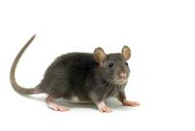
Which is the most appropriate measure of central tendency? Explain your reasons. Calculate the score for this measure of central tendency.

Section 4: Worksheet 2 – Measures of Dispersion
Measures of dispersion measure how spread out a set of data is and include the range, variance and standard deviation. For the GCSE specification you will only need to know the RANGE.
The RANGE is the difference between the lowest and highest values. It is calculated by subtracting the lowest score from the highest score in a data set.
For example:
3, 6, 8, 11, 14, 17, 18, 22, 23

23 is the highest score
3 is the lowest score
So the range is 20 (23-3)
Or
Number of seconds that it took Formula One drivers to complete a lap:

Lewis Hamilton – 75
Sebastian Vettel – 76
Nico Rosberg - 77
Felipe Massa – 77
Jenson Button –79
Pastor Maldonado – 133

133 – 75 + 1 = 59
The addition of +1 is a convention adopted to account for ‘measurement error’. +1 is only really necessary when dealing with data that are not 'absolutes' - i.e. not complete or whole figures, such as when recording reaction times and there may be error in stopping a timing device precisely on a second interval.
In the exam either method of calculating the range would be accepted.

Section 5: Worksheet 3 – Charts and Graphs
Graphs, charts and tables are all used to describe data and make it easier for the data to be understood.
There are a number of graphs and charts that you need to be able to draw and interpret, they include:
- Tally chart (frequency table)
- Line graph
- Pie chart
- Bar chart
- Histogram
- Scatter diagram

Drawing graphs and tables

Frequency tables (tally charts)
Tally marks are used for counting things. These are used in content analyses and observations. They record the number of times something is seen.
Observation of baby… | Tally | Total
Feeding | llll | 4
Crying | ll | 2
Sleeping | llll ll | 7

Bar charts can be used to represent the data from frequency tables, mean scores or the totals. The bars are kept separate from each other, for example using the data from the frequency table:
Histograms are used with interval or ratio data. There are no gaps between the columns to represent a continuous data set.
For example:
Line graphs can be used as an alternative to histograms. These are used to show the results from two or more conditions at the same time.
For example:

Pie charts are used when we have percentages. Each segment represents a percentage of the total.
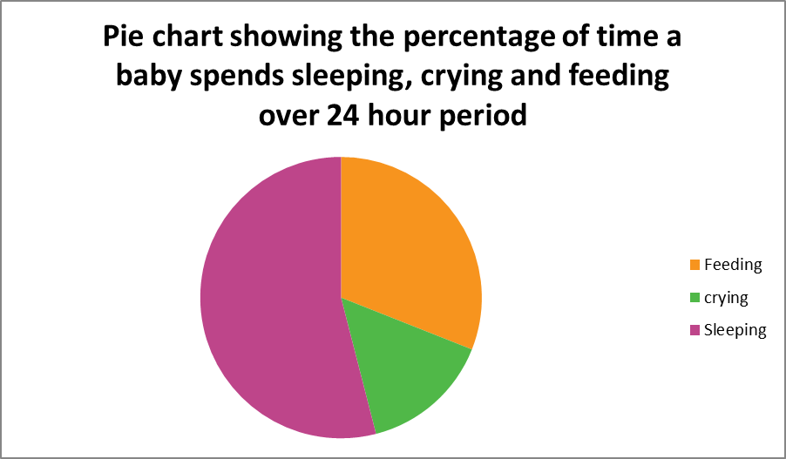
Scatter diagrams are used with correlations where the relationship of two variables is summarised. They illustrate the direction of the relationship (positive, negative or zero correlation) and can indicate the potential strength of the relationship.
For example, this scatter graph shows a positive correlation between ice cream sales and weather.

Activity
A teacher analysed the performance of her students who had sat GCSE Psychology, by the grade they achieved.
Plot the following data onto a bar chart. Remember to give the graph a title, label both axes and use a ruler!
Grade | Number of students
7 | 3
6 | 12
5 | 5
4 | 2
3 | 3
U | 0

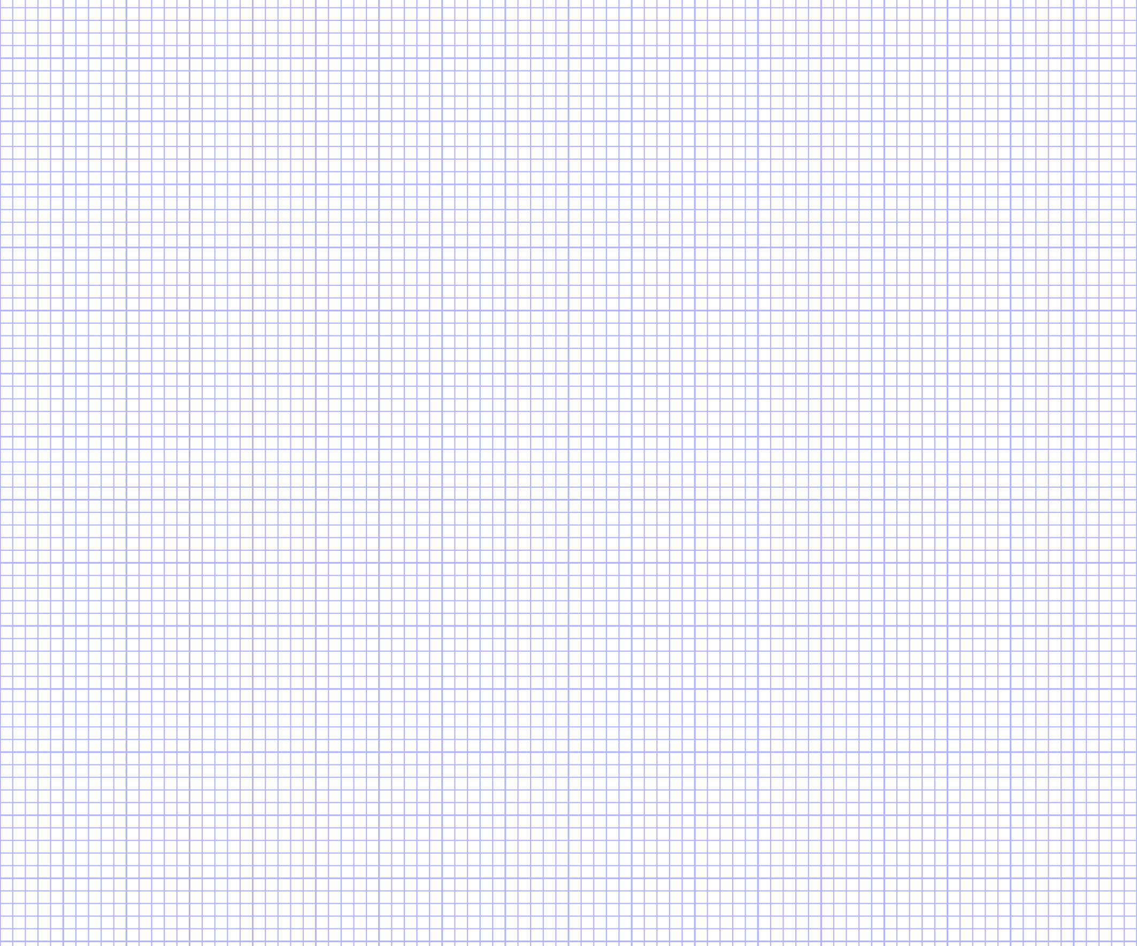
http://www.mathsisfun.com/data/data-graph.php enables graphs to be constructed on the computer.

Histograms
Bar charts should be used with categorical data, however with continuous data such as weight, height and temperature, a histogram should be used. Histograms unlike bar charts also have no gaps between the bars.
You may be interested to know how much time students spend on their homework. As an activity, you could ask other members of your class to reveal this for their last homework (although there may be some social desirability bias!) Hopefully the majority of your class spend around 100 minutes on their psychology homework!
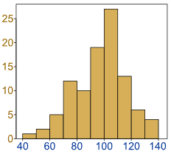
Extension task: Come up with your own examples where histograms could be used.

Interpreting graphs
When we interpret the graph or chart, we are just making sense of the information.
The first and crucial step in interpreting graphs is to make sure that you read all of the parts, including the title, axis and the direction the results are moving in.
The title tells us what the graph is about.
The axes tell us what the variables are.

Exercise
Write a statement describing what the results in the below bar chart show. Make reference to the title, both axes and the direction of the results in your answer.

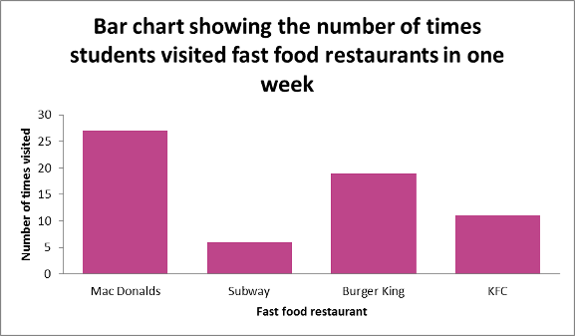

Identify the type of graph and suggest when the graph might be best used.
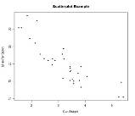

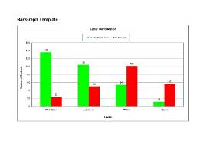

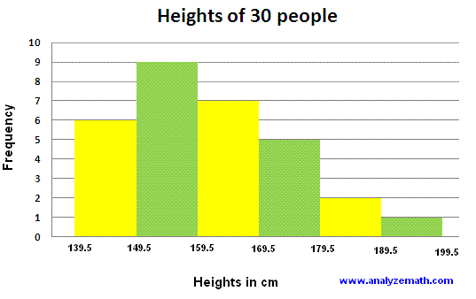

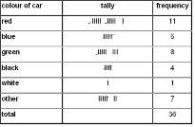
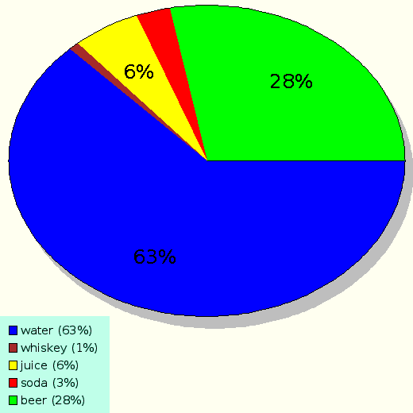
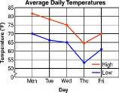

Section 6: Worksheet 4 – Types of Data

Quantitative and Qualitative Data
Some methods of data collection produce quantitative data and some qualitative.

Quantitative data
This is data in the numerical form. Experiments produce quantitative data as do closed ended questions in questionnaires or interviews.
Data analysis takes the form of making numerical comparisons or through statistical analyses and inferences or visually through graphs, charts and tables.

Qualitative Data
Is data that is non-numerical and descriptive. Diary accounts, open ended questions on a questionnaire and unstructured interviews all produce qualitative data.
Data analysis takes the form of looking for themes or patterns in the descriptions.
Tip for remembering them:
Quantitative data = numbers and Qualitative data = language

Exercise
Complete the following table with the advantages and limitations of each type of data.
Data type | Advantages | Limitations
Quantitative
Qualitative

Primary and Secondary Data
When a researcher collects data either by witnessing an event or by carrying out an experiment or questionnaire, this is known as PRIMARY data. It can be quantitative or qualitative; the key to it being primary data is that it is collected first hand by the researcher.
By contrast, when data is collected second hand, which is through the analysis of pre-existing data, we call this secondary data. When we use statistics or refer to existing research to develop our own theories, this is secondary data.
Tip for remembering them:
Primary = first (so first hand) and Secondary = second (so second hand).
PRIMARY DATA SECONDARY
Data that is …..

It takes two forms:
Quantitative data:

Qualitative data:
Data that is…

Examples include:

Strengths

Weaknesses

Strengths

Weaknesses

OCR Resources: the small print
OCR’s resources are provided to support the teaching of OCR specifications, but in no way constitute an endorsed teaching method that is required by the Board, and the decision to use them lies with the individual teacher. Whilst every effort is made to ensure the accuracy of the content, OCR cannot be held responsible for any errors or omissions within these resources.
© OCR 2017 - This resource may be freely copied and distributed, as long as the OCR logo and this message remain intact and OCR is acknowledged as the originator of this work.
OCR acknowledges the use of the following content: PI symbol: Wikimedia, pie: Crepesoles/Shutterstock.com, rat: Pakhnyushchy/Shutterstock.com, racing car: Digital Storm/Shutterstock.com,
Please get in touch if you want to discuss the accessibility of resources we offer to support delivery of our qualifications: resources.feedback@ocr.org.uk
We’d like to know your view on the resources we produce. By clicking on ‘Like’ or ‘Dislike’ you can help us to ensure that our resources work for you. When the email template pops up please add additional comments if you wish and then just click ‘Send’. Thank you.
Whether you already offer OCR qualifications, are new to OCR, or are considering switching from your current provider/awarding organisation, you can request more information by completing the Expression of Interest form which can be found here: www.ocr.org.uk/expression-of-interest
Looking for a resource? There is now a quick and easy search tool to help find free resources for your qualification:
www.ocr.org.uk/i-want-to/find-resources/

