Topic Exploration Pack

Area of Study 3 - Developments in Instrumental Jazz 1910 to the present day

Introduction 2
Activity 1: Performing the 12-bar blues in jazz 3
Activity 2: Analysing rhythm changes 5
Activity 3: Listening to Jazz 8
Activity 4: Essay question preparation 9
Preparing for the activities 12
Reading List for OCR Instrumental Jazz 16

Student activity section 18
Activity 1a – St Louis Blues 18
Activity 1b – Now’s The Time 20
Activity 2 – Analysing rhythm changes 22
Activity 3 – Listening to Jazz 25
Activity 4: Essay planning 27

These instructions cover the student activity section which can be found on page 18. This Topic Exploration Pack supports OCR A Level Music.
When distributing the activity section to the students either as a printed copy or as a Word file you will need to remove the teacher instructions section.

Mapping to specification level
From the A Level specification, in relation to Area of Study 3, students will need to:
- engage actively in the process of music study
- develop performing skills to demonstrate an understanding of musical elements, style, sense of continuity, interpretation and expression
- develop composing skills to demonstrate the manipulation of musical ideas and the use of musical devices and conventions
- engage with, and extend appreciation of, the diverse heritage of music in order to promote personal, social, intellectual and cultural development
- develop knowledge and understanding of a variety of instruments and styles, and of relevant approaches to both performing and composing
- appraise contrasting genres, styles and traditions of music, and develop understanding of musical contexts and a coherent awareness of musical chronology.

Introduction
Jazz was born in New Orleans at some point in the early 1900s. It takes its original influences from blues, church music, opera, folk music, as well as dance music from all over the world. Since its beginnings it has been ever-changing, moving through swing, bebop, cool jazz, into the avant-garde, and fusing with rock and other contemporary styles. It continues to evolve today.
As part of the OCR A Level Music course, students should understand how instrumental jazz has developed since 1910. They should look at how the quintessential ingredients of jazz, such as improvisation, syncopation and swing, have been used by great artists like Miles Davis, Charlie Parker and Herbie Hancock. Learners should study and understand how jazz began in New Orleans, and how it was disseminated throughout the USA, and beyond.
The activities in this pack encourage students to perform and compose, and listen to jazz, giving them a broad and deep understanding of the style. They will analyse famous pieces, and use their knowledge to construct clear and effective essay plans. In order to access them, students will need some familiarity with written notation, keys, chords and scales. Otherwise, they may need to be adapted for your students.
It is important for students to understand that although styles of jazz are typified by particular approaches and stylistic features; it is an imprecise art. Composers and artists borrowed, adapted and rejected musical techniques from a variety of styles, and no one piece can be said to be ‘truly’ illustrative of a particular period in jazz. Great pieces use stylistic features, and may do something new and innovative with them. It is important that students are familiar with broad developments, and key recordings, but do not get too hung up on matching all ‘stylistic features’ when trying to understand unfamiliar listening.
Above all, students should immerse themselves in the creative musical approaches valued by jazz musicians; how to construct pieces, how to improvise, and how to do these things in a variety of different styles. Encourage your students to listen to and perform as much jazz as possible.

Activities
Where possible, it is a good idea for students to sing and perform as much of this repertoire as they can. Even if you have small classes who may lack confidence, let them sing the same parts. Any singing is valuable and will help the students internalise what may be an unfamiliar style of music.
These activities are best used after some introduction to the relevant styles, where students have gained some basic understanding of the style.

Activity 1: Performing the 12-bar blues in jazz
The 12-bar blues is a staple of all styles of jazz.

The following activities will allow students to perform different styles of jazz - using three key examples of the 12-bar blues. For each piece or style, we will outline how the 12-bar blues chords are used, how a stylistic rhythm section would accompany the soloist, and how the soloist would approach performing over these changes.

St. Louis Blues (trad. jazz/swing, 1920s and 1930s)
W.C. Handy’s St. Louis Blues contains a few different sections, but there is a section that follows a clear 12-bar blues in G major. This is a popular tune amongst traditional jazz musicians.

Chords
St. Louis Blues uses a very basic 12-bar blues progression, sticking to chords I, IV and V, and using the dominant 7th chord extension. The final two chords in brackets act as a turnaround into the next chorus.

Rhythm section
In a swing or traditional jazz setting, the swing rhythm would be heard clearly on the hi-hat. A guitarist or banjo player would play staccato chords on every crotchet beat, with a slight accent on beats 2 and 4. A pianist would comp, adding chords, or might use a stride piano technique. The bass player would stick primarily to the tonic and dominant notes of each chord, on beats 1 and 3.

Soloing
Primarily the G blues scale: This is the G minor pentatonic scale plus a flattened 5th degree:

G blues: G, Bb, C, Db, D, F, G

The flattened 3rd, 5th and 7th are blue notes, creating dissonance with the chords, and the classic blues sound. As well as individual solos, a trad. jazz band would often utilise collective improvisation, where everyone improvises at once.

Now’s The Time (Bebop, 1940s)
This popular Charlie Parker bebop standard written by Gerry Mulligan, is often played in F major, and the chord progression is known as the ‘bebop blues’.

Chords
As you can see, the 12-bar blues is much more complex in the bebop period. Many more chord extensions are added, as well as chromatic substitutions and additional chords. You can see ii-V-I progressions all over the place, particularly at bars 4-5 (in Bb), 8-9 (in G) and 11-12 (in F).

Rhythm Section
Bebop is famed for its fast tempi, but this tune can be taken a little slower. In bebop, the swing rhythm moves onto the ride cymbal, with the bass drum and snare drum playing syncopated interjections. The pianist will comp freely, and the bass will play a constantly walking bass line on every crotchet beat.

Soloing
The blues scale can be used, but the bebop period is much more complex in its improvisatory language. Often soloists would use extended arpeggios of the chord being played, or play fast, swinging, chromatic ‘bebop quaver runs’. You can also experiment with the following scales:

F ‘major’ blues: F, G, Ab, A, C, D
F mixolydian mode: F, G, A, Bb, C, D, Eb
F dominant bebop scale: F, G, A, Bb, C, D, Eb

Mr P.C. (hard bop/modal jazz, 1950s and 1960s)
John Coltrane’s tribute to bassist Paul Chambers is an excellent example of a ‘minor blues’ progression. You can listen to it here: https://www.youtube.com/watch?v=Jv5j_Lx2R4g
Chords
The harmony in a minor blues is much more static compared to a bebop blues. Notice the reliance on chords I, IV and V with a few chromatic inflections.

Rhythm section
Like the bebop style, the swing is heard on the ride cymbal, and there would be a walking bass line on the double bass. The piano would make extensive use of chord extensions and substitutions, and comp in a very syncopated style.

Soloing
The uncomplicated nature of the minor blues chords allows for much experimentation within the solos. Start with the minor blues scale, or the melodic minor scale:

C blues: C, Eb, F, Gb, G, A, Bb, C
C melodic minor: C, D, Eb, F, G, A, B, C

Jazz musicians in the late 50s and 60s would make extensive use of modes in their improvisations. In combination with the previous two scales, try the following modes in your solos over this minor blues progressions:

F Dorian mode: F, G, Ab, Bb, C, D, Eb, F
D Locrian mode: D, Eb, F, G, Ab, Bb, C, D
G Phrygian dominant: G, Ab, B, C, D, Eb, F, G

Activity 2: Analysing rhythm changes
Introduction
Jazz compositions often follow the same loose structure; a tune based on a chord progression (the head), followed by solos on that chord progression, and a recap of the head to finish. One of the most popular chord progressions is known as Rhythm Changes (it is based on the chords to the Gershwin classic ‘I Got Rhythm’). Countless jazz musicians have used this progression as a basis for composition and improvisation.

Harmonic analysis
In order to fully grasp the beauty of Rhythm Changes, we must understand how the chord progression works. Students can annotate the basic chord progression on Learner Sheet 2 on page 6.

Talk through the harmonic progression with the students, playing the chords as you do so.

Key and structure
The most popular key for Rhythm Changes is Bb major - if you turned up at a jam and someone called ‘rhythm changes’, you would most likely be playing in this key. However, it can, and has, been used in a variety of different keys. Rhythm Changes is 32-bars long, and follows the phrase pattern AABA; this is a very common pattern in jazz standards.

A Section
Bars 1-4
This is a common I-vi-ii-V progression in Bb major, repeated twice. Notice how extensions are used; many jazz musicians would add other extensions, such as 9ths or 11ths, to further ‘spice up’ the harmony. The Cm7-F7-BbM7 progression creates a ii-V-I progression in the tonic, over which jazz musicians love to solo!

Common substitutions in these bars would be:
In bars 1 and 3, substituting the Gm7 chord for a G7(b9) chord
In bar 3, substituting the Bbmaj7 chord for a Dm7 chord.

Bars 5-8
There is a brief modulation in bars 5-6, this creates a ii-V-I progression in Eb major (the subdominant). Bars 7-8 are a turnaround back to the tonic - bar 7 looks like the start of a ii-V-I progression in C major (the dominant), but instead of a C major chord, bar 8 gives us Cm7, which forms the start of a ii-V-I back into Bb major, and the start of the A1 section.

Often, instead of a Fm7 chord in bar 5, it is substituted for a Bbmaj7 chord. The move from Bbmaj7 to Bb7 gives the same sense of tonal change as the music briefly moves into Eb major.

A1 Section
Bars 9-14
These bars are identical to the first A section.
Bars 15-16
To close this section, the ii-V-I in Bb major is much clearer.

B Section
Bars 17-24
This progression is based on the circle of fifths. The D7 chord in bars 17-18 implies a move to G major. However, the G7 chord that follows does not give a sense of resolution; instead it implies a move to C major. The C7 chord implies F major, and the F7 implies Bb major, the tonic. This leads us back into the tonic for the return of the A section.

This progression is very common as the ‘bridge’ of a 32-bar song. Tritone substitutions are common here, such as substituting a Db7 chord for the G7, or a B7 chord for the F7 chord.

A2 Section
The A2 section is the same as the A1 section, finishing clearly in the tonic. However, a few of the aforementioned substitutions are included here.

Suggested listening
There are many tunes that use this progression. Add them to your students’ wider listening:

- I Got Rhythm (G. Gershwin)
- Cotton Tail (Duke Ellington)
- Lester Leaps In (Lester Young)
- Moose the Mooche (Charlie Parker)
- Oleo (Sonny Rollins)
- Anthropology (Charlie Parker/Dizzy Gillespie)

Activity 3: Listening to Jazz
This listening activity allows students to approach jazz recordings using MR TIGHTS (Melody, Rhythm, Texture, Instruments, Genre, Harmony, Tonality, Structure).

Play students the tune ‘St. Thomas’ by Sonny Rollins (from the album Saxophone Colossus). Play from 0:00-1:18. Ask students to make notes under the headings on their Learner sheet 3. Some ideas are below:

Melody
- Small leaps in melody
- Each phrase ends with four accented, staccato crotchets
- Syncopated ideas at the start of phrases
- In the solo, a short, descending, two-note motif is repeated and developed.

Rhythm
- Common time
- Calypso rhythms
- No obvious swing rhythm.

Texture
- Melody and accompaniment
- Melody in saxophone
- Some homorhythm between bass, piano and sax
- Drum ostinato

Instruments
- Traditional jazz quartet
- Tune in saxophone
- Comping in piano

Genre
- 1956
- Calypso inspired jazz

Harmony
- Extended chords
- Some parallel harmonic movement

Tonality
- Major key

Structure
- Head arrangement

Activity 4: Essay question preparation
Compare two jazz recordings by Miles Davis, and explore how his style has developed between the two. [25].

The following activity will give students a step by step guide for planning and writing the above essay question, as well as pointers for planning other essay questions they may face. Use the learner sheet on page 27 to construct the plan.

Step 1: Copy the title and highlight keywords.
Copy the title into the relevant section of the planning sheet, and highlight the key words, so your essay doesn’t lose focus. Highlight ‘style’ and ‘developed’ in this case.

Step 2: Choose your material
Most essay questions ask for two, or at least two, works to be referenced during the essay. Choose them now, and note them down.

For this essay, we will choose:

So What - Miles Davis (from the album Kind of Blue)
Spanish Key - Miles Davis (from the album Bitches Brew).

Step 3: Background/contextual information
It is important to situate the chosen works in a wider context. Add the following information about your chosen works:

So What - 1959, cool jazz style, modal/motivic improvisation, reaction to bebop, more restrained style.
Spanish Key - 1970, unedited, rock influences, freer style, experimental

There may be other important points students wish to add as a result of their study in this AoS.

Step 4: Specific musical points
Students should now list specific musical features for each chosen work. They should list stylistic features that are key to the understanding of the works, and try to identify links between the chosen works. Add the following musical points for our Miles Davis works:

So What
- Cool, laid-back style.
- Traditional jazz instruments.
- Walking bass, swing.
- Pre-composed introduction by Gil Evans.
- Short, simple melody in head.
- Bass melody and choral interjections in head.
- Modal harmonies.
- Two sections each based on one chord/scale, a semitone apart (D dorian and Eb dorian), set chord progression.
- Long passages of static harmony.
- Traditional solo pattern - each instrument takes turns.
- Head arrangement.
- Miles Davis solo techniques - melodic, motivic improvisation.
- John Coltrane solo - scalic, faster.
- Cannonball Adderley solo - blues influenced.

Spanish Key
- Rock instruments, electric guitar.
- Spanish influences, extended percussion.
- No traditional ‘head’ melody, one long improvisation.
- No traditional jazz swing heard.
- Repeated bass riffs/grooves.
- One long, unedited take.
- Miles Davis, aggressive soloing, high register.
- Static harmony, but changes many times.
- Several different scales/chords used.
- Soloist dictates direction of harmony.
- Very loose structure.
- Collective improvisation throughout.

Students can highlight similar points, as well as key differences.

If students are discussing additional works, they can make notes in the third column here.

Step 4: Structure and overall planning
There are several ways to approach the structure of this essay:

- Talk about each piece separately, and draw comparisons at the end.
- Talk about each element separately, tackling both pieces together.
- Intertwine both pieces throughout, constantly comparing the two.

There are advantages and disadvantages to each approach, and students should make an informed decision after much thought and discussion. They should form an ‘overall argument’ that takes into consideration the comparison demanded in the question. Below are some key ‘themes’ to note before writing this question.

- Both pieces share similar approaches in terms of melody (short motifs and ideas) and harmony (static passages of harmony, non-traditional chord progressions).
- There are more subtle differences: So What has a head (albeit brief), and the soloists improvise around a set chord progression. Spanish Key is entirely improvised, and the changes in harmony are dictated at will by the improvising instrument.
- There are key differences in terms of instrumentation and rhythm; So What uses a more traditional set-up and swung rhythms, whereas Spanish Key brings in more rock/world influences, and rejects swing for more rock-based grooves.
- There are key differences in terms of structure; So What is a head arrangement with distinct solos, but Spanish Key is a long, freer, collective improvisation, where harmonic movement is not set in stone.

We now have an extensive plan, and are ready to write the essay. This planning system can be used to plan other essays, across the Areas of Study needed in the exam.

Preparing for the activities

Activity 1: Performing the 12-bar blues in jazz
Try to perform each piece with your class. Don’t be too hung up on the instruments you have available – make do with what you have. Backing tracks are available by searching YouTube
Encourage students to improvise – if students are reluctant, try the following techniques:
- Ask students to compose three or four note patterns based on a scale you give them
- Ask two students to improvise together, using call and response
- Come up with your own phrases, and ask students to copy them, or come up with a similar response.
As well as developing performing/improvising skills, this activity should highlight musical differences between different styles of jazz. Students could create a table to illustrate these, after the practical activity.

Illustrative recordings
- St. Louis Blues – trad/swing style
New Orleans Rhythm Kings, Original Dixieland Jazz Band, Preservation Hall Jazz Band
Be careful with the tune St. Louis Blues – it is so ubiquitous in jazz you may struggle to find a version that fully illustrates the musical features or swing or trad. jazz. The artists listed above are good places to start.
- Now’s The Time – bebop style
Charlie Parker’s 1945 recording of ‘Now’s The Time’ is a great example of the bebop sound – if fact any of his recordings on the Savoy or Dial labels are excellent examples.
- Mr P.C. – minor blues (hard bop/modal jazz style)
John Coltrane’s recording of ‘Mr P.C.’ on his 1959 album ‘Giant Steps’ is an excellent example of this style. Tunes such as ‘Equinox’, ‘Blue Trane’ (John Coltrane) or ‘Footprints’ (Wayne Shorter) are also good examples of minor blues from this period.

Activity 2: Analysing Rhythm Changes
In order to complete this activity, students will need a working knowledge of chords and keys, how roman numerals stand in for chords, and a basic knowledge of chord extensions and substitutions.

Approaches to analysis
Students should annotate their worksheets clearly with roman numerals, identifying keys and possible substitutions. Colours and highlighters work well here. They should be encourage to play through the changes themselves, as well as hearing them both in isolation and in context.

Extension tasks
Improvisation practice
Using a class rhythm section, ask students to practice improvising over these chords. YouTube contains many backing tracks for Rhythm Changes, if you need them.
Composition task
Ask students to compose a tune over these chords, following the AABA structure.
Lead sheets
The lead sheets for the tunes mentioned can easily be found online, or in ‘Real Books’ for jazz (https://officialrealbook.com/)
You can then study further variations on the Rhythm Changes progression, as well as use them to illustrate the melodies that accompany the chords.

Recommended listening is included in the main resource for this activity.

Activity 3: Listening to Jazz
Below are some broad notes and considerations when analysing jazz recordings.

MR TIGHTS
Ensure students understand the definitions of the musical elements, and what kind of musical points they should make for each one. You might consider providing typical vocabulary for each element in advance.

Differentiate between the head and the solos
Particularly when looking at melody, texture or instrumentation, there will often be a difference between the head (main melody), and each individual solo in the piece. Ensure students understand the difference, and are clear about what musical features belong to what section.

Lead sheets
You may like to provide a lead sheet for the piece you are studying. These are available online, or in a ‘Real Book’ of popular jazz pieces. Lead sheets allow you to look more carefully at the melodic and harmonic characteristics of the source material, and then compare this to the recording you are studying.

Solo transcriptions
Included on the learner sheet is a short section of the first solo in this particular example. Students can annotate this by highlighting the short motif and its development. You may find sheet music useful in highlighting typical stylistic features of styles and/or artists. Transcriptions are often found online, or you many ask students to transcribe short sections of pieces in order to develop their aural skills.

Activity 4: Essay question preparation
The essay planning template is generic, and can be used for most essays students will encounter as part of this course. It can be adapted if desired.

This activity should be undertaken in the stages outlined in the main activity. Students should discuss and fill in the planning sheet to the best of their ability, before the teacher steps in and fills in any gaps, using the points in the resource. As time progresses, students should become more and more independent when completing essay plans.

The mark scheme for this essay is the points given in the main resource. To mark the essay, teachers should use the generic marking available in the specification, or as an appendix to any mark scheme OCR produce (including sample materials). Additional guidance is given here:

Most candidates should be able to:
- Give some, perhaps general, descriptions to illustrate the harmonic and melodic composing techniques used in the music of one or both recordings.
- Give some explanation of how the recording techniques used contributes to the success of the recording.
- Support some of these observations with references to the music in some detail.

More informed answers will:
- Give a detailed description of the music of two recordings including the use of advanced harmonic and melodic techniques.
- Refer to details of instrumentation, texture, timbre and tonality showing how this contributes to the recordings.
- Give detailed explanations about the recording techniques used that contribute to the success of the recording.
- Show a close familiarity with the music in their ability to give detailed illustrations.

Should you wish to create additional essay questions for your students, some ideas are given below:
- Choose two recordings from the same artist, from different periods of their musical career.
- Choose two recordings from different styles of jazz.
- Choose two recordings of the same standard, from different styles of jazz.

In all cases, students should compare the two recordings and investigate the develop of jazz across each piece. Your essay titles can be generic or include specific musical elements that students must discuss.

Reading List for OCR Instrumental Jazz

Books (general)
Kernfield, B. (1997). What to Listen for in Jazz. USA.Yale University Press. ISBN: 978-0300072594. (NB this is a key text.)

Shipton, A. (2009) A New History of Jazz. London. Continuum (Bloomsbury). ISBN: 978-0826429728.

Giola, T. (2012) The Jazz Standards: A Guide to the Repertoire. New York. OUP USA. ISBN: 978-0199937394.

Books (for performance)

Leonard, H. The Real Book – various keys e.g.
Leonard, H. (2014) The Real Book Vol I C Edition. Hal Leonard Pub. ISBN: 978-0634060380.

Mulholland, J. Ed et al. (2013) The Berklee Book of Jazz Harmony. Pap/Com Ed. Hal Leonard Pub. ISBN: 978-0876391426.

Levine, M. (1995) The Jazz Theory Book. Petaluma. Sher Music. ISBN: 978-1883217044.

CDs and DVDs

Jazz: A Film by Ken Burns (Film)
https://www.amazon.co.uk/Jazz-Film-Ken-Burns-DVD/dp/B002VPXZ0E/ref=pd_sim_14_7?ie=UTF8&dpID=51NjeWsyZiL&dpSrc=sims&preST=_AC_UL160_SR113%2C160_&refRID=XH7GZGHB5M1FRQNPVQZY

The Story of Jazz (CD)
https://www.amazon.co.uk/Story-Jazz-Langston-Hughes/dp/B00242VT0M/ref=sr_1_6?ie=UTF8&qid=1465813611&sr=8-6&keywords=langston+jazz

Websites
http://www.jazzstandards.com/
http://www.nafme.org/my-classroom/jazz-appreciation-month/jazz-fundamentals-from-jazz-at-lincoln-center/
http://www.thejazzresource.com/
http://www.jazzadvice.com/why-jazz-theory-is-easier-than-you-think/
https://www.allaboutjazz.com/php/timeline.php

Apps/Podcast

Blue Note 75
iReal Pro
Building Blocks of Jazz (Podcast/iTunes U Series): https://itunes.apple.com/us/itunes-u/building-blocks-of-jazz/id422591775?mt=10
OCR Resources: the small print
OCR’s resources are provided to support the delivery of OCR qualifications, but in no way constitute an endorsed teaching method that is required by the Board, and the decision to use them lies with the individual teacher. Whilst every effort is made to ensure the accuracy of the content, OCR cannot be held responsible for any errors or omissions within these resources.
© OCR 2016 - This resource may be freely copied and distributed, as long as the OCR logo and this message remain intact and OCR is acknowledged as the originator of this work.
OCR acknowledges the use of the following content: n/a
Please get in touch if you want to discuss the accessibility of resources we offer to support delivery of our qualifications: resources.feedback@ocr.org.uk
In relation to the short extracts from St Louis Blues and St Thomas used in the learner activities, OCR has made every effort to contact the copyright holders but has been unable to do so. If you are the owner of any third-party material contained within this document, and you wish to question its use, please contact The Resources Team at OCR through resources.feedback@ocr.org.uk
We’d like to know your view on the resources we produce. By clicking on ‘Like’ or ‘Dislike’ you can help us to ensure that our resources work for you. When the email template pops up please add additional comments if you wish and then just click ‘Send’. Thank you.
Whether you already offer OCR qualifications, are new to OCR, or are considering switching from your current provider/awarding organisation, you can request more information by completing the Expression of Interest form which can be found here: www.ocr.org.uk/expression-of-interest
Looking for a resource? There is now a quick and easy search tool to help find free resources for your qualification:
www.ocr.org.uk/i-want-to/find-resources/

Topic Exploration Pack

Area of Study 3 – Developments in Instrumental Jazz 1910 to the present day

Student activity section
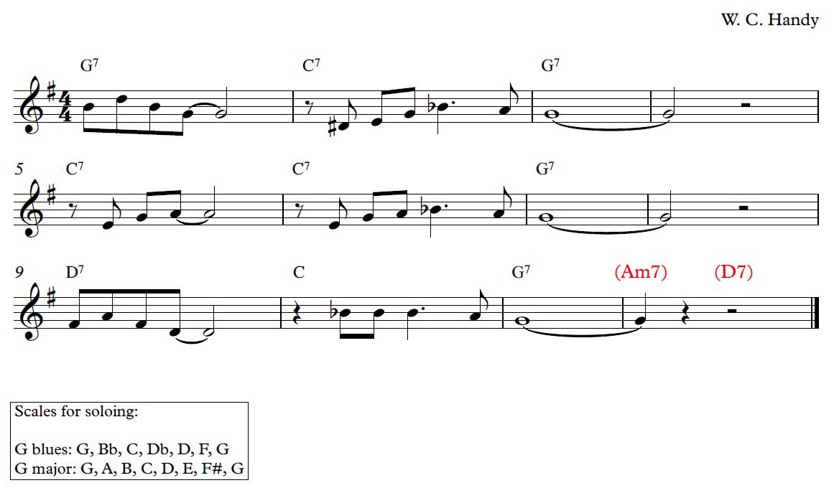

Activity 1a – St Louis Blues

The 12-bar blues is a staple of all styles of jazz.

The following activities will allow students to perform different styles of jazz - using three key examples of the 12-bar blues. For each piece or style, we will outline how the 12-bar blues chords are used, how a stylistic rhythm section would accompany the soloist, and how the soloist would approach performing over these changes.

St. Louis Blues (trad. jazz/swing, 1920s and 1930s)
W.C. Handy’s St. Louis Blues contains a few different sections, but there is a section that follows a clear 12-bar blues in G major. This is a popular tune amongst traditional jazz musicians.

Chords
St. Louis Blues uses a very basic 12-bar blues progression, sticking to chords I, IV and V, and using the dominant 7th chord extension. The final two chords in brackets act as a turnaround into the next chorus.

Rhythm section
In a swing or traditional jazz setting, the swing rhythm would be heard clearly on the hi-hat. A guitarist or banjo player would play staccato chords on every crotchet beat, with a slight accent on beats 2 and 4. A pianist would comp, adding chords, or might use a stride piano technique. The bass player would stick primarily to the tonic and dominant notes of each chord, on beats 1 and 3.

Soloing
Primarily the G blues scale: This is the G minor pentatonic scale plus a flattened 5th degree:

G blues: G, Bb, C, Db, D, F, G

The flattened 3rd, 5th and 7th are blue notes, creating dissonance with the chords, and the classic blues sound. As well as individual solos, a trad. jazz band would often utilise collective improvisation, where everyone improvises at once.

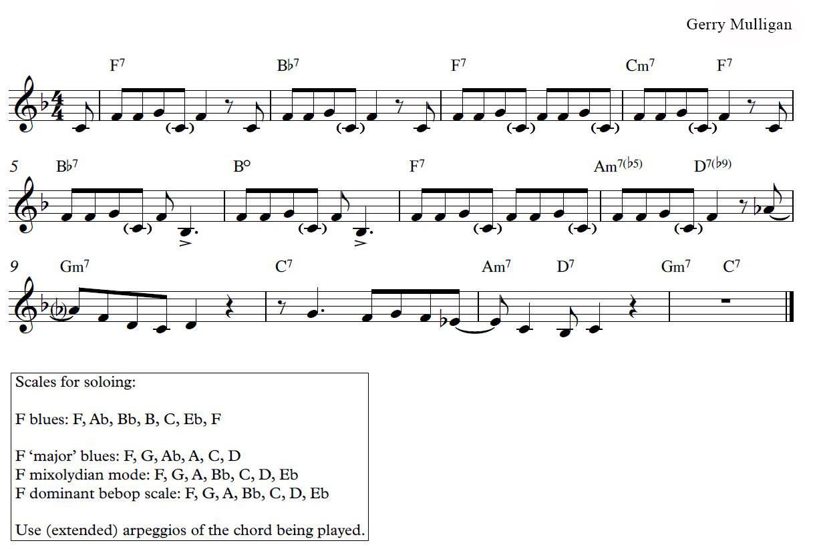
Activity 1b – Now’s The Time

Now’s The Time (Bebop, 1940s)
This popular Charlie Parker bebop standard written by Gerry Mulligan, is often played in F major, and the chord progression is known as the ‘bebop blues’.

Chords
As you can see, the 12-bar blues is much more complex in the bebop period. Many more chord extensions are added, as well as chromatic substitutions and additional chords. You can see ii-V-I progressions all over the place, particularly at bars 4-5 (in Bb), 8-9 (in G) and 11-12 (in F).

Rhythm Section
Bebop is famed for its fast tempi, but this tune can be taken a little slower. In bebop, the swing rhythm moves onto the ride cymbal, with the bass drum and snare drum playing syncopated interjections. The pianist will comp freely, and the bass will play a constantly walking bass line on every crotchet beat.

Soloing
The blues scale can be used, but the bebop period is much more complex in its improvisatory language. Often soloists would use extended arpeggios of the chord being played, or play fast, swinging, chromatic ‘bebop quaver runs’. You can also experiment with the following scales:

F ‘major’ blues: F, G, Ab, A, C, D
F mixolydian mode: F, G, A, Bb, C, D, Eb
F dominant bebop scale: F, G, A, Bb, C, D, Eb

Mr P.C. (hard bop/modal jazz, 1950s and 1960s)
John Coltrane’s tribute to bassist Paul Chambers is an excellent example of a ‘minor blues’ progression. You can listen to it here: https://www.youtube.com/watch?v=Jv5j_Lx2R4g

Chords
The harmony in a minor blues is much more static compared to a bebop blues. Notice the reliance on chords I, IV and V with a few chromatic inflections.

Rhythm section
Like the bebop style, the swing is heard on the ride cymbal, and there would be a walking bass line on the double bass. The piano would make extensive use of chord extensions and substitutions, and comp in a very syncopated style.

Soloing
The uncomplicated nature of the minor blues chords allows for much experimentation within the solos. Start with the minor blues scale, or the melodic minor scale:

C blues: C, Eb, F, Gb, G, A, Bb, C
C melodic minor: C, D, Eb, F, G, A, B, C

Jazz musicians in the late 50s and 60s would make extensive use of modes in their improvisations. In combination with the previous two scales, try the following modes in your solos over this minor blues progressions:

F Dorian mode: F, G, Ab, Bb, C, D, Eb, F
D Locrian mode: D, Eb, F, G, Ab, Bb, C, D
G Phrygian dominant: G, Ab, B, C, D, Eb, F, G

Activity 2 – Analysing rhythm changes
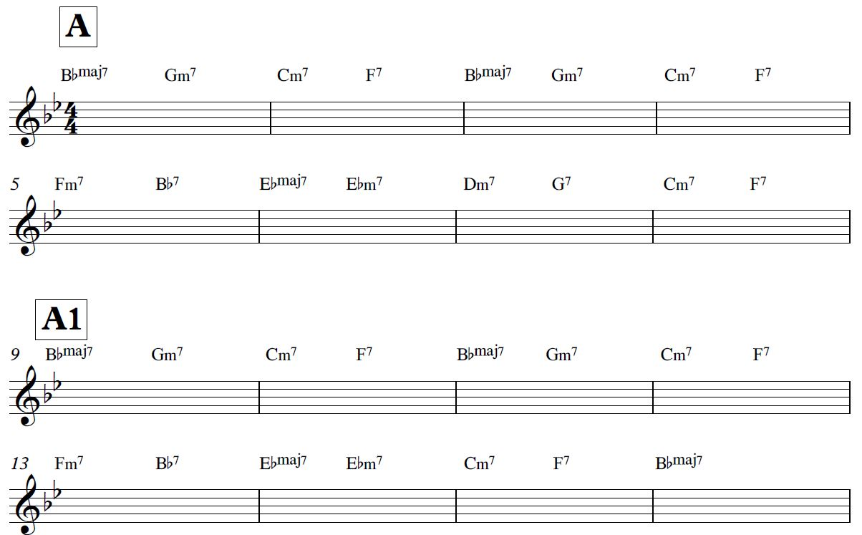

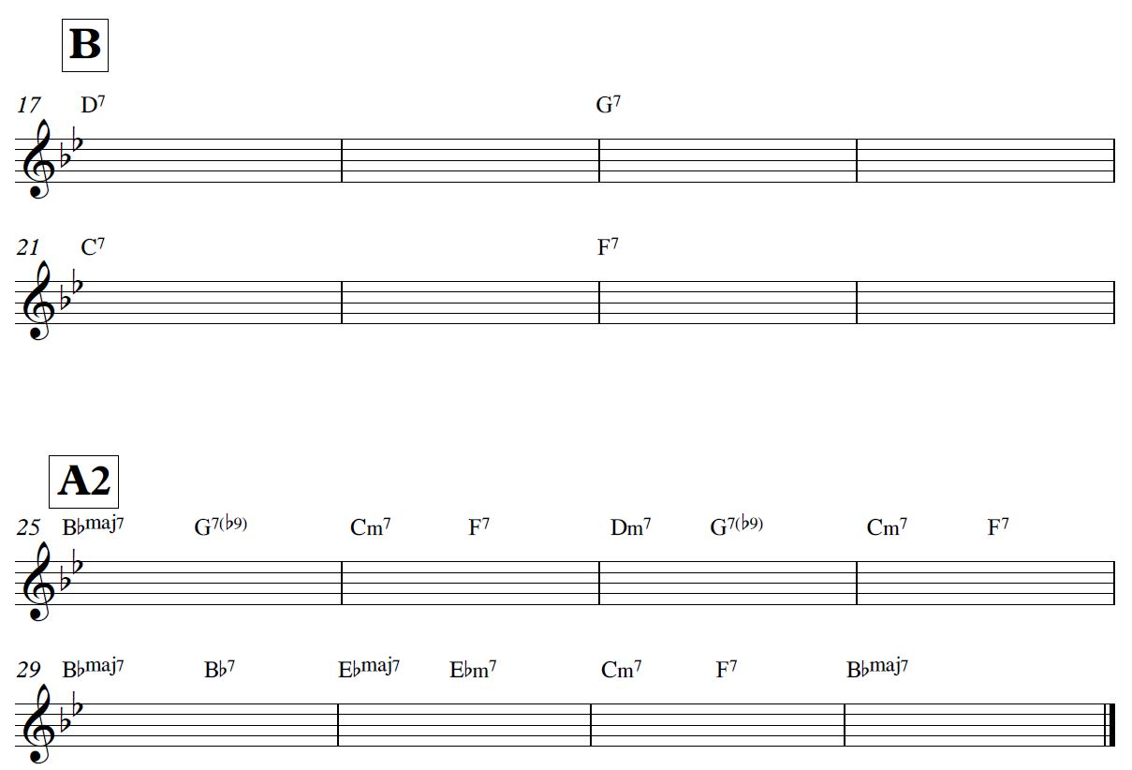
Introduction
Jazz compositions often follow the same loose structure; a tune based on a chord progression (the head), followed by solos on that chord progression, and a recap of the head to finish. One of the most popular chord progressions is known as Rhythm Changes (it is based on the chords to the Gershwin classic ‘I Got Rhythm’). Countless jazz musicians have used this progression as a basis for composition and improvisation.

Harmonic analysis
In order to fully grasp the beauty of Rhythm Changes, we must understand how the chord progression works.

Key and structure
The most popular key for Rhythm Changes is Bb major - if you turned up at a jam and someone called ‘rhythm changes’, you would most likely be playing in this key. However, it can, and has, been used in a variety of different keys. Rhythm Changes is 32-bars long, and follows the phrase pattern AABA; this is a very common pattern in jazz standards.

A Section
Bars 1-4
This is a common I-vi-ii-V progression in Bb major, repeated twice. Notice how extensions are used; many jazz musicians would add other extensions, such as 9ths or 11ths, to further ‘spice up’ the harmony. The Cm7-F7-BbM7 progression creates a ii-V-I progression in the tonic, over which jazz musicians love to solo!

Common substitutions in these bars would be:
In bars 1 and 3, substituting the Gm7 chord for a G7(b9) chord
In bar 3, substituting the Bbmaj7 chord for a Dm7 chord.

Bars 5-8
There is a brief modulation in bars 5-6, this creates a ii-V-I progression in Eb major (the subdominant). Bars 7-8 are a turnaround back to the tonic - bar 7 looks like the start of a ii-V-I progression in C major (the dominant), but instead of a C major chord, bar 8 gives us Cm7, which forms the start of a ii-V-I back into Bb major, and the start of the A1 section.

Often, instead of a Fm7 chord in bar 5, it is substituted for a Bbmaj7 chord. The move from Bbmaj7 to Bb7 gives the same sense of tonal change as the music briefly moves into Eb major.

A1 Section
Bars 9-14
These bars are identical to the first A section.

Bars 15-16
To close this section, the ii-V-I in Bb major is much clearer.

B Section
Bars 17-24
This progression is based on the circle of fifths. The D7 chord in bars 17-18 implies a move to G major. However, the G7 chord that follows does not give a sense of resolution; instead it implies a move to C major. The C7 chord implies F major, and the F7 implies Bb major, the tonic. This leads us back into the tonic for the return of the A section.

This progression is very common as the ‘bridge’ of a 32-bar song. Tritone substitutions are common here, such as substituting a Db7 chord for the G7, or a B7 chord for the F7 chord.

A2 Section
The A2 section is the same as the A1 section, finishing clearly in the tonic. However, a few of the aforementioned substitutions are included here.

Suggested listening
There are many tunes that use this progression. Add them to your students’ wider listening:

- I Got Rhythm (G. Gershwin)
- Cotton Tail (Duke Ellington)
- Lester Leaps In (Lester Young)
- Moose the Mooche (Charlie Parker)
- Oleo (Sonny Rollins)
- Anthropology (Charlie Parker/Dizzy Gillespie)

Activity 3 – Listening to Jazz

Sonny Rollins - St. Thomas (Saxophone Colossus)
Listen from 0:00 to 1:15
Make notes using the following headings:

Melody

Rhythm

Texture

Instruments

Genre

Harmony

Tonality

Structure

Opening 8 bars of Sonny Rollins’ solo: 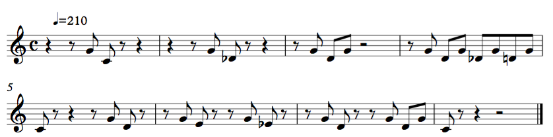

Activity 4: Essay planning
Title:
Chosen Artists/Works:
Background/contextual information:
Specific musical points:
Piece 1: | Piece 2: | Additional references:
Structure of essay/notes:

