Topic Exploration Pack

Reactions of phenols

Introduction 3
Suggested activities 4
Additional teacher preparation 5
Learner question worksheet 14
Learner activity 1 17
Learner activity 2 22
Learner activity 3 26
Learner question worksheet 29

Instructions and answers for teachers

These instructions cover the student activity section which can be found on page 16. This Topic Exploration Pack supports OCR A Level Chemistry A.
When distributing the activity section to the students either as a printed copy or as a Word file you will need to remove the teacher instructions section.

Learning outcomes
6.1.1 (h) the weak acidity of phenols shown by the neutralisation reaction with NaOH but absence of reaction with carbonates
6.1.1 (i) the electrophilic substitution reactions of phenol:
(i) with bromine to form 2,4,6-tribromophenol
(ii) with dilute nitric acid to form 2-nitrophenol
6.1.1 (j) the relative ease of electrophilic substitution of phenol compared with benzene, in terms of electron pair donation to the π-system from an oxygen p-orbital in phenol
6.1.1 (k) the 2- and 4-directing effect of electron-donating groups (OH, NH₂) and the 3-directing effect of electron-withdrawing groups (NO₂) in electrophilic substitution of aromatic compounds
6.1.1 (l) the prediction of substitution products of aromatic compounds by directing effects and the importance to organic synthesis

Introduction
While the chemistry of phenol (hydroxybenzene) is a relatively small part of the A Level specification, phenols provide an excellent example of compounds with more than one functional groups each of which affects the other. Learners should therefore have studied both arenes and alcohols before looking at phenol. It is useful to ask them to predict the likely reactions of phenol, based on their prior knowledge, at the start of the topic.

Benzene is both unreactive and banned from use in UK schools. However, learners can use phenolic compounds to look at the reactions of the aromatic ring. (The use of phenol itself by learners is best avoided because it is hazardous and difficult to handle safely, but there are suitable alternatives such as methyl 4-hydroxybenzoate). Interpretation of the reactions of phenol with bromine and nitric acid provides practice at writing equations for substitution reactions. There is also the opportunity to revise and extend the electron delocalisation model in order to explain how the presence of the OH group increases the reactivity of the arene ring.

Since the products of these reactions have at least two groups attached to the arene ring, the directing effect of the OH group can be introduced. The specification also includes the directing effects of NH₂ and NO₂ groups and the way in which these influence the choice of synthetic routes. This topic can be developed when learners are aware of a greater range of organic reactions.

The reactions of phenol as a weak acid can be linked to work on conjugate acids and bases and the significance of K_{a}.

Misconceptions and Difficulties
Learner misconceptions abound in these areas. The use of skeletal formulae, in which the benzene hydrogens are not shown, means that some learners assume that addition reactions have occurred when a bromine atom replaces an ‘invisible’ hydrogen. Alternatively, if a dibromo compound is formed they may write equations in which H₂ is the other product instead of HBr. It may be helpful if all the ring hydrogens are displayed initially. It is worth highlighting the nomenclature of the C₆H₅ ring. This is refered to as phenyl when a substituent on a parent alkane. The derivation of phenol from phenyl + alcohol can then be readily understood. If named systematically, phenol would be named hydroxybenzene, but phenol remains the IUPAC recommended name for the compound.

Learners are likely to predict that phenol behaves as typical alcohol. However, it does not react directly with carboxylic acids to form esters, requiring acyl chlorides or acid anhydrides. Additionally, phenol is a weak acid, reacting with sodium hydroxide, unlike aliphatic alcohols. However, it is not acid enough to react with carbonates to produce CO₂, unlike carboxylic acids. The absence of these reactions is now explicit in the specification and learners should learn these ‘non reactions’ as well as the reactions of phenol. Section 6.3.1 states that phenols should be identified by their ‘weak acidity but no reaction with CO₃²⁻.

Suggested activities
Benzene and its reactions should have been covered before the study of phenol is introduced. It is possible to compare the reactivity of cyclohexene with the unreactivity of methylbenzene but it is difficult to show substitution into the arene ring. Because of their greater reactivity, practical work with phenolic compounds allows learners to see the decolourisation of bromine and the formation of coloured products with nitric acid. Activity 1 provides experimental details and a specimen results table, together with a summary of the reactions of phenol.

The effect that the aromatic ring has on the properties of the OH group must also be considered. Phenol is able to donate an H⁺ ion to water because the negative charge on the phenoxide anion can be partly delocalised into the π system. However, it does not act as an acid with HCO₃– and hence does not liberate carbon dioxide when mixed with sodium carbonate. The Royal Society of Chemistry resource ‘Chemistry in your Cupboard’ (http://www.rsc.org/learn-chemistry/resource/res00000008/dettol) deals with the acidity of phenol, the meaning of K_{a} and calculation of pH, and may be useful for linking this topic with some of the physical chemistry in section 5 of the specification.

The delocalisation of an oxygen lone pair in phenol decreases its strength as a nucleophile. This accounts for phenols not forming esters by direct reaction with carboxylic acids. In the OCR suggested activity PAG 6.1 (the preparation of aspirin - https://interchange.ocr.org.uk/Downloads/GCE_Chemistry_PAG6.zip - Interchange login required) ethanoic anhydride is used to esterify the hydroxyl group of 2-hydroxybenzoic acid. The Royal Society of Chemistry Experimentation Hubhttp://www.rsc.org/learn-chemistry/resource/res00001279/experimentation-hub-featured-content) has a series of ‘pre-labs’ which learners could use before they carry out the experiment practically. Finally, the Royal Society of Chemistry ‘Aspirin’ resource (http://www.rsc.org/learn-chemistry/resource/download/res00000056/cmp00000045/pdf) has useful worksheets on recrystallisation and thin layer chromatography.

The reasons for the greater reactivity of phenols compared to aromatic hydrocarbons forms part of this topic. The formation of a delocalised π system was introduced during the study of benzene. The partial delocalisation of one of the oxygen lone pairs into this π system provides an opportunity to revise the concept and use it to explain the greater reactivity of phenol compared to benzene. Activity 2 explores this and extends it to consider the effect of other groups on reactivity.

Finally, since phenol is a mono-substituted benzene compound, the orientation of substitution with respect to the first group can be introduced here or when multi-stage synthesis is covered in section 6.2.5 of the specification. Activity 3 contains information and questions on directing effects.

Other resources
PowerPoints on phenol and benzene at http://www.knockhardy.org.uk/sci.htm cover the chemistry of phenol and the directing effects of different groups. The website also contains summary notes which can be edited to match the specification.

http://chemwiki.ucdavis.edu/Core/Organic_Chemistry/Phenols has some useful pages on the acidity of phenol, ester formation, and reactivity and directing effects. These include some useful diagrams showing the delocalised π system.

Additional teacher preparation
Activity 1: Reactions of Phenols
This resource consists of practical details for a series of test tube reactions, a specimen table of results and a worksheet on the reactions of phenol.

Phenol is toxic and corrosive, causing burns to the skin. Even when it is used carefully by learners it is likely that a few crystals will be dropped onto the bench or remain stuck to glassware. CLEAPSS recommends methyl 4-hydroxybenzoate as a safer alternative. Under the name ‘methyl paraben’ this is an ingredient of some shampoos and cosmetics, where it acts as a preservative. It is less soluble than phenol and a slightly stronger acid but gives similar results in these experiments.

NOTE: Before carrying out any experiment or demonstration based on this guidance, it is the responsibility of teachers to ensure that they have undertaken a risk assessment in accordance with their employer’s requirements, making use of up-to-date information and taking account of their own particular circumstances. Any local rules or restrictions issued by the employer must always be followed. We suggest using CLEAPSS resources (http://www.cleapss.org.uk) when carrying out risk-assessments and trial experiments in advance of giving it to learners.

Chemicals
Each learner or group will require access to the following chemicals. Solutions can be supplied in reagent bottles. Each group will need about 0.5 g of methyl 4-hydroxybenzoate.
methyl 4-hydroxybenzoate  c. 0.5 g required |  | WARNING  Irritant (skin; eyes; respiratory system)
1.0 mol dm⁻³ aqueous nitric acid, HNO₃(aq) | 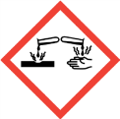 | DANGER  Corrosive (skin; eyes)  Wear splash-proof goggles
1.0 mol dm⁻³ aqueous sodium hydroxide, NaOH(aq) |  | DANGER  Corrosive (skin; eyes)  Wear splash-proof goggles
1.0 mol dm^{–3} aqueous sodium carbonate, Na₂CO₃(aq) |  | WARNING  Irritant (eyes)
Bromine water, 0.1%(v/v), Br₂(aq) |  | Currently not classified as hazardous, but use a fume cupboard if available
Universal indicator solution | 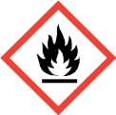 | Flammable

Equipment
The following equipment should be provided for each learner or group
- spatula
- test tubes and a test tube rack
- plastic dropping pipettes
- Bunsen burner
- heat-proof mat
- test tube tongs

Results
The following results table could be displayed with a projector so that learners can check their own results and deductions before attempting the rest of the worksheet.

Test | Result | Deduction
Solubility and pH | Most of the solid remains undissolved.  The solution is pH 5. | The phenolic compound is a weak acid.  The presence of the arene ring must affect the OH group so that it is able to donate H⁺ ions to water.  The hydrophobicity of the arene ring prevents higher solubility
Reaction with NaOH solution | All the solid dissolves. | The phenolic compound (a weak acid) has been neutralised by the alkali to make a soluble salt.  C₆H₅OH(aq) + NaOH(aq) → C₆H₅O–.Na⁺(aq) + H₂O(l)
Reaction with Na₂CO₃ solution | The solid does not fully dissolve. There is no fizzing. | The phenolic compound is too weakly acidic to react with sodium carbonate.
Reaction with Br₂ solution | The bromine is decolourised immediately.  A white precipitate forms. | The substituents on the arene ring activate it allowing reaction with Br₂. The product(s) are insoluble in water.
Reaction with dilute nitric acid | The solution turns yellow/orange as it begins to boil. The colour deepens after a minute. | The substituents on the arene ring active it allowing reaction with dilute nitric acid. The products are coloured compounds.

Reactions of phenol: answers
1,2 Bromination and nitration are substitution reactions. Some learners will need assistance to complete the equations. They may be confused by the skeletal structure of the arene moiety and not realise that a hydrogen atom, which wasn’t shown, has been replaced by Br or NO₂.

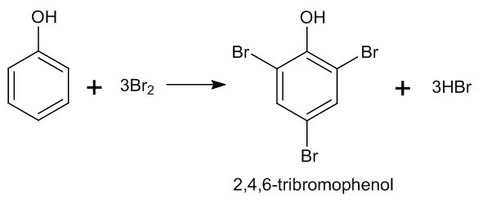

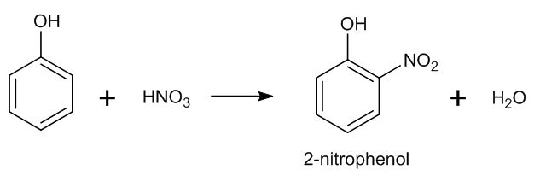

Extension
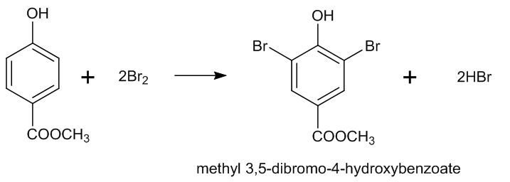
3.

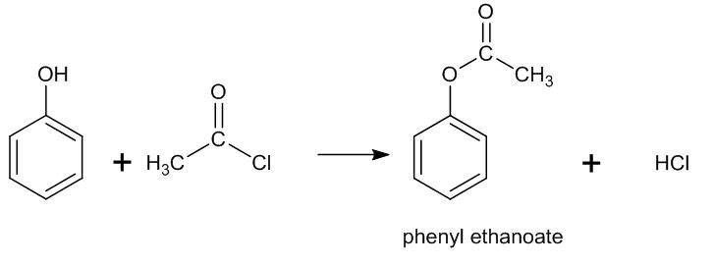
4.

The final question involves proton donation and acid dissociation constants, which are covered in section 5.1.3 of the specification, but it can be answered by using ideas of competing equilibria.

Equation | Equilibrium | K_{a} / mol dm^{–3}
1 | H₂O ⇌ H⁺ + OH– | 1.0 × 10^{–14}
2 | HCO₃– ⇌ H⁺ + CO₃^{2–} | 4.8 × 10^{–11}
3 | C₆H₅OH ⇌ H⁺ + C₆H₅O– | 1.3 × 10^{–10}
4 | H₂O + CO₂ ⇌ H⁺ + HCO₃– | 4.5 × 10^{–7}

5 Since all values of Ka are very small, the position of each equilibrium must lie far to the left hand side, i.e. all these compounds are very weak acids.
6 Phenol is a stronger acid than water, so the position of equilibrium of equation 3 is further to the right compared to equation. Hence, the H⁺ ions produced by the dissociation of phenol react with OH– ions, forming H₂O.
7 The position of equilibrium of equation 4 is further to the right compared with equation 3, i.e. carbon dioxide in water is a stronger acid than phenol. Phenol is a stronger acid than hydrogen carbonate ions, hence phenol will react with carbonate ions in solution, but not hydrogen carbonate ions and hence no CO₂ is produced. This more complete analysis of the reaction of phenol with carbonate ions is beyond the A-level specification, but worth discussing with the more interested and able learners.
If section 5.1 has already been taught, the reaction between phenol and hydroxide ions could be used as an example of how protons are transferred from a stronger acid to the conjugate base of a weaker acid.

Activity 2: Comparing benzene and phenol
This activity consists of a series of questions which could be discussed in pairs or set for homework. The answers could be handed out or projected onto a screen for discussion.
The worksheet is intended to consolidate learners’ understanding of electron delocalisation in aromatic compounds. It starts by comparing the reactivity of phenol and benzene and then looks at the way that (partial) delocalisation of a lone pair of electrons into the π system. The increased electron density causes greater attraction and polarisation of electrophiles. Learners should use the term ‘electron density’ in preference to ‘charge density’, which is less accurate, and ‘electronegativity’, which is incorrect.
To answer the extension question about nitrobenzene, learners are given a diagram showing a dative bond between the nitrogen and one of the oxygen atoms. This is a simplification and it is more accurate to show the bonding in nitrobenzene as in the diagram below. This could be shared with more able learners, who should see that this is another example of electron delocalisation.

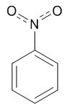

The comparison of the activating effect of the OH group on phenol with the deactivating nitro group could lead on to the consideration of the directing effects of these and other groups. This is covered in the next activity.

Answers
Reaction | Conditions for
 | phenol | benzene
Bromination | Dilute bromine solution | Liquid bromine plus a catalyst (e.g. FeBr₃)
Nitration | Dilute nitric acid  Heat | Mixture of concentrated nitric acid and concentrated sulfuric acid. Heat.

- The p orbitals overlap to form a delocalised π system. (Some books refer to ‘delocalised π bonds’. This isn’t really accurate as a π bond consists of two electrons and there are more than 2 electrons delocalised around the benzene ring. This is why the phrase ‘π system’ is preferable.)

- There are 6 electrons in the π system, delocalised over 6 carbon atoms.

- In ethene the electrons are localised in a single π bond. The π bond in ethene has a greater electron density than the benzene π system, so ethene polarises the bromine molecules more strongly and attracts the Br^{δ+} end of the molecule more strongly than benzene does.

- In phenol there are 8 p electrons delocalised over 7 atoms. Because of its increased electron density phenol is able to polarise and attract electrophiles more easily than benzene can.

- The nitrogen atom of phenylamine has one lone pair of electrons. These electrons are delocalised into the π system, so the π system of phenylamine has a greater electron density than benzene and is therefore more reactive with electrophiles.

Extension questions

6 2–methylphenol does not require a catalyst to react with bromine because the OH group is directly attached to the ring, like the OH group in phenol.

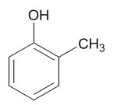

7 Phenylmethanol is much less reactive. The oxygen atom is not attached directly to the ring so the lone pair of electrons on the oxygen cannot overlap with the π system in the rest of the molecule.
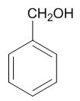

8 In nitrobenzene there is no lone pair of electrons on the nitrogen atom because it is making a dative bond with one of the oxygens. Therefore the electron density of the π system is similar to that of benzene. Nitrobenzene is actually less reactive than benzene.
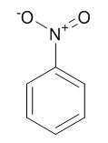

Activity 3: What positions does substitution occur at?
The directing effect of one substituent on the position of another is new to the specification. Learners need to be aware of the effect and to be able to recall and use their knowledge of the directing effects of OH, NH₂ and NO₂ groups. Others (e.g. CH₃, COOH) will be supplied on the exam paper if they are required.

The worksheet should take no more than 20 minutes. It is intended to be a brief introduction to the topic so that the ideas can be developed further when learners know enough reactions to be able to plan two-stage and multi-stage synthesis.

The reason for the directing effect is not on the specification but learners could be told that the increased electron density of phenol is not shared evenly around the molecule but concentrated on carbons 2, 4 and 6 (and the oxygen atom). In contrast, the nitro group withdraws electron density from the benzene ring, especially at carbons 2, 4 and 6. Further explanation, e.g. by drawing contributing structures (canonical forms) with separated charges, uses the concept of resonance rather than the simpler electron delocalisation model taught at A Level. If teachers wish to pursue this it would be an opportunity to discuss the use of models and their limitations (How Science Works 1).

A PowerPoint which summarises the information required is in the ‘Lesson Elements’ section of the OCR Chemistry A website: http://www.ocr.org.uk/Images/250384-directing-groups-presentation.ppt.

Directing effects can be considered when examining the product of nitration of methyl benzoate (PAG 6.3). Methyl 3-nitrobenzoate has a melting point of 78°C whereas the 4-nitro isomer melts at 94–96°C. Learners can identify which isomer they have made and deduce the directing effect of the ester group. If this approach is chosen the PAG 6.3 worksheet would require a few alterations.

Answers
- In the phenol ring, C2 and C6 are both chemically equivalent with respect to substitution reactions. Hence twice as many 2-substituted nitrophenol will be produced compared to 4-nitrophenol.

Group | Effect on Reactivity | Directing Effect
OH, NH₂ | Increased reactivity | Positions 2, 4 and 6
NO₂ | Decreased reactivity | Positions 3 and 5

- Bromination would occur mainly at carbon 3 relative to the nitro group.
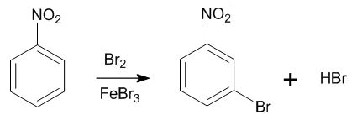

4 This reaction is a Friedel-Crafts alkylation and the ethyl group would substitute at
position 2 or 4. (Position 4 is more likely in this case due to steric clash with the OH).
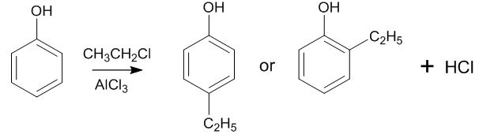

5 Six trichlorophenol isomers are possible: 2,3,4; 2,3,5; 2,3,6; 2,4,5; 2,4,6 and 3,4,5.

6 2,4,6-trichlorophenol is the main product because all three chlorines have substituted at the positions of maximum reactivity.

Extension
The correct sequence is:
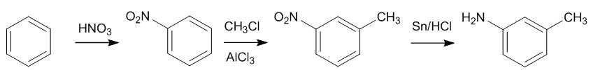

The methyl group is in position 3 relative to the amine. Of the three groups present at various points in the sequence (CH₃, NO₂ and NH₂) only the nitro group directs to position 3.

Learner question worksheet

This worksheet can be used in-class or as a homework exercise to assess learners’ knowledge of phenol chemistry. It contains a synoptic element, relating this topic to previous work on organic chemistry. The final (extension) question requires learners to have studied most of the organic chemistry in the course.

Answers
1 The first compound (paracetamol) should react, the others would not.

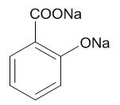
2 a) NaOH would react with both the carboxylic acid and phenol OH groups:

b) K₂CO₃ would react with the carboxylic acid group but not the phenolic OH in reaction 2.

c) A nitro group would be substituted onto the ring next to or opposite the OH group, e.g.
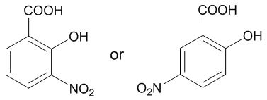

(The COOH group directs substitution to carbons 3 and 5, which are the same atoms as those in positions 2 and 4 relative to the OH group.) It would be reasonable to expect the formation of a dinitro compound as well.
d) Reaction 4 is the esterification of the carboxylic acid group. Methanol would be required, together with concentrated H₂SO₄ as a catalyst.
e) Reaction 5 is esterification of the phenol OH so requires either ethanoyl chloride, CH₃COCl, or ethanoic anhydride, (CH₃CO)₂O.

- The alkene side chain would also react. A possible equation is:
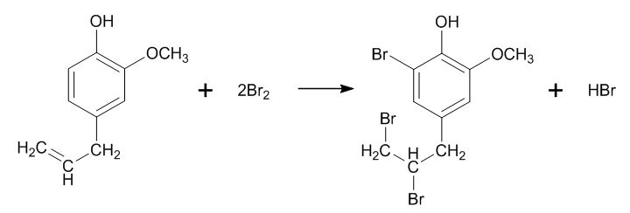

OH and OCH₃ have the same directing effect so there are other possibilities. Learners may forget the HBr produced when bromine substitutes into the benzene ring.

4 The depth of answer to an open-ended question such as this is a good indication of the extent to which a learner can apply and synthesise their knowledge. There is a phenol, primary alcohol and a secondary alcohol and amine functional groups to consider. Learners should consider the possibility that the reagents they suggest may affect other parts of the molecule.

• The phenolic OH group would react with strong alkalis, such as NaOH, while the primary and secondary alcohol groups would be unaffected.
• It would be reasonable to expect that the arene ring would undergo substitution reactions with bromine or nitric acid, probably at the carbon atom next to the phenolic OH. Nitric acid would also protonate the amine nitrogen.
• Friedel-Crafts alkylation of the arene ring could be suggested, although the amine group also reacts with halogenoalkanes, forming a tertiary amine.
• Acyl chlorides would react with all three OH groups (producing esters) and with the amine (which would form an amide). If a Friedel-Crafts catalyst was present an acyl group could also be substituted into the arene ring.
• The primary alcohol would be oxidised by acidified dichromate to make an aldehyde or carboxylic acid. The secondary alcohol would be oxidised to form a ketone.
• Both alcohol groups (but not the phenolic OH) would undergo substitution with HBr. The amine group would also react to form a bromide salt.
• Both alcohol OH groups would be esterified by heating the compound with a carboxylic acid in the presence of an acid catalyst. The phenolic OH group would not react under these conditions and the amine group would be protonated by the acid.

No answer would be expected to cover every point and other reactions could be considered. A good answer would include examples of reactions of the phenolic OH, arene, alcohol and amine groups and show awareness that reagents targeted at one group may affect one or more of the other functional groups.

For the keen burgeoning organic chemists amongst your learners, setting them a research task on organic protecting groups may be worthwhile. A good introduction is here: https://www.youtube.com/watch?v=cp5VkF0oZZ0.
We’d like to know your view on the resources we produce. By clicking on ‘Like’ or ‘Dislike’ you can help us to ensure that our resources work for you. When the email template pops up please add additional comments if you wish and then just click ‘Send’. Thank you.
Whether you already offer OCR qualifications, are new to OCR, or are considering switching from your current provider/awarding organisation, you can request more information by completing the Expression of Interest form which can be found here: www.ocr.org.uk/expression-of-interest
Looking for a resource? There is now a quick and easy search tool to help find free resources for your qualification:
www.ocr.org.uk/i-want-to/find-resources/

OCR Resources: the small print
OCR’s resources are provided to support the teaching of OCR specifications, but in no way constitute an endorsed teaching method that is required by the Board, and the decision to use them lies with the individual teacher. Whilst every effort is made to ensure the accuracy of the content, OCR cannot be held responsible for any errors or omissions within these resources.
© OCR 2017 - This resource may be freely copied and distributed, as long as the OCR logo and this message remain intact and OCR is acknowledged as the originator of this work.
OCR acknowledges the use of the following content: n/a
Please get in touch if you want to discuss the accessibility of resources we offer to support delivery of our qualifications: resources.feedback@ocr.org.uk

Topic Exploration Pack

Learner activity 1

Reactions of phenols

Aim
Phenol has two functional groups, a benzene ring and a hydroxyl group. In this experiment you will look at some of the reactions of these groups and consider how they compare with the way that an aliphatic alcohol or a typical aromatic hydrocarbon would react.
Phenol itself is very corrosive so you will be using methyl 4-hydroxybenzoate in these experiments because it is much safer to handle.
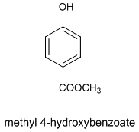
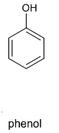

Chemicals
You are provided with the following:
methyl 4-hydroxybenzoate  c. 0.5 g required |  | WARNING  Irritant (skin; eyes; respiratory system)
1.0 mol dm⁻³ aqueous nitric acid, HNO₃(aq) |  | DANGER  Corrosive (skin; eyes)  Wear splash-proof goggles
1.0 mol dm⁻³ aqueous sodium hydroxide, NaOH(aq) |  | DANGER  Corrosive (skin; eyes)  Wear splash-proof goggles
1.0 mol dm⁻³ aqueous sodium carbonate, Na₂CO₃(aq) |  | WARNING  Irritant (eyes)
Bromine water, 0.1%(v/v), Br₂(aq) |  | Currently not classified as hazardous, but use a fume cupboard if available
Universal indicator solution |  | Flammable

Procedure
Carry out the following experiments, recording your results in a table. Include a column headed ‘deductions’. Use your answers to the questions that follow each experiment to help you fill in the ‘results’ and ‘deductions’ columns.

1 Solubility and pH: Use enough methyl 4-hydroxybenzoate (Compound A) to cover the tip of a spatula (approx. 0.1g). Place this in a test tube and add a few cm³ of distilled water.
- Comment on the solubility of the compound in cold water. What feature of the compound affects this solubility?
- Add a drop of universal indicator solution. Is the phenolic compound a strong or a weak acid?
- Most alcohols are neutral. What part of the molecule could be making the OH group act as an acid?

2 Reaction with alkalis. Place the same amount of A as in the first experiment in a clean test tube. Add a few cm³ of dilute sodium hydroxide solution and shake the tube carefully.
- Observe what happens.
- Compare this result with experiment 1. What evidence is there for a reaction between the phenolic compound and the alkali?
- Write an equation for the reaction between phenol and sodium hydroxide solution.
Repeat the experiment using sodium carbonate solution in place of sodium hydroxide.
- Think about what you would expect to see when ethanoic acid reacts with sodium carbonate. Does the phenolic compound react like ethanoic acid?
- What does this tell you about the acidity of the phenolic compound?

Reactions of the benzene ring
3 Reaction with bromine: Add a spatula-tips worth of A in a clean test tube, then add a
2-3 cm³ of water. Carefully shake the tube, then add several drops of bromine solution. Observe what happens as the bromine is added.
- Under what conditions does benzene react with bromine? Is the phenolic compound more or less reactive than benzene?

4 Reaction with nitric acid: Add a spatula-tips worth of A in a clean test tube, then add a
2-3 cm³ of dilute nitric acid. Heat the tube gently over a Bunsen burner (half-blue flame) until the solution just begins to boil. Leave the tube to cool for a minute, then place in an ice bath for
2-3 minutes.
- Under what conditions does benzene react with nitric acid? Is the phenolic compound more or less reactive than benzene?

Disposal
Test tubes should be emptied into the sink and the products rinsed away with water.
The reactions of phenol
Phenol as an alcohol
The OH group interacts with the benzene ring so that some characteristics of phenol are different to those of aliphatic alcohols.
- Water molecules are able to form hydrogen bonds with the OH group but they can’t interact with the benzene ring so phenol is sparingly soluble in water.
- The phenol OH group is able to donate a proton to water molecules, so phenol is very weakly acidic. Most aliphatic alcohols are neutral.
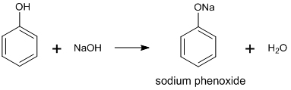
- Phenol reacts with sodium hydroxide to form a salt which is much more soluble than phenol itself.

- Phenol is such a weak acid that it does not react with carbonates.
- Like other alcohols phenol can form esters, but it doesn’t react directly with carboxylic acids. Phenol can only form an ester if it is reacted with an acid anhydride or an acyl chloride.
- Phenol cannot be oxidised by acidified potassium dichromate.

Phenol as an aromatic compound
The benzene ring in phenol interacts with the OH group. Phenol undergoes electrophilic substitution reactions much more readily than benzene.
- Phenol reacts quickly with dilute bromine solution. The reaction needs no catalyst and bromine atoms substitute in several places:
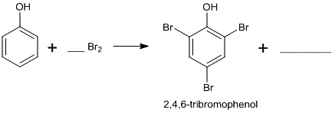

- Complete and balance the equation in the boxes above.
- Phenol can be nitrated by dilute nitric acid and needs no catalyst.

- Write a balanced equation for the formation of 2-nitrophenol from phenol and nitric acid.

Extension
- Write an equation for the reactions between methyl 4-hydroxybenzoate and bromine.

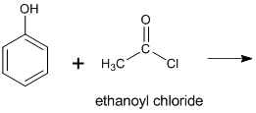
- Phenol reacts with acyl chlorides, such as ethanoyl chloride, to make an ester. Complete the equation for this reaction:

Consider the following equilibrium constants (acid dissociation constants):
Equation | Equilibrium | K_{a} / mol dm^{–3}
1 | H₂O ⇌ H⁺ + OH⁻ | 1.0 × 10^{–14}
2 | HCO₃– ⇌ H⁺ + CO₃^{2–} | 4.8 × 10^{–11}
3 | C₆H₅OH ⇌ H⁺ + C₆H₅O– | 1.3 × 10^{–10}
4 | H₂O + CO₂ ⇌ H⁺ + HCO₃– | 4.5 × 10^{–7}

- What do the K_{a} values tell you about the relative position of each equilibrium?

- Explain why phenol is able to donate a proton to OH– ions?

- Why is carbon dioxide not produced when phenol is added to sodium carbonate?

Learner activity 2

Comparing benzene and phenol
Both benzene and phenol undergo electrophilic substitution reactions, but phenol reacts much more readily than benzene. Complete the table to show the different conditions required for phenol and benzene.
Reaction | Conditions for
 | phenol | benzene
Bromination
Nitration
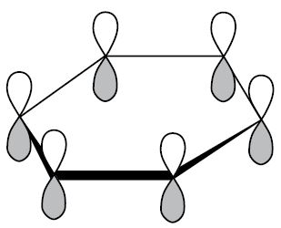
The diagram shows some of the bonding in a molecule of benzene.

The figure of symbol represents the 2p orbitals of each carbon on the benzene ring.
In addition to the σ bonds shown in the diagram, benzene also has a delocalised π system.

- Explain how this π system is formed

- How many 2p electrons are involved in the π system of benzene?

- This diagram shows a molecule of ethene. Explain why ethene reacts with bromine much more readily than benzene does.
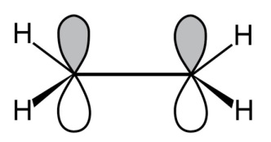

The oxygen atom in phenol has two non-bonded (lone) pairs of electrons. One of these lone pairs occupies the 2p orbital shown in the diagram and can join the delocalised π system.
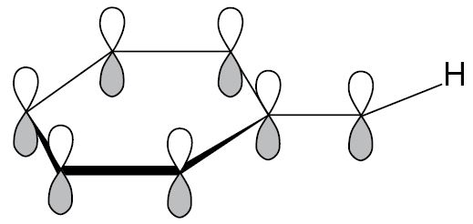
4 How many electrons are involved in the π system of phenol? Explain why phenol is more reactive than benzene, in terms of electron density.

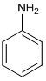
5 Phenylamine (C₆H₅NH₂) also undergoes electrophilic substitution more readily than benzene. Explain why.

Extension
- These compounds are isomers, but they require very different conditions to make them react with bromine. Decide which isomer does not require a catalyst to react with bromine and explain why.
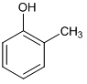
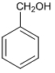

7 Try to explain why the other isomer is less reactive.

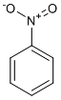
8 Consider the bonding in nitrobenzene (C₆H₅NO₂). Would you expect nitrobenzene to be more or less reactive than phenol? Explain your reasoning.

Learner activity 3

Substitutions

What positions does substitution occur at?
Attaching an OH or NH₂ group to a benzene ring increases the reactivity of the ring. Alkyl groups, such as CH₃, also increase the reactivity slightly. In each case, these groups increase reactivity mainly at the carbon atoms adjacent to and opposite the group. So when phenol reacts with nitric acid the organic products are almost entirely 2-nitrophenol and 4-nitrophenol.

- Can you explain why this reaction produces more 2-nitrophenol than 4-nitrophenol?
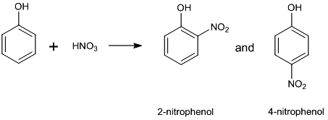

NO₂ groups reduce the electron density in the arene ring and decrease the reactivity the reactivity of the ring. They reduce the likelihood of substitution at all points on the ring but especially next to and opposite the nitro group. Therefore reaction is more likely at the 3- (or meta-) position on the ring.

These effects are called the ‘directing effect’ of the various groups. The mechanism for these directing effects are studied at undergraduate level. For your A-level study, the effects of OH, NH₂ and NO₂ need to be known for the exam, and you may be asked to use information about other groups, given appropriate information about their directing effects.

2. Summarise the above information in a simple table which you can learn.

3, 4. Draw the organic products of the following reactions, assuming only one substitution occurs.
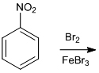

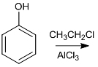

Phenol reacts with chlorine gas to make 2,4,6-trichlorophenol, a constituent of the antiseptic TCP.
- How many isomers of trichlorophenol could be formed?

- Why is the 2,4,6 isomer the main product?

Extension
Directing effects must be taken into account when planning a sequence of steps in the synthesis of a particular compound.
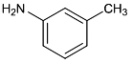
The following compound can be made from benzene in three steps: methylation (Friedel-Crafts alkylation), nitration and reduction of NO₂ to NH₂.

In which order must these steps be carried out to produce the desired arrangement? (The methyl group has the same directing effect as OH.)

Learner question worksheet
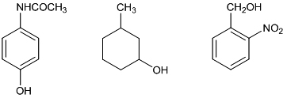
- When phenol is added to iron(III) chloride solution a deep purple colour is produced. Which of the following compounds would you expect to react in the same way as phenol?

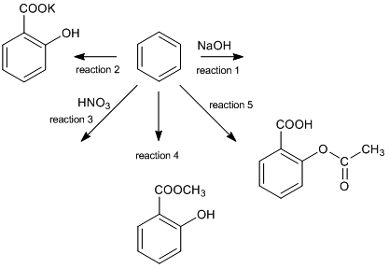
2 Consider the following reactions of 2-hydroxybenzoic acid.

- Sketch the organic product of reaction 1.

- What reagent is needed for reaction 2?

- What is the most likely organic product of reaction 3?

- Which reagent would you use for reaction 4?

- Suggest a reagent for reaction 5.

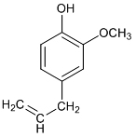
- Oil of cloves is sometimes used to treat toothache as it is a mild anaesthetic. The active ingredient is called eugenol:

Use structural formulae to write an equation for the reaction between eugenol and two mole equivalents of bromine.

Extension
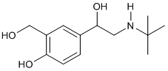
4 Salbutamol is used in the treatment of asthma.

Consider the various parts of the salbutamol molecule and suggest some reactions it is likely
to undergo and the products of those reactions. Don’t forget that some chemicals will react at more than one place in the molecule.

