Topic Exploration Pack

The Chemical Industry: Equilibrium and Kinetics

Learning outcomes 3
Background 4
Suggested activities 6
Learner Activity 1 20
Learner Activity 2 24
Learner activity 3 27
Learner activity 4 32

Instructions and answers for teachers

These instructions cover the student activity section which can be found on page 19. This Topic Exploration Pack supports OCR A Level Chemistry B (Salters).
When distributing the activity section to the students either as a printed copy or as a Word file you will need to remove the teacher instructions section.

Learning outcomes
- CI (a) the terms:
- rate of reaction
- rate constant, including units
- order of reaction (both overall and with respect to a given reagent), use of ‘∝’
- rate equations of the form: rate = k[A]^{m}[B]^{n} where m and n are integers; calculations based on the rate equation; the rate constant k increasing with increasing temperature
- CI (b) the use of given data to calculate half lives for a reaction
- CI (c) techniques and procedures for experiments in reaction kinetics; use of experimental data [graphical methods (including rates from tangents of curves), half lives or initial rates when varying concentrations are used] to find the rate of reaction, order of a reaction (zero-, first- or second order), rate constant and construction of a rate equation for the reaction
- CI (d) the Arrhenius equation and the determination of E_{a} and A for a reaction, given data on the rate constants at different temperatures [the Arrhenius equation is given on the Data Sheet]
- CI (e) the term rate-determining step; relation between rate-determining step and the orders and possible mechanism for a reaction
- CI (f) the effect of changes of temperature and pressure (if any) on the magnitude of the equilibrium constant; the fact that addition of catalysts has no effect on the position of equilibrium or the magnitude of the equilibrium constant
- CI (g) the determination of the most economical operating conditions for an industrial process using principles of equilibrium and rates of reaction
- CI (h) calculations, including units, involving Kc and initial and equilibrium concentrations for homogeneous equilibria; techniques and procedures for experiments to determine equilibrium constants
Mathematical outcomes to cover:
- M0.0 – Recognise and make use of appropriate units in calculation
- M0.4 - Use calculators to find and use power, exponential and logarithmic functions
- M2.2 – Change the subject of an equation
- M2.3 – Substitute numerical values into algebraic equations using appropriate units for physical quantities
- M2.4 – Solve algebraic equations
- M2.5 – Use logarithms in relation to quantities that range over several orders of magnitude
- M3.1 – Translate information between graphical, numerical and algebraic forms
- M3.2 – Plot two variables from experimental or other data
- M3.3 – Determine the slope and intercept of a linear graph
- M3.4 – Calculate the rate of change from a graph showing a linear relationship
- M3.5 – Draw and use the slope of a tangent to a curve as a measure of rate of change

Practicals
- PAG 9 (Rates of reaction – continuous monitoring method) and 10 (Rates of reaction – initial rates method)
- experiments to determine the change of rate of reaction over time
- experiments where the results can be used to calculate rate, orders of reaction, the rate constant and the activation enthalpy

Contexts
Synthesis of sulfuric acid and catalytic decomposition of hydrogen peroxide.

Background
The dynamic nature of the equilibrium state is introduced in the Elements from the Sea unit, together with K_{c} and the way that changes in concentration, temperature and pressure affect the position of equilibrium.
Factors that affect rate of reaction are covered at GCSE. They were linked with the concepts of collision theory and activation enthalpy as part of the Ozone story, where the use of the Boltzmann distribution to explain the effects of catalysts and temperature on reaction rate was introduced. A separate Topic Exploration Pack covering this is available at: http://www.ocr.org.uk/Images/349599-catalysis-collision-theory-and-activation-enthalpy-topic-exploration-pack.doc. The kinetics of enzyme catalysis will be discussed as part of Polymers and Life.

Common misconceptions or difficulties learners may have
Learners often learn to apply Le Chatelier’s Principle confidently but then struggle to adjust their thinking when confronted with the equilibrium constant. A distinction can be drawn between the equilibrium constant and the position of equilibrium (which is affected by concentration). Equilibrium can be modelled as a seesaw, where K_{c} represents the position of the fulcrum. If K_{c} >>1 the fulcrum is well to the right so the seesaw only balances (is at equilibrium) when there are many more product molecules than reactants.
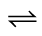
A B

K_{c} = 1

K_{c} > 1

K_{c} < 1

Many learners struggle with the way in which pressure, temperature and catalysts affect equilibria. They will state that K_{c} is constant but find it difficult to understand how changes in pressure can affect the position of equilibrium without altering the value of K_{c}. It may be helpful to explain that the easiest way of increasing the pressure of a gas is to reduce its volume and thereby increase its concentration. They will also find it difficult to accept that Kc can have a different ‘constant’ value at a different temperature. It may be worth reminding them that while the speed of light in a vacuum is constant, the ‘constant’ has different values in other materials such as glass or water. Finally they will have difficulty accepting that a catalyst has no effect on the position of equilibrium, especially when we speak of enzymes catalysing ‘the digestion of starch into glucose’, for example. Consideration of enthalpy profiles with and without catalyst may help them to appreciate qualitatively that the catalyst speeds up both forward and backward reactions.
When they are first introduced to reaction order, learners tend to associate the rate equation and stoichiometric chemical equation for a reaction and have difficulty with the concept of ‘zero order’, where, counter-intuitively, the concentration of one reactant has no effect on the rate of reaction. They will need help to realise that the rate equation cannot be deduced from the chemical equation and can only be found by experiment. The idea of a multistep reaction in which one step is potentially slower than the rest is also not easy to grasp. Analogies such as the flow of sand through an hourglass or waiting for a kettle to boil before making a cup of instant coffee may help learners understand the idea of a rate-determining step. They can then try to apply the concept to some of the organic reaction mechanisms they have encountered in the Developing Fuels and Ozone storylines. Learners will encounter zero order kinetics again in Polymers and Life when they find that the rate of an enzyme-catalysed reaction is zero order with respect to substrate at high substrate concentrations.

Calculations and graphs
Learners (especially those not studying A Level Maths) will need support with the mathematical demands of this topic, which include rearranging equations, using logarithms, drawing tangents and calculating and using gradients. They do not need to understand what logs are but must be shown how to use a calculator to find ln x and e ^{x}.
Graph drawing based on the Arrhenius equation is particularly challenging since it requires learners to plot very small values of 1/T and use the negative axis for ln k. There are many opportunities for using spreadsheets in this topic but learners must become confident in drawing smooth curves and tangents for themselves.
Units are a real difficulty in these topics, especially those for equilibrium and rate constants. Learners can be shown how to ‘calculate’ the units by fitting them into the equation and cancelling to produce the simplest form. It is worth checking their understanding of indices (especially dm⁻³ and s⁻¹) before attempting to teach this.
The OCR ‘Mathematical Skills Handbook’ (http://www.ocr.org.uk/Images/295468-mathematical-skills-handbook.pdf) and ‘Practical Skills Handbook’ (http://www.ocr.org.uk/Images/208932-practical-skills-handbook.pdf) provide detailed information on how to teach these and other concepts. It might be worth providing learners with copies of some of the pages on equilibrium constants, the Arrhenius equation, rate equations and interpreting graphs.

Suggested activities

Equilibrium
The topic can be introduced by revising how to deduce the equation for the equilibrium constant from the balanced chemical equation. Revising the calculation of Kc from equilibrium concentrations (learners will have to be reminded to use concentrations, not amounts) can lead on to showing how the units of Kc are found.
The way in which changing the concentrations of reactants and products affects the position of equilibrium can then be discussed. For example, concentrated H₂SO₄ is a good choice of catalyst in the preparation of esters (What’s in a Medicine) because it also acts as a dehydrating agent, removing one of the products and driving the position of equilibrium towards the right hand side. The idea that the position of equilibrium shifts in the direction which opposes any change can be extended to consider the effects of changes in pressure and temperature. Learners should be able to deduce which way the equilibrium moves when the temperature changes and therefore whether Kc has become larger or smaller. They will find it hard to accept that pressure can affect the position of equilibrium but not alter the value of Kc: it is probably easiest to state this and allow learners to see that it is true by looking at examples. (The final part of Activity One, below, illustrates how increasing pressure moves a system away from its previous position of equilibrium.)
Learners will need to calculate equilibrium concentrations when the initial concentrations are known and one equilibrium value is determined. The experimental determination of Kc for the equilibrium between Ag⁺, Fe²⁺ and Fe³⁺ ions is a good example of this sort of calculation (http://www.rsc.org/learn-chemistry/resource/res00000537/measuring-an-equilibrium-constant ). Kc can also be determined experimentally for the hydrolysis of ethyl ethanoate. Practical details can be found at http://www.ocr.org.uk/Images/255641-equilibrium-delivery-guide-learner-resource-2.xls and http://www.ocr.org.uk/Images/250284-finding-an-equilibrium-constant-for-esterification-teacher-instructions.pdf. Alternatively, learners can practise the calculation using specimen results.
An interesting way to tie this topic together is for each learner to research the choice of conditions for an industrial process and try to relate them to principles of equilibrium and rate of reaction. The Chemical Industry Education Centre website provides plenty of relevant contexts: http://www.essentialchemicalindustry.org/processes/catalysis-in-industry.html can provide the necessary information.

Kinetics
A good start would be for learners to revise the factors that affect reaction rate and to explain them as far as they can by referring to frequency of collisions and activation enthalpy. In this topic, only concentration and temperature will be considered but their effects will be treated quantitatively.
Measurement of reaction rate in terms of rate of change of concentration of reactant (normally mol dm⁻³ s⁻¹) must be introduced first. After this the rate equation can be developed, in which the rate of reaction is related to concentration of reactants and the rate constant, k, which represents the frequency of successful collisions and is temperature sensitive. These concepts are explained in Activity Two. Alternatively, learners could carry out an experiment in which they monitor a reaction continuously, for example the decomposition of H₂O₂ (PAG 9.1) or the reaction of marble chips with acid (PAG 9.2). The concentration of H₂O₂ or HCl remaining at various times can be calculated from the volume of gas released. Learners can draw tangents and calculate the rate of reaction at various times. In each of these examples the rate of reaction is directly proportional to the concentration of reactant, i.e. they are first order reactions.
After they have seen how the rate changes over the course of a reaction, learners can find out how the initial rate is affected by concentration and hence deduce the order of reaction with respect to the concentration of each reactant. (Only zero, first and second order relationships are examined at A-level.) The initial rate can be estimated by calculating the gradient of a concentration v time graph at the start of a reaction (e.g. PAG 9.3, the reaction between magnesium ribbon and HCl). Alternatively a reaction in which some visible change occurs when the reaction has reached a certain point can be carried out. (The ‘iodine clock’, PAG 10.1, and the ‘disappearing cross’ reaction between sodium thiosulfate and acid, PAG 10.2, are good examples.) The initial rate is then proportional to the reciprocal of the time taken for the change to occur (). These reactions can be repeated at several different concentrations to show the relationship between initial rate and reactant concentration. In PAG 9.3 the rate is proportional to the square of the HCl concentration (2nd order), whereas the reaction in PAG 10.2 is zero order with respect to acid concentration. If possible, learners should carry out one or both of these reactions so that they have experience of reactions which are not first order.
There are many examples available on the internet (e.g. http://www.a-levelchemistry.co.uk/unit-5.html) that learners can use to practise the skill of interpreting initial rate data to determine the overall rate equation for a reaction and then calculate the value of the rate constant, k. In Activity Three (below), learners use initial rate data to deduce the rate equation for the reaction between iodine and propanone and find that the concentration of propanone has no effect on the rate of the reaction. This example shows that the rate equation isn’t necessarily related to the balanced chemical equation and introduces the idea of a rate-determining or rate-limiting step. The rate equation doesn’t always include all the substances in the chemical equation, but everything involved in the rate-determining step will be represented in the rate equation. Further details are discussed at http://www.chemguide.co.uk/physical/basicrates/ordermech.html.
The concept of a rate-determining step is nicely illustrated in a Richard Thornley video: http://www.youtube.com/watch?v=swnJeRo-u8Q while the next video in the series shows how rate determining step and reaction mechanism are related (https://www.youtube.com/watch?v=l_yY3H-hVmk ).
Learners studied the mechanism of nucleophilic substitution when they looked at the hydrolysis of haloalkanes as part of the Ozone story. They can be reminded of this mechanism and asked to explain why the reaction rate depends on the concentration of both haloalkane and hydroxide ions. As an extension, they could try to suggest a mechanism which would depend on the concentration of the haloalkane alone. The two mechanisms are discussed at http://www.chemguide.co.uk/mechanisms/nucsub/whatis.html (NB The exam specification does not require knowledge of the SN1 mechanism or of SN1, SN2 nomenclature.)
Learners will encounter graphs of concentration against time and rate of reaction against concentration and need to be aware of the likely shapes for reactions of different orders. Worksheets at https://www.tes.com/teaching-resource/rates-graphs-higher-level-6409891 provide practice at plotting and identifying these graphs. One characteristic of first order reactions is that the reactant concentration has a constant half life. Learners can look at concentration against time graphs they have plotted (e.g. Activity One, PAG 9.1 or PAG 9.2) and measure three sequential half lives to prove that these reactions are first order.
Having spent a lot of time explaining the quantitative relationship between rate and concentration the final part of this topic looks at the effect of temperature and how activation enthalpy is determined. Learners should first realise that a small increase in temperature causes a large increase in reaction rate. (They may have encountered the idea that rates of enzyme-catalysed reactions approximately double for every 10ºC rise in temperature as part of their GCSE or A-level Biology course.) The idea that the relationship between rate and temperature is not linear but exponential leads on to the Arrhenius equation, which is supplied on the examination data sheet. The terms in the equation will need explanation: A is the frequency factor and indicates how frequently collisions occur in the correct orientation for reaction; e is a mathematical constant; E_{a} is the activation enthalpy; R is the gas constant (introduced in the Developing Fuels unit); and T is the temperature (in kelvin because the absolute temperature is required).
To determine activation enthalpy the initial rate of a reaction is measured at several different temperatures but always with the same concentration of reactants. Under these conditions the initial rate is proportional to the rate constant, k. The logarithmic form of the Arrhenius equation (also on the examination data sheet) shows that ln k is related to 1/T by the factor so a graph of ln k against 1/T has gradient and intercept ln A. This calculation requires mathematical understanding and calculator skills. Many learners will need to be shown how to find ln and e^{x} on their calculators. Activity Four (the reaction between magnesium and HCl) and PAG 10.3 (the reaction between manganate(VII) ions and ethanedioic acid) provide opportunities for learners to determine an experimental value for E_{a}.

Useful resources for equilibrium and kinetics
http://www.rsc.org/learn-chemistry/resource/res00001358/advanced-starters-for-ten The following worksheets are particularly useful:
1.1 Rate-determining steps
1.2 Calculating reaction rate
1.4 The rate equation
1.5 The Arrhenius equation
2.1 Kc
2.2 Calculations with Kc
http://www.knockhardy.org.uk/sci.htm
PowerPoints, notes and questions on equilibrium and kinetics.
http://www.4college.co.uk/a/ep/rates.php
Useful notes on rate of reaction, covering graphs, the rate equation, half live and the rate-determining step. (This site covers the pre-2015 Salters specification. Relevant material on rate of reaction is under the ‘Engineering Proteins’ heading at present; Feb 2016)
http://www.a-levelchemistry.co.uk/unit-5.html
Questions of varying difficulty covering:
  - Concentration v time graphs
  - Orders of reaction
  - Kc calculations
  - Kc and the position of equilibrium

Activity One: Choosing Conditions for Equilibrium Reactions
This worksheet looks at the effect of temperature and pressure on some important equilibria. Learners calculate Kc for a system which is at equilibrium and then repeat the calculation for the situation immediately after the pressure has been increased. Because the concentration ratio is no longer equal to Kc they should realise that the system is no longer at equilibrium and explain in which direction it must shift.
Learners can work through the questions individually but may benefit from discussing in pairs. Suggested answers are on a separate sheet which can be issued at the end of the task. Time required 30 to 45 minutes including feedback.

Activity Two: Modelling a Chemical Reaction
This is a dice-rolling activity which models a first order reaction. The results are used to generate a graph of reactant concentration against time and rate against concentration. The rate equation and rate constant are introduced. The initial activity takes only a few minutes. Some learners will need help with graph plotting, especially with drawing tangents and calculating gradients but the final parts of the worksheet could be completed as homework.

Activity Three: The kinetics of the reaction between iodine and propanone
The worksheet provides practice at deriving the rate equation from initial rate data and leads on to a discussion of rate-determining steps and a possible mechanism for the reaction. The whole activity should be easily completed during a lesson. An answer sheet is supplied which can be issued to learners to assess their own work.

Activity Four: Determining the activation enthalpy of a reaction
This is a simple experiment which can be completed in 15 to 20 minutes, possibly less if each learner just measures the rate at a couple of temperatures and shares results with others in the class. The results are used to show the effect of temperature on reaction rate and introduce the Arrhenius equation. Total time required for experiment and questions is about 1 hour.

Assessment
This takes the form of a card-sorting activity which learners can undertake in pairs. Allow 10 to 15 minutes for the task plus feedback and discussion.

Additional teacher preparation

Activity One: Choosing Conditions for Equilibrium Reactions
The worksheet provides practice at using Le Chatelier’s Principle to deduce the effects of temperature and pressure on position of equilibrium and K_{c}. The final question (the production of sulfur trioxide) involves the calculation of K_{c}. The immediate effect of doubling the pressure is then considered so that learners should realise that the system is no longer at equilibrium and will adjust by increasing the concentration of SO₃.
Learners may miss the significance of the state symbols in the second example (the reaction between steam and carbon). In the final question they may calculate the new value of [SO₃]² / [SO₂]²[O₂] and say that “K_{c} has changed”. This would likely not be credited in exams because K_{c} is constant at constant temperature. They must state that the ratio is no longer equal to K_{c} and that therefore the system is not at equilibrium. This worksheet takes them step-by-step through the calculation but a common error in exam answers is for learners to use equilibrium amounts to calculate K_{c} instead of converting them into concentrations.

Activity Two: Modelling a Chemical Reaction
The idea of this activity is to emphasis the randomness of chemical reactions and to show how the rate equation can be generated. It provides practice in plotting and interpreting graphs of concentration against time and rate of reaction against concentration. Most simple experimental procedures measure the amount of product formed (e.g. oxygen when hydrogen peroxide decomposes; carbon dioxide in the reaction of marble chips with acid), generating a graph with a positive gradient. Since the amount of ‘reactant’ remaining is measured in this activity the standard graph of concentration vs time is produced more easily.
Bags of dice can be purchased fairly cheaply on the internet/educational suppliers or Maths departments may have a stock. Cubes with one red side are often used for showing radioactive decay and are suitable for this activity, although the ‘reaction’ will proceed twice as slowly as described on this worksheet, where 5s and 6s represent reaction.
Dice can be thrown into a plastic Gratnells tray or similar. At the end of the lesson it is advisable to check that all 120 dice are still present.
This activity is a good opportunity for learners to use a spreadsheet to process their data but it would be helpful if they print their graphs out so they can practise drawing smooth curves and tangents.

Answers
A graph like the one below will be produced. Because of the random nature of the process the curve is unlikely to pass through each point.

1 The reaction is fastest where the curve is steepest.
2 This is because the highest number of reactant particles is present at the start of the reaction.
3,4,5 Some learners may need help with drawing tangents and with the concept of the gradient of a curve. Typical results are:
Time (minutes) | Number of dice remaining | Rate (dice / minute)
0 | 120 | 43
1.5 | 66 | 25
3.0 | 36 | 14
4.5 | 20 | 8

6 These results produce the following straight line graph:

7 Learners should realise that since their points fit a straight line which passes through the origin, the rate of reaction must be directly proportional to the number of dice.
8 Since rate of reaction is dice reacting/minute k must have units of 1/min, i.e. min^{–1}. This example should help learners realise that the rate constant has units of frequency, since it reflects the frequency with which molecules react when they collide.
Learners will need help to realise that the value of the rate constant increases when the temperature is raised.

Extension
The graph for a second order reaction would look like this:

Learners should realise that the initial rate is higher (in spite of the much smaller rate constant) but it slows down much more quickly.
When half lives are introduced the original graph of number of dice vs time will show a constant half life (approximately two throws). It should be clear that the ‘half life’ shown by the second order graph is not constant and that the term half life is inappropriate for a second order reaction.

Activity Three: The kinetics of the reaction between iodine and propanone
The reaction between iodine and propanone is an interesting example because the rate is zero order with respect to one of the reactants (iodine). Learners will find this difficult to understand in terms of simple collision theory but a possible mechanism for the reaction is introduced in which the rate-determining step is the acid-catalysed isomerization of propanone to propen-2-ol. The reaction is discussed clearly at http://www.docbrown.info/page03/ASA2rates2.htm#4.6
Many learners will find it difficult to understand the concept of a rate-determining step. Everyday illustrations will help. Boiling the water is normally the rate-determining step in making a cup of instant coffee.
This exercise could lead on to a consideration of the probable orders of reaction in the hydrolysis of halogenoalkanes according to the nucleophilic substitution mechanism they have studied in the Ozone story.
The rate-determining step is often described as the slowest step. However, subsequent steps in the mechanism cannot be preceding any more quickly because they are limited by the concentration of intermediates. It is more correct to say the rate-determining step is potentially the slowest step in the sequence.

Activity Four: Determining the activation enthalpy of a reaction
This experiment can be carried out quickly leaving lesson time for graph plotting and calculations. In any initial rate or ‘clock’ experiment the relative rate of reaction at each temperature will be proportional to 1/time taken but in this example that is the obvious unit to use so learners should need no further explanation.
The conversion into more conventional units is explained in the first two questions on the worksheet. The gradient of the graph (and hence the activation enthalpy) will be the same whatever the units of k because units are lost when ln k is calculated. However it is important to use the correct units of temperature (K) and activation enthalpy (J mol^{–1}).
The calculation is a good opportunity for learners to use a spreadsheet to analyse their data (specification statement 1.2.1g; CPAC 5a).

Health & Safety
- Before carrying out any experiment or demonstration based on this guidance, it is the responsibility of teachers to ensure that they have undertaken a risk assessment in accordance with their employer's requirement, making use of up-to-date information and taking account of their own particular circumstances. Any local rules or restrictions issued by the employer must always be followed.
- Use CLEAPSS resources (http://www.cleapss.org.uk) when carrying out risk-assessments.
- Learners should wear eye protection throughout.

Chemicals
Each learner or group will require the following:
Label | Identity | Hazard information
HCl(aq) | Aqueous dilute hydrochloric acid, approx. 0.4 mol dm^{–3}.  This should be supplied in stoppered bottles.  If possible the bottles should be put into three or four water baths at a range of temperatures between 30 and 60°C, with another bottle left at room temperature.  Each learner or group will require 50 cm³ at each temperature. | Currently no hazard classification at this concentration.  Wear eye protection.
Mg(s) | Magnesium ribbon, cut into pieces about 1 cm long and stored in a glass jar.  Each learner or group will require five pieces. | Currently not classified as hazardous in this form
H₂(g) - PRODUCED | About 12 cm³ produced per reaction. Ensure there are no naked flames in the laboratory, and the laboratory is well ventilated. | 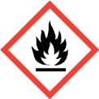 | DANGER: Extremely flammable.
It is safer if learners are provided with acid in several water baths at a range of temperatures. If they have to heat their own acid they must take care not to boil it and generate hydrogen chloride fumes.
50 cm³ of acid is used so that it is in excess and so that the exothermic nature of the reaction does not cause the temperature to rise significantly.

Equipment
The following equipment should be provided for each learner or group
- Glass beaker (100 or 150 cm³)
- Thermometer measuring 0–100°C (a short stemmed thermometer is ideal)
- Glass stirring rod
- Measuring cylinder (50 or 100 cm³)
- Stop watch or stop clock
If they have to heat the acid for themselves each group can make up a water bath with:
- Bunsen burner
- Tripod
- Gauze
- Heat-proof mat
- 250 cm³ glass beaker

Answers
1 0.012 g of magnesium reacts with 0.001 mol of hydrochloric acid.
2 0.001 mol in 50 cm³ is a change in concentration of 0.02 mol dm^{–3}.
Typical results are:
T /°C | Time taken / s | Rate of reaction / cm Mg s⁻¹
20 | 40 | 0.025
30 | 29 | 0.034
40 | 22 | 0.045
50 | 17 | 0.059
60 | 13 | 0.077

1 The line cannot be extrapolated through the origin because it is quite possible that the reaction proceeds at temperatures below 0°C.
The activation enthalpy for this reaction is quite low so the exponential nature of the graph may not be especially obvious.
2 m is and c is ln A
5 Using the same data as before:
T / °C | Time taken / s | Rate of reaction / cm Mg s⁻¹ | T / K | 1/T / K⁻¹ | ln (rate)
20 | 40 | 0.0250 | 293 | 3.41 × 10⁻³ | -3.689
30 | 29 | 0.0345 | 303 | 3.30 × 10⁻³ | -3.367
40 | 22 | 0.0455 | 313 | 3.19 × 10⁻³ | -3.090
50 | 17 | 0.0588 | 323 | 3.10 × 10⁻³ | -2.834
60 | 13 | 0.0769 | 333 | 3.00 × 10⁻³ | -2.565

6 On this graph the gradient is –2745 (learners often omit the sign).
so = -2745
E_{a} = 2745 × 8.314
= 22 822 J mol^{–1}
= 22.8 kJ mol^{–1} (3 sig fig)
Learners may be puzzled by the disappearance of any units related to rate. Logarithms have no units so the gradient is in K. R has units of J mol^{–1} K^{–1}, hence the final value is in J mol^{–1}.
7 From the graph, ln A is 5.675 so A is 293. (This is a meaningless value in the context of this experiment because the calculation used reaction rates, in unconventional units, instead of rate constants. Because all the values are relative to each other this is a valid method for determining the gradient and hence E_{a}, but it gives an incorrect value for the intercept.

Assessment Worksheet
A card-sorting exercise is used to check learners’ understanding of rates of reaction.
The activity should be printed onto card and the individual frames cut out and well shuffled. They are in the right order on the original sheet. (If you plan to re-use the cards it is worth copying each set in a different colour so that they don’t get muddled up.)
Learners should work in pairs to put the cards into three columns, headed ‘zero order’, ‘first order’ and ‘second order’. Warn them that there are different numbers of cards in some columns.
Most of this task should be straightforward but there will probably be some debate about the orders of the example reactions. This is an opportunity to remind learners that the reaction order cannot be deduced from the chemical equation, so they cannot place each example in the correct column without either doing the experiment or processing sample data, or referring to a textbook. They may, however, realise that the decomposition of hydrogen peroxide is likely to be zero order at limiting concentrations of enzyme.
When going through the answers it is worth pointing out that a reaction can be first order with respect to the concentration of each reactant but second order overall.
We’d like to know your view on the resources we produce. By clicking on ‘Like’ or ‘Dislike’ you can help us to ensure that our resources work for you. When the email template pops up please add additional comments if you wish and then just click ‘Send’. Thank you.
Whether you already offer OCR qualifications, are new to OCR, or are considering switching from your current provider/awarding organisation, you can request more information by completing the Expression of Interest form which can be found here: www.ocr.org.uk/expression-of-interest
Looking for a resource? There is now a quick and easy search tool to help find free resources for your qualification:
www.ocr.org.uk/i-want-to/find-resources/

OCR Resources: the small print
OCR’s resources are provided to support the delivery of OCR qualifications, but in no way constitute an endorsed teaching method that is required by the Board, and the decision to use them lies with the individual teacher. Whilst every effort is made to ensure the accuracy of the content, OCR cannot be held responsible for any errors or omissions within these resources.
© OCR 2017 - This resource may be freely copied and distributed, as long as the OCR logo and this message remain intact and OCR is acknowledged as the originator of this work.
OCR acknowledges the use of the following content: n/a
Please get in touch if you want to discuss the accessibility of resources we offer to support delivery of our qualifications: resources.feedback@ocr.org.uk

Topic Exploration Pack

The Chemical Industry: Equilibrium & Kinetics

Learner Activity 1

Activity One: Choosing Conditions for Equilibrium Reactions
Consider the effects of changing the pressure and temperature on the following equilibria. Explain your answers as fully as you can.
1 The oxidation of nitrogen monoxide is an important step in the production of nitric acid:
2NO(g) + O₂(g) ⇌ 2NO₂(g) Δ_{r}H = –114 kJ mol⁻¹
a) What happens to the position of equilibrium if the pressure is increased?
b) What happens to the equilibrium amount of nitrogen dioxide if the temperature is increased?
2 The reaction between coke and superheated steam is used to make ‘syngas’, which is used as a fuel and as a source of hydrogen for making ammonia:
H₂O(g) + C(s) ⇌ H₂(g) + CO(g) Δ_{r}H = +135 kJ mol⁻¹
a) Explain why lower pressures increase the yield of hydrogen and carbon monoxide.
b) Does high or low temperature favour the production of hydrogen? Explain your answer.
3 The carbon monoxide from syngas can be used to make more hydrogen:
H₂O(g) + CO(g) ⇌ H₂(g) + CO₂(g) Δ_{r}H = –41 kJ mol⁻¹
a) What happens to the yield of hydrogen if the pressure is reduced?
b) What happens to the value of the equilibrium constant, K_{c}, if the temperature is reduced?

4 The reaction of nitrogen with oxygen in diesel engines is a major cause of air pollution in cities:
N₂(g) + O₂(g) ⇌ 2NO(g) Δ_{r}H = +180 kJ mol⁻¹
a) If the pressure is increased what happens to the rate at which equilibrium is attained?
b) What happens to the value of the equilibrium constant, K_{c}, if the temperature is raised?
5 The Contact Process produces sulfur trioxide which is used to make sulfuric acid:
2SO₂(g) + O₂(g) ⇌ 2SO₃(g) Δ_{r}H = -197 kJ mol⁻¹
Two moles of sulfur dioxide were mixed with one mole of oxygen at a high temperature and constant pressure in the presence of a catalyst. At equilibrium, half the sulfur dioxide had been converted into sulfur trioxide.
- Calculate the equilibrium amounts of each gas.
- Why is the total amount of gas at equilibrium less than it was at the beginning of the experiment?
- The total volume was 6 dm³. Calculate the concentration of each gas at equilibrium.
- Show that the equilibrium constant, K_{c}, is 12 at this temperature.
- What are the units of K_{c}?
- The volume is decreased to 3 dm³, which doubles the pressure. Calculate the concentration of each component immediately after the pressure was doubled.
- Is the reaction still at equilibrium after the pressure is increased? Explain the effect of raising the pressure on this reaction.
- Putting gases under pressure is expensive. Can you suggest a cheaper way in which the yield of SO₃ can be increased?

Choosing Conditions for Equilibrium Reactions

Answers
1 a) Increasing the pressure causes the position of equilibrium to move towards the side with fewer moles of gas, i.e. to the RHS
b) Increasing the temperature causes the position of equilibrium to move in the direction which takes heat in, i.e. towards the LHS, reducing the amount of nitrogen dioxide.
2 a) Reducing the pressure causes the position of equilibrium to move towards the side with more moles of gas, i.e. to the RHS.
b) The production of hydrogen is endothermic so it is favoured by higher temperatures.
3 a) There are the same number of moles of gas on each side of this equilibrium so reducing the pressure has no effect.
b) Reducing the temperature causes the equilibrium to move in the exothermic direction, i.e. towards the right hand side, therefore K_{c} increases.
4 a) Changing the pressure has no effect on the position of equilibrium as there are two moles of gas on each side of the equation. As increasing the pressure increases the concentration of the gases, molecules collide more frequently and react faster. The system therefore reaches equilibrium more quickly.
b) Raising the temperature causes the equilibrium to move in the endothermic direction, increasing the amount of NO and reducing the amounts of NO₂ and O₂. As , the value of K_{c} increases.
5 a)
 | SO₂ / mol | O₂ / mol | SO₃ / mol
initial | 2 | 1 | 0
change | -1 | -0.5 | +1
equilibrium | 1 | 0.5 | 1
b) The forward reaction has 3 moles of gaseous reagents forming 2 moles of gaseous products.
c) SO₂ = 0.167 mol dm^{–3}; O₂ = 0.0833 mol dm^{–3}; SO₃ = 0.167 mol dm^{–3}
d) =
e) = = dm³ mol^{–1}
f) SO₂ = 0.333 mol dm^{–3}; O₂ = 0.167 mol dm^{–3}; SO₃ = 0.333 mol dm^{–3}
g)
To get back to equilibrium there will have to be an increase in the concentration of SO₃ and a reduction in the concentrations of SO₂ and O₂, i.e. the position of equilibrium will shift to the side with fewer moles of gas.
h) The reaction is exothermic so if the temperature of the reaction mixture is reduced the position of equilibrium will shift in the exothermic direction, i.e. towards the production of SO₃. If the temperature is reduced too much then the rate of the reaction will become too slow. Another alternative would be to remove SO₃ as it is produced.

Learner Activity 2
In this activity you will throw dice to model the way in which a chemical reaction proceeds. Each die represents a molecule which can decompose. Each throw represents a fixed time interval (e.g. one minute) for the reaction to take place. You will follow the reaction until almost all the molecules have decomposed.
Procedure
Throw 120 dice into a tray. Discard all those which show FIVE or SIX spots. Count the remainder and record the number in a table.
Repeat throwing the remaining dice, discarding fives and sixes and counting the dice which are left until ten or fewer remain.
Number of throws (time /mins) | Number of dice remaining
0 | 120
1
2

Analysis
You may wish to use a spreadsheet for the graphs and calculations which follow.
Use your results to plot a graph of number of dice remaining (y axis) against time in minutes (i.e. the number of throws). Draw a smooth curved line of best fit.
1 Look at your graph. How do you know when the ‘reaction’ is proceeding most quickly?
2 Explain why the reaction is fastest at the beginning?
The rate of the reaction at any time can be calculated by measuring the gradient of the line of best fit at that time. Since the line of best fit is curved, the gradient is calculated by drawing a tangent to the line of best fit, which is a straight line which just touches the curve at one point. The gradient of the tangent can then be calculated in the usual way as , sometimes called ‘rise over run’.
3 Draw a tangent to the line at the time of zero. This will allow you to calculate the initial rate of the reaction, which will probably be about 40 dice /minute.
4 Draw three more tangents to the line at 1.5 minutes, 3 minutes and 4.5 minutes. Calculate the rate of the reaction at these times.

5 Use your data to complete the following table.
Time (minutes) | Number of dice remaining | Rate (dice / minute)
0 | 120
1.5
3.0
4.5
6 Now plot a graph of rate of reaction (y axis) against number of dice remaining. Include (0,0) as a point on your graph because the rate of reaction must be zero when there is no reactant left.
7 Explain how your graph shows that the rate of this reaction is proportional to the number of dice present.
We can state mathematically the relationship between rate and number of dice:
rate α number of dice
or rate = k × number of dice
where k is the constant of proportionality.
You can find the value of k by rearranging the equation (so that) and using some values from your table. It should be about 0.33. (as there was a 1 in 3 chance of each dice ‘reacting’ during each throw.)
8 In this example, what units would k have?

Rate equations
In this example, you calculated the rate of the reaction from the gradient of the graph. It was (change in number of dice) / time taken. The units were dice / minute.
In a chemical reaction we normally measure the rate at which the concentration of a reactant changes, so the rate will be (change in concentration of reactant) / time taken. The units will be moles per cubic decimetre per second, mol dm⁻³ s⁻¹.
The way in which the rate of a reaction depends on the concentration of a reactant is described mathematically by a rate equation. You have just calculated the rate equation for the reaction you modelled.
The rate of some reactions is proportional to the concentration of a reactant,
i.e. rate = k × concentration
or rate = k [A] where [A] means the concentration of reactant A
These are called first order reactions.
You will also encounter second order reactions, where the rate of the reaction increases with the square of the reactant concentration, and zero order reactions, where the rate is unaffected by the concentration of the reactant.
In each case, the rate equation includes a constant of proportionality, k, which is called the rate constant. The rate constant shows how frequently successful collisions occur so it has different values for different reactions and at different temperatures.

Extension
Suppose this was a second order reaction. Sketch a graph of number of dice remaining against time if rate = 0.005 (number of dice)².

Learner activity 3

Activity 3: The reaction between iodine and propanone
If iodine and propanone are mixed together in acid solution the yellow colour of the iodine slowly disappears. This equation summarises the reaction that takes place:
CH₃COCH₃ (aq) + I₂(aq) CH₃COCH₂I(aq) + HI(aq)
1 Explain why this is called a substitution reaction?
The initial rate of the reaction can be measured by looking at how quickly a small amount of iodine loses its colour when it is mixed with propanone and acid. The table shows the results of four experiments using different concentrations:
 | Expt A | Expt B | Expt C | Expt D
Concentration of HCl / mol dm^{–3} | 1.0 | 0.50 | 1.0 | 1.0
Concentration of propanone / mol dm^{–3} | 0.50 | 0.50 | 0.25 | 0.50
Concentration of iodine / mol dm^{–3} | 0.001 | 0.001 | 0.001 | 0.0005
Time taken for colour to disappear / s | 125 | 264 | 243 | 62
Rate of reaction
In each experiment the time taken for all of the iodine to react was measured.
2 Use the formula below to calculate the initial rate of each reaction:
3 What are the units of rate of reaction?
4 Compare each of the experiments in turn.
Experiments A & B show that halving the concentration of HCl………………………….
The order of the reaction with respect to H⁺ ions is …….
Experiments …. & …. show that ………………………………………………………….
The order of the reaction with respect to propanone is ……….
Experiments …... & ….show that ………………………………………………………….
The order of the reaction with respect to iodine is ………
5 What is the overall order of the reaction?
6 Use your answers to question 4 to write the rate equation for the reaction:
r_{iodine} = k [iodine]ª [propanone]^{b} [H⁺]^{c}
7 Use values from the table above to calculate a value for the rate constant, k. Make sure that you include units with your answer.
8 Propanone exists in equilibrium with an isomer, propen-2-ol, CH₃C(OH)=CH₂.
Iodine is a halogen (an element in Group 17 of the periodic table). Which part of the propen-2-ol molecule might react with a halogen? (Hint: look back at your notes for the Developing Fuels unit.)
The reaction between iodine and propanone is interesting because changing the concentration of one of the reactants (iodine) does not affect the rate of the reaction. This can be explained if the reaction takes place in several steps, one of which is potentially much slower than the others. If this rate-determining step involves propanone but not iodine, then increasing the propanone concentration should speed it up whereas changing the iodine concentration would have no effect.
(An everyday example is making a cup of instant coffee. The rate-determining step is boiling the water.)
The series of steps that take place are called the reaction mechanism. One mechanism which has been proposed for the reaction between iodine and propanone in acid is:
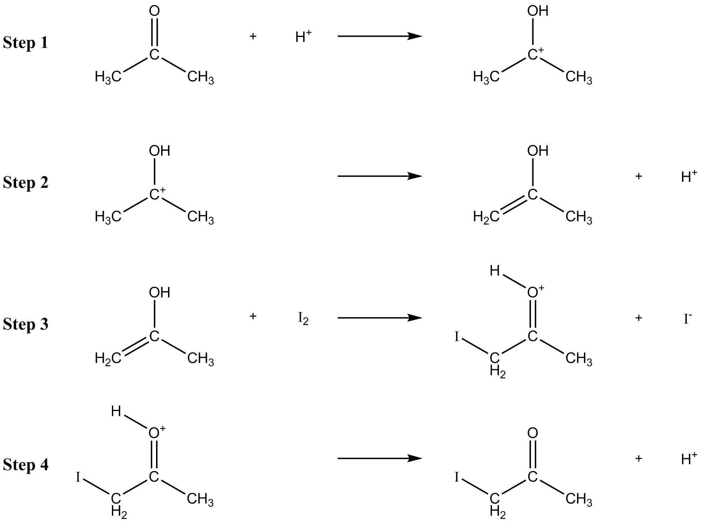
9 Look at steps 1 and 2. Explain why we say the H⁺ ions are acting as a catalyst.
10 If there is no acid present then the first step in the isomerisation of propanone to propenol involves breaking a C-H bond. Explain how the catalyst increases the rate of the reaction.
11 Explain which step is probably the rate-determining step. (Refer to your answer to question 6.)
12 If this reaction is followed over a longer time the rate appears to increase. Can you suggest why this happens? (Hint: look at step 4.)

Answers
1 An iodine atom replaces one of the hydrogen atoms in propanone.
2,3
 | Expt A | Expt B | Expt C | Expt D
Concentration of HCl / mol dm^{–3} | 1.0 | 0.50 | 1.0 | 1.0
Concentration of propanone / mol dm^{–3} | 0.50 | 0.50 | 0.25 | 0.50
Concentration of iodine / mol dm^{–3} | 0.001 | 0.001 | 0.001 | 0.0005
Time taken for colour to disappear / s | 125 | 264 | 243 | 62
Rate of reaction / mol dm^{–3} | 8.0 × 10⁻⁶ | 3.8 × 10⁻⁶ | 4.1 × 10⁻⁶ | 8.1 × 10⁻⁶
4 Comparing experiments A & B shows that halving the concentration of HCl halves the rate of the reaction. The order of the reaction with respect to H⁺ ions is first.
Comparing experiments A & C shows that halving the concentration of propanone halves the rate of the reaction. The order of the reaction with respect to propanone is first.
Comparing experiments A & D shows that halving the concentration of iodine has no effect on the rate of the reaction. The order of the reaction with respect to iodine is zero.
5 The reaction is therefore second order overall.
6 The rate equation is r_{iodine} = k [iodine]⁰ [propanone]¹ [H⁺]¹
= k [propanone] [H⁺]
7
So taking the values for experiment A:
The units of k
8 The carbon-carbon double bond reacts with the iodine molecule.
9 One mole of H⁺ ions is consumed by step 1 but step 2 produces one mole of H⁺ ions, so overall it is not used up in the reaction. However, the presence of H⁺ ions makes the reaction go faster than it would otherwise do. Therefore H⁺ ions must be acting as a catalyst in the reaction.
10 Breaking a C–H bond requires a lot of energy. The catalyst increases the rate of the reaction by providing an alternative pathway with a lower activation enthalpy. (NB It is not enough to say that the catalyst reduces the activation enthalpy.)
11 Since the only chemicals in the rate equation are propanone and H⁺ ions the rate-determining step must involve these chemicals and no others. Step 1 involves these two substances and is therefore a possible rate-determining step. *
12 One of the products of the reaction is hydrogen iodide, which is a source of H⁺ ions. H⁺ ions catalyse the reaction so it speeds up as more H⁺ is formed. This is an example of autocatalysis.
* Step 2 is another possibility for the rate-determining step because the concentration of the carbocation depends on the concentration of H⁺ and propanone. You can find a discussion of this reaction at http://www.docbrown.info/page03/ASA2rates2.htm#4.6

Learner activity 4

Activity Four: Determining the activation enthalpy of a reaction

Aim
To see how temperature affects the rate at which magnesium reacts with hydrochloric acid and use the results to calculate the activation enthalpy of the reaction.

Chemicals
Label | Identity | Hazard information
HCl(aq) | 0.4 mol dm^{–3} aqueous hydrochloric acid, HCl(aq) | Currently not classified as hazardous at this concentration
Mg(s) | magnesium ribbon | Currently not classified as hazardous in this form.
H₂(g) PRODUCED | c. 12 cm³ per reaction |  | DANGER: Extremely flammable.

Health and safety
Wear eye protection throughout. Ensure the laboratory is well ventilated. Your teacher will let you know of any further control methods.

Procedure
In this experiment you will react 1 cm lengths of magnesium ribbon with 50 cm³ of dilute hydrochloric acid (0.4 mol dm⁻³) and time how long it takes for all the magnesium to react. You will repeat the experiment at several different temperatures.
1 Measure 50 cm³ of dilute hydrochloric acid into a small beaker. Measure the temperature of the acid.
2 Add a 1 centimetre piece of magnesium ribbon to the acid and start a stopwatch. Use a glass rod to stir and to keep the magnesium ribbon beneath the surface of the acid. Stop the watch when all the magnesium has disappeared.
3 Repeat the experiment three or four more times, using fresh hydrochloric acid at different temperatures.
Use a water bath to heat the acid to 30°C, 40°C, 50°C and 60°C. If the acid becomes hotter than 60°C, allow it to cool before adding the Mg.
Record your results as you go along.

Calculating the Rate of the Reaction
The rate of this reaction can be measured in centimetres of magnesium per second
(cm Mg s⁻¹). Since you used 1 cm of ribbon the rate will be 1/time taken to react with all the magnesium.
Temperature /ºC | Time taken /s | Rate of reaction / cm Mg s⁻¹
The more common unit for rate of reaction would be the change in concentration of the hydrochloric acid in mol dm⁻³ s⁻¹.
1 Assume that 1 cm of magnesium ribbon weighs 0.012 grams. How many moles of hydrochloric acid are used up when the all the magnesium reacts? (Balance the equation to show that 1 mole of magnesium reacts with 2 moles of HCl).
2 How much has the concentration of the acid changed when the magnesium has reacted with it?

Calculating the Activation Enthalpy for the Reaction
You should remember the idea of activation enthalpy from the Ozone story. Molecules collide frequently but only a few of those collisions have enough energy to lead to a reaction. The minimum energy needed for reaction is called the activation enthalpy of the reaction. Raising the temperature increases the number of molecules which have enough energy to react when they collide.
You may wish to use a spreadsheet for the graphs and calculations which follow.
3 Plot a graph of reaction rate against the temperature of the acid. You cannot include (0,0) as a point on this graph. Why not?
It may look as if you can fit a straight line to your points but in fact the increase in reaction rate each 10ºC gets greater with increasing temperature. This type of graph is called an exponential graph and has a general equation y = a^{x} (If you are using a spreadsheet it should be able to suggest an exponential trendline.)
The Swedish chemist Svante Arrhenius worked out an equation which relates the rate constant, k, to the absolute temperature (T, in kelvin):
(This equation is on the data sheet supplied with your exam paper.)
In this equation, E_{a} is the activation enthalpy for the reaction and the term indicates the fraction of molecules which have energies equal to or greater than the activation enthalpy. A (the frequency factor) is the frequency with which molecules collide with the correct orientation to react.
The other value in the equation is the gas constant, R, which has a value of 8.314 J mol⁻¹ K⁻¹. (You met the gas constant in the equation pV = nRT in the Developing Fuels unit.)
The Arrhenius equation is often used in its logarithmic form, which is also on the exam data sheet:
where ln means ‘logarithm to base e’ and is found by using the ‘ln’ button on a calculator or typing ‘=ln(’ into a cell on a spreadsheet.
Both these equations use k, the rate constant. In our experiment we measured the initial rate of the reaction. The concentration of acid was exactly the same in each experiment so the rate of reaction must be proportional to k. So the effect of temperature on the rate constant is exactly the same as its effect on reaction rate.
In its logarithmic form the Arrhenius equation resembles the equation of a straight line,
y = mx + c
where y is ln k and x is 1/T.
4 Which terms correspond to m and c?
5 According to the Arrhenius equation, a graph of ln k against 1/T should be a straight line with gradient -E_{a}/R. As the start concentration of the reagents is the same for each experiment and rate α k, we will calculate ln(rate) instead of ln k to simplify the data processing. Use the results of your experiment to complete the following table. Make sure all values are to 3 significant figures.
T / ºC | Time taken /s | Rate of reaction / cm Mg s⁻¹ | T / K | 1/T / K⁻¹ | ln(rate)
6 Now plot a graph of ln rate (y axis) v 1/T (x axis) and fit a straight line to your data points. The gradient of the line is -E_{a}/R.
What value for the activation enthalpy do you obtain? (Note: R is in J mol⁻¹ K⁻¹ so your value for the activation enthalpy will be in J mol⁻¹.)
If you are using a spreadsheet it should be able to fit a linear trendline on your graph and suggest an equation, showing the gradient and intercept.
ln A (the logarithm of the frequency factor) is the intercept of the line when 1/T is zero. You can calculate this by reading a value of 1/T and ln k from the line of best fit, and inserting them into the Arrhenius equation along with the value of E_{a} you have just calculated.
7 What value for ln A do you get? Use the calculator function e^{x} to find e^{ln A}
i.e. the value of A.

Zero order | First order | Second order
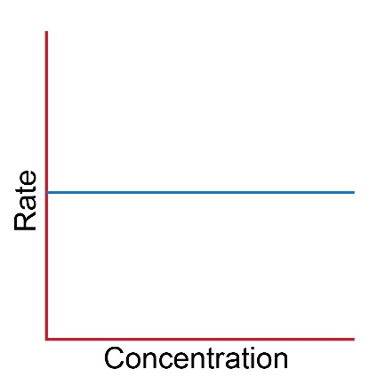 | 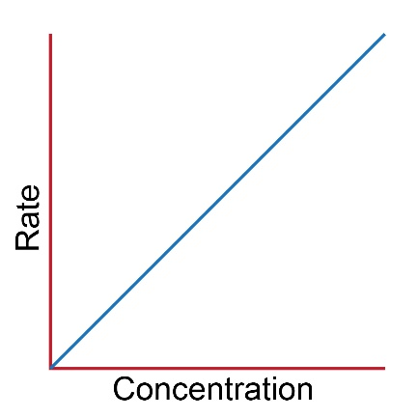 | 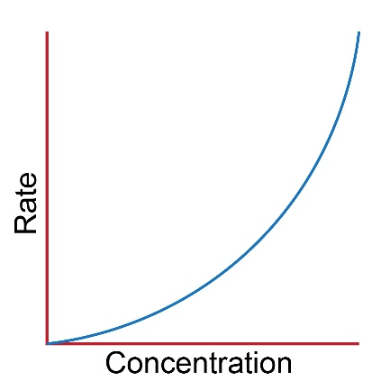
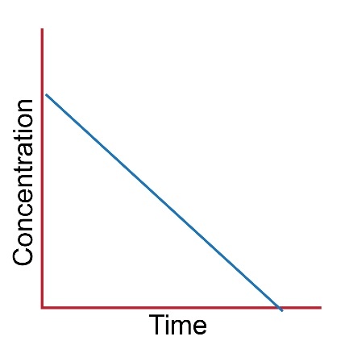 | 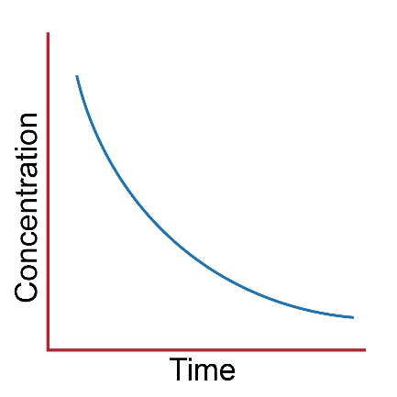 | 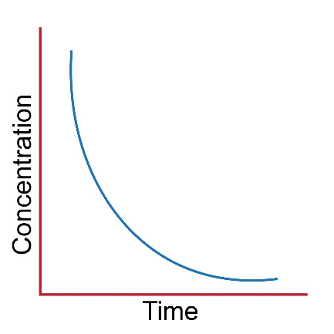
Constant rate | Constant half life | No half life
Rate = k | Rate = k [A] | Rate = k [A]²
 |  | Rate = k [A][B]
Units of rate constant:  mol dm⁻³ s⁻¹ | Units of rate constant:  s⁻¹ | Units of rate constant:  dm³ mol⁻¹ s⁻¹
Example:  2 H₂O₂ → 2H₂O + O₂  at limiting concentrations of catalase enzyme | Example:  2N₂O₅ → 4NO₂ + O₂ | Example:  Mg + 2HCl→ MgCl₂ + H₂
Example:
CH₃Br + OH⁻ → CH₃OH +Br
Concentration Rate  0.1 0.012  0.2 0.011  0.3 0.012 | Concentration  A B Rate  0.1 0.1 0.005  0.1 0.2 0.010  0.5 0.5 0.025 | Concentration  A B Rate  0.1 0.1 0.020  0.05 0.1 0.010  0.05 0.3 0.030

