Lesson Element

Mitosis and Meiosis – Spies and Trains

Instructions and answers for teachers

These instructions cover the learner activity section which can be found on page 8. This Lesson Element supports OCR GCSE (9–1) Gateway Science Biology A and the Twenty First Century Science Biology B qualifications.
When distributing the activity section to the learners either as a printed copy or as a Word file you will need to remove the teacher instructions section.

Mapping to specification level (Learning outcomes)
GCSE (9–1) Gateway Science Biology A/Combined Science A
B2.1b describe the process of mitosis in growth, including the cell cycle
B5.1h explain the role of meiotic cell division in halving the chromosome number to form gametes
GCSE (9–1) Twenty First Century Science Biology B/Combined Science B
B4.3.1 a) describe the role of the cell cycle in growth, including interphase and mitosis
b) describe how to use a light microscope to observe stages of mitosis
B4.3.3 explain the role of meiotic cell division in halving the chromosome number to form gametes, including the stages of interphase and two meiotic divisions

Introduction
The activity is about mitosis and meiosis in animal cells. This activity is designed to access higher order thinking, analysing and creating skills. Learners should know that nucleus of a cell contains genetic information. They should be aware what a gene, chromosome and DNA are. They should also have knowledge of sexual reproduction and gametes.
A common problem that learners face is that diagrams for both mitosis and meiosis are similar and easily confused. Some do not show all of the chromosomes, so it can be unclear that all chromosomes can be replicating and dividing. This modelling activity will assist in overcoming this, as the analogy will describe this. Learners find it difficult to just compare and contrast the two processes.

Activity 1:
The teacher should split the class into two. Half will be given the Learner Information Sheets 1 and 2, and half will be given the Learner Information Sheets 3 and 4. The latter meiosis activity is more difficult so this could also be used for differentiation.
Learners should work in pairs or small groups for this activity. They should be given the information sheet detailing the stages of mitosis or meiosis and make sure they are familiar with each step. They should then compare it to the analogy of the process of mitosis or meiosis.
Learners are then to:
- Link as many of the stages to the analogy as possible- highlighting where they can be found.
- Identify stages which are omitted.
- Answer the follow up questions to the process which increase in demand.
Each mitosis group should then pair up with a meiosis group and share their information with one another.

Extension ideas:
Learners could add in the omitted stages to the story or devise their own analogy for this or the other process. They could analyse the models provided and identify the strengths or weaknesses.

Suggested mitosis analogy task answers:

Spies On A Wire
00:00 Two stealth helicopters carrying special agent 1 and special agent 2 arrive at Cellattle bank headquarters. They check the perimeter is clear. (the cell)
00:10 Special agent 1 laser cuts the East skylight entrance. (pole of the cell)
00:10 Special agent 2 laser cuts the West skylight entrance. (pole of the cell)
00:12 Zip wires are secured and commence zip wire travel into the main vault area. (spindle fibres)
00:19 Special agent 1 to commence copying of the 46 electronic documents from the bank network onto electronic device A. (replication of the chromosomes)
00:24 Special agent 1 to hand over electronic device A to special agent 2 who should now secure the device to the zip line.
00:24 Special agent 1 now removes the original 46 documents from the network and saves them onto a further electronic device B. (demonstrating replication)
00:25 Special agent 1 and 2 ensure permanent deletion of the documents has occurred.
00:27 Special agent 1 and 2 are now secured to the zip wire. (spindle fibres)
00:29 Special agent 1 to exit out of the East skylight. Special agent 2 to exit out of the West skylight. (moving of chromosomes to the poles)
00:30 Commence stealth helicopter travel to the two undisclosed locations where the information will be decrypted and secured on two new networks. (Two new identical cells)

Stages that are omitted from the analogy:
The chromosomes growing thicker prior to replication.
The chromosomes do not line up along the equator.

Suggested meiosis analogy task answers:

The Mount Sisemio Train Incident
The train (original one cell) contained forty six passengers (original chromosomes) with pre booked assigned seating going up Mount Sisemio in one carriage. There had been a week of monsoon rain and the ground was wet and slippery. The train began to struggle at the first stop so the driver called for backup. Shortly another train arrived at station Gamete and twenty three passengers were selected (separation of chromosomes into new cell) to get off the original train and board train two. Officials looked at the carriages in each train and reorganised the seating (exchanging of genes) to ensure that all carriages were equal in weight. Some groups were separated and were unhappy.
The Sisemio mountain trains shortly reached the peak behind schedule. The weather had taken a turn for the worse and the Sisemio mountain authorities declared the peak as unsafe. Amid the grumbling of the passengers Sisemio train officials placed forty six passengers from the top station slope onto the two trains. (chromosomes replicating)
The two Sisemio trains begin their descent down the slope. Again it was soon realised that the additional passengers were causing a problem and were causing too much acceleration which could have led to derailing. The trains could not deal with forty six passengers in the weather conditions present on the day in question.
It was decided that the trains would be uncoupled into four carriages
It was decided that the trains would be uncoupled into four carriages, (cells splitting) which would prevent further acceleration down the slope. Each of the four trains transported twenty three passengers and had its own steam engine.
The passengers all arrived at the bottom of the Sisemo slope safely without serious incident on board the four trains. (four cells produced)
Stages that are omitted from the analogy:
The chromosomes growing thicker prior to replication.
Chromosomes lining up along the equator.
Genes are not pairing up in the analogy.
There are no spindle fibres pulling the information to poles.

Suggested guidance for extension activities:
Possible strengths of the analogies:
Both show clearly the number of chromosomes at all stages of the processes.
They show the number of cells at all stages of the processes.
Both of the models demonstrate replication.

Possible weaknesses of the analogies:
Not all stages are shown.
The analogies are not scientific.
Require higher order thinking skills.

Activity 2:
Learners can be given the Learner Task Sheet to help to consolidate the modelling activities. The questions could also be presented as a quiz or posed to learners with answers being given on mini-whiteboards to check understanding.

Suggested answers to Learner Task Sheet
What Have We Learnt?
1 How many daughter cells are produced in mitosis?
2
2 How many chromosomes does each cell produced in mitosis have?
46
3 How many daughter cells are produced in meiosis?
4
4 How many chromosomes does each cell produced in meiosis have?
23
5 There are genetic differences in the cells produced by mitosis and meiosis. What are these?
The cells produced in mitosis are genetically identical to the original, whereas the cells in meiosis are genetically different.
6 Why is it important that the chromosomes are replicated at various stages in mitosis and meiosis?
To ensure the required number of chromosomes are present for each division stage. E.g. during mitosis without replication, each daughter cell would result in 23 chromosomes.
7 Each human body cell has forty six chromosomes; however sex cells only have twenty three. Which process would be used to produce sex cells?
Meiosis
8 When do you think mitosis would be used in the body?
Growth and repair of cells.

We’d like to know your view on the resources we produce. By clicking on ‘Like’ or ‘Dislike’ you can help us to ensure that our resources work for you. When the email template pops up please add additional comments if you wish and then just click ‘Send’. Thank you.
Whether you already offer OCR qualifications, are new to OCR, or are considering switching from your current provider/awarding organisation, you can request more information by completing the Expression of Interest form which can be found here: www.ocr.org.uk/expression-of-interest
Looking for a resource? There is now a quick and easy search tool to help find free resources for your qualification:
www.ocr.org.uk/i-want-to/find-resources/

OCR Resources: the small print
OCR’s resources are provided to support the delivery of OCR qualifications, but in no way constitute an endorsed teaching method that is required by the Board, and the decision to use them lies with the individual teacher. Whilst every effort is made to ensure the accuracy of the content, OCR cannot be held responsible for any errors or omissions within these resources.
© OCR 2017 - This resource may be freely copied and distributed, as long as the OCR logo and this message remain intact and OCR is acknowledged as the originator of this work.
OCR acknowledges the use of the following content: Chromosome: Alila Medical Media/Shutterstock.com
Please get in touch if you want to discuss the accessibility of resources we offer to support delivery of our qualifications: resources.feedback@ocr.org.uk

Lesson Element

Mitosis and Meiosis

Learner Activity

Spies and Trains

Learner Information Sheet 1
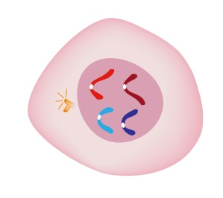
Mitosis Information Sheet

All 46 of the chromosomes grow thicker prior to replicating.
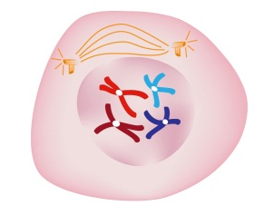
The chromosomes are replicated (copies are made) and
become visible as X shapes.

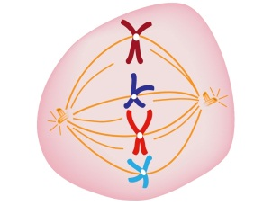
Spindle fibres form at each pole of the cell and chromosomes
line up along the equator.
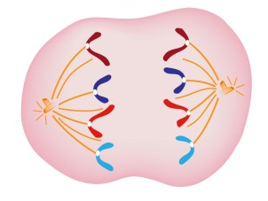
The chromosomes are pulled apart by the spindle fibres.
One half of the chromosome goes to each pole.

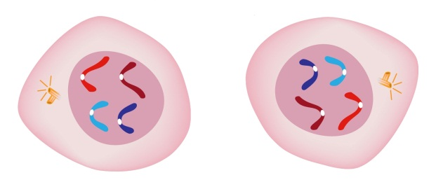
The cell splits into two new cells. Each cell contains the
same 46 chromosomes as the original.

Learner Information Sheet 2

Spies on a Wire
Mitosis
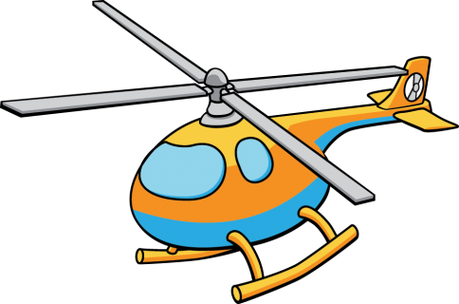
Two highly trained stealth spies from mi2 headquarters are tasked with locating and securing 46 pieces of classified information located on the Cellattle banking network.
Due to the dangerous nature of their objective the two most highly qualified staff have been selected- for the purposes of this report they shall be called special agent 1 and special agent 2.
The outline of their mission is below:
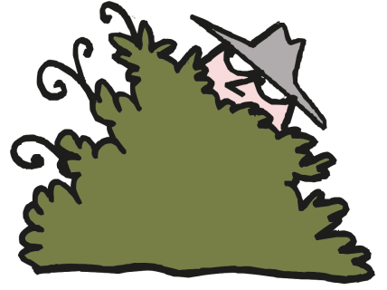
Mi2 mission outline
00:00 Two stealth helicopters carrying special agent 1 and special agent 2 arrive at Cellattle bank headquarters. They check the perimeter is clear.
00:10 Special agent 1 laser cuts the East skylight entrance.
00:10 Special agent 2 laser cuts the West skylight entrance.
00:12 Zip wires are secured and commence zip wire travel into the main vault area.
00:19 Special agent 1 to commence copying of the 46 electronic documents from the bank network onto electronic device A.
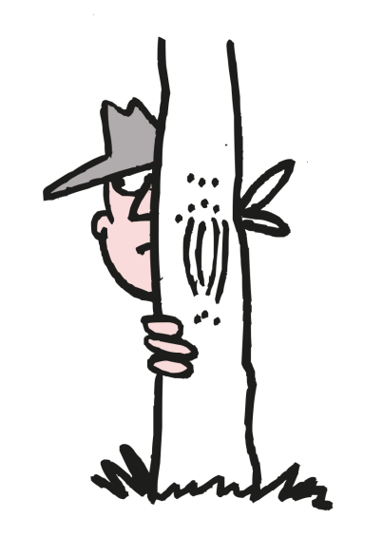
00:24 Special agent 1 to hand over electronic device A to special agent 2 who should now secure the device to the zip line.
00:24 Special agent 1 to remove the original 46 documents from the network and save them onto a further electronic device B.
00:25 Special agent 1 and 2 ensure permanent deletion of the documents has occurred from the Cellattle banking network.
00:27 Special agent 1 and 2 are now secured to the zip wire.
00:29 Special agent 1 to exit out of the East skylight. Special agent 2 to exit out of the West skylight.
00:30 Commence stealth helicopter travel to the two undisclosed locations where the information will be decrypted and secured on two new networks.

Learner Information Sheet 3
Meiosis Information Sheet

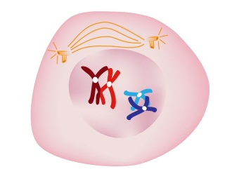
All 46 of the chromosomes grow thicker prior to replicating.

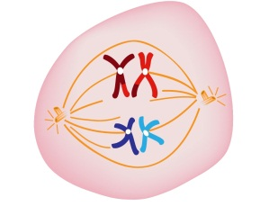
The chromosomes are replicated (copies are made) and become visible as X shapes.

The chromosomes with the same genes pair up. (E.g. hair colour which will now have two genes- the original and the copy.)
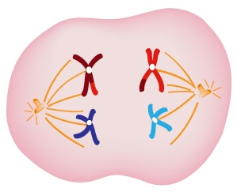
After the genes pair up they exchange some of their DNA, making unique chromosomes that are different to the original.

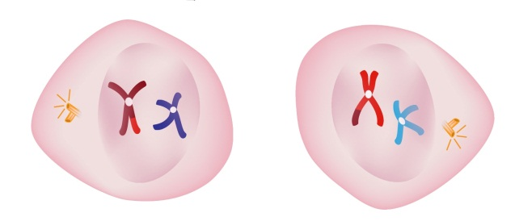

Spindle fibres form at each pole of the cell and chromosomes line up along the equator and the cell splits into two new cells. Each cell contains the same 46 chromosomes as the original.

Spindle fibres form for a second time and the chromosomes line up along the equator. They are pulled apart towards the two poles. 23 chromosomes move to each pole.

The cell splits into two further new cells. This has now produced four new cells. Each cell contains 23 chromosomes- half of the original, in their unique forms.

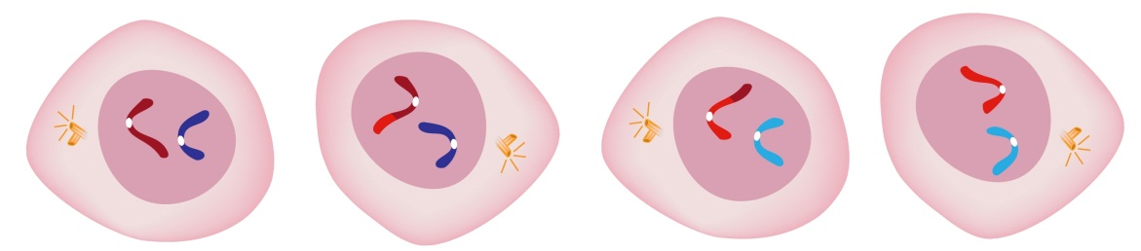
Learner Information Sheet 4

The Mount Sisemio Train Incident
Meiosis
The following is a report from the Sisemio mountain railway incident form, triggered by 23 passenger complaints on 23rd January 2010.

Sisemio mountain railway incident form
Date of incident: 23/01/10
Reporting officer: #00046
The train contained forty six passengers with pre booked assigned seating travelling to the peak of Mount Sisemio in one carriage. There had been one week of heavy monsoon rain and the ground was wet and slippery. The train began to struggle at the first stop so the driver called for back up. Shortly, another train arrived at station Gamete and twenty three passengers were selected to get off the original train and board train two. Officials looked at the carriages in each train and reorganised the seating to ensure that all carriages were equal in weight. Some groups were separated and were unhappy.
The Sisemio mountain trains shortly reached the peak behind schedule. The weather had taken a turn for the worse and the Sisemio mountain authorities declared the peak as unsafe and refused passengers to leave the two trains. Amid the grumbling of the passengers already on the trains the Sisemio train officials placed forty six passengers from the top station slope, who were being evacuated from the peak, onto the two trains as well.
The two Sisemio trains begin their descent down the slope. Again it was soon realised that the additional passengers were causing too much acceleration which could have led to derailing. The trains could not deal with forty six passengers in the weather conditions present on the day in question.
It was decided that the trains would be uncoupled into four carriages which would prevent further acceleration down the slope. Each of the four trains transported twenty three passengers and had its own steam engine.
The passengers all arrived at the bottom of the Sisemio slope safely without serious incident on board the four trains.

Learner Task Sheet

What Have We Learnt?
1 How many cells are produced in mitosis?

2 How many chromosomes does each cell produced in mitosis have?

3 How many cells are produced in meiosis?

4 How many chromosomes does each cell produced in meiosis have?

5 There are genetic differences in the cells produced by mitosis and meiosis. What are these?

6 Why is it important that the chromosomes are replicated at various stages in mitosis and meiosis?

7 Each human body cell has forty six chromosomes; however sex cells only have twenty three. Which process would be used to produce sex cells?

8 When do you think mitosis would be used in the body?

