Checkpoint Task

Chemical analysis

Instructions and answers for teachers

These instructions cover the student activity section which can be found on page 5. This Checkpoint Task should be used in conjunction with the KS3–4 GCSE (9-1) Twenty First Century Science Chemistry B Transition Guide: Chemical patterns, which supports OCR GCSE (9-1) Twenty First Century Science Chemistry B.
When distributing the activity section to the students either as a printed copy or as a Word file you will need to remove the teacher instructions section.

Introduction
The first checkpoint task 1.1 (Acids and Alkalis) checks that learners can use the pH scale to classify chemicals as acids, alkalis or neutral and compare their strength. This then leads on to see if learners can interpret results of a neutralisation experiment, in the context of acid attack of tooth enamel. This is preparation for titration calculations at Key Stage 4. A simple extraction of a soluble solid from an insoluble solid is also included, in a realistic setting of a dropped glass container. Learners could attempt this part of the task individually as homework, then compare answers in pairs or small groups. The debated answers could then be shared with the class.
The second checkpoint task 1.2 (Reaction Quantities) checks that learners are confident with the molecular idea of chemical reactions as the rearrangement of atoms whose mass is conserved, as well as representing chemical reactions using formulae and equations. It is introduced within the familiar context of cooking, to work out how much of each ingredient is required and how this affects the number of flapjacks that can be made. It includes the idea of limiting quantities of one ingredient and how that affects the amount of product. It then moves on to use models of hydrogen and oxygen molecules to predict the number of molecules of water that will be made and also the weight. An understanding of reactions at the molecular level should facilitate the more formal approach of using the mole to calculate quantities of reactants and products at Key Stage 4.

Teacher preparation
It is important that learners are confident with classifying acids and alkalis using the pH scale before neutralisation experiments can be carried out. Learners should have carried out their own neutralisation experiments before attempting the second part of the task. A range of different concentration sodium hydrogencarbonate solutions are convenient to use as different indigestion cures to illustrate this concept.
The second task requires learners to be familiar with the use of molecular model kits. The task is best carried out in class as the kits should be available for each group to use, although plasticine and cocktail sticks make suitable alternatives. If model kits are not available, then the picture can be used to stimulate discussion within a group or make posters to illustrate the ideas discussed. Using cartoon form to represent the elements can be motivating. The learners could make their own models, possibly as a homework activity, if suitable materials are available. Learners should then compare their answers in pairs or small groups. Be aware that the oxygen used in model kits can have four holes or two holes, so be clear that it is the two hole oxygen that you want the learners to use. Hopefully the idea of limiting quantities will become apparent when there are no more atoms to make more product.
The Royal Society of Chemistry produces many resources to address misconceptions, such as ‘Chemical Misconceptions – prevention, diagnosis and cure’. All of the chapters are available for free via the RSC’s Learn Chemistry site http://www.rsc.org/learn-chemistry.

Task instructions and answers
It should be possible to complete each checkpoint task within a lesson. Alternatively each could be completed as homework.

The term unit is used as instead of atomic mass unit, to allow focus on the reasoning behind the questions.

Task 1: Acids and Alkalis
- Lemon juice
- Rain water
- Pure water
- Bicarbonate of soda
- Lemon juice
- Red, orange, yellow and finally green
- Sweep up the mixture of glass and bicarbonate of soda. Carefully remove large pieces of broken glass. Mix the rest of the mixture with water to dissolve the bicarbonate of soda. Filter to remove the broken glass. Gently warm the filtrate to evaporate some of the water then leave to fully dry in a warm place.
- Neutralisation
- Honey, as less time for tooth enamel to be damaged/ less acid produced after eating it.

Task 2: Reaction Quantities

Flapjacks

  - 80:80 = 1:1
  - 80:160 = 1:2
- 16 – double the mass of sugar and butter means double the number of flapjacks.
- 16 – there is insufficient sugar to increase the number of flapjacks.

Burning hydrogen
- 2H₂O

  - 2:1
  - 1:1
- 36 units
- 10 H₂ and 5 O₂
- 3H₂ + O₂ → 2 H₂O + H₂ not enough oxygen to produce more water

Task 3: Extension task
- 5g indigestion remedy neutralises lemon juice solution. If squash is 1/10th of the amount of acid, remedy = 5/10 = 0.5g
- H⁺ hydrogen ions, the greater the concentration of hydrogen ions, the lower the pH
- OH– hydroxide ions; H⁺ + OH– → H₂O; hydrogen ions + hydroxide ions → water

  - 3
  - 2
  - 2 x 14 = 28 units for N₂(g) 2 x 1 = 2 units for H₂(g)
  - 2 x (14 + (3 x 1)) = 2 x 17 = 34 units
  - 34 ÷ 28 = 1.2 units to 1 decimal place

Supporting/further information
- http://www.rsc.org/learn-chemistry/resource/res00001756/neutralisation-curing-acidity
This simple experiment allows learners to follow the pH and temperature changes when an acidic solution is gradually neutralized. The experiment can be used to explore the issues involved in the control of soil pH in agriculture.

- https://www.youtube.com/watch?v=Eq0yGEGej3Q
A YouTube video which introduces the concept of the mole, and shows how to use Avogadro's number to convert between moles and numbers of particles.

https://www.youtube.com/watch?v=XgEuxbtP2BQ

A YouTube video that introduces molar mass as the mass of one mole of a substance. Examples of mole to mass, and mass to mole conversions are shown using molar mass.
We’d like to know your view on the resources we produce. By clicking on ‘Like’ or ‘Dislike’ you can help us to ensure that our resources work for you. When the email template pops up please add additional comments if you wish and then just click ‘Send’. Thank you.
If you do not currently offer this OCR qualification but would like to do so, please complete the Expression of Interest Form which can be found here: www.ocr.org.uk/expression-of-interest
OCR Resources: the small print
OCR’s resources are provided to support the teaching of OCR specifications, but in no way constitute an endorsed teaching method that is required by the Board, and the decision to use them lies with the individual teacher. Whilst every effort is made to ensure the accuracy of the content, OCR cannot be held responsible for any errors or omissions within these resources.
© OCR 2017 - This resource may be freely copied and distributed, as long as the OCR logo and this message remain intact and OCR is acknowledged as the originator of this work.
OCR acknowledges the use of the following content: pH testing – N Melannina/Shutterstock.com, Antacid – hafakot/Shutterstock.com
Please get in touch if you want to discuss the accessibility of resources we offer to support delivery of our qualifications: resources.feedback@ocr.org.uk

Checkpoint Task - Chemical analysis

Introduction
In Task 1 you will need to interpret results of pH tests and apply your knowledge of acids and alkalis. You will also need to work out how to separate a mixture from a laboratory accident.
In Task 2 you will need to use ratios to predict amounts that can be produced when cooking and in the reaction between hydrogen and oxygen. Using molecular models would be useful for this task.

Task 1: Acids and Alkalis
Kerry tested the pH of some liquids using universal indicator. These are her results:
liquid | pH
Lemon juice | 2
Vinegar | 3
Rain water | 6
Pure water | 7
Bicarbonate of soda | 8

- Which is the strongest acid?

- Which is the weakest acid?

- Which is the neutral liquid?

- Which liquid could be used to neutralise an acidic bee sting?

- Which liquid would cause the most damage to teeth?

- Kerry added an indigestion tablet to lemon juice and universal indicator. Describe the colour changes she would see as the lemon juice was slowly neutralised.

- The glass container of solid bicarbonate of soda was dropped. How could pure bicarbonate of soda be extracted from the mixture containing broken glass?

When sweet foods are eaten, the bacteria in the mouth produce acid. At pH 5.5 and below, the enamel on teeth will be attacked by the acid. Jack found some information about different sweeteners:
sweetener | time taken for mouth saliva to return to pH 5.5 (minutes)
honey | 13
fruit sugar | 19
cane sugar | 31

- What type of reaction is happening in the mouth to reduce the acidity?

- Use your knowledge of acids and alkalis to explain which would be the best sweetener for Jack to use on his porridge.

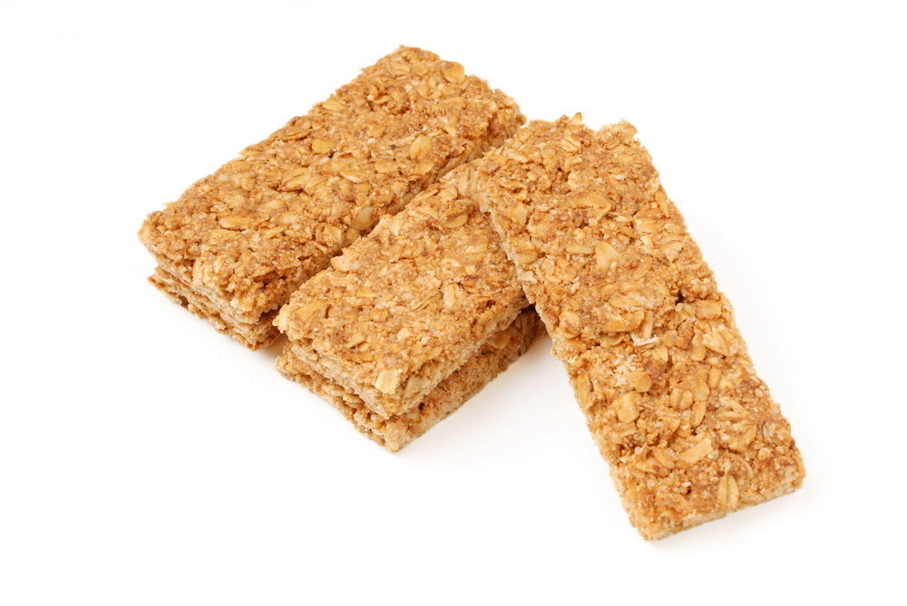
Task 2: Reaction Quantities

Flapjacks
- A flapjack recipe uses 80g butter, 80g sugar, 1 tablespoon of syrup and 160g of oats to make 8 flapjacks.
What is the ratio of masses of:

- butter:sugar ?

- sugar:oats ?
- If 160g of sugar and 160g of butter was available, how many flapjacks could be made?

- If 200g of butter and 160g of sugar was available, how many flapjacks could be made?

Burning hydrogen
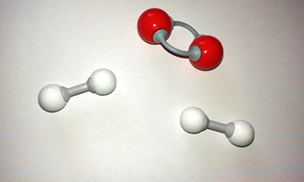
Hydrogen is a very environmentally friendly fuel as it only produces water when it burns.
- If two molecules of hydrogen gas (H₂) burn with one molecule of oxygen gas (O₂), how many molecules of water (H₂O) will be made? Use models to work out your answer. The red atoms are oxygen, the white atoms are hydrogen.

2H₂ + O₂ →
- What is the ratio of

- H₂:O₂ molecules? b) H₂:H₂O molecules?
- If one hydrogen molecule has a mass of 2 units and one oxygen molecule has a mass of 32 units, what mass of water will be made in this reaction?

- If you wanted to make 10 molecules of water, how many molecules of hydrogen and oxygen would you need?

- If 3 molecules of hydrogen gas (H₂) burn with 1 molecule of oxygen gas (O₂), how many molecules of water (H₂O) will be made? Use models to work out your answer.

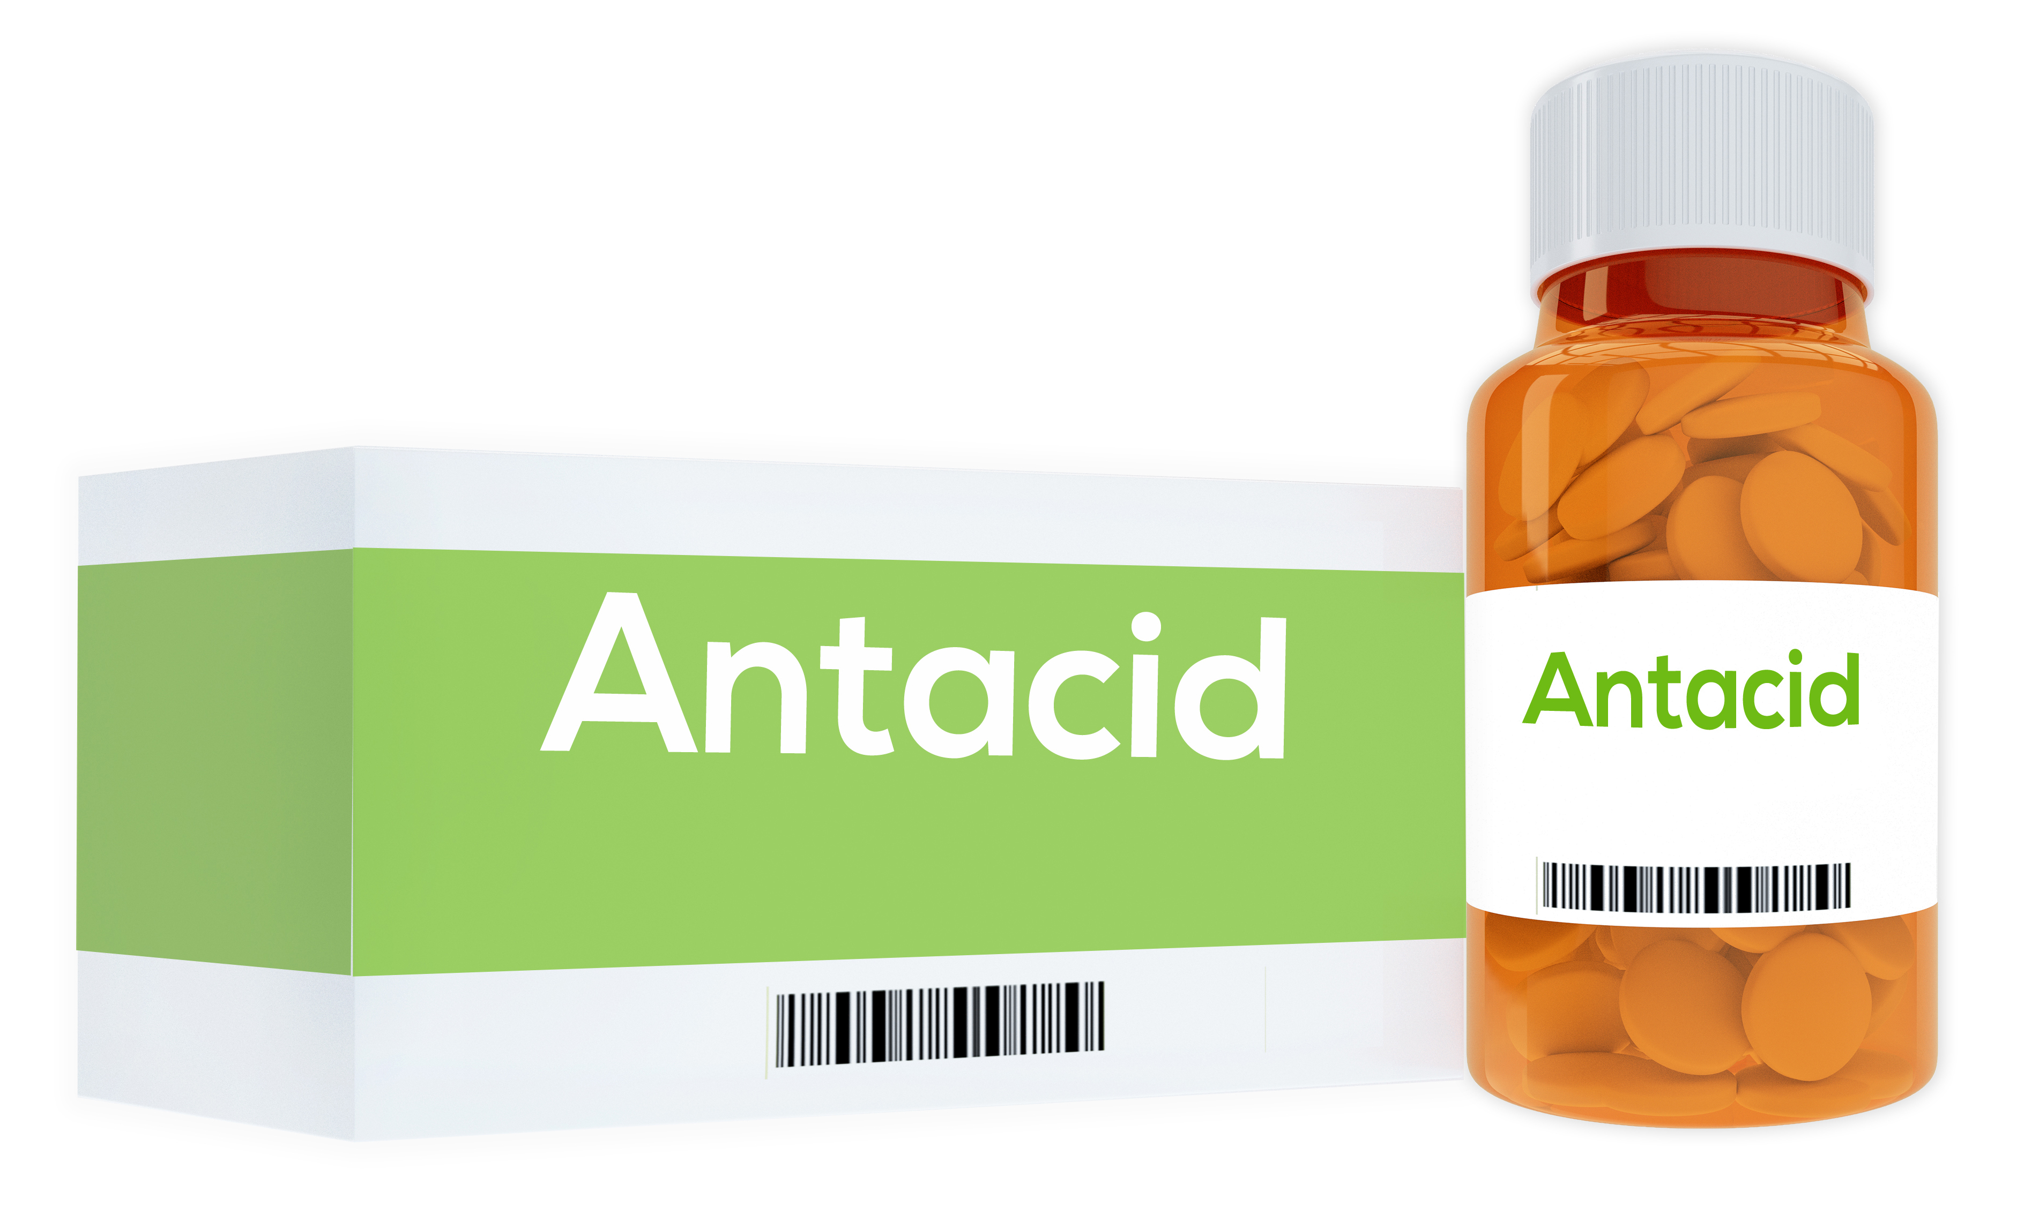
Task 3: Extension task
- A student tested an indigestion remedy by adding 5g of it to a mixture of lemon juice and water. After 5 minutes, the acid mixture had been neutralised.
If fruit squash has 1/10th of the acid that lemon juice has, how much of the indigestion remedy would be needed to neutralise the acid in it?

- Which ion do all acids contain? How does the concentration of these ions affect the pH of the solution?

- Which ion do all alkalis contain? Write the word and symbol equation for the reaction between these 2 types of ion during a neutralisation reaction.

- Ammonia is used to make fertilisers. It is made by heating nitrogen gas and hydrogen gas:
N₂(g) + 3H₂(g) → 2NH₃(g)
- How many molecules of hydrogen will be needed to react with one molecule of nitrogen gas?

- How many molecules of ammonia will be made from one molecule of nitrogen gas?

- If a nitrogen atom has a mass of 14 units, and a hydrogen atom has a mass of 1 unit, work out the mass of each reactant molecule.

- What mass (in units) of ammonia would be made from a mass of 28 units of nitrogen gas?

- What mass (in units) of ammonia would be made from a mass of 1 unit of nitrogen?

