Checkpoint Task: Material choices

Instructions and answers for teachers
These instructions cover the learner activity section which can be found on page 7. This Checkpoint Task should be used in conjunction with the KS3–4 GCSE (9-1) Twenty First Century Science Chemistry B Transition Guide: Material choices, which supports OCR GCSE (9-1) Twenty First Century Science Chemistry B.
When distributing the activity section to the students either as a printed copy or as a Word file you will need to remove the teacher instructions section.

Introduction
These tasks focus on the behaviour of particles in a solid, liquid, or gas, and the reactions between molecules. Both activities use different coloured sweets to represent atoms.
In task one, learners arrange their sweets on a piece of plain paper to represent a gas, a liquid, and a solid. It does not matter which colours they choose at this point. Learners are demonstrating that they understand how particles behave in these different states. This is underpinned by the learners describing in their own words what is happening as the particles change state. The extension activity encourages learners to remember the change of state graph for water, and what each part of the graph means.
Task two is about atoms, elements and compounds. Each different coloured sweet now represents a different element. Learners can use the sweets to represent an atom, an element and a compound. Learners are then asked to represent the reaction between hydrogen and oxygen, using the sweets. They should use one colour to represent hydrogen and a different colour to represent oxygen. After hydrogen and oxygen react together, the learners should move the sweets to show that hydrogen and oxygen have now formed a compound, hydrogen peroxide. Note, this is used instead of water at this stage to minimise the complication of balancing equations with the first example. This should show the learners that no atoms are lost in the making of a new product. All of the original atoms are still present at the end of the reaction. Learners should then recall the word equation for this reaction and the chemical equation.
This idea is built upon using other reactions involving hydrogen, oxygen, magnesium, chlorine and carbon. The extension activity is to balance the equations. By moving the atoms around during the reaction, this should make balancing the equations easier.

Teacher preparation
Learners will work in pairs for this activity and will need at least 14 sweets for each pair. These sweets should contain at least five different colours. Learners will need four sweets of one colour, four sweets of another colour and at least two sweets each of three different colours. For example, four red sweets, four orange sweets, two yellow sweets, two green sweets and two purple sweets. Any sweet that comes in multiple colours will be fine. Using sweets encourages learners to engage with these activities and are a good way of demonstrating understanding of particles. However, be aware that learners may want to eat the sweets! These can be set up as a permanent resource by dipping in PVA glue and allowing to dry. It should be possible to complete each checkpoint task within one lesson.

Task 1: Changing states
Learners should work in pairs. Each pair needs a piece of plain paper, pencils, and a small tub of sweets. Learners should show the arrangement of particles in a gas, a liquid, and a solid, using the sweets.
Model answers:
(a)
In the ‘gas’, the sweets are randomly arranged and spaced apart from each other, not touching. | 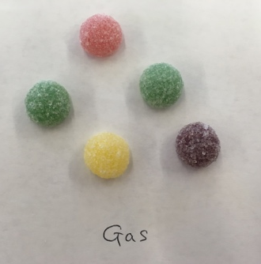
In the ‘liquid’, the sweets are touching other sweets, but in a random arrangement. | 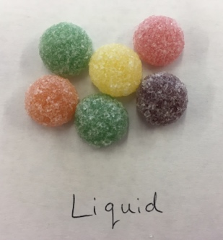
In the ‘solid’, all of the sweets should be closely packed and touching, in a regular arrangement. | 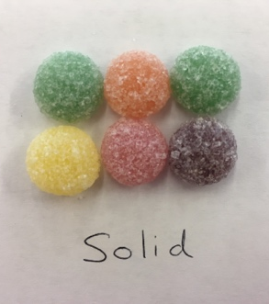

(b) The particles move apart, but the particles are still touching.
(c) The particles move apart, so that none of them are touching.
(d) The particles move closer together so that they are now touching.
Extension
(e) (i) 0 °C (ii) 100°C
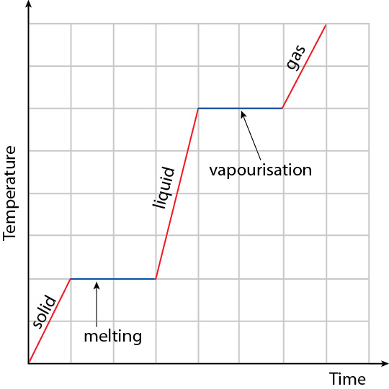

Task 2: Atoms, elements and compounds
Learners should work in pairs. Each pair needs a piece of plain paper, pencils, and a small tub of different coloured sweets e.g. smarties or jellytots. Learners will make models of atoms, elements and compounds using the sweets.
Model answers
(a) | One sweet has been used to show an atom. | 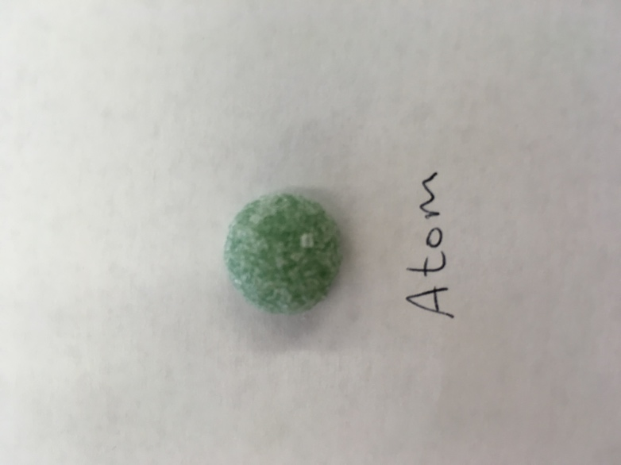

(b) | Sweets of the same colour have been used to show an element. | 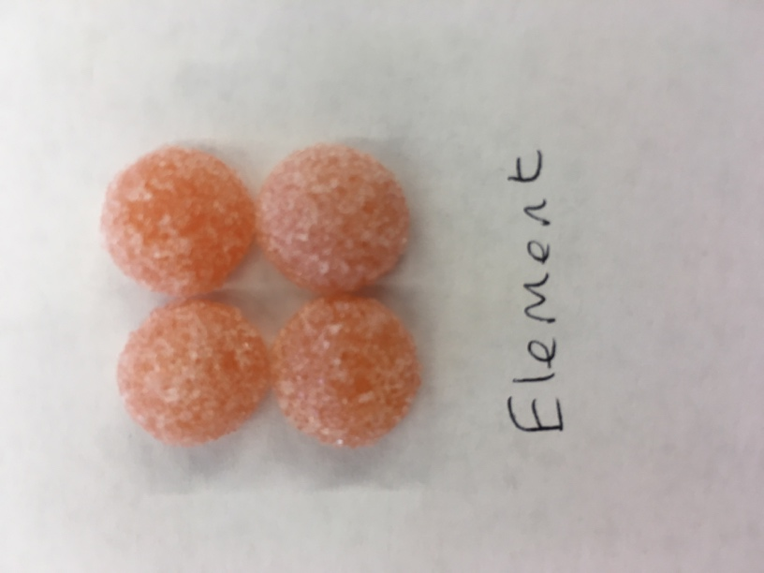

(c) | Sweets of two (or more) different colours have been used to show a compound. | 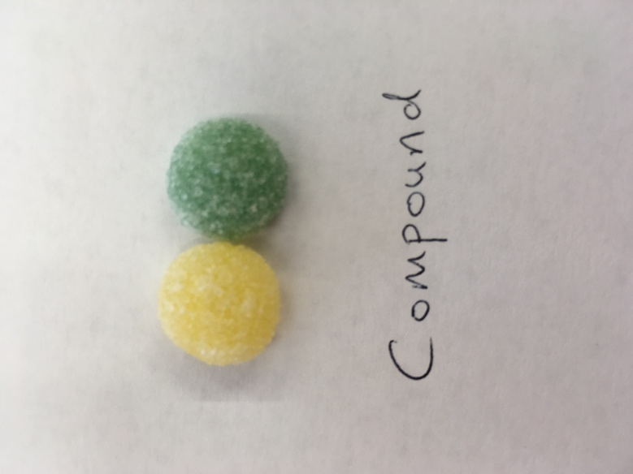
(d) hydrogen + oxygen → hydrogen peroxide
(e) H₂ + O₂ →H₂O₂

(f) (i) hydrogen + chlorine → hydrogen chloride
H₂ + Cl₂ → 2HCl
(ii) magnesium + oxygen → magnesium oxide
2Mg + O₂ → 2MgO
(iii) methane + oxygen → carbon dioxide + water
CH₄ + 2O₂ → CO₂ + 2H₂O

Supporting/further information
http://www.bbc.co.uk/education/topics/ztm6fg8
GCSE Bitesize pages from the BBC covering the topic of solids, liquids and gases. These pages revise the topic area, with linked videos. There is a quiz to test knowledge at the end.
https://www.scribd.com/doc/122210463/IGCSE-Chemistry-Atoms-Elements-and-Compounds
Revision for GCSE chemistry on the topic of atoms, elements and compounds. Detailed notes aimed at higher learners with diagrams. There are questions at the end, with answers.
We’d like to know your view on the resources we produce. By clicking on ‘Like’ or ‘Dislike’ you can help us to ensure that our resources work for you. When the email template pops up please add additional comments if you wish and then just click ‘Send’. Thank you.
If you do not currently offer this OCR qualification but would like to do so, please complete the Expression of Interest Form which can be found here: www.ocr.org.uk/expression-of-interest
OCR Resources: the small print
OCR’s resources are provided to support the teaching of OCR specifications, but in no way constitute an endorsed teaching method that is required by the Board, and the decision to use them lies with the individual teacher. Whilst every effort is made to ensure the accuracy of the content, OCR cannot be held responsible for any errors or omissions within these resources.
© OCR 2017 - This resource may be freely copied and distributed, as long as the OCR logo and this message remain intact and OCR is acknowledged as the originator of this work.
OCR acknowledges the use of the following content n/a
Please get in touch if you want to discuss the accessibility of resources we offer to support delivery of our qualifications: resources.feedback@ocr.org.uk

Checkpoint Task – Material choices

Introduction
These activities are about showing your understanding of particles. The first task is about showing your understanding of how particles behave in a gas, liquid or solid. The second task is about your understanding of atoms, elements and compounds, and how these react with each other to form new substances.
In these activities you will be using different coloured sweets to show your ideas. For task two, each colour of sweet represents one element. You can choose which colour represents which element.

Task 1: Changing states
Show how the particles in a gas, a liquid, and a solid are arranged on the paper, using the sweets.
(a) Sketch and describe the arrangement of your sweets.

Move the particles in the solid to show what happens when a solid melts.
(b) Explain what happens to the particles in a solid when it becomes a liquid.
Move the particles in the liquid to show what happens when a liquid evaporates.
(c) Explain what happens to the particles in a liquid when it becomes a gas.
Move the particles in the gas to show what happens when a gas condenses.
(d) Explain what happens to the particles in a gas when it becomes a liquid.
Move the particles in the liquid to show what happens when a liquid freezes.
(d) Explain what happens to the particles in a liquid when it becomes a solid.

Extension
On the plain paper, draw the changing state graph for water.
(e) At what temperatures does water:
(i) become a liquid
(ii) become a solid
(f) Write on the graph where melting and vapourisation occur.

Task 2: Atoms, elements and compounds

Instructions
Each colour of sweet represents a different element. Use the sweets to show an atom, an element and a compound.
(a) Describe how you have used the sweets to show an atom.
(b) Describe how you have arranged the sweets to show an element.
(c) Describe how you have arranged the sweets to show a compound.
Use two different colours of sweets to show how hydrogen (H₂) and oxygen (O₂) react together to make hydrogen peroxide (H₂O₂). Use one colour for hydrogen and another colour for oxygen.
(d) Write out the word equation for this reaction.
(e) Write out the balanced chemical equation for this reaction.
Now use the sweets to show the following reactions. Write the word and balanced chemical equation for each reaction.
(f) (i) Hydrogen (H₂) and chlorine (Cl₂)
(ii) Magnesium (Mg) and oxygen (O₂)
(iii) Methane (CH₄) and oxygen (O₂)

