# Candidate Style Answers

# Introduction to Quantitative Reasoning

# High banded responses

### Introduction

This resource has been produced by a senior member of the Core Maths examining team to offer teachers an insight into how the assessment objectives are applied. It has taken questions from the sample question paper and used them to illustrate how the questions might be answered and provide some commentary on what factors contribute to overall levels.

As these responses have not been through full moderation, they are banded to give an indication of the level of each response. Please note that this resource is provided for advice and guidance only and does not in any way constitute an indication of grade boundaries or endorsed answers.

The sample assessment material for these answers and commentary can be found on the Core Maths web pages and accessed via the following links: <https://www.ocr.org.uk/qualifications/core-maths/a-mei-level-3-certificate-h868/assessment/> or <https://www.ocr.org.uk/qualifications/core-maths/b-mei-level-3-certificate-h869/assessment/>

### Question 1 (i)

The following information is displayed at a bank in England.

|  |  |  |
| --- | --- | --- |
| Travel Bank | | |
| Currency | Sell at | Buy at |
| AUSTRALIAN DOLLAR | 1.48 | 1.64 |
| CANADIAN DOLLAR | 1.54 | 1.76 |
| EURO | 1.14 | 1.31 |
| TURKISH LIRA | 2.55 | 3.08 |
| US DOLLAR | 1.52 | 1.73 |

**(i)** How much will 200 Euros cost a customer in pounds?

**[3]**

### Sample answer for Question 1 (i)

1.14 Euros = £1

 = £175.4386 = £175.44 to the nearest 1p

### Question 1 (ii)

### Commentary on the answer

This answer uses the correct exchange rate of changing pounds to euros and performs the correct calculation to do the conversion. The answer is correctly rounded to the nearest penny.

Dave is in a shop in the USA. He sees a watch priced in US dollars at $58.50. Dave wants to know roughly what the watch would cost in pounds. He remembers the exchange rates from Travel Bank.

**(ii)** Show how, **without using a calculator**, Dave can estimate the cost of the watch in pounds.

**[3]**

### Sample answer for Question 1 (ii)

£1 is about $1.50. The watch is about $60.

60 ÷ 1.50 = 40

so about £40

### Commentary on the answer

This answer uses a sensible approximation for both the exchange rate between dollars and pounds and also for the price of the watch. Both of these are clearly stated which is in line with the need to show working when not using a calculator. Correct working leading to a correct answer is also shown.

### Question 2

This question is about estimating the average speed of the earth as it travels round the sun.

The earth travels round the sun once a year.

The average distance of the earth from the sun is m.

Assume that the sun remains still and ignore the rotation of the earth about its axis.

What assumption must be made about the path of the earth to allow you to estimate its average speed?

Carry out the estimate, giving your answer in km h-1.

**[6]**

### Sample answer for Question 2

Assume earth has a circular orbit.

Radius of the orbit = 1.5 x 1011 m

Distance in travelling one orbit = 

Speed = 2 582 130 948 metres per day

= 2 582 131 km per day

= 2 582 131 ÷ 24 = 107 589 km/hr

### 108 000 km/hQuestion 3 (i)

### Commentary on the answer

This answer starts with a correct and relevant assumption and goes on to show correct clear working leading to a correct answer, which has been rounded to a sensible degree of accuracy and stated with the correct units.

Alia takes a job as a home care worker. She travels to elderly people’s homes to provide care for them. She is with a client for either 15 minutes or half an hour. This is the blog of her first day at work.

7am set off to see first client.

Journey takes half an hour.

With first client for 15 minutes, then half an hour journey to see second client for 15 minutes.

Arrive home at noon having seen a total of 6 clients; two for 15 minutes each and 4 for half an hour each.

5pm set off for evening visits.

Takes 20 minutes to get to first client.

See total of 4 clients for 15 minutes each and get home at 7pm.

**(i)** Alia is paid £7.30 an hour but she is only paid for the time she is with clients. She is not paid for travelling time. How much is she paid for her first day?

**[2]**

### Sample answer for Question 3 (i)

6 people for 15 mins = 90 mins = 1.5 hrs

4 people for 30 mins = 2 hrs

3.5 hrs at £7.30 per hr = £25.55

### Commentary on the answer

This answer correctly identifies the number of people seen for 15 mins and for 30 mins. Working is shown clearly and is correct, leading to a correct answer.

### Question 3 (ii) (*A)*

**(ii)** Another agency pays home care workers for time with clients and time travelling between clients but not for time travelling to or from home. That agency pays £6.31 an hour.

**(*A*)** Which of the following is the most reasonable estimate of Alia’s total time travelling to and from home on her first day?

30 minutes 50 minutes

1 hour 40 minutes 3½ hour

**[1]**

### Sample answer for Question 3 (ii) (*A*)

30 mins out plus return in the morning, 20 mins out plus a return in the evening means more than 50 mins, possibly double, so 1 hr 40 mins seems the best estimate.

### Commentary on the answer

This answer is correct and correctly explained – it is just the travelling time to and from home that is asked for.

### Question 3 (ii) (*B*)

**(*B*)** How much would Alia have been paid by the second agency for the day she describes in her blog?

**[3]**

### Sample answer for Question 3 (ii) (*B*)

7am to 12pm = 5 hrs, 5pm - 7pm = 2 hrs, 5 + 2 = 7 hrs in total

7 hrs less 1 hr 40 for travel = 5 hrs and 20 mins.

5 × 6.31 = £31.55

6.31 ÷ 3 = £2.10 (nearest 1p)

Total = £33.65

Total = £33.65

### Commentary on the answer

This answer correctly works out the time with clients and time travelling between clients using an efficient method of subtracting the time Alia was travelling to and from home from the total time she was away from home. Alia’s pay is then calculated correctly using the hourly rate of £6.31. The correct method is clearly shown and recognises 20 minutes as one third of an hour.

### Question 4 (i)

Geraldine is setting up a business making hats. She needs to decide how much to sell the hats for.

* Each hat costs her £3 to make.
* She can make up to 100 hats per week.

Geraldine has done market research which suggests the following.

* She can sell 100 hats per week if she charges £15 for each hat.
* She can only sell 50 hats per week if she charges £25 for each hat.

The graph below shows the demand curve modelled as a straight line.

She uses this model and a spreadsheet to work out how to make the maximum profit.

**(i)** Fill in the rest of the numbers in column B.

**[2]**

### Sample answer for Question 4 (i)

Price (£) Hats sold Cost (£) Profit (£)

15 100 300 1200

16 95

17 90

18 85

19 80

20 75

21 70

22 65

23 60

24 55

25 50

### Commentary on the answer

The correct numbers have been filled in, making use of the given start and end numbers and going down in equal steps.

### Question 4 (ii)

**(ii)** What formula should Geraldine type in cell C2 so that she can copy it down the column to give the cost?

**[2]**

### Sample answer for Question 4 (ii)

=B2*3

### Commentary on the answer

This answer gives a correct formula, correctly expressed in terms of spreadsheet cell references and it remembers to include the equals sign at the start.

### Question 4 (iii)

**(iii)** What formula should Geraldine type in cell D2 so that she can copy it down the column to give the profit?

**[2]**

### Sample answer for Question 4 (iii)

=A2*B2-C2

### Commentary on the answer

This answer gives a correct formula, correctly expressed in terms of spreadsheet cell references and it remembers to include the equals sign at the start.

### Question 4 (iv)

**(iv)** Geraldine wants to sell each hat for a whole number of pounds.

What price should she sell the hats for to make the maximum profit?

**[4]**

### Sample answer for Question 4 (iv)

Price (£) Hats sold Cost (£) Profit (£)

15 100 300 1200

16 95 285 1235

17 90 270 1260

18 85 255 1275

19 80 240 1280

20 75 225 1275

21 70 210 1260

22 65 195 1235

23 60 180 1200

24 55 165 1155

25 50 150 1100

£19 is the selling price for maximum profit.

### Commentary on the answer

This answer correctly calculates the costs and profits and then correctly identifies the selling price to achieve the maximum profit.

### Question 5 (i)

A biology student is researching how fast a cheetah can run.

* + 1. On one website, he finds the following graph of a cheetah’s motion.

Use the graph to estimate this cheetah’s maximum speed.

Q5 graph

**[4]**

### Sample answer for Question 5 (i)

The steepest part of the graph is from 2 seconds to 3 seconds.

Distance at 2 sec is 20 m, at 3 sec the distance is 45 m;

25 m travelled in one second so speed is 25 m/s

### Commentary on the answer

The answer has recognised that the fastest speed occurs at the steepest part of the graph. The gradient for this section is estimated correctly by approximating the graph for a short section by a straight line. An alternative approach would be to draw a tangent to the curve and calculate the gradient of the line.

### Question 5 (ii)

**(ii)** The student looks at two other websites.

* One website says that the maximum speed of a cheetah is 50 metres per second.
* Another website says that the maximum speed of a cheetah is 70 miles per hour.

Work out whether these two speeds are approximately the same.

[You may use the fact that 5 miles is about the same as 8 km.]

**[4]**

### Sample answer for Question 5 (ii)

70 ÷ 5 × 8 = 112 km per hour

112 km = 112 000 m

so 112 000 metres per hr is the same as: 112 000 ÷ 60 ÷ 60 = 31.1 m/s

No they are not the same.

### Commentary on the answer

This answer uses a correct strategy of changing the speed in miles per hour to metres per second so that they can be compared. The correct conversion from miles per hour to km per hour has been made and then the speed in metres per second has been found.

### Question 6 (a)

Mrs Jones is planning to fly from London to Chicago. She checks the weather forecast for the day of her flight. The probability of snow for these places is as follows.

|  |  |
| --- | --- |
| London | 60% |
| Chicago | 80% |

What is the probability that there will be snow in at least one of these two places on that day? You can assume that the weather in London and the weather in Chicago are independent of each other.

**[5]**

### Sample answer for Question 6 (a)

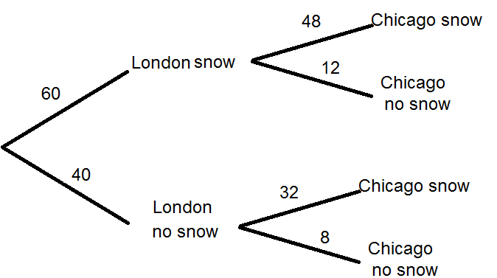

48 + 12 + 32 = 92

so  92%

### Commentary on the answer

This answer uses a frequency tree to calculate the correct probability by finding how many days out of 100 typical days it would snow in at least one of the two places. Alternative approaches include: using a two way table to show the same frequencies, or calculating the probability of no snow and subtracting from 100.

### Question 6 (b)

The histogram below shows the distribution of January rainfall near Royston for 98 years. A Normal distribution has the same mean and standard deviation as the rainfall data. Part of this Normal curve is shown on the diagram.

Q6b graph

**(i)** Use the Normal curve to write down an estimate of the mean and standard deviation of the rainfall data.

**[3]**

**(ii)** Give **two** reasons to reject the Normal distribution as a model for the rainfall data.

**[2]**

### Sample answer for Question 6 (b)

(i) The mean is about 50 mm and the standard deviation is about  30 mm.

(ii) The distribution of the rainfall data is skewed.

The Normal curve shows that there would be some negative values of rainfall to get the full Normal curve but it is not possible to get rainfall below zero.

### Commentary on the answer

(i)The answer has correctly identified the mean as being where the Normal curve has a maximum. The answer for the standard deviation is correct, recognising that almost all of the data should be in the range (mean +/- 3sd).

(ii) The answer gives two correct reasons for rejecting the Normal distribution.

### Question 7 (a) (i)

The population of the world in 1960 was 3040 million. In 1975, it was 4090 million. Two models,   
A and B, for population growth are considered.

**(i)** In model A the population grows by a constant number of people each year. Show that the average increase from 1960 to 1975 is 70 million people per year.

**[2]**

### Sample answer for Question 7 (a) (i)



so the increase is 70 million

### Commentary on the answer

This answer correctly works out the constant annual increase in millions.

### Question 7 (a) (ii)

**(ii)** In model B the population grows by a constant percentage each year.

What constant annual percentage growth rate from 1960 to 1975 would result in the population increasing from 3040 million to 4090 million?

**[3]**

### Sample answer for Question 7 (a) (ii)

4090 = 3040 × *x*15



*x =* 1.019

so 2%

### Commentary on the answer

This answer correctly calculates the annual percentage increase, recognising that the multiplier would be used 15 times to get to the 1975 population.

### Question 7 (a) (iii)

**(iii)** The population of the world in 2000 was 6090 million.

Work out which of the two models is better.

**[5]**

### Sample answer for Question 7 (a) (iii)

Using model A, 25 × 70 = 1750 million extra since 1975, so 4090 + 1750 = 5840 million

Using modelB, 4090 × 1.0225 = 6710.07

From these figures Model A looks closer to the actual figure of 6090 million; model A is 250 million out but model B is 620 million out.

### Commentary on the answer

This answer uses both model A and model B correctly to work out an estimate of the population in the year 2000. The answer uses these figures to correctly decide that model A more accurately predicts the population in 2000; it would also have been reasonable to conclude that neither model is ideal.

### Question 7 (b)

The spreadsheet chart below shows the population of the United States from 1820 to 2000.

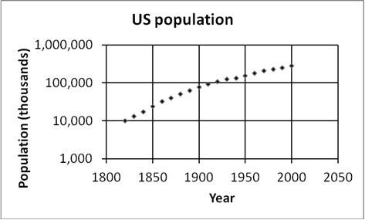

The vertical axis has a logarithmic scale.

What was the approximate population of the United States in 1860?

**[3]**

### Sample answer for Question 7 (b)



The correct answer is half way between 10 000 and 100 000 on the vertical axis.

So  = 31 622.7766

31.6 million

### Commentary on the answer

This answer correctly identifies the point corresponding to 1860 and realises that it is approximately halfway along the scale between 10 000 and 100 000. The correct value is then calculated using the geometric means because the vertical scale is logarithmic. The fact that the vertical scale is in thousands is also taken into account when giving the final answer which is rounded sensibly.

### Question 8 (i)

The chart below is from “*Combating poverty and social exclusion: A statistical portrait of the European Union 2010*”. The horizontal axis shows percentages.

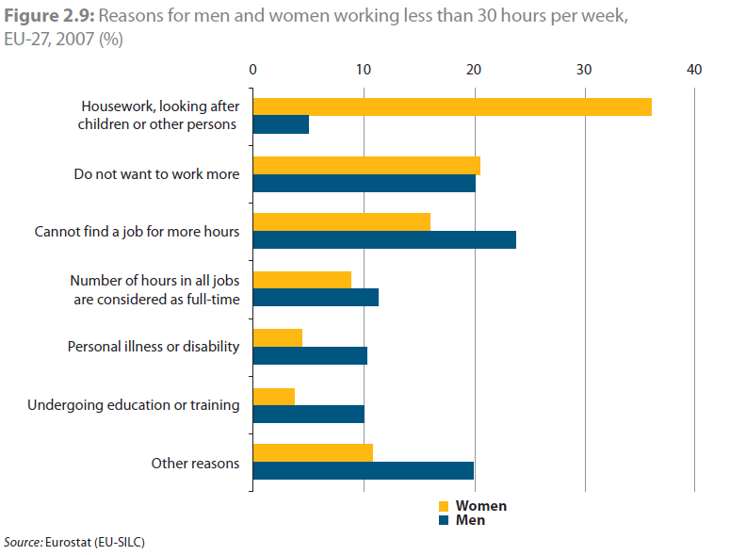

**(i)** Suggest one way that the graph could have been improved to show the information more clearly.

**[1]**

### Sample answer for Question 8 (i)

Add more divisions on the vertical scale to help when reading off values.

### Commentary on the answer

One reasonable improvement is suggested in this answer and it is clearly stated.

### Question 8 (ii)

**(ii)** Did men responding to this survey **each** choose only one reason or more than one reason?

You must justify your answer.

**[3]**

### Sample answer for Question 8 (ii)

If men gave more than one reason, the percentages would add up to more than 100%.

The percentages from the graph are:

5 20 23 12 10 10 20

The percentages total to 100 so everyone answered just once.

### Commentary on the answer

A correct strategy is explained and followed through to a correct conclusion. It isn’t possible to read exactly from the graph so percentages close to the ones given in this answer and adding up to close to 100% would also be acceptable.

### Question 8 (iii) (*A*)

**(iii)** There are four times as many women as men working less than 30 hours per week in the European Union.

**(*A*)** Show that approximately 5% of people surveyed (men and women combined) give the reason ‘undergoing education or training’.

**[2]**

### Sample answer for Question 8 (iii) (*A*)



### Commentary on the answer

The working in this answer is correct and it is related to the given answer of 5%.

### Question 8 (iii) (*B*)

**(*B*)** Find the corresponding percentage giving the reason ‘housework, looking after children or other persons’.

**[2]**

### Sample answer for Question 8 (iii) (*B*)



so approximately 30%

### Commentary on the answer

Correct working is shown, leading to a correct answer (within the allowable range given the accuracy of the graph scale), following the same method as was used in part *(A)*.

### Question 9

A typical ant is about 5 mm long and weighs about 3 mg.

An actor is about 2 m tall and weighs about 80 kg.

A science fiction film script includes shrinking an actor to 5 mm tall.

As the actor shrinks, his weight is always directly proportional to his volume.

Compare the weight of the shrunken actor to the weight of the ant.

**[5]**

### Sample answer for Question 9

2 m = 2000 mm

2000 ÷ 5 = 400

The man’s height is 400 times the ants.

The man’s volume would be divided by 4003 as he shrunk to the size of the ant. The same would happen to his weight.

So 80 kg = 80 000 g = 80 000 000 mg

 1.25 mg

The actor is less than half the weight of the ant.

### Commentary on the answer

This answer correctly works out the scale factor for length and volume between ant and man. The scale factor for volume is correctly used to get the man’s shrunk weight. The weight of the actor is then correctly calculated in mg and then compared with the weight of the ant in the same units. An appropriate final comment is given.

We’d like to know your view on the resources we produce. By clicking on [‘Like’](mailto:resources.feedback@ocr.org.uk?subject=I%20liked%20the%20Quantitative%20Reasoning%20(MEI)%20-%20Quantitative%20Problem%20Solving%20(MEI)%20Candidate%20style%20answers%20-%20Introduction%20to%20Quantitative%20Reasoning) or ‘[Dislike’](mailto:resources.feedback@ocr.org.uk?subject=I%20liked%20the%20Quantitative%20Reasoning%20(MEI)%20-%20Quantitative%20Problem%20Solving%20(MEI)%20Candidate%20style%20answers%20-%20Introduction%20to%20Quantitative%20Reasoning) you can help us to ensure that our resources work for you. When the email template pops up please add additional comments if you wish and then just click ‘Send’. Thank you.

Whether you already offer OCR qualifications, are new to OCR, or are considering switching from your current provider/awarding organisation, you can request more information by completing the Expression of Interest form which can be found here: [www.ocr.org.uk/expression-of-interest](http://www.ocr.org.uk/expression-of-interest)

Looking for a resource? There is now a quick and easy search tool to help find free resources for your qualification:   
[www.ocr.org.uk/i-want-to/find-resources/](http://www.ocr.org.uk/i-want-to/find-resources/)

**OCR Resources**: *the small print*OCR’s resources are provided to support the teaching of OCR specifications, but in no way constitute an endorsed teaching method that is required by the Board, and the decision to use them lies with the individual teacher. Whilst every effort is made to ensure the accuracy of the content, OCR cannot be held responsible for any errors or omissions within these resources.   
© OCR 2020 - This resource may be freely copied and distributed, as long as the OCR logo and this message remain intact and OCR is acknowledged as the originator of this work.

OCR acknowledges the use of the following content: n/a

Please get in touch if you want to discuss the accessibility of resources we offer to support delivery of our qualifications: [resources.feedback@ocr.org.uk](mailto:resources.feedback@ocr.org.uk)