# OCR 12 Statistics (Higher)

1. As a car increases its speed, the length of time taken to reach the final destination decreases. State this type of correlation.
2. The multiple bar chart represents the amount of expenses claimed by four employees in three months.

How much more did Theresa claim than Mark in March?

1. The cumulative frequency graph gives information about the times it took 80 students to complete a homework task. Use the graph to find an estimate for the median time.
2. Use the cumulative frequency graph above to find an estimate for the number of students who took longer than 40 minutes to complete the homework task.
3. The box plot shows information about 20 students’ marks in a maths mock exam.

Calculate the range of marks.

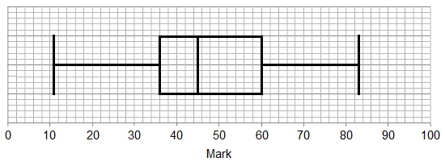

1. The table shows the monthly income for a gift shop.

Draw a time series graph to show this information.

|  |  |  |  |  |  |  |
| --- | --- | --- | --- | --- | --- | --- |
| **Month** | May | June | July | August | September | October |
| **Income (£)** | 1200 | 1400 | 3700 | 3900 | 1500 | 1000 |

1. Below is a table showing prices of two shares over a period of time.

|  |  |  |
| --- | --- | --- |
| **Date** | **Share A price (pence)** | **Share B price (pence)** |
| 01/01/16 | 88.42 | 329.12 |
| 01/02/16 | 90.67 | 340.93 |
| 01/03/16 | 87.29 | 326.44 |
| 01/04/16 | 89.51 | 330.14 |
| 01/05/16 | 91.48 | 331.26 |
| 01/06/16 | 92.63 | 328.11 |

Calculate the range and mean for Share A and for Share B.

1. Below is a table showing the ages of people holidaying on a ship.

Draw a cumulative frequency graph to show this information.

|  |  |
| --- | --- |
| **Age (*x* years)** | **Number of people** |
|  | 58 |
|  | 55 |
|  | 178 |
|  | 245 |
|  | 258 |
|  | 178 |
|  | 175 |
|  | 40 |
|  | 12 |
|  | 1 |
|  |  |

1. A school carries out a survey to find out what its students think about fast food. 100 students are randomly chosen to answer the survey questions. What is the population and what is the sample for this survey?
2. The table below shows information about the amount spent in a restaurant by 40 customers on a particular day. Calculate an estimate of the mean amount spent.

|  |  |
| --- | --- |
| **Amount spent (£*x*)** | **Frequency** |
|  | 18 |
|  | 10 |
|  | 8 |
|  | 3 |
|  | 1 |

1. A company claims that the bar chart below shows that their sales have doubled in 2016 compared to 2015. Describe two things that are wrong with the bar chart.

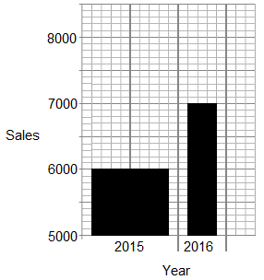

1. The table below shows information about the amount spent by two groups of individuals on a night out.

|  |  |  |
| --- | --- | --- |
|  | **Group A** | **Group B** |
| Median | 60 | 60 |
| Interquartile range | 10 | 30 |

Dylan says that Group B spent more on average than Group A.

Give a reason why he may not be correct.

1. Casey has to decide which clinic to attend for treatment, Clinic A or Clinic B.

The cumulative frequency curve shows waiting times for 80 patients in Clinic A.

Here is data for waiting times in Clinic B.

|  |  |
| --- | --- |
| Median | 70 minutes |
| Lower quartile | 55 minutes |
| Upper quartile | 80 minutes |

Based on waiting times, which clinic should Casey choose? Explain your answer.

1. Below is a table showing the number of letters sent using four different postage types from a Post Office. Draw a pie chart to show this information.

|  |  |
| --- | --- |
| **Postage** | **Frequency** |
| First Class | 200 |
| Second Class | 115 |
| Recorded Delivery | 180 |
| Special Delivery | 210 |

1. Outliers can significantly impact the mean. Explain what is meant by this.
2. The cumulative frequency graph gives information about the marks of 60 students who took a maths test.

The lowest mark scored in the test was 3 and the highest mark scored was 97.

Use this information and the cumulative frequency graph to draw a box plot of the students’ maths marks.

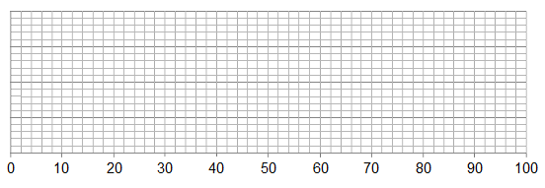

1. Use the cumulative frequency graph above to estimate the probability that a student chosen at random will achieve a mark greater than 80. Write this probability as a fraction.
2. Sean believes property is more expensive to rent nearer the town centre.

The diagram shows the distance from the town centre and the monthly rent of 30 properties.

Does the diagram prove his claim? Give a reason for your decision.

1. Here are five values.

, -2, , 12 and 

If the mean of these values is 5, list the five values numerically.

1. A marathon race is yet to be run in two hours or less. The graphs below show the frequency of times in the fastest 100 recorded times for men and for women. Use these graphs to find an estimate of the difference between the mean time for the 100 fastest men and the mean time for the 100 fastest women.

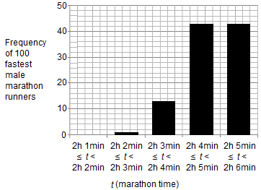

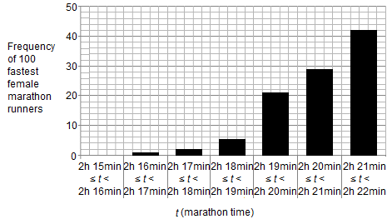

### Answers

1. Negative
2. £40
3. 36-37 minutes
4. 38 students
5. Range  marks

|  |  |  |
| --- | --- | --- |
|  | **Share A price (pence)** | **Share B price (pence)** |
| **Range** | 5.34 | 14.49 |
| **Mean** | 90 | 331 |

1. The population is all the students at the school. The sample is the 100 students who are involved in answering the survey questions.

|  |  |  |  |
| --- | --- | --- | --- |
| **Amount spent (£*x*)** | **Frequency** | **Midpoint** | **Frequency × midpoint** |
|  | 18 | 5 | 90 |
|  | 10 | 15 | 150 |
|  | 8 | 25 | 200 |
|  | 3 | 35 | 105 |
|  | 1 | 45 | 45 |
| **Total** | **40** |  | **590** |

Estimate of the mean amount spent .

1. The scale on the bar chart is inappropriate as it should start at zero, and the bars should be of equal width rather than different widths.
2. The table simply shows that the median is the same for each group and there is greater variation in the amount spent by those in Group B. The data does not provide sufficient information about the amount spent by individuals. For example, values for Group A could be 55, 55, 55, 60, 60, 60, 65, 65, 65 and values for Group B could be 25, 35, 35, 60, 60, 60, 65, 65, 65 in which case the Group B mean spend would be less than the Group A mean spend.
3. Clinic A: median  60 mins; LQ  30 mins; UQ  75 mins; IQR  45 mins.

Clinic B: median  70 mins; LQ  55 mins; UQ  80 mins; IQR  25 mins.

Casey should choose Clinic A. The median waiting time is lower (60 mins compared to 70 mins in Clinic B) and while the interquartile range for Clinic A is higher than for Clinic B (45 mins compared to 25 mins), the lower and upper quartiles for Clinic A are both lower than the respective values for Clinic B.

|  |  |  |
| --- | --- | --- |
| **Postage** | **Frequency** | **Angle** |
| First Class | 200 | 102° |
| Second Class | 115 | 59° |
| Recorded Delivery | 180 | 92° |
| Special Delivery | 210 | 107° |

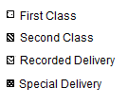

1. An outlier is a value in a data set which is significantly smaller or larger than the rest. When calculating the mean of a data set that has outliers, the inclusion of the outliers can cause the mean to be much greater (or smaller) than if the outliers were excluded.

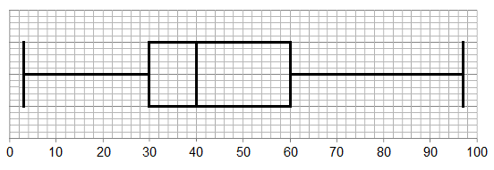

1. 
2. No, there are other factors involved e.g. type of property and number of bedrooms. The sample is also very small and may not represent the population very well.
3. 

Temperatures were 5°C, -2°C, -1°C, 12°C and 11°C.

1. The mean number of minutes for men is 2 hours 4 min to 2 hours 5 min.

The mean number of minutes for females is 2 hours 20 min to 2 hours 21 min.

The difference is 16 minutes.

We’d like to know your view on the resources we produce. By clicking on ‘[Like’](mailto:resources.feedback@ocr.org.uk?subject=I%20liked%20the%20GCSE%20(9-1)%20Mathematics%20Section%20Check%20In%2012%20Higher) or [‘Dislike’](mailto:resources.feedback@ocr.org.uk?subject=I%20disliked%20the%20GCSE%20(9-1)%20Mathematics%20Section%20Check%20In%2012%20Higher) you can help us to ensure that our resources work for you. When the email template pops up please add additional comments if you wish and then just click ‘Send’. Thank you.

Whether you already offer OCR qualifications, are new to OCR, or are considering switching from your current provider/awarding organisation, you can request more information by completing the Expression of Interest form which can be found here: [www.ocr.org.uk/expression-of-interest](http://www.ocr.org.uk/expression-of-interest)

Looking for a resource? There is now a quick and easy search tool to help find free resources for your qualification:   
[www.ocr.org.uk/i-want-to/find-resources/](http://www.ocr.org.uk/i-want-to/find-resources/)

**OCR Resources**: *the small print*OCR’s resources are provided to support the delivery of OCR qualifications, but in no way constitute an endorsed teaching method that is required by the Board, and the decision to use them lies with the individual teacher. Whilst every effort is made to ensure the accuracy of the content, OCR cannot be held responsible for any errors or omissions within these resources. This formative assessment resource has been produced as part of our free GCSE teaching and learning support package. All the GCSE teaching and learning resources, including delivery guides, topic exploration packs, lesson elements and more are available on the qualification webpages. If you are looking for examination practice materials, you can find Sample Assessment Materials (SAMs) and Practice Papers on the qualification webpage <http://www.ocr.org.uk/qualifications/gcse-mathematics-j560-from-2015/>

© OCR 2017 - This resource may be freely copied and distributed, as long as the OCR logo and this message remain intact and OCR is acknowledged as the originator of this work.

OCR acknowledges the use of the following content: n/a

Please get in touch if you want to discuss the accessibility of resources we offer to support delivery of our qualifications: [resources.feedback@ocr.org.uk](mailto:resources.feedback@ocr.org.uk)

| **Assessment Objective** | **Qu.** | **Topic** | **R** | **A** | **G** |  | **Assessment Objective** | **Qu.** | **Topic** | **R** | **A** | **G** |
| --- | --- | --- | --- | --- | --- | --- | --- | --- | --- | --- | --- | --- |
| AO1 | 1 | Describe correlation |  |  |  |  | AO1 | 1 | Describe correlation |  |  |  |
| AO1 | 2 | Interpret a multiple bar chart |  |  |  |  | AO1 | 2 | Interpret a multiple bar chart |  |  |  |
| AO1 | 3 | Calculate an estimate for the median from a cumulative frequency graph |  |  |  |  | AO1 | 3 | Calculate an estimate for the median from a cumulative frequency graph |  |  |  |
| AO1 | 4 | Interpret a cumulative frequency graph |  |  |  |  | AO1 | 4 | Interpret a cumulative frequency graph |  |  |  |
| AO1 | 5 | Interpret a box plot and calculate the range |  |  |  |  | AO1 | 5 | Interpret a box plot and calculate the range |  |  |  |
| AO1 | 6 | Construct a time series graph |  |  |  |  | AO1 | 6 | Construct a time series graph |  |  |  |
| AO1 | 7 | Calculate the range and mean |  |  |  |  | AO1 | 7 | Calculate the range and mean |  |  |  |
| AO1 | 8 | Construct a cumulative frequency graph |  |  |  |  | AO1 | 8 | Construct a cumulative frequency graph |  |  |  |
| AO1 | 9 | Define the population and sample |  |  |  |  | AO1 | 9 | Define the population and sample |  |  |  |
| AO1 | 10 | Calculate an estimate of the mean of grouped data |  |  |  |  | AO1 | 10 | Calculate an estimate of the mean of grouped data |  |  |  |
| AO2 | 11 | Recognise and explain graphical misrepresentation |  |  |  |  | AO2 | 11 | Recognise and explain graphical misrepresentation |  |  |  |
| AO2 | 12 | Interpret median and interquartile range |  |  |  |  | AO2 | 12 | Interpret median and interquartile range |  |  |  |
| AO2 | 13 | Calculate estimates for the median, quartiles and interquartile range from a cumulative frequency graph |  |  |  |  | AO2 | 13 | Calculate estimates for the median, quartiles and interquartile range from a cumulative frequency graph |  |  |  |
| AO2 | 14 | Construct a pie chart |  |  |  |  | AO2 | 14 | Construct a pie chart |  |  |  |
| AO2 | 15 | Understand and appreciate that there may be errors in data from values (outliers) |  |  |  |  | AO2 | 15 | Understand and appreciate that there may be errors in data from values (outliers) |  |  |  |
| AO3 | 16 | Draw a box plot |  |  |  |  | AO3 | 16 | Draw a box plot |  |  |  |
| AO3 | 17 | Interpret and use graphical data to solve a problem |  |  |  |  | AO3 | 17 | Interpret and use graphical data to solve a problem |  |  |  |
| AO3 | 18 | Interpret results and know the difference between population and sample |  |  |  |  | AO3 | 18 | Interpret results and know the difference between population and sample |  |  |  |
| AO3 | 19 | Solve a problem using the mean |  |  |  |  | AO3 | 19 | Solve a problem using the mean |  |  |  |
| AO3 | 20 | Solve a problem involving graphs |  |  |  |  | AO3 | 20 | Solve a problem involving graphs |  |  |  |