Lesson Element

Developing artistic intention

Instructions and answers for teachers

These instructions cover the student activity section which can be found on page 8. This Lesson Element supports OCR AS and A Level Drama and Theatre and GCSE (9–1) Drama.
When distributing the activity section to students either as a printed copy or as a Word file you will need to remove the teacher instructions section.

Introduction
Artistic intention in drama refers to the decisions, made by theatre makers, to communicate deeper meaning through their work. Without an artistic intention a piece of drama lacks a purpose or a message for its intended audience. Theatre makers speak through their work and comment on the world around them, or even attempt to change it. Artistic intention in theatre is mostly the responsibility of the director. If dealing with a text, the director collaborates with actors and designers to create a system of signs using costume, set, lighting, dramatic form, acting style and so on. The idea of what a director is can be extended to the ensemble in more collaborative work. Learners will collaborate to create theatre. It is therefore their responsibility to arrive at an artistic intention for their work then use the medium of drama to communicate that to their audience.
When deciding on artistic intention, learners should consider the events, issues and cultural concerns of the world around them. What excites them, troubles them, angers them or inspires them. When they can connect with a theme or issue, then they will be able to create theatre and connect with audiences.

Supporting/further information
- BBC Bitesize offers this excellent, step by step guide for learners about devising work: http://www.bbc.co.uk/education/guides/zg9x34j/revision/2
- The classic text on understanding how meaning is communicated through drama: Aston, E. (1991). Theatre as Sign-System: A Semiotic of Text and Performance. Routledge. ISBN: 978-0415049320.
- Advice about the most up to date methods of mind mapping is abundant on the internet. Sites like this are a good start: http://www.tonybuzan.com/about/mind-mapping/
- Splendid Theatre offer some excellent visual resources as guides to practitioners, their idiologies and how that manifests through the work. These mind maps are also good revision tools. http://www.splendidproductions.co.uk/shop/
Teacher preparation
Teachers may wish to use the following questions and prompts as a starting point for the topic:
- How has one play been staged over time to comment on society at that moment? Shakespeare’s tragedies offer lots of scope.
- What is going on in the world right now and what sort of issues might be of concern to your learners?
- Getting learners to engage with current affairs can be challenging. Showing editions of BBC’s Newsround on the iPlayer can be an accessible way for them to engage with issues and stories. Older or more advanced learners might be asked to look as more mature news media. For example, looking at print journalism and establishing political bias.
- Learners will struggle to see, or even resist seeing that entertainment has a deeper meaning. Think about non theatre texts which can incite debate. What might a current pop video say about gender? Does an action movie contain references to current, real life conflicts?
- When asking learners to consider intention, ask them to consider which character we are being asked to empathise with. Whose side does the audience take?
- The SCHEP acronym is a good way for you and your students to prompt thinking about context:
  - Social context: Shifts and trends in society, such as the ages of feminism, moral panics, attitudes towards ethnicity and sexuality and the movement of society’s moral compass.
  - Cultural context: What were or are the prevailing artistic movements?
  - Historical context: The major events of the time, what preceded that era and what followed.
  - Economic context: Where the money comes from to create work. For example,
non subsidised theatre in the West End has to be populist, conventional and
non confrontational, whereas subsidised theatre can be more experimental, progressive and niche, because it does not exist primarily to make money.
  - Political context: Tied closely to social and historical context but can also consider the ideology of the theatre maker, such as Brecht as a Marxist.

A Level learners must understand and apply the methodologies and intentions of practitioners. It is essential therefore that this practical work is informed by prior teaching of such practitioners and an awareness of the ideologies which underpins their work.

Task instructions and answers

Activity 1: Identifying artistic intention
Warm up, starter or bell work
In small groups, create a still image which sums up your point of view about an issue, such as being made to wear uniform, trolling on social media or how girls and boys treat each other in school.

Discussion
Evaluate the still images. What do the learners think each group was trying to communicate? In other words, what was the intention of their still image? Did groups get their point across effectively, and how?

Development
Option 1 - a longer way in but suitable for GCSE classes
For this option, you will need:
- Learner worksheet for Sleeping Beauty/Maleficent activity.
- Costumes (optional).
- Large sheets of paper and coloured pens for mind mapping.
- Research tasks can be set as homework, but a trip to an ICT room can be a more focused way of guiding research. Laptops or tablets in the drama studio are convenient. Let us remember that out learners often carry powerful web based devices in their pockets, and using them in class can be engaging if handled appropriately. This is nothing quite so effective than a good school library and a well stocked drama section as well.
Show the learners YouTube clips of trailers or excerpts from Sleeping Beauty (Geronimi, 1959) and Maleficent (Sromberg, 2014). For example:
- Sleeping Beauty: https://www.youtube.com/watch?v=Cdw16GHJ4zI
- Maleficent: https://www.youtube.com/watch?v=yPSlqweuhkg

Use the table to compare and contrast the films, how they represent gender and, in so doing, consider how the directors in 1959 and 2014 had very different artistic intentions.
Once they have watched, discussed and analysed the two clips, ask the learners to consider what each director wanted to communicate. In particular, what did Stromberg want to say about the story of Sleeping Beauty? The following might become apparent:
- The 1959 Sleeping Beauty shows a female figure who is subject to the whims of others. She is shown to be childlike and vulnerable. Women in Sleeping Beauty are also only evil (Maleficent), old and ineffectual (the fairies) or powerless (the mother). Sleeping Beauty’s happy ending is brought about by the actions of a male hero, who fights to save her and then wins her by virtue of kissing her. Her prize is to become the wife of a man.
- The more recent film shows a central character who is independent and strong minded. Maleficent, who was the antagonist in the previous version, becomes more complex and sympathetic, because we now that her anger is a result of her mistreatment by the king and her mutilation by him, when he steals her wings. In this version of the story the prince cannot provide true love’s kiss, only Maleficent can, so true love here is the love between two women. Sleeping Beauty’s prize is to return to the fairy kingdom and live in freedom. The prince follows her there and seeks a relationship on her terms. This film is, arguably, the first genuinely feminist Disney movie.
- So, what did Stromberg want to say about women, men, gender and society in this film?
- How does this film reflect the changes in context between 1959 and 2014?

Option 2 - a less laborious activity but suitable for higher ability groups
You could jump straight to this if you were confident that the Disney exercise was unnecessary, or even do both, depending on time.
Watch the first minute or so of this clip from the National Theatre’s YouTube channel, concerning the rehearsal process for their production of Othello: https://www.youtube.com/watch?v=qHsaO2IpTYg
- Discuss why it is important to have an artistic intention for this 400 year old play?
- Identify some ways that the director was going to use to signify his intention. For example, putting Desdemona in a uniform.
- How does this production reflect or comment upon contemporary contexts? We are more used to seeing women as front line soldiers today. His artistic decisions are about keeping the text relevant and resonant.

Plenary
For their own records, learners could complete the following sentences to summarise their learning to this point:
- Artistic intension is…
- Artistic intention in drama is controlled by…
- Artistic intention is important because…

Activity 2: Applying our understanding of artistic intention
Warm up, starter or bell work
In small groups, create three still images to demonstrate a traditional re-telling of a fairy story.

Discussion
Reflecting upon the conversation held previously about the 1959 Sleeping Beauty, discuss how they show traditional or even old fashioned ideas about gender and power.

Development
Taking a fairy story of their choice, or one given to them if they need it, stage that story in order to communicate a new artistic intention. For example:
- A feminist Cinderella.
- A vegetarian three little pigs.
- A pro-giant Jack and the Beanstalk.
- A post 9-11 Aladdin.

Learners could be asked to consider:
- Selection and omission, or what parts of the story they choose to use or not to emphasise their intent.
- Costume to signify context and emphasise the issue.
- Characters that need to become more in-depth or novelistic.
- Characters which need to be altered so their role or actions emphasises the intention or message.

Extension: More skilled or experienced learners might be able to select dramatic form to better communicate their intention, for example, using epic theatre or theatre of cruelty.

Plenary
Watch and evaluate performances. Which groups were most successful in communicating their intentions? How did they do that? What targets should we set ourselves in order to better ensure that our future devised work makes clearly its artistic intentions? This might include evaluating the creative process, for example; were learners clear from the outset what the intention was and did they use the rehearsal process effectively to see that was embedded in the work?

Ideas for extension tasks
The style and form of Activity 2 would obviously be enhanced with additional drama resources found in most departments, such as costumes, masks, pens and paper for placards and audio/visual resources.

Activity 3: Mind map the now
This is a standalone activity which might be a good starter in a lesson where learners have to arrive at the artistic intention of their own work.
Preparation
Learners will be supported in this task if they have been asked to prepare for it. Whether you call it homework, research or flip learning learners might want to come prepared to a lesson having done one or more of the following:
- Watched the news the night before and noted down the big issues of the day
- Bring in yesterday or last week’s news paper
- Interview their peers about the issues that concern them in their lives
- Create a news report on a smartphone about an issue in the news or of concern to their peers.
Development
In small groups, begin with as large a sheet of paper as possible. A few big sheets of sugar paper, taped together are ideal. With THE NOW written in the centre, begin mapping out as many issues and cultural concerns as possible.

Learners might be reluctant to write down what occurs to them, so ensure that you encourage them to record everything. For example, if one writes down the issue of childhood obesity, the next might be reluctant to record the latest teen fad, but all answers are valuable.
Once groups begin to slow up, rotate them to look at what another group has done and add to that. Alternatively, have each group send an envoy to another group to share/steal ideas.

Next steps: Deciding what to use
With a bewildering selection of current issues and cultural concerns in front of them, it can prove contentious and divisive to then get a group to choose a focus. This concentric circles method is a good way to narrow down ideas in a democratic fashion.
- On a large sheet of paper draw two concentric circles. The first circle takes up most of the page, with space around it to allow writing. The second circle is half the size and in the centre.
- Around the outside of the large circle learners write down all this things that interest them. This should include the issues and concerns that came from the mind mapping the now activity.
- Allow them to also add in anything else that excites them or that they would want to have in their performance. This can be colours, places, characters, forms, drama elements and so on.
- Learners then look at all the things their group have written down and copy the things they like into the next, inner ring. Learners should be selective but make independent choices, even if others have named the same choices.
- Anything which has been written more than once in the inner ring gets copied into the central circle. This should result in a very small selection of key words, which have been chosen by more than one learner. This can then help form the starting point of their work.

OCR Resources: the small print
OCR’s resources are provided to support the teaching of OCR qualifications, but in no way constitute an endorsed teaching method that is required by the Board, and the decision to use them lies with the individual teacher. Whilst every effort is made to ensure the accuracy of the content, OCR cannot be held responsible for any errors or omissions within these resources.
© OCR 2017 - This resource may be freely copied and distributed, as long as the OCR logo and this message remain intact and OCR is acknowledged as the originator of this work.
OCR acknowledges the use of the following content: Page 8: Sleeping Beauty – Walt Disney Productions/UIG/Britannica.com, Maleficent – Nadiia Kalameiets/Shutterstock.com
Please get in touch if you want to discuss the accessibility of resources we offer to support delivery of our qualifications: resources.feedback@ocr.org.uk
We’d like to know your view on the resources we produce. By clicking on ‘Like’ or ‘Dislike’ you can help us to ensure that our resources work for you. When the email template pops up please add additional comments if you wish and then just click ‘Send’. Thank you.
If you do not currently offer this OCR qualification but would like to do so, please complete the Expression of Interest Form which can be found here: www.ocr.org.uk/expression-of-interest

Lesson Element

Learner Resource 1 – Artistic intentions analysis table

Student activity
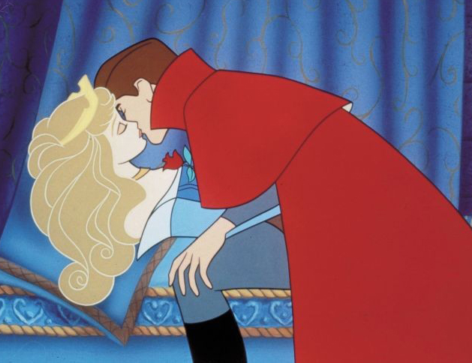
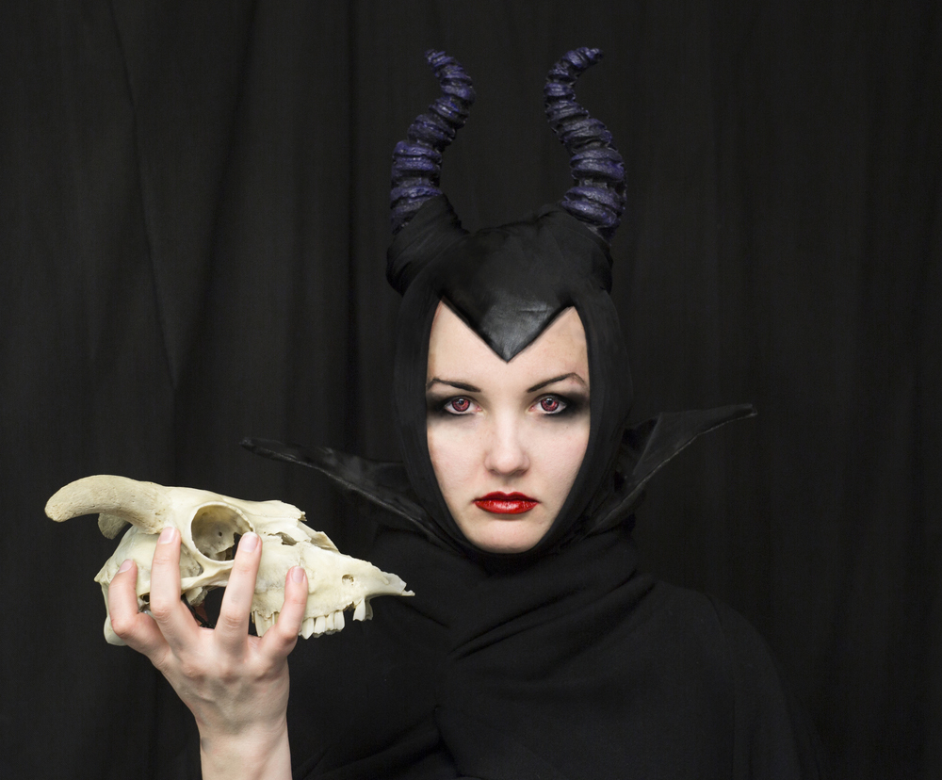

Objective: compare and contrast Sleeping Beauty (Geronimi, 1959) and Maleficent (Sromberg, 2014). Both of these films use the same, basic story, but the story is told in different ways.
Sleeping Beauty (1959) | Maleficent (2014)
Who is the hero and how do we know?

Sleeping Beauty (1959) | Maleficent (2014)
Who is the antagonist and how do we know?
Who saves the day and how do they do that?
What is Sleeping Beauty’s reward or happy ending?

Sleeping Beauty (1959) | Maleficent (2014)
What is the role of men in the story? What impact do they have on others?

