# OCR 09 Congruence and Similarity (Higher)

1. Calculate .
2. If  and  find .
3. If  and  find .
4. The two triangles below are similar. Calculate length AB.

15 cm

62°

6 cm

62°

A

C

B

10 cm

**Not to scale**

1. Rectangle **A** is similar to rectangle **B**. Calculate the area of rectangle **B**.

3 cm

**B**

2 cm

**A**

**Not to scale**

5 cm

Use the diagram below to answer questions 6 to 8.

ABCDEF is a regular hexagon, with centre O*.*

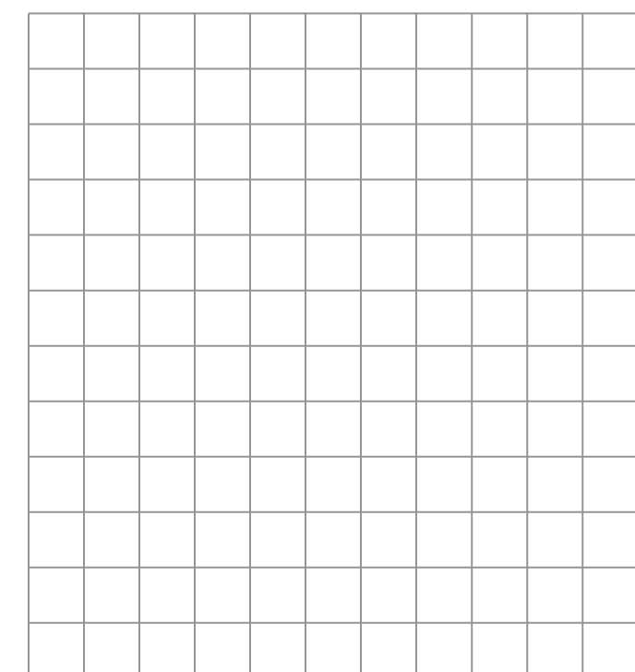

O

A*O*

B

C

D

E

F**

**b**

**a**

**Not to scale**

1. Write the vector  in terms of **a** and **b**.
2. Write the vector in terms of **a** and **b**.
3. Write the vector  in terms of **a** and **b**.

Use the diagram below to answer questions 9 and 10.

The diagram shows two mathematically similar solids.

**A**

**B**

3 cm

9 cm

1. Solid **A** has a volume of 30 cm3. Calculate the volume of Solid **B**.
2. Solid **B** has a surface area of 558 cm2. What is the surface area of solid **A**?
3. ABC is an equilateral triangle. D is the midpoint of BCand AD is perpendicular to BC*.*

Prove that triangles ADC and ADB are congruent.

D

C

B

A

**Not to scale**

1. On the grid below, enlarge triangle **A** by scale factor , centre (5, 4).

*y*

*x*

**A**

1. On the grid above, enlarge triangle **A** by scale factor -2, centre (0, 0).
2. Triangle **A** is shown on the grid below. Triangle **A** is reflected in the *y*-axis to give triangle **B**. Triangle **B** is then reflected in the line  to give triangle **C**. Describe the single transformation that maps triangle **A** to triangle **C**.

*y*

**A**

*x*

1. A £5 note is a rectangle, 125 mm  65 mm. A £50 note is a rectangle, 156 mm  85 mm.

Show that the two notes are not mathematically similar.

1. A packing company has boxes in two sizes, small and large. A large box is a cube with volume

216 cm3. A small box is a cube with side length 1.5 cm.

What is the maximum number of small boxes that will fit in a large box?

1. Two shapes A and B are mathematically similar. The area of shape A is 27 cm2 and the area of shape B is 432 cm2. One length of shape A is 5 cm. Find the corresponding length for shape B.
2. A coffee shop sells coffee in two different cup sizes, medium and large. The cups are mathematically similar. The large cup holds 490 ml and is 18 cm tall. The medium cup is 12 cm tall. How much does the medium cup hold? Give your answer to the nearest millilitre.
3. Two similar shapes have volumes in the ratio 1 : 343.

What is the ratio of their surface areas?

1. Quadrilateral ABCD is shown below.

, ,  and .

Are triangles ACB and ACD congruent?

7

5

3

120°

60°

A

B

D

C

**Not to scale**

### Answers

1. 
2. 
3. 
4. Scale factor is 1.5 so cm.
5. Scale factor is 2.5 so missing length in **B** cm.

Area of rectangle **B** cm2.

1. 
2.  or 
3. 
4. Scale factor of sides is 3, so volume scale factor is 27. Therefore, volume of solid **B** cm3.
5. Scale factor of sides is 3, so area scale factor is 9. Surface area of solid **A** cm2.
6. Triangles are congruent as angles and sides are equal. Can be proved by SSS, SAS, ASA or RHS.
7. Triangle at , , .
8. Triangle at , , .
9. Rotation, 180° about .
10. They are not mathematically similar as .
11. Side length of large box cm

Ratio of side lengths 

(Ratio of areas )

Ratio of volumes 

So the maximum number of small boxes that will fit in a large box is 64.

1. , so the area scale factor is 16.

Length scale factor is 4.

, so missing length is 20 cm.

1. Scale factor .

Volume of medium cup ml

1. Surface area ratio .
2. Using the cosine rule

 so 









 or 

The length cannot be negative so .

Length AC is common to both triangles ABC and ADC.

Angle ACB  angle ACD.

Length BC  length CD.

Triangles ABC and ADC are congruent (SAS).

**OCR Resources**: *the small print*OCR’s resources are provided to support the delivery of OCR qualifications, but in no way constitute an endorsed teaching method that is required by the Board, and the decision to use them lies with the individual teacher. Whilst every effort is made to ensure the accuracy of the content, OCR cannot be held responsible for any errors or omissions within these resources. This formative assessment resource has been produced as part of our free GCSE teaching and learning support package. All the GCSE teaching and learning resources, including delivery guides, topic exploration packs, lesson elements and more are available on the qualification webpages. If you are looking for examination practice materials, you can find Sample Assessment Materials (SAMs) and Practice Papers on the qualification webpage <http://www.ocr.org.uk/qualifications/gcse-mathematics-j560-from-2015/>

© OCR 2017 - This resource may be freely copied and distributed, as long as the OCR logo and this message remain intact and OCR is acknowledged as the originator of this work.

OCR acknowledges the use of the following content: n/a

Please get in touch if you want to discuss the accessibility of resources we offer to support delivery of our qualifications: [resources.feedback@ocr.org.uk](mailto:resources.feedback@ocr.org.uk)

We’d like to know your view on the resources we produce. By clicking on [‘Like’](mailto:resources.feedback@ocr.org.uk?subject=I%20liked%20the%20GCSE%20(9-1)%20Mathematics%20Check%20In%2009H) or ‘[Dislike’](mailto:resources.feedback@ocr.org.uk?subject=I%20disliked%20the%20GCSE%20(9-1)%20Mathematics%20Check%20In%2009H) you can help us to ensure that our resources work for you. When the email template pops up please add additional comments if you wish and then just click ‘Send’. Thank you.

Whether you already offer OCR qualifications, are new to OCR, or are considering switching from your current provider/awarding organisation, you can request more information by completing the Expression of Interest form which can be found here: [www.ocr.org.uk/expression-of-interest](http://www.ocr.org.uk/expression-of-interest)

Looking for a resource? There is now a quick and easy search tool to help find free resources for your qualification:   
[www.ocr.org.uk/i-want-to/find-resources/](http://www.ocr.org.uk/i-want-to/find-resources/)

| **Assessment Objective** | **Qu.** | **Topic** | **R** | **A** | **G** |  | **Assessment Objective** | **Qu.** | **Topic** | **R** | **A** | **G** |
| --- | --- | --- | --- | --- | --- | --- | --- | --- | --- | --- | --- | --- |
| AO1 | 1 | Calculate with vectors |  |  |  |  | AO1 | 1 | Calculate with vectors |  |  |  |
| AO1 | 2 | Calculate with vectors |  |  |  |  | AO1 | 2 | Calculate with vectors |  |  |  |
| AO1 | 3 | Calculate with vectors |  |  |  |  | AO1 | 3 | Calculate with vectors |  |  |  |
| AO1 | 4 | Find a length in similar shapes |  |  |  |  | AO1 | 4 | Find a length in similar shapes |  |  |  |
| AO1 | 5 | Find an area in similar shapes |  |  |  |  | AO1 | 5 | Find an area in similar shapes |  |  |  |
| AO1 | 6 | Identify a vector |  |  |  |  | AO1 | 6 | Identify a vector |  |  |  |
| AO1 | 7 | Identify a vector |  |  |  |  | AO1 | 7 | Identify a vector |  |  |  |
| AO1 | 8 | Identify a vector |  |  |  |  | AO1 | 8 | Identify a vector |  |  |  |
| AO1 | 9 | Understand relationship between lengths and volumes of similar shapes |  |  |  |  | AO1 | 9 | Understand relationship between lengths and volumes of similar shapes |  |  |  |
| AO1 | 10 | Understand relationship between lengths and surface areas of similar shapes |  |  |  |  | AO1 | 10 | Understand relationship between lengths and surface areas of similar shapes |  |  |  |
| AO2 | 11 | Prove that two triangles are congruent |  |  |  |  | AO2 | 11 | Prove that two triangles are congruent |  |  |  |
| AO2 | 12 | Enlarge using a fractional scale factor |  |  |  |  | AO2 | 12 | Enlarge using a fractional scale factor |  |  |  |
| AO2 | 13 | Enlarge using a negative scale factor |  |  |  |  | AO2 | 13 | Enlarge using a negative scale factor |  |  |  |
| AO2 | 14 | Identify a single transformation |  |  |  |  | AO2 | 14 | Identify a single transformation |  |  |  |
| AO2 | 15 | Show that two rectangles are not similar |  |  |  |  | AO2 | 15 | Show that two rectangles are not similar |  |  |  |
| AO3 | 16 | Understand relationship between lengths and volumes of similar shapes |  |  |  |  | AO3 | 16 | Understand relationship between lengths and volumes of similar shapes |  |  |  |
| AO3 | 17 | Understand relationship between lengths and areas of similar shapes |  |  |  |  | AO3 | 17 | Understand relationship between lengths and areas of similar shapes |  |  |  |
| AO3 | 18 | Understand relationship between lengths and volumes of similar shapes |  |  |  |  | AO3 | 18 | Understand relationship between lengths and volumes of similar shapes |  |  |  |
| AO3 | 19 | Find surface area ratio given volume ratio of similar shapes |  |  |  |  | AO3 | 19 | Find surface area ratio given volume ratio of similar shapes |  |  |  |
| AO3 | 20 | Determine if two triangles are congruent |  |  |  |  | AO3 | 20 | Determine if two triangles are congruent |  |  |  |