# OCR 07 Graphs of Equations and Functions (Foundation)

1. The equation of a straight line is . Write down the gradient of the line.
2. The equation of a straight line is . Find the coordinates of the point where the line intercepts the *y*-axis.
3. Use the graph below to calculate the speed during the first two hours of this journey.
4. Which graph below shows the equation ?

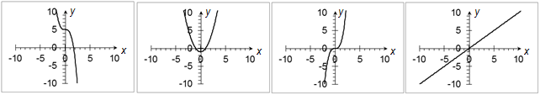

Graph 3

Graph 2

Graph 1

Graph 4

1. Find the equation of the straight line below.

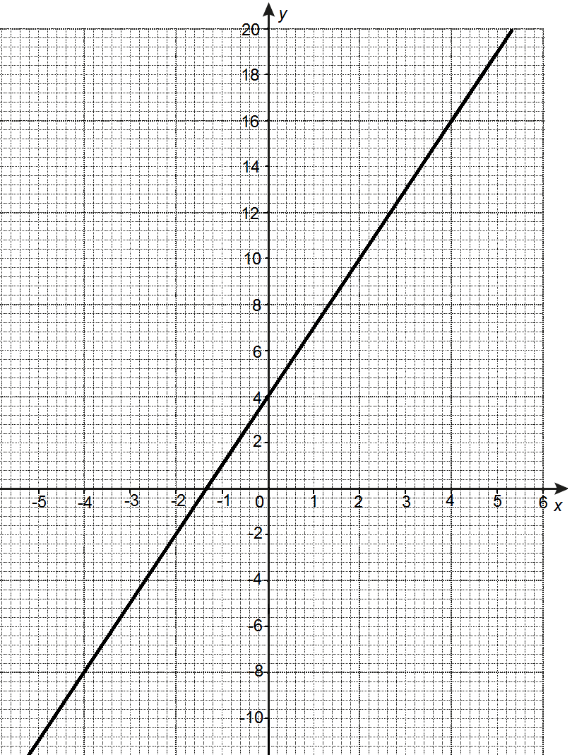

1. Write down the coordinates of the turning point of the graph below.
2. Find the equation of the line that is parallel to  and that passes through the

point (1, 3).

1. Find the equation of the straight line that passes through the points (1, 11) and (3, 16).
2. A graph has the equation . Find the coordinates of the points where the line intercepts the *x*-axis.
3. Complete the table below of values for  and use this table to plot the graph.

|  |  |  |  |  |  |  |  |
| --- | --- | --- | --- | --- | --- | --- | --- |
| *x* | -3 | -2 | -1 | 0 | 1 | 2 | 3 |
| *y* | -18 |  | 2 | 0 |  | 2 |  |

1. The graph below shows . Explain how the graph can be used to find the solutions to the equation  and write down these solutions.
2. Jacob says that the graph below illustrates direct proportion.

Is he correct? Explain your answer.

1. Mrs Bates travels from Liverpool to Leeds, which is a distance of 70 miles.

During the first 30 minutes, she travels at a constant speed of 40 mph. She then stops for half an hour to pick up a friend. She then travels at a constant speed of 50 mph until she reaches Leeds. Draw a distance-time graph for Mrs Bates complete journey.

1. Ethan is asked to identify a straight line parallel to the line. His answer is . Is he correct? Explain your answer.
2. Below is a distance-time graph for two runners over a time period of 30 seconds.

Bella says that Runner 2 is faster than Runner 1 over the first 10 seconds but Runner 1 is faster than Runner 2 over the 30 seconds. Is she correct? Explain your answer.

1. The straight line  crosses the graph  at two points.

Find the coordinates of these two points.

1. Identify if , (4, 19) and (7, 29) are on a straight line.
2. The straight line  goes through the points (*a*, -5) and .

Find the values of *a* and *b*.

1. ABCD is a rectangle. A is the point (5, 6), B is the point (10, 6) and D is the point (5, 3).

Find the gradient of the line AC.

1. Corrida's record time for a 2400 metre distance race is 360 seconds. The distance-time graph below shows the first 400 m of her latest race. State whether you think she will beat her record time, along with any assumptions you make.

Time (seconds)

Distance (metres)

### Answers

1. -2
2. (0, )
3. 45 mph
4. Graph 3
5. 
6. (-3, -2)
7. 
8. 
9. Line intercepts the *x*-axis when .









Coordinates of points are (3, 0) and (-3, 0).

|  |  |  |  |  |  |  |  |
| --- | --- | --- | --- | --- | --- | --- | --- |
| *x* | -3 | -2 | -1 | 0 | 1 | 2 | 3 |
| *y* | -18 | -2 | 2 | 0 | -2 | 2 | 18 |



1. The solutions of the quadratic are the *x*-axis intercepts of the graph so the solutions are  and .
2. Jacob is correct. The graph goes through (0, 0) and as the amount in kg increases, the amount in pounds also increases at a constant rate.
3. The line  has a gradient of 3 and the line  has a gradient of -3. The gradients are different so the lines are not parallel.
4. The statement is not correct as Runner 1 is faster than Runner 2 over the first 10 seconds but Runner 2 is faster than Runner 1 over the 30 seconds.
5. 





Coordinates are (2, 6) and (-2, 6).

1. No. The line between  and (4, 19) is , but the point (7, 29) is not on this line.
2. At (*a*, -5):









At :





1. C is the point (10, 3)

Gradient 

1. No, as she will probably not be able to keep up the same speed over the whole race distance as she has done in the first 400 m.

OR

Assuming she can keep the same speed over the whole distance, she should match her record.

We’d like to know your view on the resources we produce. By clicking on [‘Like’](mailto:resources.feedback@ocr.org.uk?subject=I%20liked%20the%20GCSE%20(9-1)%20Mathematics%20Check%20In%2007%20Foundation) or ‘[Dislike](mailto:resources.feedback@ocr.org.uk?subject=I%20disliked%20the%20GCSE%20(9-1)%20Mathematics%20Check%20In%2007%20Foundation)’ you can help us to ensure that our resources work for you. When the email template pops up please add additional comments if you wish and then just click ‘Send’. Thank you.

Whether you already offer OCR qualifications, are new to OCR, or are considering switching from your current provider/awarding organisation, you can request more information by completing the Expression of Interest form which can be found here: [www.ocr.org.uk/expression-of-interest](http://www.ocr.org.uk/expression-of-interest)

Looking for a resource? There is now a quick and easy search tool to help find free resources for your qualification:   
[www.ocr.org.uk/i-want-to/find-resources/](http://www.ocr.org.uk/i-want-to/find-resources/)

**OCR Resources**: *the small print*OCR’s resources are provided to support the delivery of OCR qualifications, but in no way constitute an endorsed teaching method that is required by the Board, and the decision to use them lies with the individual teacher. Whilst every effort is made to ensure the accuracy of the content, OCR cannot be held responsible for any errors or omissions within these resources. This formative assessment resource has been produced as part of our free GCSE teaching and learning support package. All the GCSE teaching and learning resources, including delivery guides, topic exploration packs, lesson elements and more are available on the qualification webpages. If you are looking for examination practice materials, you can find Sample Assessment Materials (SAMs) and Practice Papers on the qualification webpage <http://www.ocr.org.uk/qualifications/gcse-mathematics-j560-from-2015/>

© OCR 2017 - This resource may be freely copied and distributed, as long as the OCR logo and this message remain intact and OCR is acknowledged as the originator of this work.

OCR acknowledges the use of the following content: n/a

Please get in touch if you want to discuss the accessibility of resources we offer to support delivery of our qualifications: [resources.feedback@ocr.org.uk](mailto:resources.feedback@ocr.org.uk)

| **Assessment Objective** | **Qu.** | **Topic** | **R** | **A** | **G** |  | **Assessment Objective** | **Qu.** | **Topic** | **R** | **A** | **G** |
| --- | --- | --- | --- | --- | --- | --- | --- | --- | --- | --- | --- | --- |
| AO1 | 1 | Find the gradient of a straight line using |  |  |  |  | AO1 | 1 | Find the gradient of a straight line using |  |  |  |
| AO1 | 2 | Find the intercept of a straight line using |  |  |  |  | AO1 | 2 | Find the intercept of a straight line using |  |  |  |
| AO1 | 3 | Interpret the gradient of a distance-time graph |  |  |  |  | AO1 | 3 | Interpret the gradient of a distance-time graph |  |  |  |
| AO1 | 4 | Recognise the graph of |  |  |  |  | AO1 | 4 | Recognise the graph of |  |  |  |
| AO1 | 5 | Use  to find the equation of a straight line |  |  |  |  | AO1 | 5 | Use  to find the equation of a straight line |  |  |  |
| AO1 | 6 | Identify a turning point |  |  |  |  | AO1 | 6 | Identify a turning point |  |  |  |
| AO1 | 7 | Find the equation of a parallel line |  |  |  |  | AO1 | 7 | Find the equation of a parallel line |  |  |  |
| AO1 | 8 | Find the equation of a line through two given points |  |  |  |  | AO1 | 8 | Find the equation of a line through two given points |  |  |  |
| AO1 | 9 | Identify intercepts of a quadratic graph |  |  |  |  | AO1 | 9 | Identify intercepts of a quadratic graph |  |  |  |
| AO1 | 10 | Use a table of values to plot a polynomial graph |  |  |  |  | AO1 | 10 | Use a table of values to plot a polynomial graph |  |  |  |
| AO2 | 11 | Identify intercepts and explain how a graph can be used to find solutions to a quadratic equation |  |  |  |  | AO2 | 11 | Identify intercepts and explain how a graph can be used to find solutions to a quadratic equation |  |  |  |
| AO2 | 12 | Recognise a graph that illustrates direct proportion |  |  |  |  | AO2 | 12 | Recognise a graph that illustrates direct proportion |  |  |  |
| AO2 | 13 | Construct a graph in a real-world context |  |  |  |  | AO2 | 13 | Construct a graph in a real-world context |  |  |  |
| AO2 | 14 | Use  to identify parallel lines |  |  |  |  | AO2 | 14 | Use  to identify parallel lines |  |  |  |
| AO2 | 15 | Interpret a graph in a real-world context |  |  |  |  | AO2 | 15 | Interpret a graph in a real-world context |  |  |  |
| AO3 | 16 | Find intercepts between a straight line and a quadratic graph |  |  |  |  | AO3 | 16 | Find intercepts between a straight line and a quadratic graph |  |  |  |
| AO3 | 17 | Use  to identify straight lines |  |  |  |  | AO3 | 17 | Use  to identify straight lines |  |  |  |
| AO3 | 18 | Identify points on a straight line with algebra |  |  |  |  | AO3 | 18 | Identify points on a straight line with algebra |  |  |  |
| AO3 | 19 | Solve a gradient problem |  |  |  |  | AO3 | 19 | Solve a gradient problem |  |  |  |
| AO3 | 20 | Use gradient in context |  |  |  |  | AO3 | 20 | Use gradient in context |  |  |  |