M1.3 – Construct and interpret frequency tables and diagrams, bar charts and histograms

Tutorials
Learners may be tested on their ability to:
- represent a range of data in a table with clear headings, units and consistent decimal places
- interpret data from a variety of tables, e.g. data relating to organ function
- plot a range of data in an appropriate format, e.g. enzyme activity over time represented on a graph
- interpret data for a variety of graphs, e.g. explain electrocardiogram traces.

Construct and interpret frequency tables and diagrams, bar charts and histograms
You should have come across frequency tables, bar charts and histograms in GCSEs. There are a few important rules that you need to follow whenever you represent data in a table or plot a graph. For tables you need to include clear headings and units and also be consistent with decimal places. For graphs including histograms and bar charts you must always:
- include a title
- include axes labels (with units)
- plot the independent variable (IV) on the x axis
- plot the dependent variable (DV) on the y axis
- ensure that the scales for both axes are linear (0, 1, 2, 3, 4...) unless producing a logarithmic plot (see M0.5 and M2.5)
- plot your data carefully
- make sure the graph is large enough to be easily readable (aim to use >50% of the space available).

You also need to remember the important differences between histograms and bar charts. Bar charts are used when the data is qualitative (either as categories such as different plant species or in a rankable form such as ACFOR abundance scores) or is quantitative but discrete - it can only take specific values and there are no ‘in between’ values. Examples of data suitable to be plotted on a bar chart include variables such as eye colour (qualitative categoric) or number of offspring (quantitative discrete). The bars in bar charts are the same width and there are gaps between the bars, they are not touching, when it is plotted.
Histograms on the other hand are used when the data is quantitative and continuous. Height, weight, and age are all examples of continuous data where they are measured to a specified resolution. Unlike bar charts there are no gaps between the bars.
Note: the class width of different classes in a histogram can be different as it is the area of the bars that is proportional to frequency. However, this can be confusing for people interpreting the histogram so it is good practice, whenever possible, to use classes of the same width.
Bar chart | Histogram
Qualitative data (categoric or rankable)  Discrete quantitative data | Continuous quantitative data
Bars the same width | Differing widths of bars possible but not advised
Bars not touching | Bars touch

Let’s try an example of plotting a histogram. The heights of different plants of the same species were measured to the nearest cm:
Plant | 1 | 2 | 3 | 4 | 5 | 6 | 7 | 8 | 9 | 10 | 11 | 12
Height (cm) | 157 | 188 | 163 | 188 | 171 | 184 | 187 | 161 | 175 | 169 | 193 | 175
Plant | 13 | 14 | 15 | 16 | 17 | 18 | 19 | 20 | 21 | 22 | 23 | 24
Height (cm) | 181 | 199 | 166 | 163 | 177 | 150 | 171 | 156 | 172 | 172 | 183 | 166
The first step in producing a histogram is to choose the number and width of classes and then create a frequency table using those classes:
Height to the nearest cm | Frequency
150≤x<160 | 3
160≤x<170 | 6
170≤x<180 | 7
180≤x<190 | 6
190≤x<200 | 2

The histogram can now be plotted using the processed data and with each class represented by a bar on the histogram:
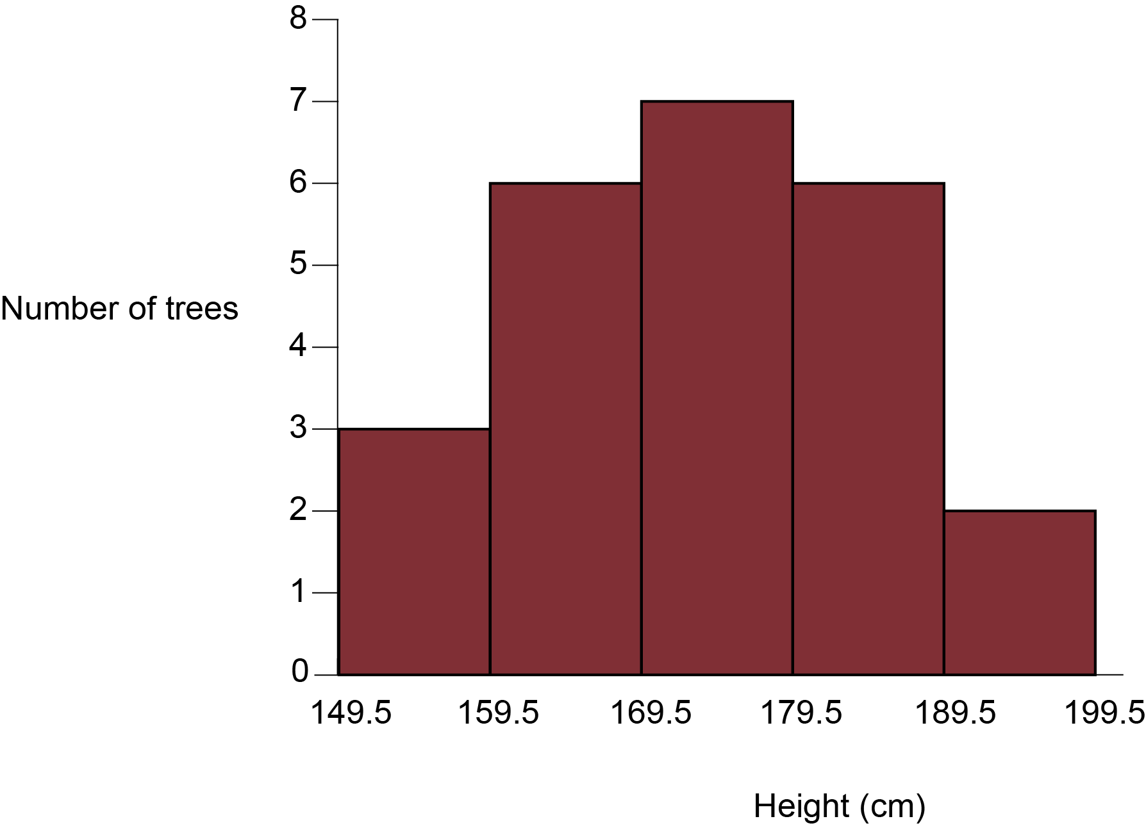
As well as understanding when to use histograms and bar charts, and how to plot them, you must also be able to plot and interpret line graphs and scattergrams. More information about graphs can be found in M3.

Document updates
v1.0 April 2017 Original version.
v1.1 June 2019 Changed how the word accuracy was used in order to be in line with the ‘Language of measurement’

Produced in collaboration with the University of East Anglia
This resource has been produced as part of our free A Level teaching and learning support package. All the A Level teaching and learning resources, including delivery guides, topic exploration packs, lesson elements and more are available on the qualification webpages.
If you are looking for examination practice materials, you can find the Sample Assessment Materials (SAMs) on the qualification webpages: Biology A / Biology B

We’d like to know your view on the resources we produce. By clicking on ‘Like’ or ‘Dislike’ you can help us to ensure that our resources work for you. When the email template pops up please add additional comments if you wish and then just click ‘Send’. Thank you.
If you do not currently offer this OCR qualification but would like to do so, please complete the Expression of Interest Form which can be found here: www.ocr.org.uk/expression-of-interest
Looking for a resource? There is now a quick and easy search tool to help find free resources for your qualification:
www.ocr.org.uk/i-want-to/find-resources/

OCR Resources: the small print
OCR’s resources are provided to support the delivery of OCR qualifications, but in no way constitute an endorsed teaching method that is required by the Board, and the decision to use them lies with the individual teacher. Whilst every effort is made to ensure the accuracy of the content, OCR cannot be held responsible for any errors or omissions within these resources.
© OCR 2019 - This resource may be freely copied and distributed, as long as the OCR logo and this message remain intact and OCR is acknowledged as the originator of this work.
OCR acknowledges the use of the following content: n/a
Please get in touch if you want to discuss the accessibility of resources we offer to support delivery of our qualifications: resources.feedback@ocr.org.uk

