Physics PAG 8: Interaction of waves

Suggested Activity 2

Combined Science PAG P4: Waves

Suggested Activity 4

Reflection within a material

Instructions and answers for teachers & technicians
These instructions cover the learner activity section which can be found on page 9. This Practical activity supports OCR GCSE Physics.
When distributing the activity section to the learners either as a printed copy or as a Word file you will need to remove the teacher instructions section.
This is a suggested practical activity that can be used as part of teaching the GCSE (9-1) Gateway Science (A) and Twenty First Century Science (B) specifications.
These are not controlled assessment tasks, and there is no requirement to use these particular activities.
You may modify these activities to suit your learners and centre. Alternative activities are available from, for example, Royal Society of Biology, Royal Society of Chemistry, Institute of Physics, CLEAPSS and publishing companies, or of your own devising.
Further details are available in the specifications (Practical Skills Topics), and in these videos.
OCR recommendations:
Before carrying out any experiment or demonstration based on this guidance, it is the responsibility of teachers to ensure that they have undertaken a risk assessment in accordance with their employer’s requirements, making use of up-to-date information and taking account of their own particular circumstances. Any local rules or restrictions issued by the employer must always be followed.
CLEAPSS resources are useful for carrying out risk-assessments: (http://science.cleapss.org.uk).
Centres should trial experiments in advance of giving them to learners. Centres may choose to make adaptations to this practical activity, but should be aware that this may affect the Apparatus and Techniques covered by the learner.

Introduction
In this activity, learners will investigate the behaviour of light through a semi-circular block.

DfE Apparatus and Techniques covered
The codes used below match the OCR Practical Activity Learner Record Sheet (Physics / Combined Science) and Trackers (Physics / Combined Science) available online. There is no requirement to use these resources.
4b [16b]) Making observations of the effects of the interaction of electromagnetic waves with matter
8) Making observations of waves to identify the suitability of apparatus to measure the effects of interactions of waves with matter in: ii) solids

Aims
To use suitable apparatus to measure the angle of incidence and the angle of reflection and refraction when light passes through a semi-circular block.
Determine the relationship between the angle of incidence and the angle of reflection when light is reflected off a surface
To use suitable apparatus to measure the angle of incidence and the angle of refraction when light is passed from one medium to another
To relate this to the speed that light travels through different materials.

Intended class time
50-60 minutes

Links to Specifications:

Gateway Science (Suite A) including Working Scientifically (WS)
P5.1g describe the effects of reflection, transmission, and absorption of waves at material interface
P5.3a recall that different substances may absorb, transmit, refract, or reflect electromagnetic waves in ways that vary with wavelength
P5.3b explain how some effects are related to differences in the velocity of electromagnetic waves in different substances
P5.3d construct two-dimensional ray diagrams to illustrate reflection and refraction (qualitative only)
WS1.2a, use scientific theories and explanations to develop hypotheses
WS1.2c, apply a knowledge of a range of techniques, instruments, apparatus, and materials to select those appropriate to the experiment
WS1.3f, presenting reasoned explanations
WS1.3h, identifying potential sources of random and systematic error
WS1.4a use scientific vocabulary, terminology and definitions
WS2a, carry out experiments
WS2d communicating the scientific rationale for investigations, methods used, findings and reasoned conclusions

Twenty First Century Science (Suite B) including Ideas about Science (IaS)
P1.3.8a describe the effects of reflection and refraction of waves at material interfaces
P1.3.9 recall that waves travel in different substances at different speeds and that these speeds may vary with wavelength
P1.3.10 explain how refraction is related to differences in the speed of the waves in different substances
P1.4.1 construct and interpret two-dimensional ray diagrams to illustrate specular reflection by mirrors (qualitative only)
P1.4.2 construct and interpret two-dimensional ray diagrams to illustrate refraction at a plan surface and dispersion by a prism (qualitative only)
IaS1.1 suggest appropriate apparatus, materials and techniques, justifying the choice with reference to the precision, accuracy and validity of the data that will be collected
IaS2.1 present observations and other data using appropriate formats
IaS2.9 in given context evaluate data in terms of accuracy, precision, repeatability and reproducibility, identify potential sources of random and systematic error, and discuss the decision to discard or retain an outlier

Health and Safety
Use a low voltage power supply for the ray box so not to blow the bulb
Turn off switch between readings to ensure ray boxes don’t get too hot
Be aware that ray boxes can get very hot so do not touch the ray box until they are cooled down
Before carrying out any experiment or demonstration based on this guidance, it is the responsibility of teachers to ensure that they have undertaken a risk assessment in accordance with their employer’s requirements, making use of up-to-date information and taking account of their own particular circumstances. Any local rules or restrictions issued by the employer must always be followed.

Method 1
Learners use a ray box and single slit to investigated reflection and refraction using a semi-circular block of Perspex/glass. Learners vary the angle of incident and measure any reflected and refracted angles. Learner are encouraged to draw conclusions from what they observe.

Notes
Teachers should trial this activity to be able to modify the learner sheet in the light of the equipment and lesson time available at the centre. These should include the appropriate voltage setting for use with the ray boxes available. Learners do not need to calculate refractive indices.

Technicians notes

For this practical the teacher will require:

1 set per group
- Ray box
- Low voltage power supply
- Single slit
- Protractor (if not using the sheet provided)
- White paper
- Pencil
- Glass/Perspex semi-circular block

Answers for quiz questions
1. | (a) A student shines a light from a ray box onto a mirror. The image below shows the path of the ray as it leaves the ray box and hits the mirror. Draw on the reflected ray, and label the angle of incidence and angle of reflection. [4 marks]
normal
mirror

Line reflected off the mirror with arrow head in correct direction
Angle of reflection same as angle of incidence (judged by eye)
Angle of incidence correctly labelled to the left of the normal
Angle of reflection correctly labelled to the right of the normal

(b) [2 marks]
Any two correct uses of mirrors. Examples may include:
- Periscopes
- To see your reflection
- To see behind you in the car

2. (a) If the quality of the image is important, then right angled triangular glass blocks can be used instead of mirrors. Complete the diagram to show the position and orientation of the glass blocks. [1 mark]

(b) On the above image, use two ray lines to show that the image seen is upright [2 marks]

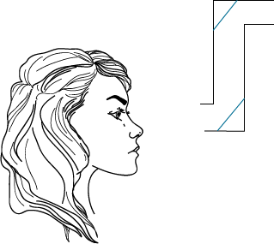

(a) Glass blocks positioned as above
(b) Two straight lines drawn from entrance to top mirror, reflected down to second mirror and into eye
Arrow head on rays in correct direction

3. (a) 3 x 10⁸ m/s
(b) Wavelength = 560 nm = 560 x 10⁻⁹ m
Wave speed = frequency x wavelength
Frequency = wave speed / wavelength
Frequency = 3 x 10⁸ / 560 x 10⁻⁹
Frequency = 0.0005 Hz

4 | (a) A student is investigating reflection of light within materials. They shine a light through curved block of Perspex. The diagram below shows the ray as it hits the block. Complete the diagram to show the path of the ray and label the angle of incidence and angle of reflection. [3 marks]
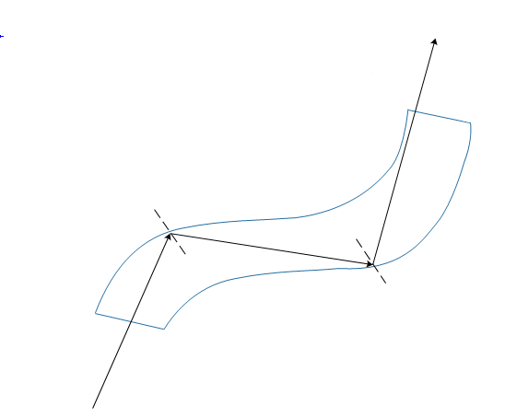
Straight line reflection off the inner surface of the curved block (arrow should be present)
Angles of incidence and reflection equal by eye
Angles correctly labelled
 | (b) The student has observed total internal reflection. List a use of total internal reflection. [1 mark]
Endoscopes – used by medical professionals to see inside the body
Fibre optic cables – to transfer information over long distances very quickly and efficiently.

We’d like to know your view on the resources we produce. By clicking on ‘Like’ or ‘Dislike’ you can help us to ensure that our resources work for you. When the email template pops up please add additional comments if you wish and then just click ‘Send’. Thank you.
If you do not currently offer this OCR qualification but would like to do so, please complete the Expression of Interest Form which can be found here: www.ocr.org.uk/expression-of-interest
Looking for a resource? There is now a quick and easy search tool to help find free resources for your qualification:
www.ocr.org.uk/i-want-to/find-resources/
OCR Resources: the small print
This formative assessment resource has been produced as part of our free GCSE teaching and learning support package. All the GCSE teaching and learning resources, including delivery guides, topic exploration packs, lesson elements and more are available on the qualification webpages.
If you are looking for examination practice materials, you can find Sample Assessment Materials (SAMs) on the qualification webpages: here

OCR’s resources are provided to support the teaching of OCR qualifications, but in no way constitute an endorsed teaching method that is required by the Board, and the decision to use them lies with the individual teacher. Whilst every effort is made to ensure the accuracy of the content, OCR cannot be held responsible for any errors or omissions within these resources.
© OCR 2017 - This resource may be freely copied and distributed, as long as the OCR logo and this message remain intact and OCR is acknowledged as the originator of this work.
OCR acknowledges the use of the following content: page 6, 11 and 15: Glass - Mr Aesthetics/Shutterstock.com
Please get in touch if you want to discuss the accessibility of resources we offer to support delivery of our qualifications: resources.feedback@ocr.org.uk

Physics PAG 8: Interaction of waves

Suggested Activity 2

Combined Science PAG P4: Waves

Suggested Activity 4

Reflection within a material

Learner Activity

Introduction
In this activity, you will investigate the behaviour of light through a semi-circular block.

Aims
To use suitable apparatus to measure the angle of incidence and the angle of reflection and refraction when light passes through a semi-circular block.
Determine the relationship between the angle of incidence and the angle of reflection when light is reflected off a surface
To use suitable apparatus to measure the angle of incidence and the angle of refraction when light is passed from one medium to another
To relate this to the speed that light travels through different materials.

Intended class time
50-60 minutes

Equipment (per group)
- Ray box
- Low voltage power supply
- Single slit
- Protractor (if not using the sheet provided)
- White paper
- Pencil
- Glass/Perspex semi-circular block

Health and Safety
Use a low voltage power supply for the ray box so not to blow the bulb
Turn off switch between readings to ensure ray boxes don’t get too hot
Be aware that ray boxes can get very hot so do not touch the ray box until they are cooled down

Method
- Set up apparatus as shown below; do not turn on the power pack.
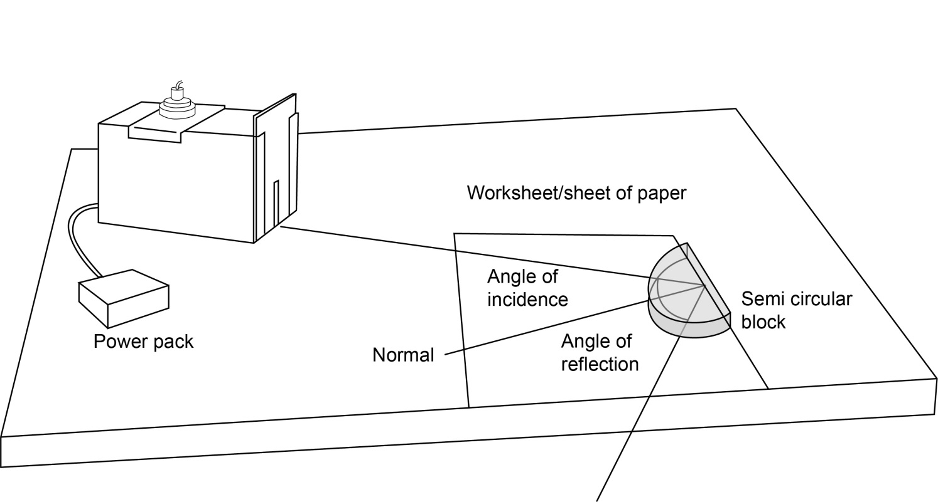
2. Turn on the power pack at the voltage suggested by your teacher.
3. Move the ray box so that the ray of light now hits the flat surface of the block at the point where the normal is, but at an angle so that light is reflected off. Draw over the path of the light with a pencil. If any light is refracted, draw over this path too, and label these lines with the number 1.
4. Remove the block and complete the lines.
5. Measure the angle of incidence (the angle at which the light hits the block from the normal) and the angle of reflection (the angle at which the light is reflected off the surface from the normal). If light is refracted measure this angle also. Record measurements in the table below.
6. Repeat steps 3, 4 and 5 till you have measurements for a least 5 angles, between 20° and 80°. Record all results in the table below.

Results
Measurement number | Angle of incidence (°) | Angle of reflection (°) | Angle of refraction (°)
1
2
3
4
5

Place a cross in the space if no reflection or refraction is observed.

Analysis
Look at your results what did you observe? Comment on any trends seen
Did you observe anything unexpected?

Evaluation
- Using your results, write down the relationship between the angle of incidence and the angle of reflection.

- In relation to the normal, in which way did the light bend when it left the block?

- Write down, using ideas about particle model, how the density of the glass block in compares to the density of air.

- How does the speed of the light change when it enters the glass block?

- Why does the speed of light change when travelling through the glass block?

Research
Find out what the critical angle is and use it to explain what you have observed.

Practical worksheet
Use the protractor on this sheet as an aid to measuring your angles

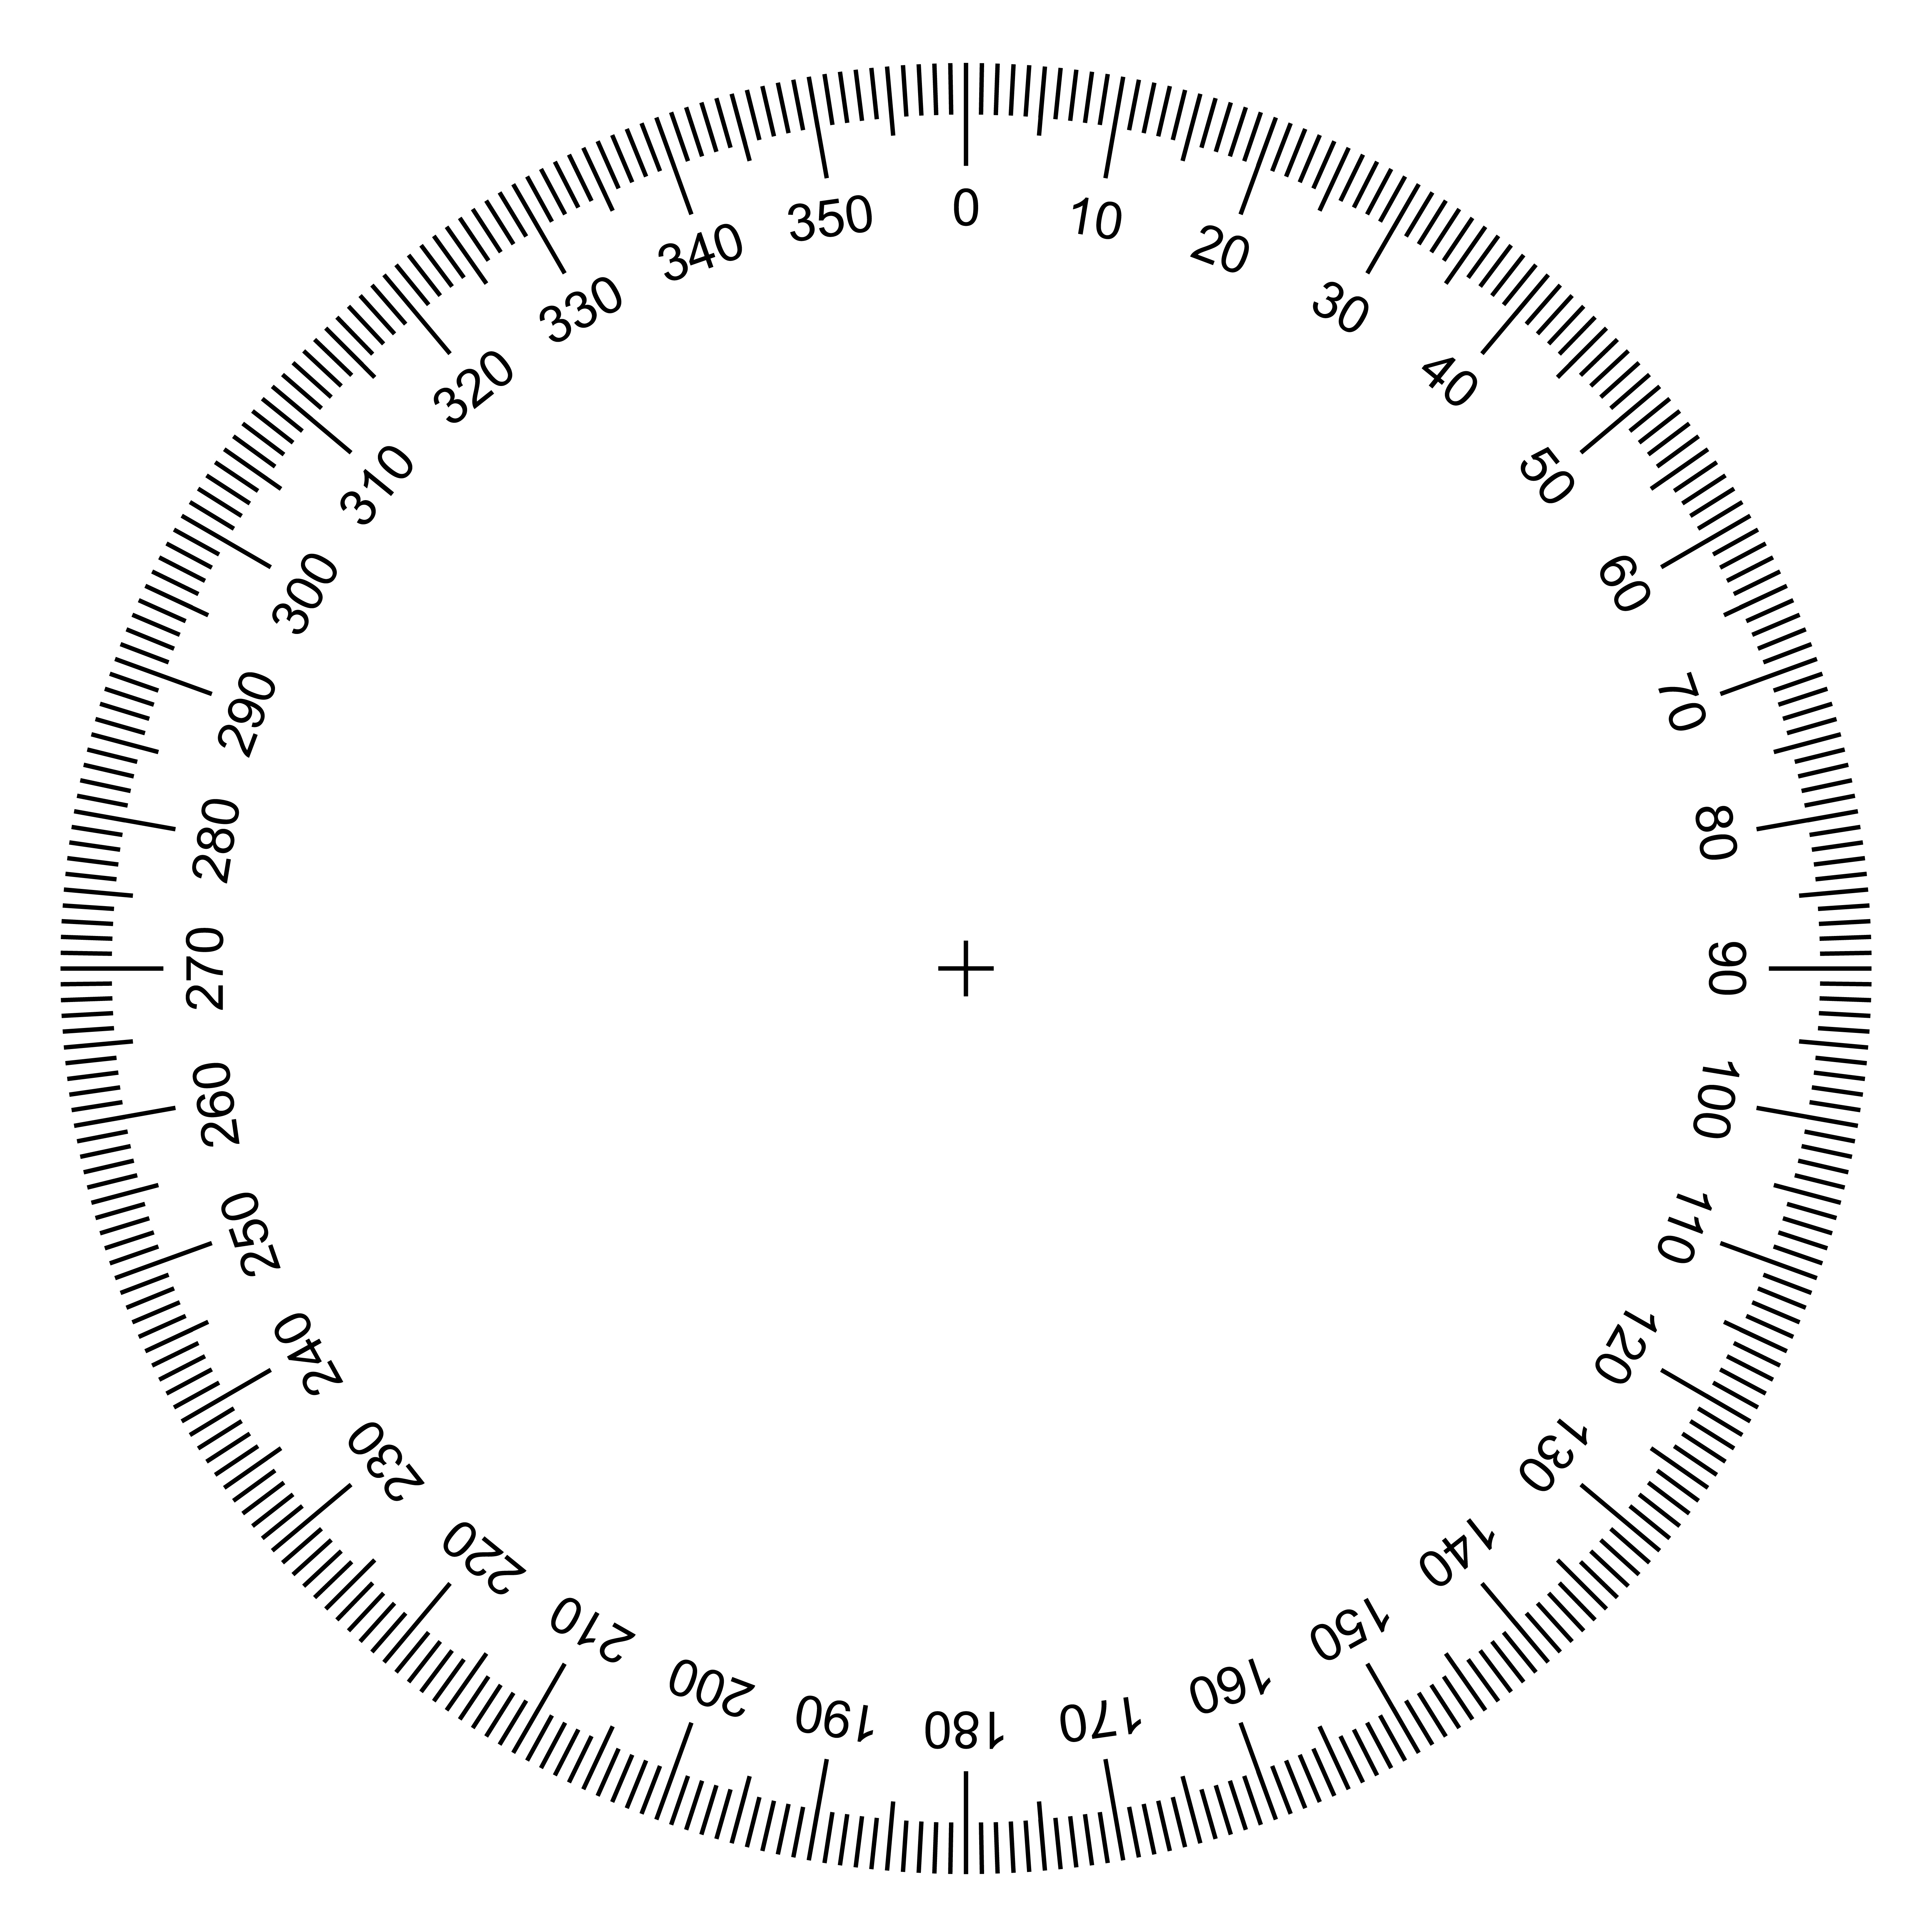

Quiz - test your knowledge and understanding
1. | (a) A student shines a light from a ray box onto a mirror. The image below show the path of the ray as it leaves the ray box and hits the mirror. Draw on the reflected ray, and label the angle of incidence and angle of reflection.  [4 marks]
normal
mirror

(b) List up 2 uses for mirrors [2 marks]

2. | A periscope is used in a submarine to allow people to see above the water’s surface. A simple diagram of a periscope using mirrors is shown below.
- If the quality of the image is important, then right angled triangular glass blocks can be used instead of mirrors. Complete the diagram to show the position and orientation of the glass blocks. [1 mark]

- On the above image, use two ray lines to show that the image seen is upright
[2 marks]
3. Complete the following

(a) The speed of light in a vacuum is
[1 mark]
(b) Yellow light has a wavelength of 560 nm. Calculate the frequency of yellow light.
[3 marks]

4 | (a) A student is investigating reflection of light within materials. They shine a light through curved block of Perspex. The diagram below shows the ray as it hits the block. Complete the diagram to show the path of the ray and label the angle of incidence and angle of reflection. [3 marks]
 | 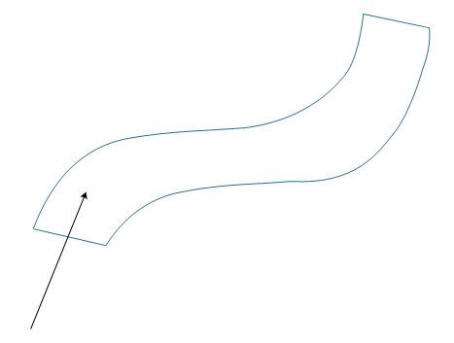
 | (b) The student has observed total internal reflection. List a use of total internal reflection. [1 mark]

DfE Apparatus and Techniques covered
If you are using the OCR Practical Activity Learner Record Sheet (Physics / Combined Science) you may be able to tick off the following skills:

Physics |  |  | Combined Science
4b | 8−ii |  | 16b

