Physics PAG 5: Energy

Combined Science PAG P5: Energy

Suggested Activity 2: Kettle design

Instructions and answers for teachers & technicians
These instructions cover the learner activity section which can be found on page 9. This Practical activity supports OCR GCSE Physics.
When distributing the activity section to the learners either as a printed copy or as a Word file you will need to remove the teacher instructions section.
This is a suggested practical activity that can be used as part of teaching the GCSE (9-1) Gateway Science (A) and Twenty First Century Science (B) specifications.
These are not controlled assessment tasks, and there is no requirement to use these particular activities.
You may modify these activities to suit your learners and centre. Alternative activities are available from, for example, Royal Society of Biology, Royal Society of Chemistry, Institute of Physics, CLEAPSS and publishing companies, or of your own devising.
Further details are available in the specifications (Practical Skills Topics), and in these videos.

OCR recommendations:
Before carrying out any experiment or demonstration based on this guidance, it is the responsibility of teachers to ensure that they have undertaken a risk assessment in accordance with their employer’s requirements, making use of up-to-date information and taking account of their own particular circumstances. Any local rules or restrictions issued by the employer must always be followed.
CLEAPSS resources are useful for carrying out risk-assessments: (http://science.cleapss.org.uk).
Centres should trial experiments in advance of giving them to learners. Centres may choose to make adaptations to this practical activity, but should be aware that this may affect the Apparatus and Techniques covered by the learner.

Introduction
In this activity learners will be using ratio and their understanding of specific heat capacity to estimate the energy required to boil one litre of water in an electric kettle.

DfE Apparatus and Techniques covered
The codes used below match the OCR Practical Activity Learner Record Sheet (Physics / Combined Science) and Trackers (Physics / Combined Science) available online. There is no requirement to use these resources.
1a [1]: Use of appropriate apparatus to make and record a range of measurements accurately, including: iii [iii]) mass; v [v]) volume; iv [iv]) time; vi [v]) temperature
5 [17]) Safe use of appropriate apparatus in a range of contexts to measure: i) energy changes/transfers; ii) associated values such as work done

Aims
To use appropriate apparatus to take measurements to determine energy transferred
To use appropriate apparatus to determine temperature rise
To use the measurements obtained and concept of ratio to determine the power required to boil a defined amount of water
To identify sources of energy transfer which decrease the efficiency of heating water

To propose improvements to the activity to optimise energy transfer

Intended class time
50-60 minutes or multiple lessons with extension activities

Links to Specifications:

Gateway Science (Suite A) including Working Scientifically (WS)
P1.2c describe how heating a system will change the energy stored within the system and raise its temperature or produce changes of state
P1.2d define the term specific heat capacity and distinguish between it and the term specific latent heat
P1.2e apply the relationship between change in internal energy of a material and its mass, specific heat capacity and temperature change to calculate the energy change involved
P3.2l explain how the power transfer in any circuit device is related to the potential difference across it and the current, and to the energy changes over a given time
P3.2m apply the equations relating potential difference, current, [quantity of charge], resistance, power, energy, and time and solve problems for circuits which include resistors in series, using the concept of equivalent resistance
WS1.2e evaluate methods and suggest possible improvements and further investigations
WS1.3a presenting observations and other data using appropriate methodsWS1.3f presenting reasoned explanations
WS1.3f Presenting reasoned explanations
WS1.3h identifying potential sources of random and systematic error
WS1.4a use scientific vocabulary, terminology and definitions
WS1.4b recognise the importance of scientific quantities and understand how they are determined
WS1.4c use SI units and IUPAC chemical nomenclature unless inappropriate
WS1.4e interconvert units
WS1.4f use an appropriate number of significant figures in calculations
WS2a carry out experiments
WS2b make and record observations and measurements using a range of apparatus and methods

Twenty First Century Science (Suite B) including Ideas about Science (IaS)
P3.4.1 describe the energy transfers that take place when a system is changed by work done when a current flows through a component

P3.4.2 explain, with reference to examples, how the power transfer in any circuit device is related to the energy transferred from the power supply to the device and its surroundings over a given time:
power (W) = energy (J) ÷ time (s)

P3.4.3 recall and use the relationship between the potential difference across the component and the total charge to calculate the energy transferred in an electric circuit when a current flows through a component:
energy transferred (work done) (J) = charge (C) x potential difference (V)

P3.4.3 recall and apply the relationships between power transferred in any circuit device, the potential difference across it, the current through it, and its resistance:
power (W) = potential difference (V) x current (A)
power (W) = (current (A))² x resistance (Ω)

P6.1.3 describe the energy transfers involved when a system is changed by heating (in terms of temperature change and specific heat capacity)

P6.1.4 define the term specific heat capacity and distinguish between it and the term specific latent heat

P6.1.5 a) select and apply the relationship between change in internal energy of a material and its mass, specific heat capacity and temperature:
change in internal energy (J) = mass (kg) x specific heat capacity (J / kg / °C) x change in temperature (°C)

P6.1.5 b) explain how to safely use apparatus to determine the specific heat capacity of materials

P6.1.8 make calculations of the energy transfers associated with changes in a system when the temperature changes, recalling or selecting the relevant equations for mechanical, electrical, and thermal processes (M1a, M1c, M2a, M3b, M3c, M3d)

IaS1.3 Recognise the importance of scientific quantities and understand how they are determined
IaS1.4 Identify factors that need to be controlled, and the ways in which they could be controlled
IaS1.8 Use appropriate scientific vocabulary, terminology and definitions to communicate the rationale for an investigation and the methods used using diagrammatic, graphical, numerical and symbolic forms
IaS2.1 Present observations and other data using appropriate formats
IaS2.2 When processing data use SI units where appropriate (e.g. kg, g, mg, km, m, mm, kJ, J)
IaS2.5 When processing data interconvert units
IaS2.6 When processing data use an appropriate number of significant figures
IaS2.10 Evaluate an experimental strategy, suggest improvements and explain why they would increase the quality (accuracy, precision, repeatability and reproducibility) of the data collected, and suggest further investigations

Mathematical Skills covered
M1a Recognise and use expressions in decimal form
M1c, Use ratios, fractions and percentages
M1d, Make estimates of the results of simple calculations
M3b Change the subject of an equation
M3c Substitute numerical values into algebraic equations using appropriate units for physical quantities
M3d Solve simple algebraic equations

Health and Safety
The heater and metal block will get hot, learners should be warned not to touch hot objects and a heatproof mat should be used to protect working surfaces.
Electric circuits should be checked to ensure that they are connected correctly.

Method
Learners will construct a circuit to power the electric heater with meters to determine the energy transferred to a defined amount of water for a measured temperature rise.
In its most simple form this will be using the voltmeter and ammeter to determine power using P=IV, then converting this into energy by multiplying by time (in seconds).
The learners can then use the specific heat capacity in joules per kilogram per degree centigrade and their understanding of ratio to estimate the energy required to boil one litre of water.
Should the centre have joule meters then these can be used to provide the measurement for the amount of energy.
Should the centre have data logging equipment this can be used to record voltage and current to determine power and temperature

Extension
In carrying out the activity learners can be challenged to identify factors contributing to inaccuracy or uncertainty.
The key aspect will be transfer of energy from the block to the surroundings. Providing insulation materials allows a comparative set of data to be obtained which should give a more accurate result.

Notes
Learners should be encouraged to give a step by step explanation as to how their data was translated into a value for the energy required using the specific heat capacity in the appropriate S.I. units.
This investigation could be set as the start of a project to develop the most energy efficient kettle (based on the beaker, heater and insulating materials provided). Learners can investigate the varying impact of insulating the contact of the bottom of the beaker with desk, the side walls of the beaker with the atmosphere and the addition of a lid.
The teacher will want to amend the student sheet to include the correct voltage for the heater supply depending on those being used at the centre.
Aspects of the activity which introduce uncertainty or cause inaccuracy are:
- Thermal capacity of the beaker
- Thermal capacity of the heater
- Conduction from the base to the surface
- Transfer from the sides of the beaker to the surroundings
- Convection and evaporation from the surface

Technician Notes

For this practical the teacher will require:
- 15x250 cm³ beaker
- 15x Measuring cylinder
- 15x Low voltage electric heater
- 15x Low voltage power supply
- 15x Voltmeter
- 15x Ammeter
- 15x Stopclock
- 15x Thermometer
- 15x Connecting leads
- 15x Heatproof mat
- Insulating materials, aluminium foil, cardboard, paper

Dependent on availability and teacher preference;
- Joulemeters (in place of voltmeters and ammeters)
- Data loggers with voltage, current and temperature sensors (in place of voltmeter, ammeter, stopclock and thermometer)

Answers for quiz questions
1ai [2 marks]
P = 2kW = 2000 W
E = P x t
= 2000 x 90
= 180,000J

1aii [2 marks]
_{E = m c Δ T}
_{So c = E / (m ΔT)}
= 180 000 / (0.5 x 80)
= 4,500

1b [1 mark]
Not all the energy supplied is transferred usefully. Some is lost to the surroundings

2 [4 marks]
- Conduction
- Radiation
- Convection
- Convection

3 [5 marks]
Measurements to be taken: Voltage, Current, Time, Temperature change, Mass of block
_{P = I x V}
_{E = P x t}
_{E = m c Δ T}
_{P t = m c ΔT}
_{c = (P t )/ (m ΔT)}

4. [1 mark] A material with a higher specific heat capacity requires more energy per kg to cause a one degree change in temperature (or AW)

OCR Resources: the small print
This formative assessment resource has been produced as part of our free GCSE teaching and learning support package. All the GCSE teaching and learning resources, including delivery guides, topic exploration packs, lesson elements and more are available on the qualification webpages.
If you are looking for examination practice materials, you can find Sample Assessment Materials (SAMs) on the qualification webpages: here

OCR’s resources are provided to support the teaching of OCR qualifications, but in no way constitute an endorsed teaching method that is required by the Board, and the decision to use them lies with the individual teacher. Whilst every effort is made to ensure the accuracy of the content, OCR cannot be held responsible for any errors or omissions within these resources.
© OCR 2017 - This resource may be freely copied and distributed, as long as the OCR logo and this message remain intact and OCR is acknowledged as the originator of this work.
OCR acknowledges the use of the following content: n/a
Please get in touch if you want to discuss the accessibility of resources we offer to support delivery of our qualifications: resources.feedback@ocr.org.uk
We’d like to know your view on the resources we produce. By clicking on ‘Like’ or ‘Dislike’ you can help us to ensure that our resources work for you. When the email template pops up please add additional comments if you wish and then just click ‘Send’. Thank you.
If you do not currently offer this OCR qualification but would like to do so, please complete the Expression of Interest Form which can be found here: www.ocr.org.uk/expression-of-interest
Looking for a resource? There is now a quick and easy search tool to help find free resources for your qualification:
www.ocr.org.uk/i-want-to/find-resources/

Physics PAG 5: Energy

Combined Science PAG P5: Energy

Suggested Activity 2: Kettle design

Learner Activity

Introduction
You, and your colleagues, are the development department of the Chocolate Kettle Company. Your first task is to determine the amount of energy used to boil a litre of water in the most basic version of the kettle, shown in the picture on the below.
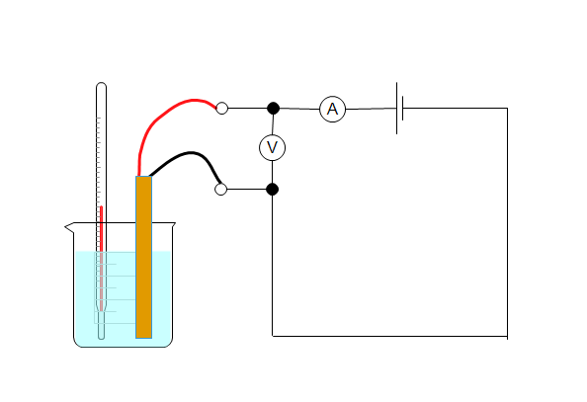
thermometer
heater
beaker with water
You should then carry out investigations of methods to increase the efficiency of the kettle to advise the company on the design of the new E-Konomy Kettle.

Aims
To use appropriate apparatus to take measurements to determine energy transferred
To use appropriate apparatus to determine temperature rise
To use the measurements obtained and concept of ratio to determine the power required to boil a defined amount of water
To identify sources of energy transfer which decrease the efficiency of heating water

To propose improvements to the activity to optimise energy transfer

Intended class time
50-60 minutes or multiple lessons with extension activities

Equipment (per group)
- 250 cm³ beaker
- Measuring cylinder
- Low voltage electric heater
- Low voltage power supply
- Voltmeter
- Ammeter
- Stopclock
- Thermometer
- Connecting leads
- Heatproof mat
- Insulating materials, aluminium foil, cardboard, paper

Alternative equipment
CENTRE SHOULD AMEND WORKSHEET BASED ON EQUIPMENT PROVIDED
- Joulemeter ( in place of voltmeter and ammeter)
- Data logger with voltage, current and temperature sensors (in place of voltmeter, ammeter, stopclock and thermometer)

Health and Safety
The heater and metal block will get hot, do not to touch hot objects and use a heatproof mat to protect working surfaces.
Electric circuits should be checked by the teacher before turning on to ensure that they are connected correctly.

Method
- Connect the circuit as shown in the diagram below and ask your teacher to check it. Make sure that the beaker and heater are placed on the heatproof mat.
thermometer
heater
beaker with water
- Record the mass of the water to be heated.
- Record the temperature of the water before turning on the power supply.
- Turn on the power supply with the voltage set at the value instructed by your teacher.
- Leave the water to heat for a time given by your teacher. Check that the voltage remains constant during this time.
- Record the current at the start of the heating
- Calculate the power of the heater from the voltage and current.
- Calculate the energy transferred from the power and time.
- Record the temperature at the end of the heating time.
- Calculate the energy transferred for each degree centigrade
- Use the idea of ratio to determine how much energy would be needed to boil one litre of water.

Results
Measurement | Value | Unit
Volume of water (cm³)
Initial temperature of water (T₁)
Final temperature of water (T₂)
Voltage (V)
Current (I)
Time taken (t)

Evaluation
1. | Work out the power of the heater
 |  | P = I x V
 |  | Power = | W

2. | Work out the energy transferred by the heater
 |  | E = P x t
 |  | Energy = | J

3. | Record the temperature at the end of the heating time and use this to work out temperature change.
 |  | T = T₂ – T₁
 |  | Temperature change = | ºC

4. | Work out the energy transferred for each degree centigrade that the temperature increased.
 |  | E_{o} = E_{h} ÷ T
 |  | Energy transferred for  each degree centigrade = | J

5. | Calculate the energy which would be required to heat the water to boiling point.
 |  | Energy needed to boil the water = | J

6. | To boil 1 litre will require more / less energy than for my kettle.  Should I multiply / divide my answer in 5) by the volume of water in my beaker to get the value for 1litre? (try it out)
7. | How many times a day is the kettle boiled at home?  Estimate how many joules of energy per year are used in boiling the kettle.  Is the joule a useful measure for energy transferred by the domestic electricity supply?
 |  | Estimate =

Extension
Think through the process of carrying out this activity and list things about this activity which would cause your result to be inaccurate.
For each of these, write down what you could do to make your result more accurate.

Extension
If there is time and there is material available for you to carry out any of these improvements repeat the activity, and determine which, if any, of these improvements make your kettle more efficient.
Write a recommendation for the manager of the company for the design of the E-Konomy Kettle.

Quiz - test your knowledge and understanding
- A 2kW kettle takes 90 seconds to boil 0.5 kg of 20 ⁰C water.
- (i) Use Energy = Power x time to calculate the energy transferred by the kettle to the water. [2 marks]

- (ii) Use this value to calculate the specific heat capacity of water. [2 marks]

- When a kettle boils energy is transferred to the water, but it is not 100% efficient. What does this mean? [1 mark]

- Using insulation in the home can reduce heat loss in the home.
Complete the following sentences [4 marks]
- Carpets can reduce heat loss by (convection/conduction)
- Placing reflective foil behind radiators can reduce heat loss by (conduction/convection/radiation)
- Cavity wall insulation reduces the movement of air, and hence reduces heat loss by (conduction/convection)
- Draught excluders reduce heat loss by (conduction/convection/radiation)
- A student completes an experiment to find the specific heat capacity of a metal.
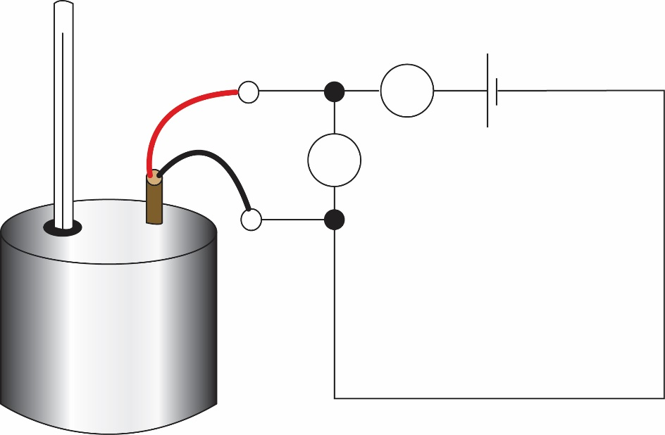
Thermometer
Heater
Metal block
A
V

What readings does the student need to take?
Outline how these values are used to find the specific heat capacity [5 marks]
4. What has a higher specific heat capacity than the specific heat for copper? What does this mean? [1 mark]

DfE Apparatus and Techniques covered
If you are using the OCR Practical Activity Learner Record Sheet (Physics / Combined Science) you may be able to tick off the following skills:

Physics |  |  |  |  | Combined Science
1a-iii | 1a-iv | 1a-v | 1a-vi |  | 1-iii | 1-iv | 1-v | 1-viii
5-i | 5-ii | 6a-i | 6a-ii |  | 2-ii | 17-i | 17-ii | 18a-i
 |  |  |  |  | 18a-ii

