M3.1 – Translate information between graphical, numerical and algebraic forms

Quiz
1. Describe the graphs below focussing on the relationship between the x and y axis variables.
A. B.
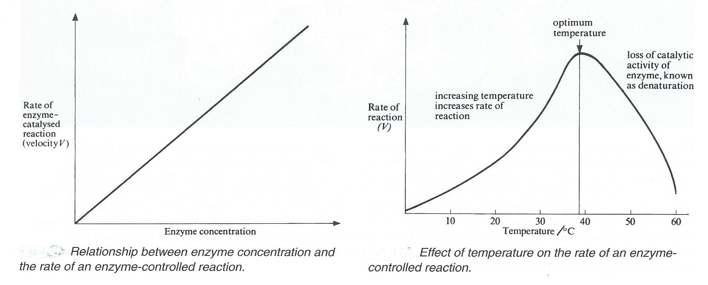

2. A simplified description of photosynthesis: ‘Photosynthesis is dependent on light. When there is no light no photosynthesis takes place. As light intensity increases, the rate of photosynthesis increases linearly until it reaches an upper limit. Further increases in light intensity beyond this point have no effect on rate of photosynthesis.’
Draw a sketch graph to show this description of the relationship between rate of photosynthesis and light intensity.

How would the curve you have drawn change if you were to represent the following modifications to the description?
- at very low light intensity no photosynthesis occurs – a threshold light intensity must be reached before any photosynthesis happens

- in addition, at very high light intensity the chlorophyll is damaged and the rate of photosynthesis drops sharply

Produced in collaboration with the University of East Anglia

Produced in collaboration with the University of East Anglia
We’d like to know your view on the resources we produce. By clicking on ‘Like’ or ‘Dislike’ you can help us to ensure that our resources work for you. When the email template pops up please add additional comments if you wish and then just click ‘Send’. Thank you.
If you do not currently offer this OCR qualification but would like to do so, please complete the Expression of Interest Form which can be found here: www.ocr.org.uk/expression-of-interest
Looking for a resource? There is now a quick and easy search tool to help find free resources for your qualification:
www.ocr.org.uk/i-want-to/find-resources/

This formative assessment resource has been produced as part of our free A Level teaching and learning support package. All the A Level teaching and learning resources, including delivery guides, topic exploration packs, lesson elements and more are available on the qualification webpages.
If you are looking for examination practice materials, you can find the Sample Assessment Materials (SAMs) on the qualification webpages: Biology A / Biology B

OCR Resources: the small print
OCR’s resources are provided to support the delivery of OCR qualifications, but in no way constitute an endorsed teaching method that is required by the Board, and the decision to use them lies with the individual teacher. Whilst every effort is made to ensure the accuracy of the content, OCR cannot be held responsible for any errors or omissions within these resources.
© OCR 2017 - This resource may be freely copied and distributed, as long as the OCR logo and this message remain intact and OCR is acknowledged as the originator of this work.
OCR acknowledges the use of the following content: n/a
Please get in touch if you want to discuss the accessibility of resources we offer to support delivery of our qualifications: resources.feedback@ocr.org.uk

