M3.1 – Translate information between graphical, numerical and algebraic forms

Tutorials
Learners may be tested on their ability to:
- understand that data may be presented in a number of formats and be able to use these data, e.g. dissociation curves.

Translating information
You need to be able to represent numerical data as a graph, and you need to be able to do the reverse: read numerical data from a graph.
Translate from numerical to graphical – drawing a graph.
Representing numerical data as a graph simply means ‘drawing graphs’. You’ve been doing this in science and maths lessons for years. Refer to M1.3 for a reminder of the different types of graphs and when to use them. The OCR Practical Skills Handbook also has useful information about how to present data in graphical form. The key point always is to think about what you are trying to communicate and draw your graph in the way that makes this clearest to whoever will be seeing it.
Translate from graphical to numerical – reading data from a graph.
When looking at a graph you need to be able to pick any value along the x axis (or any bar if it is a bar chart) and accurately identify the corresponding value on the y axis. And the other way round – for a value on the y axis you should be able to identify and report the corresponding value (or values – there could be more than one!) on the x axis. This is a simple-seeming skill but it takes care to get it right every time. It’s all too easy to make ‘silly’ mistakes by misreading the scale.
When describing graphical data you need to make sure you refer to both the x axis and y axis variables, using co-ordinates if possible. In addition you need to accurately describe the relationship between the variables using data from the graph.
- Refer to x and y axis variables
- Use coordinates if possible
- Describe the relationship between the variables

For example, here are oxygen dissociation curves for myoglobin and haemoglobin.
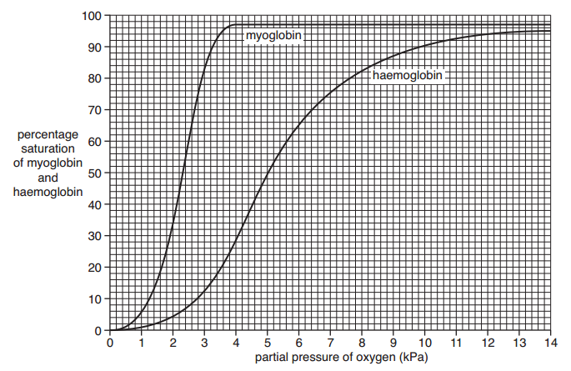
You could be asked to find the percentage saturation of oxygen at a particular partial pressure, compare oxygen dissociation curves for different proteins or species, or to consider how the dissociation curve changes at different concentrations of carbon dioxide (the Bohr effect).
For example, when describing the features of the myoglobin curve you could describe the steep gradient in the middle part of the curve by saying:
“At pO₂ between 1 and 3kPa the percentage saturation of haemoglobin increases rapidly as pO₂ increases”.
This statement clearly refers to both the x axis and y axis variables and accurately describes the relationship using data from the graph.
Translate from graphical to algebraic and back.
You also need to be able to identify some relationships between variables and either use graphs to show the relationship, or describe the relationship when you are shown it as a graph.
This will become a lot clearer when we look at a couple of examples but first let’s look at the (short!) list of relationships you need to deal with.

- Nothing is changing
A graph showing a horizontal straight line parallel to the x-axis shows that the variable plotted on the y-axis is independent of the variable plotted on the x-axis. Or, in other words, the value of the variable y is always the same (constant) no matter what the value of the variable x.
$$y=constant$$

- Linear growing (or shrinking!)
A second kind of graph that you need to know is a non-horizontal straight line. This graph shows that the variable plotted on the y-axis is linearly proportional to the variable plotted on the x-axis, or y α x. This can also be expressed as y = mx + c, where m is the gradient of the graph and c is the value of the intercept on the y axis. This sort of graph is covered in more detail in M3.3.
$$y x$$
$y= mx+c$

- Non-linear growing (or shrinking!)
A third kind of graph is one where there is some dependence of the y variable on the x variable but it is not a linear relationship. The y variable might increase according to the square or the cube of the x variable (resulting in a steeper and steeper curve on the graph).

You do not need to be able to identify and distinguish these different kinds of non-linearity except for the case of exponential growth. As long as you know it is a non-linear relationship you have done enough.
Refer to M2.5 to see an example of exponential growth in the context of the growth of microorganisms and to see how a logarithmic scale allows you to turn this type of graph into a linear representation.
Exponential is a special kind of non-linear relationship, where the y variable changes according to some number raised to the power of the x variable.
$$y=n^{x}$$
Note that the word ‘exponential’ gets used in everyday speech in quite an imprecise way, often simply to mean ‘getting bigger quickly’. In Biology we should try to only describe the relationship we see as ‘exponential’ when we believe, or suspect, that our y variable really is changing as n^{x}.

Examples
In the first graph below we can see that the relationship between the x and y variables (temperature and rate respectively) is different in different sections of the graph.
At temperatures below 15°C and above 37°C the rate is unaffected by changes in temperature. Rate is independent of temperature.
Between 15°C and 37°C the relationship between the variables is linear. Rate increases in direct proportion to the increase in temperature.

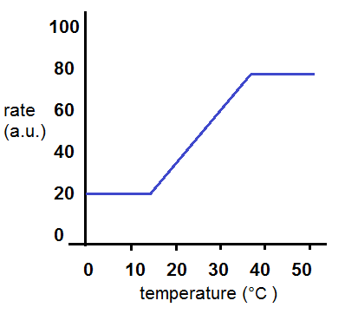

Now let’s have a look at a second curve (shown in red) added to the original graph.
It shows a similar independent relationship between rate and temperature below 15°C and above 37°C but the relationship between these temperatures is clearly non-linear.
We would not describe the relationship as exponential between 15°C and 37°C but we might suspect that there is a small section between about 15°C and 20°C where rate could be increasing exponentially as temperature rises.
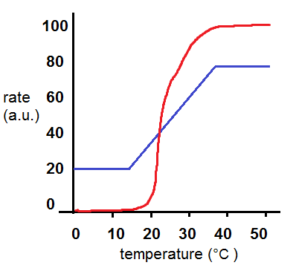
We’d like to know your view on the resources we produce. By clicking on ‘Like’ or ‘Dislike’ you can help us to ensure that our resources work for you. When the email template pops up please add additional comments if you wish and then just click ‘Send’. Thank you.
If you do not currently offer this OCR qualification but would like to do so, please complete the Expression of Interest Form which can be found here: www.ocr.org.uk/expression-of-interest
Looking for a resource? There is now a quick and easy search tool to help find free resources for your qualification:
www.ocr.org.uk/i-want-to/find-resources/

Produced in collaboration with the University of East Anglia
OCR Resources: the small print
OCR’s resources are provided to support the delivery of OCR qualifications, but in no way constitute an endorsed teaching method that is required by the Board, and the decision to use them lies with the individual teacher. Whilst every effort is made to ensure the accuracy of the content, OCR cannot be held responsible for any errors or omissions within these resources.
© OCR 2017 - This resource may be freely copied and distributed, as long as the OCR logo and this message remain intact and OCR is acknowledged as the originator of this work.
OCR acknowledges the use of the following content: n/a
Please get in touch if you want to discuss the accessibility of resources we offer to support delivery of our qualifications: resources.feedback@ocr.org.uk

This resource has been produced as part of our free A Level teaching and learning support package. All the A Level teaching and learning resources, including delivery guides, topic exploration packs, lesson elements and more are available on the qualification webpages.
If you are looking for examination practice materials, you can find the Sample Assessment Materials (SAMs) on the qualification webpages: Biology A / Biology B

OCR Resources: the small print
OCR’s resources are provided to support the delivery of OCR qualifications, but in no way constitute an endorsed teaching method that is required by the Board, and the decision to use them lies with the individual teacher. Whilst every effort is made to ensure the accuracy of the content, OCR cannot be held responsible for any errors or omissions within these resources.
© OCR 2017 - This resource may be freely copied and distributed, as long as the OCR logo and this message remain intact and OCR is acknowledged as the originator of this work.
OCR acknowledges the use of the following content: n/a
Please get in touch if you want to discuss the accessibility of resources we offer to support delivery of our qualifications: resources.feedback@ocr.org.uk

Produced in collaboration with the University of East Anglia
We’d like to know your view on the resources we produce. By clicking on ‘Like’ or ‘Dislike’ you can help us to ensure that our resources work for you. When the email template pops up please add additional comments if you wish and then just click ‘Send’. Thank you.
If you do not currently offer this OCR qualification but would like to do so, please complete the Expression of Interest Form which can be found here: www.ocr.org.uk/expression-of-interest
Looking for a resource? There is now a quick and easy search tool to help find free resources for your qualification:
www.ocr.org.uk/i-want-to/find-resources/

This resource has been produced as part of our free A Level teaching and learning support package. All the A Level teaching and learning resources, including delivery guides, topic exploration packs, lesson elements and more are available on the qualification webpages.
If you are looking for examination practice materials, you can find the Sample Assessment Materials (SAMs) on the qualification webpages: Biology A / Biology B

