M3.2 – Plot two variables from experimental or other data

Tutorials
Learners may be tested on their ability to:
- select an appropriate format for presenting data, e.g. bar charts, histograms, line graphs and scattergrams.

Plotting variables
The best format for presenting data depends on what data you have.
Bar charts and histograms
Refer to M1.3 for a reminder about when to use a bar chart or a histogram.
Here is the summary table from M1.3 to help decide whether to use a bar chart or histogram and as a reminder of the differences when plotting:
Bar chart | Histogram
Qualitative data (categoric or rankable)  Discrete quantitative data | Continuous quantitative data
Bars the same width | Differing widths of bars possible but not advised
Bars not touching | Bars touch
Line graphs and scattergrams
Line graphs and scattergrams can be used when we have data where each data point has two variables.
In many experimental situations we are able to identify one of these variables as ‘independent’ (generally this will be the variable that we change) and the other as ‘dependent’ (generally this is the variable that we measure – to see what effect changing the independent variable has had).

Line graphs
For example, we might carry out an enzymatic reaction using different substrate concentrations to see what effect this has on the rate at which product is made. The substrate concentration is the independent variable and the rate of product formation is the dependent variable.
These kinds of experimental data are best presented as a line graph. We plot the data, with the independent variable on the x axis and the dependent on the y axis. If we can identify a trend we add a line of best fit (straight or curved). We can use this line of best fit to interpolate (which simply means read off values in between our data points) and, in some cases, extrapolate (which means going beyond the range of our data points to read off other values).
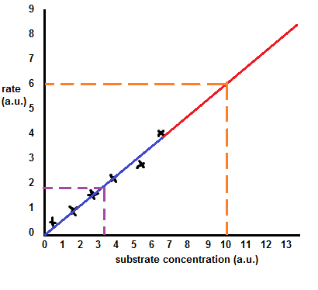
In the line graph above the data points are shown as black crosses. The line of best fit has been drawn, including extrapolation beyond the range of substrate concentrations used. For clarity the extrapolated portion has been shown in red while the part of the line confined to the data range is in blue. When plotting your graphs and adding a line of best fit, use black for the whole line. Extrapolate only when your aim in performing the experiment and communicating results is to comment on values outside your data range. If you are only wishing to discuss results within your data range, do not extrapolate.
The dashed purple lines show interpolation – it is possible to read off an expected value for the rate at a substrate concentration not actually tested (in the example shown we can see that a substrate concentration of 3.3 a.u. would be expected to give a rate of 1.8 a.u.).
The dashed orange line shows extrapolation – a substrate concentration of 10.0 a.u. is higher than the highest concentration tested but we can still suggest a possible corresponding rate of 6.0 a.u.
Tips for plotting line graphs
Plotting a graph is fairly straightforward but there are a few tips which may help you:
Be very careful plotting points accurately
Use appropriate linear scales on axes
Use ‘sensible’ scales, for example using a decimal or straightforward scale
Scales must be chosen so that all points fall within the graph area
Axes must be labelled, with units included
Make the graphs as large as the available space allows
Use an informative title.
A line (or curve) of best-fit should be drawn to identify trends. The line must be smooth and have a balance of data points above and below the line.
Sometimes extrapolation of data is required, for example to determine the intercept with the y-axis. To do this you need to extend the line of best fit to the appropriate point. Extrapolation can be used to predict values beyond the existing data set based on the current trend.
In some situations the line of best fit needs to be drawn through the origin, for example for rate–concentration graphs. However, the line of best fit should only go through the origin if the data and trend allow it.
Scattergrams
In some cases data which can look superficially very similar to the line graph scenario is better presented as a scattergram.
Once again we have two variables for each data point. It might also be the case that we have a variable we can identify as the independent and a variable we would call the dependent. But scattergrams are also appropriate when this is not the case. We might be interested in a possible association between two variables without being in a situation to change one variable and see what effect it has on the other variable.
The clearest case where we would choose to present data as a scattergram rather than as a line graph is when we have obtained our data set by sampling a natural or pre-existing situation rather than by performing a lab-based experiment where we control most variables, change one and measure another.
For example we could sample tree species in a woodland. For each species we could measure two variables (height of canopy and surface area of leaf).
The resulting data could be appropriately presented as a scattergram. In this case we might choose to add a line very much like a line of best fit but in this case it is intended to highlight the suspected association between the variables. A quantitative analysis of the suspected association could be done using the statistical test ‘Spearman’s rank correlation’ – see M1.9.
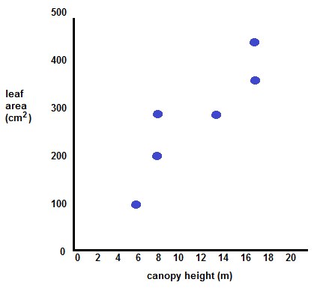
We’d like to know your view on the resources we produce. By clicking on ‘Like’ or ‘Dislike’ you can help us to ensure that our resources work for you. When the email template pops up please add additional comments if you wish and then just click ‘Send’. Thank you.
If you do not currently offer this OCR qualification but would like to do so, please complete the Expression of Interest Form which can be found here: www.ocr.org.uk/expression-of-interest
Looking for a resource? There is now a quick and easy search tool to help find free resources for your qualification:
www.ocr.org.uk/i-want-to/find-resources/

Produced in collaboration with the University of East Anglia
OCR Resources: the small print
OCR’s resources are provided to support the delivery of OCR qualifications, but in no way constitute an endorsed teaching method that is required by the Board, and the decision to use them lies with the individual teacher. Whilst every effort is made to ensure the accuracy of the content, OCR cannot be held responsible for any errors or omissions within these resources.
© OCR 2017 - This resource may be freely copied and distributed, as long as the OCR logo and this message remain intact and OCR is acknowledged as the originator of this work.
OCR acknowledges the use of the following content: n/a
Please get in touch if you want to discuss the accessibility of resources we offer to support delivery of our qualifications: resources.feedback@ocr.org.uk

This resource has been produced as part of our free A Level teaching and learning support package. All the A Level teaching and learning resources, including delivery guides, topic exploration packs, lesson elements and more are available on the qualification webpages.
If you are looking for examination practice materials, you can find the Sample Assessment Materials (SAMs) on the qualification webpages: Biology A / Biology B

