M3.2 – Plot two variables from experimental or other data

Quiz
A calibration curve
Calibration curves and lines are used to plot the relationship between two variables so that the resulting curve or line can be used to read off the value of an unknown sample. They are examples of line graphs.
For example, in colorimetry a calibration curve is used to establish the relationship between the absorption of a particular wavelength of light by a solution, and the concentration of a coloured solution.
This technique may be used to plot the data for the absorption of a reducing sugar of known concentrations tested with Benedict’s reagent, for example:
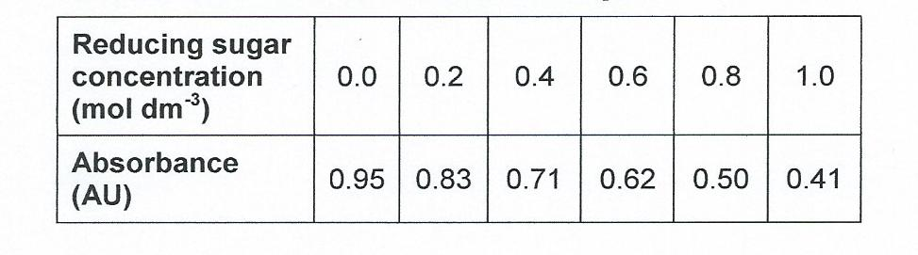

- Plot the data to produce a calibration graph.

- If a reducing sugar solution of unknown concentration is now tested with Benedict’s reagent, the absorbance value allows us to read off the concentration of the unknown solution.

Solution A gives an absorbance reading of 0.56 arbitrary units.

What is the concentration of reducing sugar?

Produced in collaboration with the University of East Anglia

Produced in collaboration with the University of East Anglia

