M3.2 – Plot two variables from experimental or other data

Teacher answers

Quiz
A calibration curve
Calibration curves and lines are used to plot the relationship between two variables so that the resulting curve or line can be used to read off the value of an unknown sample. They are examples of line graphs.
For example, in colorimetry a calibration curve is used to establish the relationship between the absorption of a particular wavelength of light by a solution, and the concentration of a coloured solution.
This technique may be used to plot the data for the absorption of a reducing sugar of known concentrations tested with Benedict’s reagent, for example:
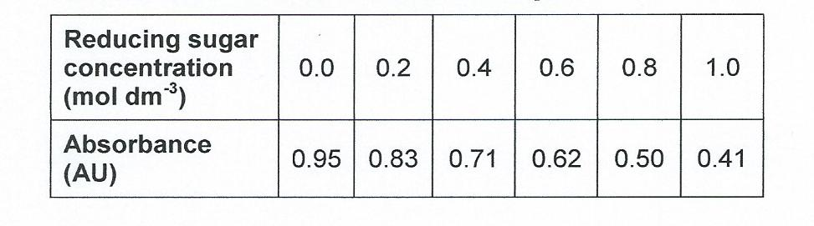

- Plot the data to produce a calibration graph.
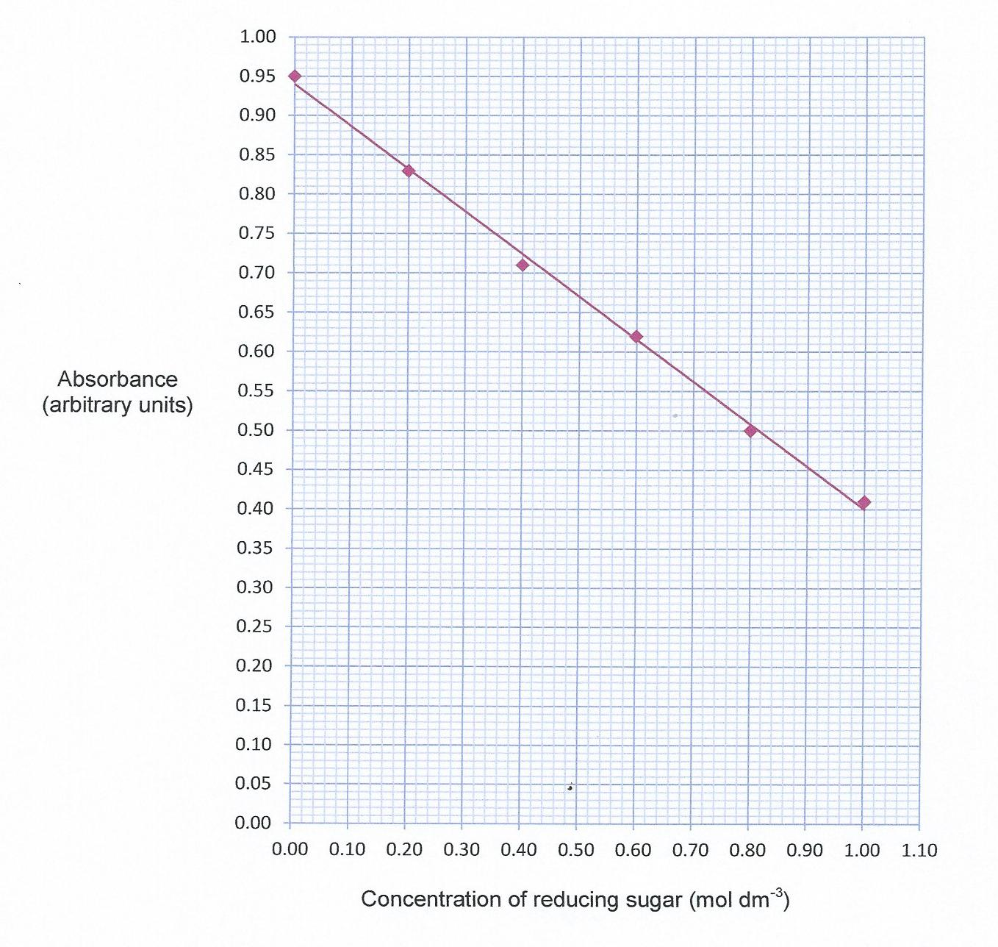

- If a reducing sugar solution of unknown concentration is now tested with Benedict’s reagent, the absorbance value allows us to read off the concentration of the unknown solution.

Solution A gives an absorbance reading of 0.56 arbitrary units.

What is the concentration of reducing sugar?
Concentration of reducing sugar = 0.71 mol dm⁻³

Produced in collaboration with the University of East Anglia
We’d like to know your view on the resources we produce. By clicking on ‘Like’ or ‘Dislike’ you can help us to ensure that our resources work for you. When the email template pops up please add additional comments if you wish and then just click ‘Send’. Thank you.
If you do not currently offer this OCR qualification but would like to do so, please complete the Expression of Interest Form which can be found here: www.ocr.org.uk/expression-of-interest
Looking for a resource? There is now a quick and easy search tool to help find free resources for your qualification:
www.ocr.org.uk/i-want-to/find-resources/

This formative assessment resource has been produced as part of our free A Level teaching and learning support package. All the A Level teaching and learning resources, including delivery guides, topic exploration packs, lesson elements and more are available on the qualification webpages.
If you are looking for examination practice materials, you can find the Sample Assessment Materials (SAMs) on the qualification webpages: Biology A / Biology B

OCR Resources: the small print
OCR’s resources are provided to support the delivery of OCR qualifications, but in no way constitute an endorsed teaching method that is required by the Board, and the decision to use them lies with the individual teacher. Whilst every effort is made to ensure the accuracy of the content, OCR cannot be held responsible for any errors or omissions within these resources.
© OCR 2017 - This resource may be freely copied and distributed, as long as the OCR logo and this message remain intact and OCR is acknowledged as the originator of this work.
OCR acknowledges the use of the following content: n/a
Please get in touch if you want to discuss the accessibility of resources we offer to support delivery of our qualifications: resources.feedback@ocr.org.uk

