M3.3 – Understanding that y = mx +c represents a linear relationship

Tutorials
Learners may be tested on their ability to:
- predict/sketch the shape of a graph with a linear relationship, e.g. the effect of substrate concentration on the rate of an enzyme-controlled reaction with excess enzyme.
Linear relationships represented by y = mx + c
As we discussed in section M3.1, you should be able to identify a linear relationship when given a graph that looks like this. You also must be able to sketch a graph when given a linear relationship.
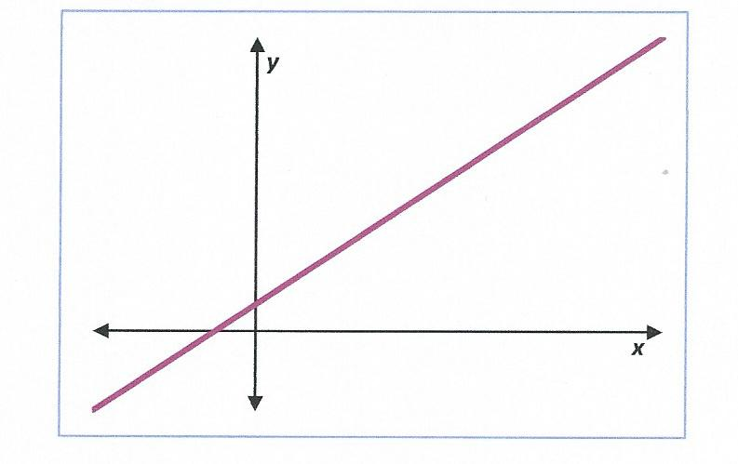
A sloping straight line shows that the dependent variable on the y axis is proportional to the independent variable on the x axis. To demonstrate something is proportional to something else we use the symbol α.
Dependent variable (y axis)
Independent variable (x axis)
y α x

Mathematically this is represented by the equation y = mx + c. The letter “m” is the gradient of the line – we explain how to calculate this in section M3.5, and “c” is the value of the intercept on the y axis, which we explain in section M3.4.
m Gradient of the line
c Y intercept
You need to be able to determine whether the linear relationship is positive or negative. If the line slopes up from left to right this shows a positive relationship, and the gradient “m” will be a positive number. If the line slopes down from left to right, it’s a negative relationship and the gradient “m” is a negative number.
Positive relationship – positive gradient (m)

Negative relationship – negative gradient (m)
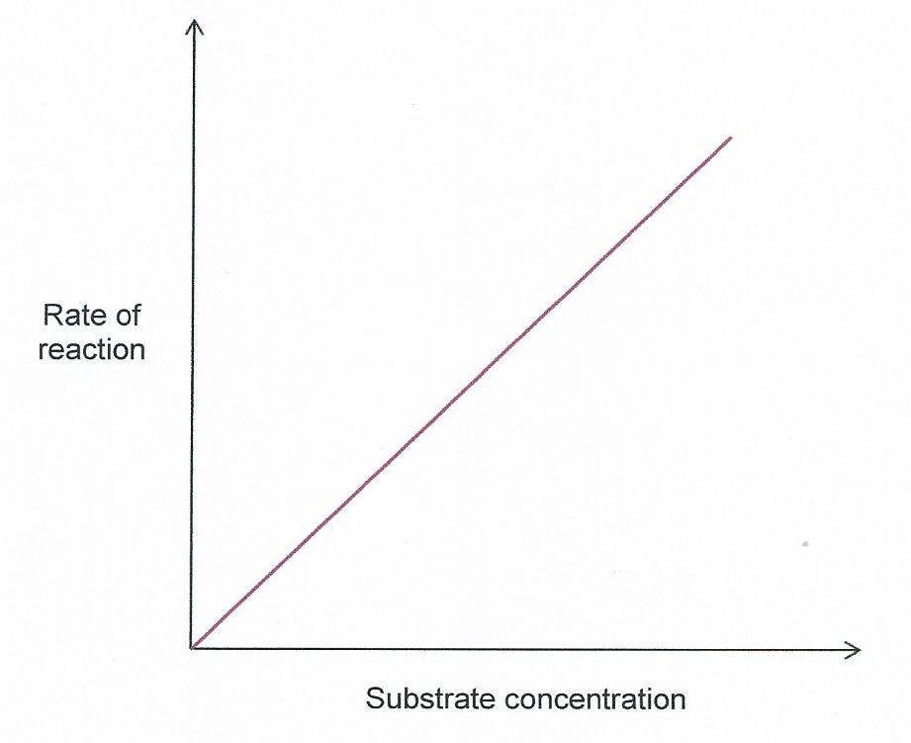

For example, this graph of rate of an enzyme reaction against substrate concentration shows a positive relationship.

In this example the intercept on the y axis (represented by “c” in the equation) is zero. Therefore in this case the equation becomes y = mx + 0, or y = mx.
y = mx + 0
y = mx

This resource has been produced as part of our free A Level teaching and learning support package. All the A Level teaching and learning resources, including delivery guides, topic exploration packs, lesson elements and more are available on the qualification webpages.
If you are looking for examination practice materials, you can find the Sample Assessment Materials (SAMs) on the qualification webpages: Biology A / Biology B

OCR Resources: the small print
OCR’s resources are provided to support the delivery of OCR qualifications, but in no way constitute an endorsed teaching method that is required by the Board, and the decision to use them lies with the individual teacher. Whilst every effort is made to ensure the accuracy of the content, OCR cannot be held responsible for any errors or omissions within these resources.
© OCR 2017 - This resource may be freely copied and distributed, as long as the OCR logo and this message remain intact and OCR is acknowledged as the originator of this work.
OCR acknowledges the use of the following content: n/a
Please get in touch if you want to discuss the accessibility of resources we offer to support delivery of our qualifications: resources.feedback@ocr.org.uk

Produced in collaboration with the University of East Anglia
We’d like to know your view on the resources we produce. By clicking on ‘Like’ or ‘Dislike’ you can help us to ensure that our resources work for you. When the email template pops up please add additional comments if you wish and then just click ‘Send’. Thank you.
If you do not currently offer this OCR qualification but would like to do so, please complete the Expression of Interest Form which can be found here: www.ocr.org.uk/expression-of-interest
Looking for a resource? There is now a quick and easy search tool to help find free resources for your qualification:
www.ocr.org.uk/i-want-to/find-resources/

