M3.4 – Determine the intercept of a graph

Quiz
1. An experiment was carried out to find the water potential of the cells in potato tubers.
Cylinders of potato were cut from potatoes and weighed. These cylinders were then immersed in sucrose solutions of different concentrations for 4 hours. The cylinders were then weighed again and the percentage change in mass was recorded.
The results were plotted and the line of best fit is shown in the graph below.
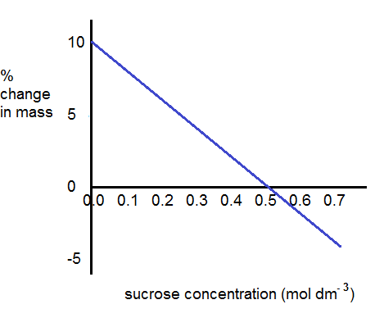
What are the intercepts in this graph?

Which intercept will be used to find the water potential of the cells?

2. Measurements were made of pressure changes within the left side of the heart and the aorta during the cardiac cycle of a healthy adult human. The intercepts of the various curves indicate moments in the cycle when pressure is equal in the two chambers or vessels. This is when valves open and close.
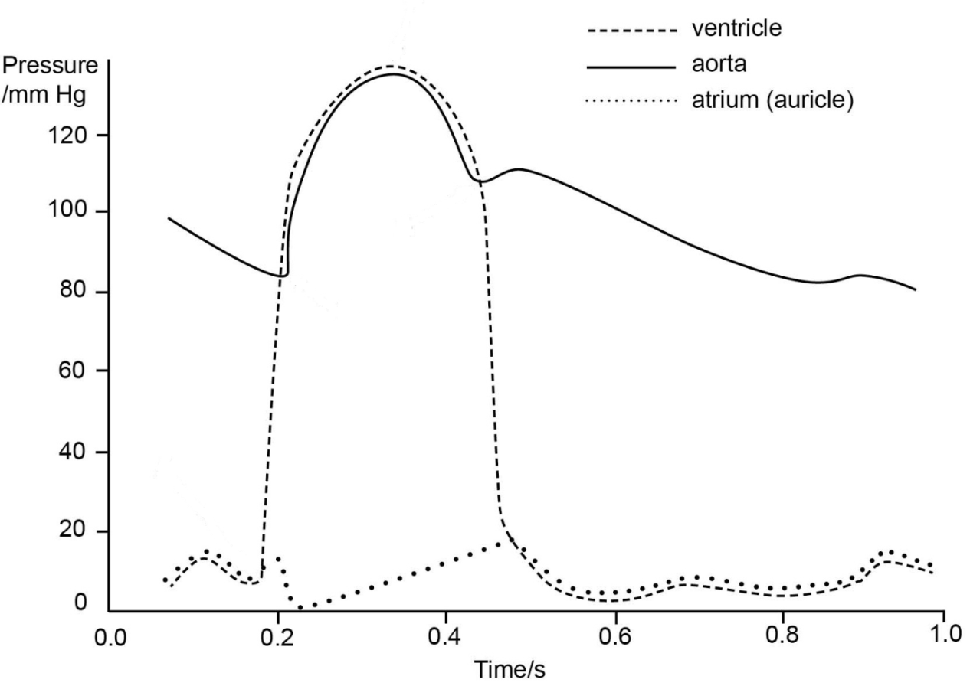
Identify the intercepts and give their meanings in terms of valve opening/closing.

Produced in collaboration with the University of East Anglia

Produced in collaboration with the University of East Anglia
We’d like to know your view on the resources we produce. By clicking on ‘Like’ or ‘Dislike’ you can help us to ensure that our resources work for you. When the email template pops up please add additional comments if you wish and then just click ‘Send’. Thank you.
If you do not currently offer this OCR qualification but would like to do so, please complete the Expression of Interest Form which can be found here: www.ocr.org.uk/expression-of-interest
Looking for a resource? There is now a quick and easy search tool to help find free resources for your qualification:
www.ocr.org.uk/i-want-to/find-resources/

This formative assessment resource has been produced as part of our free A Level teaching and learning support package. All the A Level teaching and learning resources, including delivery guides, topic exploration packs, lesson elements and more are available on the qualification webpages.
If you are looking for examination practice materials, you can find the Sample Assessment Materials (SAMs) on the qualification webpages: Biology A / Biology B

OCR Resources: the small print
OCR’s resources are provided to support the delivery of OCR qualifications, but in no way constitute an endorsed teaching method that is required by the Board, and the decision to use them lies with the individual teacher. Whilst every effort is made to ensure the accuracy of the content, OCR cannot be held responsible for any errors or omissions within these resources.
© OCR 2017 - This resource may be freely copied and distributed, as long as the OCR logo and this message remain intact and OCR is acknowledged as the originator of this work.
OCR acknowledges the use of the following content: n/a
Please get in touch if you want to discuss the accessibility of resources we offer to support delivery of our qualifications: resources.feedback@ocr.org.uk

