M3.6 – Draw and use the slope of a tangent to a curve as a measure of rate of change

Quiz
This graph shows concentration of maltose produced over time for an enzyme-controlled reaction. Find the rate of maltose production at 2 min.
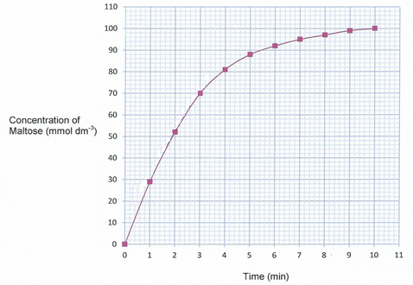

Produced in collaboration with the University of East Anglia

