M3.6 – Draw and use the slope of a tangent to a curve as a measure of rate of change

Teacher answers

Quiz
This graph shows concentration of maltose produced over time for an enzyme-controlled reaction. Find the rate of maltose production at 2 min.
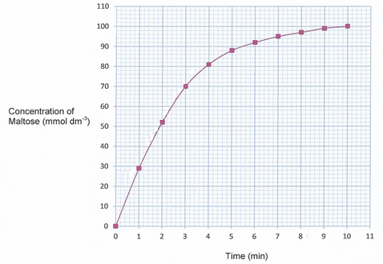
The graph is curved so we need to draw a tangent line to the curve at the point for 2 minutes to approximate the gradient.

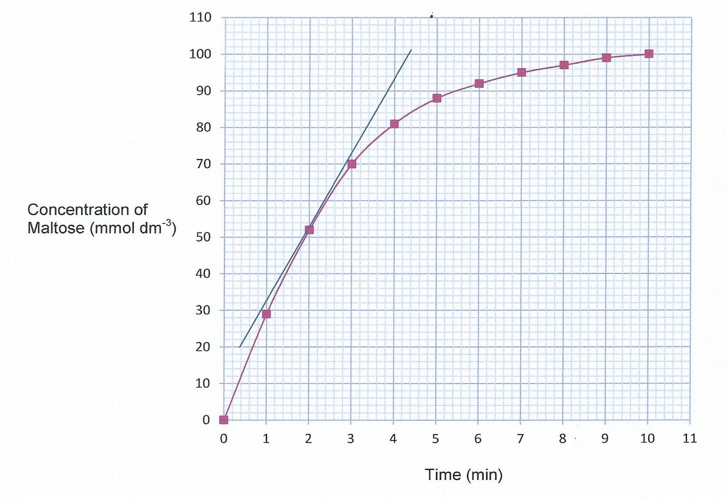
Using this tangent line we can use the formula gradient equals the change in y divided by the change in x (or rise over run) between 2 points.
$$Gradient=\frac{'change in y'}{'change in x'}$$

Using the points (1,33) and (3.3, 80) we get a change in y (“rise”) of 80 – 33 = 47, and a change in x (“run”) of 3.3 – 1 = 2.3. So the gradient and thus the rate of reaction at 2 minutes is 47 divided by 2.3 which equals 20.4 mmol dm⁻³ min ⁻¹.
Change in y: 80 – 33 = 47
Change in x: 3.3 – 1 = 2.3
The rate of reaction (gradient) at 2 minutes: $\frac{47}{2.3}$ = 20.4 mmol dm⁻³ min⁻¹

Produced in collaboration with the University of East Anglia
This formative assessment resource has been produced as part of our free A Level teaching and learning support package. All the A Level teaching and learning resources, including delivery guides, topic exploration packs, lesson elements and more are available on the qualification webpages.
If you are looking for examination practice materials, you can find the Sample Assessment Materials (SAMs) on the qualification webpages: Biology A / Biology B

We’d like to know your view on the resources we produce. By clicking on ‘Like’ or ‘Dislike’ you can help us to ensure that our resources work for you. When the email template pops up please add additional comments if you wish and then just click ‘Send’. Thank you.
If you do not currently offer this OCR qualification but would like to do so, please complete the Expression of Interest Form which can be found here: www.ocr.org.uk/expression-of-interest
Looking for a resource? There is now a quick and easy search tool to help find free resources for your qualification:
www.ocr.org.uk/i-want-to/find-resources/

OCR Resources: the small print
OCR’s resources are provided to support the delivery of OCR qualifications, but in no way constitute an endorsed teaching method that is required by the Board, and the decision to use them lies with the individual teacher. Whilst every effort is made to ensure the accuracy of the content, OCR cannot be held responsible for any errors or omissions within these resources.
© OCR 2017 - This resource may be freely copied and distributed, as long as the OCR logo and this message remain intact and OCR is acknowledged as the originator of this work.
OCR acknowledges the use of the following content: n/a
Please get in touch if you want to discuss the accessibility of resources we offer to support delivery of our qualifications: resources.feedback@ocr.org.uk

